**The Fastest and the most natural language to use when scraping web data is python, therefore I’m using python plus beautifulSoup4 for this demonstration.**

First thing First we need to inspect elements and view source to locate the useful content and their tags that contains them.

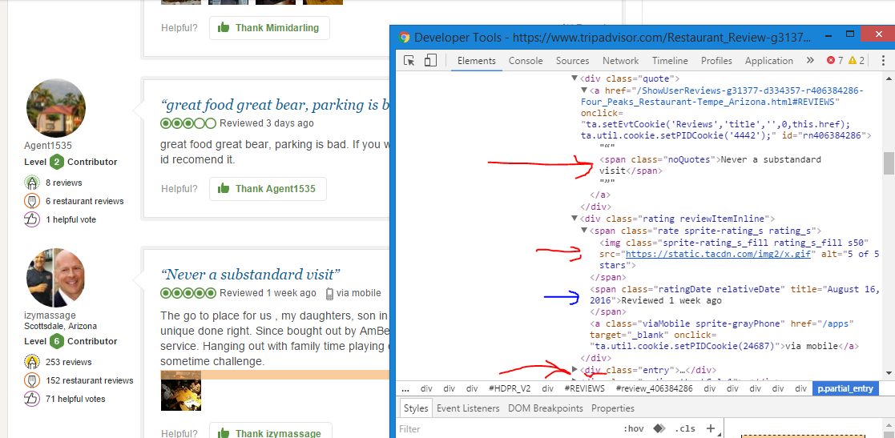

**Grabbing Tittle data from html**

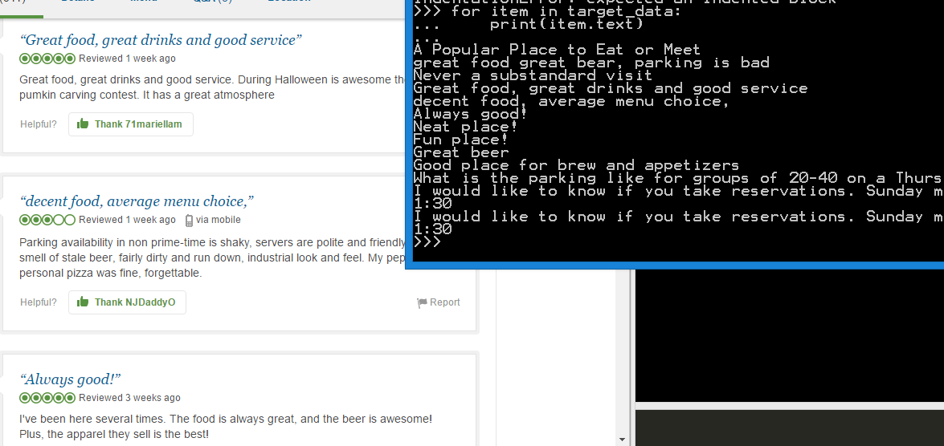

**Titles:**

**A Popular Place to Eat or Meet;**

**great food great bear, parking is bad;**

**Never a substandard visit;**

**Great food, great drinks and good service;**

**decent food, average menu choice,;**

**Always good!;**

**Neat place!;**

**Fun place!;**

**Great beer;**

**Good place for brew and appetizers;**

What is the parking like for groups of 20-40 on a Thursday 5:00-7:00pm?

I would like to know if you take reservations. Sunday morning the 02/151:30 I would like to know if you take reservations. Sunday morning the 02/151:30

***(Due to the title label tags, extra comment titles were scraped)***

***(Notice semi-colon were added at the end for easier Excel data parsing)***

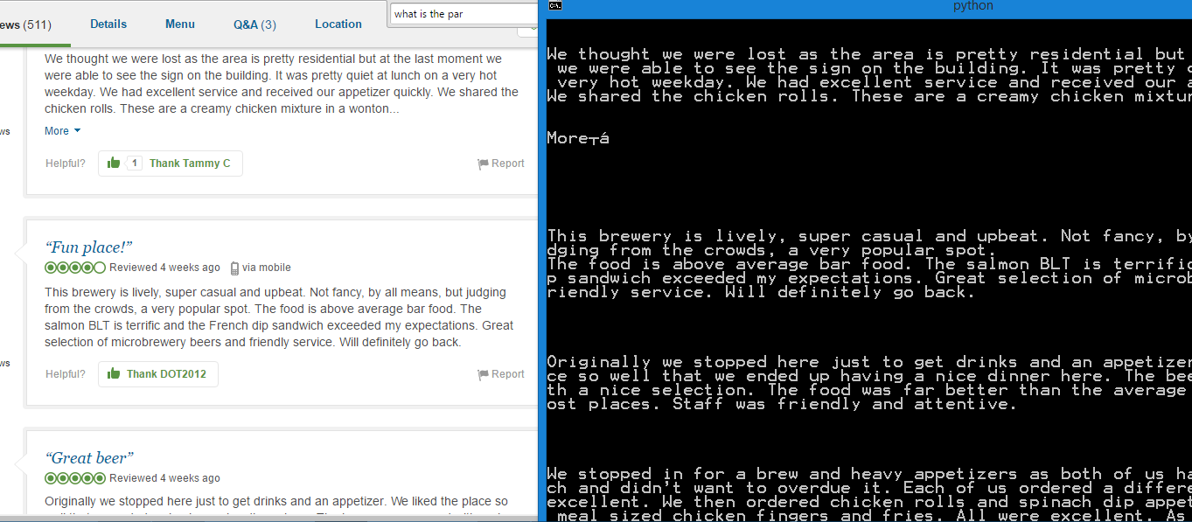

**Review Contents:**

We visited here after getting our grandson settled into ASU. The atmosphere was

lively. There were a lot of people inside and outside on the really nice eating

area. We sat in the back by the bear vats. There are a lot of awards on the wall

which was impressive. The food was pretty good. I had pork chops which...

great food great bear, parking is bad. If you want to drive around and look for

parking, id recomend it.

The go to place for us , my daughters, son in law friends. Food is always over t

he top, unique done right. Since bought out by AmBev several more beer selection

s, same service. Hanging out with family time playing cards, watching sports. Pa

rking a sometime challenge.

Great food, great drinks and good service. During Halloween is awesome they have

a pumkin carving contest. It has a great atmosphere

Parking availability in non prime-time is shaky, servers are polite and friendly

. The smell of stale beer, fairly dirty and run down, industrial look and feel.

My pepperoni personal pizza was fine, forgettable.

I've been here several times. The food is always great, and the beer is awesome!

Plus, the apparel they sell is the best!

We thought we were lost as the area is pretty residential but at the last moment

we were able to see the sign on the building. It was pretty quiet at lunch on a

very hot weekday. We had excellent service and received our appetizer quickly.

We shared the chicken rolls. These are a creamy chicken mixture in a wonton...

This brewery is lively, super casual and upbeat. Not fancy, by all means, but ju

dging from the crowds, a very popular spot.

The food is above average bar food. The salmon BLT is terrific and the French di

p sandwich exceeded my expectations. Great selection of microbrewery beers and f

riendly service. Will definitely go back.

Originally we stopped here just to get drinks and an appetizer. We liked the pla

ce so well that we ended up having a nice dinner here. The beer was very good wi

th a nice selection. The food was far better than the average bar food you get m

ost places. Staff was friendly and attentive.

We stopped in for a brew and heavy appetizers as both of us had eaten a late lun

ch and didn't want to overdue it. Each of us ordered a different beer they were

excellent. We then ordered chicken rolls and spinach dip appetizers along with a

meal sized chicken fingers and fries. All were excellent. As much as we liked..

**Here is a snapshot of the python code that I wrote in order to grab the above information:**

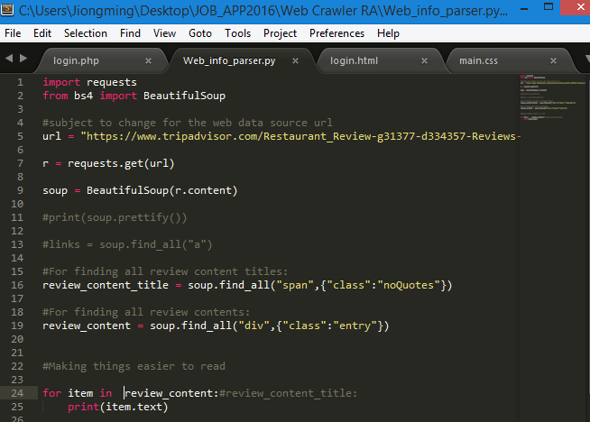

**Alt keys for the image tags stores the rating values:**

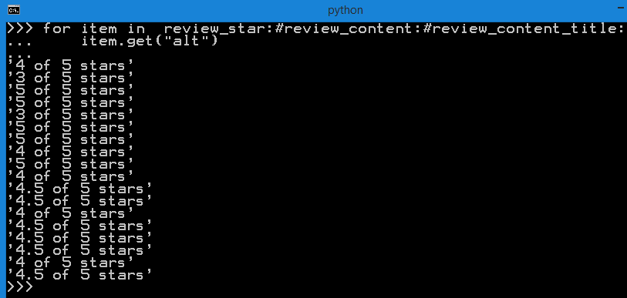

**Title for the review date, text for the day since reviewed:**

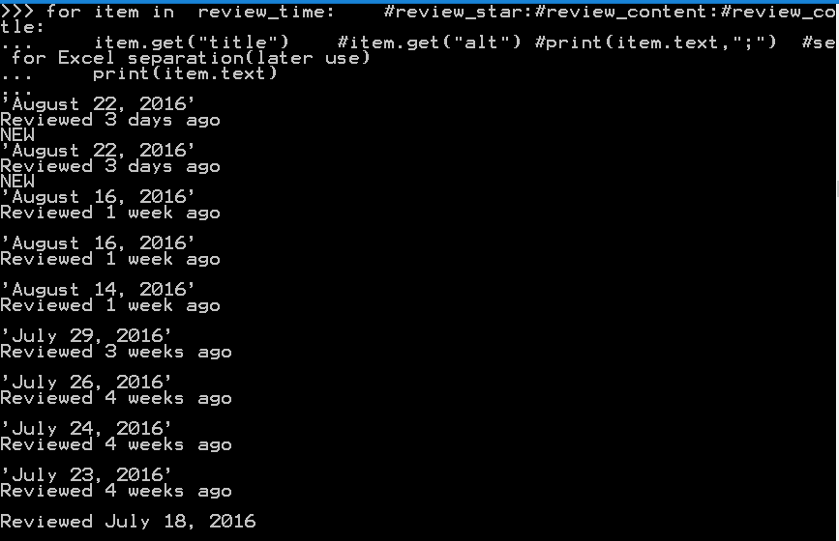

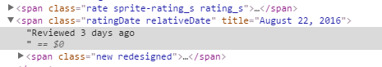

**The overall service review:**

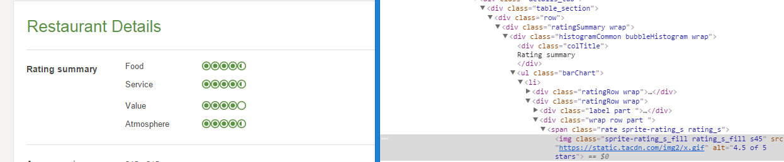

Because the change of their website’s detail display when hover over user icon. Now only overall user summary are shown:

**Food:4.5**

**Service:4.5**

**Value:4**

**Atomosphere:4.5**

**USERS:**

**Usernames:**

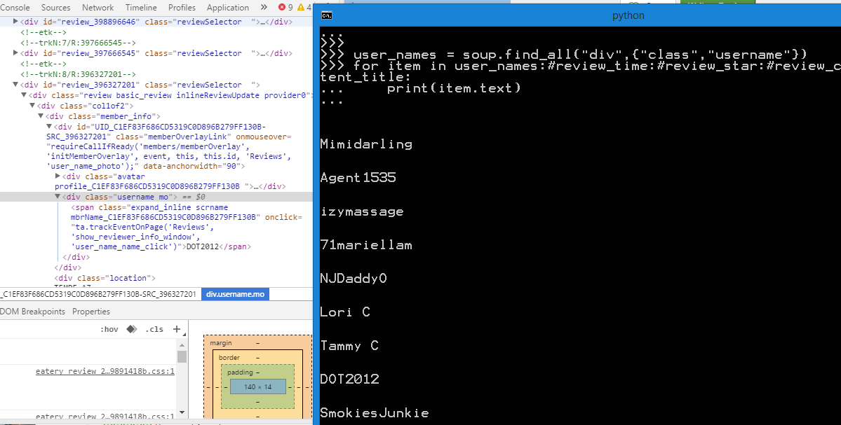

**User Levels:**

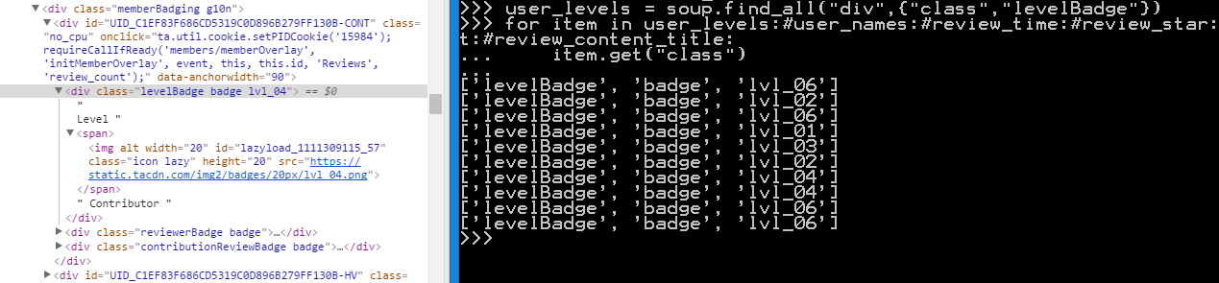

**User votes and reviews:**

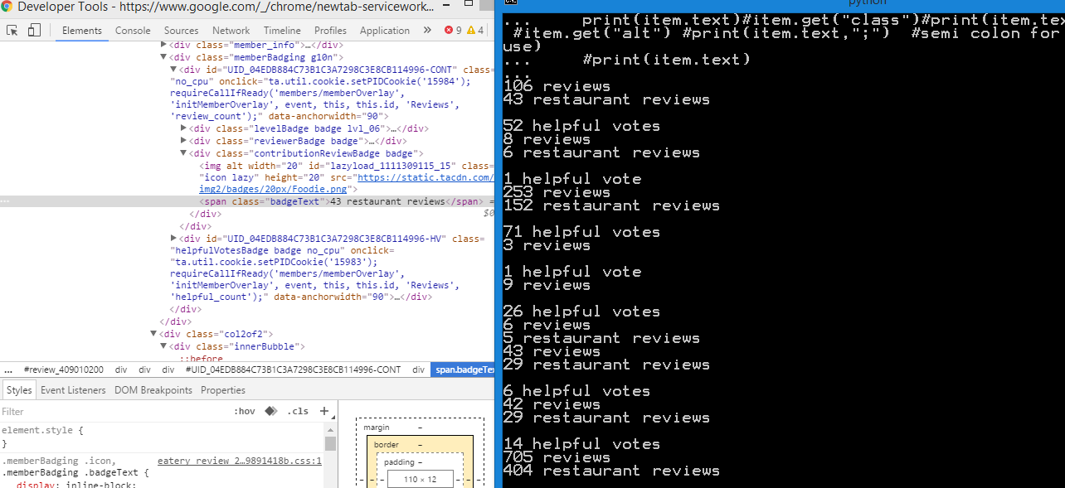

For the hover over layover window scraping I assume we need to use **Node.js** and other request to render the JavaScript content in order to scrape it, as BeautifulSoup could only parse and scrape HTML data, further investigation needed.

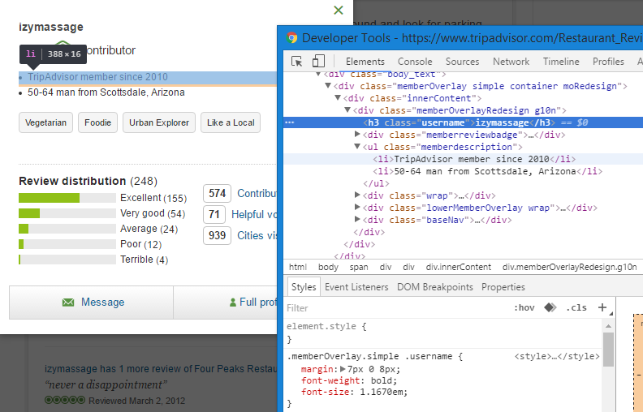

**Multi Pages Scraping:**

https://www.tripadvisor.com/Restaurant_Review-g31377-d334357-Reviews-Four_Peaks_Restaurant-Tempe_Arizona.html

https://www.tripadvisor.com/Restaurant_Review-g31377-d334357-Reviews-or10-Four_Peaks_Restaurant-Tempe_Arizona.html#REVIEWS

https://www.tripadvisor.com/Restaurant_Review-g31377-d334357-Reviews-or20-Four_Peaks_Restaurant-Tempe_Arizona.html#REVIEWS

Noticing that they all have a base URL which is the original one and the only difference is that for page 2 and 3, it has the “-or10” in between which specify the second paged 10 user reviews

And we could simply modify the URL to start scraping more data on other pages.

**Second pages of the user data are all recorded into text files for later excel analysis:**

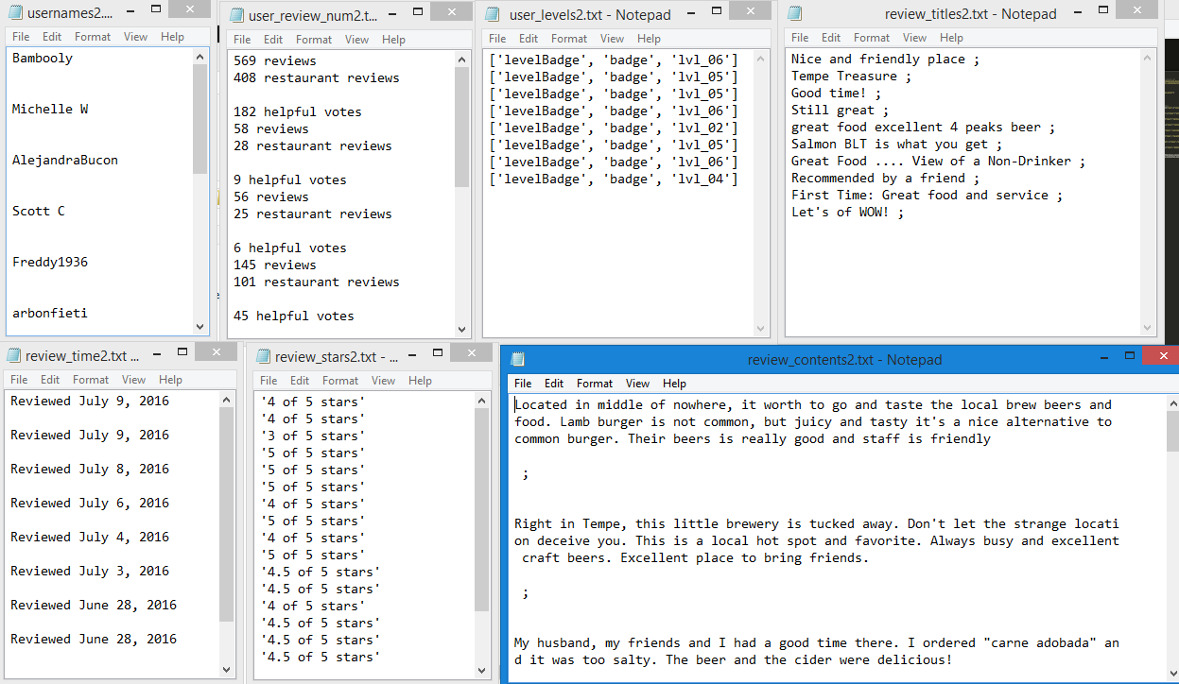

**The Easy Solution For Other Languages to Parse:**

Luckily Excel has got the built in function that allows us to dynamically pull data in from a website. We can achieve this by going to the **data** tab and click on the **From Web.** Then we will be able to open up an New Web Query as shown below:

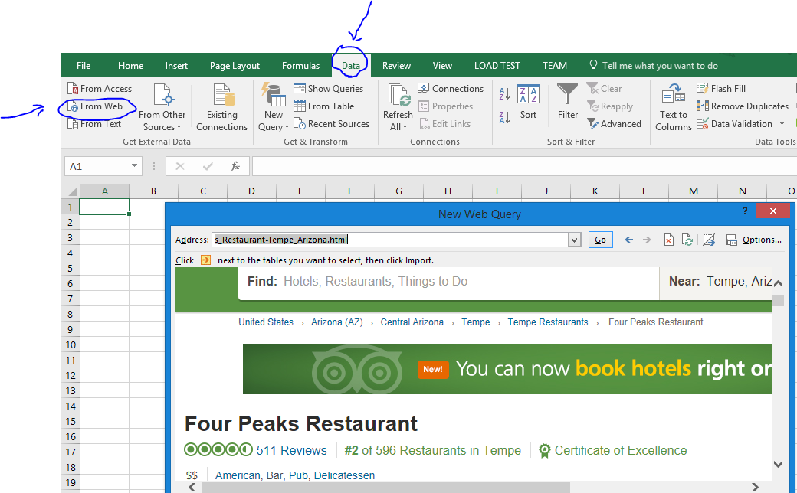

**Then as we could see we might be able to build a Parser using Java or C++ extract some useful information from there:**

