CENTRO DE ENSEÑANZA TÉCNICA Y SUPERIOR

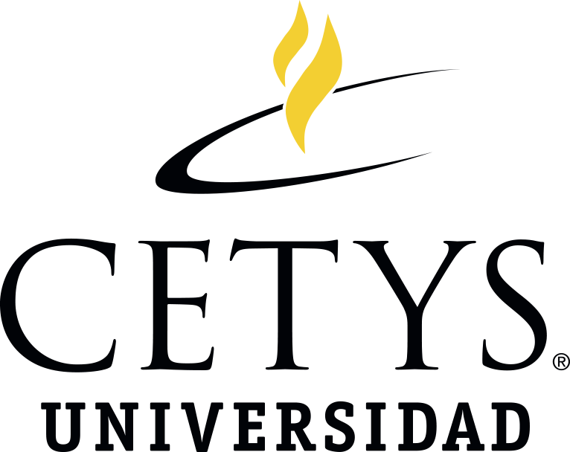

Engineering School

Oral and Written Communication in English

**What is a Job Interview?**

Presents:

David Espina López - 32025

Marcos Alberto Moroyoqui Olán - 30934

Hector Osuna Medrano - 26950

Tijuana, B. C., June 28th, 2021.

**What is a Job Interview?**

**Job Interview definition**

A job interview is a conversation which occurs between a potential employer and a job applicant. During this process, the interviewer evaluates the applicant's appearance, qualifications, and general fitness for the position (International Hellenic University, n. d.).

**Types of Interview Questions**

* To demonstrate abilities
  + What is your greatest accomplishment?
  + Tell me about what you did in your current job
* To determine qualifications
  + Why should we select you instead of other applicants?
* To assess personality
  + What are your reasons for selecting this position?
  + Why did you select this company?
  + How do you see yourself in 10 years?
  + Why did you decide to study (AREA)?
  + What makes you unique?
* To demonstrate knowledge
  + Do you have any questions?
  + What interests you about this role?
* To predict behavior
  + How do you deal with conflict in the workplace?
  + Can you tell me about a difficult work situation and how you overcame it?

**Diagram**

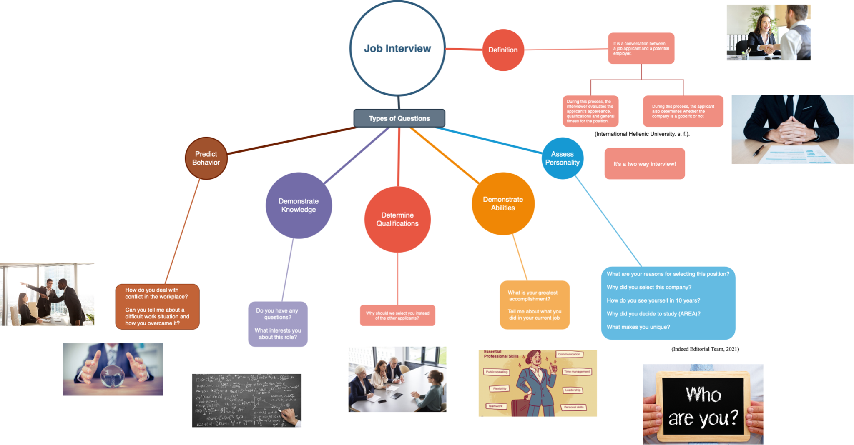

https://drive.google.com/file/d/1JZqb86lrE7W6KB5MBm2oofkhhHJEUKTu/view?usp=sharing

**References**

International Hellenic University. (n. d.). *What is an Interview*?. University Center of International Programmes of Studies. Retrieved from https://ecs.ihu.edu.gr/co/employment-interviews/what-interview