MySQL 数据表增删改查设计与系统展示证明

一、MySQL 连接与数据库总览
本系统默认连接 MySQL 数据库 population_insight，使用 PyMySQL 完成连接、参数化查询、新增、修改和删除。

1.MySQL 连接成功(如下图所示)
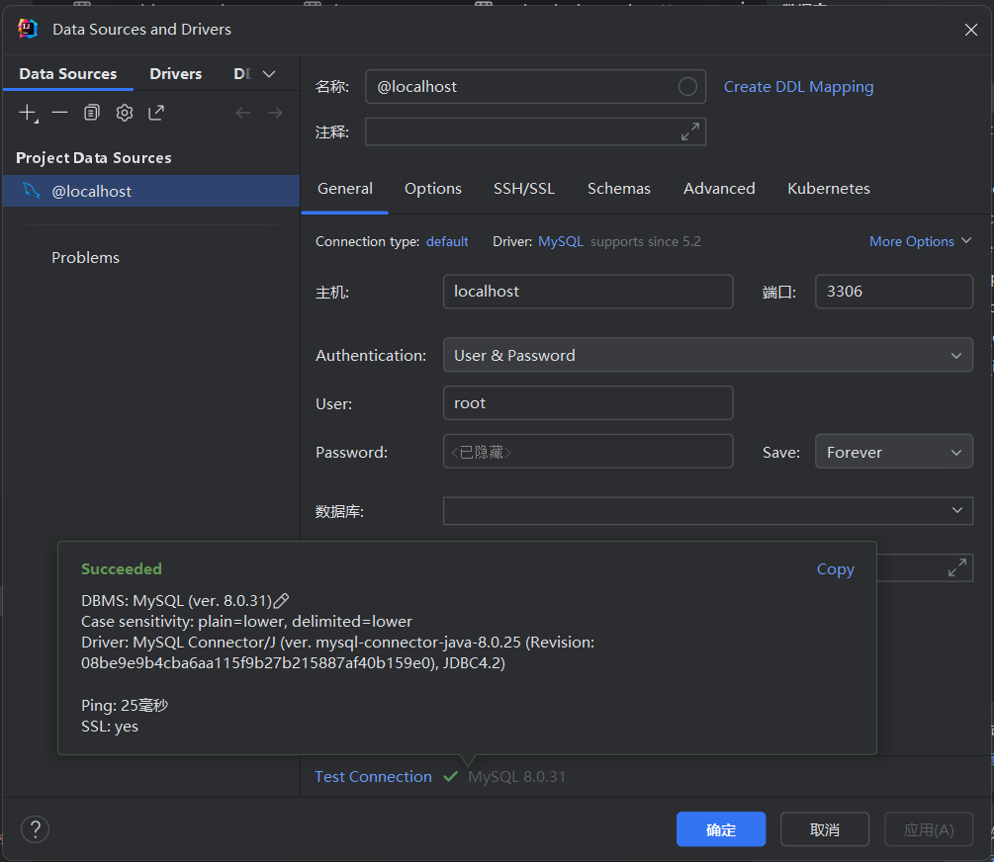
图1-1 MySQL 连接成功

2.MySQL 连接与通用执行函数
75: def get_connection():
76: if is_mysql():
77: try:
78: import pymysql
79: from pymysql.cursors import DictCursor
80: except ImportError as error:
81: raise DatabaseConfigError(
82: "MySQL mode requires PyMySQL. Install dependencies with: pip install -r requirements.txt"
83: ) from error
84:
85: raw_connection = pymysql.connect(
86: host=MYSQL_CONFIG["host"],
87: port=MYSQL_CONFIG["port"],
88: user=MYSQL_CONFIG["user"],
89: password=MYSQL_CONFIG["password"],
90: database=MYSQL_CONFIG["database"],
91: charset=MYSQL_CONFIG["charset"],
92: cursorclass=DictCursor,
93: autocommit=False,
94: )
95: return MySQLConnectionAdapter(raw_connection)
96:
97: connection = sqlite3.connect(DB_PATH)
98: connection.row_factory = sqlite3.Row
99: connection.execute("PRAGMA foreign_keys = ON")
100: return connection
101:
102:
103: def execute_query(connection, query: str, params: Iterable[Any] | None = None):
104: return connection.execute(_translate_query(query), tuple(params or []))
105:
106:
107: def execute_many_query(connection, query: str, params_list: Iterable[Iterable[Any]]) -> None:
108: connection.executemany(_translate_query(query), params_list)
109:
110:
111: def fetch_one(query: str, params: Iterable[Any] | None = None) -> dict[str, Any] | None:
112: with get_connection() as connection:
113: row = execute_query(connection, query, params).fetchone()
114: return dict(row) if row else None
115:
116:
117: def fetch_all(query: str, params: Iterable[Any] | None = None) -> list[dict[str, Any]]:
118: with get_connection() as connection:
119: rows = execute_query(connection, query, params).fetchall()
120: return [dict(row) for row in rows]
121:
122:
123: def execute_write(query: str, params: Iterable[Any] | None = None) -> int:
124: with get_connection() as connection:
125: cursor = execute_query(connection, query, params)
126: connection.commit()
127: return cursor.lastrowid
128:
129:
130: def execute_many(query: str, params_list: Iterable[Iterable[Any]]) -> None:

数据库表清单
表名 | 中文说明 | 记录数 | 可视页面 | CRUD 摘要
users | 用户表 | 2 | 用户管理页面 /users 可查看用户列表；登录页会通过该表校验账号。 | 增:已实现；查:已实现；改:未开放；删:未开放
population_data | 人口数据表 | 311 | 人口数据管理 /records 支持查询；/records/new 支持新增；编辑和删除入口在记录列表中。 | 增:已实现；查:已实现；改:已实现；删:已实现
operation_logs | 操作日志表 | 10 | 操作日志页面 /logs 可查看最近操作。 | 增:已实现；查:已实现；改:未开放；删:未开放
regions | 地区档案表 | 31 | 地区档案页面 /regions 支持新增和查看。 | 增:已实现；查:已实现；改:未开放；删:未开放
data_sources | 数据来源表 | 31 | 数据来源页面 /sources 支持新增和查看。 | 增:已实现；查:已实现；改:未开放；删:未开放
population_indicators | 扩展指标定义表 | 3 | 扩展指标页面 /indicators 上半部分支持新增和查看指标定义。 | 增:已实现；查:已实现；改:未开放；删:未开放
annual_indicator_values | 年度扩展指标值表 | 6 | 扩展指标页面 /indicators 下半部分支持新增和查看年度指标值。 | 增:已实现；查:已实现；改:未开放；删:未开放
analysis_reports | 分析报告表 | 0 | 分析报告页面 /reports 支持新增和查看；统计、预测等页面也可保存报告。 | 增:已实现；查:已实现；改:未开放；删:未开放
national_population_series | 全国长序列表 | 76 | 全国长序列页面 /national-series 展示摘要、趋势图和年度明细。 | 增:已实现；查:已实现；改:已实现于初始化同步；删:未开放

二、逐表增删改查分析

1. users（用户表）
表用途：保存系统登录账号、密码哈希、角色和创建时间，用于后台登录认证和权限判断。
系统展示：用户管理页面 /users 可查看用户列表；登录页会通过该表校验账号。

CRUD 覆盖情况
操作 | 系统实现情况
增 | 已实现。系统初始化 seed_users() 写入默认 admin/viewer 账号；当前系统未开放前端新增用户表单。
查 | 已实现。authenticate_user() 查询登录用户，users_view() 在 /users 页面查询并展示用户列表。

字段结构
字段 | 类型 | 可空 | 键 | 默认值 | 额外信息
id | int | NO | PRI |  | auto_increment
username | varchar(100) | NO | UNI
password_hash | varchar(255) | NO
role | varchar(20) | NO
created_at | timestamp | NO |  | CURRENT_TIMESTAMP | DEFAULT_GENERATED

users 系统页面
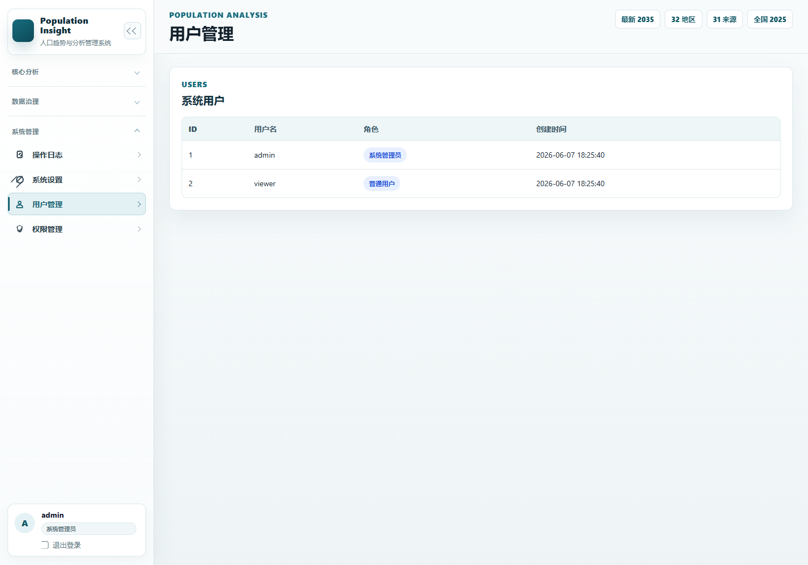
图2-1用户管理界面

users MySQL 表数据
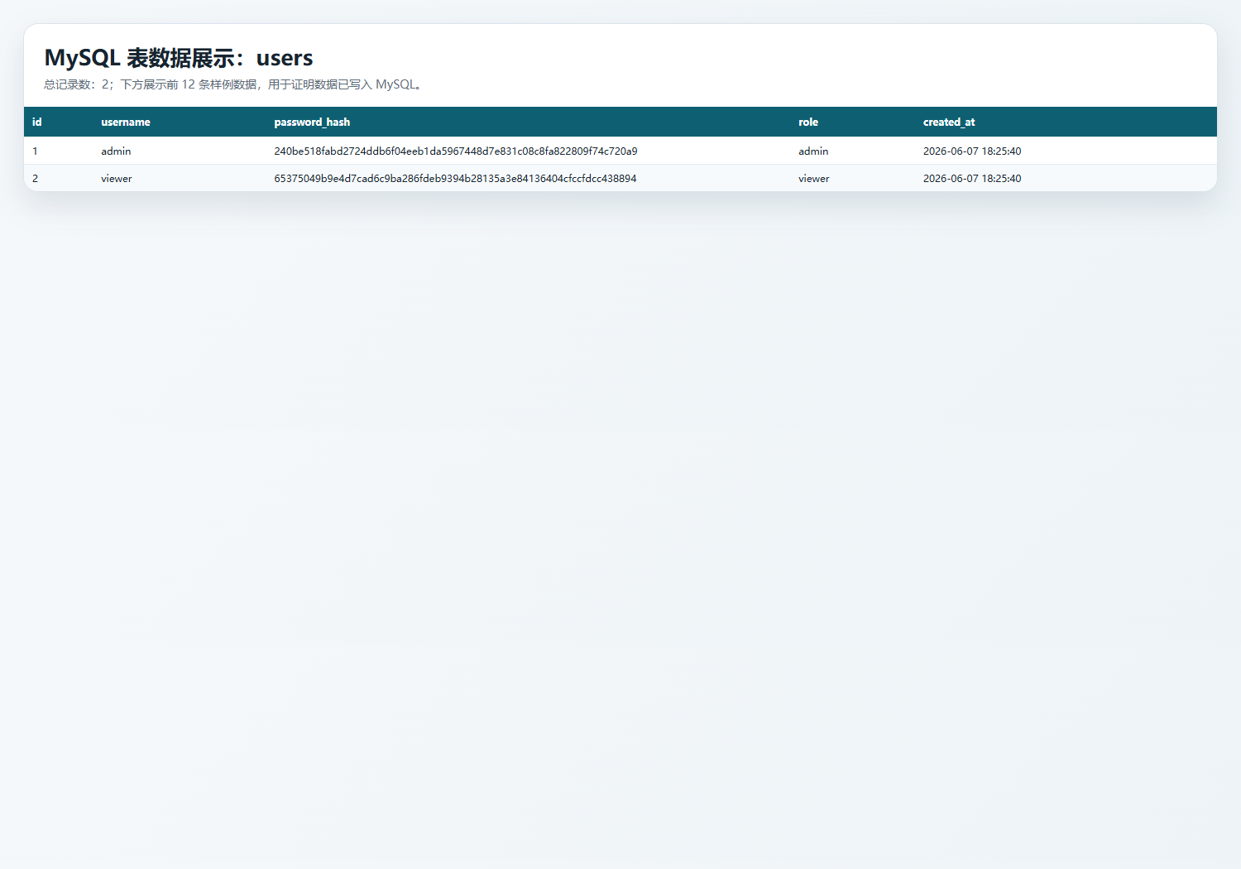
图2-2 MySQL查表功能界面展示

对应代码片段

初始化新增默认用户
406: def seed_users() -> None:
407: user_rows = [
408: (user["username"], hash_password(user["password"]), user["role"])
409: for user in DEFAULT_USERS
410: ]
411: with get_connection() as connection:
412: connection.executemany(
413: _insert_ignore_sql("users (username, password_hash, role)", "?, ?, ?"),
414: user_rows,
415: )
416: connection.commit()
417:
418:

登录与用户查询
1: from population_insight.db.connection import fetch_one
2: from population_insight.services.log_service import log_operation
3: from population_insight.utils.security import verify_password
4:
5:
6: def login(username: str, password: str) -> dict | None:
7: user = fetch_one(
8: """
9: SELECT id, username, password_hash, role, created_at
10: FROM users
11: WHERE username = ?
12: """,
13: (username.strip(),),
14: )
15: if not user:
16: return None
17:
18: if not verify_password(password, user["password_hash"]):
19: log_operation(user["username"], "LOGIN_FAILED", details="密码错误")
20: return None
21:
22: log_operation(user["username"], "LOGIN_SUCCESS", target_id=user["id"])
23: return {
24: "id": user["id"],

用户页面路由
665: @app.route("/users")
666: @admin_required
667: def users_view():
668: from population_insight.db.connection import fetch_all
669:
670: users = fetch_all("SELECT id, username, role, created_at FROM users ORDER BY username ASC")
671: return render_template("users.html", users=users)

2. population_data（人口数据表）
表用途：核心业务表，保存地区、年份、总人口、性别人口、出生率、死亡率、自然增长率、老龄化率、城镇化率、来源和质量标记。
系统展示：人口数据管理 /records 支持查询；/records/new 支持新增；编辑和删除入口在记录列表中。

CRUD 覆盖情况
操作 | 系统实现情况
增 | 已实现。add_population_record() 校验表单后 INSERT INTO population_data。
查 | 已实现。query_population_records() 按地区、年份和指标区间动态查询。
改 | 已实现。update_population_record() 根据 id 更新记录。
删 | 已实现。delete_population_record() 根据 id 删除记录。

字段结构
字段 | 类型 | 可空 | 键 | 默认值 | 额外信息
id | int | NO | PRI |  | auto_increment
region | varchar(100) | NO | MUL
year | int | NO
total_population | bigint | NO
male_population | bigint | NO
female_population | bigint | NO
birth_rate | double | NO
death_rate | double | NO
natural_growth_rate | double | NO
aging_rate | double | NO
urbanization_rate | double | NO
aging_rate_basis | varchar(50) | YES |  | 60_plus
data_source_name | varchar(255) | YES
source_url | text | YES
data_quality | varchar(100) | YES
remarks | text | YES
created_at | timestamp | NO |  | CURRENT_TIMESTAMP | DEFAULT_GENERATED
updated_at | timestamp | NO |  | CURRENT_TIMESTAMP | DEFAULT_GENERATED

population_data 系统页面
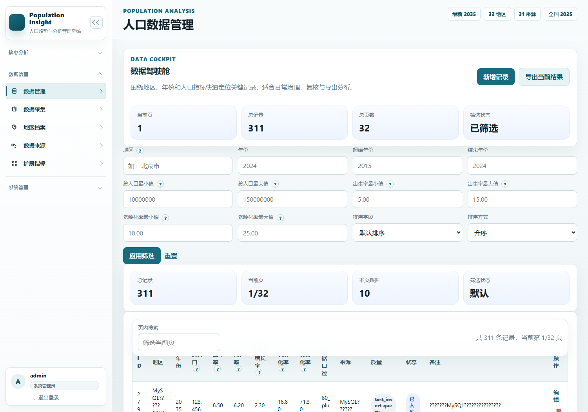
图2-3数据管理界面

population_data MySQL 表数据
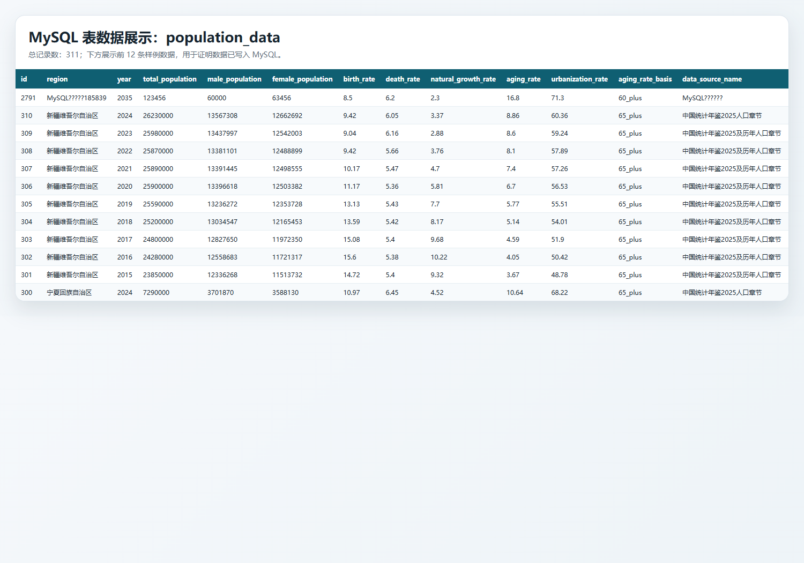
图2-4 population_data表数据界面

对应代码片段

新增函数
70: def add_population_record(data_dict: dict[str, Any], username: str = "system") -> int:
71: normalized = validate_population_payload(data_dict)
72: values = [normalized.get(field, "") for field in INSERT_FIELDS]
73:
74: try:
75: with get_connection() as connection:
76: cursor = connection.execute(
77: f"""
78: INSERT INTO population_data ({", ".join(INSERT_FIELDS)})
79: VALUES ({", ".join("?" for _ in INSERT_FIELDS)})
80: """,
81: values,
82: )
83: connection.commit()
84: record_id = cursor.lastrowid
85: except get_integrity_error_types() as error:
86: if is_unique_constraint_error(error):
87: raise ValueError("同一地区同一年份的数据已存在。") from error
88: raise ValueError("新增数据失败，请检查输入内容。") from error
89:
90: log_operation(username, "ADD_RECORD", target_id=record_id, details=normalized["region"])
91: return record_id
92:
93:
94: def get_population_record_by_id(record_id: int) -> dict[str, Any] | None:
95: return fetch_one(
96: """
97: SELECT *
98: FROM population_data
99: WHERE id = ?
100: """,
101: (record_id,),
102: )
103:

查询函数
105: def query_population_records(filters: dict[str, Any] | None = None) -> list[dict[str, Any]]:
106: filters = filters or {}
107: query = ["SELECT * FROM population_data WHERE 1 = 1"]
108: params: list[Any] = []
109:
110: if filters.get("region"):
111: query.append("AND region LIKE ?")
112: params.append(f"%{str(filters['region']).strip()}%")
113: if filters.get("year"):
114: query.append("AND year = ?")
115: params.append(int(filters["year"]))
116: if filters.get("start_year"):
117: query.append("AND year >= ?")
118: params.append(int(filters["start_year"]))
119: if filters.get("end_year"):
120: query.append("AND year <= ?")
121: params.append(int(filters["end_year"]))
122:
123: range_filters = {
124: "min_total_population": ("total_population", ">="),
125: "max_total_population": ("total_population", "<="),
126: "min_birth_rate": ("birth_rate", ">="),
127: "max_birth_rate": ("birth_rate", "<="),
128: "min_aging_rate": ("aging_rate", ">="),
129: "max_aging_rate": ("aging_rate", "<="),
130: }
131: for key, (column, operator) in range_filters.items():
132: if filters.get(key) in (None, ""):
133: continue
134: query.append(f"AND {column} {operator} ?")
135: params.append(float(filters[key]))
136:
137: query.append("ORDER BY region ASC, year ASC")
138: return fetch_all(" ".join(query), params)
139:
140:
141: def update_population_record(
142: record_id: int, updates: dict[str, Any], username: str = "system"

修改与删除函数
144: existing = get_population_record_by_id(record_id)
145: if not existing:
146: raise ValueError("要修改的记录不存在。")
147:
148: normalized = validate_population_payload(updates, partial=True, existing=existing)
149: assignments = [f"{field} = ?" for field in normalized]
150: values = list(normalized.values())
151: values.append(record_id)
152:
153: try:
154: with get_connection() as connection:
155: connection.execute(
156: f"""
157: UPDATE population_data
158: SET {", ".join(assignments)}, updated_at = CURRENT_TIMESTAMP
159: WHERE id = ?
160: """,
161: values,
162: )
163: connection.commit()
164: except get_integrity_error_types() as error:
165: if is_unique_constraint_error(error):
166: raise ValueError("修改后会与已有地区年份记录冲突。") from error
167: raise ValueError("修改数据失败。") from error
168:
169: log_operation(username, "UPDATE_RECORD", target_id=record_id, details=existing["region"])
170:
171:
172: def delete_population_record(record_id: int, username: str = "system") -> None:
173: existing = get_population_record_by_id(record_id)
174: if not existing:
175: raise ValueError("要删除的记录不存在。")
176:
177: with get_connection() as connection:
178: connection.execute("DELETE FROM population_data WHERE id = ?", (record_id,))
179: connection.commit()
180:
181: log_operation(username, "DELETE_RECORD", target_id=record_id, details=existing["region"])

页面路由
225: @app.route("/records")
226: @login_required
227: def records_view():
228: try:
229: filters, raw_filters = _parse_record_filters(request.args)
230: except ValueError as error:
231: flash(str(error), "error")
232: filters, raw_filters = {}, {key: _clean_text(request.args.get(key)) for key in [
233: "region",
234: "year",
235: "start_year",
236: "end_year",
237: "min_total_population",
238: "max_total_population",
239: "min_birth_rate",
240: "max_birth_rate",
241: "min_aging_rate",
242: "max_aging_rate",
243: ]}
244:
245: sort_field = _clean_text(request.args.get("sort_field"))
246: sort_order = _clean_text(request.args.get("sort_order")) or "asc"
247: page = _parse_page(request.args.get("page"))
248:
249: records = query_population_records(filters)
250: try:
251: sorted_records = _apply_record_sort(records, sort_field, sort_order)
252: except ValueError as error:
253: flash(str(error), "error")
254: sort_field = ""
255: sort_order = "asc"
256: sorted_records = _apply_record_sort(records, sort_field, sort_order)
257:
258: pagination = _paginate(sorted_records, page)
259: query_params = {**raw_filters, "sort_field": sort_field, "sort_order": sort_order}
260:
261: return render_template(
262: "records.html",
263: filters=raw_filters,
264: records=pagination["items"],
265: pagination=pagination,
266: sort_field=sort_field,
267: sort_order=sort_order,
268: export_query=_querystring(query_params),
269: page_query=_querystring(query_params),
270: region_options=get_distinct_regions(),
271: )
272:
273:
274: @app.route("/collection", methods=["GET", "POST"])
275: @admin_required
276: def collection_view():
277: form_data = request.form.to_dict()
278: preview_records: list[dict] = []
279: records_payload = ""
280: import_summary = None
281:
282: if request.method == "POST":
283: action = _clean_text(request.form.get("action")) or "preview"
284: try:
285: if action == "import":
286: preview_records = decode_records(request.form.get("records_payload", ""))
287: source_name = _clean_text(request.form.get("source_name"))
288: source_url = _clean_text(request.form.get("source_url"))
289: quality = _clean_text(request.form.get("data_quality")) or "official_verified"
290: aging_basis = _clean_text(request.form.get("aging_rate_basis")) or "60_plus"
291: preview_records = [
292: {
293: **record,
294: "data_source_name": record.get("data_source_name") or source_name,
295: "source_url": record.get("source_url") or source_url,
296: "data_quality": record.get("data_quality") or quality,
297: "aging_rate_basis": record.get("aging_rate_basis") or aging_basis,
298: }
299: for record in preview_records
300: ]
301: import_summary = import_collected_records(preview_records, username=g.user["username"])
302: log_operation(
303: g.user["username"],
304: "IMPORT_COLLECTED_RECORDS",
305: details=f"imported={import_summary['imported']}, failed={import_summary['failed']}",
306: )
307:
308: publisher = _clean_text(request.form.get("publisher"))
309: if source_name and publisher:
310: try:
311: add_data_source(
312: {
313: "name": source_name,
314: "publisher": publisher,
315: "source_url": _clean_text(request.form.get("source_url")),
316: "published_date": _clean_text(request.form.get("published_date")),
317: "reliability_level": _clean_text(request.form.get("reliability_level")) or "高",
318: "remarks": _clean_text(request.form.get("source_remarks")) or "人口数据采集导入",
319: },
320: username=g.user["username"],
321: )
322: except ValueError as source_error:
323: flash(f"数据来源整理提示：{source_error}", "warning")
324:
325: level = "success" if import_summary["failed"] == 0 else "warning"
326: flash(
327: f"采集导入完成：成功 {import_summary['imported']} 条，失败 {import_summary['failed']} 条。",
328: level,
329: )
330: records_payload = encode_records(preview_records)
331: if import_summary["failed"] == 0:
332: return redirect(url_for("records_view"))
333: else:
334: result = collect_population_records(
335: raw_text=request.form.get("raw_text", ""),
336: source_url=_clean_text(request.form.get("source_url")),
337: )
338: preview_records = result["records"]
339: records_payload = encode_records(preview_records)
340: flash(f"已识别 {len(preview_records)} 条人口记录，请核对后导入。", "success")
341: except ValueError as error:
342: flash(str(error), "error")
343:
344: return render_template(
345: "collection.html",
346: form_data=form_data,
347: preview_records=preview_records,
348: records_payload=records_payload,
349: import_summary=import_summary,
350: )
351:
352:
353: @app.route("/records/new", methods=["GET", "POST"])
354: @admin_required
355: def record_create_view():
356: form_data = {}
357: if request.method == "POST":
358: form_data = request.form.to_dict()
359: try:
360: record_id = add_population_record(form_data, username=g.user["username"])
361: flash(f"新增成功，记录 ID：{record_id}", "success")
362: return redirect(url_for("records_view"))
363: except ValueError as error:
364: flash(str(error), "error")
365:
366: return render_template(
367: "record_form.html",
368: mode="create",
369: form_data=form_data,
370: region_options=get_distinct_regions(),
371: )
372:
373:
374: @app.route("/records/<int:record_id>/edit", methods=["GET", "POST"])
375: @admin_required
376: def record_edit_view(record_id: int):
377: record = get_population_record_by_id(record_id)
378: if not record:
379: flash("记录不存在。", "error")
380: return redirect(url_for("records_view"))
381:
382: form_data = dict(record)
383: if request.method == "POST":
384: form_data = request.form.to_dict()
385: try:
386: update_population_record(record_id, form_data, username=g.user["username"])
387: flash("记录修改成功。", "success")
388: return redirect(url_for("records_view"))
389: except ValueError as error:
390: flash(str(error), "error")
391:
392: return render_template(
393: "record_form.html",
394: mode="edit",
395: form_data=form_data,
396: record=record,
397: region_options=get_distinct_regions(),
398: )
399:
400:
401: @app.route("/records/<int:record_id>/delete", methods=["POST"])
402: @admin_required
403: def record_delete_view(record_id: int):
404: try:
405: delete_population_record(record_id, username=g.user["username"])
406: flash("记录已删除。", "success")
407: except ValueError as error:

3. operation_logs（操作日志表）
表用途：保存用户对数据的新增、修改、删除、扩展信息维护等操作记录，用于审计追踪。
系统展示：操作日志页面 /logs 可查看最近操作。

CRUD 覆盖情况
操作 | 系统实现情况
增 | 已实现。log_operation() 在业务操作后自动 INSERT INTO operation_logs。
查 | 已实现。list_operation_logs() 查询日志，/logs 页面展示。

字段结构
字段 | 类型 | 可空 | 键 | 默认值 | 额外信息
id | int | NO | PRI |  | auto_increment
username | varchar(100) | NO
action | varchar(100) | NO
target_id | int | YES
details | text | YES
action_time | timestamp | NO |  | CURRENT_TIMESTAMP | DEFAULT_GENERATED

operation_logs 系统页面
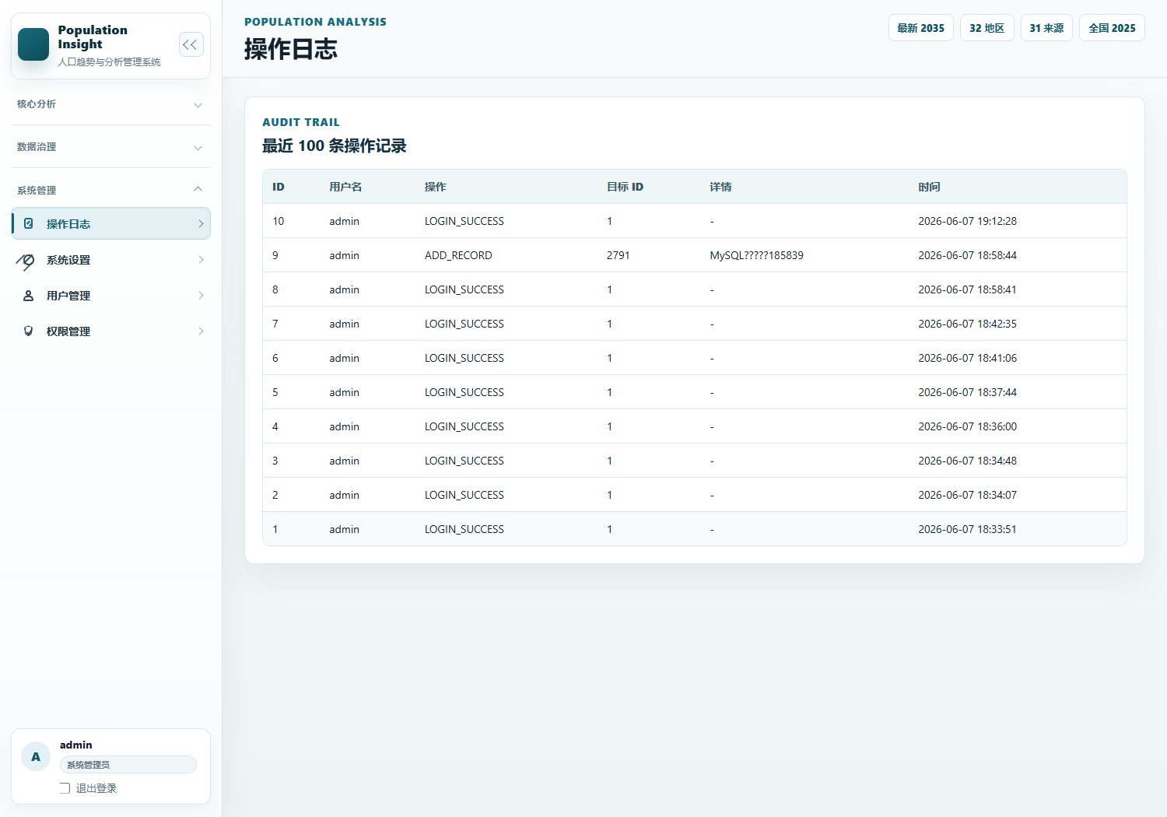
图2-5操作页面

operation_logs MySQL 表数据
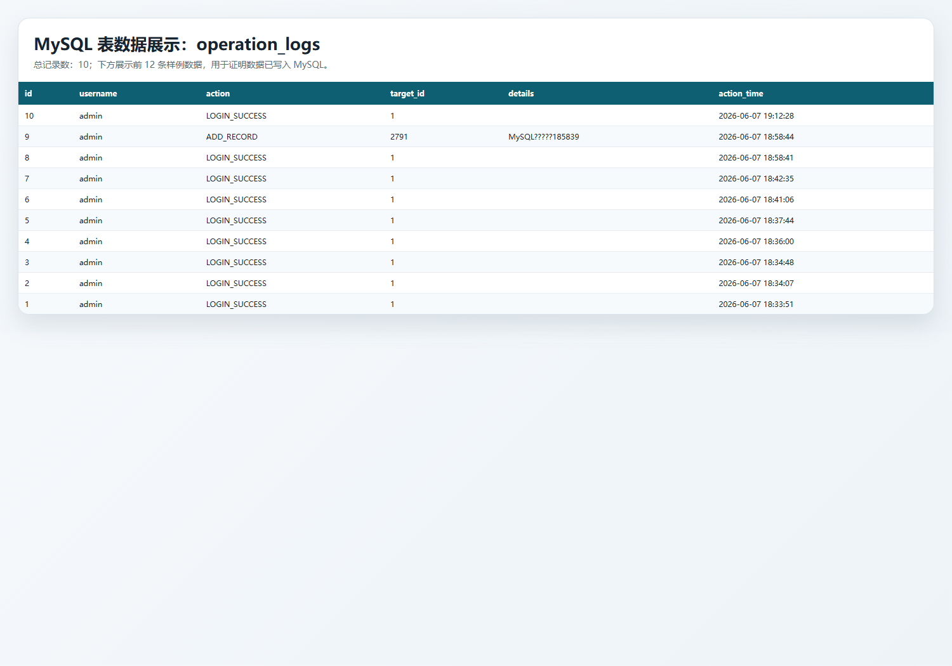
图2-6 operation_logs表数据

对应代码片段

日志新增与查询函数
1: from population_insight.db.connection import execute_write, fetch_all
2:
3:
4: def log_operation(
5: username: str,
6: action: str,
7: target_id: int | None = None,
8: details: str = "",
9: ) -> None:
10: execute_write(
11: """
12: INSERT INTO operation_logs (username, action, target_id, details)
13: VALUES (?, ?, ?, ?)
14: """,
15: (username, action, target_id, details),
16: )
17:
18:
19: def list_operation_logs(limit: int = 30) -> list[dict]:
20: return fetch_all(
21: """
22: SELECT id, username, action, target_id, details, action_time
23: FROM operation_logs
24: ORDER BY action_time DESC, id DESC
25: LIMIT ?
26: """,
27: (limit,),
28: )

日志页面路由
652: @app.route("/logs")
653: @admin_required
654: def logs_view():
655: logs = list_operation_logs(limit=100)
656: return render_template("logs.html", logs=logs)

4. regions（地区档案表）
表用途：保存地区名称、地区类型、行政区划代码、上级地区和备注，用于地区档案维护。
系统展示：地区档案页面 /regions 支持新增和查看。

CRUD 覆盖情况
操作 | 系统实现情况
增 | 已实现。add_region() 写入 regions 表。
查 | 已实现。list_regions() 查询地区档案列表。

字段结构
字段 | 类型 | 可空 | 键 | 默认值 | 额外信息
id | int | NO | PRI |  | auto_increment
name | varchar(100) | NO | UNI
region_type | varchar(100) | NO
admin_code | varchar(50) | YES
parent_region | varchar(100) | YES
remarks | text | YES
created_at | timestamp | NO |  | CURRENT_TIMESTAMP | DEFAULT_GENERATED

regions 系统页面
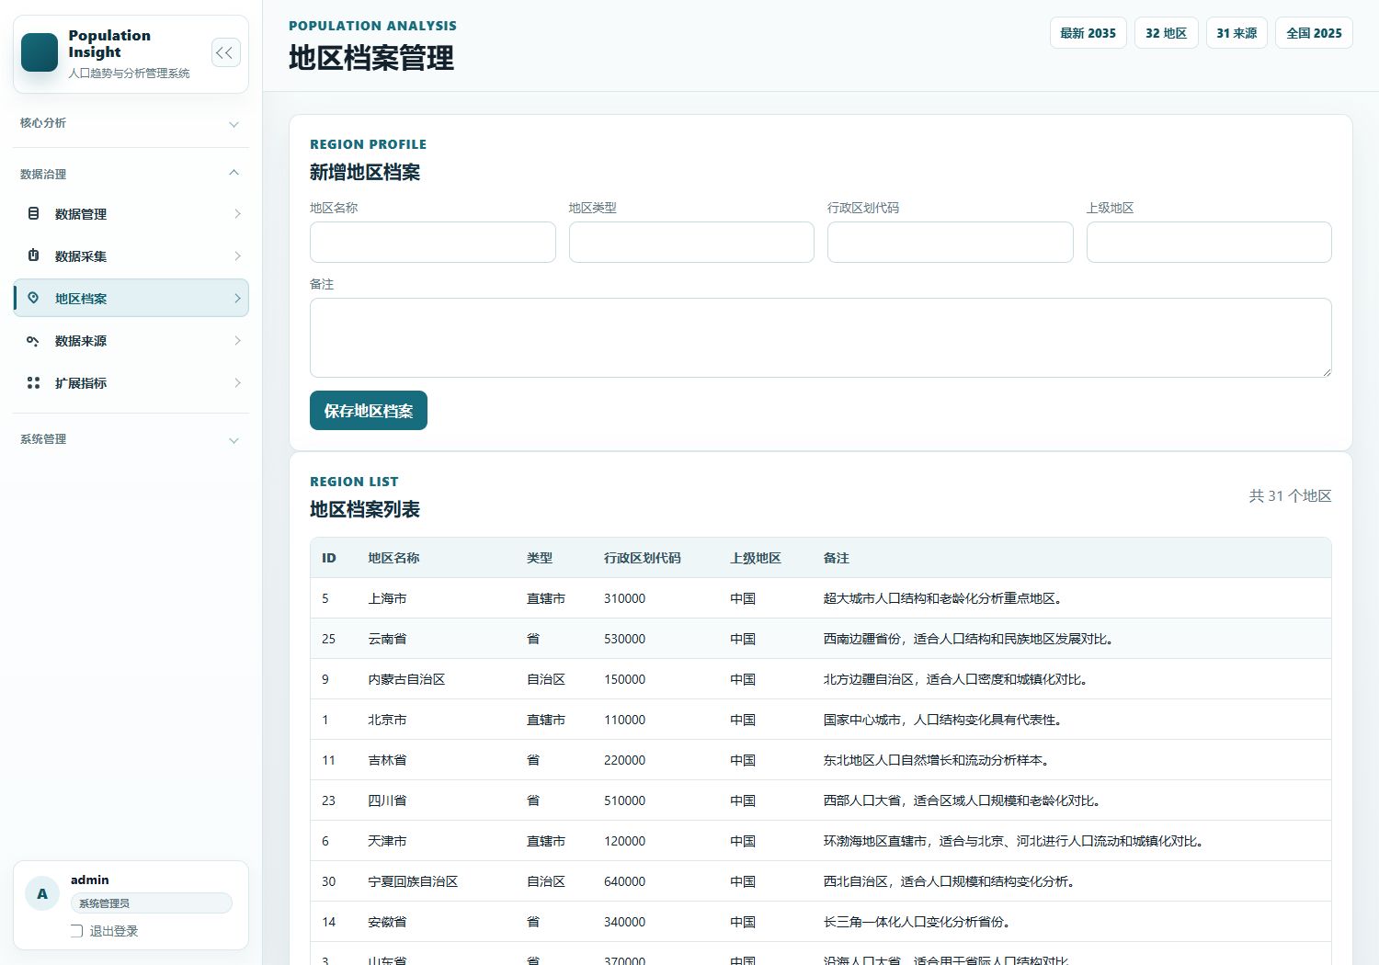
图2-7地区档案界面

regions MySQL 表数据
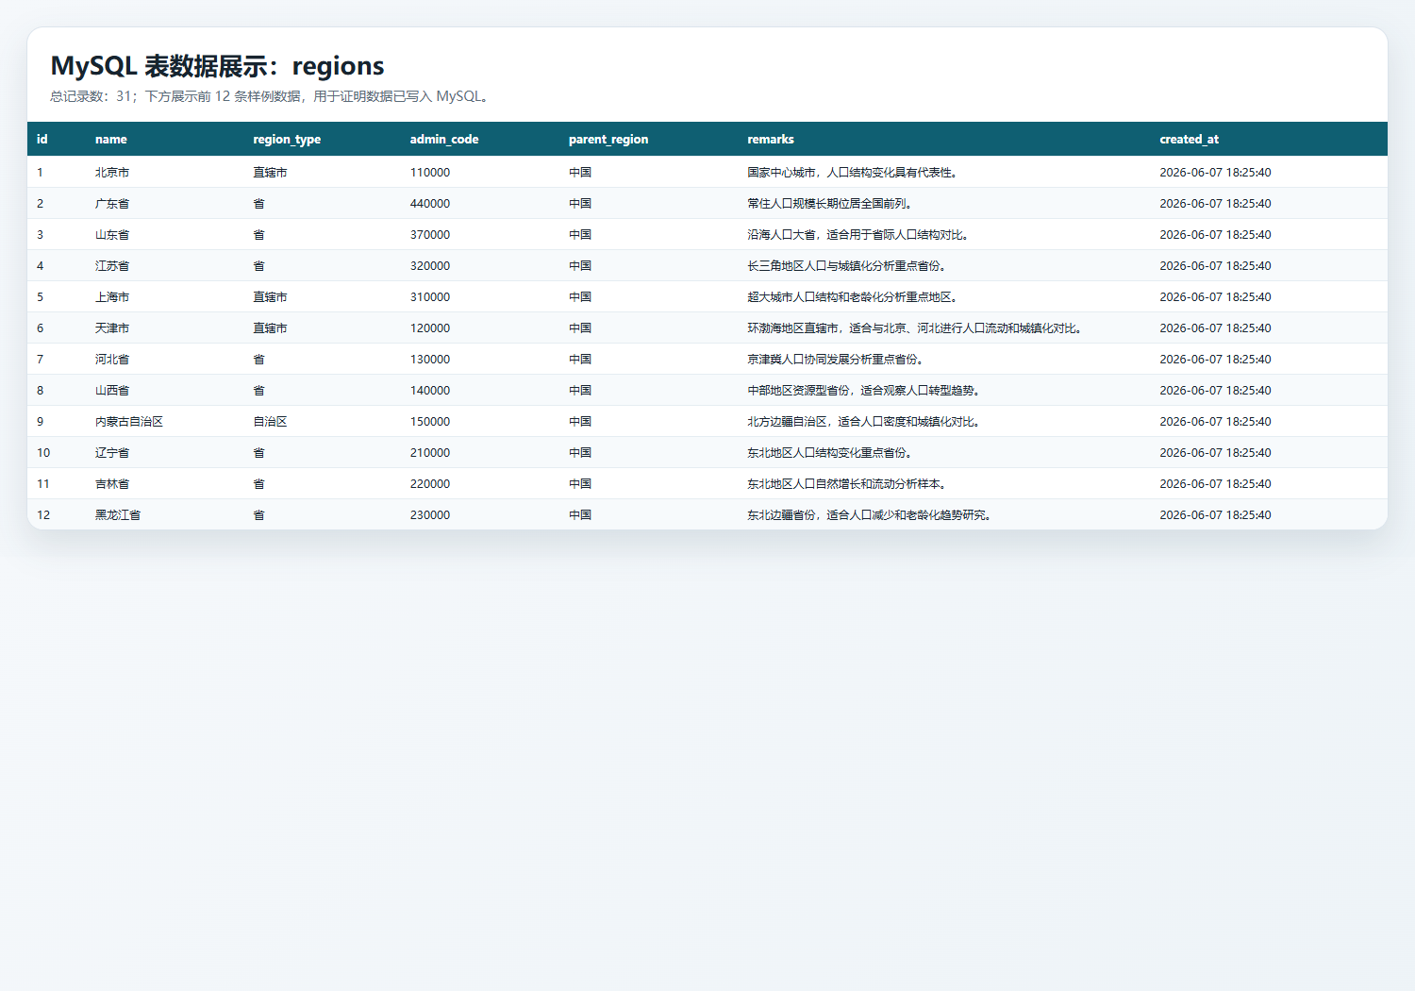
图2-8 regions表数据界面

对应代码片段

地区新增与查询函数
28: def list_regions() -> list[dict[str, Any]]:
29: return fetch_all("SELECT * FROM regions ORDER BY name ASC")
30:
31:
32: def add_region(data: dict[str, Any], username: str = "system") -> int:
33: name = ensure_text(data.get("name"), "地区名称")
34: region_type = ensure_text(data.get("region_type"), "地区类型")
35: values = (
36: name,
37: region_type,
38: _clean(data.get("admin_code")),
39: _clean(data.get("parent_region")),
40: _clean(data.get("remarks")),
41: )
42: try:
43: record_id = execute_write(
44: """
45: INSERT INTO regions (name, region_type, admin_code, parent_region, remarks)
46: VALUES (?, ?, ?, ?, ?)
47: """,
48: values,
49: )
50: except get_integrity_error_types() as error:
51: raise ValueError("地区名称已存在。") from error
52: log_operation(username, "ADD_REGION", record_id, name)
53: return record_id

地区页面路由
684: @app.route("/regions", methods=["GET", "POST"])
685: @admin_required
686: def regions_view():
687: form_data = {}
688: if request.method == "POST":
689: form_data = request.form.to_dict()
690: try:
691: add_region(form_data, username=g.user["username"])
692: flash("地区档案已新增。", "success")
693: return redirect(url_for("regions_view"))
694: except ValueError as error:
695: flash(str(error), "error")
696: return render_template("regions.html", regions=list_regions(), form_data=form_data)

5. data_sources（数据来源表）
表用途：保存数据来源名称、发布机构、来源链接、发布日期、可信等级和备注，用于数据质量说明。
系统展示：数据来源页面 /sources 支持新增和查看。

CRUD 覆盖情况
操作 | 系统实现情况
增 | 已实现。add_data_source() 写入 data_sources 表。
查 | 已实现。list_data_sources() 查询数据来源列表。

字段结构
字段 | 类型 | 可空 | 键 | 默认值 | 额外信息
id | int | NO | PRI |  | auto_increment
name | varchar(255) | NO | UNI
publisher | varchar(255) | NO
source_url | text | YES
published_date | varchar(30) | YES
reliability_level | varchar(20) | NO |  | 中
remarks | text | YES
created_at | timestamp | NO |  | CURRENT_TIMESTAMP | DEFAULT_GENERATED

data_sources 系统页面
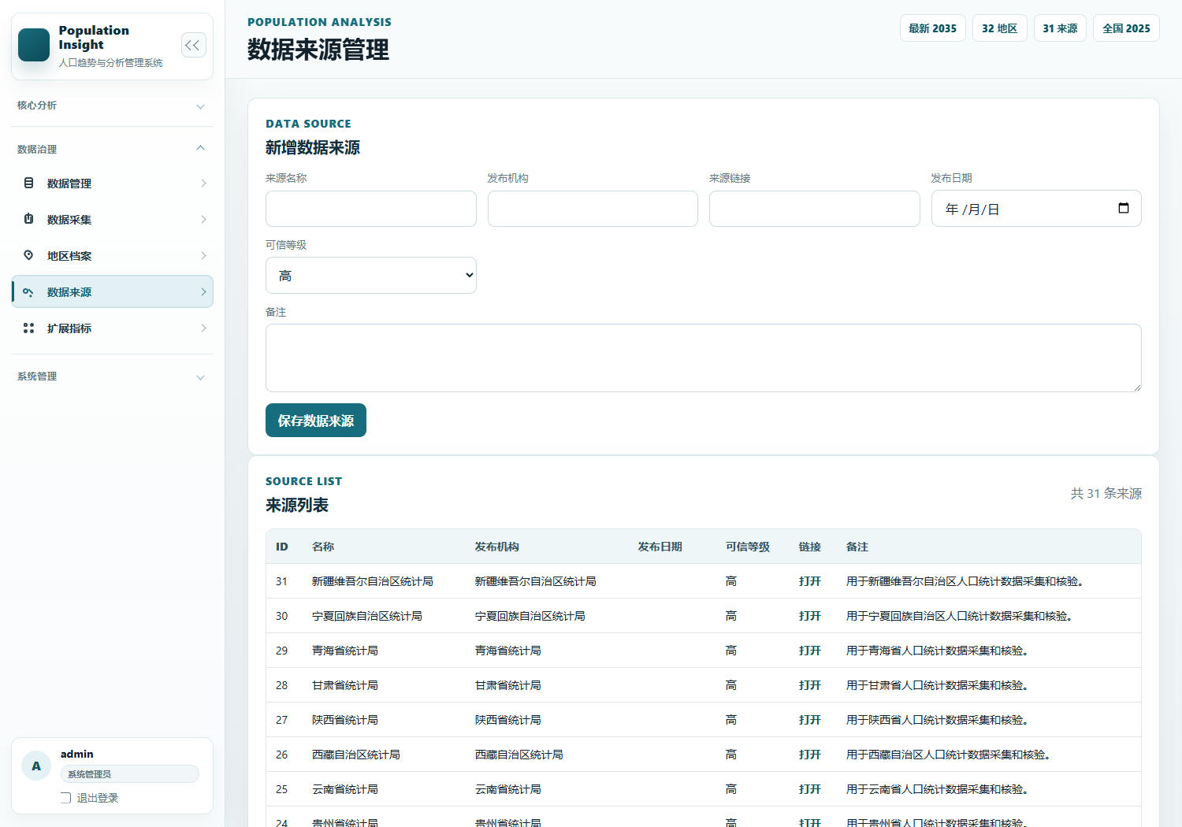
图2-9 数据来源界面

data_sources MySQL 表数据
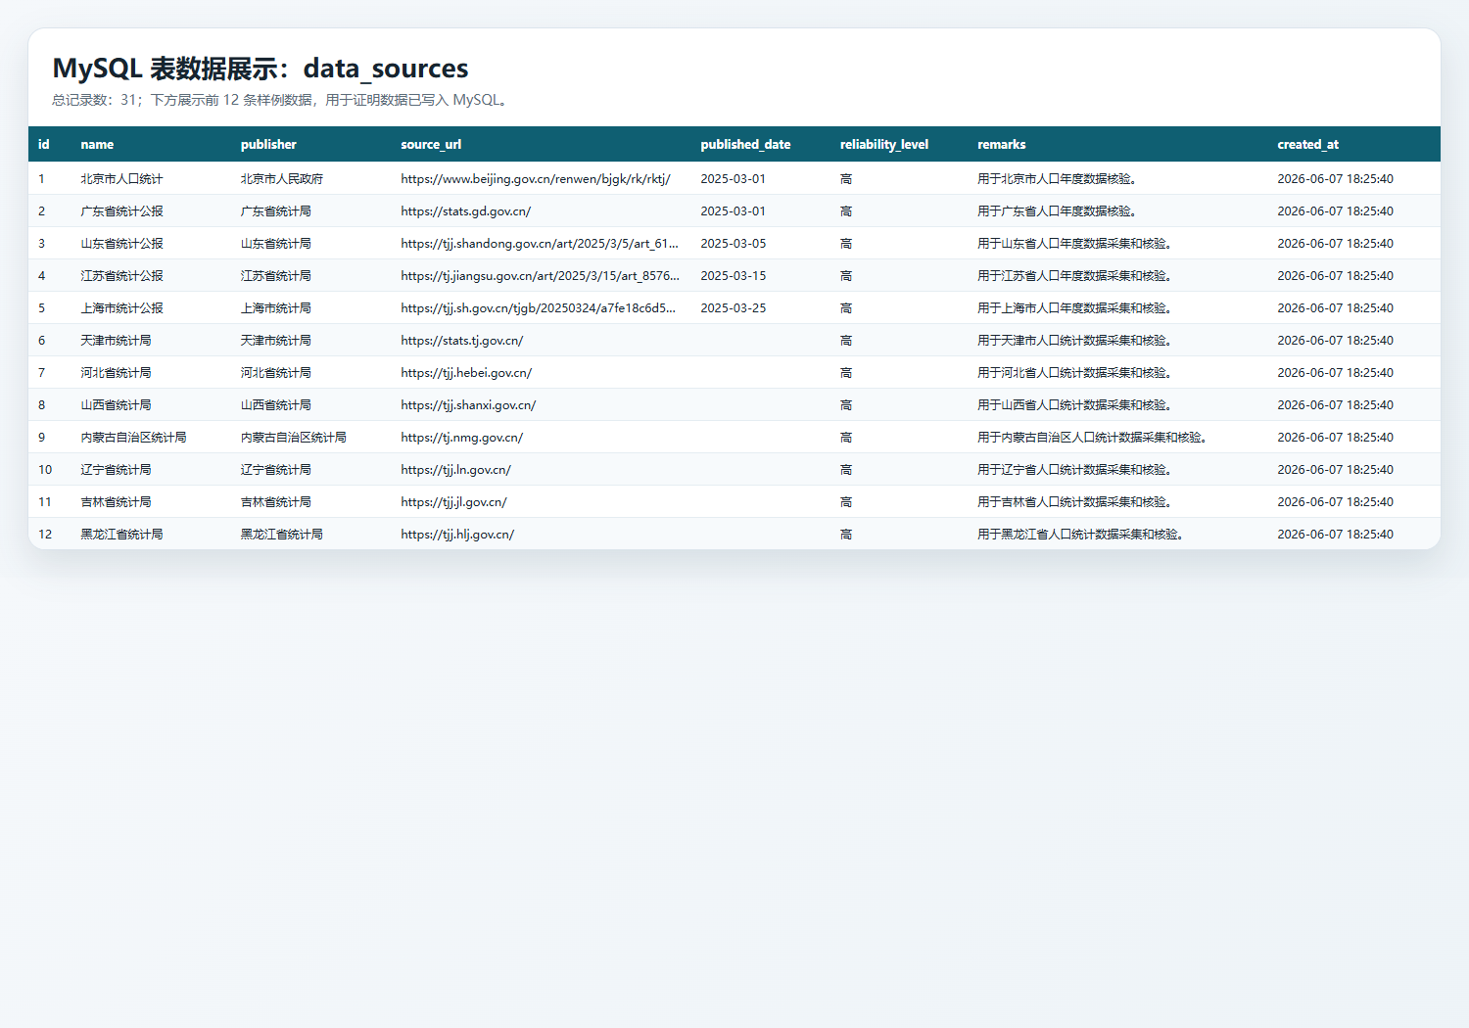
图2-10 data_sources表数据界面

对应代码片段

来源新增与查询函数
56: def list_data_sources() -> list[dict[str, Any]]:
57: return fetch_all("SELECT * FROM data_sources ORDER BY created_at DESC, id DESC")
58:
59:
60: def add_data_source(data: dict[str, Any], username: str = "system") -> int:
61: name = ensure_text(data.get("name"), "来源名称")
62: publisher = ensure_text(data.get("publisher"), "发布机构")
63: reliability_level = _clean(data.get("reliability_level")) or "中"
64: if reliability_level not in {"高", "中", "低"}:
65: raise ValueError("可信等级只能是高、中、低。")
66: published_date = _clean(data.get("published_date"))
67: if published_date:
68: try:
69: datetime.strptime(published_date, "%Y-%m-%d")
70: except ValueError as error:
71: raise ValueError("发布日期必须使用 YYYY-MM-DD 格式。") from error
72: values = (
73: name,
74: publisher,
75: _clean(data.get("source_url")),
76: published_date,
77: reliability_level,
78: _clean(data.get("remarks")),
79: )
80: try:
81: record_id = execute_write(
82: """
83: INSERT INTO data_sources (
84: name, publisher, source_url, published_date, reliability_level, remarks
85: ) VALUES (?, ?, ?, ?, ?, ?)
86: """,
87: values,
88: )
89: except get_integrity_error_types() as error:
90: raise ValueError("数据来源名称已存在。") from error
91: log_operation(username, "ADD_DATA_SOURCE", record_id, name)
92: return record_id

来源页面路由
699: @app.route("/sources", methods=["GET", "POST"])
700: @admin_required
701: def sources_view():
702: form_data = {}
703: if request.method == "POST":
704: form_data = request.form.to_dict()
705: try:
706: add_data_source(form_data, username=g.user["username"])
707: flash("数据来源已新增。", "success")
708: return redirect(url_for("sources_view"))
709: except ValueError as error:
710: flash(str(error), "error")
711: return render_template("sources.html", sources=list_data_sources(), form_data=form_data)

6. population_indicators（扩展指标定义表）
表用途：保存扩展指标编码、名称、单位和说明，为年度扩展指标值提供指标字典。
系统展示：扩展指标页面 /indicators 上半部分支持新增和查看指标定义。

CRUD 覆盖情况
操作 | 系统实现情况
增 | 已实现。add_population_indicator() 写入 population_indicators 表。
查 | 已实现。list_population_indicators() 查询指标定义列表。

字段结构
字段 | 类型 | 可空 | 键 | 默认值 | 额外信息
id | int | NO | PRI |  | auto_increment
code | varchar(100) | NO | UNI
name | varchar(100) | NO
unit | varchar(50) | NO
description | text | YES
created_at | timestamp | NO |  | CURRENT_TIMESTAMP | DEFAULT_GENERATED

population_indicators 系统页面
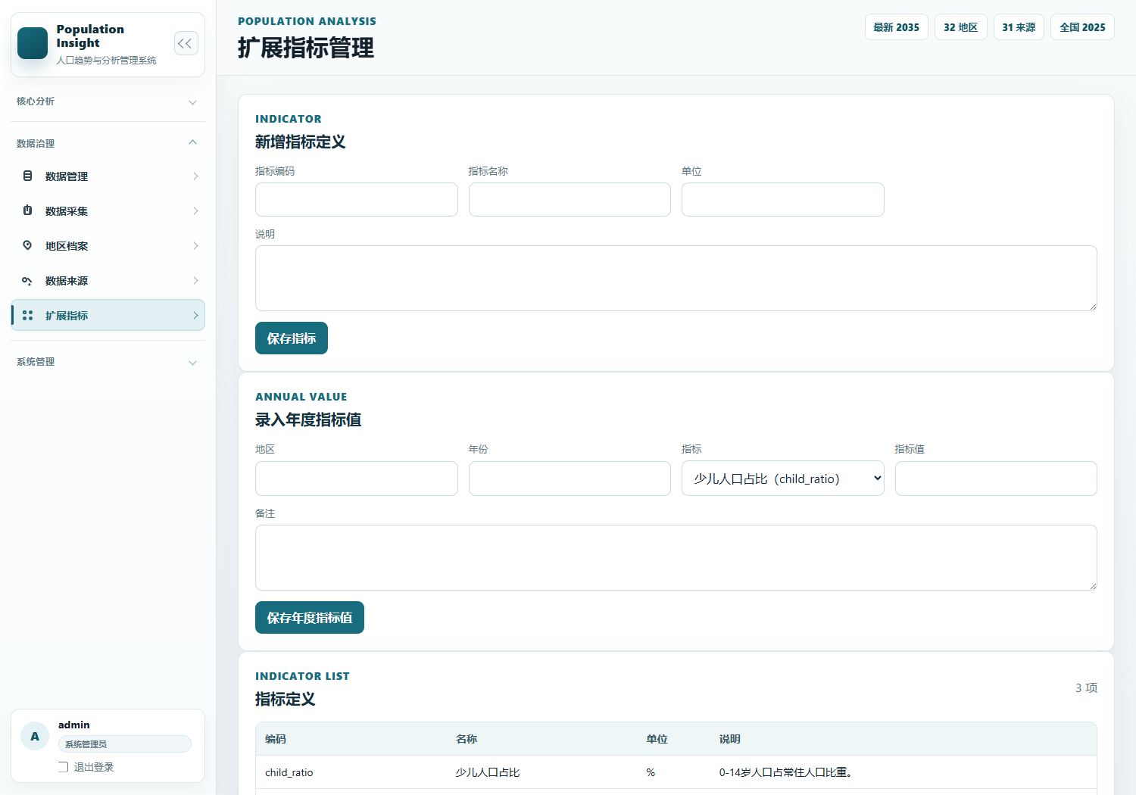
图2-11 扩展指标页面

population_indicators MySQL 表数据
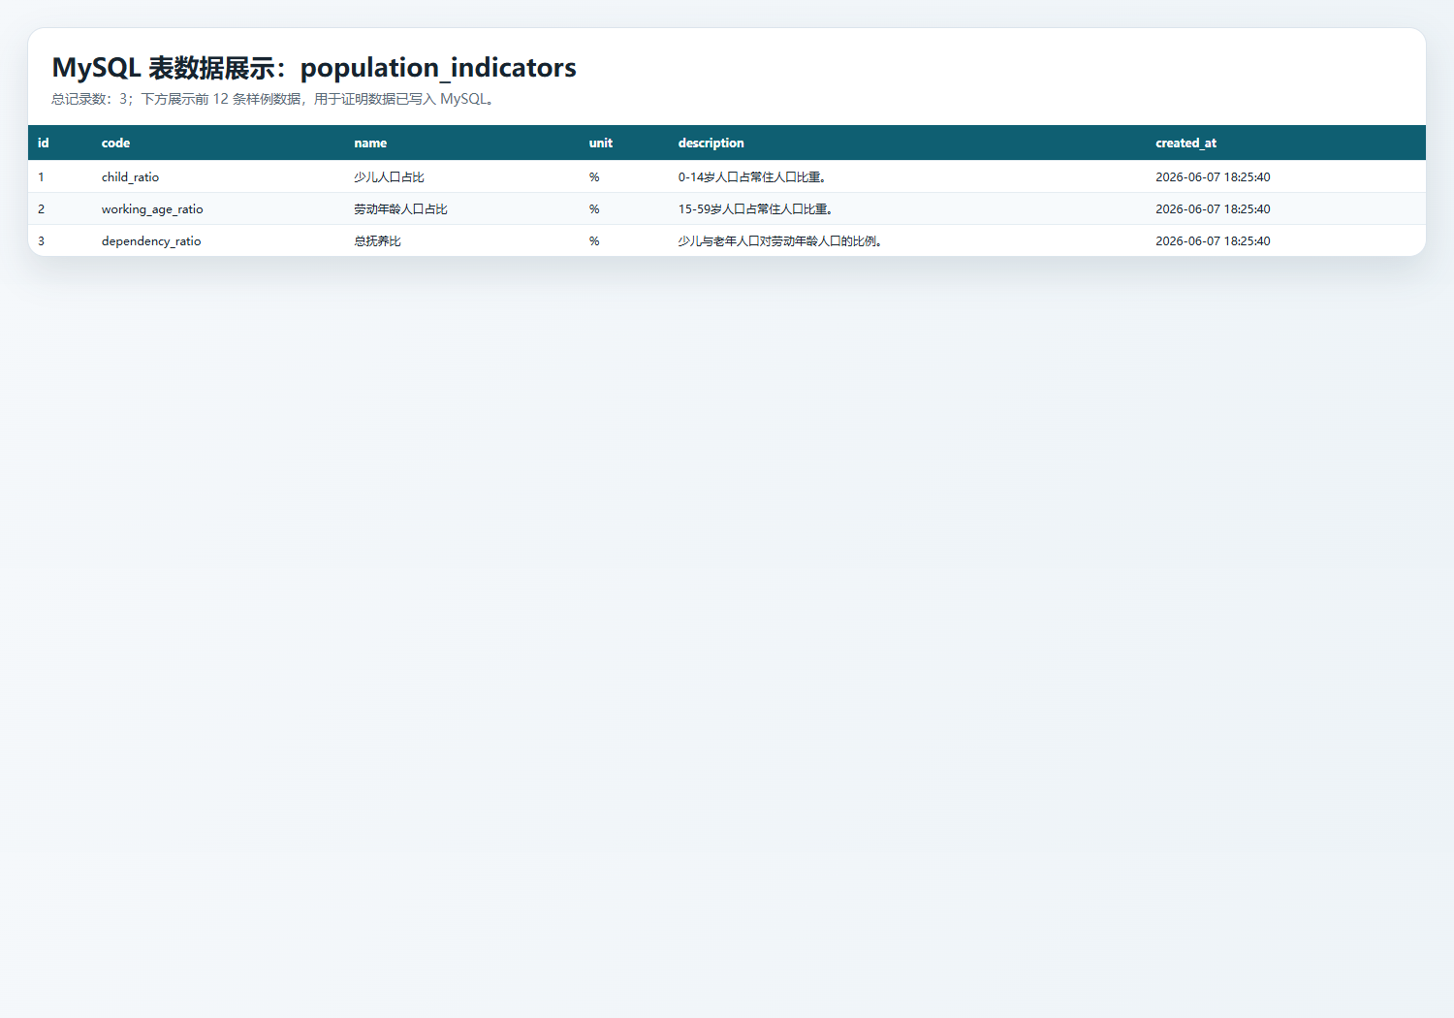
图2-12 population_indicators表数据界面

对应代码片段

指标定义新增与查询函数
95: def list_population_indicators() -> list[dict[str, Any]]:
96: return fetch_all("SELECT * FROM population_indicators ORDER BY code ASC")
97:
98:
99: def add_population_indicator(data: dict[str, Any], username: str = "system") -> int:
100: code = ensure_text(data.get("code"), "指标编码")
101: name = ensure_text(data.get("name"), "指标名称")
102: unit = ensure_text(data.get("unit"), "单位")
103: try:
104: record_id = execute_write(
105: """
106: INSERT INTO population_indicators (code, name, unit, description)
107: VALUES (?, ?, ?, ?)
108: """,
109: (code, name, unit, _clean(data.get("description"))),
110: )
111: except get_integrity_error_types() as error:
112: raise ValueError("指标编码已存在。") from error
113: log_operation(username, "ADD_INDICATOR", record_id, code)
114: return record_id

指标页面路由
714: @app.route("/indicators", methods=["GET", "POST"])
715: @admin_required
716: def indicators_view():
717: form_data = {}
718: if request.method == "POST":
719: form_data = request.form.to_dict()
720: try:
721: add_population_indicator(form_data, username=g.user["username"])
722: flash("扩展指标已新增。", "success")
723: return redirect(url_for("indicators_view"))
724: except ValueError as error:
725: flash(str(error), "error")
726: return render_template(
727: "indicators.html",
728: indicators=list_population_indicators(),
729: values=list_annual_indicator_values(),
730: regions=get_distinct_regions(),
731: form_data=form_data,
732: )

7. annual_indicator_values（年度扩展指标值表）
表用途：保存某地区某年份某扩展指标的数值，和 population_indicators 通过 indicator_code 关联。
系统展示：扩展指标页面 /indicators 下半部分支持新增和查看年度指标值。

CRUD 覆盖情况
操作 | 系统实现情况
增 | 已实现。add_annual_indicator_value() 写入 annual_indicator_values 表。
查 | 已实现。list_annual_indicator_values() 联表查询指标名称和单位。

字段结构
字段 | 类型 | 可空 | 键 | 默认值 | 额外信息
id | int | NO | PRI |  | auto_increment
region | varchar(100) | NO | MUL
year | int | NO
indicator_code | varchar(100) | NO | MUL
value | double | NO
remarks | text | YES
created_at | timestamp | NO |  | CURRENT_TIMESTAMP | DEFAULT_GENERATED

annual_indicator_values 系统页面

图2-13 扩展指标页面

annual_indicator_values MySQL 表数据
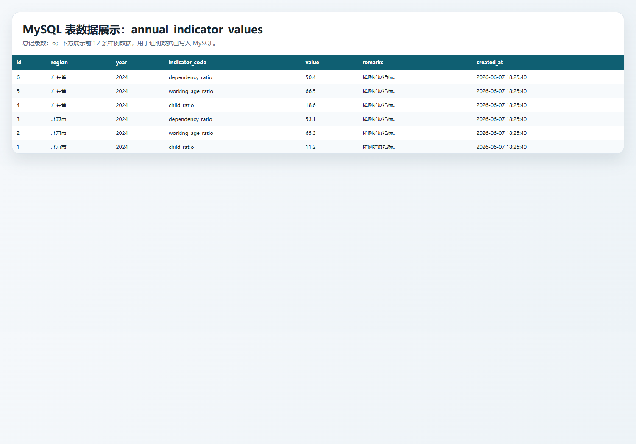
图2-14 annual_indicator_values表数据界面

对应代码片段

年度指标值新增与查询函数
117: def list_annual_indicator_values() -> list[dict[str, Any]]:
118: return fetch_all(
119: """
120: SELECT
121: v.id,
122: v.region,
123: v.year,
124: v.indicator_code,
125: i.name AS indicator_name,
126: i.unit,
127: v.value,
128: v.remarks,
129: v.created_at
130: FROM annual_indicator_values v
131: LEFT JOIN population_indicators i ON i.code = v.indicator_code
132: ORDER BY v.year DESC, v.region ASC, v.indicator_code ASC
133: """
134: )
135:
136:
137: def add_annual_indicator_value(data: dict[str, Any], username: str = "system") -> int:
138: region = ensure_text(data.get("region"), "地区")
139: year = ensure_year(data.get("year"))
140: indicator_code = ensure_text(data.get("indicator_code"), "指标编码")
141: value = ensure_non_negative_number(data.get("value"), "指标值")
142: if not fetch_one("SELECT 1 FROM population_indicators WHERE code = ?", (indicator_code,)):
143: raise ValueError("指标编码不存在。")
144: try:
145: record_id = execute_write(
146: """
147: INSERT INTO annual_indicator_values (
148: region, year, indicator_code, value, remarks
149: ) VALUES (?, ?, ?, ?, ?)
150: """,
151: (region, year, indicator_code, value, _clean(data.get("remarks"))),
152: )
153: except get_integrity_error_types() as error:
154: if is_unique_constraint_error(error):
155: raise ValueError("同一地区、年份、指标的扩展值已存在。") from error
156: raise ValueError("年度扩展指标值保存失败。") from error
157: log_operation(username, "ADD_INDICATOR_VALUE", record_id, f"{region}-{year}-{indicator_code}")
158: return record_id

年度指标值路由
735: @app.route("/indicator-values", methods=["POST"])
736: @admin_required
737: def indicator_values_create_view():
738: try:
739: add_annual_indicator_value(request.form.to_dict(), username=g.user["username"])
740: flash("年度扩展指标值已新增。", "success")
741: except ValueError as error:
742: flash(str(error), "error")
743: return redirect(url_for("indicators_view"))

8. analysis_reports（分析报告表）
表用途：保存用户生成或填写的分析报告标题、筛选摘要、报告摘要和创建时间。
系统展示：分析报告页面 /reports 支持新增和查看；统计、预测等页面也可保存报告。

CRUD 覆盖情况
操作 | 系统实现情况
增 | 已实现。add_analysis_report() 写入 analysis_reports 表。
查 | 已实现。list_analysis_reports() 查询报告列表。

字段结构
字段 | 类型 | 可空 | 键 | 默认值 | 额外信息
id | int | NO | PRI |  | auto_increment
title | varchar(255) | NO
username | varchar(100) | NO
filter_summary | text | YES
report_summary | text | NO
created_at | timestamp | NO |  | CURRENT_TIMESTAMP | DEFAULT_GENERATED

analysis_reports 系统页面
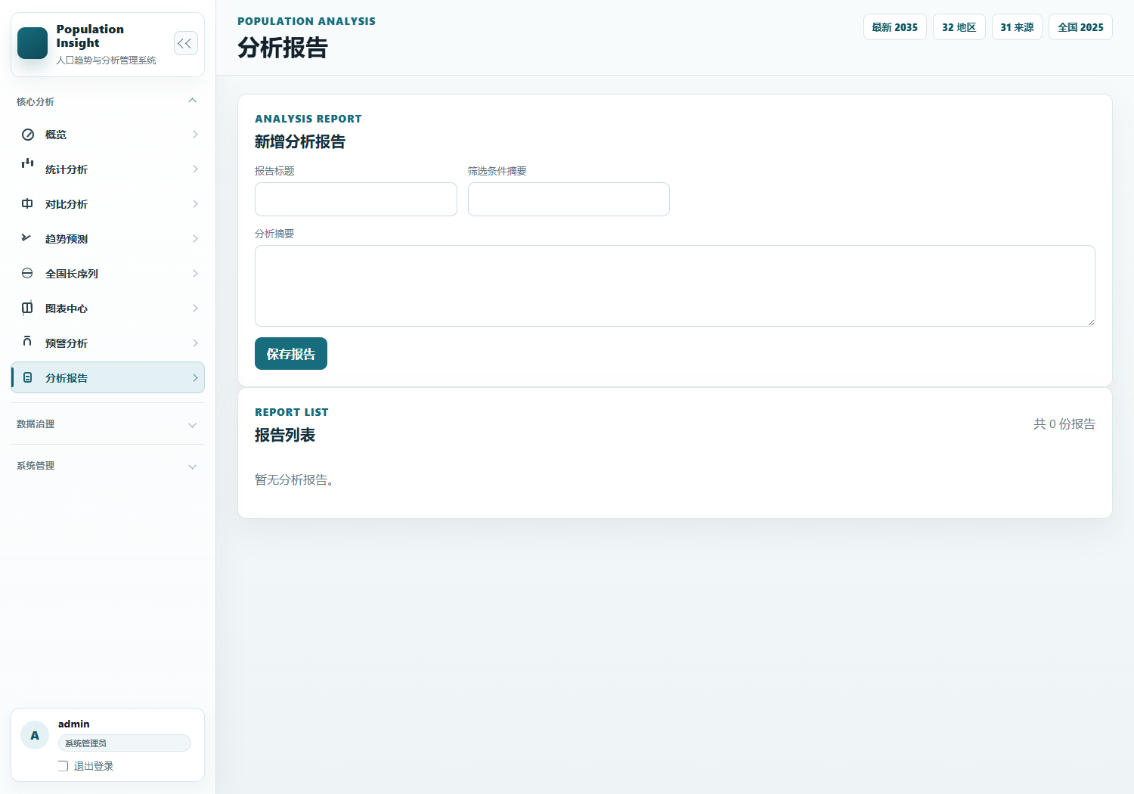
图2-15 分析报告页面

analysis_reports MySQL 表数据

对应代码片段

报告新增与查询函数
161: def list_analysis_reports() -> list[dict[str, Any]]:
162: return fetch_all("SELECT * FROM analysis_reports ORDER BY created_at DESC, id DESC")
163:
164:
165: def add_analysis_report(data: dict[str, Any], username: str = "system") -> int:
166: title = ensure_text(data.get("title"), "报告标题")
167: report_summary = ensure_text(data.get("report_summary"), "分析摘要")
168: filter_summary = _clean(data.get("filter_summary"))
169: record_id = execute_write(
170: """
171: INSERT INTO analysis_reports (title, username, filter_summary, report_summary)
172: VALUES (?, ?, ?, ?)
173: """,
174: (title, username, filter_summary, report_summary),
175: )
176: log_operation(username, "ADD_ANALYSIS_REPORT", record_id, title)
177: return record_id

报告页面路由
746: @app.route("/reports", methods=["GET", "POST"])
747: @login_required
748: def reports_view():
749: form_data = {}
750: if request.method == "POST":
751: form_data = request.form.to_dict()
752: try:
753: add_analysis_report(form_data, username=g.user["username"])
754: flash("分析报告已新增。", "success")
755: return redirect(url_for("reports_view"))
756: except ValueError as error:
757: flash(str(error), "error")
758: return render_template("reports.html", reports=list_analysis_reports(), form_data=form_data)

9. national_population_series（全国长序列表）
表用途：保存全国 1950-2025 年人口长序列，用于全国趋势图和长期预测。
系统展示：全国长序列页面 /national-series 展示摘要、趋势图和年度明细。

CRUD 覆盖情况
操作 | 系统实现情况
增 | 已实现。seed_national_series() 初始化时插入全国长序列。
查 | 已实现。list_national_series()、get_national_trend_data() 查询并生成全国趋势图数据。
改 | 已实现于初始化同步。seed_national_series() 使用 ON DUPLICATE KEY UPDATE 更新已有年份数据；当前没有前端手动编辑入口。

字段结构
字段 | 类型 | 可空 | 键 | 默认值 | 额外信息
id | int | NO | PRI |  | auto_increment
year | int | NO | UNI
total_population | bigint | NO
birth_rate | double | YES
death_rate | double | YES
natural_growth_rate | double | YES
urban_population | bigint | YES
urbanization_rate | double | YES
source_name | varchar(255) | YES
source_url | text | YES
data_quality | varchar(100) | YES
remarks | text | YES
created_at | timestamp | NO |  | CURRENT_TIMESTAMP | DEFAULT_GENERATED
updated_at | timestamp | NO |  | CURRENT_TIMESTAMP | DEFAULT_GENERATED

national_population_series 系统页面
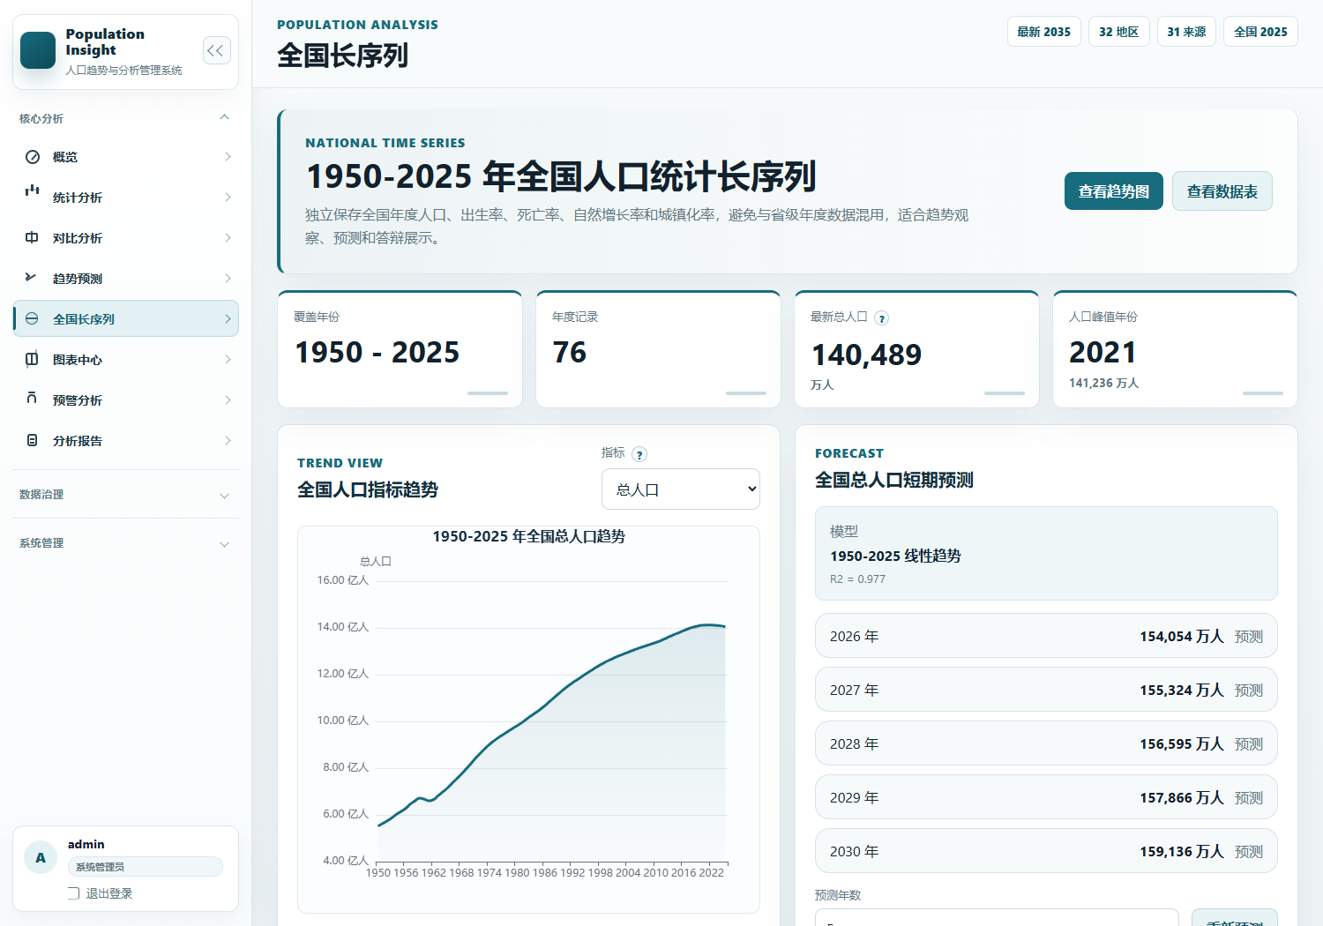
图2-16 全国长序列页面

national_population_series MySQL 表数据
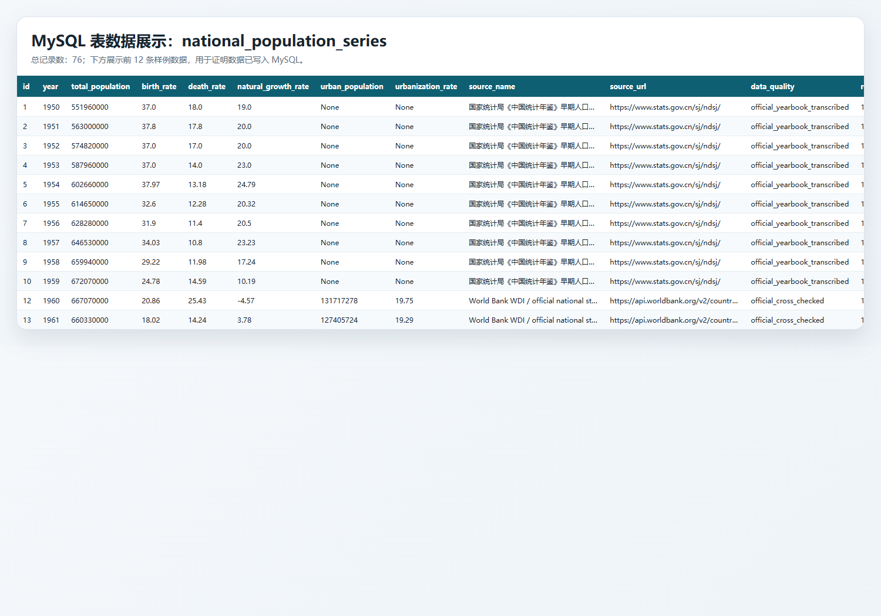
图2-17 national_population_series表数据页面

对应代码片段

全国长序列初始化新增/更新
512: def seed_national_series() -> None:
513: existing = fetch_one(
514: """
515: SELECT COUNT(*) AS count, MIN(year) AS min_year, MAX(year) AS max_year
516: FROM national_population_series
517: """
518: )
519: if (
520: existing
521: and existing.get("count", 0) >= 76
522: and existing.get("min_year") == 1950
523: and existing.get("max_year") == 2025
524: ):
525: return
526:
527: records = build_seed_records()
528: with get_connection() as connection:
529: connection.executemany(
530: _national_series_upsert_sql(),
531: [
532: (
533: item["year"],
534: item["total_population"],
535: item.get("birth_rate"),
536: item.get("death_rate"),
537: item.get("natural_growth_rate"),
538: item.get("urban_population"),
539: item.get("urbanization_rate"),
540: item.get("source_name", ""),
541: item.get("source_url", ""),
542: item.get("data_quality", ""),
543: item.get("remarks", ""),
544: )
545: for item in records
546: ],
547: )
548: connection.commit()
549:
550:
551: def init_database() -> None:
552: DATA_DIR.mkdir(parents=True, exist_ok=True)

全国长序列查询与趋势函数
251: def list_national_series() -> list[dict[str, Any]]:
252: return fetch_all(
253: """
254: SELECT *
255: FROM national_population_series
256: ORDER BY year ASC
257: """
258: )
259:
260:
261: def list_national_metric_records(
262: metric: str = "total_population",
263: start_year: int | None = None,
264: end_year: int | None = None,
265: ) -> list[dict[str, Any]]:
266: if metric not in NATIONAL_SERIES_SUPPORTED_METRICS:
267: raise ValueError("全国长序列暂不支持该指标。")
268:
269: records = []
270: for item in list_national_series():
271: if start_year and item["year"] < start_year:
272: continue
273: if end_year and item["year"] > end_year:
274: continue
275: if item.get(metric) is None:
276: continue
277: records.append(
278: {
279: "region": "全国",
280: "year": item["year"],
281: "total_population": item["total_population"],
282: "birth_rate": item["birth_rate"],
283: "death_rate": item["death_rate"],
284: "natural_growth_rate": item["natural_growth_rate"],
285: "aging_rate": None,
286: "urbanization_rate": item["urbanization_rate"],
287: "data_source_name": item.get("source_name", ""),
288: "source_url": item.get("source_url", ""),
289: "data_quality": item.get("data_quality", ""),
290: "remarks": item.get("remarks", ""),
291: }
292: )
293: return records
294:
295:
296: def get_national_series_summary() -> dict[str, Any]:
297: summary = fetch_one(
298: """
299: SELECT
300: COUNT(*) AS total_years,
301: MIN(year) AS min_year,
302: MAX(year) AS max_year
303: FROM national_population_series
304: """
305: ) or {}
306: records = list_national_series()
307: if not records:
308: return {
309: "total_years": 0,
310: "min_year": None,
311: "max_year": None,
312: "latest": None,
313: "peak": None,
314: "recent_growth": None,
315: "avg_birth_rate_recent": None,
316: }
317:
318: latest = records[-1]
319: peak = max(records, key=lambda item: item["total_population"])
320: previous = records[-2] if len(records) >= 2 else None
321: recent_growth = (
322: latest["total_population"] - previous["total_population"]
323: if previous
324: else None
325: )
326: recent_birth_values = [
327: item["birth_rate"]
328: for item in records[-5:]
329: if item.get("birth_rate") is not None
330: ]
331: return {
332: "total_years": summary.get("total_years", 0),
333: "min_year": summary.get("min_year"),
334: "max_year": summary.get("max_year"),
335: "latest": latest,
336: "peak": peak,
337: "recent_growth": recent_growth,
338: "avg_birth_rate_recent": round(mean(recent_birth_values), 2) if recent_birth_values else None,
339: }
340:
341:
342: def get_national_trend_data(metric: str) -> dict[str, Any]:
343: if metric not in NATIONAL_METRIC_LABELS:
344: raise ValueError("不支持的全国长序列指标。")
345:
346: records = [item for item in list_national_series() if item.get(metric) is not None]
347: if not records:
348: raise ValueError("当前指标暂无可视化数据。")
349:
350: return {
351: "title": f"1950-2025 年全国{NATIONAL_METRIC_LABELS[metric]}趋势",
352: "metric": metric,
353: "metricLabel": NATIONAL_METRIC_LABELS[metric],
354: "axisUnit": NATIONAL_METRIC_UNITS[metric],
355: "xAxis": [item["year"] for item in records],
356: "series": [item[metric] for item in records],
357: "source": records[-1]["source_name"],
358: "sourceUrl": records[-1]["source_url"],

全国趋势接口路由
889: @app.route("/api/national-series/trend")
890: @login_required
891: def national_series_trend_api():
892: try:
893: metric = _clean_text(request.args.get("metric")) or "total_population"
894: return jsonify({"success": True, "data": get_national_trend_data(metric)})
895: except ValueError as error:
896: return jsonify({"success": False, "message": str(error)}), 400

三、结论
系统已成功连接 MySQL，并围绕 9 张业务表完成数据初始化、查询展示、核心业务新增、部分表修改与删除。
其中 population_data 为核心业务表，系统提供完整新增、查询、修改、删除；其他配置类、日志类、报告类和长序列表根据业务需要提供新增/查询或初始化同步能力。未开放修改/删除入口的表，文档中已明确标注，避免把未实现功能误写为已实现。

