3. MySQL 基础连接 + 增查功能证明材料
项目：Population Insight 生成时间：2026-06-07 19:04:32

一、评分点对应说明
• 连接成功：JetBrains Data Sources and Drivers 测试 MySQL 连接，截图显示 Succeeded，DBMS 为 MySQL 8.0.31。
• 新增功能：Web 平台“新增人口记录”页面提交测试记录，后端 add_population_record() 写入 MySQL。
• 查询功能：Web 平台“人口数据管理”页面按地区和年份筛选，后端 query_population_records() 从 MySQL 查询并展示。
• 数据库配置：项目默认数据库引擎已设为 MySQL，连接参数写入 population_insight/config.py。

二、MySQL 连接成功截图

图1：MySQL Data Source 测试连接成功
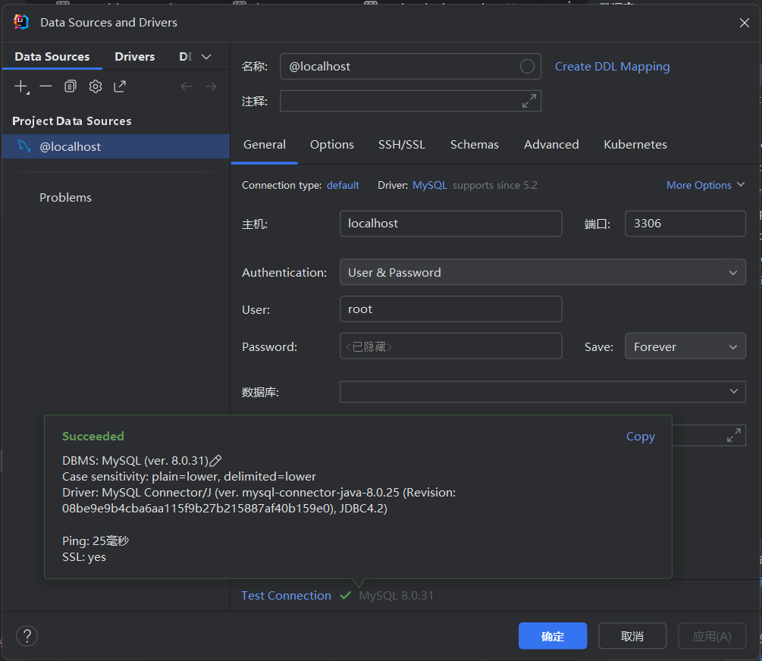
截图文件：C:\Users\29588\Pictures\Screenshots\屏幕截图 2026-06-07 185343.png

连接配置代码：population_insight/config.py
10: DB_ENGINE = os.getenv("POPULATION_INSIGHT_DB_ENGINE", "mysql").strip().lower()
11: MYSQL_CONFIG = {
12: "host": os.getenv("MYSQL_HOST", "127.0.0.1"),
13: "port": int(os.getenv("MYSQL_PORT", "3306")),
14: "user": os.getenv("MYSQL_USER", "root"),
15: "password": os.getenv("MYSQL_PASSWORD", "Zhang123."),
16: "database": os.getenv("MYSQL_DATABASE", "population_insight"),
17: "charset": os.getenv("MYSQL_CHARSET", "utf8mb4"),
18: }

连接与通用查询函数：population_insight/db/connection.py
75: def get_connection():
76: if is_mysql():
77: try:
78: import pymysql
79: from pymysql.cursors import DictCursor
80: except ImportError as error:
81: raise DatabaseConfigError(
82: "MySQL mode requires PyMySQL. Install dependencies with: pip install -r requirements.txt"
83: ) from error
84:
85: raw_connection = pymysql.connect(
86: host=MYSQL_CONFIG["host"],
87: port=MYSQL_CONFIG["port"],
88: user=MYSQL_CONFIG["user"],
89: password=MYSQL_CONFIG["password"],
90: database=MYSQL_CONFIG["database"],
91: charset=MYSQL_CONFIG["charset"],
92: cursorclass=DictCursor,
93: autocommit=False,
94: )
95: return MySQLConnectionAdapter(raw_connection)
96:
97: connection = sqlite3.connect(DB_PATH)
98: connection.row_factory = sqlite3.Row
99: connection.execute("PRAGMA foreign_keys = ON")
100: return connection
101:
102:
103: def execute_query(connection, query: str, params: Iterable[Any] | None = None):
104: return connection.execute(_translate_query(query), tuple(params or []))
105:
106:
107: def execute_many_query(connection, query: str, params_list: Iterable[Iterable[Any]]) -> None:
108: connection.executemany(_translate_query(query), params_list)
109:
110:
111: def fetch_one(query: str, params: Iterable[Any] | None = None) -> dict[str, Any] | None:
112: with get_connection() as connection:
113: row = execute_query(connection, query, params).fetchone()
114: return dict(row) if row else None
115:
116:
117: def fetch_all(query: str, params: Iterable[Any] | None = None) -> list[dict[str, Any]]:
118: with get_connection() as connection:
119: rows = execute_query(connection, query, params).fetchall()
120: return [dict(row) for row in rows]
121:
122:
123: def execute_write(query: str, params: Iterable[Any] | None = None) -> int:
124: with get_connection() as connection:
125: cursor = execute_query(connection, query, params)
126: connection.commit()
127: return cursor.lastrowid
128:
129:
130: def execute_many(query: str, params_list: Iterable[Iterable[Any]]) -> None:

三、新增功能证明
平台入口：登录系统后进入“人口数据管理 / 新增人口记录”。填写测试地区、年份、人口数据后提交，系统将数据写入 MySQL 的 population_data 表。

图2：平台新增记录表单截图
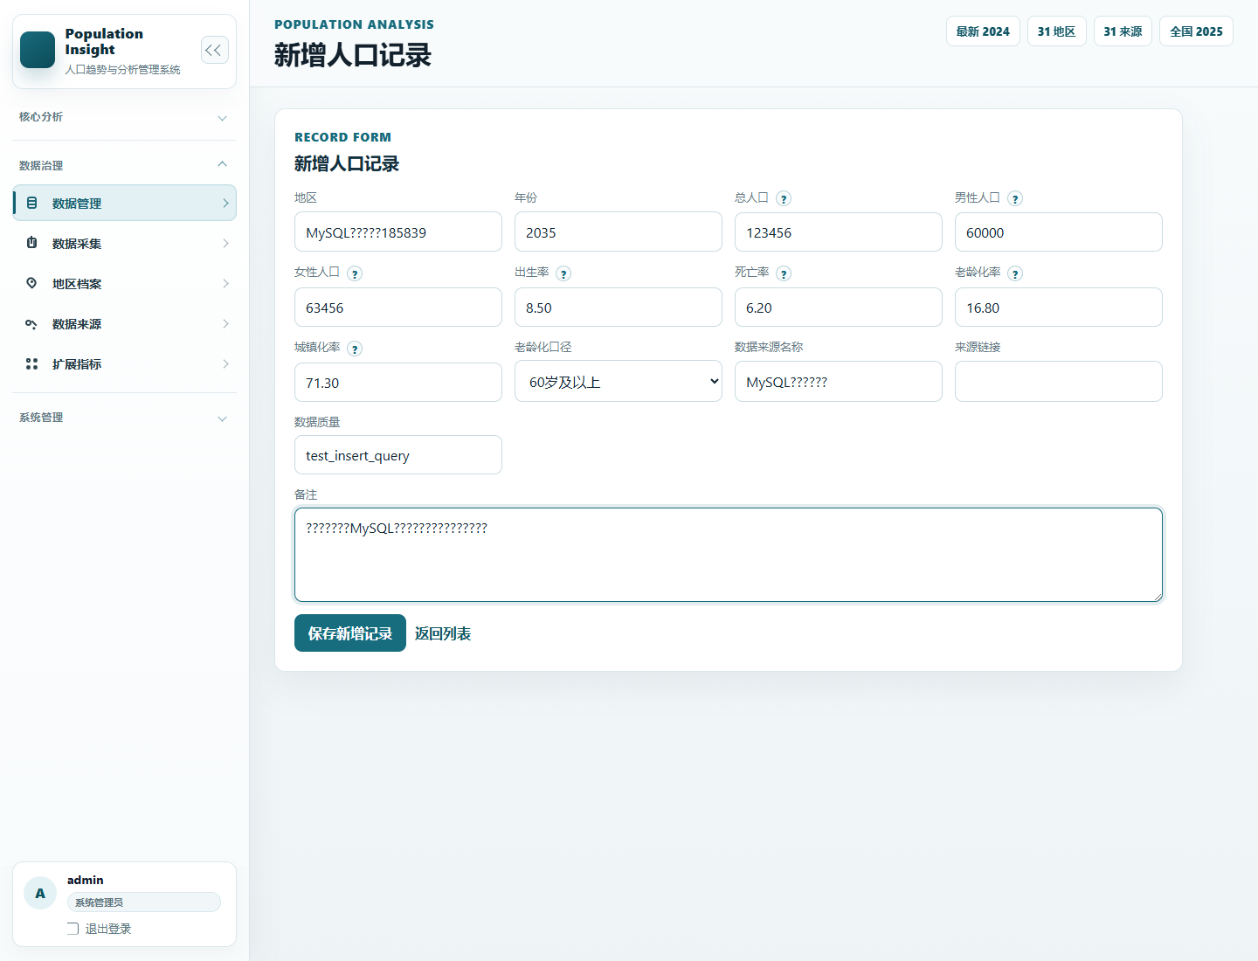
截图文件：F:\Development\Population-Insight-main\Population-Insight-main\output\mysql_evidence\02_platform_add_form_filled.png

图3：提交新增后返回列表截图
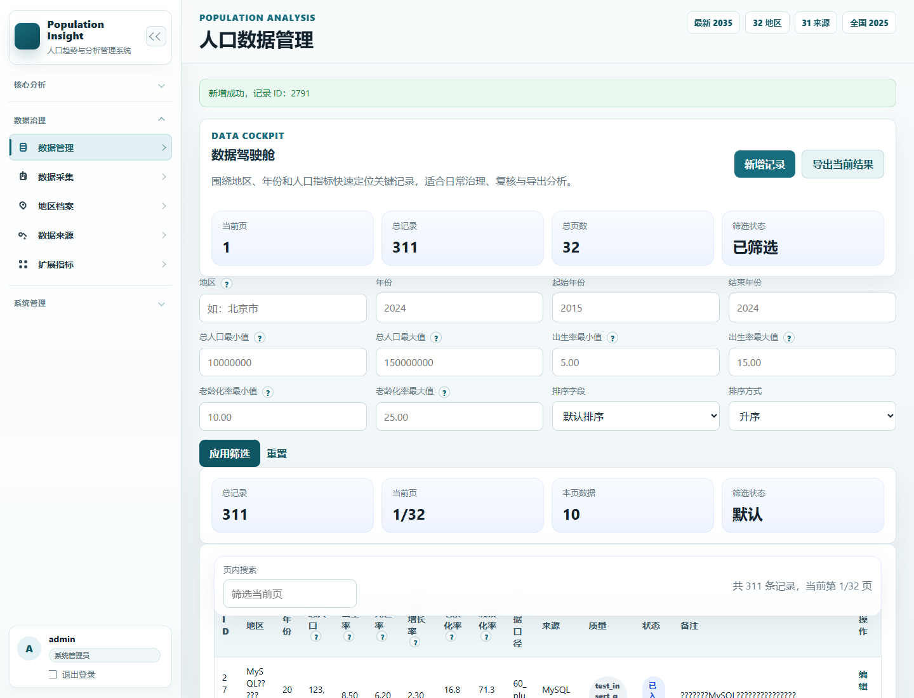
截图文件：F:\Development\Population-Insight-main\Population-Insight-main\output\mysql_evidence\03_platform_after_insert.png

新增函数：population_insight/services/population_service.py
70: def add_population_record(data_dict: dict[str, Any], username: str = "system") -> int:
71: normalized = validate_population_payload(data_dict)
72: values = [normalized.get(field, "") for field in INSERT_FIELDS]
73:
74: try:
75: with get_connection() as connection:
76: cursor = connection.execute(
77: f"""
78: INSERT INTO population_data ({", ".join(INSERT_FIELDS)})
79: VALUES ({", ".join("?" for _ in INSERT_FIELDS)})
80: """,
81: values,
82: )
83: connection.commit()
84: record_id = cursor.lastrowid
85: except get_integrity_error_types() as error:
86: if is_unique_constraint_error(error):
87: raise ValueError("同一地区同一年份的数据已存在。") from error
88: raise ValueError("新增数据失败，请检查输入内容。") from error
89:
90: log_operation(username, "ADD_RECORD", target_id=record_id, details=normalized["region"])
91: return record_id
92:
93:
94: def get_population_record_by_id(record_id: int) -> dict[str, Any] | None:
95: return fetch_one(
96: """
97: SELECT *
98: FROM population_data
99: WHERE id = ?
100: """,
101: (record_id,),
102: )
103:

四、查询功能证明
平台入口：人口数据管理页面使用地区和年份筛选条件查询。截图中显示刚刚新增的测试记录，说明查询功能可从 MySQL 正常读取数据并展示到前端。

图4：平台查询结果截图
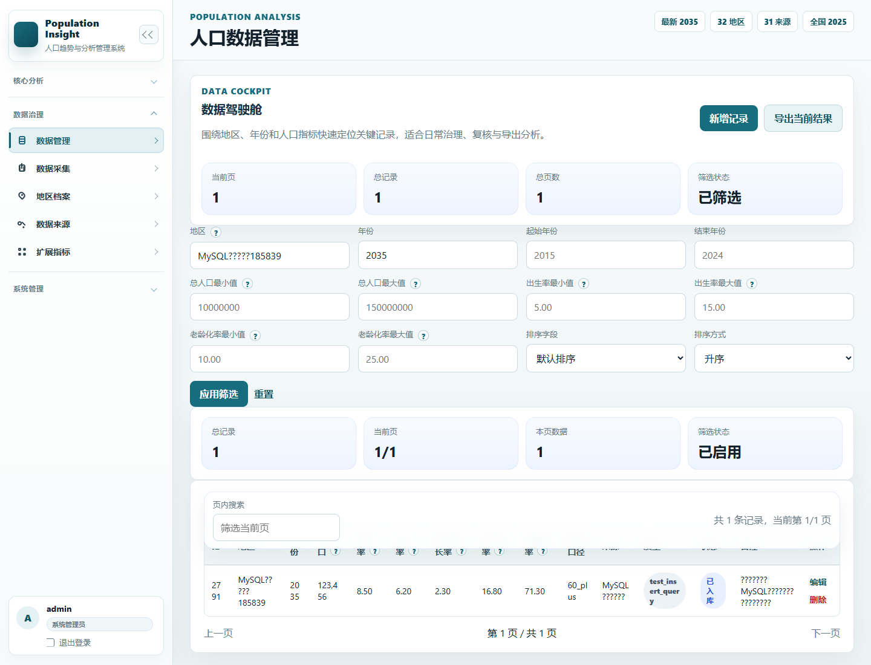
截图文件：F:\Development\Population-Insight-main\Population-Insight-main\output\mysql_evidence\04_platform_query_result.png

查询函数：population_insight/services/population_service.py
105: def query_population_records(filters: dict[str, Any] | None = None) -> list[dict[str, Any]]:
106: filters = filters or {}
107: query = ["SELECT * FROM population_data WHERE 1 = 1"]
108: params: list[Any] = []
109:
110: if filters.get("region"):
111: query.append("AND region LIKE ?")
112: params.append(f"%{str(filters['region']).strip()}%")
113: if filters.get("year"):
114: query.append("AND year = ?")
115: params.append(int(filters["year"]))
116: if filters.get("start_year"):
117: query.append("AND year >= ?")
118: params.append(int(filters["start_year"]))
119: if filters.get("end_year"):
120: query.append("AND year <= ?")
121: params.append(int(filters["end_year"]))
122:
123: range_filters = {
124: "min_total_population": ("total_population", ">="),
125: "max_total_population": ("total_population", "<="),
126: "min_birth_rate": ("birth_rate", ">="),
127: "max_birth_rate": ("birth_rate", "<="),
128: "min_aging_rate": ("aging_rate", ">="),
129: "max_aging_rate": ("aging_rate", "<="),
130: }
131: for key, (column, operator) in range_filters.items():
132: if filters.get(key) in (None, ""):
133: continue
134: query.append(f"AND {column} {operator} ?")
135: params.append(float(filters[key]))
136:
137: query.append("ORDER BY region ASC, year ASC")
138: return fetch_all(" ".join(query), params)
139:
140:
141: def update_population_record(
142: record_id: int, updates: dict[str, Any], username: str = "system"

Web 路由：app.py /records 与 /records/new
225: @app.route("/records")
226: @login_required
227: def records_view():
228: try:
229: filters, raw_filters = _parse_record_filters(request.args)
230: except ValueError as error:
231: flash(str(error), "error")
232: filters, raw_filters = {}, {key: _clean_text(request.args.get(key)) for key in [
233: "region",
234: "year",
235: "start_year",
236: "end_year",
237: "min_total_population",
238: "max_total_population",
239: "min_birth_rate",
240: "max_birth_rate",
241: "min_aging_rate",
242: "max_aging_rate",
243: ]}
244:
245: sort_field = _clean_text(request.args.get("sort_field"))
246: sort_order = _clean_text(request.args.get("sort_order")) or "asc"
247: page = _parse_page(request.args.get("page"))
248:
249: records = query_population_records(filters)
250: try:
251: sorted_records = _apply_record_sort(records, sort_field, sort_order)
252: except ValueError as error:
253: flash(str(error), "error")
254: sort_field = ""
255: sort_order = "asc"
256: sorted_records = _apply_record_sort(records, sort_field, sort_order)
257:
258: pagination = _paginate(sorted_records, page)
259: query_params = {**raw_filters, "sort_field": sort_field, "sort_order": sort_order}
260:
261: return render_template(
262: "records.html",
263: filters=raw_filters,
264: records=pagination["items"],
265: pagination=pagination,
266: sort_field=sort_field,
267: sort_order=sort_order,
268: export_query=_querystring(query_params),
269: page_query=_querystring(query_params),
270: region_options=get_distinct_regions(),
271: )
272:
273:
274: @app.route("/collection", methods=["GET", "POST"])
275: @admin_required
276: def collection_view():
277: form_data = request.form.to_dict()
278: preview_records: list[dict] = []
279: records_payload = ""
280: import_summary = None
281:
282: if request.method == "POST":
283: action = _clean_text(request.form.get("action")) or "preview"
284: try:
285: if action == "import":
286: preview_records = decode_records(request.form.get("records_payload", ""))
287: source_name = _clean_text(request.form.get("source_name"))
288: source_url = _clean_text(request.form.get("source_url"))
289: quality = _clean_text(request.form.get("data_quality")) or "official_verified"
290: aging_basis = _clean_text(request.form.get("aging_rate_basis")) or "60_plus"
291: preview_records = [
292: {
293: **record,
294: "data_source_name": record.get("data_source_name") or source_name,
295: "source_url": record.get("source_url") or source_url,
296: "data_quality": record.get("data_quality") or quality,
297: "aging_rate_basis": record.get("aging_rate_basis") or aging_basis,
298: }
299: for record in preview_records
300: ]
301: import_summary = import_collected_records(preview_records, username=g.user["username"])
302: log_operation(
303: g.user["username"],
304: "IMPORT_COLLECTED_RECORDS",
305: details=f"imported={import_summary['imported']}, failed={import_summary['failed']}",
306: )
307:
308: publisher = _clean_text(request.form.get("publisher"))
309: if source_name and publisher:
310: try:
311: add_data_source(
312: {
313: "name": source_name,
314: "publisher": publisher,
315: "source_url": _clean_text(request.form.get("source_url")),
316: "published_date": _clean_text(request.form.get("published_date")),
317: "reliability_level": _clean_text(request.form.get("reliability_level")) or "高",
318: "remarks": _clean_text(request.form.get("source_remarks")) or "人口数据采集导入",
319: },
320: username=g.user["username"],
321: )
322: except ValueError as source_error:
323: flash(f"数据来源整理提示：{source_error}", "warning")
324:
325: level = "success" if import_summary["failed"] == 0 else "warning"
326: flash(
327: f"采集导入完成：成功 {import_summary['imported']} 条，失败 {import_summary['failed']} 条。",
328: level,
329: )
330: records_payload = encode_records(preview_records)
331: if import_summary["failed"] == 0:
332: return redirect(url_for("records_view"))
333: else:
334: result = collect_population_records(
335: raw_text=request.form.get("raw_text", ""),
336: source_url=_clean_text(request.form.get("source_url")),
337: )
338: preview_records = result["records"]
339: records_payload = encode_records(preview_records)
340: flash(f"已识别 {len(preview_records)} 条人口记录，请核对后导入。", "success")
341: except ValueError as error:
342: flash(str(error), "error")
343:
344: return render_template(
345: "collection.html",
346: form_data=form_data,
347: preview_records=preview_records,
348: records_payload=records_payload,
349: import_summary=import_summary,
350: )
351:
352:
353: @app.route("/records/new", methods=["GET", "POST"])
354: @admin_required
355: def record_create_view():
356: form_data = {}
357: if request.method == "POST":
358: form_data = request.form.to_dict()
359: try:
360: record_id = add_population_record(form_data, username=g.user["username"])
361: flash(f"新增成功，记录 ID：{record_id}", "success")
362: return redirect(url_for("records_view"))
363: except ValueError as error:
364: flash(str(error), "error")
365:
366: return render_template(

五、MySQL 中测试记录核验
通过项目 MySQL 连接层读取到的最新测试记录如下：
id | region | year | total_population | male_population | female_population | birth_rate | death_rate | natural_growth_rate | data_quality
2791 | MySQL?????185839 | 2035 | 123456 | 60000 | 63456 | 8.5 | 6.2 | 2.3 | test_insert_query

六、建议手工截图位置
• 连接成功截图：JetBrains Data Sources and Drivers 窗口，保留左下角 Succeeded、DBMS、Ping 信息。
• 新增功能截图：/records/new 页面，表单填好但提交前截图，能看到地区、年份、人口字段。
• 查询展示截图：/records 页面按测试地区和年份筛选后的表格，能看到新增记录。
• 代码截图：connection.py 中 get_connection/fetch_all/execute_write，population_service.py 中 add_population_record/query_population_records。

