**FFR projection based on the factors of FFR and Treasury Yields with HMM**

**Abstract**

As we all know, in the last two years the Federal Reserve has raised interest rates multiple times (increasing the Federal Funds Rate), which has had a significant impact on financial markets around the world. The rate hikes have not only brought about the strength of the US dollar, which affects the Currency Markets, but also the pricing of global assets and the anchoring of sovereigns' credits, which makes the projection of the FFR very important. However, there are a number of obstacles to FFR forecasting: 1) lagging and insufficient publicly available data due to the low frequency of macro data releases; and 2) the susceptibility of market participants to historical data bias (e.g., being overly optimistic about FFR reductions). This study hopes to combine the Taylor Rule, commonly used by the FOMC, with the treasury yields to make a more forward-looking judgement on FFR.

**Introduction**

**Literature Review**

1. FFR

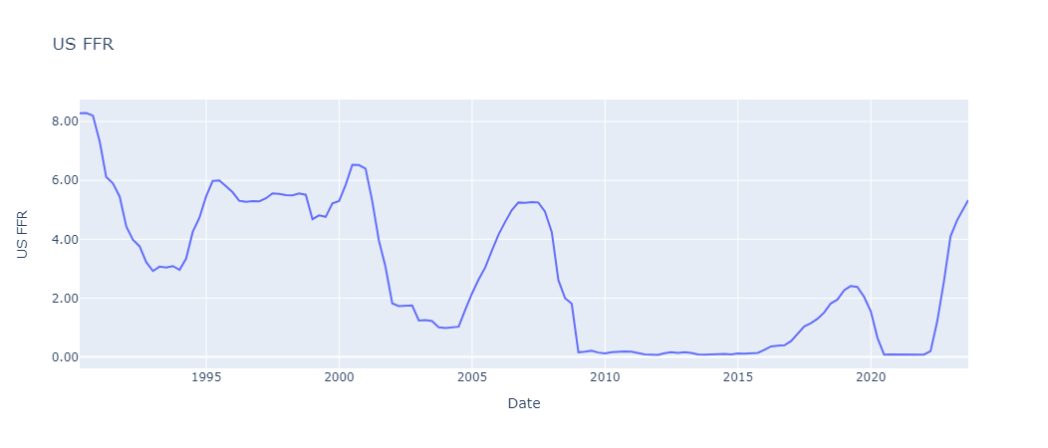

*Figure 1. US FFR Diagram*

1. Taylor Rule

It means that the FFR is determined by two factors: Actual GDP Growth Rate and Inflation growth rate . Hence, it can be rewritten as:

1. Treasury Yield

U.S. Treasury yield is the yield on U.S. government bonds, whose metric measures the return an investor can earn by purchasing U.S. government bonds. U.S. government bonds are bonds issued by the government to raise funds and are usually classified as having different maturities, including short-term, intermediate-term, and long-term bonds.

Treasury yield is often used by investors and economic observers as an indicator of risk and market expectations. Based on the risk-neutral interpretation, treasury yields are equal to the average value of expected future short rates [5]. A low Treasury yield may indicate market concerns about future economic uncertainty, while a high Treasury yield may reflect investor optimism about economic growth and inflation. In addition, Treasury yield is used to determine the pricing of other financial instruments, such as mortgage rates and corporate bonds. Treasury yields can reflect economic conditions, monetary and fiscal policies, and expectations about future economic activity, real interest rates, and inflation [6]. What can be agreed upon is that whenever macroeconomic data is released differently than the consensus, treasury yields always have a noticeable jump, indicating the influence of macro economy situations to the treasury yields. In this research, we take 6 U.S. treasury yields from Bloomberg into consideration according to the dataset coverage [1], and the remained NAN values are forward filled based on the previous dates’ yield data. A visualization of the Treasury Yields is shown in Fig. 2:

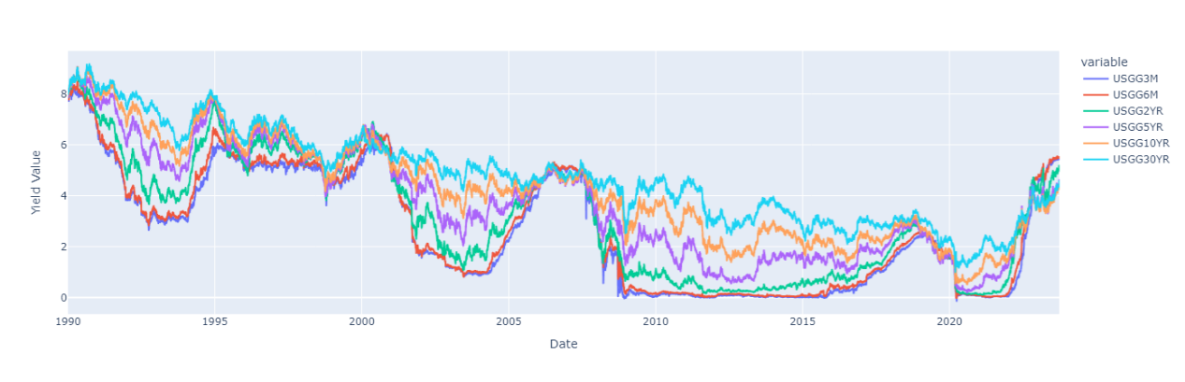

*Figure 2. US Treasury Yields Diagram (Maturities including 3 Months, 6 Months, 2 Year, 5 Year, 10 Year, and 30 Year)*

Additionally, the term structure of the treasury yields is also an important dimension to understand the economic situation at that point of time.

However, sometimes the yield curve was inverted, just like the current situation.

Indeed, treasury yields have strong correlation with FFR, this is because…

**Research Objective**

1. Transform the treasury yields into

**Methodologies**

1. Principle Component Analysis
2. GMM-HMM

Macro Factors from Taylor Rule

**??**

According to the basic assumptions of time series modelling, forecasts at moment t cannot use future information, but only current moment as well as ever information [3]. However, in the actual publication of economics data, although different economic indicators reflect economic conditions over the same period of time, they cannot be regarded as variables with the same time stamp due to the difference in publication time. This is also the case in our study, although based on the Taylor Rule, the FFR can be calculated using the relevant macroeconomic indicators for this period, the corresponding macroeconomic indicators are published 1-2 days after the publication time of the FFR (see Fig. ), and therefore in practice it is not possible to use such future information for FFR determination. In reality, researchers generally use the previous period's macroeconomic data as the input factor for the Taylor Rule, however, this can lead to a lagged effect as the calculation of the FFR ignores the most recent period's economic situation. There are also many relevant financial institutions that present alternative data for use, but this is not always publicly available and authoritative.

Perfect Situation:

,

Real Implication

,

is biased as it doesn’t consider the information from to .

We aim to provide an equation to build the with and the information from to , which is denoted by . As is the hidden information during the period of (,T), it is unobservable, but should still has the linear relationship with . Therefore, we have the new established formula:

,

Based on our thinking, when the FFR is adjusted, Treasury Yield is affected first, while macroeconomic indicators are affected later on. This is because the adjustment of the FFR directly affects the cost of short-term borrowing, so that the short-term borrowing rates of banks and other financial institutions usually quickly follow the change in the FFR, which in turn affects Treasury Yield. However, macroeconomic indicators are affected by a variety of factors, and it usually takes time for changes in the economy to be transmitted, e.g. it takes some time for firms and individuals to make decisions about investing and consuming. time to adjust to the new interest rate environment. In addition, changes in Treasury yields have a direct impact on capital markets, which in turn affect economic activity and ultimately the macroeconomy. [4] stated that the short-term bond yields have relatively significant transmission effects on some output variables, such as consumption, investment, and the consumer price index, which are the macro indicators we concerned.

**Results Analysis**

**Conclusion**

**Reference**

[1] Bloomberg Terminal Data on Treasury Yields (USGG). Bloomberg Terminal, 2023-09-25.

[2] Brooks, Jordan, et al. “Post-FOMC Announcement Drift in U.S. Bond Markets.” *National Bureau of Economic Research*, 1 Oct. 2018, www.nber.org/papers/w25127.

[3] Taylor, Stephen J. *Modelling Financial Time Series*. Hackensack N.J., World Scientific, 2013.

[4] Zhang, Hui, and Hao Huang. “An Empirical Study of the Asset Price Channel of Monetary Policy Transmission in China.” *Emerging Markets Finance and Trade*, vol. 53, no. 6, 8 Nov. 2016, pp. 1278–1288.

[5] Diebold, Francis X, et al. “Modeling Bond Yields in Finance and Macroeconomics.” *American Economic Review*, vol. 95, no. 2, 1 Apr. 2005, pp. 415–420.

[6] Evans, Charles L., and David A. Marshall. “Economic Determinants of the Nominal Treasury Yield Curve.” *Journal of Monetary Economics*, vol. 54, no. 7, Oct. 2007, pp. 1986–2003.

[7]

[8]

U.S. BUREAU OF LABOR STATISTICS. “12-Month Percentage Change, Consumer Price Index, Selected Categories.” *Bls.gov*, 2023, www.bls.gov/charts/consumer-price-index/consumer-price-index-by-category-line-chart.htm.