**Praktikum DW Layout, Font, dan Warna  
Desain Web**

**Kelas A**



Oleh :

Adjie Firmansyah

4523210004

Dosen :

# **Adi Wahyu Pribadi, S.Si., M.Kom**

**S1 Teknik Informatika**

**Universitas Pancasila**

**Program**

**index.html**

**<!DOCTYPE html>**

**<html lang="en">**

**<head>**

**<meta charset="UTF-8">**

**<meta http-equiv="X-UA-Compatible" content="IE=edge">**

**<meta name="viewport" content="width=device-width, initial-scale=1.0">**

**<title>Website Sekolah</title>**

**<link rel="stylesheet" href="style.css">**

**</head>**

**<body>**

**<header>**

**<div class="container">**

**<h1>SMA KONOHAGAKURE</h1>**

**<nav>**

**<ul>**

**<li><a href="#">Home</a></li>**

**<li><a href="#">Tentang Kami</a></li>**

**<li><a href="#">Fasilitas</a></li>**

**<li><a href="#">Kontak</a></li>**

**</ul>**

**</nav>**

**</div>**

**</header>**

**<section class="hero">**

**<div class="container">**

**<h2>Selamat Datang di Website Resmi SMA KONOHAGAKURE</h2>**

**<p>Website ini merupakan portal resmi untuk memberikan informasi terkini mengenai kegiatan sekolah dan akademik.</p>**

**<img src="https://rumahproduksiindonesia.com/wp-content/uploads/2024/07/ed0982111a6e04d288da2c3247d17053.gif" style="width:100%; max-width:300px;">**

**</div>**

**</section>**

**<section class="content">**

**<div class="container">**

**<h3>Informasi Terkini</h3>**

**<p>Kami selalu menyediakan informasi terbaru mengenai kegiatan sekolah, pengumuman akademik, dan berita lainnya.</p>**

**</div>**

**</section>**

**<footer>**

**<div class="container">**

**<p>&copy; 2024 SMA KONOHAGAKURE. All Rights Reserved.</p>**

**</div>**

**</footer>**

**<section class="content">**

**<div class="container">**

**<div class="item">**

**<h4>Pengumuman 1</h4>**

**<p>Lorem ipsum dolor sit amet, consectetur adipiscing elit. Quisque nisl eros.</p>**

**</div>**

**<div class="item">**

**<h4>Pengumuman 2</h4>**

**<p>Pellentesque habitant morbi tristique senectus et netus et malesuada fames ac turpis egestas.</p>**

**</div>**

**<div class="item">**

**<h4>Pengumuman 3</h4>**

**<p>Donec sollicitudin molestie malesuada. Cras ultricies ligula sed magna dictum porta.</p>**

**</div>**

**</div>**

**</section>**

**</body>**

**</html>**

**style.css**

**/* Import Google Fonts */**

**@import url('https://fonts.googleapis.com/css2?family=Roboto:wght@400;700&family=Open+Sans:wght@400;600&display=swap');**

**/* Reset CSS */**

**\* {**

**margin: 0;**

**padding: 0;**

**box-sizing: border-box;**

**}**

**/* Body Style */**

**body {**

**font-family: 'Open Sans', sans-serif;**

**color: #333;**

**background-image: url('https://thumb.viva.co.id/media/frontend/thumbs3/2024/01/29/65b734734dc70-desa-konoha-naruto_1265_711.jpeg');**

**line-height: 1.6;**

**}**

**/* Container */**

**.container {**

**width: 90%;**

**max-width: 1200px;**

**margin: 0 auto;**

**}**

**/* Header */**

**header {**

**background-color: #2C3E50;**

**color: #fff;**

**padding: 20px 0;**

**text-align: center;**

**}**

**header h1 {**

**font-family: 'Roboto', sans-serif;**

**font-size: 36px;**

**}**

**nav ul {**

**list-style: none;**

**margin-top: 10px;**

**}**

**nav ul li {**

**display: inline;**

**margin-right: 20px;**

**}**

**nav ul li a {**

**color: #ecf0f1;**

**text-decoration: none;**

**font-weight: bold;**

**}**

**nav ul li a:hover {**

**color: #000000;**

**}**

**/* Hero Section */**

**.hero {**

**background-color: #1e00ff;**

**color: #fff;**

**padding: 50px 0;**

**text-align: center;**

**}**

**.hero h2 {**

**font-family: 'Roboto', sans-serif;**

**font-size: 28px;**

**}**

**.hero p {**

**font-size: 18px;**

**}**

**/* Content Section */**

**.content {**

**padding: 50px 0;**

**text-align: center;**

**}**

**.content h3 {**

**font-family: 'Roboto', sans-serif;**

**font-size: 24px;**

**color: #ffffff;**

**}**

**.content p {**

**font-size: 16px;**

**margin-top: 10px;**

**color: #ffffff;**

**}**

**/* Footer */**

**footer {**

**background-color: #2C3E50;**

**color: #fff;**

**text-align: center;**

**padding: 20px 0;**

**}**

**footer p {**

**margin: 0;**

**}**

**/* Responsive Design */**

**@media (max-width: 768px) {**

**header h1 {**

**font-size: 28px;**

**}**

**.hero h2 {**

**font-size: 24px;**

**}**

**.content h3 {**

**font-size: 20px;**

**}**

**nav ul li {**

**display: block;**

**margin: 10px 0;**

**}**

**}**

**/* Content Grid Layout */**

**.content .container {**

**display: grid;**

**grid-template-columns: repeat(auto-fit, minmax(300px, 1fr));**

**gap: 20px;**

**}**

**.content .item {**

**background-color: #ecf0f1;**

**padding: 20px;**

**border-radius: 5px;**

**text-align: left;**

**}**

**.content .item h4 {**

**font-size: 20px;**

**color: #2C3E50;**

**}**

**.content .item p {**

**font-size: 14px;**

**color: #7f8c8d;**

**}**

**output/layout**

**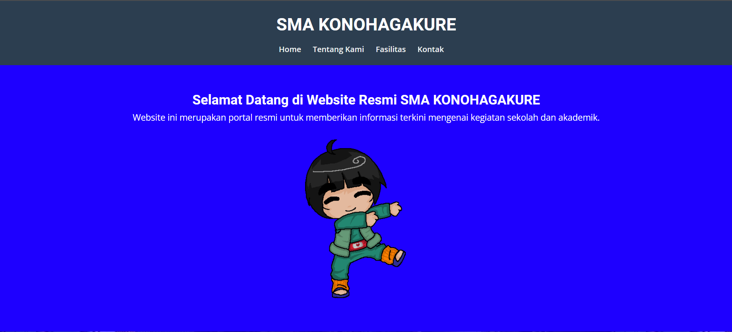  
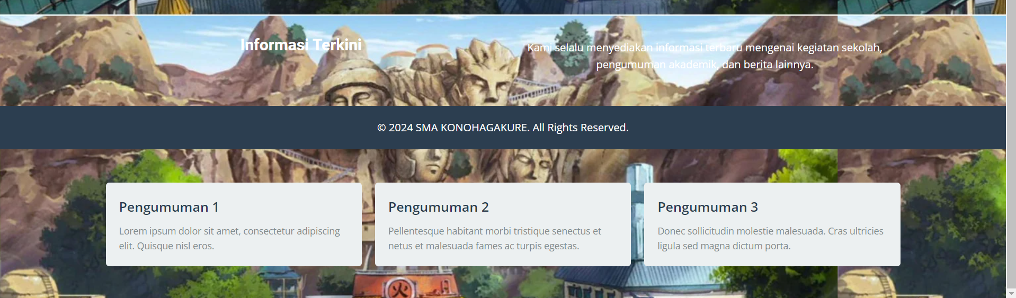**

**Penjelasan**

struktur dasar halaman HTML untuk website sekolah "SMA KONOHAGAKURE." Halaman ini mencakup elemen seperti header dengan navigasi, bagian hero yang menyambut pengunjung, dan bagian konten untuk informasi terkini serta pengumuman. Desain ini memberikan informasi tentang kegiatan sekolah dan akademik, dilengkapi dengan gambar dan footer untuk hak cipta.