Figure S1. Binding analysis of NrpR to the sRNA₁₅₄ promoter by EMSA. 4 ng of ³²P-labeled PCR fragment of the sRNA₁₅₄ upstream region including potential NrpRI operator sequence was incubated without protein (NC) and in the presence of increasing amounts of purified MBP-NrpRI (0.26, 0.65, 1.3, 1.95, 2.6, 3.9 µg) (lanes 1-6, respectively). To saturate unspecific binding 100 ng poly(d[I-C]) and 30 µg BSA were added to samples 1-6. The shifted PCR fragment is indicated by an arrow.

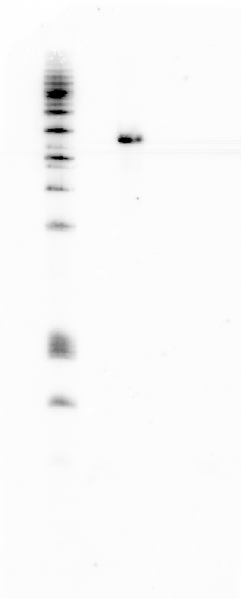
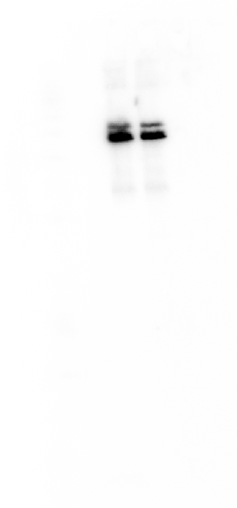
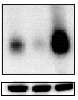
A B
∆sRNA₁₅₄::pac
wt
5 S rRNA
∆sRNA₁₅₄::markerless
OP sRNA₁₅₄
wt
5 S rRNA

C
wild type
∆ sRNA₁₅₄::pac

Figure S2: Characterization of sRNA₁₅₄ mutant strains. Northern blot analysis of sRNA_{154.} Total RNA was isolated from (A) the markerless deletion strain of sRNA₁₅₄ (∆sRNA₁₅₄::markerless) and overexpression mutant of sRNA₁₅₄ (OP sRNA₁₅₄) encoded from a plasmid and (B) from the sRNA₁₅₄ deletion mutant strain with inserted pac-cassette (∆sRNA₁₅₄::pac). Cells were harvested at an optical density of OD₆₀₀ = 0.15 - 0.2 and northern blot was performed as described in Material and Methods. (C) Growth of M. mazei wt and M. mazei ∆sRNA₁₅₄::pac on methanol was monitored at 37 °C under nitrogen fixing conditions. The standard deviation of three independent growth experiments is depicted. Wild type, red curve; ∆sRNA₁₅₄::pac, green curve.
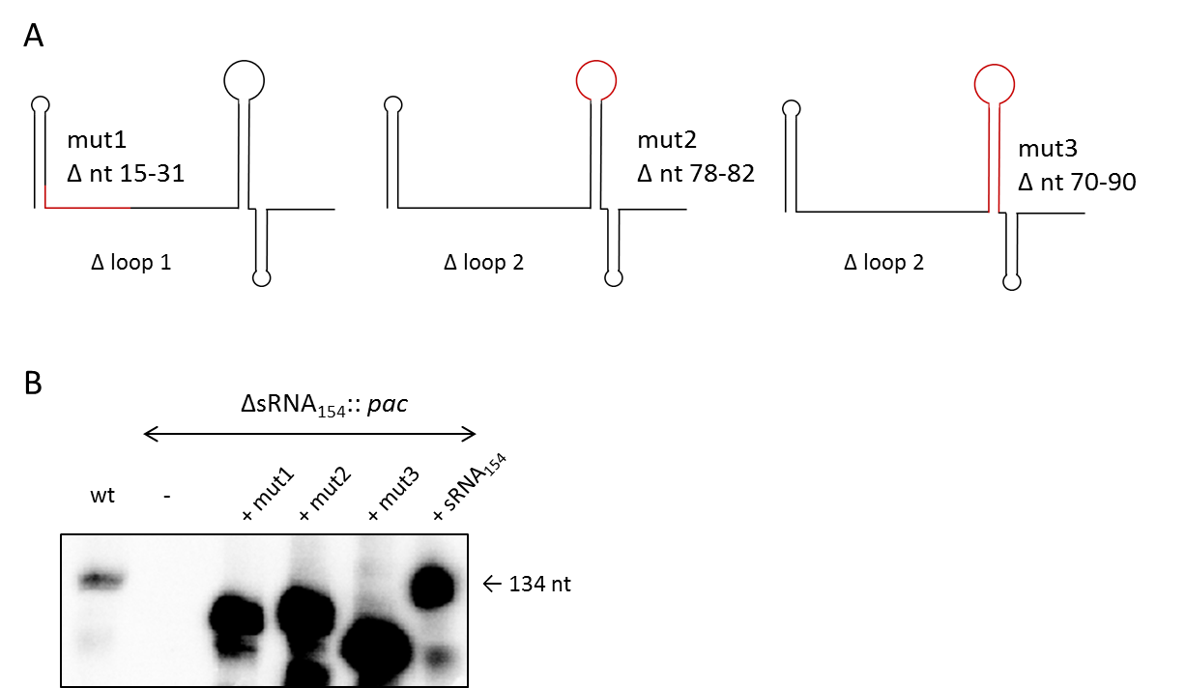
Figure S3: Generated mutant versions of sRNA₁₅₄ for complementation assays. (A) Illustration of the mutant versions of sRNA₁₅₄. (B) Northern blot analysis of total RNA isolated from wt and the sRNA₁₅₄ deletion mutant strain (∆sRNA₁₅₄::pac) complemented with the respective plasmid encoded mutant versions of sRNA₁₅₄ harvested at an optical density of OD₆₀₀ = 0.15 - 0.2.

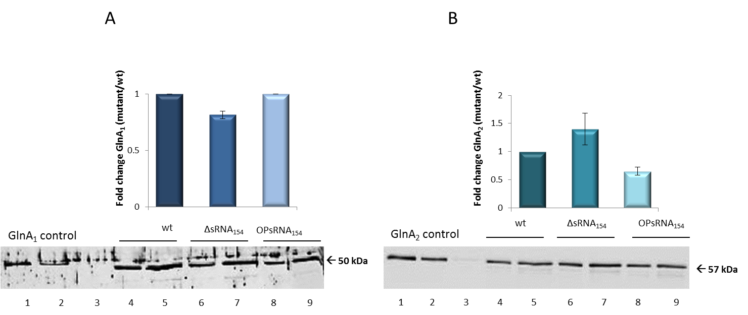
Figure S4: Expression analysis of GlnA₁ and GlnA₂ in sRNA₁₅₄ mutant strains. Cell extracts were prepared from exponentially growing cultures of M. mazei wt, M. mazei overexpression strain of sRNA₁₅₄ (OP sRNA₁₅₄) and M. mazei sRNA₁₅₄:: pac-mutant strain (∆sRNA₁₅₄) under N-limitation. Equal amounts of cell extract protein were separated by SDS PAGE followed by western blot analysis using polyclonal antibodies generated against GlnA₁ and GlnA₂. Relative amounts of GlnA₁ and GlnA₂ in the M. mazei sRNA₁₅₄ deletion -mutant strain compared to M. mazei wt strain were calculated using the Aida image analyzer for three independent biological replicates. The average fold-expression changes are depicted, the lower panel represents one exemplarily chosen original western blot. A) Western blot against GlnA₁, lanes 1-3, purified His-GlnA₁ standards (225 ng, 45 ng, 9 ng); lanes 4-5, M. mazei wt cell extract (5 µg, 10 µg); lanes 6-7, M. mazei ∆sRNA₁₅₄::pac-mutant strain (5 µg, 10 µg); lanes 8-9, M. mazei overproduction sRNA₁₅₄ strain (5 µg, 10 µg). B) Western blot against GlnA₂, lanes 1-3, purified His-GlnA₂ standards (425 ng, 7 ng, 2.4 ng); lanes 4-5, M. mazei wt cell extract (0.5 µg, 1 µg); lanes 6-7, M. mazei ∆sRNA₁₅₄::pac-mutant strain (0.5 µg, 1µg); lanes 8-9, M. mazei overproduction sRNA₁₅₄ strain (0.5 µg, 1 µg).

Figure S5: Predicted interaction regions within sRNA₁₅₄. In silico prediction of potential interaction sites of sRNA₁₅₄ and mRNA targets using the tool IntaRNA ^{1, 2}. Interacting regions of sRNA₁₅₄ with its targets were mainly located in the single stranded conserved loop regions as depicted in Fig. 2. The colored boxes indicate the loop regions of sRNA₁₅₄ (blue box= loop 1; purple box= loop 2). Interaction regions are shown for the 25 most reliable predicted interactions in the genome wide approach (data not shown).

Figure S6: Target predictions for sRNA₁₅₄ (IntaRNA). In silico prediction of potential interactions between sRNA₁₅₄ and polycistronic nifHI₁I₂DKEN-operon performed with IntaRNA ^{1, 2}. Selected predicted interactions of the genes nifI₁KEN are shown. Loop1 of sRNA₁₅₄, indicated in blue, loop2 of sRNA₁₅₄, indicated in purple.

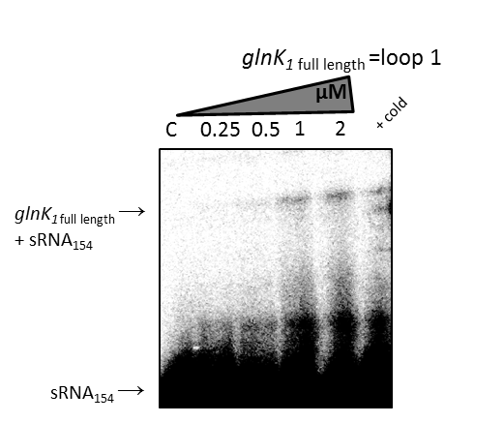
Figure S7: Electrophoretic mobility shift assay (EMSA) of sRNA₁₅₄ with truncated nifH and full length glnK₁ transcript. EMSA was performed using approximately 5 nM of radioactively 5’-end-labeled sRNA₁₅₄. The assay was performed as described in ‘Materials and Methods’ with increasing concentrations of unlabeled target nifH mRNA (1-100 nt) from 0.25 to 4 µM and glnK₁ full length mRNA from 0.25 to 2 µM. After 15 min incubation, samples were run on a native 6 % PAA gel. NC = negative control (0 µM).
Figure S8: RNA-RNA pulldown using biotinylated sRNA₁₅₄ and isolated total RNA from M. mazei grown under N-depletion. A) Illustration of the streptavidin magnetic bead which bounds the biotinylated sRNA₁₅₄. B) Dot blots were performed with the eluate received from the RNA-RNA pulldown. As internal controls 5 pmol of the respective in vitro transcribed RNA as well as 10 µg total RNA isolated from M. mazei wt strain were subjected to the membrane. The membranes were hybridized with the respective radioactively 5’-end-labeled oligonucleotides. The respective autoradiographs are shown for: glnA₁; glnA₂; nrpA; glnK₁; nifH.

Figure S9: Conservation of nrpA mRNA. Multiple secondary structure alignment of nrpA mRNA homologues in related Methanosarcina species performed with LocARNA ³, MM, Methanosarcina mazei strains Goe1, S-6, C16, LYC, WWM610, Tuc01, SarPi; MMHB, Methanosarcina horonobensis HB1; Mlacustris, Methanosarcina lacustris strain Z7289 ⁴. Colored boxes indicate conservation of interaction sites with sRNA₁₅₄ loop 1(blue) and loop 2 (purple).

Table S1: Differential gene expression analysis. Selected genes analyzed by differential RNA sequencing (DEseq2) with at least 2-fold change in transcript levels in M. mazei ∆sRNA₁₅₄::pac in comparison to the wt, both grown exponentially under N limitation, for each strain two biological replicates were analyzed.
 |  | RNA-seq (Deseq2)
Gene | function | fold change  ∆sRNA₁₅₄/wt | p-value
MM_0581 | hypothetical protein | 0.1 | 1.25E-53
MM_0732 | nitrogen regulatory protein, P-II-like, glnK₁ | 0.11 | 6.57E-36
MM_0964 | glutamine synthetase, glnA₁ | 0.15 | 6.62E-50
MM_2005 | phosphate-binding protein | 0.17 | 5.54E-30
MM_2699 | transposase | 0.2 | 3.68E-22
MM_1708 | nrpA | 0.23 | 2.19E-18
MM_578 | phosphate-binding protein | 0.28 | 3.24E-13
MM_2887 | hypothetical protein | 0.29 | 2.31E-13
MM_0957 | ammonium transporter, amtB₂ | 0.31 | 4.92E-11
MM_0313 | hypothetical protein | 0.32 | 7.12E-11
MM_0733 | ammonium transporter, amtB₁ | 0.34 | 1.64E-12
MM_1986 | regulatory protein | 0.35 | 2.67E-42
MM_1901 | hypothetical protein | 0.38 | 2 E-09
MM_1411 | hypothetical protein | 0.38 | 5.24E-19
MM_3334 | monomethylamine corrinoid protein | 0.42 | 5.25E-07
MM_0719 | nitrogenase reductase, nifH | 0.42 | 1.92E-06
MM_1902 | hypothetical protein | 0.43 | 3.47E-08
MM_1798 | molecular chaperone GroEL | 0.43 | 4.11E-20
MM_3188 | glutamine synthetase, glnA₂ | 0.43 | 7.21E-39
MM_0083 | hypothetical protein | 0.44 | 4 E-06
MM_0580 | hypothetical protein | 0.44 | 9.64E-08
tRNA | tRNA-Asp | 0.45 | 4.57E-09
MM_1221 | chromosomal protein | 0.45 | 4.42E-18
MM_2833 | ABC transporter ATP-binding protein | 0.46 | 6.21E-07
MM_1460 | hypothetical protein | 0.46 | 6.89E-08
MM_1187 | hypothetical protein | 0.46 | 3.74E-11
MM_0237 | hypothetical protein | 0.46 | 3.44E-08
MM_1025 | thiamine biosynthesis protein ThiC | 0.46 | 3.8E-21
MM_2531 | hypothetical protein | 0.46 | 5.99E-11
MM_0434 | hypothetical protein | 0.46 | 6.14E-08
MM_2289 | hypothetical protein | 0.47 | 7.61E-09
MM_2599 | hypothetical protein | 0.47 | 3.22E-07
MM_1096 | thermosome subunit alpha | 0.47 | 1.77E-23
tRNA | tRNA-Ile | 0.48 | 7.81E-10
MM_2174 | hypothetical protein | 0.48 | 1.01E-09
MM_3340 | hypothetical protein | 0.48 | 3.94E-05
MM_0859 | hypothetical protein | 0.49 | 2.65E-13
MM_3220 | transporter | 0.5 | 1.08E-14
MM_1793 | hypothetical protein | 0.5 | 2.78E-05
MM_1531 | regulatory protein | 2.01 | 1.01E-06
MM_0127 | Zinc metalloprotease | 2.02 | 1.28E-16
MM_0490 | phycocyanin subunit alpha | 2.04 | 9.6E-09
MM_0239 | hypothetical protein | 2.04 | 6.47E-11
MM_1836 | cell division control protein | 2.05 | 4.31E-21
MM_2775 | hypothetical protein | 2.07 | 4.62E-06
MM_2125 | 50S ribosomal protein L4 | 2.07 | 2.15E-08
MM_3191 | hypothetical protein | 2.17 | 6.67E-08
MM_2824 | glucose-6-phosphate dehydrogenase | 2.18 | 2.9E-12
MM_1818 | hypothetical protein | 2.23 | 6.65E-21
MM_0695 | cleavage and polyadenylation specificity factor 100 kD subunit | 2.25 | 4.19E-29
MM_3192 | hypothetical protein | 2.41 | 4.09E-14
MM_1272 | 3-dehydroquinate synthase | 2.42 | 3.51E-14
MM_2164 | hydrogenase expression %2Fformation protein | 2.44 | 2.3E-13
MM_2427 | methylcobalamin:coenzyme M methyltransferase | 2.44 | 4.34E-15
MM_0747 | ATP-dependent RNA helicase | 2.46 | 2.67E-28
MM_0363 | hypothetical protein | 2.47 | 4.95E-14
MM_3271 | glutaredoxin | 2.49 | 2.96E-20
MM_0008 | hypothetical protein | 2.78 | 1.02E-16
MM_1274 | shikimate 5-dehydrogenase | 2.86 | 5.15E-19
MM_1273 | 3-dehydroquinate dehydratase | 3.13 | 3.88E-23
MM_1275 | prephenate dehydrogenase | 3.7 | 6.61E-30
MM_3337 | hypothetical protein | 5.93 | 2.6E-45

Table S2: Strains and plasmids used in this study.
Strain or plasmid | Genotype or description | Source or reference
Strain
Methanosarcina mazei strain Gö1 | wild-type | DSMZ No. 3647
Methanosarcina mazei strain Gö1* | M. mazei derivativeª | Ehlers et al. ⁵
Escherichia coli DH5α | General cloning strain | Hanahan et al. ⁶
Escherichia coli λpir JM109 | General cloning strain | Miller et al. ⁷
E. coli BL21-CodonPlus®-RIL | Strain for overproduction | Stratagene, la Jolla, USA
Methanosarcina mazei Mm mut 89 | M. mazei derivativeª + plasmid  pWM-neo | This study
Methanosarcina mazei Mm mut137 | M. mazei with sRNA154 disrupted by  pac-cassette; Pur resistant | This study
Methanosarcina mazei Mm mut157 | M. mazei Mm mut 137 + plasmid pRS953, Pur, Neo resistant | This study
Methanosarcina mazei Mm mut158 | M. mazei Mm mut 137 + plasmid pRS954, Pur, Neo resistant | This study
Methanosarcina mazei Mm mut159 | M. mazei Mm mut 137 + plasmid  pRS , Pur, Neo resistant | This study
Methanosarcina mazei Mm mut160 | M. mazei Mm mut 137 + plasmid  pRS974, Pur, Neo resistant | This study
Plasmide
pRS207 | pac-cassette in pBluescript SK+ | Ehlers et al. ⁵
pRS723 | pWM321 + sRNA₁₅₄ | This study
pRS927 | Flanking regions of sRNA₁₅₄ disrupted with pac-cassette | This study
pRS 953 | pWM-neo + derivate 1 of sRNA₁₅₄ | This study
pRS 954 | pWM-neo + derivate 3 of sRNA₁₅₄ | This study
pRS 1194 | pWM-neo + sRNA₁₅₄ | This study
pRS 974 | pWM-neo + derivate 2 of sRNA₁₅₄ | This study
pCRII | General cloning vector for PCR products | Invitrogen, Darmstadt, GER
pDrive | General cloning vector for PCR products | Qiagen, Hilden, GER
pWM321 | oriR6K, pC2A replicon, pur^{R}, bla^{R} | Metcalf et al. ⁸
pWM-neo | oriR6K, pC2A replicon, neo^{R}, bla^{R} | Mondorf et al. ⁹
pRS772 | (His)6tag-NifH under the control of the T7 promoter in pET28a | Weidenbach et al. ¹⁰
pRS196 | (His)6tag-GlnA₁ under the control of the T7 promoter in pET28a | Ehlers et al. ¹¹
pRS195 | (His)6tag-GlnA₂ under the control of the T7 promoter in pET28a | This work

Table S3: Primer pairs and oligonucleotides used in this study.

Primer/ oligonucleotide designations | 5'→3'
RACE
5’-RLM-sRNA₁₅₄ | TGCTCACGAGTCAACGTCAGGAAC
3‘-RACE-sRNA₁₅₄-GSP | TGCTTACGAGTAAATCAAAGCC
Mutant construction
s154 SDM1 for 2  s154 SDM1 rev 2  s154 SDM2 for 2  s154 SDM2 rev 2  SDM3 s154 for P  SDM3 s154 rev P  sRNA154 for Xho1  sRNA154 rev Xho1 | TTACTCGTAAGCAACCGGTATCTTAC  CACACACACACGAGAATCGAAACG  AACCTATCCTTCTAGAGTAATCGTTTCG  TCCTGTCCGTTCCTGACGTTGAC  TTCTAGAGTAATCGTTTCGATTCTCGTG  GTTCCTGACGTTGACTCGTGAGC  AATCTCGAGCTGACCCTGTGAAATACTGCC  GCAGAATTGAGGCTCGAGCTGCAGGG
Northern blot
sRNA154-NB | GATGAAACCTATCCTTCTAGAGT
NB sRNA154 NEU | GAAGTTAGTTGCTCACGAGTC
qRT PCR
MM_0719 for  MM_0719 rev  MM_0732 for  MM_0732 rev | CCACGCAGAATCTTACTG  AGCACGGTTTTCTGGTTC  CGATGGAATATGATGCAAACC  CCAACGTAACCGTCACTG
amtB1 for.rt | GGGCTTGTCCAGCGTAAAAAC
amtB1 rev.rt | AAACACATTCTCAAGGCCGCC
MM_0964 for  MM_0964 rev | GGGAGGATACTTCGATTTCG  TGATGGGAGGCTTCTATCTG
MM_orf957 for.rt | GATAACGCAACCTGGAACAGC
MM_orf957 rev.rt | GGACACAGTAAACAAGGTAAGC
MM_1708 rt2.for | GGAGAACTTCTGCGAGAAGAT
MM_1708 rt2. rev | TGGAAGTTCCAGCTGTGGATG
MM_3188 for  MM_3188 rev | CTACCGGAGAAAGAGTGG  GGTCAAGGGTAGGGATTTC
MM1215 for.rt | TCAAGAGCGAGGGCATGAATG
MM1215 rev.rt | GCACTACCGAGAACAATAGCC
MM1621 for.rt | TAGGAGGTTTTCTCGGAAGCG
MM1621 rev.rt | AAGCGTATCTCCATCAAGCCC
MM2181 for.rt | GCCTCCATGAGAAGAATGCTC
MM2181 rev.rt | CTTCAAGGTCTCCAACTCCTG
In vitro templates
MM719 for T7 | TAATACGACTCACTATAGGGTACCGGCTTCCGGTGAAGAA
MM719 rev Sma1 | CCCGGGTAGCTCAACAATCCCGAATTCCACCATCATGG
MM1708 for T7 | TAATACGACTCACTATAGGGGAGACCTGCCATGACATAGC
MM1708 rev Sma1 | CCCGGGTCAGCTTTCATCAACTACTTCCAAATATTCGGAA
MM3188 for T7 | TAATACGACTCACTATAGGGTCCTAGCAGGCCATAATTCA
MM3188 rev Sma1 | TCAGCCAATGTGGATGTAGTTGTCCACAAGCTTCCT
MM732 for T7 | TAATACGACTCACTATAGGGTACCTACTGGTGGTCGCGAT
MM732 rev Sma1 | CCCGGGCAATTGCCTCAGGTCCGGTTTCGTT
MM964 for T7 | TAATACGACTCACTATAGGGTACCTAATGCCTAGTGAGGA
MM964 rev Sma1 | CCCGGGCAGCATAGAGAGATATCTGGAAAGTTC
glnA1 rev2 Sma1 | CCCGGGCTTTGATTGCGGTCTTAAGTACATATCTCGGGTCTC
glnA1 for2 T7 | TAATACGACTCACTATAGGGTCTCTGATCCGTATCCCGGC
glnA2 rev2 Sma1 | CCCGGGATGATGTAGTATTCGAGTTCAGCCATTGCGTTTAAC
glnA1 rev3 Sma1 | CCCGGGCAGCATAGAGAGATATCTGGAAAGTTCCCAGG
MM719 rev2 Sma1 | CCCGGGGGTAGTGGATTTTCCTATA
MM3188 T7 for 2 | TAATACGACTCACTATAGGGGATACTCGAATATACAAC
MM3188 rev2 Sma1 | CCCGGGGTTGTATATTCGAGTATC
MM3188 rev3 Sma1 | CCCGGGCTTTGGTGAATTCACTTG
MM3188 T7 for 3 | TAATACGACTCACTATAGGGATGACATCATCAAATTC
MM3188 rev4 Sma1 | CCCGGGCATTGTCGAGGTGTTCCTC
MM3188 T7 for 4 | TAATACGACTCACTATAGGGAGCTCTGCTGAAAACATC
MM3188 rev5 Sma1 | CCCGGGATGATGTAGTATTCGAGTTC
3188 rev 6 Sma1 | CCCGGGTGATGAAGCTGAGGGCTTTG

References
1. Busch A, Richter AS, Backofen R. IntaRNA: efficient prediction of bacterial sRNA targets incorporating target site accessibility and seed regions. Bioinformatics 2008; 24:2849-56.
2. Richter AS, Schleberger C, Backofen R, Steglich C. Seed-based INTARNA prediction combined with GFP-reporter system identifies mRNA targets of the small RNA Yfr1. Bioinformatics 2010; 26:1-5.
3. Heyne S, Will S, Beckstette M, Backofen R. Lightweight comparison of RNAs based on exact sequence-structure matches. Bioinformatics 2009; 25:2095-102.
4. Youngblut ND, Wirth JS, Henriksen JR, Smith M, Simon H, Metcalf WW, et al. Genomic and phenotypic differentiation among Methanosarcina mazei populations from Columbia River sediment. ISME J 2015; 9:2191-205.
5. Ehlers C, Weidenbach K, Veit K, Deppenmeier U, Metcalf WW, Schmitz RA. Development of genetic methods and construction of a chromosomal glnK(1) mutant in Methanosarcina mazei strain Gö1. Mol Genet Genomics 2005; 273:290-8.
6. Hanahan D. Studies on transformation of Escherichia coli with plasmids. J Mol Biol 1983; 166:557-80.
7. Miller VL, Mekalanos JJ. A novel suicide vector and its use in construction of insertion mutations: osmoregulation of outer membrane proteins and virulence determinants in Vibrio cholerae requires toxR. J Bacteriol 1988; 170:2575-83.
8. Metcalf WW, Zhang JK, Apolinario E, Sowers KR, Wolfe RS. A genetic system for Archaea of the genus Methanosarcina: liposome-mediated transformation and construction of shuttle vectors. Proc Natl Acad Sci U S A 1997; 94:2626-31.
9. Mondorf S, Deppenmeier U, Welte C. A novel inducible protein production system and neomycin resistance as selection marker for Methanosarcina mazei. Archaea 2012; 2012:973743.
10. Weidenbach K, Ehlers C, Schmitz RA. The transcriptional activator NrpA is crucial for inducing nitrogen fixation in Methanosarcina mazei Go1 under nitrogen-limited conditions. FEBS J 2014; 281:3507-22.
11. Ehlers C, Weidenbach K, Veit K, Forchhammer K, Schmitz RA. Unique mechanistic features of post-translational regulation of glutamine synthetase activity in Methanosarcina mazei strain Go1 in response to nitrogen availability. Mol Microbiol 2005; 55:1841-54.

