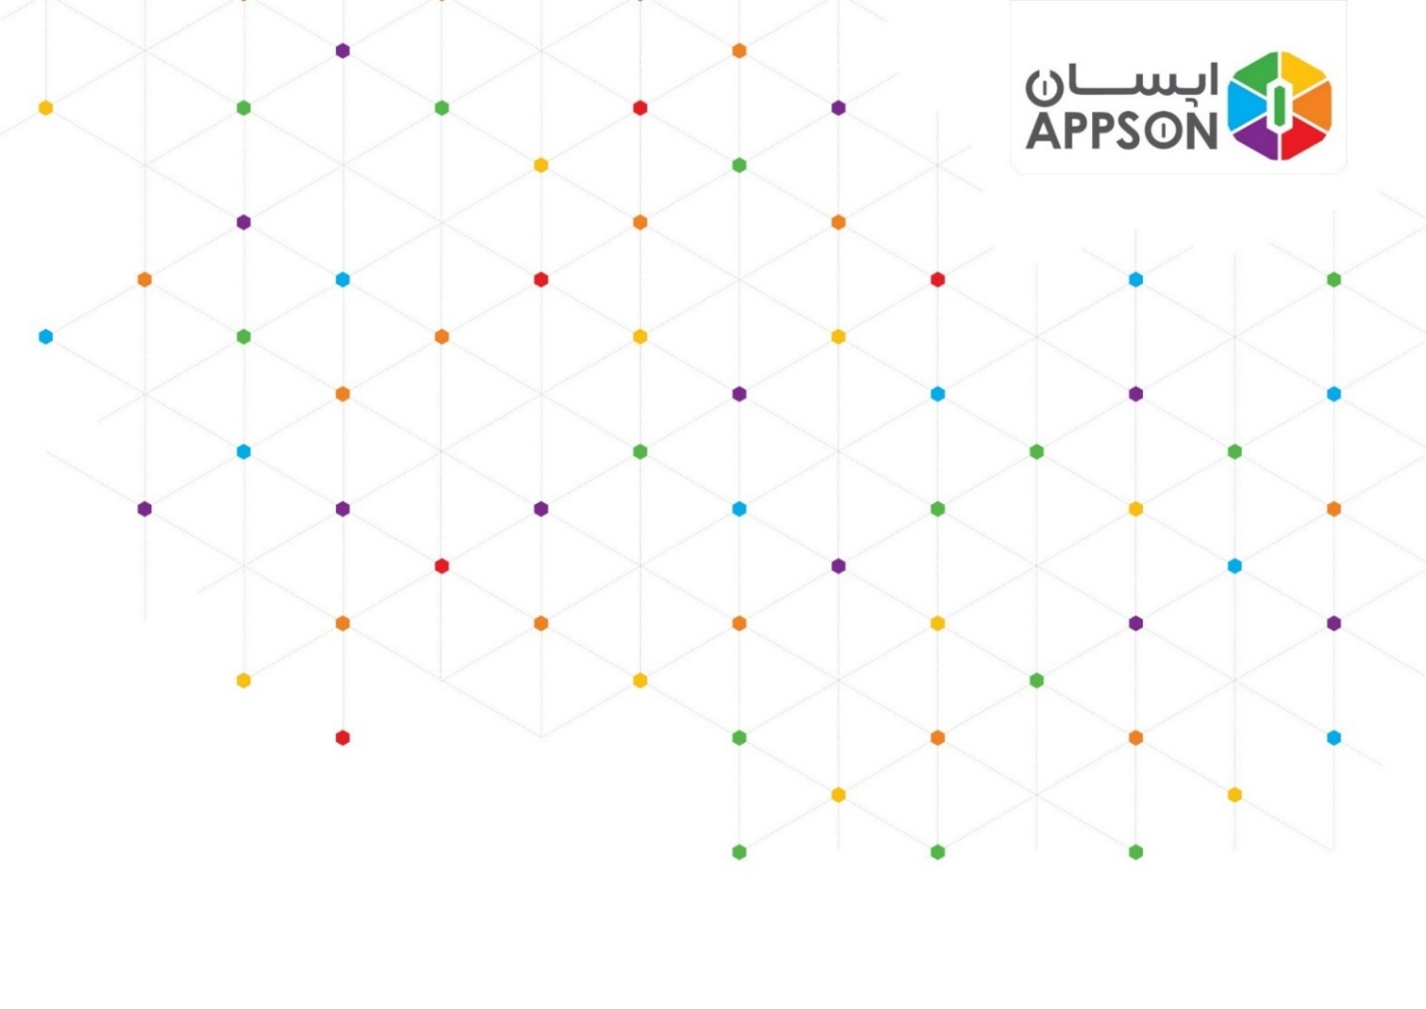

**Creating a Product in PIQO Portal**

**Version 1.0.0.0**

**01/03/2018**

**After logging into the portal, select “Products” section from “Developers’” menu. Then click on “Create a new Product”. Fill the fields in the form as follows:**

## **نام**

Define a custom name for your application.

## **شناسه**

This should be a Nickname for your product, starting with “PRD”. It is preferred that this name be in all caps.

## **AppID**

This value should be acquired from the Identity team.

You can click on [this link](https://github.com/appson/integration-public/blob/master/Workflows/AppID.vsdx) to view the process and [this link](https://github.com/appson/identity-public/blob/master/Documents/Submit%20Request%20Guide.pdf) to find out about requirements.

## **توضیحات**

Briefly describe your application.

## **RSA کلید**

Place your public key in this field. You can use “امضای دیجیتال” section available in [this link](https://github.com/appson/payment-public/blob/master/Imi%20Api.pdf) as a guide.

## **آدرس بازگشتی**

You can leave this field blank.