*Task desciption:*

In the hydrological cycle of the Earth, various areas affect the weather as well as areas are also affected by various weathers. Areas involved in the simulation: plain, grassland, lakes region. Each area has a name, and the amount of water stored in the certain area is also given in km3. The humidity of the air over the areas is also given in percentage. The possible types of weather are the following: sunny, cloudy, rainy, depending on the humidity of the air. In case the humidity exceeds 70%, the weather gets rainy and the humidity decreases to 30%. In case the humidity is between 40-70%, the calculation of the chance of rainy weather is: (humidity-30)*3,3%, otherwise the weather is cloudy. Humidity below 40% leads to sunny weather.

In the following, we declare how the certain areas respond to the different type of weathers. First the amount of water stored by the area varies then the weather will be affected. There is no type of areas with negative amount of water stored.

In case the type is plain, if the weather is sunny, the amount of water will be decreased by 3 km3; if cloudy, it will be decreased by 1 km3; for rainy weather it will be increased by 20 km3. The humidity of the air is increased by 5%. If the amount of the stored water is greater than 15 km3, the plain area changes into grassland. In case of type grassland: in sunny weather, the amount of water is decreased by 6 km3, for cloudy it will be decreased by 2 km3, but and for rainy, it will be increased by 15 km3. The humidity of the air is increased by 10%. The area becomes lakes region obtaining amount of water over 50 km3, whereas in case the amount of stored water goes below 16 km3, the area changes to plain. In case of type lakes region: in sunny weather, the amount of water is decreased by 10 km3, for cloudy it will be decreased by 3 km3, for rainy it will be increased by 20 km3. The humidity will be increased by 15%. Beyond an amount of water of 51 km3 the area changes into grassland.

The program reads data from a text file. The first line of the file contains a single integer N indicating the number of areas. Each of the following N lines contains the attributes of an area separated by spaces: the owner of the area, the type of the area, and the amount of water stored by the area. In the last line, the humidity of the air is given in percentage. The type is identified by a character: P – plain, G – grassland, L – lakes region.

After 10 simulation rounds, determine the owner of the area which is storing the greatest amount of water. The amount of water is also required to be determined. The program should print all attributes of the certain areas by simulation rounds!

Analysis:

Independent objects in the task are the areas. They can be devided into 3 different groups: Plain, Grassland, Lake region.

All of them have a name(for the type of areas), the amount of water that they have stored in the area, the humidity, and the owner of the land. It can be examined what happens when they encounter a certain kind of weather. The weather effect the water storage of the land, the humidity and then the humidity in turns have certain effect on the weather, and so on and so forth.

Plain:

|  |  |  |
| --- | --- | --- |
| weather | Water storage(in km3) | Humidity(in percentage) |
| sunny | -3 | +5 |
| cloudy | -1 | +5 |
| rainy | +20 | +5 |

Grassland:

|  |  |  |
| --- | --- | --- |
| weather | Water storage(in km3) | Humidity(in percentage) |
| sunny | -6 | +10 |
| cloudy | -2 | +10 |
| rainy | +15 | +10 |

Lake region:

|  |  |  |
| --- | --- | --- |
| weather | Water storage(in km3) | Humidity(in percentage) |
| sunny | -10 | +15 |
| cloudy | -3 | +15 |
| rainy | +20 | +15 |

Plan:

To describe the Area, 4 classes are introduced: base class Area to describe the general properties and 3 children for the concrete species: Plain, Grassland and Lake region. Regardless the type of the areas, they have several common properties, like the type of the area(_name), the type of weather(weathertype) the water storage(water), the humidity over the area(humidity), and the name of the owner of the area. The getter of the water storage, the setter of the water storage, the getter and setter of the owner, the getter and setter for the humidity, the operation waterchange() modifies the water storage, the humidity, and the weather of the area, the operation change() examine the multiple properties of the area and see weather the type of area has changed or not. Both of these methods have to be abstract as its effect depends on the type pf area and we do not wish to instantiate such class.

General description of the area is done on the base class Area from which concrete areas are inherited: Plain, Grassland and Lake region. Every concrete area had 3 methods that show how each different area changes due to different type of weathers, and also show us how the weather change in turns after the humidity is changed since the only factor that effects the weather is the humidity. Object are referred by pointers.

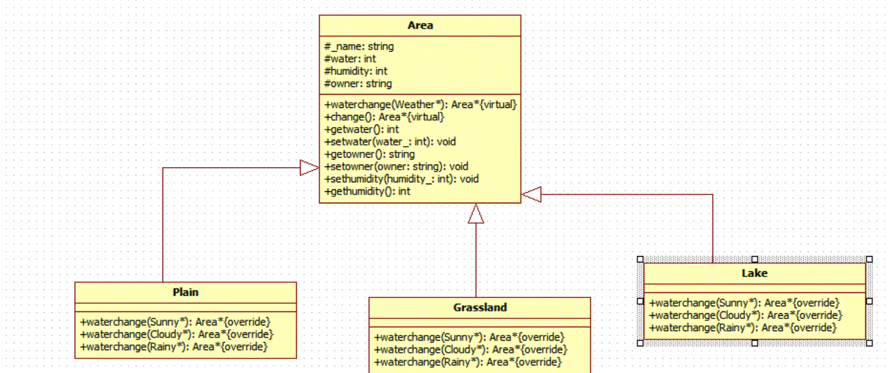

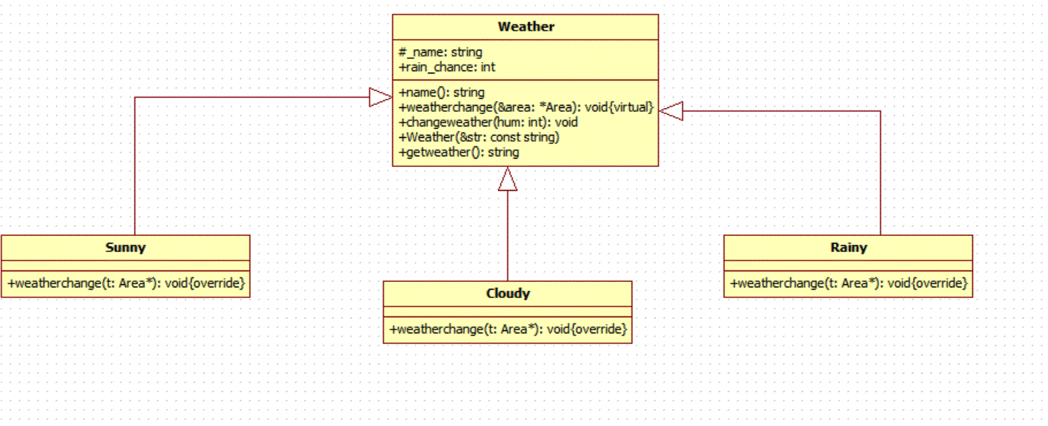

Note: here the function method in the weather class do this: t:=t->waterchange(this)

General idea: In the specification, it is necessary to calculate step by step the changes in the area, humidity and the weather.

Create(const string &str, vector<Area*> &area, Weather* &weather)We first read the file and store the data in an Area type pointer array, each element in the array stands for the area that is owned by an individual owner. And then we store the humidity into a Weather type pointer (at the same time passing by reference) and according to the percentage of the humidity, we set the type of the initial weather.

Int main():

In the main funtion, we first read in the data in the file using create function to get the initial states of each individual areas, and then we start the stimulation by creating a for loop. Within the for loop, we first see what kind of weather we are dealing with, and then, after we get the information of the weather, we create another inter loop in the if statement to iterate through the Area array and change individually the data of each area, and at the end of the inner for loop, we call the change() function to see whether the type of area has changed or not, and change the data of the area accordingly.

And then by the end of the outer loop, we do a maxim selection within the array and print out the result.

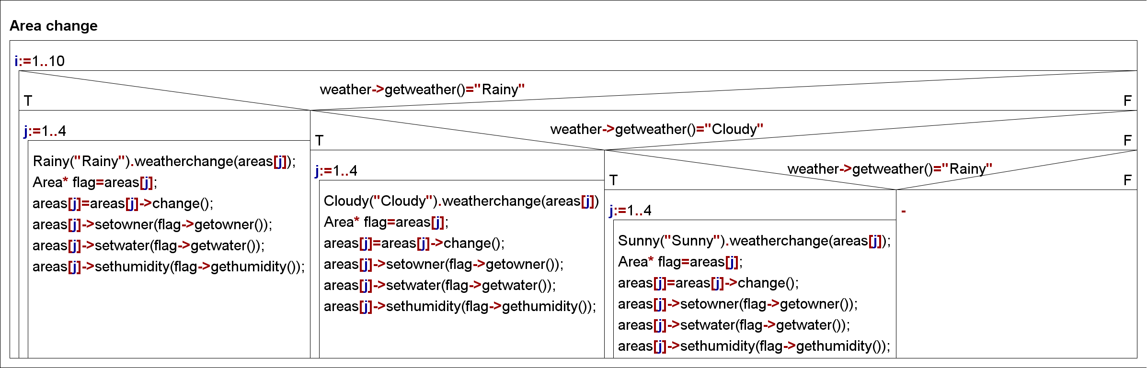

And then after this we do a maximum selection among the element in the array.

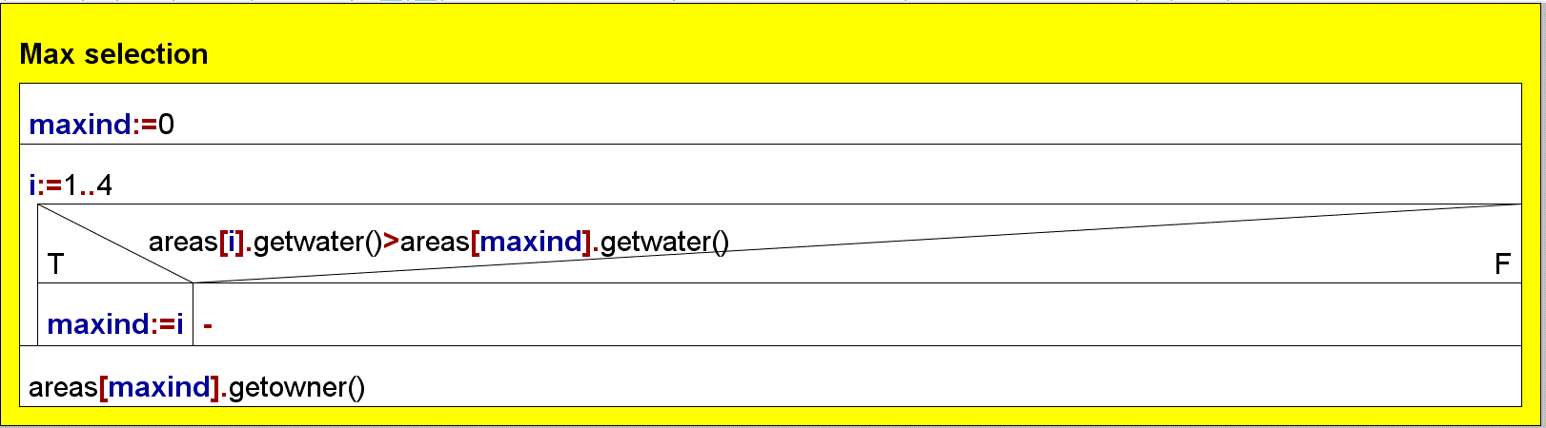

Testing:

Test_case 1:

Here we have the edge test for the case where there is only one owner, and the result after the maximum selection should be just the name of the only owner in the file.

Test_case 2:

Here we have the test for multiple lands and owners and we have only one round of stimulation. The result should be of course the owner of the land with the highest water storage after just one stimulation.

Test_case 3:

Here we have the test case for multiple lands and owners and we have zero stimulation and the result should be of course the owner in the file with the highest water storage.