MATLABRealsense

Alexandre Silva @AVL

What is it?

* MATLAB app
* sets parameters on SR300 cameras
* saves parameters as mat files
* loads parameters back into the cameras
* automatic color checker detection and image color calibration
* roughly 3200 lines of code
* TEAM work

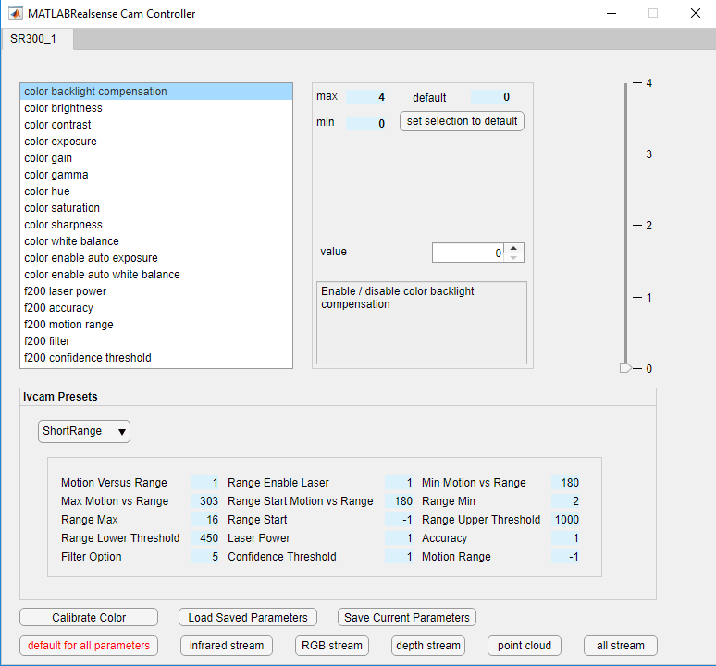User Interface

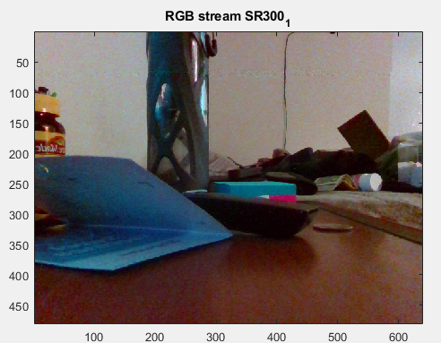Available Streams

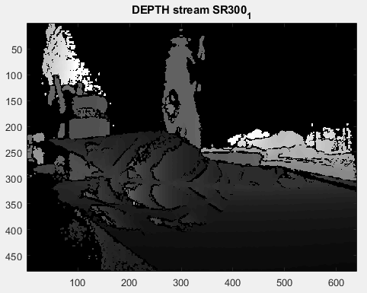

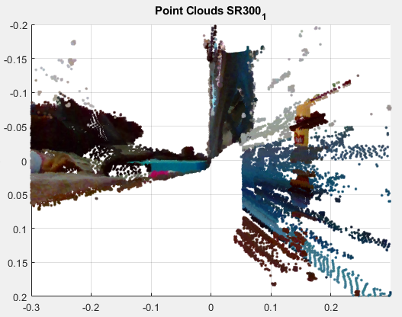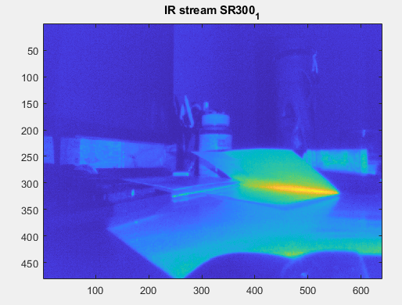

Turning on the camera and building the UI

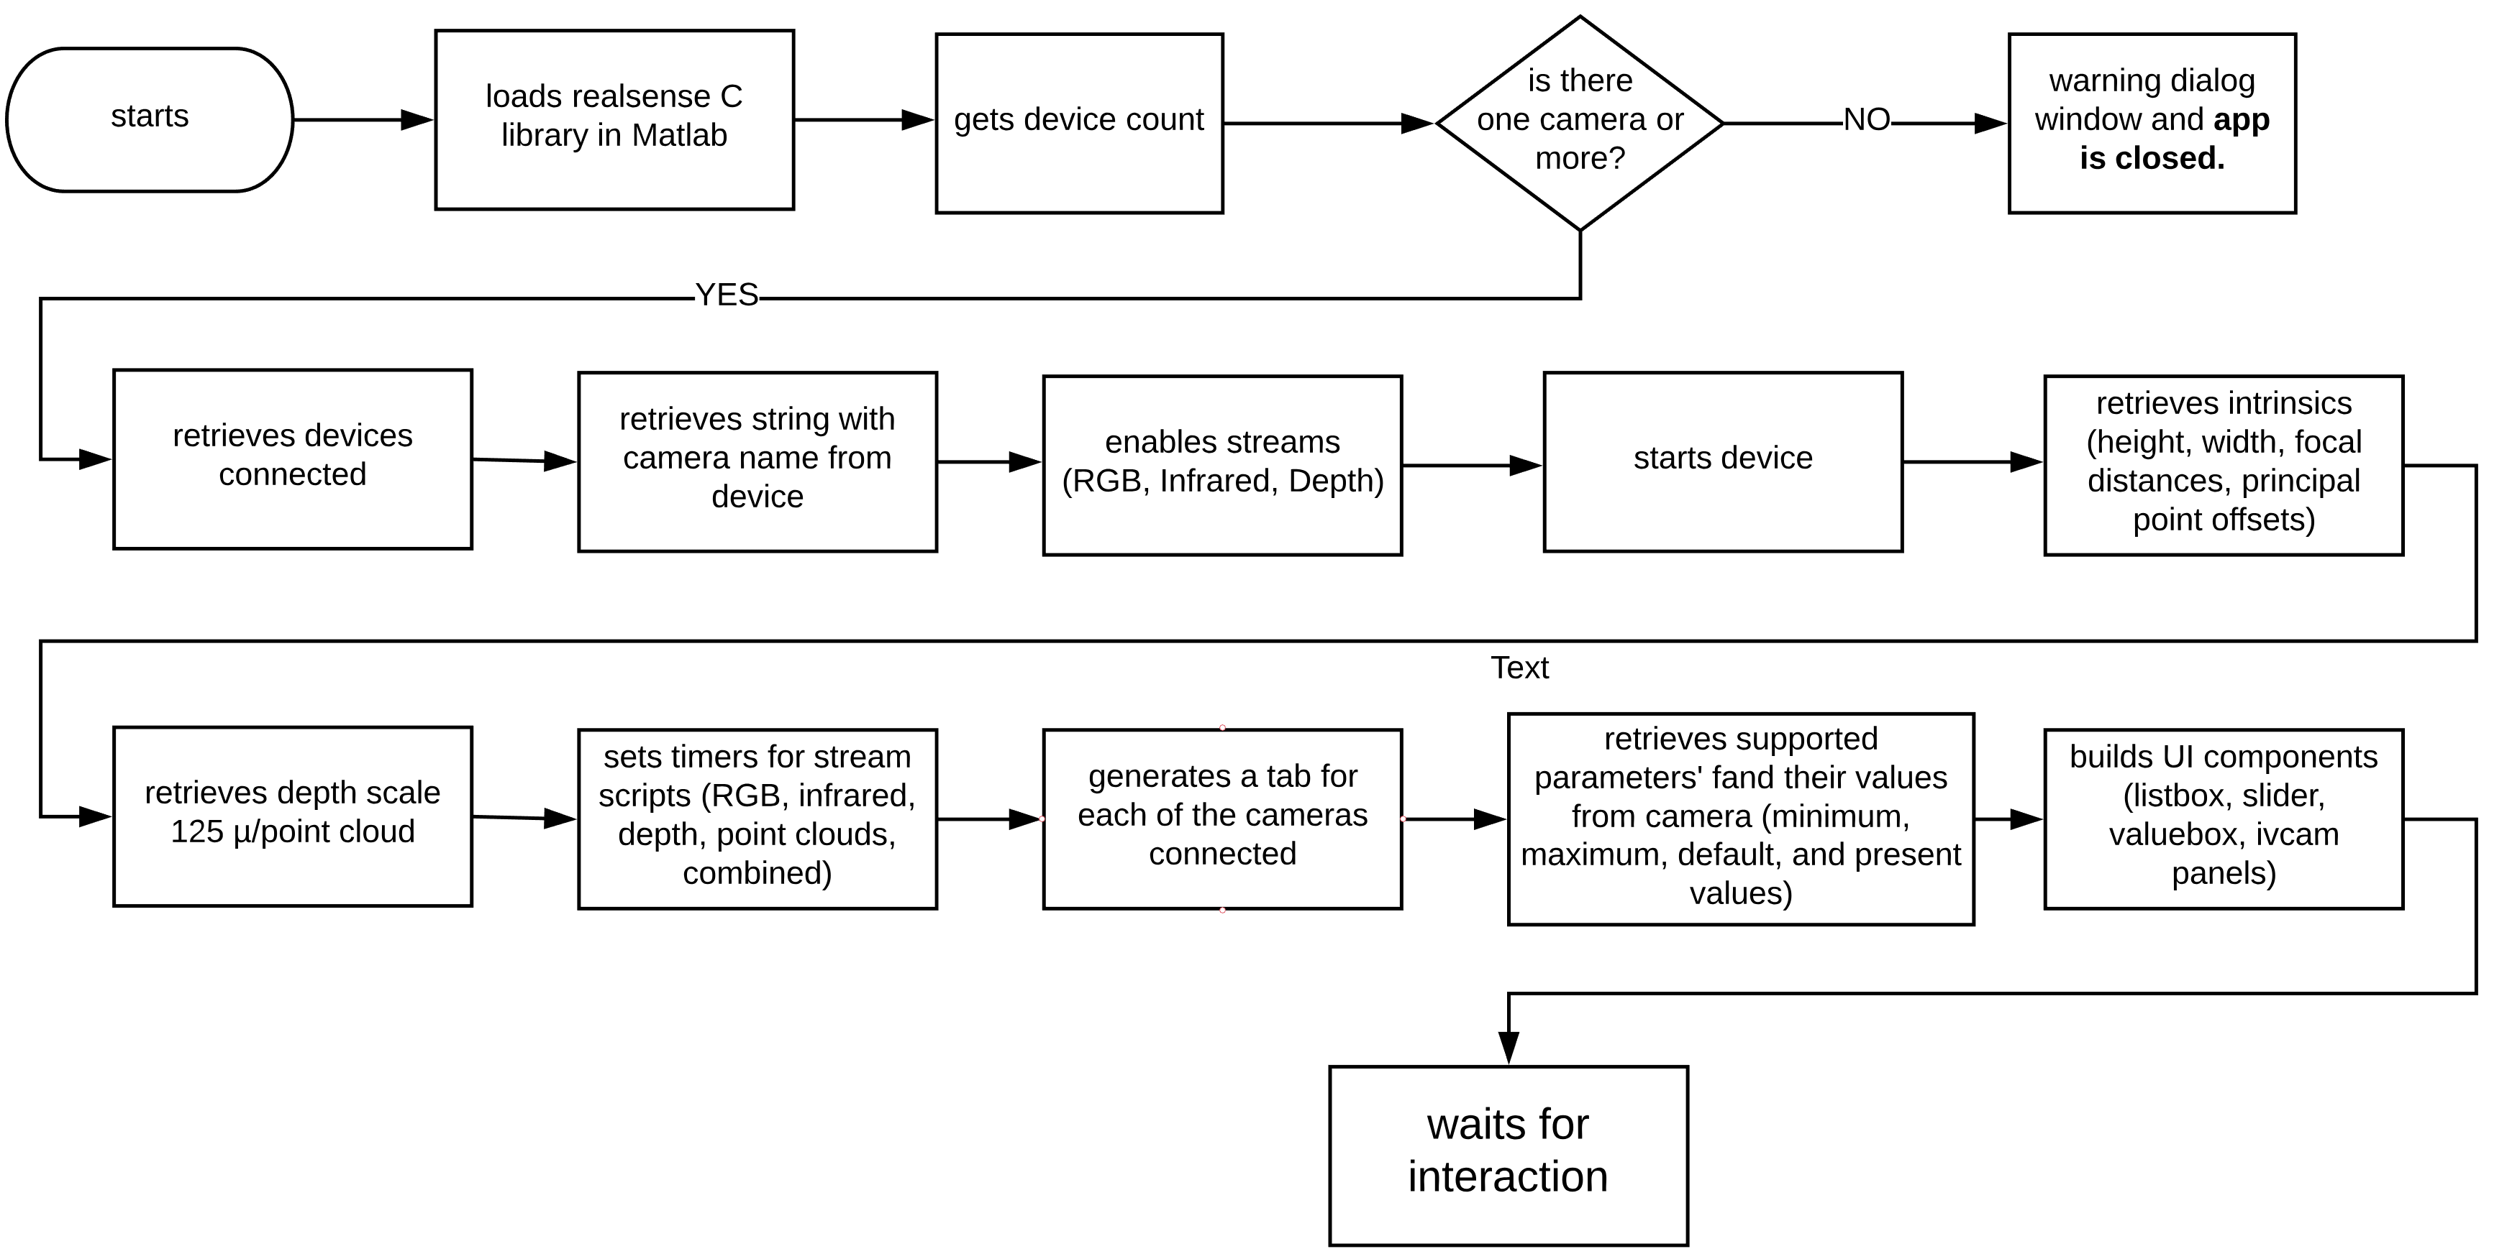

Running a timed stream script (RGB stream example)

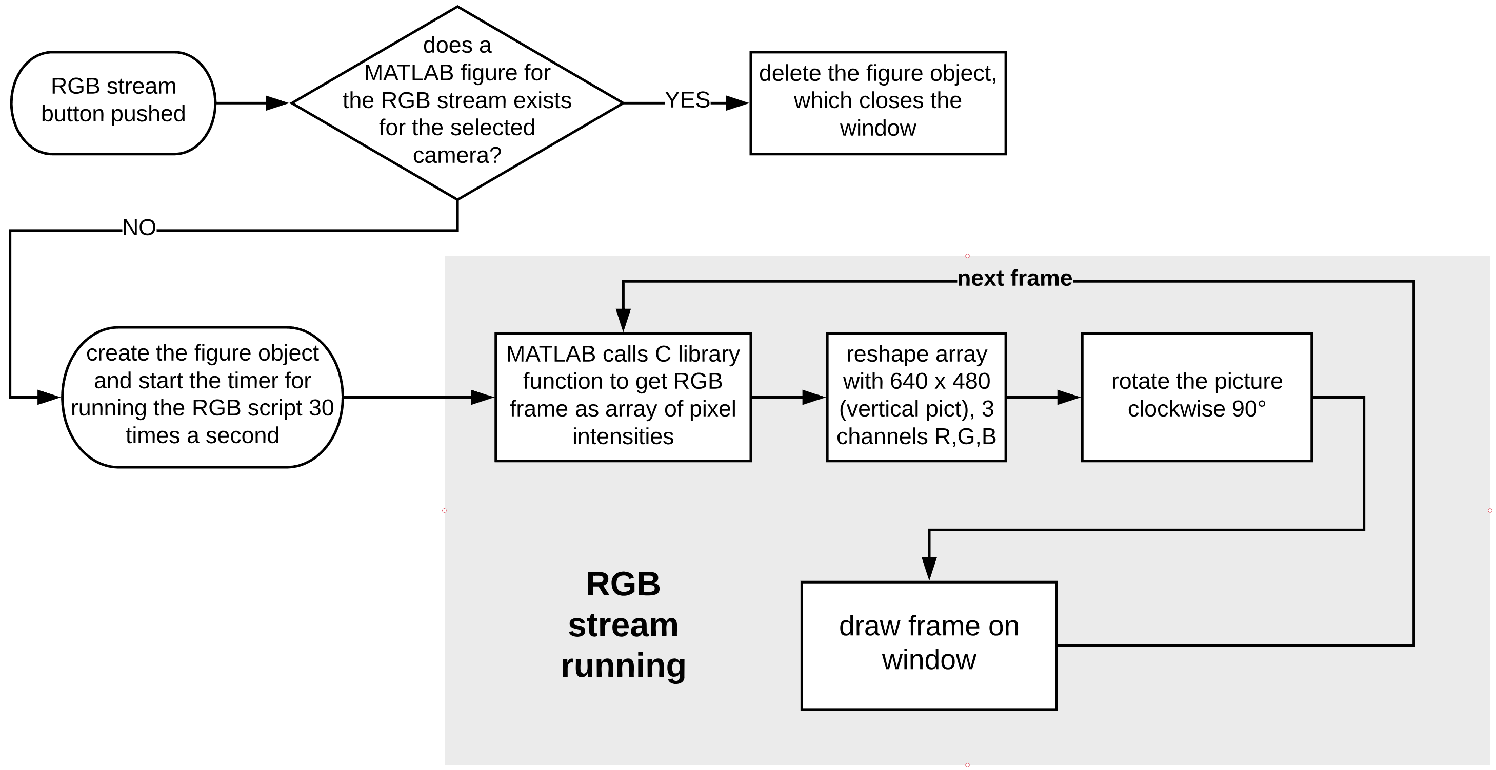

Auto Color Calibration

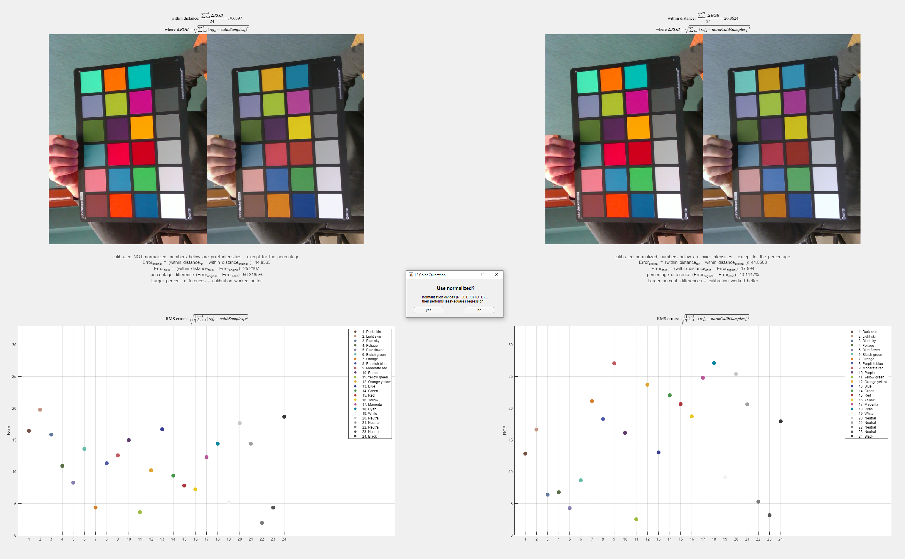

Auto Color Calibration

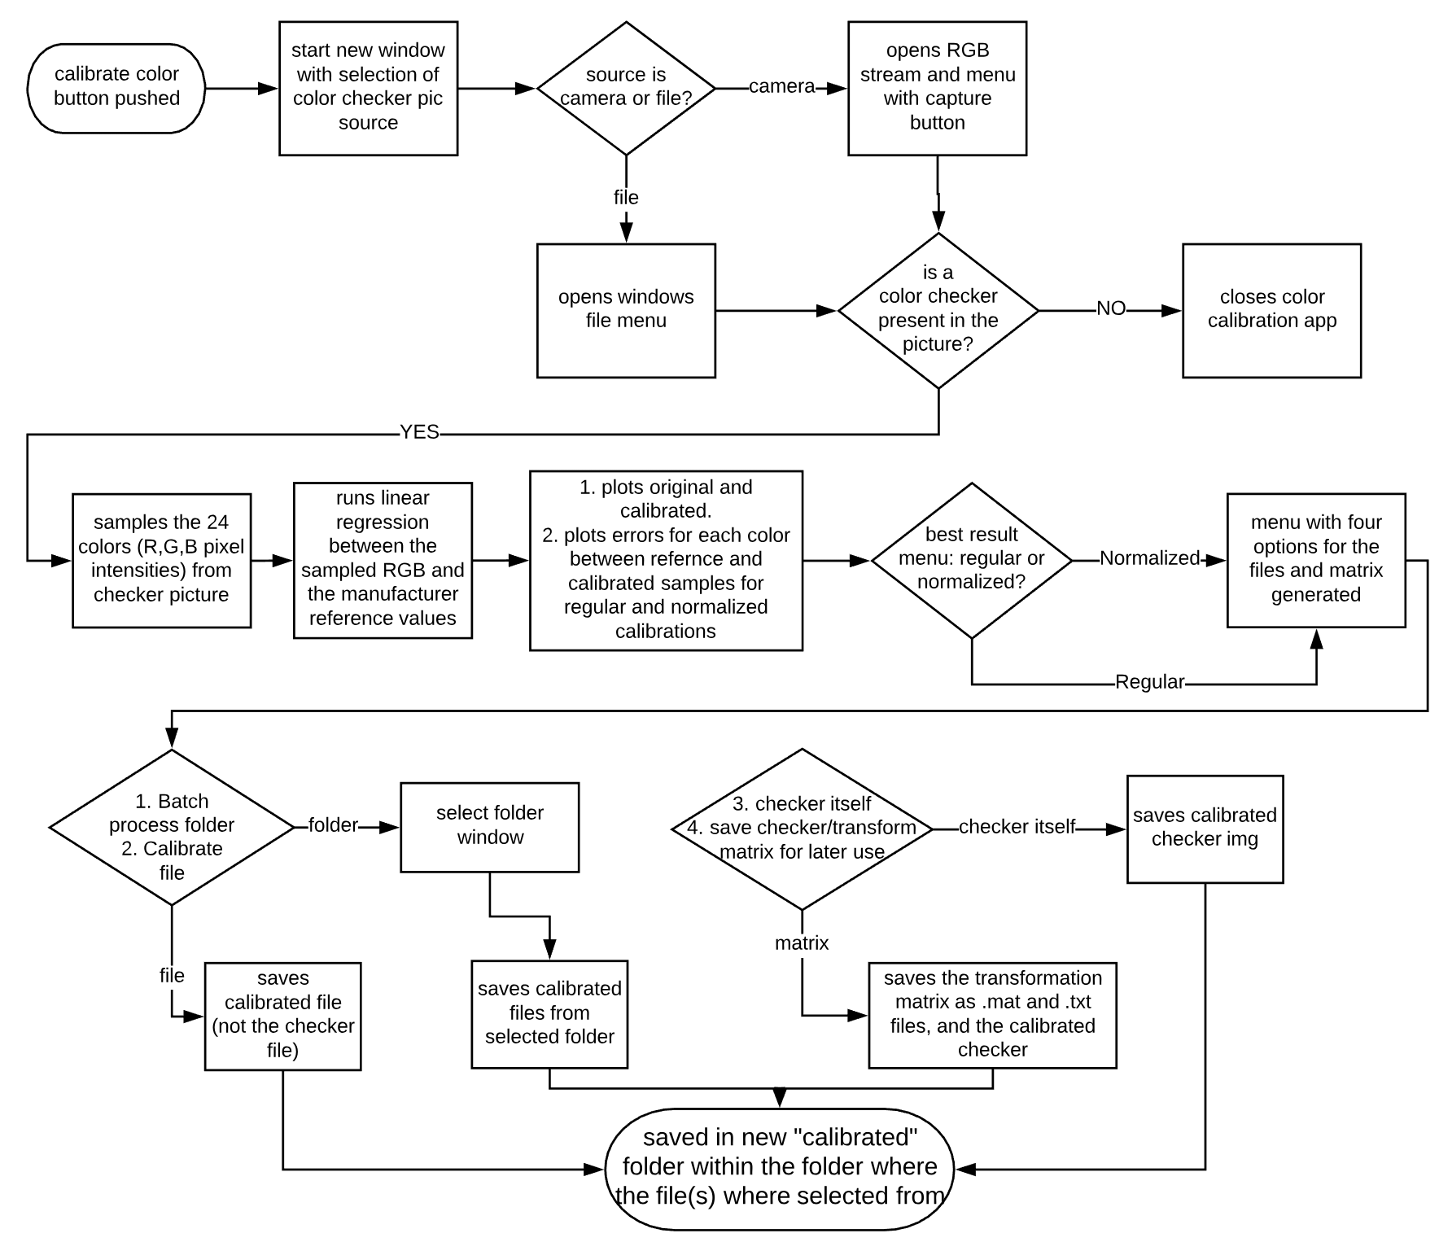

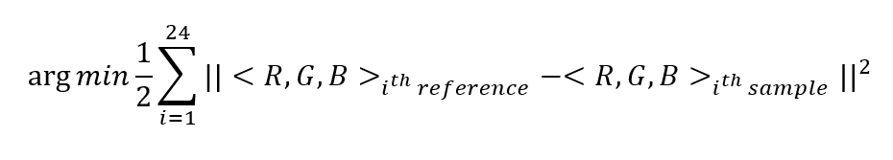Linear Least Squares Regression

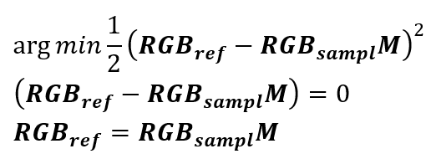

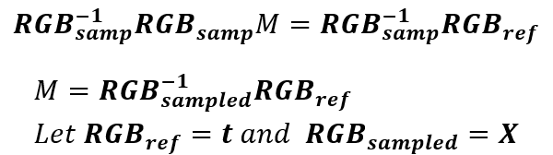

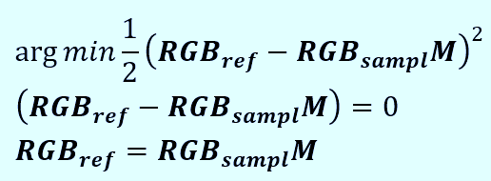

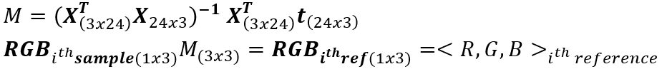



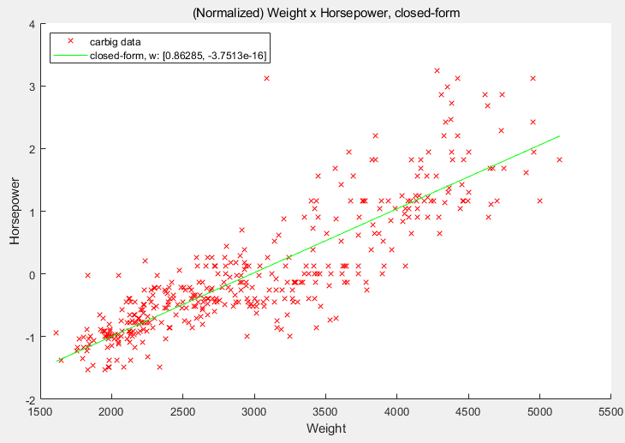Linear Least Squares Regression

