1. 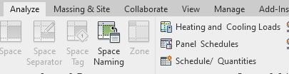Analyze Tab -> Schedule/Quantities
2. 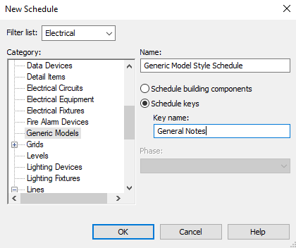Select discipline filter and under “Category” select “General Models” Select radial button “Schedule keys” and enter Schedule Name
3. Make sure the “fields” say “Key Name” and “Comments”

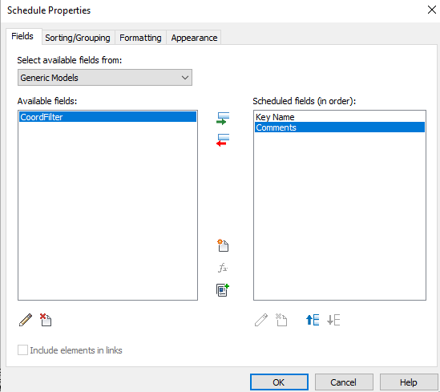

1. 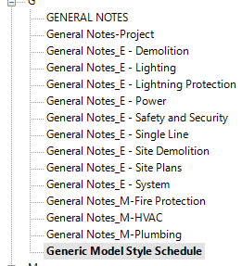Open the “Project Browser” and open the schedule. Make sure you give it a unique name.
2. 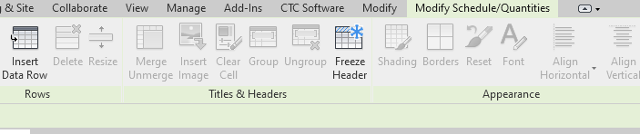Under “Modify Schedule/Quantities” select “Insert Data Row”