**Project deployment**

SSMS needs to be installed for the project

For the correct operation of the project, you must perform the following steps:

**1**.Run cmd and type: **dotnet tool install –global dotnet-ef version 3.1.26**

**2**.Go to the API derictory, run cmd and enter:

**dotnet ef database update**

**dotnet run**

do not disable cmd.

**3**.Run the sql script in the project folder. When the connection window appears, copy the server name

Click connect, then run the script

(If the script fails to run, then please fill in the Genres table yourself)

**4**. Open the appsettings.json file in the API directory. In the DefaultConnection field, **paste the copied value before “Database=”**

**5**.Open the movies directory, run cmd and enter:

**npm install**

**npm start**

do not disable cmd.

**Site functionality**

The start page displays a list of movies from the database.

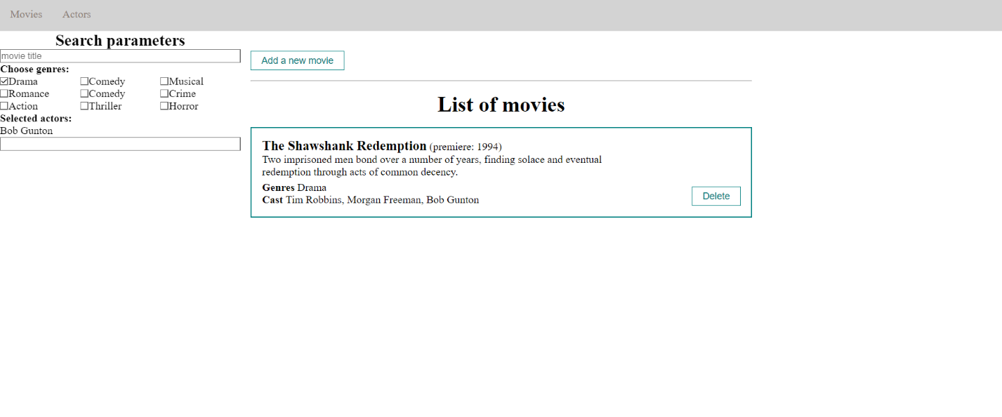

It is possible to add new movies and filter by title, genre and actors. You can also delete any movie

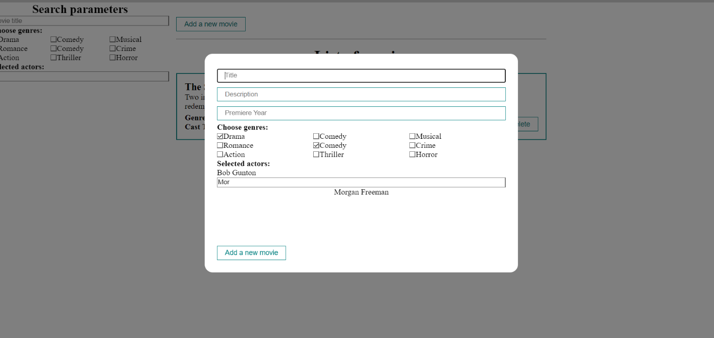

The second page shows all the actors that are in the database.

A list is formed from the received data.

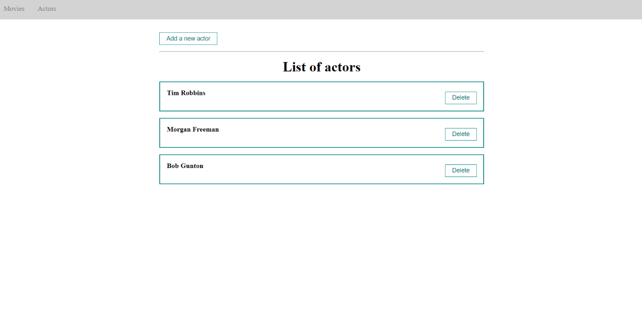

It is possible to add new actors or remove current ones.

