**CMPT 412**

**Project 2**

**Deep learning by PyTorch**

Instructor : Yasutaka Furukawa

Name: Kaikun Fang

Student ID: 301416542

**Note: Use 1 free late-day**

**Note: Use 1 free late-day**

**Part 1: Improving BaseNet on CIFAR100**

**1. Kaggle Group Name:** 🍺

**Members:** Cheng Hu (301435966), Kaikun Fang (301416542)

**2. Best accuracy:**

The highest score of our group on Kaggle is 0.747

**3. Layer Structure Table:**

|  |  |  |  |  |
| --- | --- | --- | --- | --- |
| **Layer No.** | **Layer Type** | **Kernel size**  **(for conv layer)** | **Input | Output**  **dimension** | **Input | Output**  **Channels**  **(for conv layers)** |
| 1 | Conv2d | 5 | 32 | 32 | 3 | 64 |
| 2 | BatchNorm2d |  | 32 | 32 |  |
| 3 | ReLU |  | 32 | 32 |  |
| 4 | Conv2d | 5 | 32 | 32 | 64 | 64 |
| 5 | BatchNorm2d |  | 32 | 32 |  |
| 6 | ReLU |  | 32 | 32 |  |
| 7 | Conv2d | 5 | 32 | 32 | 64 | 64 |
| 8 | BatchNorm2d |  | 32 | 32 |  |
| 9 | ReLU |  | 32 | 32 |  |
| 10 | MaxPool2d | 2 | 32 | 16 |  |
| 11 | Conv2d | 5 | 16 | 16 | 64 | 128 |
| 12 | BatchNorm2d |  | 16 | 16 |  |
| 13 | ReLU |  | 16 | 16 |  |
| 14 | Conv2d | 5 | 16 | 16 | 128 | 128 |
| 15 | BatchNorm2d |  | 16 | 16 |  |
| 16 | ReLU |  | 16 | 16 |  |
| 17 | Conv2d | 5 | 16 | 16 | 128 | 128 |
| 18 | BatchNorm2d |  | 16 | 16 |  |
| 19 | ReLU |  | 16 | 16 |  |
| 20 | Conv2d | 5 | 16 | 16 | 128 | 256 |
| 21 | BatchNorm2d |  | 16 | 16 |  |
| 22 | ReLU |  | 16 | 16 |  |
| 23 | Conv2d | 5 | 16 | 16 | 256 | 256 |
| 24 | BatchNorm2d |  | 16 | 16 |  |
| 25 | ReLU |  | 16 | 16 |  |
| 26 | Conv2d | 5 | 16 | 16 | 256 | 256 |
| 27 | BatchNorm2d |  | 16 | 16 |  |
| 28 | ReLU |  | 16 | 16 |  |
| 29 | MaxPool2d | 2 | 16 | 8 |  |
| 30 | Conv2d | 5 | 8 | 8 | 256 | 512 |
| 31 | BatchNorm2d |  | 8 | 8 |  |
| 32 | ReLU |  | 8 | 8 |  |
| 33 | Conv2d | 5 | 8 | 8 | 512 | 512 |
| 34 | BatchNorm2d |  | 8 | 8 |  |
| 35 | ReLU |  | 8 | 8 |  |
| 36 | Conv2d | 5 | 8 | 8 | 512 | 512 |
| 37 | BatchNorm2d |  | 8 | 8 |  |
| 38 | ReLU |  | 8 | 8 |  |
| 39 | Conv2d | 5 | 8 | 8 | 512 | 512 |
| 40 | BatchNorm2d |  | 8 | 8 |  |
| 41 | ReLU |  | 8 | 8 |  |
| 42 | MaxPool2d | 2 | 8 | 4 |  |
| 43 | Linear |  | 8192 | 2000 |  |
| 44 | BatchNorm1d |  |  |  |
| 45 | ReLU |  | 2000 | 2000 |  |
| 46 | Dropout |  |  |  |
| 47 | Linear |  | 2000 | 2000 |  |
| 48 | BatchNorm1d |  |  |  |
| 49 | ReLU |  | 2000 | 2000 |  |
| 50 | Dropout |  |  |  |
| 51 | Linear |  | 2000 | 100 |  |

I conceived my model structure based on the idea of VGG16 model, mainly every three layers ("Conv2d", "BatchNorm2d" and "ReLU") form a group, and then repeat the stacked groups to form three large groups. The last layer of each big group is "MaxPool2d", and the fc layer is processed after the operation of the three big groups.

**4. plot.png:**

To make it easier to debug the structure and parameters, I set the epoch at 20 at the beginning.

Figure 1 Epochs = 30

After several attempts at the latter, I found that keeping the structure and parameters unchanged, setting the epochs at 80 gives the best efficiency without leading to wasted computational units. val images has an accuracy of around 66% and achieves a score of 0.685 when uploaded to kaggle.

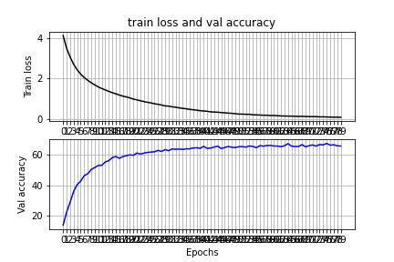

Figure 2 Epochs = 80

**5. Ablation study:**

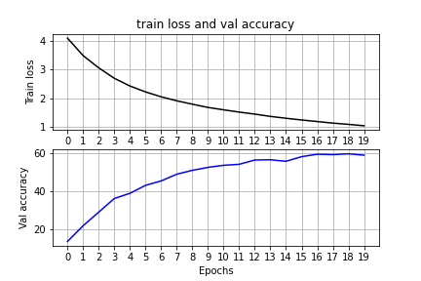I conducted an ablation study on the effect of Data normalization. Because of the limitation of the number of available computational units, I set the epoch at 20 for the experiment. I used the version with Normalize ( transforms.Normalize ( [0.485, 0.456, 0.406], [0.229, 0.224, 0.225] ) ) as the experimental group and the version without Normalize as the control group, while keeping the layer structure and other parameters the same. Running results :

Figure 4 Normalize

Figure 3 No Normalize

From the data in the table, it appears that the difference between the control and experimental groups is not large. However, after uploading the CSV files to kaggle, it can be found that there is a gap between the two in terms of accuracy. The accuracy of the code without Normalize is 0.611, while the accuracy of the code with Normalize is 0.639. increases 2.8%. The difference should be more obvious if we increase the value of epochs.

**Part 2: Transfer Learning**

Base on resnet18. After many attempts, I set hyperparameter to the following values. (batch_size =16, learning_rate =0.0005, num_epochs =50).

**文本

**

* **ResNet as fixed feature extractor** vs. **fine-tuning whole network:**

1. **When ‘**RESNET_LAST_ONLY = **True’:**

**Train Accuracy:** About 65%

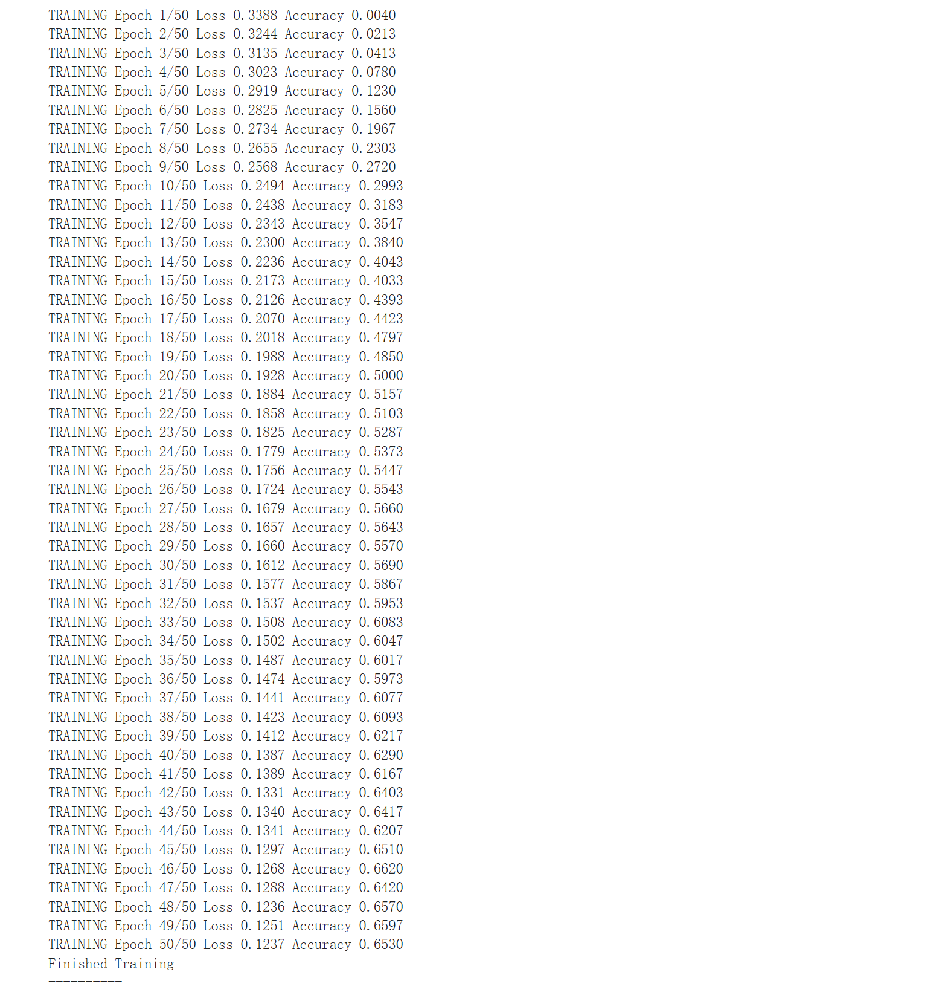

**Test Accuracy:** 43.98%

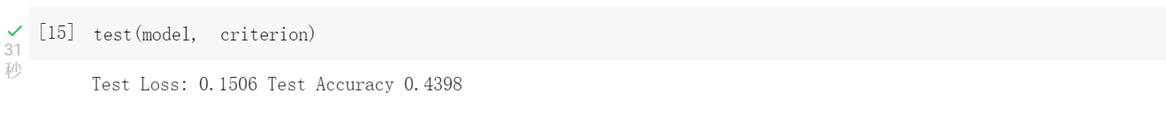

**Visualizing:**

1. **When ‘**RESNET_LAST_ONLY = **False’:**

**Train Accuracy:** Above 86%

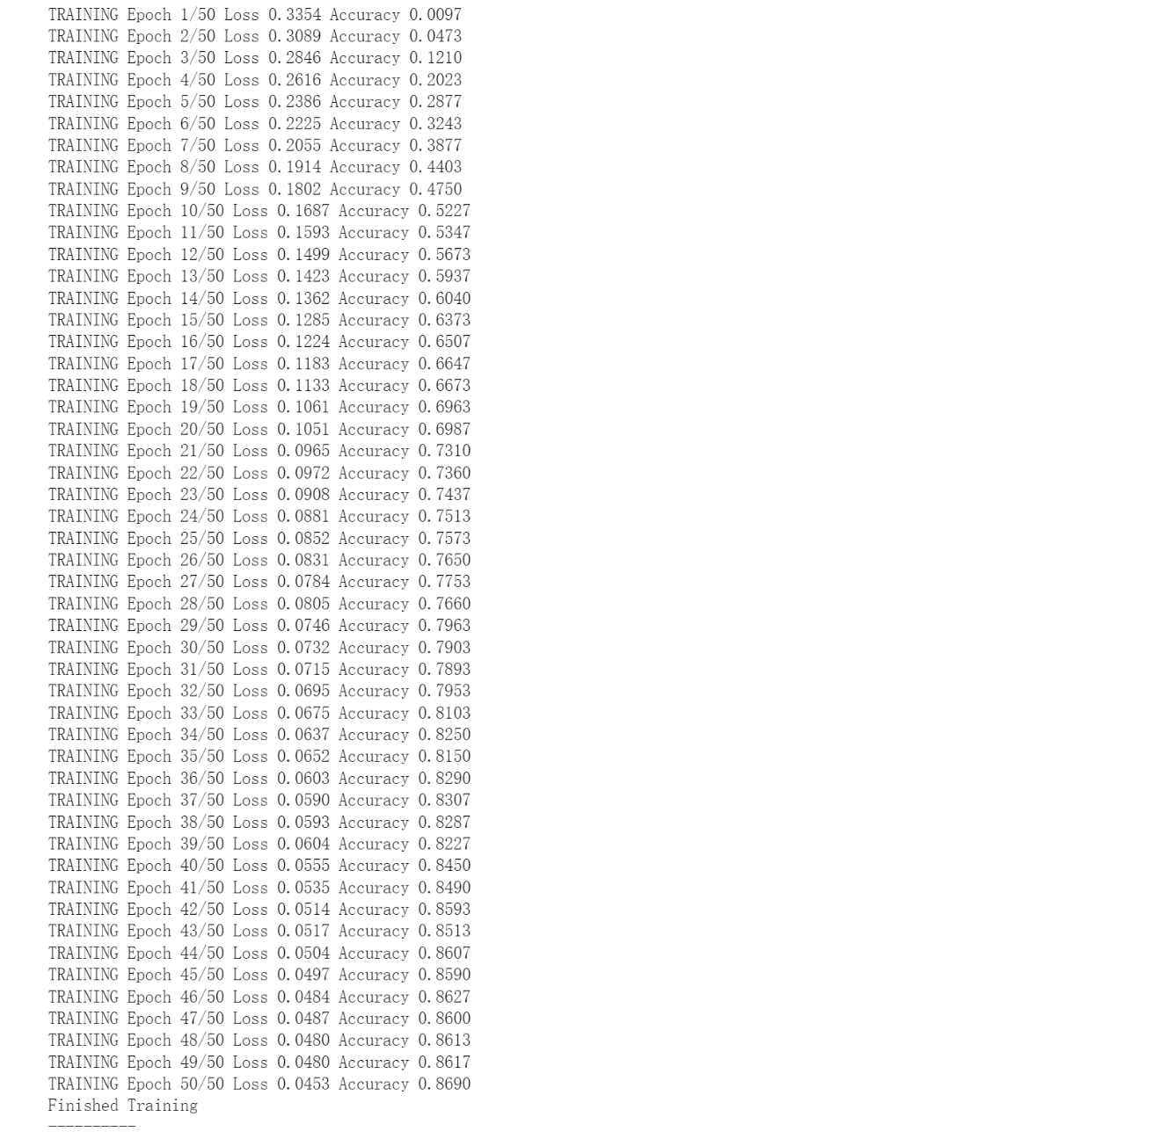

**Test Accuracy:** 59.74%



**Visualizing:**

**Statement:** The code inspiration and principles are derived from the videos and materials provided by the teacher. Discussions were also held with my group member(Cheng Hu 301435966).