**CMPT 412**

**Project 4**

**Augmented Reality with Planar Homographies**

Instructor : Yasutaka Furukawa

Name: Kaikun Fang

Student ID: 301416542

**4.1 Feature Detection, Description, and Matching:**

'MatchThreshold', 10:

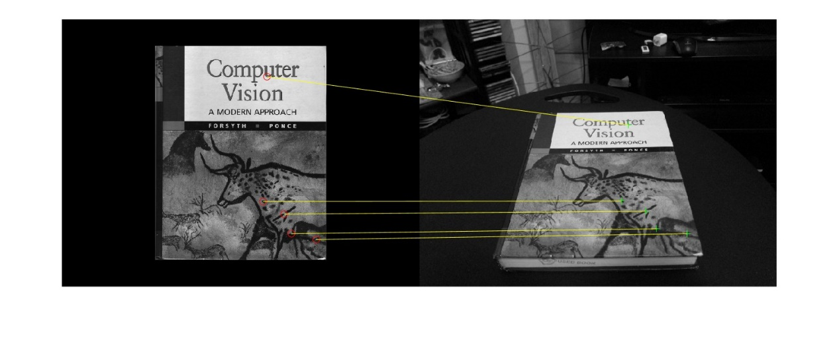

'MatchThreshold', 10,'MaxRatio',0.68:

'MatchThreshold', 10,'MaxRatio',0.69:

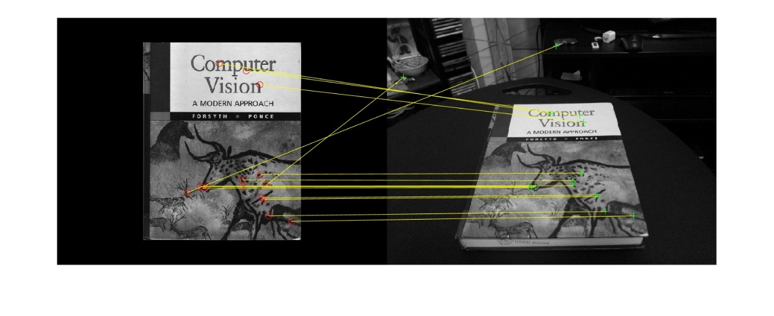

'MatchThreshold', 10,'MaxRatio',0.72

一叠宣传广告

From several tests, we found that there is no matching point when the value of "MaxRatio" is 0.1. When it is 0.5, there is only one matching point. When the value of "MaxRatio" is increased gradually, when it reaches 0.69, there is an offset point. So the best value without offset point is 0.68. With a few offset points, 0.72 is the best value.

**4.2 BRIEF and Rotations:**

Use BRIEF, Rotate 50 degrees:

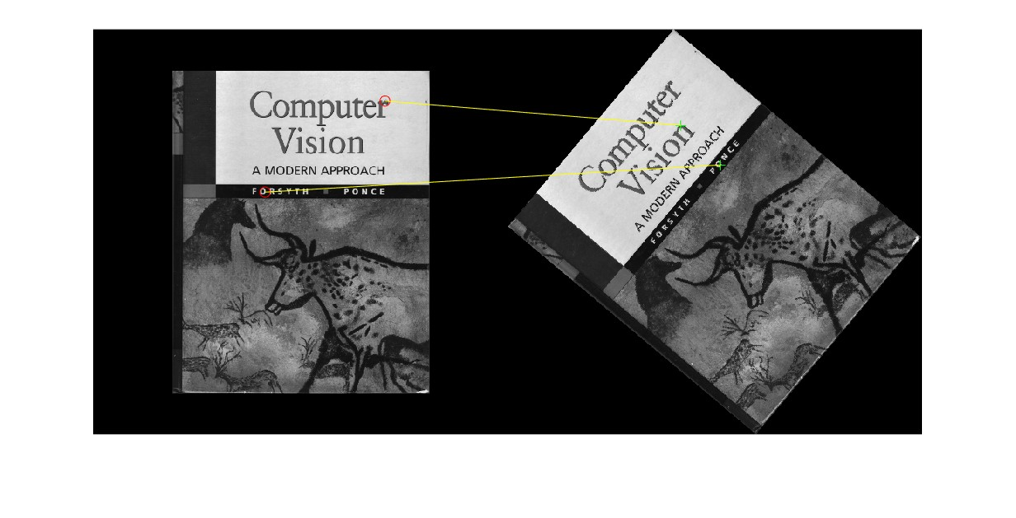

Use BRIEF, Rotate 160 degrees:

Use BRIEF, Rotate 270 degrees:

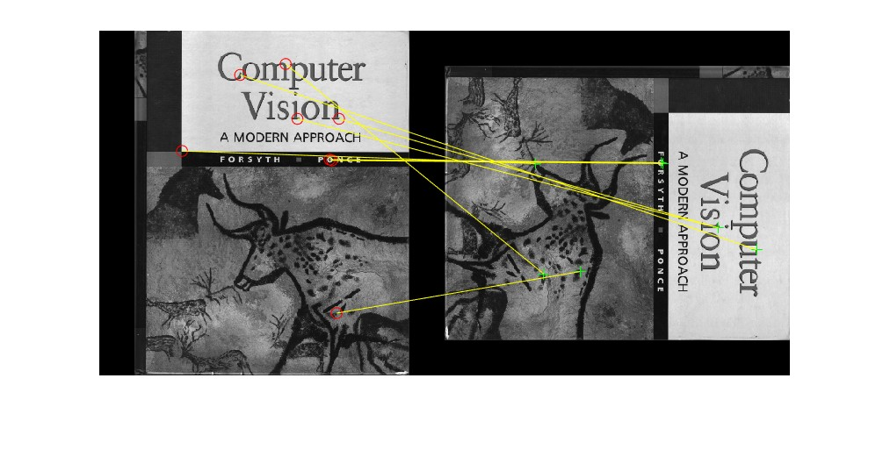

Use SURF, Rotate 50 degrees:

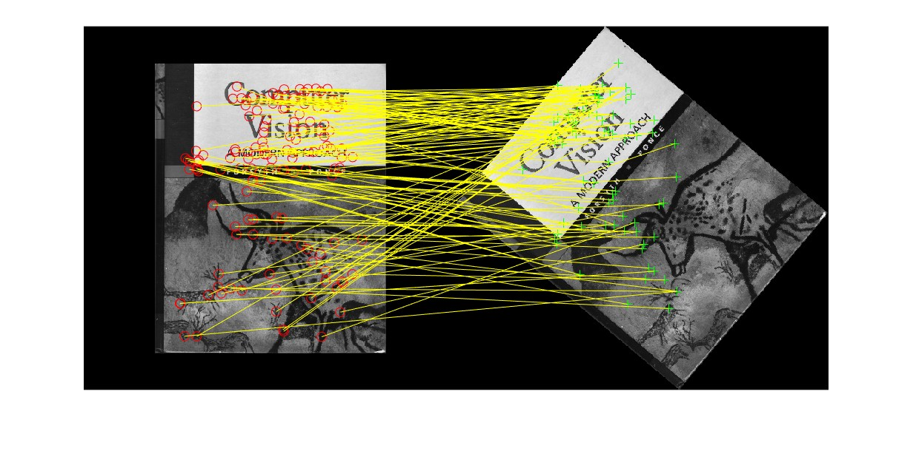

Use SURF, Rotate 160 degrees:

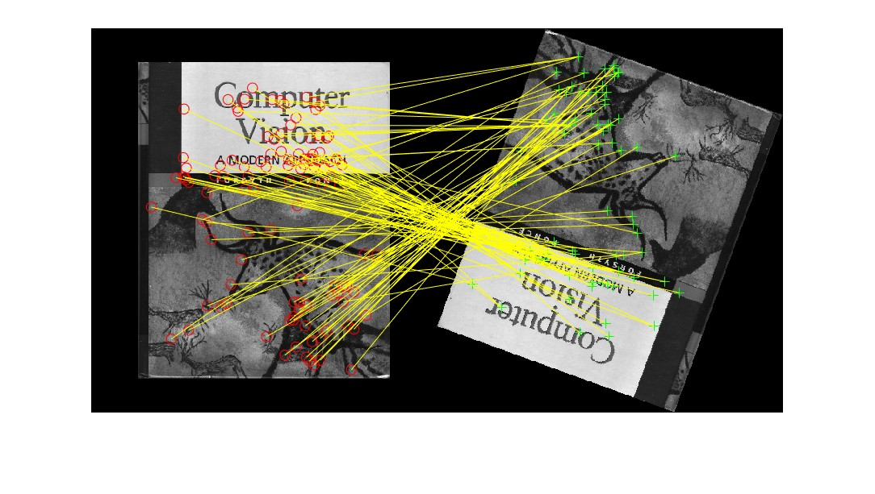

Use SURF, Rotate 270 degrees:

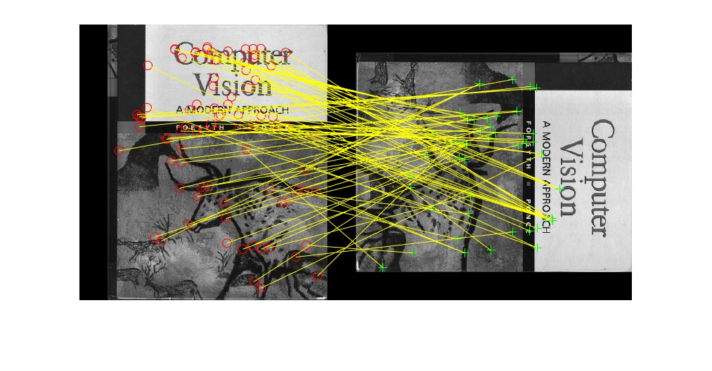

Plot BRIEF: Plot SURF:

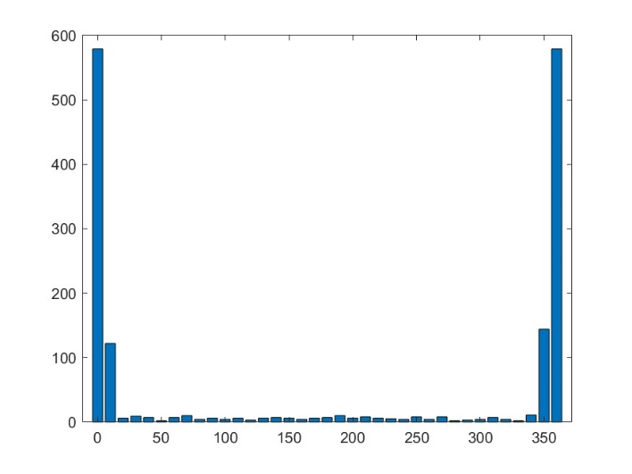

From the plot, we can visually see that more points can be detected by using SURF after rotation, but there are also some points with inaccurate matching positions.

**4.3 Homography Computation:**

10 randomly selected points(Red point):

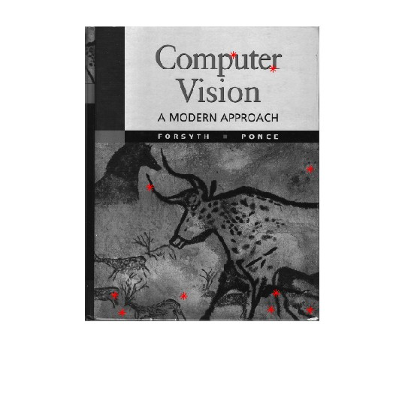

The corresponding locations in the second image:

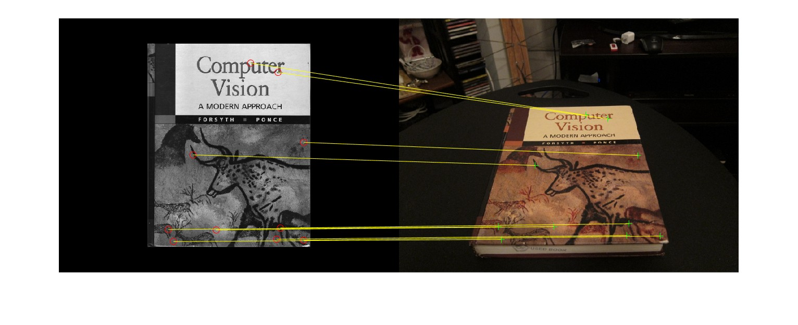

**4.4 Homography Normalization:**

10 randomly selected points(Red points):

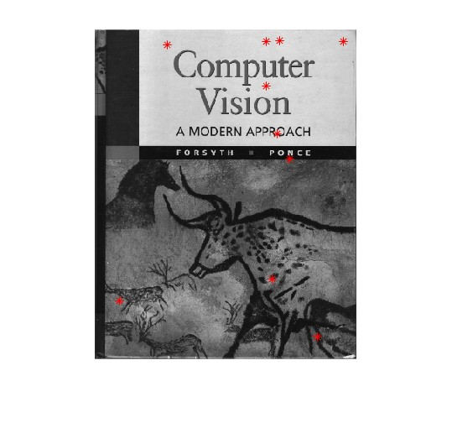

The corresponding locations in the second image:

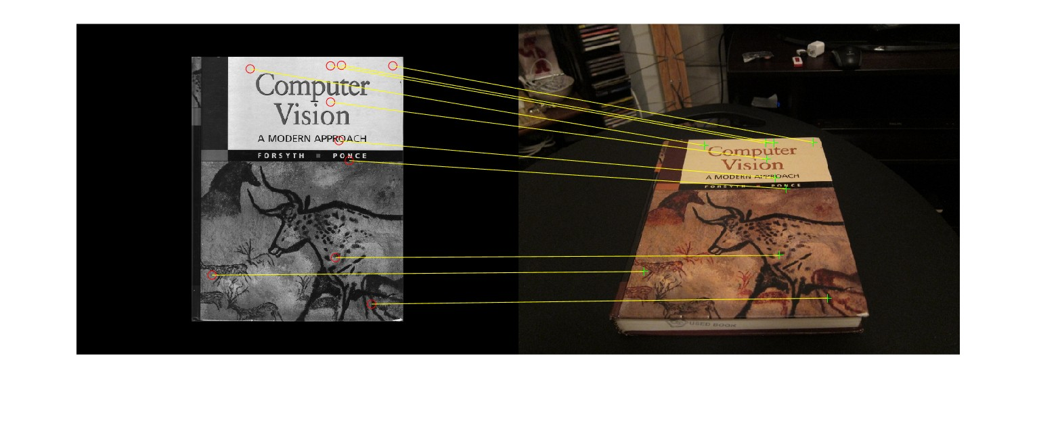

**4.5 RANSAC:**

The 4 point-pairs that produced the most number of inliers(Red points):

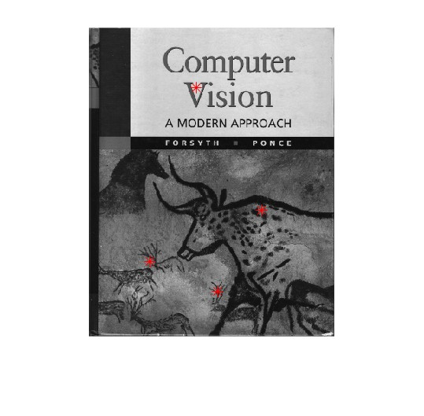

The inlier matches that were selected by RANSAC algorithm:

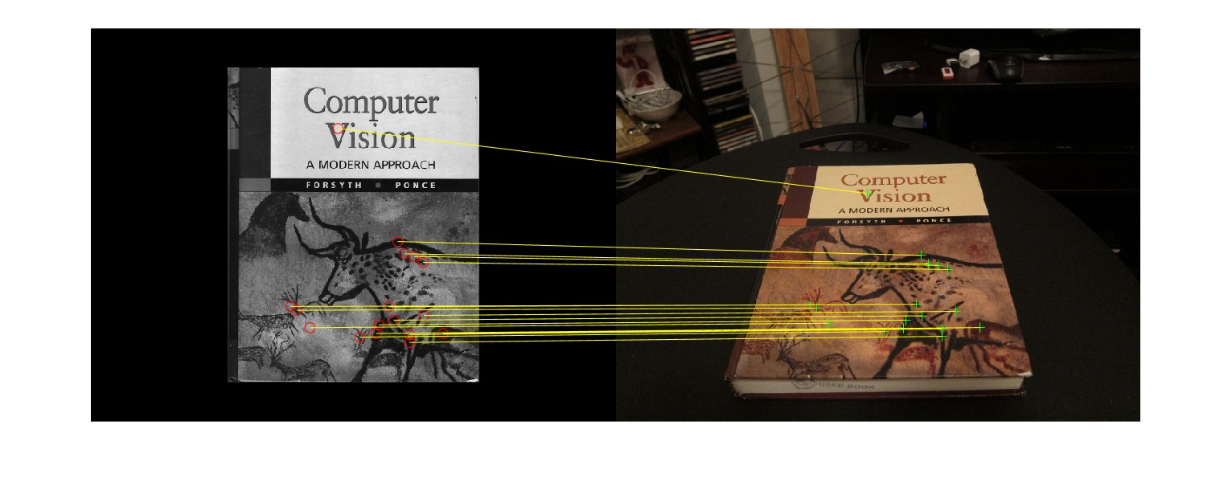

**4.6. HarryPotterizing a Book:**

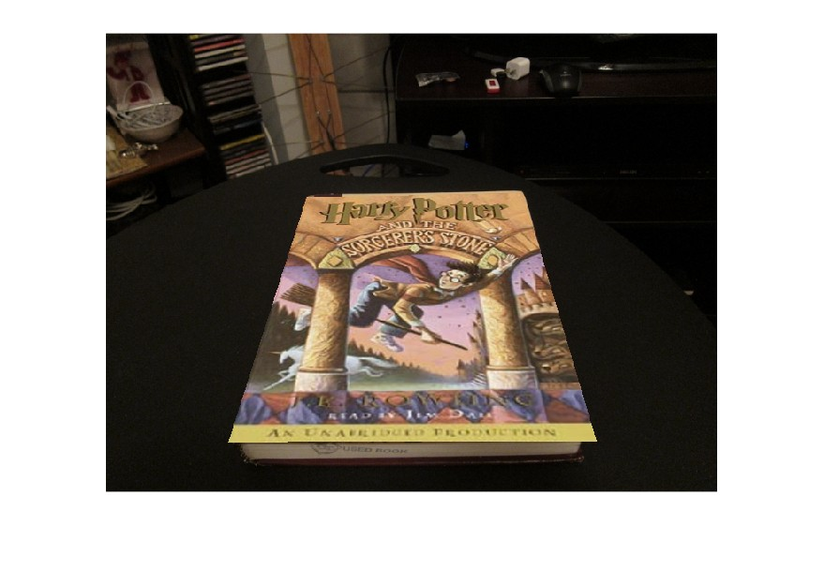

**5. Creating your Augmented Reality application:**

The name of the video is “video.avi”, in the “results” folder. At the very beginning, I used Brief in my matchPics and the generated results were not ideal, there would be many strange images. After changing to use SURF in matchPics, the generated results were much better. This should be because Brief matches too few points for effective calculation.