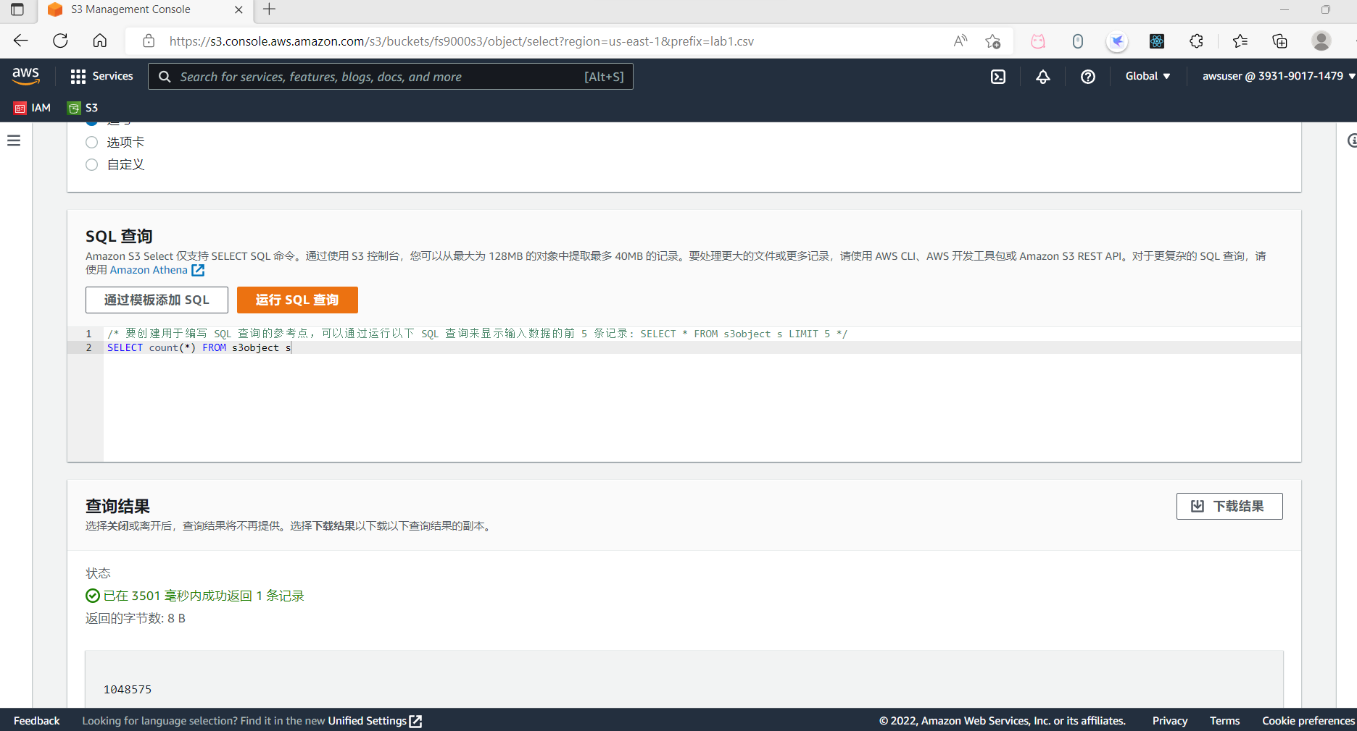

**Lab 1 Step 43 query results**

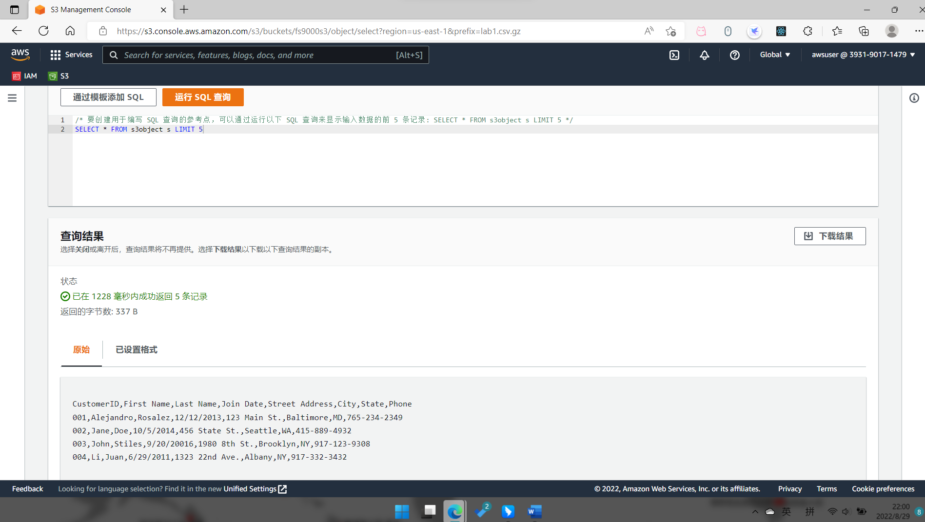

**Lab 1 Step 58 second query results**

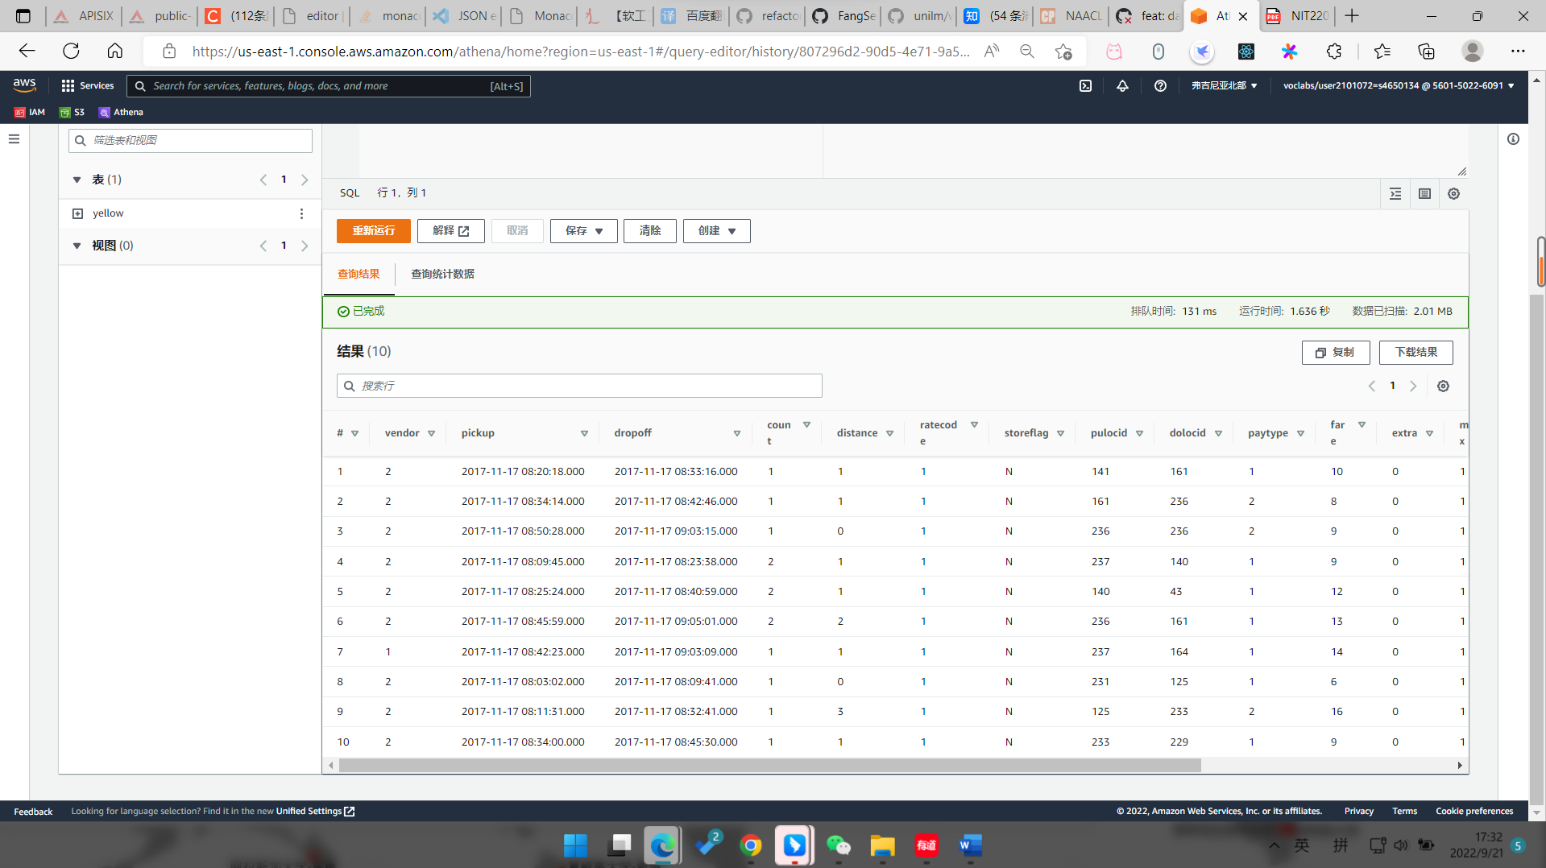

**Lab 2 Step 31 preview table**

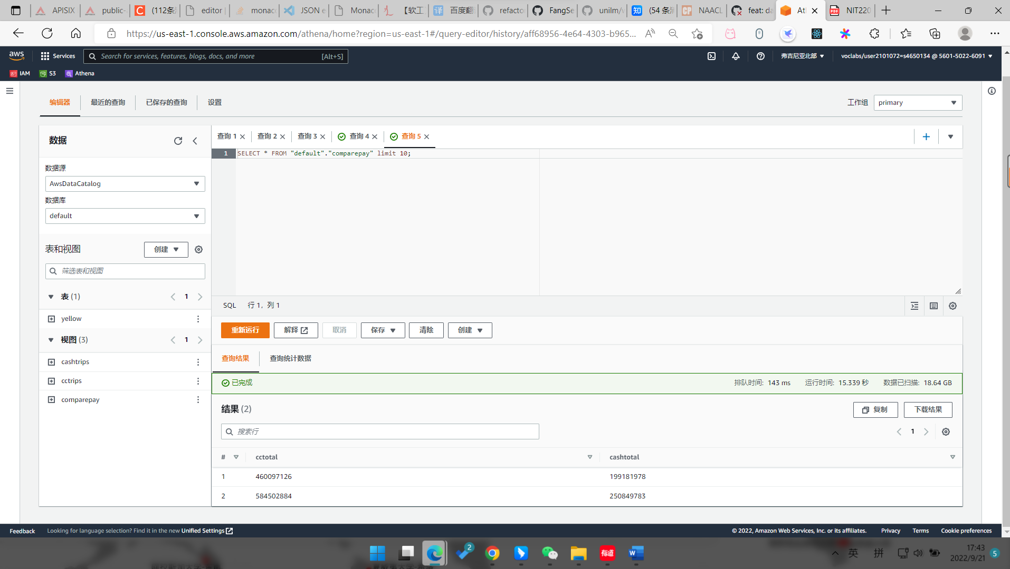

**Lab 2 Step 41 preview cmparepay**

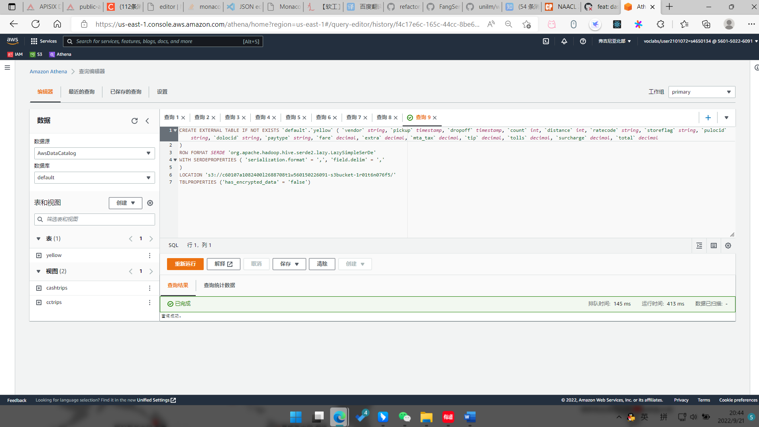

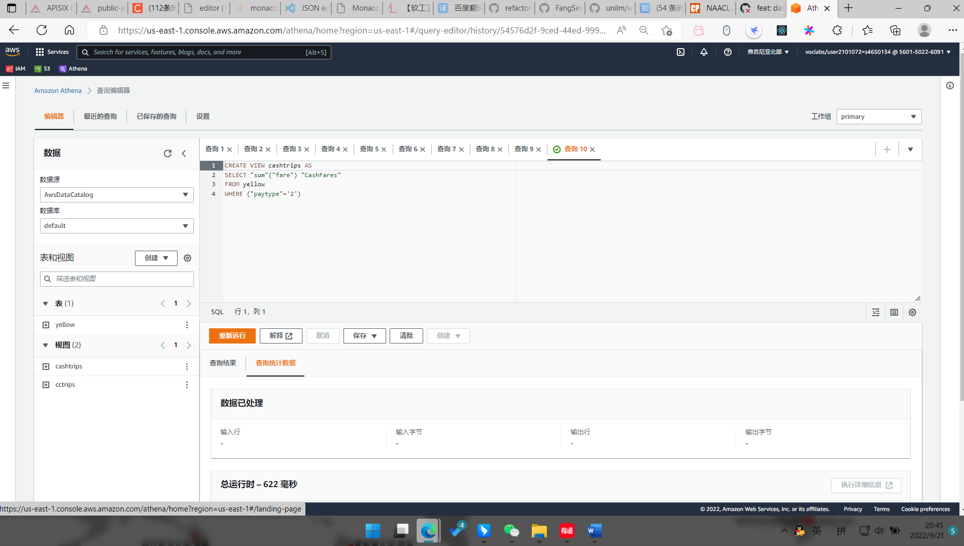

**Lab 2 Challenge**

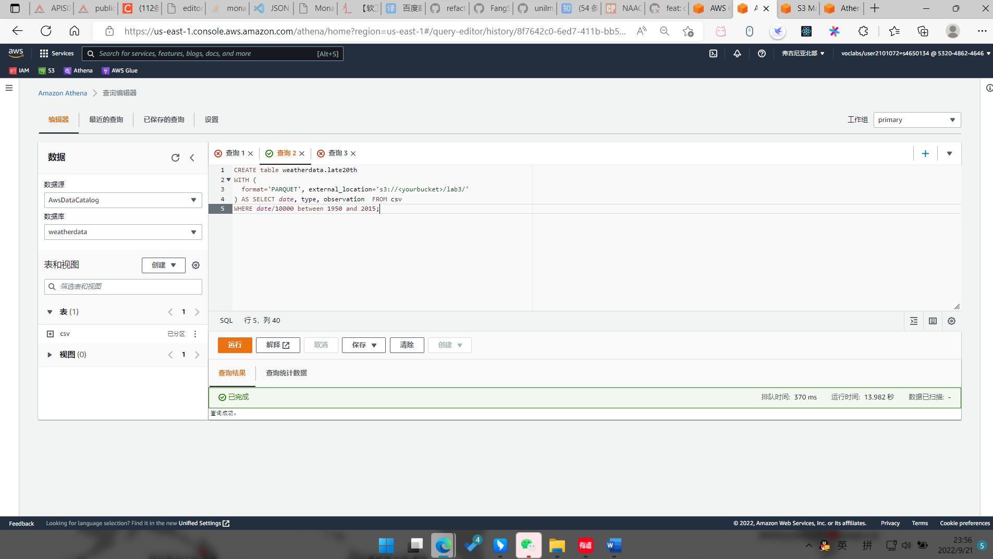

**Lab 3 Step 56 run query**

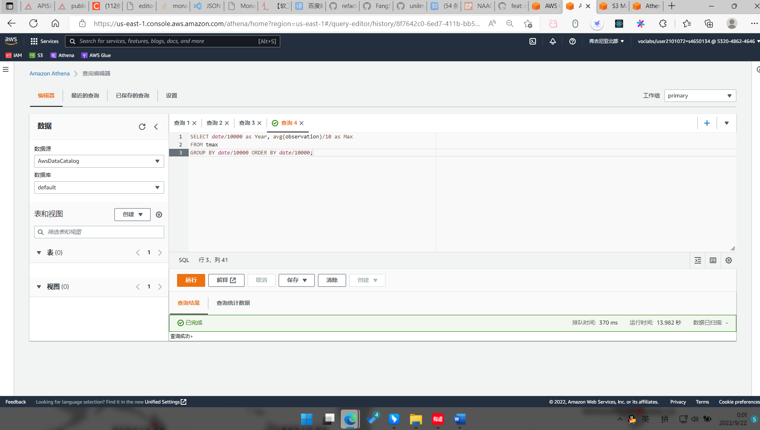

**Lab 3 Step 62 run query**

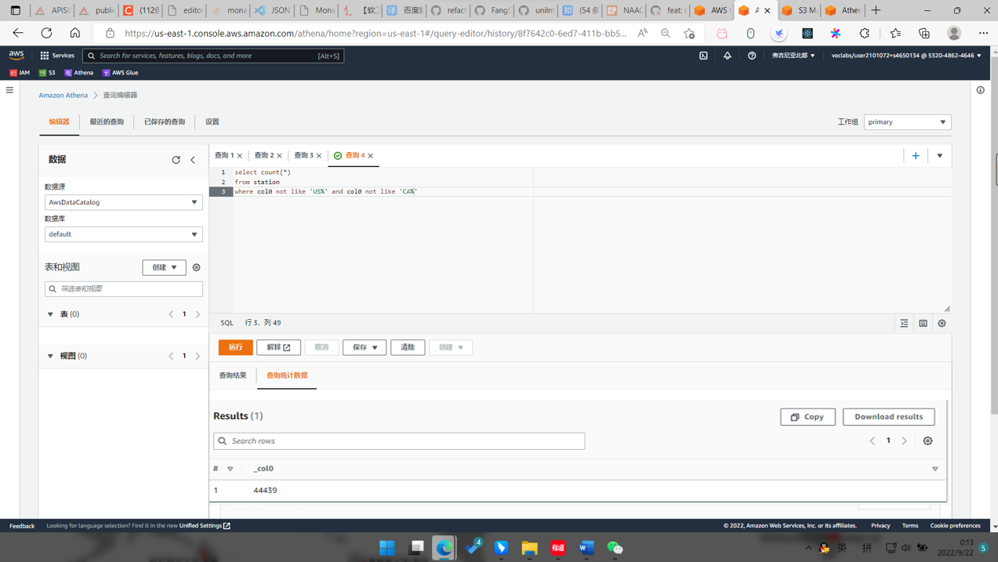

**Lab 3 Challenge**