Lab 4：

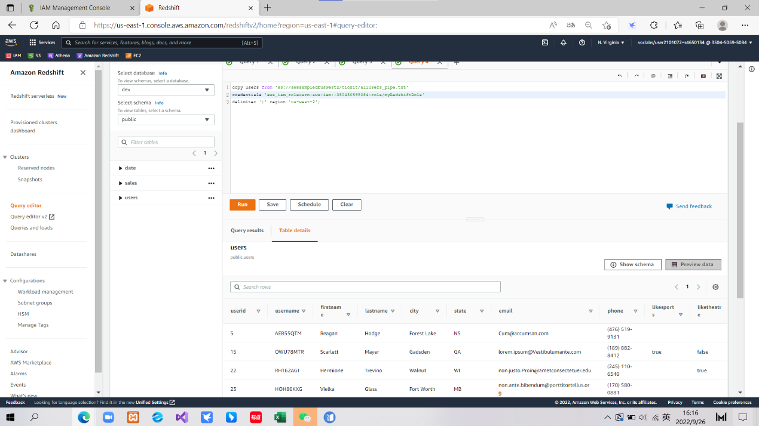

Lab 4 Step 45 Preview users Table

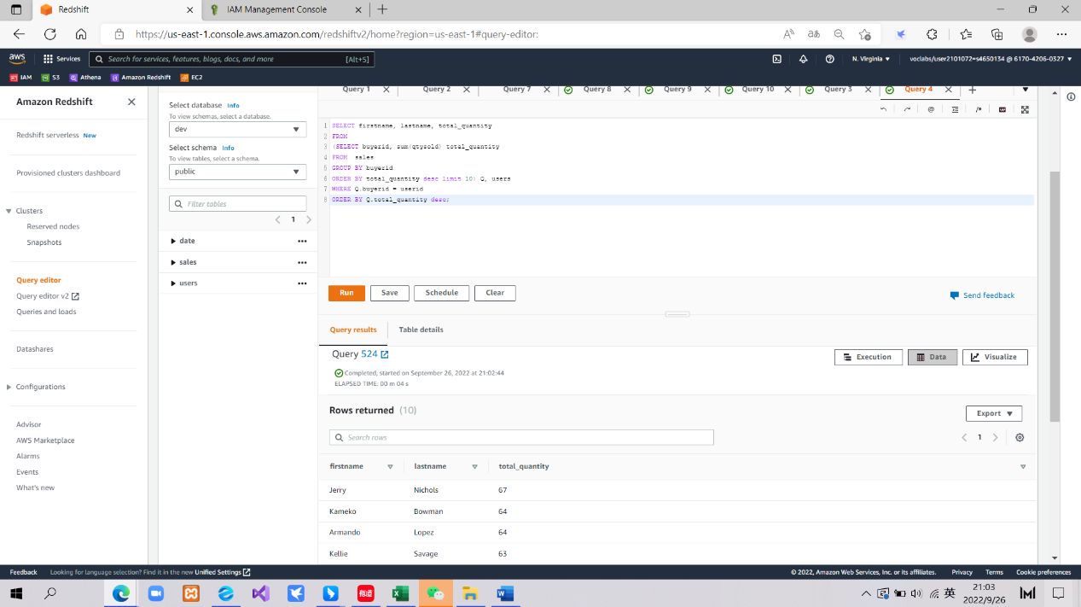

Lab 4 Step 50 Return a list

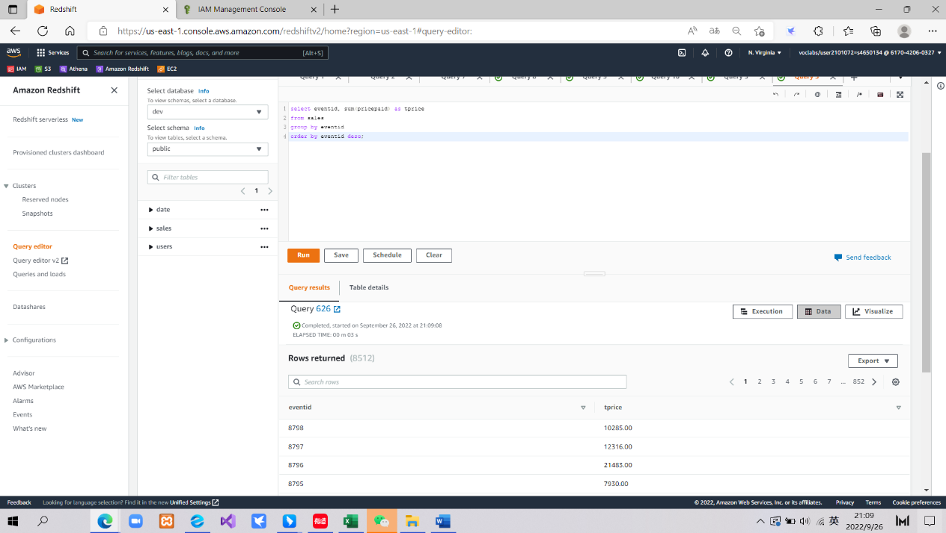

Lab 4 Challenge List The Event

Lab 5：

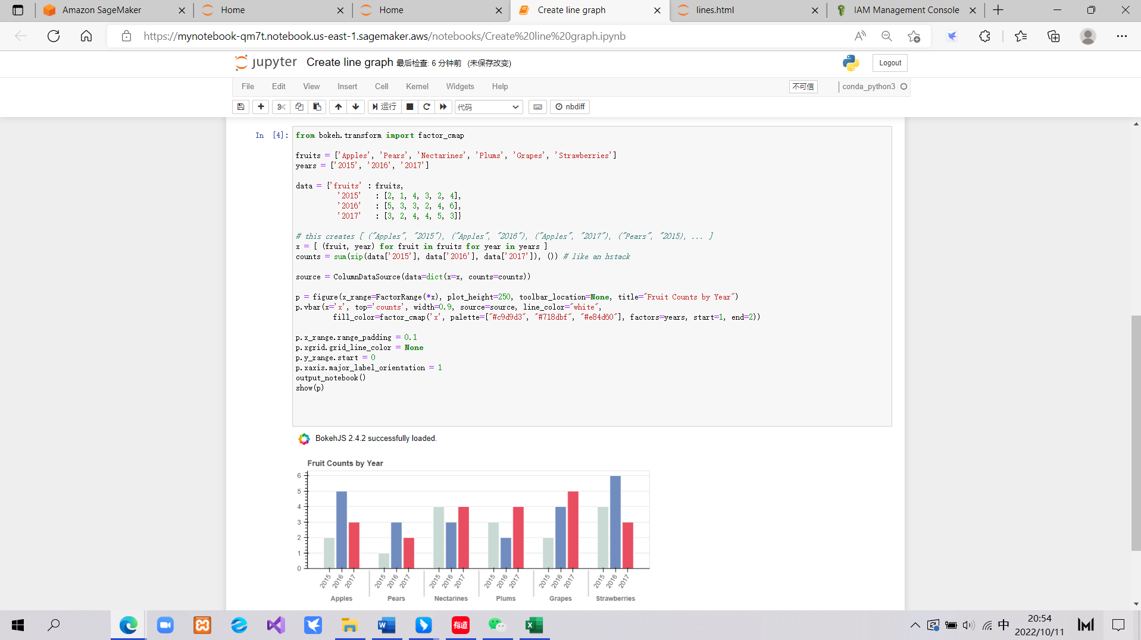

Lab 5 Step 36 Display grouped bar

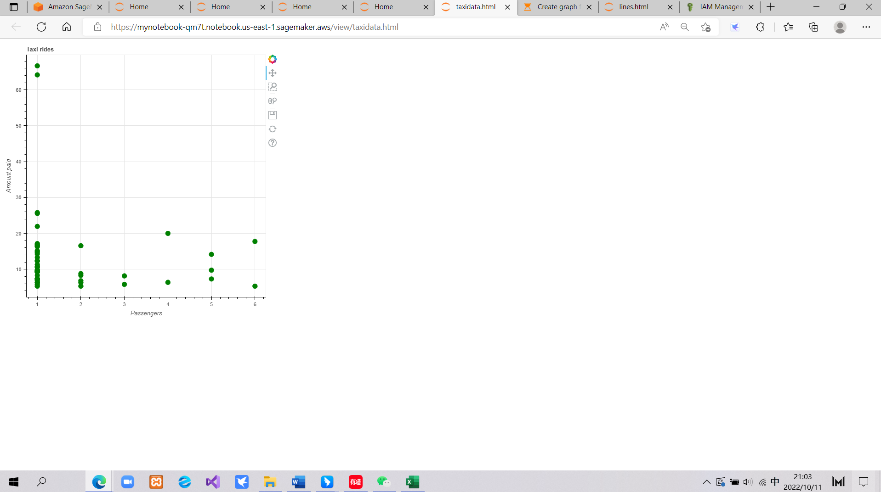

Lab 5 Step 50 Choose taxidata. html

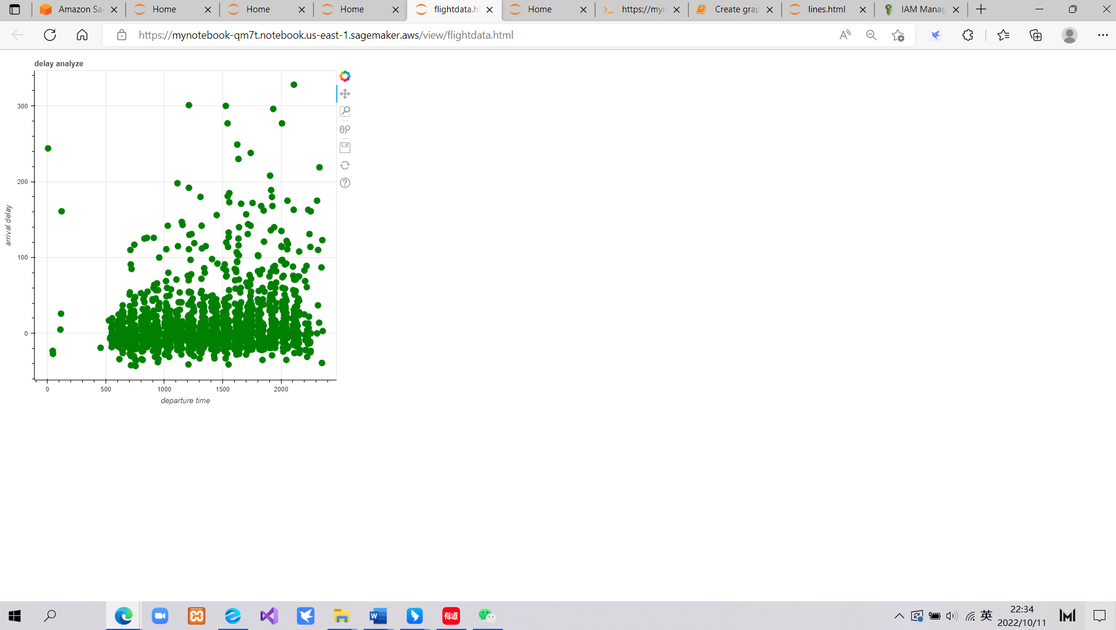

Lab 5 Challenge Develop a visualization[1]

1.