## COURSE Diploma of Information Technology (VDIT)

## UNIT OF STUDY VIT1104 – Computer Networks

## ASSESSMENT TITLE Practical Task

## ASSESSMENT TYPE Practical Task

Student name: Sen Fang Student ID: _s4650134_

Instructor name: _Zhang Ge__ Date: _5.29__ Group:_17___

## Instructions

* **Weighting** This assessment is worth 20% of your final result for this unit of study
* You must put your VU student ID on all items submitted for assessment.
* You have 90 minutes to complete this assessment.
* This assessment is restricted OPEN BOOK. Only your paper based study notes or engineering hand written journals are permitted. No electronic resources or storage devices are allowed.
* Download the Assessment Packet Tracer Activity File (VIT1104 Skills Assessment v8.pka) under Assessment Information – Practical Task – Assessment.
* Rename the Packet Tracer Activity file VIT1104 Skills Assessment s1234567.pka where the digits represent your student ID. Save this file.
* Complete all steps in Part 1 – 2 in this assessment. Answer the reflection questions.
* When you are ready to submit the completed solution please make sure you do the following:
* **Save the file.**
* Upload the Packet Tracer file Activity file solution to **Assessment -** **Lab Task 3 drop box** on your VU Collaborate space.
* Upload this Assessment sheet with your answers to the reflection questions to the **Assessment -** **Lab Task 3 drop box** on your VU Collaborate space.

## Resources required

* PC with Packet Tracer Software (student version) installed
* Select Cisco Models1941 routers and 2960 Catalyst switches
* Access to the VU Collaborate Learning Management System.
* Assessment Packet Tracer File

1. Topology

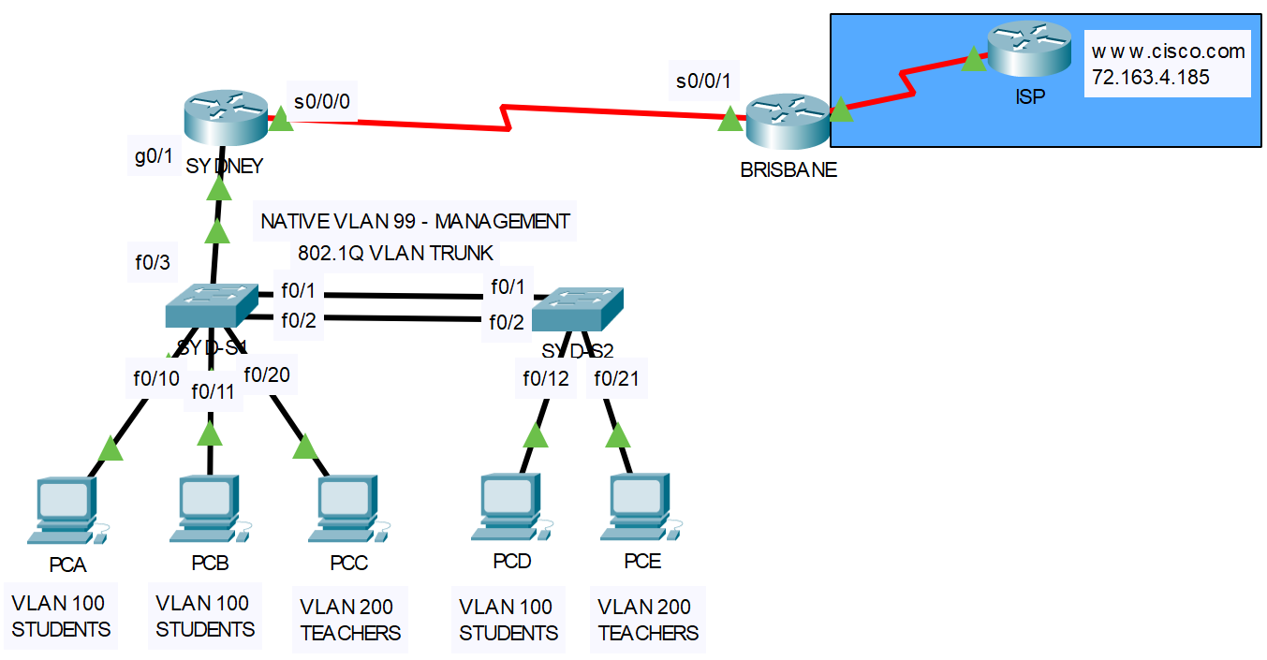

## Scenario

In this assessment you will configure a LAN and WAN network. You will configure routers, switches, and PCs to support IPv4 connectivity, switch security, and inter VLAN routing. You will then configure static and dynamic routing to enable users from SYDNEY’s LANs to communicate with the internet (www.cisco.com). Note the ISP router is preconfigured and locked. You will test the network using common CLI commands

The objectives of this practical task:

1. Users from the **same VLANs** can communicate with each other.
2. Users from **different VLANs** must be able to communicate with each other.
3. Users from **all VLANs** must be able to communicate with the **network switches**.
4. Ports between the two switches, switch and router, should know how to handle tagged or untagged traffic.
5. All users from **SYDNEY’s VLANs** can communicate with the internet (www.cisco.com).

## Instructions

You are required to design and implement a LAN and WAN network for an organisation. Use the addressing scheme to calculate the host IP addresses, subnet masks and, default-gateways if applicable. For each VLAN network assign the SYDNEY Router sub-interfaces the first host address. Assign the PC’s with the next available host addresses in the VLAN network. Assign the Switches with the next available host addresses in the VLAN network. Assign the WAN link end points with the first and last host address in the WAN network. Complete the second table with the IP addressing as per these specifications:

## Addressing Scheme

|  |  |  |
| --- | --- | --- |
| Network address | SNM | Used for |
| 192.168.100.0/24 | 255.255.255.0 | VLAN 100 (STUDENTS) |
| 192.168.200.0/24 | 255.255.255.0 | VLAN 200 (TEACHERS) |
| 192.168.99.0/24 | 255.255.255.0 | VLAN 99 (Management) |
| 10.0.0.0/30 | 255.255.255.252 | WAN (**SYDNEY** to **BRISBANE**) |
| 209.195.205.0/30 | 255.255.255.252 | WAN(BRISBANE to ISP) |

|  |  |  |  |  |
| --- | --- | --- | --- | --- |
| Device | Interface | IP Address | Mask | Default  Gateway |
| SYDNEY | S0/0/0 | 10.0.0.1 | 255.255.255.252 | N/A |
|  | G0/1.100 | 192.168.100.1 | 255.255.255.0 | N/A |
|  | G0/1.200 | 192.168.200.1 | 255.255.255.0 | N/A |
|  | G0/1.99 | 192.168.99.1 | 255.255.255.0 | N/A |
| BRISBANE | S0/0/1 | 10.0.0.2 | 255.255.255.252 | N/A |
|  | S0/0/0 | 209.195.205.1 | 255.255.255.252 | N/A |
| S1 | VLAN 99 | 192.168.99.11 | 255.255.255.0 | 192.168.99.1 |
| S2 | VLAN 99 | 192.168.99.22 | 255.255.255.0 | 192.168.99.1 |
| PC-A | NIC | 192.168.100.2 | 255.255.255.0 | 192.168.100.1 |
| PC-B | NIC | 192.168.100.3 | 255.255.255.0 | 192.168.100.1 |
| PC-C | NIC | 192.168.200.2 | 255.255.255.0 | 192.168.200.1 |
| PC-D | NIC | 192.168.100.4 | 255.255.255.0 | 192.168.100.1 |
| PC-E | NIC | 192.168.200.3 | 255.255.255.0 | 192.168.200.1 |

## Description of Task

1. Cable the topology

Use the following network topology diagram. Select the appropriate media, cables, ports, and connectors to connect routers to other network devices and hosts. Refer to this diagram for your IP addressing scheme.

|  |  |
| --- | --- |
| Configuration Item or Task |  |
| Cable the WAN serial link between SYDNEY and BRISBANE.  Cable SYDNEY’s LAN networks:  Connect S1 F0/3 to SYDNEY G0/1  Connect S1 F0/1 to S2 F0/1 and S1 F0/2 to S2 F0/2  Connect PC-A to S1 F0/10, PC-B to S1 F0/11 and PC-C to F0/20  Connect PC-D to S2 F0/12, and PC-E to F0/21 |  |

1. Configure Network Devices with Basic Parameters and Security Settings

**Configure Router SYDNEY:**

|  |  |
| --- | --- |
| Configuration Item or Task |  |
| Disable DNS lookup |  |
| Router name to SYDNEY |  |
| Encrypted privileged exec password = class |  |
| Console access password = cisco |  |
| Telnet access password = cisco |  |
| Encrypt the clear text passwords |  |
| Configure Interface S0/0/0  Set Description to WAN LINK TO BRISBANE  Set IP address  Set clock rate 128000  Activate interface |  |

**Configure Router BRISBANE:**

|  |  |
| --- | --- |
| Configuration Item or Task |  |
| Disable DNS lookup |  |
| Router name to BRISBANE |  |
| Encrypted privileged exec password = class |  |
| Console access password = cisco |  |
| Telnet access password = cisco |  |
| Encrypt the clear text passwords |  |
| Configure Interface S0/0/0  Set Description to WAN LINK TO ISP  Set IP address  Activate interface |  |
| Configure Interface S0/0/1  Set Description to WAN LINK TO SYDNEY  Set clock rate to 128000  Set IP address  Activate interface |  |

Verify network connectivity between Routers.

Use the **ping** command to test connectivity between Routers SYDNEY and BRISBANE.

**Configure Switch S1:**

|  |  |
| --- | --- |
| Configuration Item or Task | Points |
| Disable DNS lookup |  |
| Switch name to S1 |  |
| Encrypted privileged exec password = class |  |
| Console access password = cisco |  |
| Telnet access password = cisco |  |
| Encrypt the clear text passwords |  |

**Configure Switch S2:**

|  |  |
| --- | --- |
| Configuration Item or Task | Points |
| Disable DNS lookup |  |
| Switch name to S2 |  |
| Encrypted privileged exec password = class |  |
| Console access password = cisco |  |
| Telnet access password = cisco |  |
| Encrypt the clear text passwords |  |

1. Configure Switch Security, VLANS, and Inter VLAN Routing

Configure S1:

|  |  |
| --- | --- |
| Configuration Item or Task | Points |
| Create the VLANs :  VLAN 100 STUDENTS  VLAN 200 TEACHERS  VLAN 99 MANAGEMENT |  |
| Assign the management IP address  Activate the management interface |  |
| Assign the default-gateway |  |
| Enable trunking on Interfaces F0/1, F0/2, F0/3  Use VLAN 99 as the native VLAN for trunks  Only allow User and Management VLAN traffic on the trunk links |  |
| Enable F0/10 as an access port  Assign F0/10 to VLAN 100 |  |
| Enable F0/11 as an access port  Assign F0/11 to VLAN 100 |  |
| Enable F0/20 as an access port  Assign F0/20 to VLAN 200 |  |

Configure S2:

|  |  |
| --- | --- |
| Configuration Item or Task | Points |
| Create the VLANs :  VLAN 100 STUDENTS  VLAN 200 TEACHERS  VLAN 99 MANAGEMENT |  |
| Assign the management IP address  Activate the management interface |  |
| Assign the default-gateway |  |
| Enable trunking on Interfaces F0/1 , F0/2  Use VLAN 99 as the native VLAN for trunks  Only allow User and Management VLAN traffic on the trunk links |  |
| Enable F0/12 as an access port  Assign F0/12 to VLAN 100 |  |
| Enable F0/21 as an access port  Assign F0/21 to VLAN 200 |  |

Configure SYDNEY.

Configuration tasks for SYDNEY include the following:

|  |  |
| --- | --- |
| Configuration Item or Task |  |
| Configure 802.1Q sub-interface .100 on G0/1  Assign IP address to the sub-interface |  |
| Configure 802.1Q sub-interface .200 on G0/1  Assign IP address to the sub-interface |  |
| Configure 802.1Q sub-interface .99 on G0/1 (VLAN 99 is native VLAN)  Assign IP address to the sub-interface |  |
| Activate Interface G0/1 |  |

Configure PC Hosts:

|  |  |
| --- | --- |
| Configuration Item or Task |  |
| Assign IP, subnet mask and default gateway address to PC-A |  |
| Assign IP, subnet mask and default gateway address to PC-B |  |
| Assign IP, subnet mask and default gateway address to PC-C |  |
| Assign IP, subnet mask and default gateway address to PC-D |  |
| Assign IP, subnet mask and default gateway address to PC-E |  |

Verify network connectivity:

Use the **ping** command to test connectivity between SYDNEY’s VLANS. Take corrective action to establish connectivity if a test fails.

1. Configure Routing

Configure SYDNEY

|  |  |
| --- | --- |
| Configuration Item or Task |  |
| Enable the RIP (version 2) routing protocol |  |
| Advertise the serial link network via RIP |  |
| Advertise the VLAN connected networks via RIP |  |
| Do not send RIP routing updates LAN network |  |
| Disable auto-summarisation on RIP |  |

Configure BRISBANE

|  |  |
| --- | --- |
| Configuration Item or Task |  |
| Configure a default route to ISP router. |  |
| Enable the RIP (version 2) routing protocol |  |
| Advertise the serial link network via RIP |  |
| Do not send RIP routing updates to ISP network |  |
| Propagate the default route into the RIP domain |  |
| Disable auto-summarisation on RIP |  |

Verify network connectivity:

Use the **ping** command to test connectivity to the internet (IP address of the CISCO server) from the user VLANs’. Take corrective action to establish connectivity if a test fails.

If any ping results were unsuccessful troubleshoot the issues by using show and debug commands.

Rubrics

|  |  |  |
| --- | --- | --- |
| Rubrics | Marks possible | Your Marks |
| Cables connected to the correct ports | 13 |  |
| Disable DNS lookup (1 mark for each network device) | 4 |  |
| Device host names (1 mark for each network device) | 4 |  |
| Encrypted privileged exec password (1 mark for each network device) | 4 |  |
| Console access password (2 mark for each network device) | 8 |  |
| Telnet access Password (1 mark for each network device) | 4 |  |
| Encrypt all clear passwords (1 mark for each network device) | 4 |  |
| Configure Serial Interfaces on Routers (4 marks for SYDNEY, 9 marks for BRISBANE) | 13 |  |
| Configure VLANs on Switches (3 marks for each device) | 6 |  |
| Configure Trunk ports for Switches (5 ports x 5 marks each interface)  Must trunk on Native VLAN 99 and must only allow User and Management traffic | 25 |  |
| Assign PC ports on Switches to the user VLANs (5 ports x 4 marks each interface) | 20 |  |
| Assign IP addresses and default-gateways to Switches (4 marks for each device) | 8 |  |
| Assign IP addressing to PCs (3 mark x 5 PCs) | 15 |  |
| Configure 802.1q sub-interfaces on SYDNEY Router (3 interfaces x 4 marks)  One must be on Native VLAN 99 | 12 |  |
| Configure RIPv2 routing on both routers including propagation of default route and do not routing updates to LANs and ISP network(6 marks for each device) | 12 |  |
| Running Configurations Saves on all Devices | 4 |  |
| Use the ping or trace utility to test connectivity for the following: |  |  |
| PC-A can communicate with PC-B, PC-C, PC-D, PC-E (4 tests x 4 marks each) | 16 |  |
| PC-A can communicate with SYD-S1, SYD-S2 (2 tests x 4 marks each) | 8 |  |
| All PCs can communicate with Internet (5 test x 4 marks) | 20 |  |
| Total Marks | /200 |  |
| Total Adjusted | /20 |  |

Refer to the Activity Results with breakdown of items given by the Packet Tracer Assessment Activity File at the end of the assessment session. Your result for this assessment is the total points correctly configured assessment items (out of 156) and successful connectivty tests (out of 44).