## COURSE Diploma of Information Technology (VDIT)

## UNIT OF STUDY VIT1104 – Computer Networks

## ASSESSMENT TITLE Lab Task 2

## ASSESSMENT TYPE Lab Work

Student name: Sen Fang(Wirth) Student ID: s4650134

Instructor name: Zhang Ge Date: 5.12 Group: 17

## Instructions

* **Weighting** This assessment is worth 10% of your final result for this unit of study.
* You must put your name and VU student ID on all items submitted for assessment.
* You have 90 minutes to complete this assessment.
* This assessment is restricted OPEN BOOK. Only your paper based study notes or engineering hand written journals are permitted. No electronic resources or storage devices are allowed.
* When you are ready to submit the completed solution please make sure you do the following:
* **Save the file and show your teacher your work before uploading the file to VU Collaborate.**
* Upload the Packet Tracer file to **Assessment -** **Lab Task 2 drop box** on your VU Collaborate space.
* Upload this Assessment sheet with your answers to the reflection questions to the **Assessment -** **Lab Task 2 drop box** on your VU Collaborate space.

## Resources required

* PC with Packet Tracer Software (student version) installed
* Select Cisco Models1941 routers and 2960 Catalyst switches
* Access to the VU Collaborate Learning Management System.

1. Topology

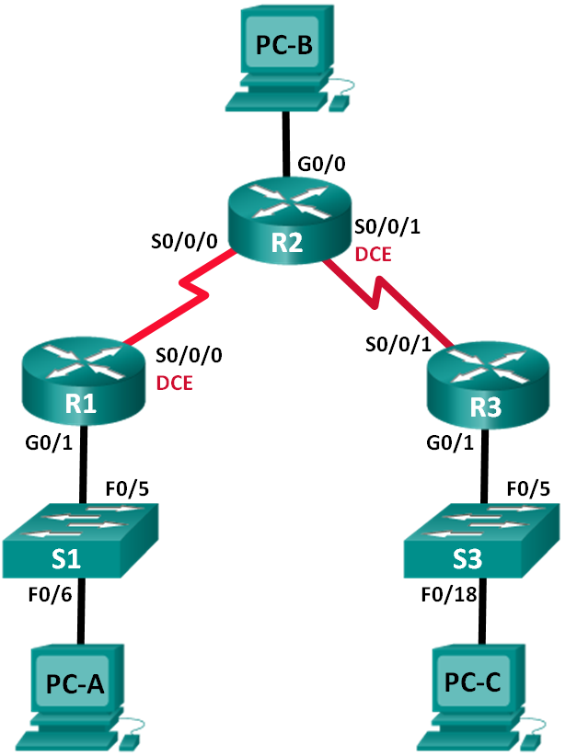

1. Addressing Scheme

|  |  |  |  |  |
| --- | --- | --- | --- | --- |
| Device | Interface | IP Address | Subnet Mask | Default Gateway |
| R1 | G0/1 | 192.168.10.1 | 255.255.255.0 | N/A |
|  | S0/0/0 (DCE) | 10.1.1.1 | 255.255.255.252 | N/A |
| R2 | G0/0 | 209.165.201.1 | 255.255.255.0 | N/A |
|  | S0/0/0 | 10.1.1.2 | 255.255.255.252 | N/A |
|  | S0/0/1 (DCE) | 10.2.2.1 | 255.255.255.252 | N/A |
| R3 | G0/1 | 192.168.30.1 | 255.255.255.0 | N/A |
|  | S0/0/1 | 10.2.2.2 | 255.255.255.252 | N/A |
| S1 | VLAN 1 | 192.168.10.11 | 255.255.255.0 | 192.168.10.1 |
| S3 | VLAN 1 | 192.168.30.33 | 255.255.255.0 | 192.168.30.1 |
| PC-A | NIC | 192.168.10.10 | 255.255.255.0 | 192.168.10.1 |
| PC-B | NIC | 209.165.201.2 | 255.255.255.0 | 209.165.201.1 |
| PC-C | NIC | 192.168.30.30 | 255.255.255.0 | 192.168.30.1 |

1. Objectives

Part 1: Build the Network and Configure Basic Device Settings

Part 2: Configure and Verify RIPv2 Routing

1. Background / Scenario

RIP version 2 (RIPv2) is used for routing of IPv4 addresses in small networks. RIPv2 is a classless, distance-vector routing protocol, as defined by RFC 1723. Because RIPv2 is a classless routing protocol, subnet masks are included in the routing updates.

In this lab, you will configure the network topology with RIPv2 routing, disable automatic summarization, propagate a default route, and use CLI commands to display and verify RIP routing information.

**Note**: The routers used with CCNA hands-on labs are Cisco 1941 Integrated Services Routers (ISRs) with Cisco IOS Release 15.2(4) M3 (universalk9 image). The switches used are Cisco Catalyst 2960s with Cisco IOS Release 15.0(2) (lanbasek9 image).

**Note**: Make sure that the routers and switches have been erased and have no startup configurations. If you are unsure, contact your instructor.

1. Required Resources

* 3 Routers (Cisco 1941 with Cisco IOS Release 15.2(4)M3 universal image or comparable)
* 2 Switches (Cisco 2960 with Cisco IOS Release 15.0(2) lanbasek9 image or comparable)
* 3 PCs (Windows 10, Putty)
* Console cables to configure the Cisco IOS devices via the console ports
* Ethernet and Serial cables as shown in the topology

1. Build the Network and Configure Basic Device Settings

In Part 1, you will set up the network topology and configure basic settings.

* 1. Cable the network as shown in the topology.
  2. Initialize and reload the router and switch.
  3. Configure basic settings for each router.
     1. Disable DNS lookup.
     2. Configure device names as shown in the topology.
     3. Configure password encryption.
     4. Assign **class** as the privileged EXEC password.
     5. Assign **cisco** as the console and vty passwords.
     6. Configure a MOTD banner to warn users that unauthorized access is prohibited.
     7. Configure **logging synchronous** for the console line.
     8. Configure the IP addresses listed in the Addressing Table for all interfaces.
     9. Configure a description for each interface with an IP address.
     10. Configure the clock rate, if applicable, to the DCE serial interface.
     11. Copy the running-configuration to the startup-configuration.
  4. Configure IP addressing on Switches.
     1. Configure SVI Management IP address and default gateway on each switch.
  5. Configure PC IP Addressing.
     1. Refer to the Addressing Table for IP address information of the PCs.

1. Configure and Verify RIPv2 Routing
   1. Configure RIPv2 Routing on all Routers.
   2. Disable Auto-Summarisation on all RIP routing.
   3. Configure and redistribute a default route for Internet access.
   4. Verify the routing configuration.
   5. Verify connectivity.
2. Reflection
3. Enter the command used to view the routing table of each router? (1 mark)

**show run**

1. How many RIP route entries are listed in router R2’s routing table? (1 mark)

2

1. List all the learned routes in router R1’s table: (1 mark)

**R 10.2.2.0/30 [120/1] via 10.1.1.2, 00:00:15, Serial0/0/0**

**192.168.10.0/24 is variably subnetted, 2 subnets, 2 masks**

1. Why do we need to disable auto summarisation in our RIP configuration? (1 mark)

**solve the problem of discontinuous subnet access to each other**

1. How did routers R1 and R3 learn the pathway to the internet? (1 mark)

**RIP order makes R1 R2 learn the pathway to the internet**

1. How did routers R1 and R3 learn about each other’s private LAN networks? (1 mark)

**they can use the dynamic routing protocol to learn**

RUBRICS

* You are free to choose own host addresses (within the host range of each network) for your device’s interfaces.

|  |  |  |
| --- | --- | --- |
| Mark Breakdown | Your Marks | Marks possible |
| Disable DNS lookup (1 mark for each network device) |  | 3 |
| Device host names (1 mark for each network device) |  | 3 |
| Message of the day (1 mark for each network device) |  | 3 |
| Encrypted privileged exec password (1 mark for each network device) |  | 3 |
| Console access password (1 mark for each network device) |  | 3 |
| Telnet access Password (1 mark for each network device) |  | 3 |
| Encrypt all clear passwords (1 mark for each network device) |  | 3 |
| Set clock on the routers (1 mark for each network device) |  | 3 |
| Save the running configuration files on all network devices (1 mark for each) |  | 5 |
| Assign appropriate IP addresses/Subnet mask/Default Gateways on interfaces of 3 PCs |  | 9 |
| Assign appropriate IP addresses/Subnet mask/Descriptions on Router’s Lan interfaces (R1 G0/1, R2 G0/0, and R3 G0/1). Activate interfaces. |  | 12 |
| Assign appropriate IP addresses/Subnet mask/Descriptions on Router’s Serial interfaces (R1 s0/0/0, R2 s0/0/0 s0/0/1, R3 s0/0/1). Activate interfaces. |  | 16 |
| Assign appropriate IP address/Subnet mask and Default Gateway on each LAN Switch. |  | 6 |
| Configure RIPv2 routing on each router |  | 3 |
| Advertise the required networks |  | 6 |
| Disable Auto-Summarisation |  | 3 |
| Propagate the default route into the RIP domain |  | 3 |
| Use the ping or trace utility to test connectivity for the following: |  |  |
| PC-A can communicate with internet (R2’s PCB) |  | 1 |
| PC-C can communicate with internet (R2’s PCB) |  | 1 |
| PC-A can communicate with PC-C |  | 1 |
| PC-A can communicate with Switch S1 |  | 1 |
| Switch S1 can communicate with internet (R2’s PCB) |  | 1 |
| PC-C can communicate with Switch S3 |  | 1 |
| Switch S3 can communicate with internet (R2’s PCB) |  | 1 |
| Reflection Questions (Answers must be feasible) |  | 6 |
| Total Marks |  | /100 |
| Total Adjusted |  | /10 |

EN**D OF LAB TASK 1 ASSESSMENT**