Student ID: 06996263 Student name: Fang Zhu

Q1:

Code:

import numpy as np

import matplotlib

import matplotlib.pyplot as plt

%matplotlib inline

import math

import textwrap

import numpy as np

import sklearn

from sklearn.model_selection import KFold

upper = 1

lower = 0

Num = 100*1

gVar = 0.1

split_num = 4

scalar=1

step = (upper-lower)/(Num)

x = np.arange(lower+step/2,upper+step/2,step)

ntr = np.random.normal(0,gVar,Num-25*scalar)

nte = np.random.normal(0,gVar,Num-75*scalar)

m_num = 10

kf = KFold(split_num)

kf.get_n_splits(x)

print(kf)

E_train=np.zeros(m_num)

E_test=np.zeros(m_num)

M1=np.zeros(m_num)

E=np.zeros(m_num)

for train_index, test_index in kf.split(x):

x_train, x_test = x[train_index], x[test_index]

#print(x_train)

#print(x_test)

for M in range(0,m_num):

X_train = np.array([x_train**m for m in range(M+1)]).T

w = np.linalg.inv(X_train.T@X_train)@X_train.T@ntr

X_tr=np.array([x_train**m for m in range(M+1)]).T

X_te=np.array([x_test**m for m in range(M+1)]).T

y_test=X_te@w

y_train=X_tr@w

y_trn=np.sin(2*math.pi*x_train)+ntr

y_ten=np.sin(2*math.pi*x_test)+nte

y1=np.sin(2*math.pi*x_test)

y2=np.sin(2*math.pi*x_train)

e_1=(y_train-y_trn)**2

E_1=(sum(e_1)/50)**0.5

E_train[M]=E_1

e_2=(y_test-y_ten)**2

E_2=(sum(e_2)/50)**0.5

E_test[M]=E_2

M1[M]=M

#print(E_train)

p1 = plt.plot(M1,E_test,'r')

p2 = plt.plot(M1,E_train,'b')

plt.scatter(M1,E_test,facecolors='none',edgecolors='r')

plt.scatter(M1,E_train,facecolors='none',edgecolors='b')

plt.ylabel('Erms') #label x and y axes

plt.xlabel('M')

plt.legend((p1[0],p2[0]),('Test Data', 'Training Data'), fontsize=12)

Picture: (m=3 according to the picture)

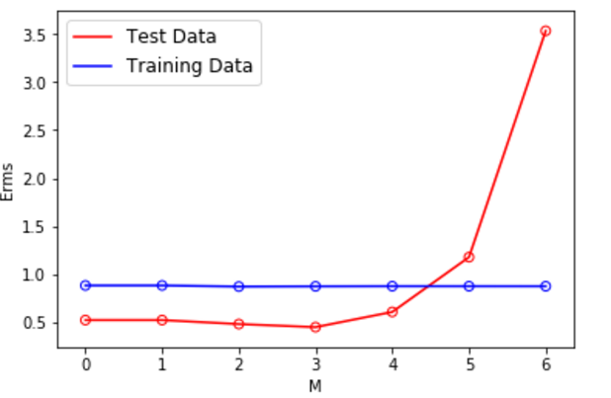

Discussion:

In this example I can take the more training data and different test validation data set to form different shape, and comparing different types of line chart, we can find a proper number.

Q2:

1. XY size: M×N
2. YX size: not defined
3. YXT size: N×M
4. aX size: not defined
5. aTX size: 1×N
6. aXT size: not defined
7. aTb size: not defined
8. bTb size: is constant
9. bbT size: N×N
10. sX+Y size: not defined

Q3:

Suppose the size of X is a*b, and because of definition of XH, the size of XH is b*a.

In order to make the computation meaningful, the size of v should be a*1 and the size of u should be b*1.

Then:

XHXv = λv : a*b @ b*a @ a*1 = a*1

XHXu = λu : b*a @ a*b @ a*1 = b*1

I found here “ b*a @ a*1 = b*1 ”, so I try to define “ XHv=n ”.

Afterwards:

XHX (XHv) = XH λv = λ (XHv)

XHXn = λn

Therefore, they have the same eigenvalues but different eigenvectors.

Q4:

1. $\frac{∂f}{∂x}$ = 3xT + 3xT + 4yT = 6xT + 4yT
2. = 6

Q5:

1. $\frac{∂f}{∂x}$ =- 10(QX)T - 10XTQ + 4yT=-10 (XTQT + XTQ) + 4yT =

-10XT (QT + Q) + 4yT

1. = -10 (QT + Q)T = -10QT - 10Q