Student ID: 06996263 Student name: Fang Zhu

Q1:

1.1 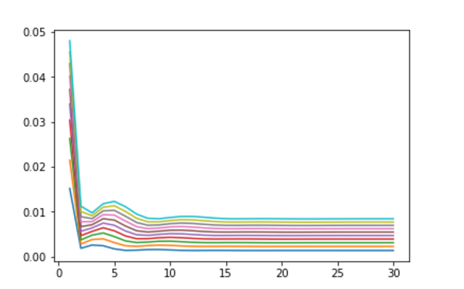

This the picture of lines in different color which indicate lambda ranging from 0.01 to 0.09, the x-axis is the number of order, the y-axis is the Erms.

When the order equals to 18 and lambda equals to 0.01, I get the least Erms(0.0014)

1.2

Comparing with the data of the Erms for order of 4, 8 and 30 while using the testnoisy data, The 30th filter order get the lowest Erms. Because the testnoisy data is too complex due to the noise, more order filter with small regularization could be overfitting but less error. 4th order would contain a bit more error but less overfitting, so the 4th data would be the best one.

Q2

2.1

Comparing with the data of the Erms for order of 4, 8 and 30 while using the testnoisy data, The 4th filter order get the lowest Erms. Because in this case we use online learning, the w is changed step by step and the sum error of each order turned to be big when the order is too big, the error would be larger than others for 30th . So the 4th order works better.

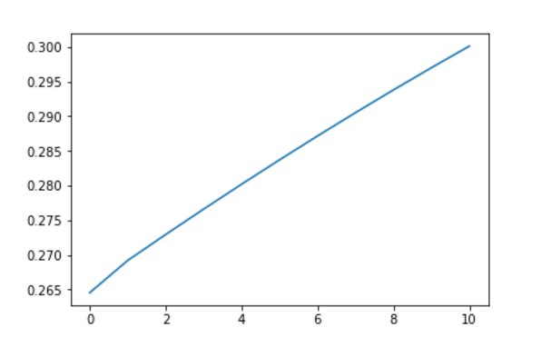

2.2

When the step-size is too large, the weight would not be convergent to the w* (to get the LMS), When the learning rate is small, the cost function takes a long time to reach the minimum.. In order to get the optimal solution, we need to find a proper time to get a proper error. (for example, we can draw a 2-d plot with the two axis(time and error))

Code:

import numpy as np

import matplotlib

import matplotlib.pyplot as plt

%matplotlib inline

import math

import codecs

import textwrap

import numpy as np

testnoisy = np.loadtxt('testnoisy.txt')

training = np.loadtxt('training.txt')

validate = np.loadtxt('validate.txt')#load data

order_upper = 30

N = 10

Er = np.arange(0.1,((N+1)*(order_upper)+1)/10,0.1)

Error = Er.reshape((N+1),order_upper)

#print(Error.shape)

l = np.arange(0,11,1)

E_lowest = np.arange(0,31,1)

for o in range(order_upper):

order = o + 1

Err = 0

training_length = 3000 - order

test_length = 1000 - order #the size of set of data

validate_length = 1000 - order

x = np.arange(0.1,(training_length*order+1)/10,0.1)

X = x.reshape(training_length,order)

v = np.arange(0.1,(validate_length*order+1)/10,0.1)

V = v.reshape(validate_length,order)

for i in range(order):

X[:,i] = training[i:training_length+i]

for i in range(order):

V[:,i] = validate[i:validate_length+i]

X_w = training[order:3000]

d_validate = validate[order:1000]

for lamb in range(N + 1):

I = np.identity(X.shape[1])

z = X.T@X + ((lamb+1)/100)*np.identity(X.shape[1])

W = np.linalg.inv(z)@X.T@X_w.T

#print(W)

X_predict = V@W.T

#print(W)

for i in range(validate_length):

Err = Err + (X_predict[i]-d_validate[i])**2

#print((X_predict[i]-d_validate[i]))

Error[lamb,o] = math.sqrt(Err/(validate_length))

#print(Error.shape)

k0 = np.array(Error[0,:])

k1 = np.array(Error[1,:])

k2 = np.array(Error[2,:])

k3 = np.array(Error[3,:])

k4 = np.array(Error[4,:])

k5 = np.array(Error[5,:])

k6 = np.array(Error[6,:])

k7 = np.array(Error[7,:])

k8 = np.array(Error[8,:])

k9 = np.array(Error[9,:])

t = np.arange(1,order_upper+1,1)

#print(k)

#print(t.size)

plt.plot(t,k0)

plt.plot(t,k1)

plt.plot(t,k2)

plt.plot(t,k3)

plt.plot(t,k4)

plt.plot(t,k5)

plt.plot(t,k6)

plt.plot(t,k7)

plt.plot(t,k8)

plt.plot(t,k9)

#print(Error[5,2])

E = np.array(np.arange(0,10,1))

print("the least error is: ")

print(" ")

print(Error.min())

print(" ")

for i in range(10):

for j in range(30):

if Error[i,j] == Error.min():

lamb_final = (i+1)/100

print("the best lambda is: ")

print(" ")

print((i+1)/100)

print(" ")

print("the best order is: ")

print(" ")

order_final = j + 1

print(j+1)

print(" ")

training_length = 3000 - order_final

test_length = 1000 - order_final #the size of set of data

test = np.arange(0.1,(test_length*order_final+1)/10,0.1)

Test = test.reshape(test_length,order_final)

x_t = np.arange(0.1,(training_length*order_final+1)/10,0.1)

X_t = x_t.reshape(training_length,order_final)

#print(X_t.shape)

for i in range(order_final):

Test[:,i] = testnoisy[i:test_length+i]

for i in range(order_final):

X_t[:,i] = training[i:training_length+i]

X_w_t = training[order_final:3000]

d_test = testnoisy[order_final:1000]

#print(X_w_t.shape)

#print(X_t.shape)

I_t = np.identity(X_t.shape[1])

z_t = X_t.T@X_t + (lamb_final)*np.identity(X_t.shape[1])

#print(z_t.shape)

W_t = np.linalg.inv(z_t)@X_t.T@X_w_t

#print(W)

X_test = Test@W_t.T

#print(d_test.shape)

Err_t = 0

for i in range(test_length):

Err_t = Err_t + (X_test[i]-d_test[i])**2

Error_final = math.sqrt(Err_t/(test_length))

print("the error under the w for testnoisy data:")

print(" ")

print(Error_final)

print(" ")

ti = 0

Error_tt = np.zeros(3)

for k in np.array([4, 8, 30]):

training_length = 3000 - k

test_length = 1000 - k #the size of set of data

tes = np.arange(0.1,(test_length*k+1)/10,0.1)

Tes = tes.reshape(test_length,k)

x_tt = np.arange(0.1,(training_length*k+1)/10,0.1)

X_tt = x_tt.reshape(training_length,k)

for i in range(k):

Tes[:,i] = testnoisy[i:test_length+i]

for i in range(k):

X_tt[:,i] = training[i:training_length+i]

X_w_tt = training[k:3000]

d_testt = testnoisy[k:1000]

I_tt = np.identity(X_tt.shape[1])

z_tt = X_tt.T@X_tt + (lamb_final)*np.identity(X_tt.shape[1])

W_tt = np.linalg.inv(z_tt)@X_tt.T@X_w_tt

X_testt = Tes@W_tt.T

Err_tt = 0

for i in range(test_length):

Err_tt = Err_tt + (X_testt[i]-d_testt[i])**2

Error_tt[ti] = math.sqrt(Err_tt/(test_length))

ti = ti + 1

print("the error for order 4:")

print(" ")

print(Error_tt[0])

print(" ")

print("the error for order 8:")

print(" ")

print(Error_tt[1])

print(" ")

print("the error for order 30:")

print(" ")

print(Error_tt[2])

print(" ")

/*************************************************************************/

import numpy as np

import matplotlib

import matplotlib.pyplot as plt

%matplotlib inline

import math

import codecs

import textwrap

import numpy as np

testnoisy = np.loadtxt('testnoisy.txt')

training = np.loadtxt('training.txt')

validate = np.loadtxt('validate.txt')#load data

order_upper = 30

N = 10

Er = np.arange(0.1,((N+1)*(order_upper)+1)/10,0.1)

Error = Er.reshape((N+1),order_upper)

l = np.arange(0,11,1)

E_lowest = np.arange(0,31,1)

k = 10000

for o in range(order_upper):

order = o + 1

Err = 0

W = np.matrix(np.zeros(order))

training_length = 3000 - order

test_length = 1000 - order #the size of set of data

validate_length = 1000 - order

x = np.arange(0.1,(training_length*order+1)/10,0.1)

X = x.reshape(training_length,order)

v = np.arange(0.1,(validate_length*order+1)/10,0.1)

V = v.reshape(validate_length,order)

for i in range(order):

X[:,i] = training[i:training_length+i]

for i in range(order):

V[:,i] = validate[i:validate_length+i]

X_w_t = training[order:3000]

d_validate_t = validate[order:1000]

X_w = X_w_t.reshape((3000-order),1)

d_validate = d_validate_t.reshape((1000-order),1)

#print(d_validate.shape)

for step in range(N + 1):

for j in range(training_length):

E_s = W@X[j,:].T - X_w[j].T

reg = ((step+1)/k)*(E_s@np.matrix(X[j,:]))

W = W - reg

X_predict = V@W.T

#print(E_s)

for i in range(validate_length):

Err = Err + (X_predict[i]-d_validate[i])**2

Error[step,o] = math.sqrt(Err/(validate_length))

#print(E_s)

k0 = np.array(Error[:,4])

t = np.arange(0,N+1,1)

plt.plot(t,k0)

print("the least error is: ")

print(" ")

print(Error.min())

print(" ")

for i in range(10):

for j in range(30):

if Error[i,j] == Error.min():

step_final = (i+1)/k

print("the best step is: ")

print(" ")

print((i+1)/k)

print(" ")

print("the best order is: ")

print(" ")

order_final = j + 1

print(j+1)

print(" ")

ti = 0

Error_tt = np.zeros(3)

for k in np.array([4, 8, 30]):

W = np.matrix(np.zeros(k))

training_length = 3000 - k

test_length = 1000 - k #the size of set of data

t = np.arange(0.1,(test_length*k+1)/10,0.1)

T = t.reshape(test_length,k)

x_tt = np.arange(0.1,(training_length*k+1)/10,0.1)

X_tt = x_tt.reshape(training_length,k)

for i in range(k):

X_tt[:,i] = training[i:training_length+i]

for i in range(k):

T[:,i] = testnoisy[i:test_length+i]

X_w_t = training[k:3000]

d_test_t = testnoisy[k:1000]

X_w = X_w_t.reshape((3000-k),1)

d_test = d_test_t.reshape((1000-k),1)

for j in range(training_length):

E_s = W@X_tt[j,:].T - X_w[j].T

reg = (step_final)*(E_s@np.matrix(X_tt[j,:]))

W = W - reg

X_predict = T@W.T

#print(E_s)

for i in range(test_length):

Err = Err + (X_predict[i]-d_test[i])**2

Error_tt[ti] = math.sqrt(Err/(test_length))

ti = ti + 1

print("the error for order 4:")

print(" ")

print(Error_tt[0])

print(" ")

print("the error for order 8:")

print(" ")

print(Error_tt[1])

print(" ")

print("the error for order 30:")

print(" ")

print(Error_tt[2])

print(" ")

/******************************************************************************/