Chapter 2 Getting Started

1. Unix systems provide two special files that are particularly useful in shell programming.
2. The first file, /dev/null. Data sent to this file is thrown away by the system. In other words, a program writing data to this file always believes that it has successfully written the data, but in practice, nothing is done with it.

For example, to test if a file contains a pattern:

if grep pattern myfile > /dev/null

then

... *Pattern is there*

else

... *Pattern is not there*

In contrast to writes, reading from /dev/null always returns end-of-file immediately.

1. The second file, /dev/tty. When a program opens this file, Unix automatically redirects it to the real terminal.

Chapter 3 Searching and Substitutions

1. Within bracket expressions, all other metacharacters lose their special meanings. Thus, [\*\.] matches a literal asterisk, a literal backslash, or a literal period.
2. To get a ] into the set, place it first in the list: [ ]\*\.] adds the ] to the list. To get a minus character into the set, place it first in the list: [-\*\.]. If you need both a right bracket and a minus, make the right bracket the first character, and make the minus the last one in the list: [ ]\*\.-].
3. BRE operator precedence

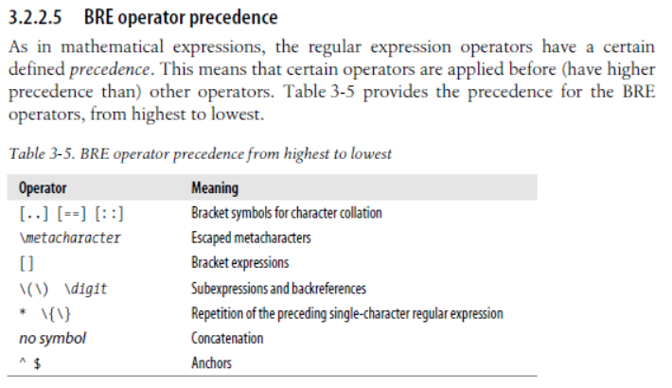

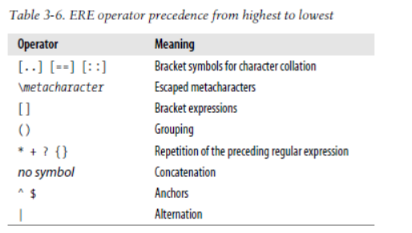

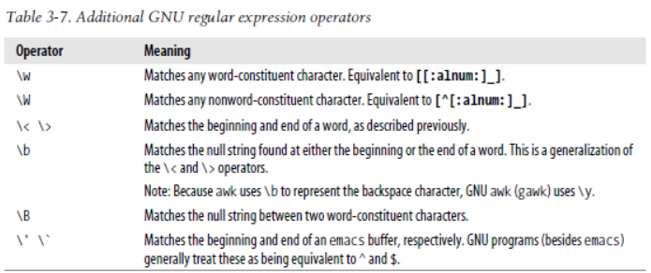

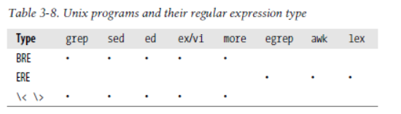

By default, POSIX grep uses BREs. With the –E option, it uses EREs, and with the –F option, it uses the fgrep fixed-string matching algorithm.

1. Most of the time, the right program to use for text substitutions is sed, the Stream Editor. sed is designed to edit files in a batch fashion, rather than interactively.

2016-05-29

1. Command: cut

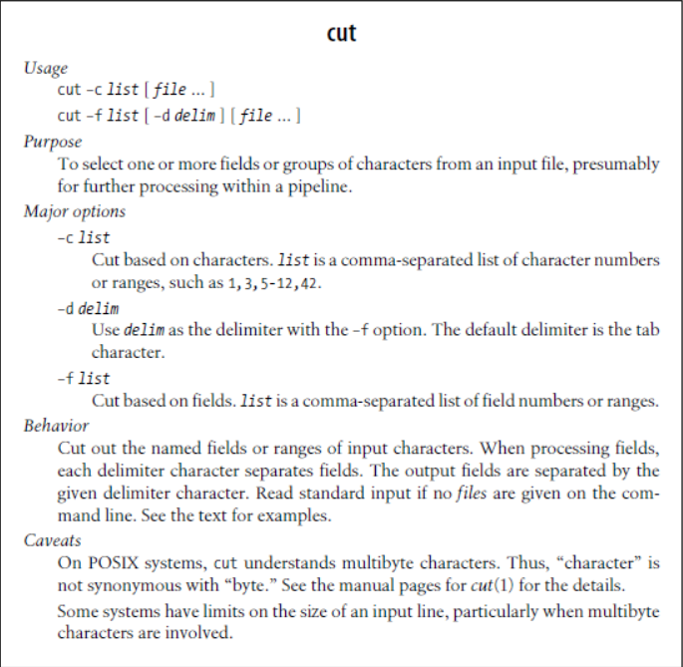

1. Command: join

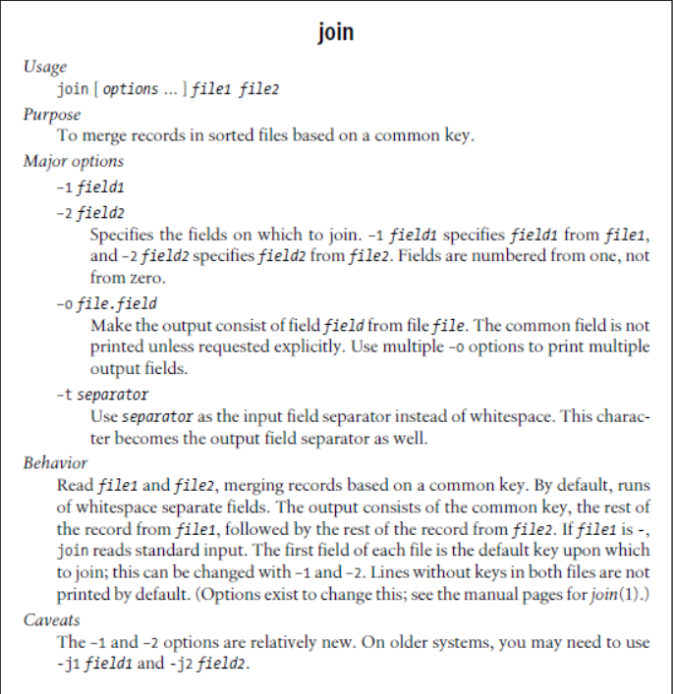

1. awk is often used for simple one-liners, where it’s necessary to just print selected fields, or rearrange the order of fields within a line. Since it’s a programming language, you have much more power, flexibility, and control, even in small programs.