1. What are three conclusions we can make about Kickstarter campaigns given the provided data?
   * Preliminary analysis suggests that theater projects make up the biggest category of all the projects on kickstarter worldwide in the past 8 years. They also have a high chance of success. Under theater category, plays make up the biggest sub-category with a high chance of success.
   * The collective number of projects seem to increase towards the middle of the year (May-July) and the chance of success in general is likely to be higher at the same time as the “successful” line shows a slightly steeper growth.
   * Success rate is higher for projects with lower goals (perhaps for smaller projects) and decreases as the goal amount increases.
2. What are some of the limitations of this dataset?
   * The dataset only contains numerical and categorical data that describes past success and failure based on the types of projects, time range, and dollar amount. It’s hard to predict people’s reaction to any specific project, which determines the success and failure of these projects. An in-depth study on the theme, cause or narrative of them will offer more insights
3. What are some other possible tables/graphs that we could create?
   * Looking at percentage instead of count shows a project’s success rate within its own category. As the following chart indicates, although theater projects make up the majority, music project has a considerably higher success rate. While photography projects make up a small number, it has similar success rate as theater and music.



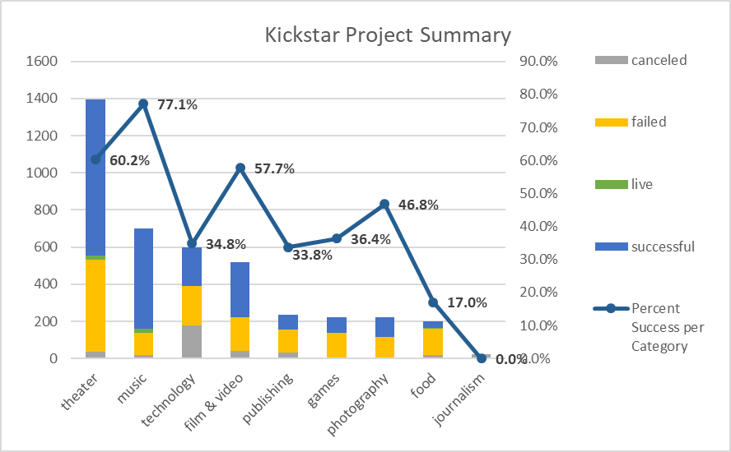

* A bar chart by country shows that certain countries contribute to most of the statistics from certain categories. This shows us that we should include country/region as a variable

