# Fangyi Liu Coding Assignment - Tester Matching

**Configuration:**

There are two zip files:

**TesterMatchingSourceCode.**zip is the source code tree, **TesterMatchingClasses**.zip contains compiled java classes.

Configuration for source code:

1. Please import the source code to IDE.
2. Build and run via IDE. (The Main class is **TesterMatching)**

Run the class file:

1. Change directory to the path of TesterMatchingClasses

$cd {path to ApplauseTestMatchingClasses}

1. Run the java class

$java TesterMatching.

**Testing Instructions:**

1. Input the countries (please use comma to separate multiple countries).

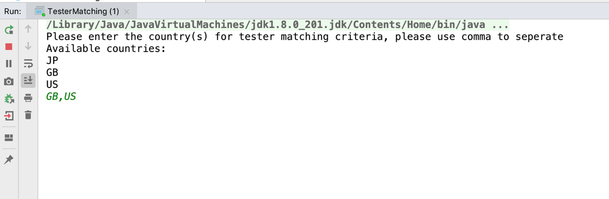

1. Input the devices (please use comma to separate multiple devices).

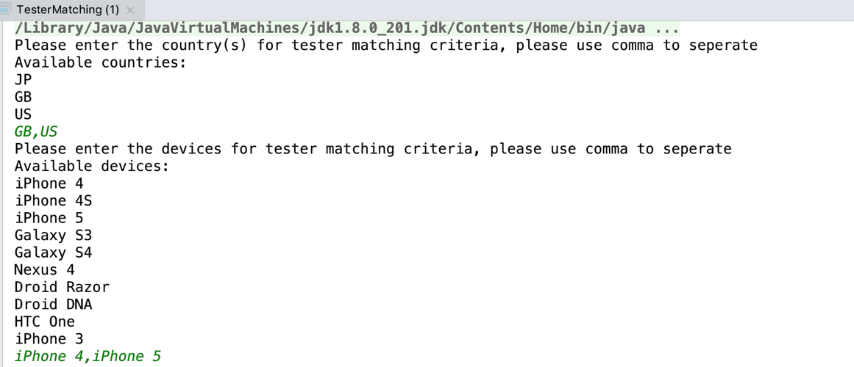

1. The expected output.

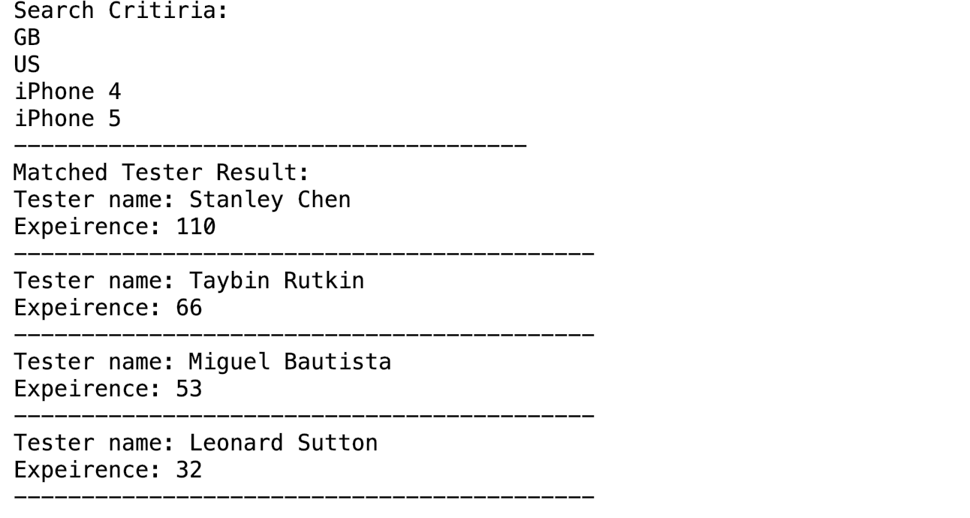

**Test Examples:**

**Example 1:**

* **Criteria:** Country="US", Device="iPhone 4"or"HTC One"
* **Result:** Taybin Rutkin 66, Miguel Bautista 23, Michael Lubavin 17

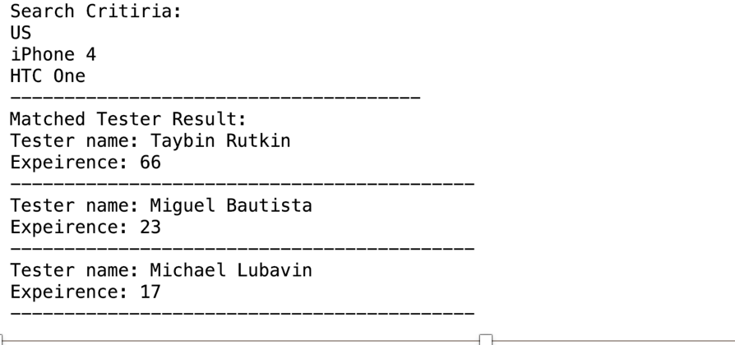

**Example 2:**

* **Criteria:** Country="US" or "GB", Device="iPhone 4"or"iPhone 5"
* **Result:** Stanley Chen 110, Taybin Rutkin 66, Miguel Bautista 53, Leonard Sutton 32



**Example 3:**

* **Criteria:** Country="ALL", Device="ALL"
* **Result:** Taybin Rutkin 125, Lucas Lowry 117, Sean Wellington 116, Miguel Bautista 114, Stanley Chen 110, Mingquan Zheng 109, Leonard Sutton 106, Darshini Thiagarajan 104, Michael Lubavin 99

