Project Plan: Crypto Volatility Prediction API (MVP)
1. Project Description
Goal: Build a scalable, containerized backend system that continuously ingests real-time cryptocurrency market data, processes it through pre-trained volatility forecasting models (GARCH, STGNN), stores the predictions, and serves them via REST API and WebSockets to a frontend dashboard.
Architecture Paradigm: Decoupled Micro-monolith.
- FastAPI handles user requests and WebSocket connections instantly.
- PostgreSQL acts as the persistent truth for users and historical predictions.
- Redis acts as the message broker.
- Celery Workers act as the heavy lifters, running in the background, fetching Binance data, and executing the Python ML models (.npy weights/PyTorch).

2. The Toolchain (Tech Stack)
- Language: Python 3.11+ (Type-hinted strictly)
- Web Framework: FastAPI
- Database: PostgreSQL 15+
- ORM (Object Relational Mapper): SQLAlchemy 2.0 (with async support)
- Database Migrations: Alembic
- Task Queue / Message Broker: Celery + Redis
- Data Validation: Pydantic V2
- Containerization: Docker + Docker Compose
- Package Management: Poetry (Better than pip for production dependency locking)
- Linting & Formatting: Ruff (Extremely fast, replaces Flake8/Black)
- Testing: Pytest

3. Production Folder & File Structure
- We will use a domain-driven structure. This keeps the codebase clean as it grows.

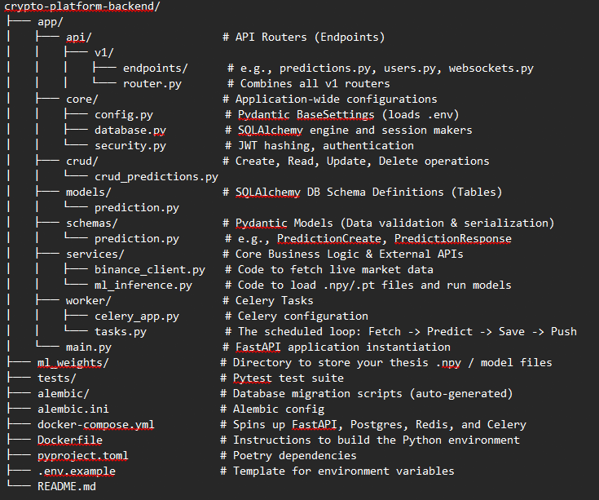

4. Phase-by-Phase Task List
Phase 1: Infrastructure & Boilerplate (Days 1-3)
- [ ] Initialize Git repository.
- [ ] Setup pyproject.toml with Poetry and install core dependencies (FastAPI, Uvicorn, SQLAlchemy, psycopg2-binary, Redis, Celery, Pandas, Numpy).
- [ ] Create .env.example and .env files for secure secrets (DB passwords, API keys).
- [ ] Write the Dockerfile for the FastAPI application.
- [ ] Write the docker-compose.yml to orchestrate 4 services: api, postgres, redis, and celery_worker.
- [ ] Create a basic "Hello World" endpoint in app/main.py and ensure the Docker container boots successfully.
Phase 2: Database & Data Modeling (Days 4-6)
- [p2-t1] Setup SQLAlchemy async engine in app/core/database.py.
- [p2-t2] Define the Database Table in app/models/prediction.py. (Columns: id, timestamp, cryptocurrency_pair, model_used, predicted_volatility, actual_volatility_later).
- [p2-t3] Initialize Alembic (alembic init alembic) and configure it to read your SQLAlchemy models.
- [p2-t4] Generate the first database migration (alembic revision --autogenerate -m "Initial tables") and apply it (alembic upgrade head).
- [p2-t5] Write CRUD functions in app/crud/crud_predictions.py to insert and read data easily.
Phase 3: The ML Engine & Background Workers (Days 7-10)
- [p3-t1] Migrate your thesis code into app/services/ml_inference.py. Write a class that loads your .npy predictions or PyTorch weights into memory once upon startup.
- [p3-t2] Write app/services/binance_client.py to fetch the required sliding window of recent crypto data needed for the model's input.
- [p3-t3] Setup Celery in app/worker/celery_app.py pointing to the Redis broker.
- [p3-t4] Write the background task in app/worker/tasks.py. (Logic: Fetch Binance Data -> Pass to ML Inference -> Save to Database via CRUD -> (Later) Push to Redis Pub/Sub for WebSockets).
- [p3-t5] Setup Celery Beat to trigger this task automatically every X minutes.
Phase 4: API & Data Delivery (Days 11-14)
- [p4-t1] Create REST endpoints in app/api/v1/endpoints/predictions.py (e.g., GET /api/v1/predictions/btc to fetch the last 24 hours of predictions).
- [p4-t2] Create a WebSocket endpoint ws://api/v1/ws/live-predictions.
- [p4-t3] Wire the Celery task to publish new predictions to a Redis channel, and have the WebSocket endpoint subscribe to that channel to push data to connected users in real-time.
5. Production Rules
Before you write a single line of code, agree to these rules:
- Never commit secrets: Your .env file must be in your .gitignore immediately.
- Model Loading: Machine learning models take time to load. Load them into RAM in the global scope of your worker file before the tasks run. Do not reload the .npy files from the disk every time a prediction runs.
- Graceful Failures: If the Binance API goes down, your platform should not crash. Wrap external API calls in try/except blocks and log the errors.
- Stateless API: The FastAPI backend should hold NO state. If the Docker container restarts, it should just reconnect to Postgres/Redis and continue as normal.

