Q1. For source code management, at sprint 0, TL want to create a private Git

repository named “basic_git_flow” on Github with default “master/main” branch.

(hints: go to Github and do somethings then take a screen shot with browser url).

Answer:

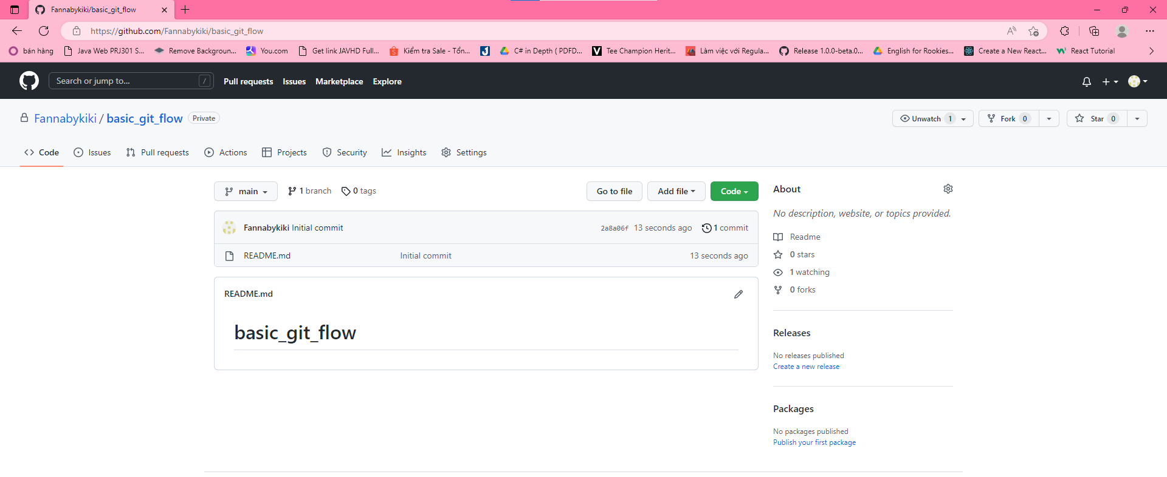

Q2. At sprint 0, TL want to create “develop” branch, branch contains “src” folder and

file “commonBehavior” in “src” folder. Write Git commands to the requirement.

(hints: clone repo, checkout master, create new branch, add some files, stage

changes, commit, push)

Answer:

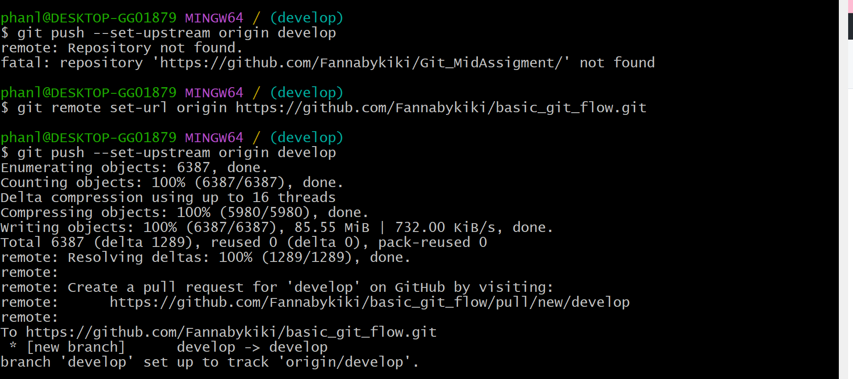

Q3. At Sprint 0, DevA must do task which is “feat1”, then DevA creates new branch

named “feature/feat1” based on “develop” branch and add file “feat1” to “src” folder.

After finishing this task, DevA creates a pull request to merge code from “feature/feat1”

into “develop” branch. Write Git commands to do the requirement then go to Github

merge the PR.

(hints: as same as Q2 hints and what is git pull request command)

Answer:

Q4. At Sprint 0, DevC and DevD must do task which is “feat2”. DevC creates new

branch named “feature/feat2” based on “develop” branch and add file “feat2” to “src”

folder. DevC and DevD work on the same file “feat2”. After finishing this task, DevD

creates a pull request to merge code from “feature/feat2” into “develop” branch. Write

Git commands to do the requirement (include commands to use merge tools, assumes

that conflicts are automatically merge).

4

(hints: how to decrease the conflicts when DevC/DevD commit changes on the same

file/branch or what they do before each committing changes)

Answer:

Q5. At sprint 0, after DevD create a pull request to merge code from “feature/feat2”

into “develop”. TL review the PR and see that there are many commits on

“feature/feat2”. TL wants to do “rebase” commits on this branch before merging PR.

Write Git commands to do the requirement then go to Github to merge the PR.

(hints: make 5 - 8 commit changes, git rebase interactive/squash on one branch,

force push after finishing rebase process).

Answer:

Q6. At sprint 1, DevA must do task which is “feat3”. DevA creates new branch

named “feature/feat3” based on “develop” branch and add file “feat3” to “src” folder.

At the same time, DevB do task to add some extra behavior to project. DevB creates

new branch named “feature/ex_behavior” based on “develop” branch and add file

“extraBehavior” to “src” folder. After some days, DevA and Dev realize that

“feature/feat3” can re-use code of “feature/ex_behavior”. They accept merge code

from “feature/ex_behavior” into “feature/feat3” and only make PR to merge code

from “feature/feat3” to “develop”. Write Git commands to do the requirement and at

the part of [merge code from “feature/ex_behavior” into “feature/feat3”], provide 2

ways of merging branches (git merge and git rebase).

(hints: git merge branches, git rebase onto, force push after finishing rebase

process)

Answer:

Q7. After n-1 sprint, team must create a release branch to go live some features. TL

create release branch named “release/r1” based on “develop”. For uat/production

environments, team must update some log message, then team adds

“extraLogMessage” file to “src” folder. As your understanding of Git flow (section 1),

5

write Git commands to ensure that release branch and its changes are merged into

develop/master.

Answer: