**Business rules:** Store information about a stock market where users and bots can trade stocks between each other. Stocks are originally stored on local market but after being bought they belong to the user or bot that bought them last time. We need to store information on users: their ID, name, username, password, cash and total value. Bots: ID, Name, Upper sell Risk, Lower sell Risk, Buy risk, Cash and total value. Stocks: ID, name, Original Market price, Current market price, last % change, Normal Value change, Owner, Status, Sell price. Transactions between users and bots: ID, stock id, Seller, Buyer, Price. Game is played in rounds where users get to play first and then bots get to do their turn. After each transaction the database gets updated. Each user or bot can buy or sell any amount of stocks and each stock can be owned by one user, one bot or by no one.

* Analysis
  + Entities
    - User(UserID – PK, Username, Current_Cash, Total_value, Bot, Password, Upper_sell_risk, Lower_sell_risk, Buy risk,)
    - Stock(StockID – PK, Name, Original_market_price, Current_market_price, Last_percent_change, Normal_value_change, Owner)
    - Transaction(TransactionID – PK, BuyerID – FK, SellerID – FK, Price)
  + Relationships
    - User 0..1 – (Owns) – 0..M Stock (Status, Sell price)

User 1..1– (Sells) 0..M Transaction

* + - User 1..1– (Buys) 0..M Transaction
* E.R. diagram

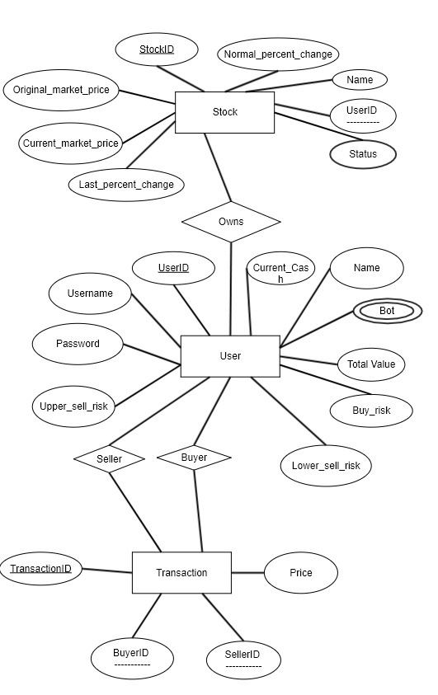

* EDR_map

