
FORMATO DE INFORME DE PRÁCTICA DE LABORATORIO / TALLERES /
CENTROS DE SIMULACIÓN – PARA ESTUDIANTES

CARRERA: Ingeniería en Sistemas |  |  | ASIGNATURA: Sistemas Expertos
NRO. PRÁCTICA: | 8 | TÍTULO PRÁCTICA: KNN Clasificación de miembros del congreso utilizando algoritmos de similitud en Neo4j
OBJETIVO ALCANZADO:

- Adquirir destrezas en el manejo de algoritmos desarrollados por neo4j.
- Entender la lógica de implementación en inteligencia artificial de los algoritmos de neo4j
ACTIVIDADES DESARROLLADAS
1. La información sobre el conjunto de datos y el conjunto de datos en sí, exportamos los datos.

LOAD CSV FROM "http://archive.ics.uci.edu/ml/machine-learning-databases/voting-records/house-votes-84.data" as row
CREATE (p:Person) SET p.class = row[0],
p.features = row[1..]
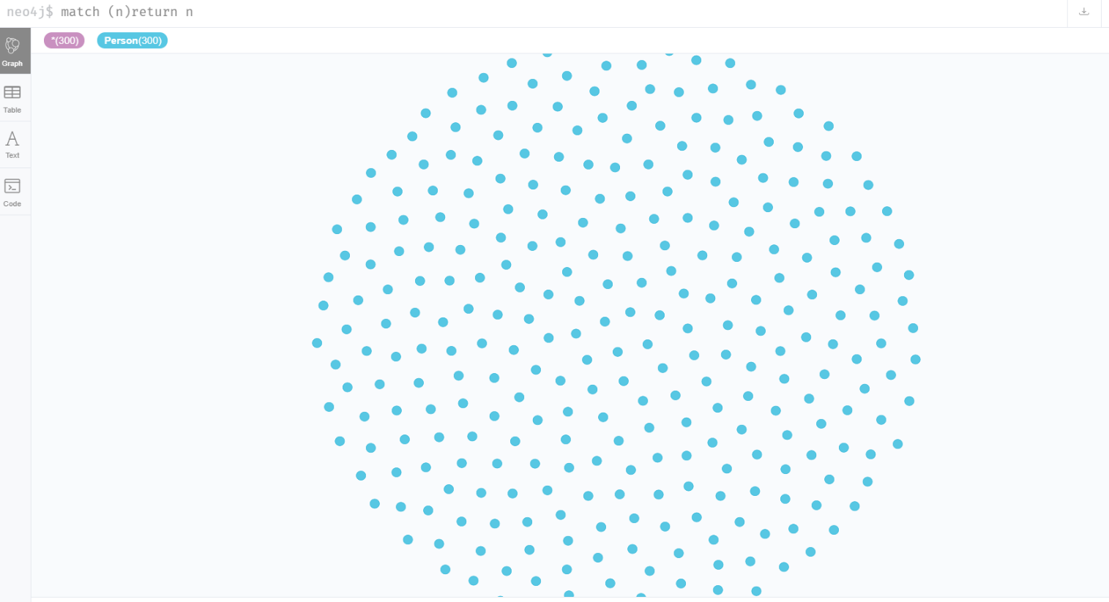

2. Verificamos la cantidad de votos.

MATCH (n:Person)
WHERE "?" in n.features
RETURN count(n)

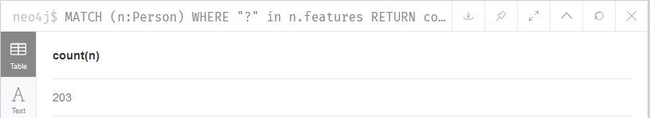

3. Distribucion de votos faltantes

MATCH (p:Person)
WHERE '?' in p.features
WITH p,apoc.coll.occurrences(p.features,'?') as missing
RETURN missing,count(*) as times ORDER BY missing ASC

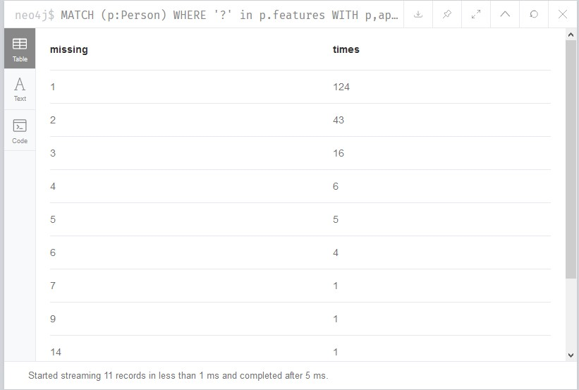

4. Eliminar nodos que no tienen votos
MATCH (p:Person)
WITH p,apoc.coll.occurrences(p.features,'?') as missing
WHERE missing > 6
DELETE p
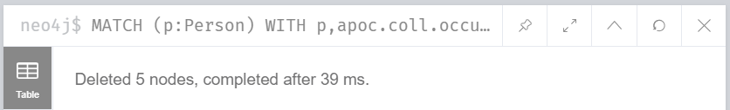

5. Dividimos el conjunto

MATCH (p:Person)
WITH p LIMIT 344
SET p:Training;

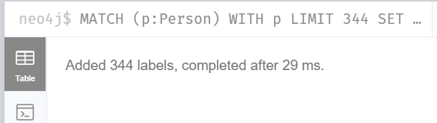

MATCH (p:Person)
WITH p SKIP 344
SET p:Test;

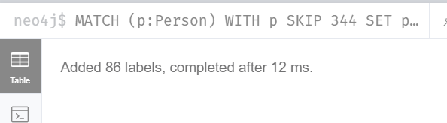

6. Transformar a vector de características
MATCH (n:Person)
UNWIND n.features as feature
WITH n,collect(CASE feature WHEN 'y' THEN 1
WHEN 'n' THEN 0
ELSE 0.5 END) as feature_vector
SET n.feature_vector = feature_vector

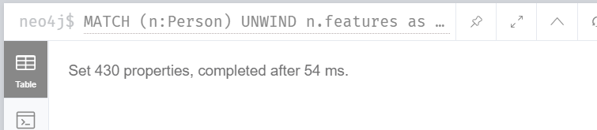

7. Algoritmo KNN

MATCH (test:Test)
WITH test,test.feature_vector as feature_vector
CALL apoc.cypher.run('MATCH (training:Training) WITH training, gds.alpha.similarity.euclideanDistance($feature_vector, training.feature_vector) AS similarity
ORDER BY similarity ASC LIMIT 3
RETURN collect(training.class) as classes',
{feature_vector:feature_vector}) YIELD value WITH test.class as class, apoc.coll.sortMaps(apoc.coll.frequencies(value.classes),
'^count')[-1].item as predicted_class
WITH sum(CASE when class = predicted_class THEN 1 ELSE 0 END) as correct_predictions, count(*) as total_predictions RETURN correct_predictions,total_predictions,
correct_predictions / toFloat(total_predictions) as ratio

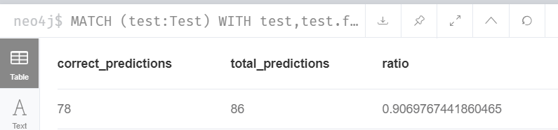

Nombre de los estudiantes: Fanny Gutama

