JanRain/PAC Integration
Technical Design Specification

Table of Contents
Table of Contents 2
Approval Signatures 4
1 Introduction 5
2 Nomenclature 5
2.1 PAC 5
2.2 JanRain 5
2.3 Single Sign-On 5
2.4 Drupal 6
2.5 PingFederate 6
2.6 Windows Active Directory 6
3 Project Overview 7
4 Technical Specifications 8
4.1 Main System Flows and Components 8
1. Login Flow - HCP 8
2. Login Flow – Pfizer employees 9
3. Logout Flow 10
4.2 Environments and Testing 10
1. Environments per party 10
2. Testing responsibility and accounts 11
4.3 Security Testing 11
4.4 Drupal Scope and Design 11
1. Scope 11
2. User experience 12
3. Module Configurability 13
4.5 JanRain Scope and Design 15
1. Scope 15
2. Design 16
4.6 PingFederate Scope and Design 17
1. Scope 17
2. Design 17
4.7 PAC Scope and Design 18
1. Scope 18
2. Current layout 19
5 Supporting References 21

Approval Signatures

This project deliverable may be signed digitally. If digital signatures are used, they will be attached to the end of this document and this section will identify the names, roles and intent of the signatories. Otherwise, handwritten signatures will also be included in this section.
Signatures

I have authored this deliverable to document the architecture and design specifications for JanRain PAC Integration.
Mile Lamb, DMP Lead Architect | DD-MMM-YYYY
Oscar Rodriguez, DMP Solutions Architect | DD-MMM-YYYY
Caio Luppi, Drupal Tech Architect | DD-MMM-YYYY

I agree that this documentation accurately and adequately represents the product architecture and design specifications and that the design is consistent with recommended Pfizer architecture and infrastructure.

QA signatures may be required based on compliance risk.
I have reviewed the content of this record and found that it meets the applicable compliance requirements.

Introduction
The purpose of this document is to outline the technical design of the JanRain PAC integration project. This document will be the main input to the development and testing activities of the project. The document will be managed by the Development Leads with support from the Architects, Solution Engineers, Information Product Leads, and Database Administrators.

Nomenclature

PAC
PAC is an application where Health Care Professionals (HCPs) can register and have access to several other sites within Pfizer’s organization.

JanRain
JanRain offers Software as a Service (SaaS) solutions to connect applications to the social web and other networks. This project leverages two of their products:
- JanRain Engage
A turnkey social login and social sharing solution. Janrain Engage lets a website's visitors register or login with their existing social network accounts from Facebook, Google, Twitter, Yahoo, LinkedIn or other networks, and share content or their site activities with friends on multiple social networks. Additional functionality lets users import their social network profile data and invite their friends to visit a website.¹
- JanRain Federate
A turnkey single sign-on solution that lets users register or login once for multiple web properties or partner sites.²

Single Sign-On
Single sign-on (SSO) is a session/user authentication process that permits a user to enter one name and password in order to access multiple applications. The process authenticates the user for all the applications they have been given rights to and eliminates further prompts when they switch applications during a particular session.³

Drupal
Drupal is a free software package that allows you to easily organize, manage and publish your content, with an endless variety of customization.⁴
Currently there are two platforms where Drupal sites can be served from:
- Drupal Gardens
Site builder platform in a Software as a Service (SaaS) model. Non-complex sites are easily created through an interface and can be production-live within minutes.
- Managed Cloud
The platform of choice when talking about custom Drupal site development for Pfizer, Managed Cloud is a Platform as a Service (PaaS) where complex sites are deployed.

PingFederate
PingFederate is an enterprise-grade identity federation (SAML) server for organizations that require a flexible and cost-effective way to integrate, manage, and secure disparate users and applications across internal and external security domains. It provides authentication, attribute, and authorization portability across autonomous security domains.⁵

Windows Active Directory
Active Directory provides a central location for network administration and security. Server computers that run Active Directory are called domain controllers. An AD domain controller authenticates and authorizes all users and computers in a Windows domain type network—assigning and enforcing security policies for all computers and installing or updating software. For example, when a user logs into a computer that is part of a Windows domain, Active Directory checks the submitted password and determines whether the user is a system administrator or normal user.⁶

Project Overview
The main purpose of this project is to have Health Care Professionals (HCP) and internal Pfizer employees access Pfizer’s Drupal sites without having to register for a new account for each single site, i.e. using their PAC or Pfizer network credentials.
In order to accomplish our goal, we have to integrate PAC and PXED (Pfizer Extended Enterprise Directory) with the sites we want our HCP users and Pfizer employees to be able to access. This integration will leverage JanRain and PingFederate to single sign-on users into Pfizer’s portals. In summary, Drupal will import JanRain library to exchange SAML messages with PingFederate that authenticates users against PAC or PXED.
Additionally, non-function aspects of this integration are equally important in this project and should be considered at all times during this implementation to reach success. User experience should be smooth and this integration performance should be improved to its best.
Lastly, this document covers the scope and design for each component that plays a role in this integration and should be updated every time there is any change to the solution hereby documented.

Technical Specifications

Main System Flows and Components

Login Flow – HCP (Login box in an overlay)
The HCP login flow will have Drupal including JanRain Javascript library that is responsible for exchanging SAML messages with PingFederate, which ultimately authenticates against PAC. This approach is leveraging the standard Service Provider (SP) initiated SAML transactions to single sign-on users into the portal. The diagram below demonstrates how all the components interact with each other.

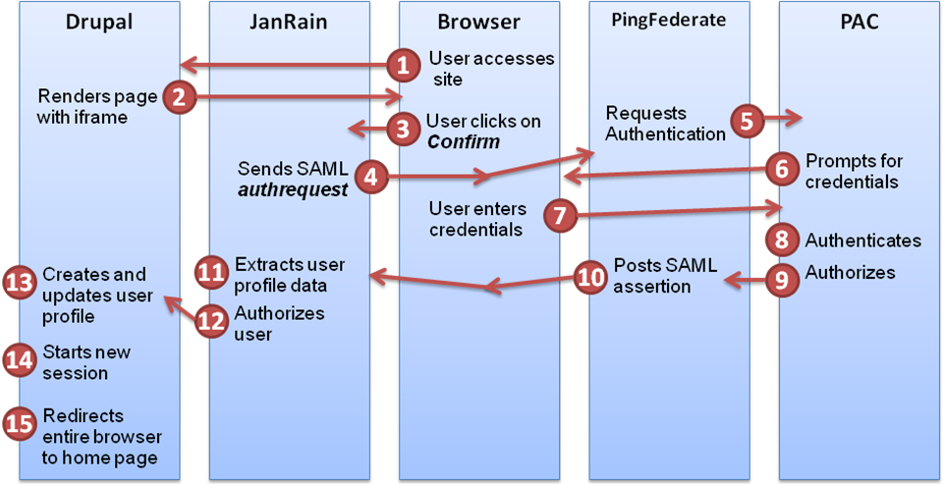
Figure 1 – HCP Login flow utilizing iframe and service provider (SP) initiated transactions.

Login Flow – HCP (Custom login box inline within the home page)
This approach is leveraging custom built Identity Service Provider (SP) initiated SAML transactions to single sign-on users into the portal. In this flow the login module will be custom built by individual Pfizer site and will post credentials directly to PAC/PING federate bypassing janrain. After successful authentication, PING federate will submit unsolicited SAML assertion to preconfigured Janrain url. Based on the relay state within the SAML token, Jainrain will create a SSO session and redirect user to the appropriate web site. The diagram below demonstrates how all the components interact with each other.

Figure 2 – HCP Login flow utilizing idp service provider (SP) initiated transactions. (To be revised)

Registration Flow
User will be redirected to PAC’s registration page to register. After successful registration IDP initiated login flow is triggered.

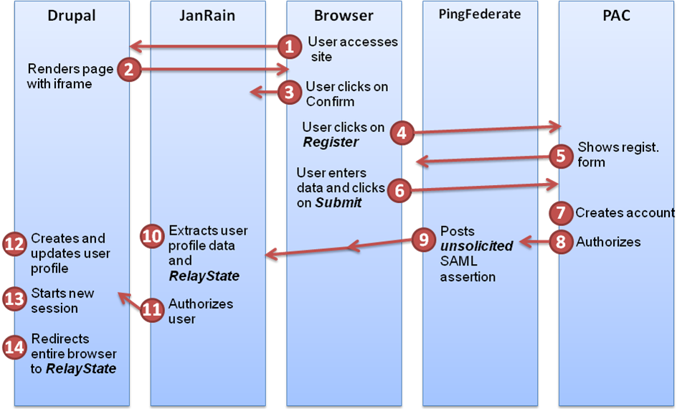
Figure 3 - Registration flow. An unsolicited response is sent after the registration process is completed.

Login Flow – Pfizer employees
The login flow for Pfizer employees will have Drupal including JanRain Javascript library that is responsible for exchanging SAML messages with PingFederate, which ultimately authenticates against PXED. This approach is leveraging the standard Service Provider (SP) initiated SSO transactions to authenticate users. Note that this flow does not prompt users for credentials as the user is already logged in to Windows, and users are authenticated by IWA (Integrated Windows Authentication). The diagram below demonstrates how all the components interact with each other.

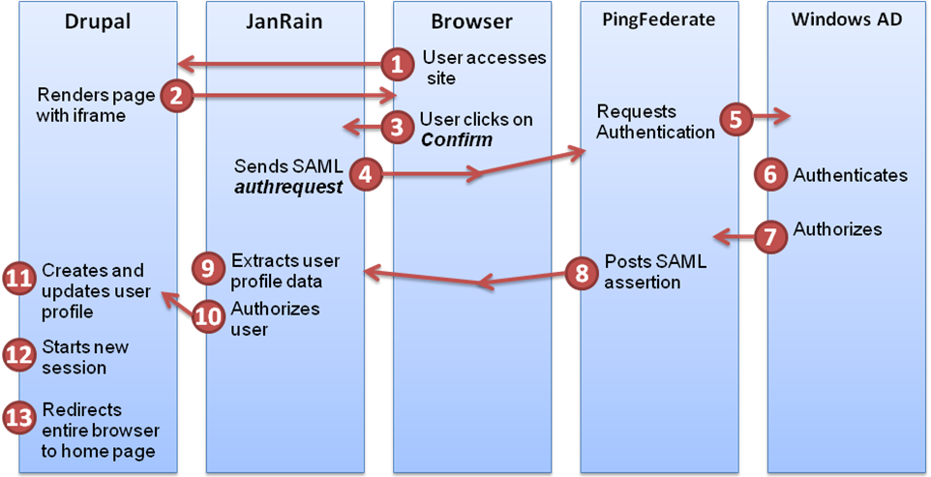
Figure 4 - Windows Active Directory login flow leveraging Service Provider (SP) initiated SAML.

Logout Flow
The logout flow simply single log-out users from the application across all components as described below. The logout flow is the same across HCP and Pfizer employees.
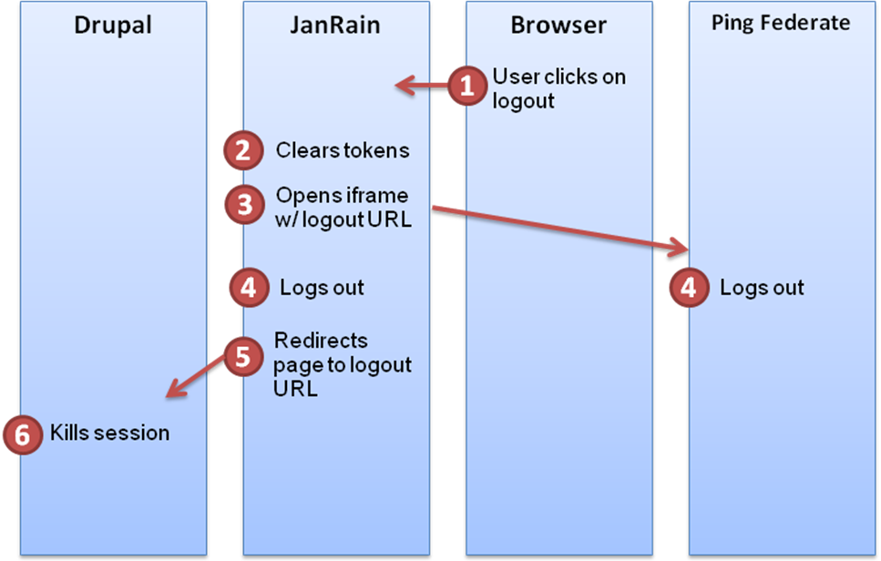
Figure 5 - Single Log-out flow.

Environments and Testing
All components will have two distinct environments, one for testing purposes and the other for production. All environments should be publicly accessible to allow all parties to perform end-to-end tests and validate their changes. The table below shows all pieces and their endpoints.

Environments per party
Party/Env. | Testing | Production
Drupal | TBD | TBD
JanRain | https://rpxstaging.com | TBD
PingFederate | https://devfederate.pfizer.com | TBD
PAC | https://groxs40b3a.pfizer.com:4443  /sites/registration/pages/Login.aspx | TBD

Testing responsibility and accounts
Testing accounts provided in this document are provided to all parties and should be used to test and validate changes across all moving pieces. End-to-end tests should be performed to all impacted flows upon changes to any of the components hereby mentioned. All necessary credentials to execute tests can be found below:
Party/Env. | Testing | Production
Drupal (popup) | TBD | TBD
PAC | User: prime001@mailinator.com  Pass: Prime123$ | TBD

Security Testing
All parties have to take into account data security while developing or configuring their components. Upon completion of the QA process, a security test will be conducted to validate end-to-end whether this integration is secure and can be released live.

Drupal Scope and Design

Scope
A module will be developed to integrate the already existing JanRain module and components with any Drupal site under either Drupal Gardens or Managed Cloud platform.
Additionally, an installation guide will be written to easily explain how to set up this integration for a new Pfizer Drupal website. Also, this document will specify all advanced configurations that can be changed to accommodate special scenarios.

User experience
The user experience has to be seamless as if a single site is being accessed. From past implementations, we identified that popping up a new window confuses users and should be avoided. This project utilizes iframes as replacement to external windows but keeps the current approach, i.e. decoupling the authentication process from the application. Below there are a few wireframes created to demonstrate how the user-interface will function with this new approach:
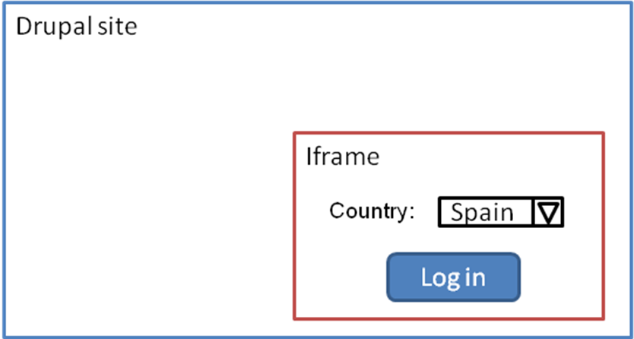
Figure 6 - Drupal site at entry point.

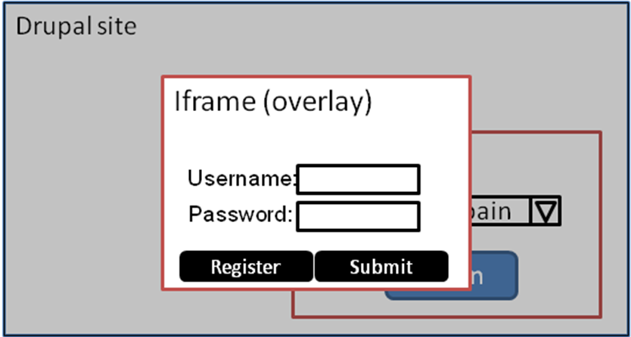
Figure 7 - Login page within an iframe
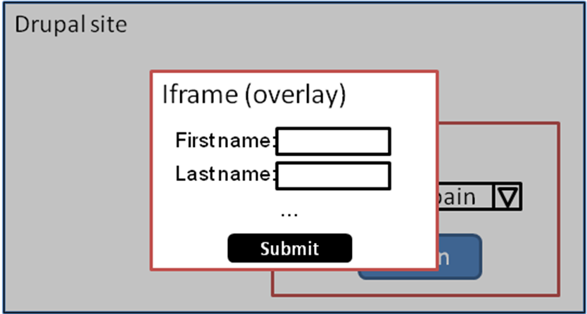
Figure 8 - Registration page (case user has click on register)

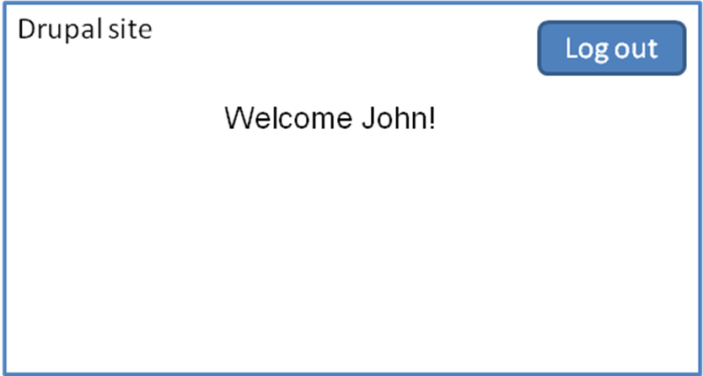
Figure 9 - Home page (logged in)

Module Configurability
This new module will have to extend the already existing JanRain module and provide an administrative interface to configure its components and JanRain’s settings. This interface will be very user-friendly and have everything that’s necessary to set up the module to any Drupal site, as shown below:

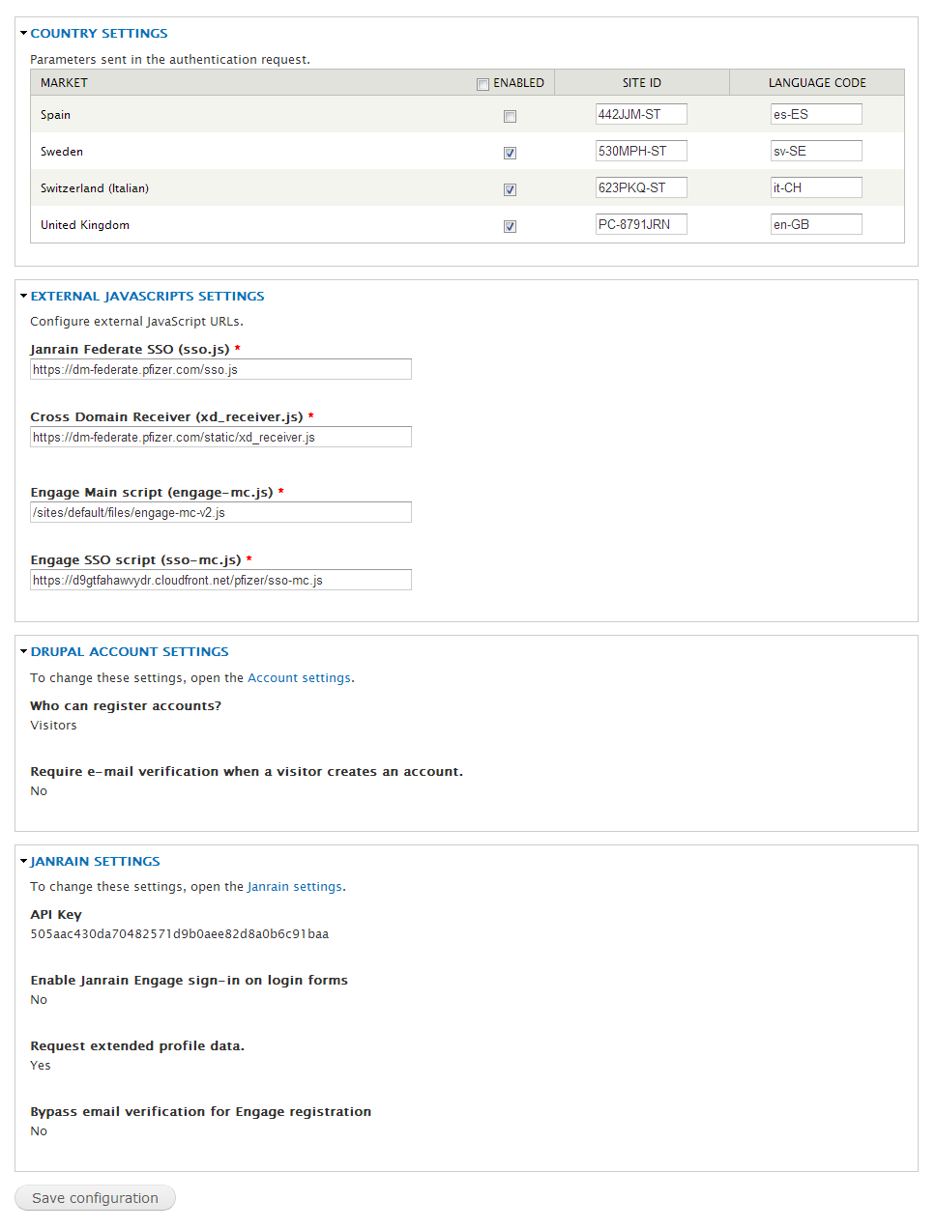
Figure 10 - Module configuration interface

The configurable variables that were identified at this point and will be included in this release, but not limited to them, are:
    - Market settings
      - Enabled – Defines whether it has to be shown in the dropdown at the landing page.
      - Site ID – Field that holds the site ID that is passed to PAC.
      - Language code – Field that specifies the language code that is sent to PAC.
    - External Javascript settings
Fields that define where JanRain library can be found. They will be pre-set to a hardcoded value, but can be changed at any time if necessary.
    - Drupal account settings
Read-only section that easily shows the current account settings. Also provides a link to the section where these configurations can be changed.
    - JanRain settings
Read-only section that easily shows the current JanRain settings. Also provides a link to the section where these configurations can be changed.

IDP Initiated login configurations
Form element on a Drupal sites with following info:
Form action: https://groxs40b3a.pfizer.com:4443/sites/registration/pages/Login.aspx
successurl: https://devfederate.pfizer.com/idp/startSSO.ping?PartnerSpId=https://pfizer.rpxstaging.com&TARGET=https://pfizer.rpxstaging.com
failureurl: url where user will be taken in case of authentication failure (This is typically same as login page and should accept parameter errorcode which will be set by PAC)
username
password

IDP initiated registration auto login configurations
Drupal should send user to following registration page
https://qa.pfizerpro.com/sites/registration/pages/registration.aspx?CampaignID=[provide CampaignID here]
&successURL=https://devfederate.pfizer.com/idp/startSSO.ping
?PartnerSpId=[provide PartnerSpId here]
&amp;TARGET=[provide TARGET here]
&siteID=999

Check SSO session for PAC
There is a requirement to check PAC/PING SSO session and log user in if user has an existing PAC session. To meet this requirement, it is proposed to use IDP initiated flow. PAC will be called with success and failure url parameters and PAC will redirect to successurl if PAC session exists. If PAC session does not exist then it will redirect to the failure url.
Following url is proposed:

https:// accountcenterstg.pfizer.com/sites/registration/pages/checksso.aspx?successurl= https://devfederate.pfizer.com/idp/startSSO.ping
?PartnerSpId=[provide PartnerSpId here]
&amp;TARGET=[provide TARGET here] &siteID=999&failureurl=[home page of Drupal site/SP]

JanRain Scope and Design

Scope
A new connector will be developed to have JanRain libraries support SAML integration with PingFederate. Initially, the Service Provider (SP) initiated approach will be supported and used to have the login flow working. In a next release, the Identity Provider initiated approach support will be added and potentially used for the registration flow.
Furthermore, any configuration to JanRain’s components including, but not limited to: SAML endpoints, metadata import/export, and so forth are in scope. These include multiple entity ids for the same endpoint; which are, for this project, PAC and PXED entity ids.

Design

Javascript / UI Configuration
- Drupal will host all configuration files:
  - Drupal Gardens
    - http://d9gtfahawvydr.cloudfront.net/pfizer/engage-dg.js
  - Managed Cloud
    - http://d9gtfahawvydr.cloudfront.net/pfizer/sso-mc.js
    - http://d9gtfahawvydr.cloudfront.net/pfizer/engage-mc-v2.js
- The following additional configuration has to be added to the Engage settings to set up the two SAML providers:
janrain.settings.customSAML = true; janrain.settings.customSAMLProviderID = ['pfizer-pac', 'pfizer-emp'];
- The function calls below kick off either flow and should be binded to each login flow:

janrain.engage.signin.triggerFlow('pfizer-pac');
janrain.engage.signin.triggerFlow('pfizer-emp');

Janrain / Pfizer Field Mapping

Pfizer Field | Janrain Merged Poco
pfizerexternalguid | profile/identifier  merged_poco/id
firstName | profile/name/givenName  merged_poco/name/givenName
lastName | profile/name/lastName  merged_poco/name/familyName
Mail | profile/email  merged_poco/emails
postalAddress | profile/address/streetAddress  merged_poco/addresses/streetAddress
PFPZip | profile/address/postalCode  merged_poco/addresses/postalCode
telephoneNumber | profile/phoneNumber  merged_poco/phoneNumbers
Groups | provider/pfizer/groups
categories | provider/pfizer/categories
pfizerPartyId | provider/pfizer/partyId

Attributes for employee portal
Pfizer Field | Janrain Merged Poco
pfizerexternalguid | profile/identifier  merged_poco/id
firstName | profile/name/givenName  merged_poco/name/givenName
lastName | profile/name/lastName  merged_poco/name/familyName
Mail | profile/email  merged_poco/emails
Uid | Provider/uid
Group | Provider/group

PingFederate Scope and Design

Scope
PingFederate will be responsible to play the role of Identity Provider (IDP) whenever SAML messages have to be exchanged to single sign-on users into the application. JanRain, which in this integration is the Service Provider (SP), will exchange messages with PingFederate in order to log users in.

Design
There are two main tasks that have to be done to have PingFederate integrate with JanRain:
- Setup
  - Create a new assertion endpoint (HTTPS) for each environment.
- Exchange metadata
  - Export metadata file and hand it over to JanRain.
  - Import JanRain metadata file to map their Service Provider (SP).
The sample assertion XML message below demonstrates how and what attributes should be passed from PingFederate to JanRain.

The metadata file is an XML file describing the endpoints, certificates, and other necessary information necessary for one party to connect to another. Below there is an example of a metadata file.


PAC Scope and Design

Scope
PAC is currently live and can already be used as an authentication party for Pfizer applications. However, our goal is to have PAC shown in an iframe window, and new layout will have to be built to accomplish this. The new screens will not have the header, footer, etc. and will have to fit an iframe.
A web style guide and wireframes will be put together and provided to PAC team. These deliverables will provide everything that’s necessary for building a new layout. Then, new login and registration screens will have to be built accordingly and tested in iframes. Forgot password and other not mentioned functionalities are not part of the scope for this project.

Current layout
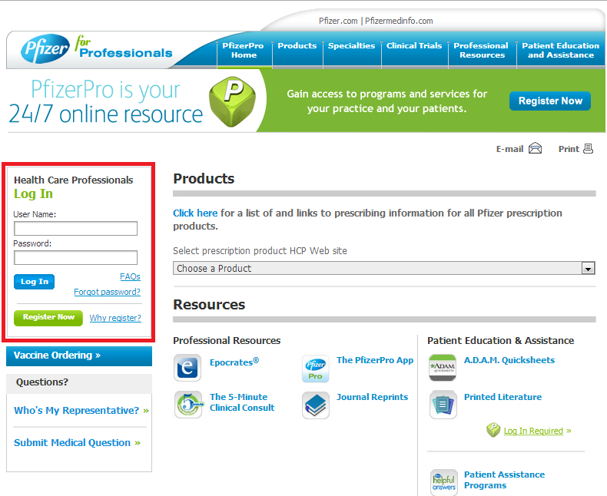
Figure 11 - A new layout will be put together to fit inside an iframe based on the login box in red.
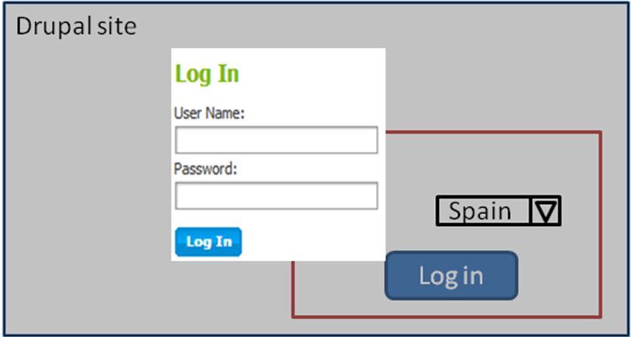
Figure 12 - Proposed layout for the first release shown in an iframe.
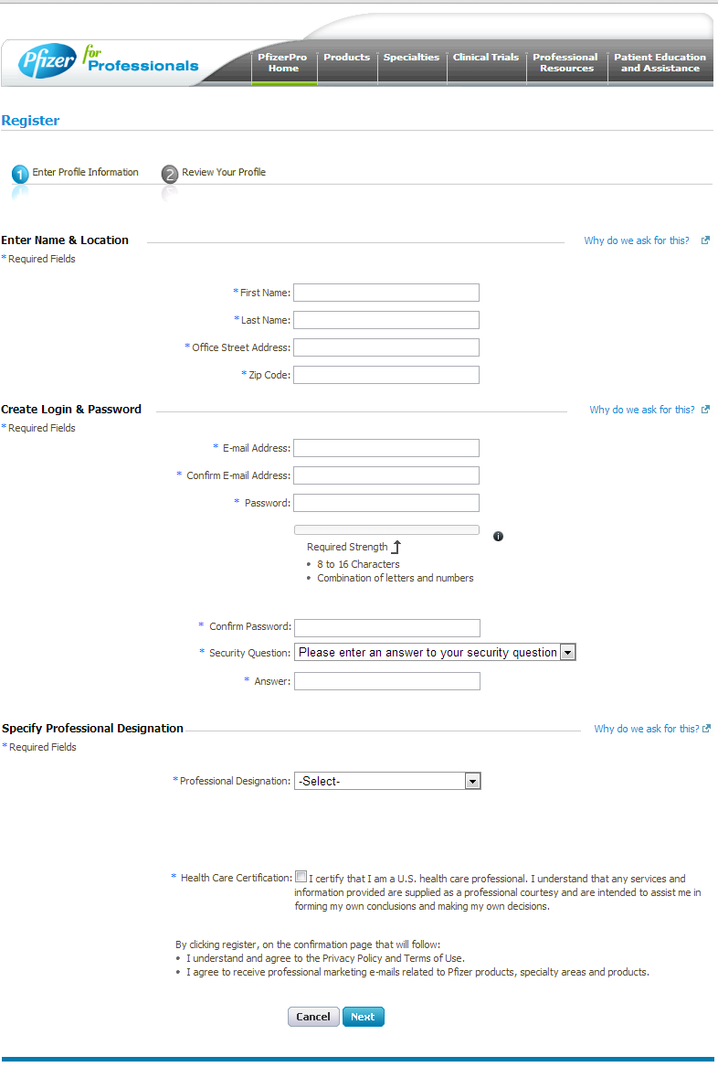
Figure 13 - A new registration screen will be created to fit an iframe.

Supporting References

http://en.wikipedia.org/wiki/Janrain

http://en.wikipedia.org/wiki/Janrain

http://searchsecurity.techtarget.com/definition/single-sign-on

http://drupal.org/about

http://wiki.apache.org/tapestry/PingFederate

http://technet.microsoft.com/en-us/library/cc780036(WS.10).aspx#w2k3tr_ad_over_qbjd

