1. User interface is the front-end application view to which user interacts in order to use the software.
2. User can manipulate and control the software as well as hardware by means of user interface.
3. Today, user interface is found at almost every place where digital technology exists, right from computers, mobile phones, cars, music players, airplanes, ships etc.

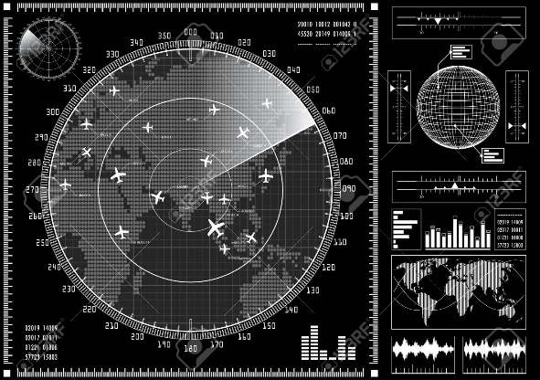 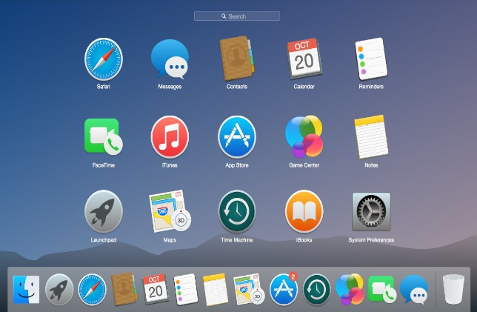 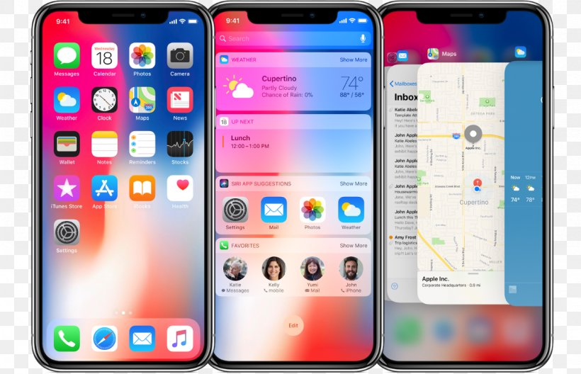

1. UI provides fundamental platform for human-computer interaction.
2. UI can be graphical, text-based, audio-video based, depending upon the underlying hardware and software combination. UI can be hardware or software or a combination of both.
3. The software becomes more popular if its user interface is:

* Attractive(Hấp dẫn)
* Simple to use(Dễ dàng sử dụng)
* Responsive in short time(Thời gian đáp ứng ngắn)
* Consistent on all interfacing screens(Đồng nhất tất cả các màn hình giao diện khi hiển thị cho người dùng)

1. UI is broadly divided into two categories:

* Command Line Interface
* Graphical User Interface