Logo & Company Name
System/Software Requirements Specification
for
Life Insurance Customer Management System
Version 1.0
Prepared by KhoiVT
FPT University
28/02/2021
Table of Contents
Table of Contents ii
Revision History iii
1. Introduction 1
1.1 Purpose 1
1.2 System Purpose 1
1.3 Definitions, Acronyms and Abbreviations 1
1.4 Document Conventions 1
1.5 Intended Audience and Reading Suggestions 1
1.6 Project Scope 1
1.7 References 2
2. Overall Description 2
2.1 Product/System Perspective 2
2.2 System/Product Features 2
2.3 User requirements 2
2.4 User Classes and Characteristics 2
2.5 Operating Environment 2
2.6 Design and Implementation Constraints 3
2.7 User Documentation 3
2.8 Assumptions and Dependencies 3
2.9 Apportioning of Requirements 3
3. Specific Requirements 3
3.1 Functional Requirements Specification 3
3.1.1 Function1 /Use-case 1 3
3.1.2 UC01-Login<Sample> 4
3.1.3 Function2 /Use-case 2 5
3.2 Non-Functional Requirements Specification 5
3.2.1 External Interface Requirements 5
3.2.2 Other Nonfunctional Requirements 6
4. Other Requirements 7
Appendix A: Glossary 7
Appendix B: Analysis Models 7
Appendix C: Issues List 7

Revision History
Name | Date | Reason For Changes | Version
Life Insurance Customer Management System | 28/02/2021 | Review | 1.0

Introduction

Purpose
<Describe the document purposes; what information this document will contain; who are readers that this document aims at…>
The purpose of this document is to build an Life Insurance Customer Management System to manage and take care their customer to improve their customer service

System Purpose
<Identify the product whose system requirements are specified in this document, including the revision or release number. Describe the system objectives, scope of the product that is covered by this SRS, particularly if this SRS describes only part of the system or a single subsystem.>

This product is the new version and it is a part of the subsy that is built for customer manager or customer care staff can manage and support their customer in the better way. That is also our wish to help customers to has the best user experience.

Definitions, Acronyms and Abbreviations
<Describe all common business/technical definitions, acronyms, and abbreviations that are used in the whole document>
Life Insurance : insurance that pays out a sum of money either on the death of the insured person or after a set period.
customer care staff: the assistance that customers receive from a company or its sales staff. Supporting customers through the process of selecting, purchasing, and maintaining a product or service can be done by hiring knowledgeable employees, providing online or telephone support, offering generous return policies, or including warranties that guarantee customer satisfaction.
User experience: the experience of someone using a product, system, or service, for example whether they find it enjoyable and easy to use

Document Conventions
<Describe any standards or typographical conventions that were followed when writing this SRS, such as fonts or highlighting that have special significance. For example, state whether priorities for higher-level requirements are assumed to be inherited by detailed requirements, or whether every requirement statement is to have its own priority.>
The Bold text: the common business/technical word.
The Italic text: the definition of the common business/technical word.

Intended Audience and Reading Suggestions
<Describe the different types of reader that the document is intended for, such as developers, project managers, marketing staff, users, testers, and documentation writers. Describe what the rest of this SRS contains and how it is organized. Suggest a sequence for reading the document, beginning with the overview sections and proceeding through the sections that are most pertinent to each reader type.>
The audience and reader should be the developers, project managers, testers, document writers, users. The document is organized by beginning with introduction and overall so readers can have overview for this project. If reader want to know how product look like or how it work they can read Specific Requirement part that contain GUI and diagram that describe product.

Project Scope
<Provide a short description of the software being specified and its purpose, including relevant benefits, objectives, and goals. Relate the software to corporate goals or business strategies. If a separate vision and scope document is available, refer to it rather than duplicating its contents here. An SRS that specifies the next release of an evolving product should contain its own scope statement as a subset of the long-term strategic product vision.>
The product is built for an Life Insurance company that help them to manage customer more effective. Moreover, it can help research customer’s behavior and develop their service to have more advantage in the future.

References
<List any other documents or Web addresses to which this SRS refers. These may include user interface style guides, contracts, standards, system requirements specifications, use case documents, or a vision and scope document. Provide enough information so that the reader could access a copy of each reference, including title, author, version number, date, and source or location.>
References for Business/Technical word Definitions: https://dictionary.cambridge.org/
References for Insurance Business: https://www.aia.com.vn/

Overall Description

Product/System Perspective
<Describe the context and origin of the product being specified in this SRS. For example, state whether this product is a follow-on member of a product family, a replacement for certain existing systems, or a new, self-contained product. If the SRS defines a component of a larger system, relate the requirements of the larger system to the functionality of this software and identify interfaces between the two. A simple diagram that shows the major components of the overall system, subsystem interconnections, and external interfaces can be helpful.>

System/Product Features
<Summarize the major features the product contains or the significant functions that it performs or lets the user perform. Details will be provided in Section 3, so only a high level summary is needed here. Organize the functions to make them understandable to any reader of the SRS. A picture of the major groups of related requirements and how they relate, such as a top level data flow diagram or a class diagram, is often effective.>

User requirements
<List of all requirements comes from end users>

User Classes and Characteristics
<Identify the various user classes that you anticipate will use this product. User classes may be differentiated based on frequency of use, subset of product functions used, technical expertise, security or privilege levels, educational level, or experience. Describe the pertinent characteristics of each user class. Certain requirements may pertain only to certain user classes. Distinguish the favored user classes from those who are less important to satisfy.>

Operating Environment
<Describe the environment in which the software will operate, including the hardware platform, operating system and versions, and any other software components or applications with which it must peacefully coexist.>

Design and Implementation Constraints
<Describe any items or issues that will limit the options available to the developers. These might include: corporate or regulatory policies; hardware limitations (timing requirements, memory requirements); interfaces to other applications; specific technologies, tools, and databases to be used; parallel operations; language requirements; communications protocols; security considerations; design conventions or programming standards (for example, if the customer’s organization will be responsible for maintaining the delivered software).>

User Documentation
<List the user documentation components (such as user manuals, on-line help, and tutorials) that will be delivered along with the software. Identify any known user documentation delivery formats or standards.>

Assumptions and Dependencies
<List any assumed factors (as opposed to known facts) that could affect the requirements stated in the SRS. These could include third-party or commercial components that you plan to use, issues around the development or operating environment, or constraints. The project could be affected if these assumptions are incorrect, are not shared, or change. Also identify any dependencies the project has on external factors, such as software components that you intend to reuse from another project, unless they are already documented elsewhere (for example, in the vision and scope document or the project plan).>

Apportioning of Requirements
<List of all the requirements is optional. They can be deferred to the future or not necessary to implement >

Specific Requirements
<This template illustrates organizing the functional requirements for the product by system features, the major services provided by the product. You may prefer to organize this section by use case, mode of operation, user class, object class, functional hierarchy, or combinations of these, whatever makes the most logical sense for your product.>

Functional Requirements Specification

Function1 /Use-case 1
<Describe the system scenarios (interactions between software-to-be and other system components) basing on scenarios technique>
….
And business rules for this function/use-case
….

Product Statistical

Screen Design

Figure 3-1: Screen Design of Login

Table 3-1: Screen Definition
# | Field Name | Type | Mandatory | Max Length | Description
1 | Generate report | button |  |  | Generate report for manager
2 | Line chart customer access | Line chart |  |  | Display data about number customer visit to the website
3 | Pie chart customer age | Pie chart |  |  | Display data age of customer
4 | Column chart product analysis | Column chart |  |  | Display data about number of product buy new and maintain

Use Case Specification

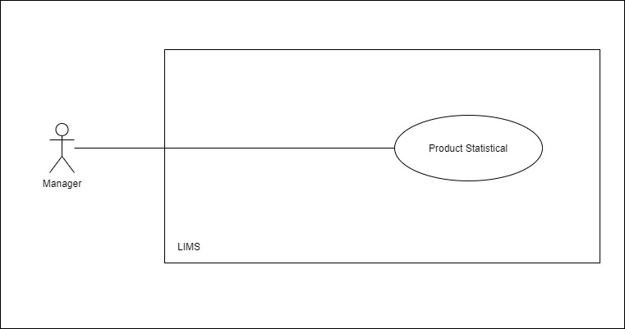 | 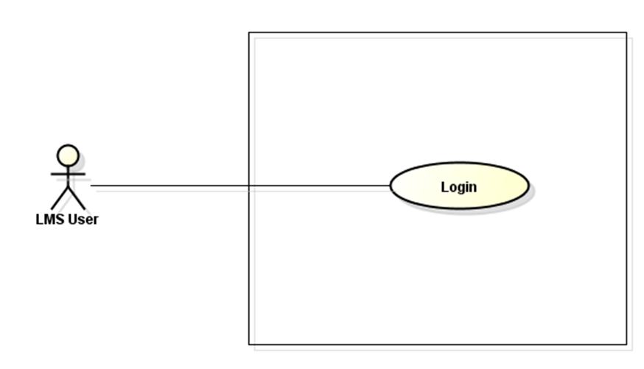  LMS

Figure 3-2: Product Statistical Use-Case Diagram

Use Case ID |  |  | UC01
Use Name |  |  | Product Statistical
Actor |  |  | LIMS User
Description |  |  | The function allows a manager can keep track of statistical about product
Precondition
Trigger
Post-Condition
Main flows
Step | Actor |  | Action
1 | Manager |  | Type URL into location field of internet browser and then press enter
2 | LMS |  | Display Product statistical screen with the following fields:  - Line chart customer access  - Pie chart customer age  - Column chart product analysis  - Generate report button
3 | Manager |  | Enter generate report button.
4 | LIMS |  | Export report to file

Business Rules
# | Rule Description
BR01
BR02

Customer Analysis

Screen Design
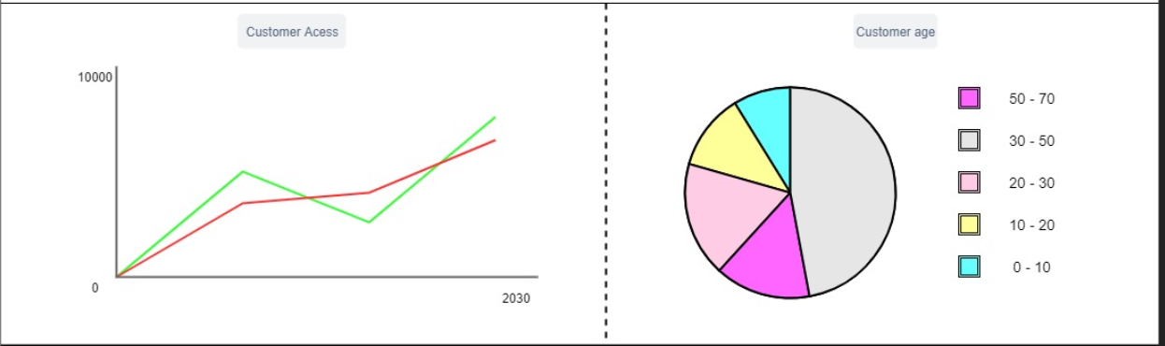

Table 3-1: Screen Definition
# | Field Name | Type | Mandatory | Max Length | Description
1 | Customer Access chart | Line chart |  |  | Display number of customer visit website by time
2 | Customer age chart | Pie chart |  |  | Display data about age group of customer enroll or use product of website

Use Case Specification
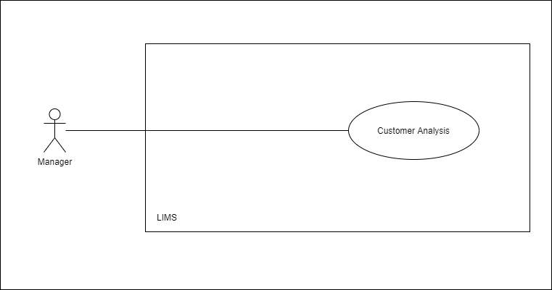

Use Case ID |  | UC02
Use Name |  | Customer Analysis
Actor |  | LIMS User
Description |  | The function allows a manager can keep track of statistical about customer
Precondition
Trigger
Post-Condition
Main flows
Step | Actor | Action
1 | Manager | Type URL into location field of internet browser and then press enter
2 | LIMS | Display Product statistical screen with the following fields:  - Line chart customer access  - Pie chart customer age

Insurance Analysis

Screen Design

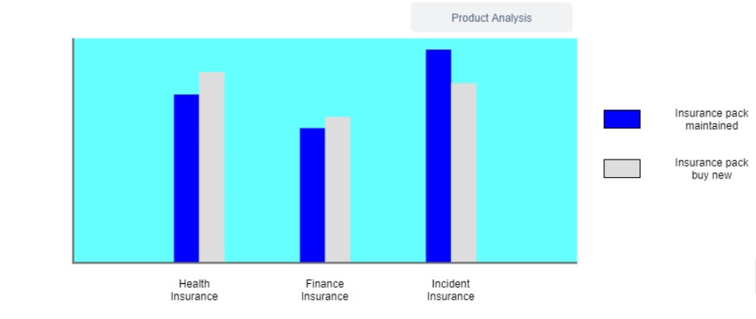
Table 3-1: Screen Definition
# | Field Name | Type | Mandatory | Max Length | Description
1 | Insurance chart | Column chart |  |  | Display number of insurance pack that is bought or maintaining

Use Case Specification
Use Case ID |  | UC02
Use Name |  | Insurance Analysis
Actor |  | LIMS User
Description |  | The function allows a manager can keep track of statistical about Insurance pack and manage it in effective way
Precondition
Trigger
Post-Condition
Main flows
Step | Actor | Action
1 | Manager | Type URL into location field of internet browser and then press enter
2 | LIMS | Display Product statistical screen with the following fields:  - Column chart Insurance analysis

Non-Functional Requirements Specification

External Interface Requirements

User Interfaces
<Describe the logical characteristics of each interface between the software product and the users. This may include sample screen images, any GUI standards or product family style guides that are to be followed, screen layout constraints, standard buttons and functions (e.g., help) that will appear on every screen, keyboard shortcuts, error message display standards, and so on. Define the software components for which a user interface is needed. Details of the user interface design should be documented in a separate user interface specification.>

Hardware Interfaces
<Describe the logical and physical characteristics of each interface between the software product and the hardware components of the system. This may include the supported device types, the nature of the data and control interactions between the software and the hardware, and communication protocols to be used.>

Software Interfaces
<Describe the connections between this product and other specific software components (name and version), including databases, operating systems, tools, libraries, and integrated commercial components. Identify the data items or messages coming into the system and going out and describe the purpose of each. Describe the services needed and the nature of communications. Refer to documents that describe detailed application programming interface protocols. Identify data that will be shared across software components. If the data sharing mechanism must be implemented in a specific way (for example, use of a global data area in a multitasking operating system), specify this as an implementation constraint.>

Communications Interfaces
<Describe the requirements associated with any communications functions required by this product, including e-mail, web browser, network server communications protocols, electronic forms, and so on. Define any pertinent message formatting. Identify any communication standards that will be used, such as FTP or HTTP. Specify any communication security or encryption issues, data transfer rates, and synchronization mechanisms.>

Other Nonfunctional Requirements

Performance Requirements
<If there are performance requirements for the product under various circumstances, state them here and explain their rationale, to help the developers understand the intent and make suitable design choices. Specify the timing relationships for real time systems. Make such requirements as specific as possible. You may need to state performance requirements for individual functional requirements or features.

This section lists all requirements whose Category has been stated in the goal model to be ‘performance’>

Design constraints
<This section lists all requirements whose Category has been stated in the goal model to be ‘development’ or ‘architecture’ (see Figure 7.5)

Safety Requirements
<Specify those requirements that are concerned with possible loss, damage, or harm that could result from the use of the product. Define any safeguards or actions that must be taken, as well as actions that must be prevented. Refer to any external policies or regulations that state safety issues that affect the product’s design or use. Define any safety certifications that must be satisfied.

This section lists all requirements whose Category has another value e.g. ‘safety’

>

Security Requirements
<Specify any requirements regarding security or privacy issues surrounding use of the product or protection of the data used or created by the product. Define any user identity authentication requirements. Refer to any external policies or regulations containing security issues that affect the product. Define any security or privacy certifications that must be satisfied.>

Software Quality Attributes
<Specify any additional quality characteristics for the product that will be important to either the customers or the developers. Some to consider are: adaptability, availability, correctness, flexibility, interoperability, maintainability, portability, reliability, reusability, robustness, testability, and usability. Write these to be specific, quantitative, and verifiable when possible. At the least, clarify the relative preferences for various attributes, such as ease of use over ease of learning.

This section lists all requirements whose Category has another value e.g. ‘accuracy’ >

Other Requirements
<Define any other requirements not covered elsewhere in the SRS. This might include database requirements, internationalization requirements, legal requirements, reuse objectives for the project, and so on. Add any new sections that are pertinent to the project.>
Appendix A: Glossary
<Define all the terms necessary to properly interpret the SRS, including acronyms and abbreviations. You may wish to build a separate glossary that spans multiple projects or the entire organization, and just include terms specific to a single project in each SRS.>
Appendix B: Analysis Models
<Optionally, include any pertinent analysis models, such as data flow diagrams, class diagrams, state-transition diagrams, or entity-relationship diagrams.>
Appendix C: Issues List
< This is a dynamic list of the open requirements issues that remain to be resolved, including TBDs, pending decisions, information that is needed, conflicts awaiting resolution, and the like.>

