GGR 321 – Assignment 1: Model Builder

Ziran Jeffrey Zhou – 1002425477

**Part 1 – 2: Attribute Exploration**

Question 1. [2 marks]. Fill in Table 1 with the correct data type and level of measurement of each variable.

|  |  |  |
| --- | --- | --- |
| Field Name | Data Type | Level of Measurement |
| Type | String | Nominal |
| MunID | Numeric | Nominal |
| POP2011 | Numeric | Ratio |
| PopRank | Numeric | Ordinal |
| AvgTemp | Numeric | Interval |

Question 2. [3 Marks] Which projection (Include the WKID) and field type did you select?

I used the Canada Albers Equal Area Conic Projected Coordinate Systems WKID 102001 since it is an equal area projection. The field type used is Double since it has the largest size to accommodate fractional values

Question 3. [2 marks] What is the *Township* with the largest area? And what is its area in square kilometers?

The Township with the largest area is Northern Bruce Peninsula with an area of 3508.089106 SqKM.

**Part 2 – 1: Model Builder**

Question 1. [1 Mark] What is the cell size of your new raster layer?

The cell size is 50 meters.

Question 2. [2 Marks] Which is the better data model for representing municipal boundaries, raster or vector, and why?

Municipal boundaries would better be represented with vector data, as boundaries contain lines that separate boundaries, which are harder to represent in raster. Additionally, Canadian municipals are usually very large in size, thus raster representation would require create a large file size.

**Part 2 – 2: Raster to Vector**

Question 3. [3 marks]. Create a figure showing the differences between the simplified polygon of Thunder Bay and the un-simplified polygon of Thunder Bay.

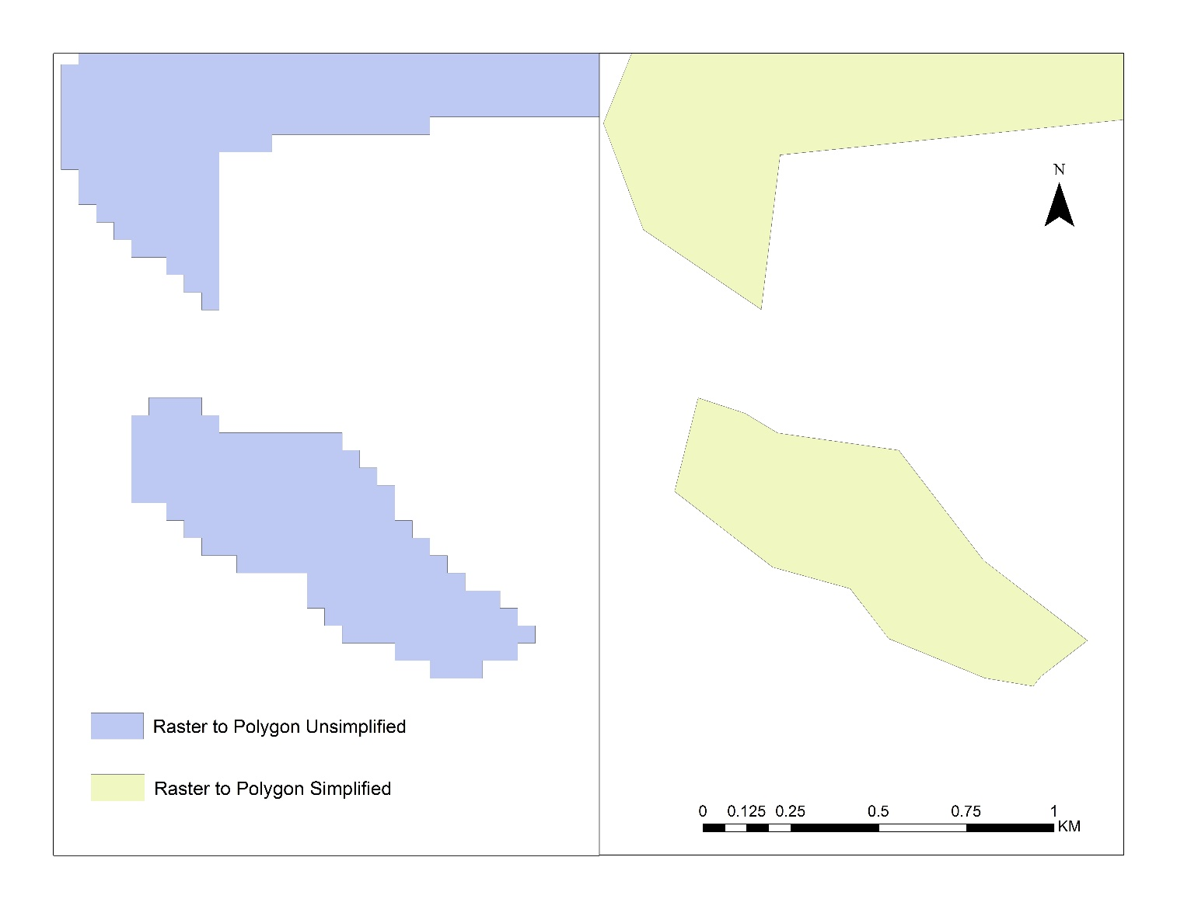

Figure 1: Comparison between unsimplified and simplified raster to polygon. Note how the simplified (yellow) polygon as smoothed edges while the unsimplified (blue) polygon has right angle edges. This is due to the cell shaped nature of raster data creating blocks.

Question 4. [1 Mark] Include a graphic of your Model Builder that shows the selection of Thunder Bay and the creation of the two vector files.

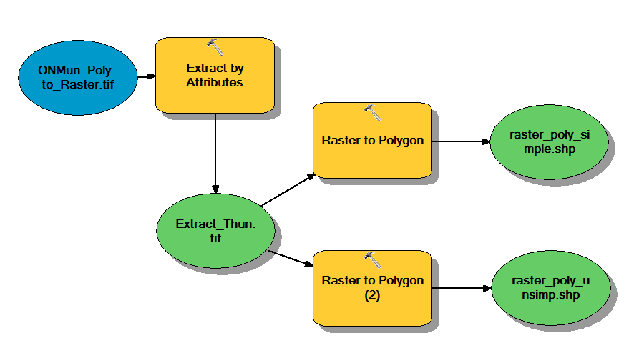

**Part 2 – 3: Site Selection**

Question 5. [12 marks] Create a figure showing the suitable agricultural land (binary 1 = Yes). Include a copy of your Model Builder.

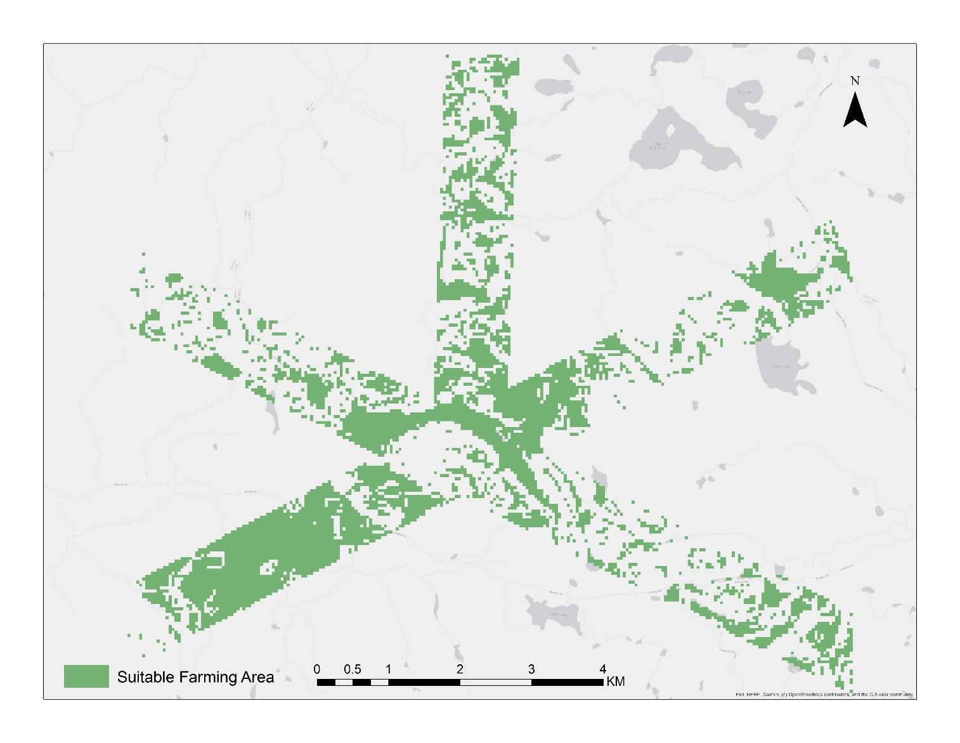

Figure 2: Areas suitable for agricultural land. The green areas indicate land that has a slope increase less than 5%, while being within 500 meters from a main road.

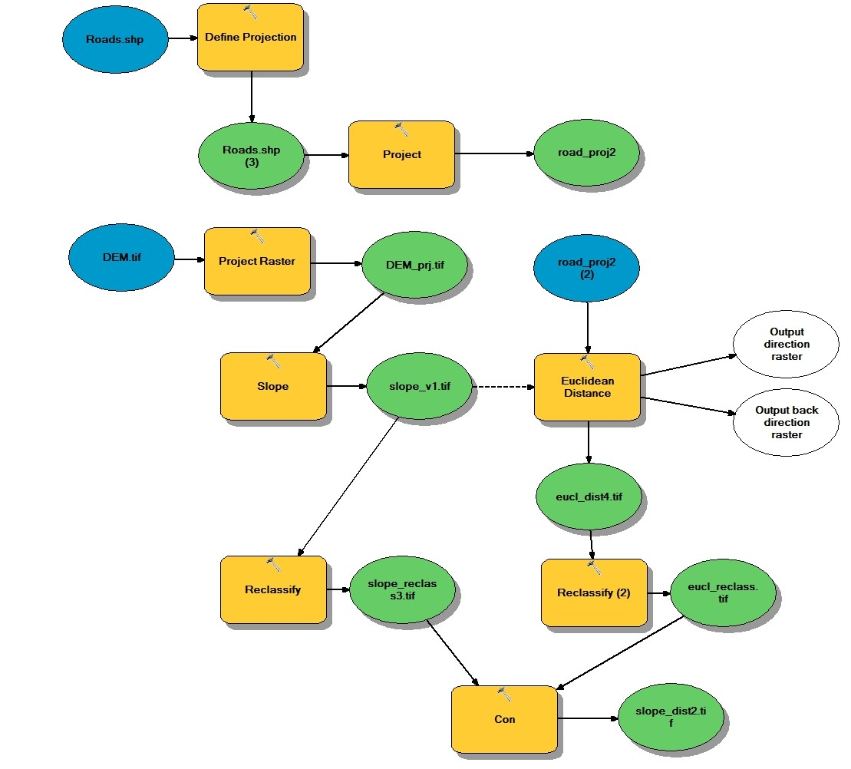

**Please note the following error when trying to connect the **road_proj2** file to the **Euclidean Distance** tool. Model builder could not connect the file directly from the projection output, thus, I had to create a new input named **road_proj2(2)** to connect to the **Euclidean Distance** tool. However, this new input file is the same as the output from the **Project** tool.

ERROR 000865: Input raster or feature source data: \\medusa\StudentWork\zhouzir1\GGR321\Assignment 1\Part 2 Model Builder\road_proj2 does not exist.

ERROR 000581: Invalid parameters.

Failed to execute (Euclidean Distance).

Failed at Thu Sep 26 18:50:16 2019 (Elapsed Time: 0.11 seconds)