山西大学
实验报告
姓 名 | 牛璐瑶 |  |  | 学 号 | 202201006124 |  | 专业班级 | 人工智能
课程名称 | 中文信息处理技术实验 |  |  |  |  |  |  | 实验日期 | 2024.4.8
成 绩 |  |  |  | 指导老师 |  | 王元龙 |  | 批改日期
实验名称 |  | 实验七 基于Word2Vec的文本表示
一、实验目的：
本课程作业加深对汉语文本信息处理基础理论及方法的认识和了解，锻炼和提高分析问题、解决问题的能力。通过对具体项目的任务分析、数据准备、算法设计和编码实现以及测试评价几个环节的练习，基本掌握实现一个自然语言处理系统的基本过程。
二、实验说明：
该子任务使用gensim工具包中的Word2Vec模型。

要求熟练掌握工具包安装、数据读取、模型训练、参数调整、结果保存、模型加载以及词向量获取相关内容。
主要流程如下：
1) gensim安装(https://radimrehurek.com/gensim/) 。请自行配置pip和anaconda环境，可使用以下两种方式进行安装。
pip安装：Run in your terminal (recommended)
pip install --upgrade gensim
conda安装：Run in your Anaconda Prompt
conda install -c conda-forge gensim

- 详细阅读word2vec模型的说明文档(https://radimrehurek.com/gensim/models/word2vec.html)，了解各函数的基本使用方法和参数意义。
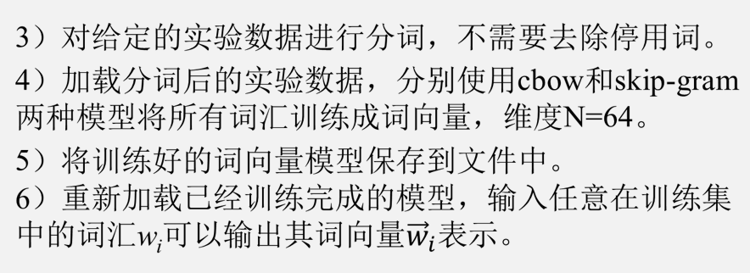
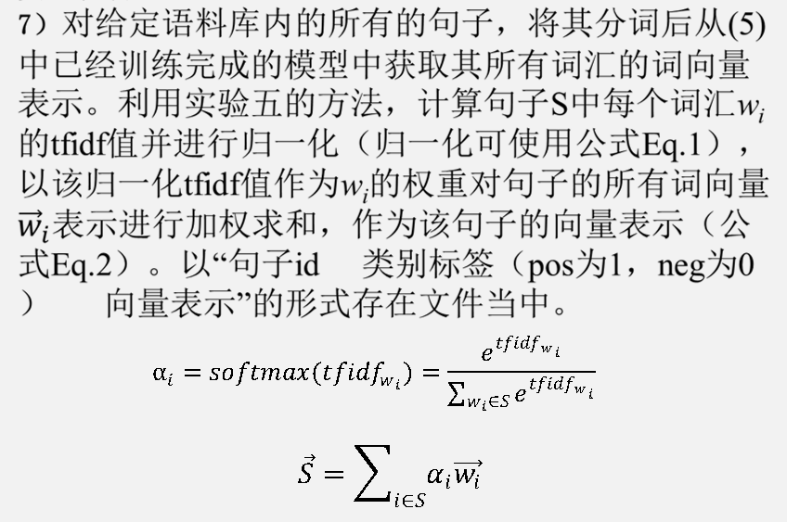

三、实验数据说明：
实验数据采用htl_del_4000宾馆情感分析数据进行处理，所有数据已按照情感极性划分为褒(pos)贬(neg)两类，各2000篇，每个文本文件为一篇文章，实验数据需要先进行分词，分词方法不限。
- 实验代码及结果截图：
import logging
import sys
import jieba
import gensim.models as word2vec
from gensim.models.word2vec import logger
sentence = []
for i in range(0, 2670):
try:
with open(f'.\自然语言处理实验数据\htl_del_4000\\neg\\neg.{i}.txt', encoding='GBK', errors='ignore') as f1:
for line in f1:
if line == "\n":
continue
sentence.append(jieba.lcut(line.strip()))
except FileNotFoundError:
pass
for i in range(4, 2670):
try:
with open(f'.\自然语言处理实验数据\htl_del_4000\\pos\\pos.{i}.txt', encoding='GBK', errors='ignore') as f2:
for line in f2:
if line == "\n":
continue
sentence.append(jieba.lcut(line.strip()))
except FileNotFoundError:
pass
logging.basicConfig(format='%(asctime)s : %(levelname)s : %(message)s', level=logging.INFO)
logger.info("running %s" % ' '.join(sys.argv))
model = word2vec.Word2Vec(sentences=sentence, min_count=1, vector_size=64, sg=1)
model.build_vocab(sentence, update=True)
model.save("Skip-Gram.model")
# 以CBOW模型存储
logging.basicConfig(format='%(asctime)s : %(levelname)s : %(message)s', level=logging.INFO)
logger.info("running %s" % ' '.join(sys.argv))
model = word2vec.Word2Vec(sentences=sentence, min_count=1, vector_size=64, sg=0)
model.build_vocab(sentence, update=True)
model.save("CBOW.model")
# 加载模型
def load_word2vec_model(w2v_path):
Model = word2vec.Word2Vec.load(w2v_path)
return Model
model = load_word2vec_model("CBOW.model")
print(model.wv["好评"].tolist())
model = load_word2vec_model("Skip-Gram.model")
print(model.wv["好评"].tolist())
from math import log
import jieba
dicts = {}
for i in range(0, 2670):
try:
with open(f'.\自然语言处理实验数据\htl_del_4000\\neg\\neg.{i}.txt', encoding='GBK', errors='ignore') as f1:
for sentence_to_cut in f1:
sentence = jieba.lcut(sentence_to_cut.strip())
for word in sentence:
if word not in dicts:
dicts[word] = 1
else:
dicts[word] += 1
except FileNotFoundError:
pass
for i in range(4, 2670):
try:
with open(f'.\自然语言处理实验数据\htl_del_4000\\pos\\pos.{i}.txt', encoding='GBK', errors='ignore') as f2:
for sentence_to_cut in f2:
sentence = jieba.lcut(sentence_to_cut.strip())
for word in sentence:
if word not in dicts:
dicts[word] = 1
else:
dicts[word] += 1
except FileNotFoundError:
pass
with open("句子向量表示.txt", 'w', encoding='utf8') as f4:
for i in range(0, 2670):
try:
with open(f'.\自然语言处理实验数据\htl_del_4000\\neg\\neg.{i}.txt', encoding='GBK', errors='ignore') as f5:
sentence = []
sentence_vec = []
for sentence_to_cut in f5:
if sentence_to_cut == "\n":
continue
sentence += jieba.lcut(sentence_to_cut.strip())
for word in sentence:
if word in dicts:
fre = dicts[word]
else:
fre = 0
sentence_vec.append((sentence.count(word) / len(sentence)) * log(4000 / (fre + 1)))
f4.write(f"neg{i}\t{sentence_vec}\n")
except FileNotFoundError:
pass
for i in range(4, 2670):
try:
with open(f'.\自然语言处理实验数据\htl_del_4000\\pos\\pos.{i}.txt', encoding='GBK', errors='ignore') as f6:
sentence = []
sentence_vec = []
for sentence_to_cut in f6:
if sentence_to_cut == "\n":
continue
sentence += jieba.lcut(sentence_to_cut.strip())
for word in sentence:
if word in dicts:
fre = dicts[word]
else:
fre = 0
sentence_vec.append((sentence.count(word) / len(sentence)) * log(4000 / (fre + 1)))
f4.write(f"pos{i}\t{sentence_vec}\n")
except FileNotFoundError:
pass
import gensim.models as word2vec
import jieba
import numpy as np
import torch
model = word2vec.Word2Vec.load("Skip-Gram.model")
All_sentence_vec = []
for i in range(0, 2670):
try:
with open(f'.\自然语言处理实验数据\htl_del_4000\\neg\\neg.{i}.txt', encoding='GBK', errors='ignore') as f1:
sentence = []
for line in f1:
if line == "\n":
continue
for j in jieba.lcut(line.strip()):
sentence.append(model.wv[j].tolist())
All_sentence_vec.append(sentence)
except FileNotFoundError:
pass
for i in range(4, 2670):
try:
with open(f'.\自然语言处理实验数据\htl_del_4000\\pos\\pos.{i}.txt', encoding='GBK', errors='ignore') as f2:
sentence = []
for line in f2:
if line == "\n":
continue
for j in jieba.lcut(line.strip()):
sentence.append(model.wv[j].tolist())
All_sentence_vec.append(sentence)
except FileNotFoundError:
pass
All_sentence_tfidf = []
All_sentence_id = []
with open("句子向量表示.txt", 'r', encoding="utf8") as f3:
for line in f3:
tfidf = list(eval(line.strip().split('\t')[1]))
sentence_id = line.strip().split('\t')[0]
All_sentence_id.append(sentence_id)
All_sentence_tfidf.append(tfidf)
with open("实验七.txt", 'w', encoding='utf8') as f4:
for i in range(0, len(All_sentence_tfidf)):
sentence_id = All_sentence_id[i]
sentence_class = sentence_id[0:3]
if sentence_class == "neg":
sentence_class = 0
else:
sentence_class = 1
sentence_tfidf = torch.tensor(np.array(All_sentence_tfidf[i]))
TFIDF_wight = torch.softmax(sentence_tfidf, dim=0)
tfidf_wight = []
for num in TFIDF_wight:
tfidf_wight.append([num])
tfidf_wight = torch.tensor(tfidf_wight)
sentence_vec = torch.tensor(All_sentence_vec[i])
output = (tfidf_wight * sentence_vec).sum(dim=0).tolist()
f4.write(f"{sentence_id}\t{sentence_class}\t{output}\n")
import logging
import sys
import jieba
import gensim.models as word2vec
from gensim.models.word2vec import logger
sentence = []
for i in range(0, 2670):
try:
with open(f'.\自然语言处理实验数据\htl_del_4000\\neg\\neg.{i}.txt', encoding='GBK', errors='ignore') as f1:
for line in f1:
if line == "\n":
continue
sentence.append(jieba.lcut(line.strip()))
except FileNotFoundError:
pass
for i in range(4, 2670):
try:
with open(f'.\自然语言处理实验数据\htl_del_4000\\pos\\pos.{i}.txt', encoding='GBK', errors='ignore') as f2:
for line in f2:
if line == "\n":
continue
sentence.append(jieba.lcut(line.strip()))
except FileNotFoundError:
pass
logging.basicConfig(format='%(asctime)s : %(levelname)s : %(message)s', level=logging.INFO)
logger.info("running %s" % ' '.join(sys.argv))
model = word2vec.Word2Vec(sentences=sentence, min_count=1, vector_size=64, sg=1)
model.build_vocab(sentence, update=True)
model.save("Skip-Gram.model")
# 以CBOW模型存储
logging.basicConfig(format='%(asctime)s : %(levelname)s : %(message)s', level=logging.INFO)
logger.info("running %s" % ' '.join(sys.argv))
model = word2vec.Word2Vec(sentences=sentence, min_count=1, vector_size=64, sg=0)
model.build_vocab(sentence, update=True)
model.save("CBOW.model")
# 加载模型
def load_word2vec_model(w2v_path):
Model = word2vec.Word2Vec.load(w2v_path)
return Model
model = load_word2vec_model("CBOW.model")
print(model.wv["好评"].tolist())
model = load_word2vec_model("Skip-Gram.model")
print(model.wv["好评"].tolist())
from math import log
import jieba
dicts = {}
for i in range(0, 2670):
try:
with open(f'.\自然语言处理实验数据\htl_del_4000\\neg\\neg.{i}.txt', encoding='GBK', errors='ignore') as f1:
for sentence_to_cut in f1:
sentence = jieba.lcut(sentence_to_cut.strip())
for word in sentence:
if word not in dicts:
dicts[word] = 1
else:
dicts[word] += 1
except FileNotFoundError:
pass
for i in range(4, 2670):
try:
with open(f'.\自然语言处理实验数据\htl_del_4000\\pos\\pos.{i}.txt', encoding='GBK', errors='ignore') as f2:
for sentence_to_cut in f2:
sentence = jieba.lcut(sentence_to_cut.strip())
for word in sentence:
if word not in dicts:
dicts[word] = 1
else:
dicts[word] += 1
except FileNotFoundError:
pass
with open("句子向量表示.txt", 'w', encoding='utf8') as f4:
for i in range(0, 2670):
try:
with open(f'.\自然语言处理实验数据\htl_del_4000\\neg\\neg.{i}.txt', encoding='GBK', errors='ignore') as f5:
sentence = []
sentence_vec = []
for sentence_to_cut in f5:
if sentence_to_cut == "\n":
continue
sentence += jieba.lcut(sentence_to_cut.strip())
for word in sentence:
if word in dicts:
fre = dicts[word]
else:
fre = 0
sentence_vec.append((sentence.count(word) / len(sentence)) * log(4000 / (fre + 1)))
f4.write(f"neg{i}\t{sentence_vec}\n")
except FileNotFoundError:
pass
for i in range(4, 2670):
try:
with open(f'.\自然语言处理实验数据\htl_del_4000\\pos\\pos.{i}.txt', encoding='GBK', errors='ignore') as f6:
sentence = []
sentence_vec = []
for sentence_to_cut in f6:
if sentence_to_cut == "\n":
continue
sentence += jieba.lcut(sentence_to_cut.strip())
for word in sentence:
if word in dicts:
fre = dicts[word]
else:
fre = 0
sentence_vec.append((sentence.count(word) / len(sentence)) * log(4000 / (fre + 1)))
f4.write(f"pos{i}\t{sentence_vec}\n")
except FileNotFoundError:
pass
import gensim.models as word2vec
import jieba
import numpy as np
import torch
model = word2vec.Word2Vec.load("Skip-Gram.model")
All_sentence_vec = []
for i in range(0, 2670):
try:
with open(f'.\自然语言处理实验数据\htl_del_4000\\neg\\neg.{i}.txt', encoding='GBK', errors='ignore') as f1:
sentence = []
for line in f1:
if line == "\n":
continue
for j in jieba.lcut(line.strip()):
sentence.append(model.wv[j].tolist())
All_sentence_vec.append(sentence)
except FileNotFoundError:
pass
for i in range(4, 2670):
try:
with open(f'.\自然语言处理实验数据\htl_del_4000\\pos\\pos.{i}.txt', encoding='GBK', errors='ignore') as f2:
sentence = []
for line in f2:
if line == "\n":
continue
for j in jieba.lcut(line.strip()):
sentence.append(model.wv[j].tolist())
All_sentence_vec.append(sentence)
except FileNotFoundError:
pass
All_sentence_tfidf = []
All_sentence_id = []
with open("句子向量表示.txt", 'r', encoding="utf8") as f3:
for line in f3:
tfidf = list(eval(line.strip().split('\t')[1]))
sentence_id = line.strip().split('\t')[0]
All_sentence_id.append(sentence_id)
All_sentence_tfidf.append(tfidf)
with open("实验七.txt", 'w', encoding='utf8') as f4:
for i in range(0, len(All_sentence_tfidf)):
sentence_id = All_sentence_id[i]
sentence_class = sentence_id[0:3]
if sentence_class == "neg":
sentence_class = 0
else:
sentence_class = 1
sentence_tfidf = torch.tensor(np.array(All_sentence_tfidf[i]))
TFIDF_wight = torch.softmax(sentence_tfidf, dim=0)
tfidf_wight = []
for num in TFIDF_wight:
tfidf_wight.append([num])
tfidf_wight = torch.tensor(tfidf_wight)
sentence_vec = torch.tensor(All_sentence_vec[i])
output = (tfidf_wight * sentence_vec).sum(dim=0).tolist()
f4.write(f"{sentence_id}\t{sentence_class}\t{output}\n")
实验结果：
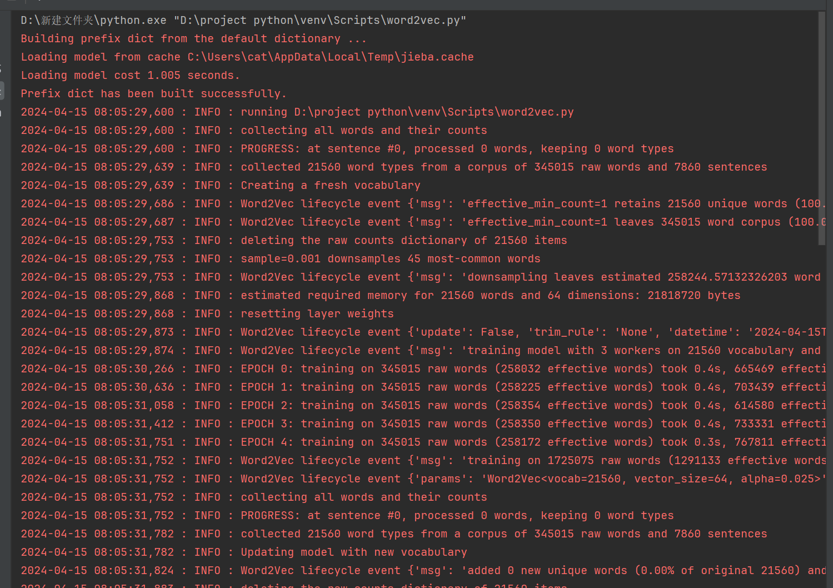
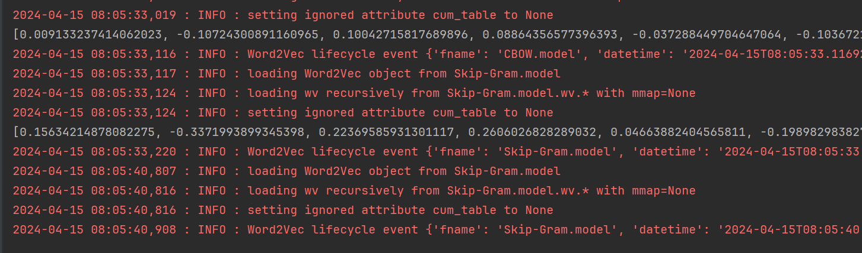
句子向量表示：
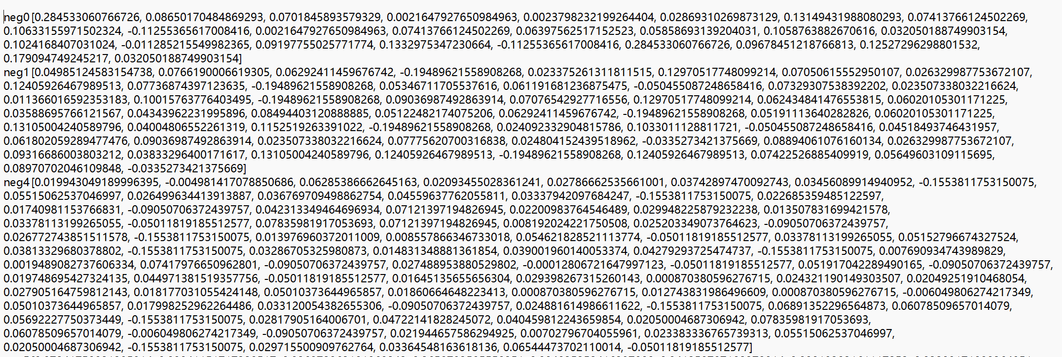
实验七：
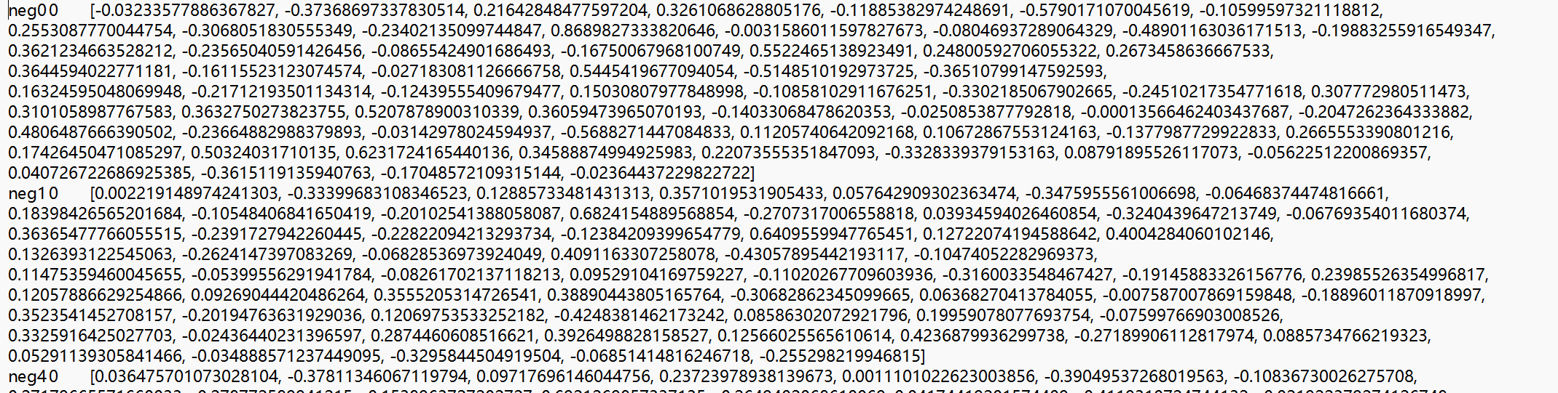
教师
评语

