山西大学
实验报告
姓 名 | 牛璐瑶 |  |  | 学 号 | 202201006124 |  | 专业班级 | 人工智能
课程名称 | 中文信息处理技术实验 |  |  |  |  |  |  | 实验日期 | 2024.4.1
成 绩 |  |  |  | 指导老师 |  | 王元龙 |  | 批改日期
实验名称 |  | 实验六 文本表示
一、实验目的：
本课程作业加深对汉语文本信息处理基础理论及方法的认识和了解，锻炼和提高分析问题、解决问题的能力。通过对具体项目的任务分析、数据准备、算法设计和编码实现以及测试评价几个环节的练习，基本掌握实现一个自然语言处理系统的基本过程。
二、实验说明：
实验6.1：基于tfidf的特征权重计算方法

依据实验五得到文本的表示特征，从文件中读取特征词集，构建向量空间模型，计算每个句子表示向量表示中每一个特征维度的权重。计算方法可采用TFIDF进行。

词频-逆文档频度（Term Frequency - Inverse Document Frequency，TF-IDF）字词的重要性随着它在文件中出现的次数成正比增加，但同时会随着它在语料库中出现的频率成反比下降。
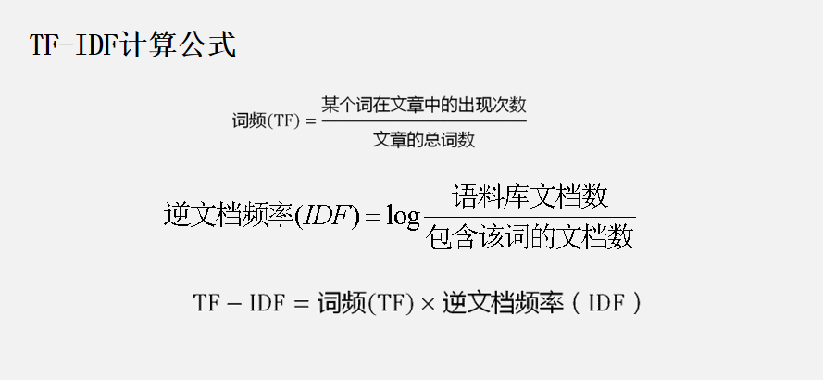
对于一个带标签的句子sen，遍历特征词表，若sen含有第i个特征词，则计算该词的TFIDF值作为向量对应维度的权重值，否则特征权重为0。遍历完成后得到句子的向量表示。
对给定语料库内的所有带标签的句子，要求输出其句子表示向量，以“句子id 向量表示”的形式存在文件当中。

存储格式：一行为一个文本特征，以utf-8进行编码。

实验6.2：基于余弦距离的文本相似度计算方法

利用实验五中构建的特征集，对任意输入的文本序列，能将其转变为以TFIDF为权重的向量表示，并从实验6.2的文本句子中依照余弦相似度给出相似度最高的三篇文章并输出其相似度的值。
余弦相似度的计算公式如下：
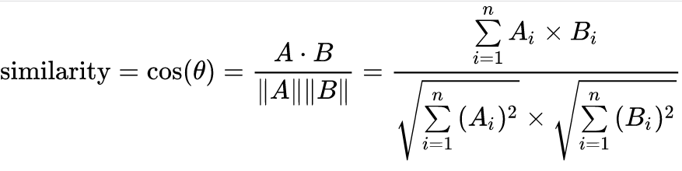

三、实验数据说明：
实验数据采用htl_del_4000宾馆情感分析数据进行处理，所有数据已按照情感极性划分为褒(pos)贬(neg)两类，各2000篇，每个文本文件为一篇文章，实验数据需要先进行分词，分词方法不限。

统计频数时按照篇章级共现进行计算。

停用词表采用中文通用停用词表，文件名为“cn_stopwords.txt”，可用于数据预处理中的去除停用词
- 实验代码及结果截图：
import sys
from math import log
import jieba
dict = {}
num = 0
# 加载特征词集及包含该词的文档数
with open("特征词.txt", 'r', encoding="utf8")as f1:
for words in f1:
num += 1
x = words.strip().split('\t')
word = x[0]
fre = int(x[1])
if word not in dict:
dict[word] = fre
# 构造句子的特征向量
with open("句子向量表示（文档频率）.txt", 'w', encoding='utf8')as f3:
for i in range(0, 2670):
try:
with open(f'.\自然语言处理实验数据\htl_del_4000\\neg\\neg.{i}.txt', encoding='GBK', errors='ignore')as f2:
sentence = []
count = 0
sentence_vec = [0] * num
for sentence_to_cut in f2:
if sentence_to_cut == '\n':
continue
sentence += jieba.lcut(sentence_to_cut.strip())
for word, fre in dict.items():
if word in sentence:
sentence_vec[count] = (sentence.count(word) / len(sentence)) * log(4000 / (fre + 1))
count += 1
f3.write(f"neg{i}\t{sentence_vec}\n")
except FileNotFoundError:
pass
for i in range(4, 2670):
try:
with open(f'.\自然语言处理实验数据\htl_del_4000\\pos\\pos.{i}.txt', encoding='GBK', errors='ignore') as f4:
sentence = []
count = 0
sentence_vec = [0] * num
for sentence_to_cut in f4:
if sentence_to_cut == "\n":
continue
sentence += jieba.lcut(sentence_to_cut.strip())
for word, fre in dict.items():
if word in sentence:
sentence_vec[count] = (sentence.count(word) / len(sentence)) * log(4000 / (fre + 1))
count += 1
f3.write(f"pos{i}\t{sentence_vec}\n")
except FileNotFoundError:
pass
from math import log
import jieba
stopwords = []
dicts = {}
dic = {}
num = 0
# 建立停用词表
with open('cn_stopwords.txt', encoding='utf8') as f0:
for stopword in f0:
stopwords.append(stopword.strip())
for i in range(0, 2670):
try:
with open(f'.\自然语言处理实验数据\htl_del_4000\\neg\\neg.{i}.txt', encoding='GBK', errors='ignore') as f1:
for sentence_to_cut in f1:
sentence = jieba.lcut(sentence_to_cut.strip())
for word in sentence:
if word in stopwords:
continue
if word not in dicts:
dicts[word] = 1
else:
dicts[word] += 1
except FileNotFoundError:
pass
for i in range(4, 2670):
try:
with open(f'.\自然语言处理实验数据\htl_del_4000\\pos\\pos.{i}.txt', encoding='GBK', errors='ignore') as f2:
for sentence_to_cut in f2:
sentence = jieba.lcut(sentence_to_cut.strip())
for word in sentence:
if word in stopwords:
continue
if word not in dicts:
dicts[word] = 1
else:
dicts[word] += 1
except FileNotFoundError:
pass
with open("互信息值.txt", 'r', encoding='utf8')as f3:
for sentence in f3:
sentence = sentence.strip().split(":")
num += 1
if sentence[0] not in dic:
dic[sentence[0]] = dicts[sentence[0]]
with open("6.1句子向量表示（互信息）.txt", 'w', encoding='utf8') as f4:
for i in range(0, 2670):
try:
with open(f'.\自然语言处理实验数据\htl_del_4000\\neg\\neg.{i}.txt', encoding='GBK', errors='ignore') as f5:
sentence = []
count = 0
sentence_vec = [0] * num
for sentence_to_cut in f5:
if sentence_to_cut == "\n":
continue
sentence += jieba.lcut(sentence_to_cut.strip())
for word, fre in dic.items():
if word in sentence:
sentence_vec[count] = (sentence.count(word) / len(sentence)) * log(4000 / (fre + 1))
count += 1
f4.write(f"neg{i}\t{sentence_vec}\n")
except FileNotFoundError:
pass
for i in range(4, 2670):
try:
with open(f'.\自然语言处理实验数据\htl_del_4000\\pos\\pos.{i}.txt', encoding='GBK', errors='ignore') as f6:
sentence = []
count = 0
sentence_vec = [0] * num
for sentence_to_cut in f6:
if sentence_to_cut == "\n":
continue
sentence += jieba.lcut(sentence_to_cut.strip())
for word, fre in dic.items():
if word in sentence:
sentence_vec[count] = (sentence.count(word) / len(sentence)) * log(4000 / (fre + 1))
count += 1
f4.write(f"pos{i}\t{sentence_vec}\n")
except FileNotFoundError:
pass
from math import log, sqrt
import numpy as np
import jieba
dicts = {}
dic = {}
sentences = {}
stopwords = []
num = 0
# 加载特征词集及包含该词的文档数
with open("特征词.txt", 'r', encoding="utf8") as f1:
for words in f1:
num += 1
x = words.strip().split('\t')
word = x[0]
fre = int(x[1])
if word not in dic:
dic[word] = fre
# 建立停用词表
with open('cn_stopwords.txt', encoding='utf8') as f0:
for stopword in f0:
stopwords.append(stopword.strip())
for i in range(0, 2670):
try:
with open(f'.\自然语言处理实验数据\htl_del_4000\\neg\\neg.{i}.txt', encoding='GBK', errors='ignore') as f1:
for sentence_to_cut in f1:
sentence = jieba.lcut(sentence_to_cut.strip())
for word in sentence:
if word in stopwords:
continue
if word not in dicts:
dicts[word] = 1
else:
dicts[word] += 1
except FileNotFoundError:
pass
for i in range(4, 2670):
try:
with open(f'.\自然语言处理实验数据\htl_del_4000\\pos\\pos.{i}.txt', encoding='GBK', errors='ignore') as f2:
for sentence_to_cut in f2:
sentence = jieba.lcut(sentence_to_cut.strip())
for word in sentence:
if word in stopwords:
continue
if word not in dicts:
dicts[word] = 1
else:
dicts[word] += 1
except FileNotFoundError:
pass
with open("句子向量表示（文档频率）.txt", 'r', encoding='utf8') as f3:
for sentence in f3:
sentence = sentence.strip().split("\t")
if sentence[0] not in sentences:
sentences[sentence[0]] = np.array(eval(sentence[1]))
MyComment = "早餐太差，全是素菜。另外礼宾部还弄丢了我一件行李，最后发现是被别人领走了，半天才找回来。其他都还可以。"
MyComment = jieba.lcut(MyComment.strip(''))
count = 0
MyComment_vec = [0] * num
for word, fre in dic.items():
if word in MyComment:
MyComment_vec[count] = (MyComment.count(word) / len(MyComment)) * log(4000 / (fre + 1))
count += 1
MyComment_vec = np.array(MyComment_vec)
max_sim = {}
flag = 0
for id, vec in sentences.items():
sim = np.dot(vec, MyComment_vec) / (sqrt(np.dot(vec, vec)) * sqrt(np.dot(MyComment_vec, MyComment_vec)))
if flag < 3:
max_sim[id] = sim
flag += 1
elif sim > max_sim[min(max_sim, key=max_sim.get)]:
max_sim.pop(min(max_sim, key=max_sim.get))
max_sim[id] = sim
for id, sim in max_sim.items():
print(f"序号为{id}， 相似度为{sim}\n")
基于文本频率的句子向量表示
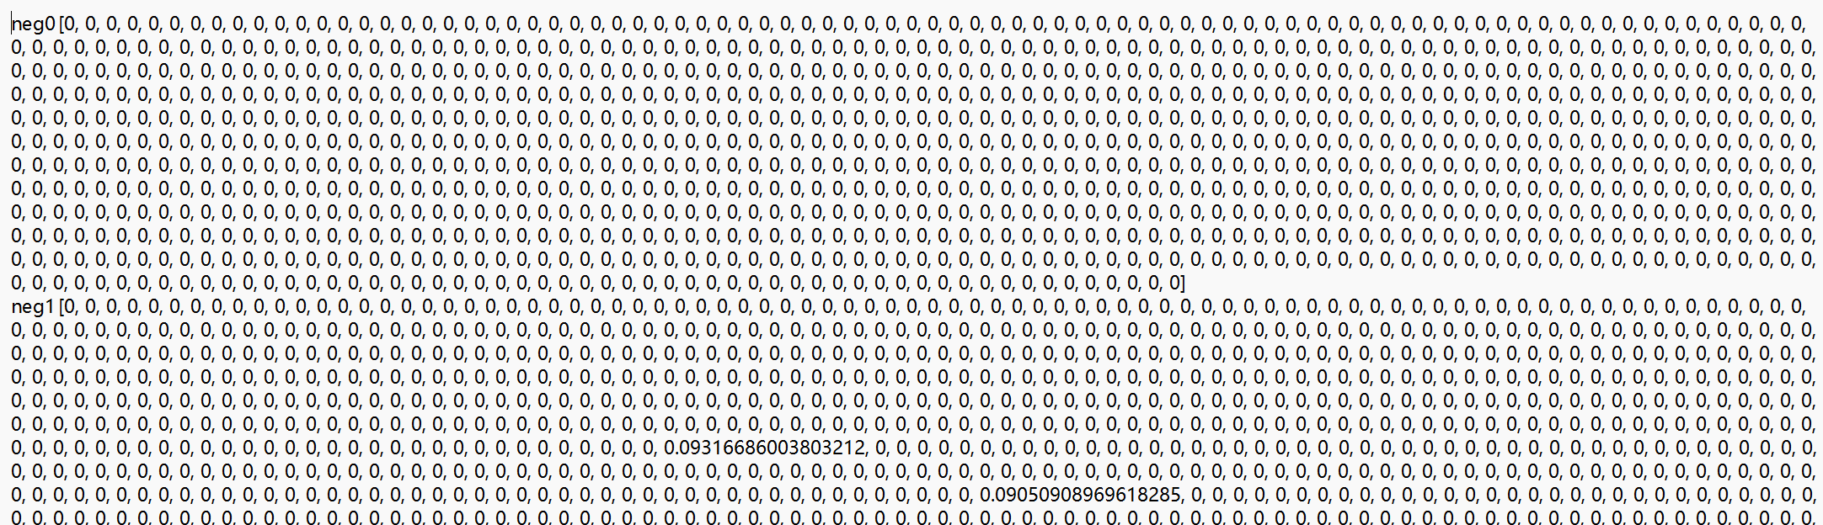
基于互信息的句子向量表示
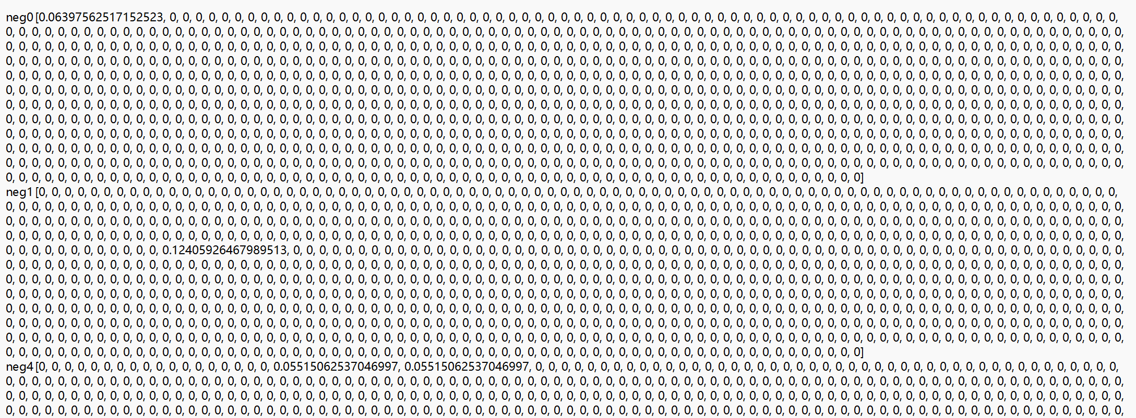

相似度计算
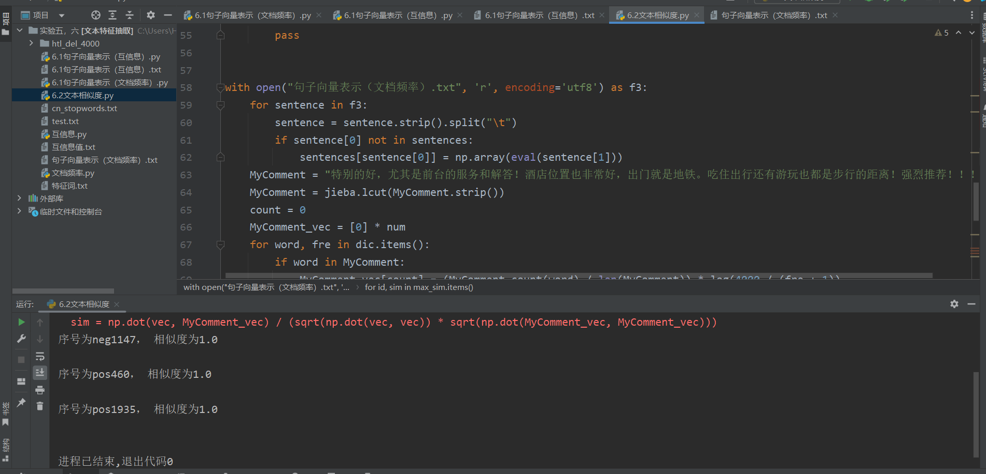

教师
评语

