山西大学计算机与信息技术学院
实验报告
姓 名 |  | 王江涛 |  |  | 学 号 |  | 202301006133 |  | 专业、班级 |  | 人工智能2301
课程名称 |  | Python程序设计课程设计 |  |  |  |  |  |  |  |  | 实验日期 | 2024/10/21
成 绩 |  |  |  | 指导教师 |  | 解宇 |  | 小组 |  |  | 批改日期
实验名称 |  |  | 网络爬虫，request库的使用，beautifulsoup库的使用。
import requests
from bs4 import BeautifulSoup
url = "https://example.com"
headers = {'User-Agent': 'Mozilla/5.0 (Windows NT 10.0; Win64; x64) AppleWebKit/537.36 (KHTML, like Gecko) Chrome/58.0.3029.110 Safari/537.3'}
response = requests.get(url, headers=headers, timeout=1000)
if response.status_code == 200:
soup = BeautifulSoup(response.content, 'html.parser')
titles = soup.find_all('h1')
for title in titles:
print(title.get_text())



import requests
from bs4 import BeautifulSoup
import pandas as pd
url = 'https://www.niuluyao.com/yiliao/all_requests.php'
response = requests.get(url)
if response.status_code ==200:
soup = BeautifulSoup(response.content,'html.parser')
table=soup.find('table')
headers = []
for th in table.find_all('th'):
headers.append(th.text.strip())
rows=[]
for tr in table.find_all('tr')[1:]:
cells = tr.find_all('td')
row = [cell.text.strip()for cell in cells]
rows.append(row)
df = pd.DataFrame(rows,columns=headers)
print(df)
else:
print(f"请求失败")
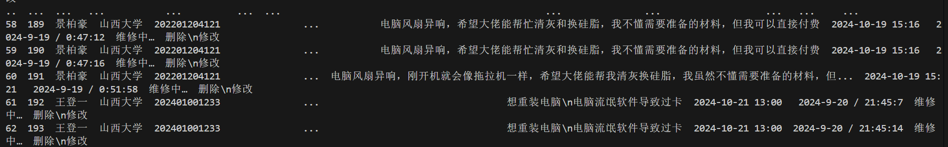

from lib2to3.pgen2 import driver
from bs4 import BeautifulSoup
from selenium import webdriver
from selenium.webdriver.common.by import By
from selenium.webdriver.chrome.service import Service as ChromeService
from webdriver_manager.chrome import ChromeDriverManager
import time
options = webdriver.ChromeOptions()
options.add_argument("--headless")
driver = webdriver.Chrome(service=ChromeService(ChromeDriverManager().install()),options=options)
driver.get('https:/www.sxu.edu.cn/')
time.sleep(5)
content = driver.page_source
soup = BeautifulSoup(content,'html.parser')
dynamic_data = soup.find_all('div',class_='dynamic_class')
for data in dynamic_data:
print(data.get_text())
driver.quit()

import requests
from urllib.robotparser import RobotFileParser

robots_url = "https://cn.bing.com/robots.txt"
rp = RobotFileParser()
rp.set_url(robots_url)
rp.read()

url_to_check = " https://cn.bing.org"
if rp.can_fetch('*', url_to_check):
print(f"允许爬取: {url_to_check}")
else:
print(f"禁止爬取: {url_to_check}")

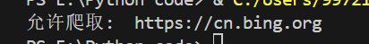
教 师
评 语

