Project 1: Static Foundations
Feedback for Mango Moon
Student: Elliot Radov Course: CSC 436, Fall 2026 Reviewed at: a6fa8b1
Repo: github.com/FantasyGodX/436_Proj1 Live: mango-moon.netlify.app

Grade: 79 / 100
Category | Points | Earned | One line
Semantic HTML | 20 | 18 | Every element the brief lists, one h1, a label on every field, zero validator errors; hero text wrapped in an article, toggle has no pressed state
CSS layout | 25 | 18 | Flexbox header, nav and form, auto-fit Grid menu, all yours and working; no container so desktop text runs 1240 px wide, menu items unstyled, dark mode stops at the inputs
Responsive design | 15 | 12 | No horizontal scroll anywhere, header stacks, grid steps 1 to 2 to 3; one desktop-first query, hero never uses the width it has
JavaScript interaction | 15 | 11 | Dark mode toggle works and relabels itself; the order form submits to nowhere and wipes itself, the choice is lost on reload
Repository and deployment | 15 | 14 | Best commit history in the class, README has everything, deploy matches repo; editor settings committed, no .gitignore
Content and polish | 10 | 6 | Coherent little restaurant with consistent copy and color; a 2.2 MB hero that repeats the menu and disagrees with it, plain menu, 2024 footer
Total | 100 | 79 | Disciplined and correct, and much smaller than it needed to be. Finish the form and give it a design.

How this review was made
Your instructor reviewed this project with Claude (Anthropic's AI) as a second set of eyes. Claude cloned the repo, read every line of the HTML and CSS, loaded the live site at phone, tablet and desktop widths, ran the W3C validator, clicked the dark mode toggle and reloaded to see if it stuck, filled in the order form and submitted it, measured the image, diffed the live site against the repo, and read all twenty-four commits. Every note and every point in this document was read and approved by your instructor. Same rubric, same standard, just more time spent looking at your code than one person has in a grading week.

The short version
Everything you built works and validates. Header, nav with a list, main with three sections, articles for the menu items, a figure, a form with a label on every field, a footer, one h1. Flexbox does the header, the nav and the form; an auto-fit Grid does the menu and steps from one column to three without a single media query. The dark mode toggle flips the page and relabels itself. The commit history is the best in the class: twenty-four commits that read like a build log. Anyone could follow how this site was made.
The grade is in the seventies rather than the eighties because the site stops at the skeleton. The whole thing is 123 lines of HTML and 138 of CSS. On a desktop the text runs edge to edge across 1240 pixels because nothing sets a max-width. The menu items are three headings in a grid with no card around them. The order form, which is the page's reason to exist, has a #form-message paragraph waiting for a confirmation that no script ever writes, so submitting it reloads the page and empties every field. Dark mode leaves the inputs white. And the hero image is a 2.2 MB PNG of the same three bowls the menu lists underneath it, with names and prices baked into the pixels, one of which does not match the text. None of this is hard to fix. The roadmap at the end is three evenings.

What Claude measured
Check | Result
Horizontal scroll at 375 / 768 / 1280 px | None at any width
W3C HTML validator | 0 errors, 0 warnings, 8 info notes (trailing slashes, hero section has no heading of its own)
Heading order | h1 > h2 > h3, no skipped levels
Semantic elements | header, nav (ul of 3), main, 3 section, 4 article, figure, form with a label per field, footer
Media queries | 1, max-width: 600px (desktop-first)
Menu grid columns at 375 / 768 / 1280 | 1 / 2 / 3 via auto-fit
Header at 375 | Stacks to a column
Dark mode toggle | Body class flips, button text swaps; inputs stay white; nothing saved, back to light on reload
Order form, valid values, Submit | Page reloads with a GET; all fields cleared; #form-message never written
Console errors | 0
CSS | 138 lines, 3 Flexbox containers, 1 Grid, 0 custom properties, 0 focus styles, 0 !important
Image | rice_img.png is 1536 by 1024, 2.2 MB PNG, shown at 500 px; 99 percent of the page weight
Commits | 24; 22 on Sep 12 between 19:58 and 22:23, 2 on Sep 15; every message says what changed
README | Title, description, run instructions, live URL, features, tech: all there
Live vs repo | Identical apart from the badge script Netlify injects
Housekeeping | No .gitignore; .vscode/settings.json committed

The site at three widths
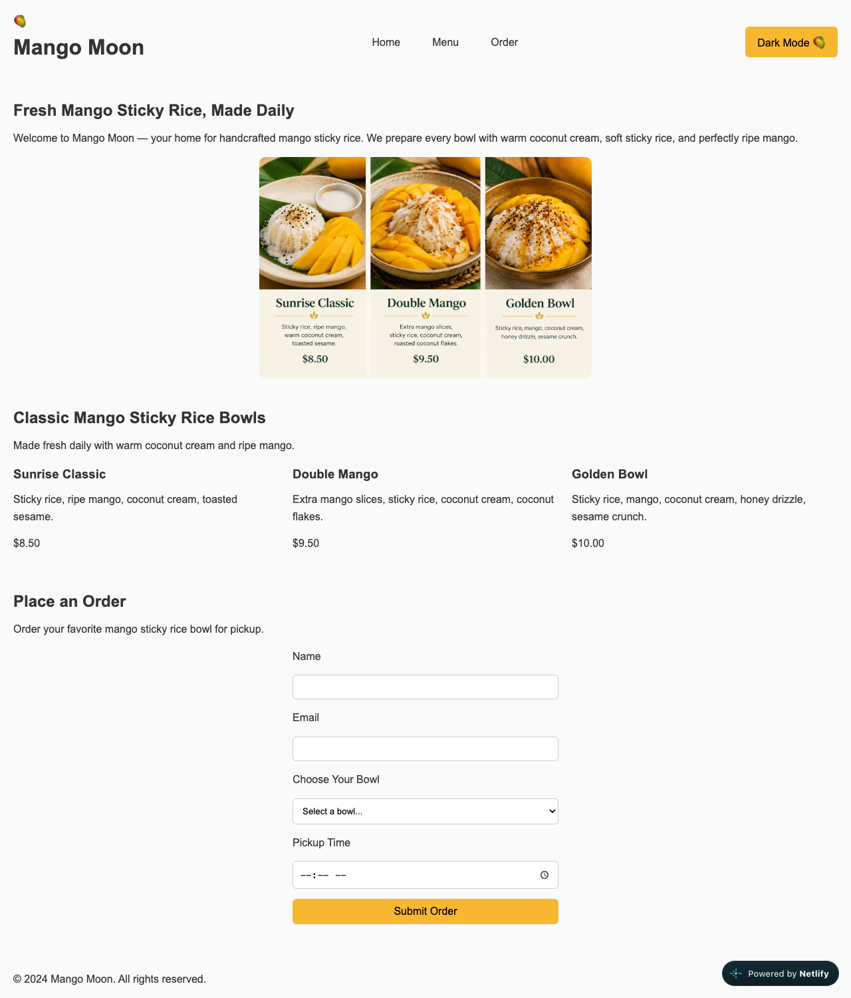
Desktop, 1280px. Text runs the full width; menu in three plain columns; centered form.
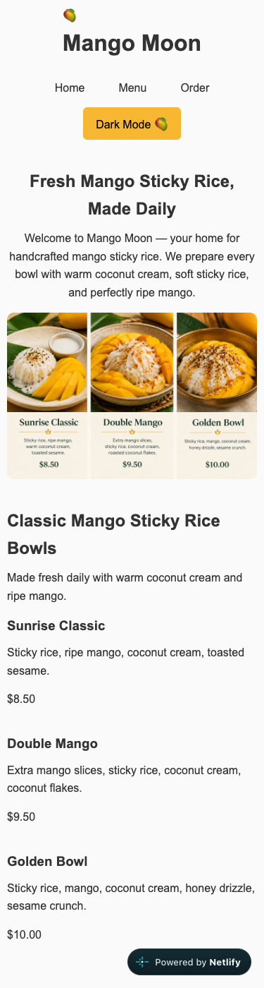  Phone, 375px. Header stacks; one column; no horizontal scroll. | 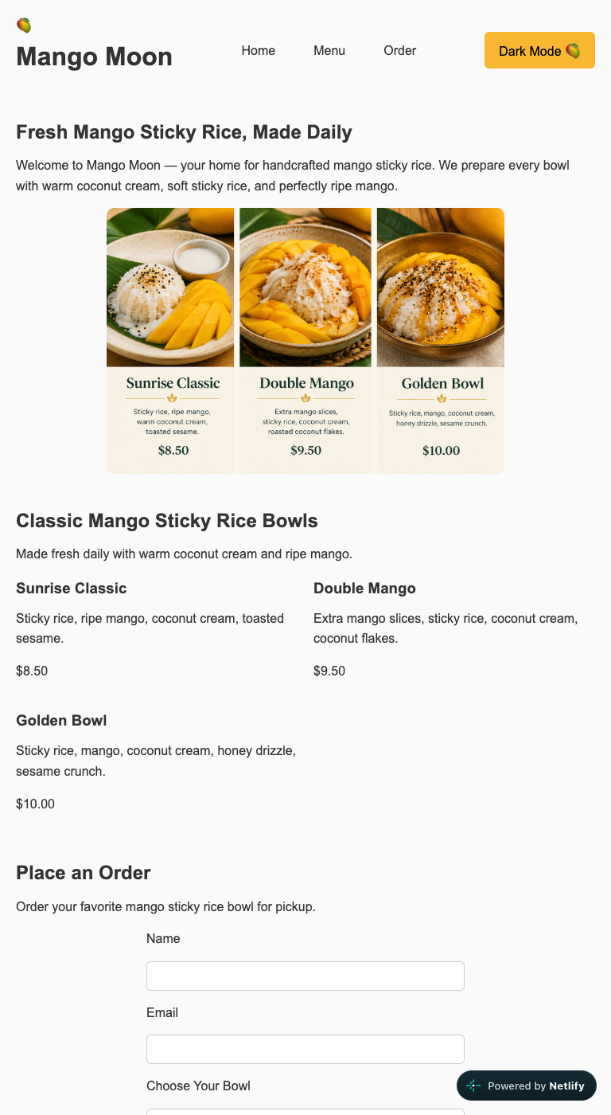  Tablet, 768px. Header in a row; menu in two columns via auto-fit.

Semantic HTML: 18 / 20

What is working
- The outline is exactly what the brief asks for. header with the brand and a nav holding a ul of anchors (index.html lines 12 to 27), main with three sections each with its own h2, an article per menu item with an h3, a figure for the hero image, and a footer. One h1. The validator finds zero errors.
- The form is done right: a label for every control, type="email" and type="time" so the browser validates and gives the right keyboard, required on every field, a select with a real placeholder option (lines 78 to 99). Most of the class did not get this far with a form. The toggle is a real button, not a div.

What to change
- The hero text is not an article (lines 33 to 40). An article is content that would make sense on its own somewhere else, like a menu item or a blog post. A headline and a welcome sentence are not that. Make it a div.hero-content and the hero section gets its h2 back as a direct child, which also clears the validator's "section lacks heading" note.
- The toggle button announces nothing (line 26). Add aria-pressed="false" and flip it in the click handler. A screen reader then says "Dark mode, toggle button, not pressed."
- Small: the trailing slashes on meta, link, img and input are harmless in HTML5 but the validator flags them eight times. Drop them.

CSS layout: 18 / 25

What is working
- Flexbox and Grid, both authored, both doing real work. The header is a three-part flex row with space-between (style.css lines 45 to 50), the nav list is flex with gap, and the form is a flex column with gap (lines 84 to 90). The menu grid is repeat(auto-fit, minmax(250px, 1fr)) (lines 77 to 81), which is the one line of Grid that most people take a semester to learn. It gives you 1, 2 and 3 columns with no media query at all. A real reset, border-box, line-height 1.6, max-width on the image. The basics are in place.

What to change
- Nothing has a max-width except the form and the image (lines 8 to 14). On a 1280px screen the hero paragraph is one line 1240px long, about 180 characters. Readable text is 60 to 75. Give main (or each section) max-width: 1100px; margin: 0 auto; and the hero text max-width: 60ch. One rule, and the desktop stops looking like a text file.
- The menu items are not cards (lines 77 to 81). The grid is there, but each .menu-item has no background, padding, border or styled price. The result is three columns of plain text, and on desktop the section looks emptier than the image above it. Give .menu-item a surface (background, padding, border-radius, box-shadow), make .price bold and mango-colored, and the same grid becomes a menu.
- Dark mode stops at the inputs (lines 116 to 138). Body, header, sections, footer, buttons and nav links all flip. The text inputs and the select stay white with black text, and the time picker popup stays light. Add .dark-mode input, .dark-mode select { background: #333; color: #eee; border-color: #555; } and .dark-mode { color-scheme: dark; } so the browser's own widgets follow.
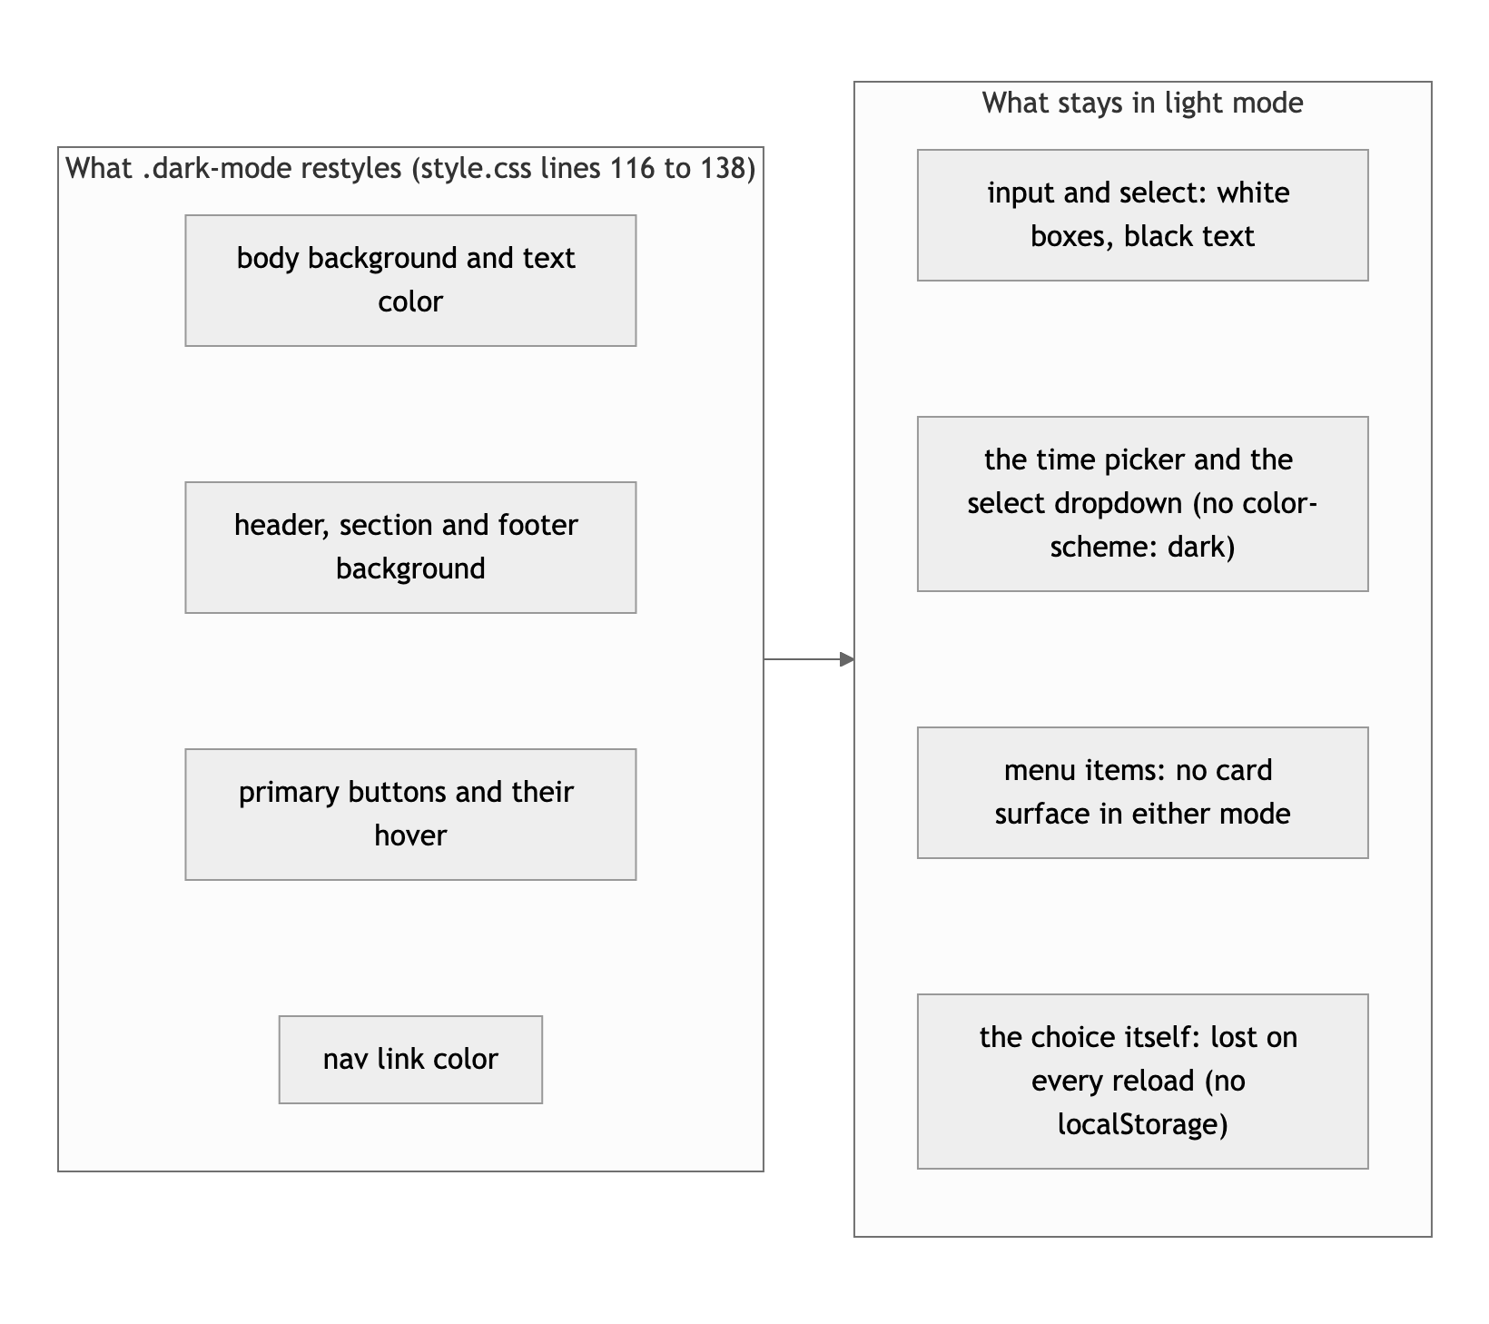
Diagram 1. What the dark-mode block covers, and what it leaves behind.
- Nav links have padding and a radius but no hover or focus (lines 58 to 64). The rounded padding box is clearly waiting for a :hover background that never got written. Add .site-nav a:hover, .site-nav a:focus-visible { background: #f7b731; }. There is no :focus style anywhere in the file, so keyboard users cannot see where they are.
- Small: the mango gold #f7b731 and the dark-mode gold #c68d11 are typed by hand. Put them in :root as --accent and --accent-dark and the dark mode block gets shorter.

Responsive design: 12 / 15

What is working
- No horizontal scroll at 375, 768 or 1280. The header stacks to a column under 600px, the grid goes 1 to 2 to 3 on its own, the form is capped at 400px and centered, the image scales. Claude verified all of this in a real 375px viewport.

What to change
- One query, and it is max-width (lines 100 to 113). The brief asked for mobile-first. Your base styles are the desktop and the query undoes them for phones. Flip it: make .site-header { flex-direction: column } the default and add the row inside @media (min-width: 600px). Same result, right direction.
- The hero never uses the width it has. .hero is display: block at every size, so on a tablet or desktop the headline, the paragraph and then the image stack in the middle with empty space either side. Make .hero a flex row at 768px and up (align-items: center; gap: 40px) with the text left and the image right. That is the one layout change that would make the desktop look designed.

JavaScript interaction: 11 / 15

What is working
- The toggle works and is written cleanly (index.html lines 110 to 119). classList.toggle on the body, then classList.contains to pick the label. Ten lines, no state variable to get out of sync. Claude clicked it, the background went from #fafafa to #1e1e1e, and the button read "Light Mode." Zero console errors.

What to change
- The order form goes nowhere (lines 78 to 99). You gave the form an id, gave every field an id, and put an empty p#form-message at the bottom. Then no script touches any of it. Claude filled in a name, an email, a bowl and a time and clicked Submit Order. The browser did a GET to the same URL, the page reloaded, and every field was empty. A customer would assume the site is broken. This is the biggest single fix on the page and it is about ten lines: listen for submit, event.preventDefault(), read the bowl and time, write a sentence into form-message, form.reset().
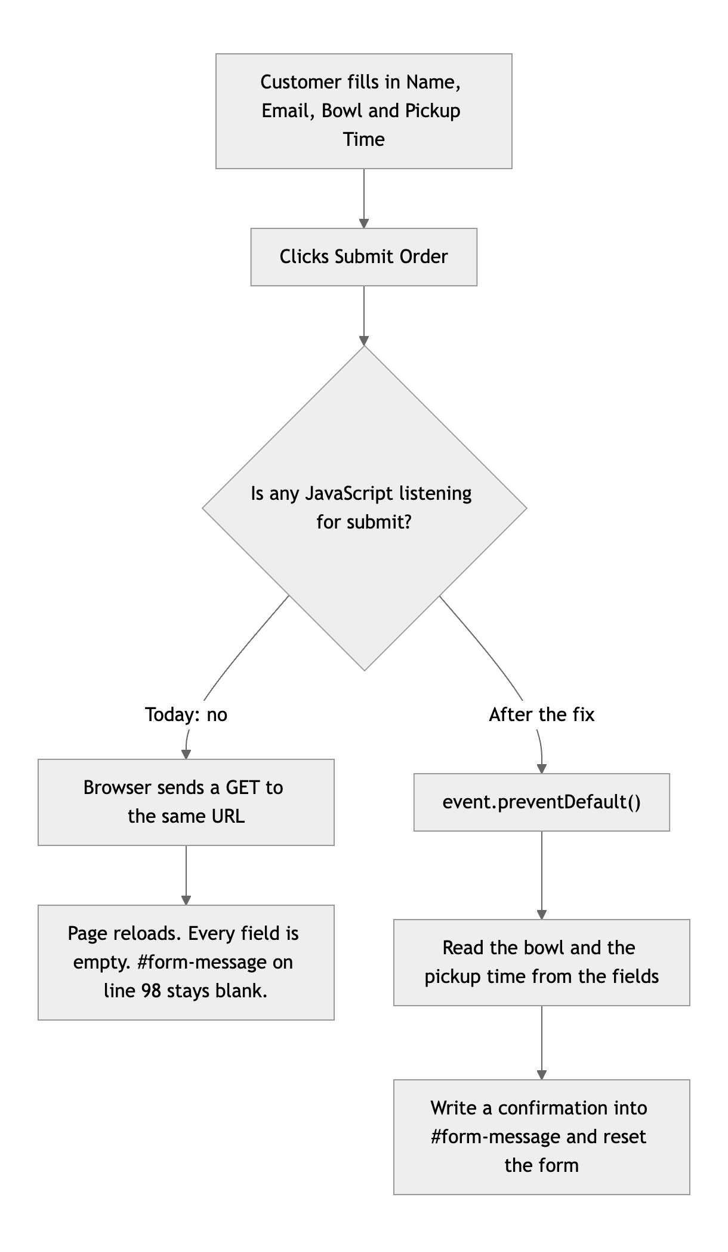
Diagram 2. What happens when a customer submits the form today, and after the fix.
- The theme is forgotten on reload. Save it with localStorage.setItem("theme", ...) in the handler, and on load read it back and add the class before the first paint. Three lines. Bonus: use matchMedia("(prefers-color-scheme: dark)") as the default when nothing is saved.
- Small: put the script in script.js and load it with defer. Inline is fine for ten lines, but Project 2 will not fit in a script tag.

Repository and deployment: 14 / 15

What is working
- This is the commit history the brief describes. Twenty-four commits, each one a step: README, header, body structure, hero, form, footer, stylesheet, base styles, flex, grid, media queries, dark mode, polish, deploy fix. Every message is a sentence in your own words, including "Fixed indentation (red boxes were annoying me)." Two follow-ups on Sep 15 after class feedback. Nobody else in the class has a history this readable. It was all one evening (Sep 12, 19:58 to 22:23), and that is fine, because the work is genuinely broken into steps.
- README has everything: title, description, live URL, features, tech, how to run, author. The live site is public and matches the repo apart from the script Netlify injects.

What to change
- No .gitignore, and .vscode/settings.json is committed. That file is your Live Server port, which is about your machine, not the project. Add a .gitignore with .vscode/, .DS_Store and .env, then git rm --cached .vscode/settings.json.
- Small: the live URL in the README is plain text. Make it a link.

Content and polish: 6 / 10

What is working
- The idea is coherent and the copy is consistent: one dish, three bowls, real prices, a pickup form, "made fresh daily in Staten Island." The mango gold on off-white is a palette, and the emoji logo is a nice touch for a one-evening build. Nothing is lorem ipsum.

What to change
- The hero image is 2.2 MB (index.html line 43). It is a 1536 by 1024 PNG shown at 500px, and it is 99 percent of everything the page downloads. The HTML and CSS together are under 6 KB. Export it as a JPEG at 1000px wide and it drops to about 150 KB.
- The page says the menu twice, and the two versions disagree. The hero picture has "Sunrise Classic, $8.50," "Double Mango, $9.50" and "Golden Bowl, $10.00" baked into the pixels, with descriptions. The menu section under it lists the same three bowls in text. The image says Double Mango has "roasted coconut flakes"; the HTML says "coconut flakes." Either crop the image to a single bowl with no text, or put the three bowl images inside the three menu articles and let the HTML carry the words.
- The menu section looks unfinished next to the image above it. Three bold names, three sentences, three prices in plain body text. See the card note under CSS; it is the same fix.
- Small: the footer says 2024 (line 105). It is 2026. One line of JS (new Date().getFullYear()) or just type the right year.

Your next three moves
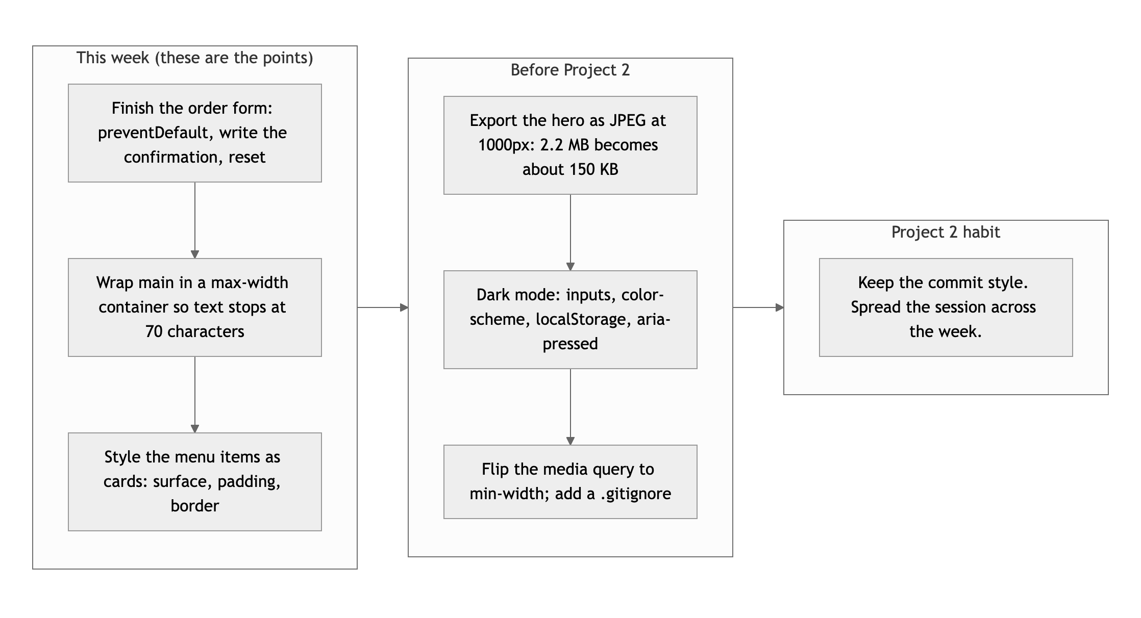
Diagram 3. Priority order. Left column first: it is where the points are.
- Finish the form. Ten lines of JS and the page's main feature works. This is the single largest gap on the site.
- Give the desktop a shape. A max-width on main, cards on the menu items, and a two-column hero at 768px and up. Three rules, and it goes from a skeleton to a site.
- Shrink the image and fix the two-menus problem. JPEG at 1000px, and either a text-free hero photo or the bowl photos inside the menu cards.

Your process is already right, Elliot. The next step is to keep going past the skeleton.
This review lives in a pull request on your repo. It only adds feedback files and does not touch your code. Merge it, close it, or just read it. Questions go to office hours or the Brightspace board.

