Manual Test Document
Room Allocation module - Hostel Management System
BCSE301P Software Engineering - Assessment 8
School of Computer Science Engineering and Information Systems, VIT
Document generated | 2026-10-26 02:15 UTC
Test cases | 65 (30 priority P1, 33 P2, 2 P3)
Execution status | NOT EXECUTED: 0 of 65 cases executed
Results so far | Pass 0 Fail 0 Blocked 0 Not executed 65
Reference screenshots captured | 2026-10-26 02:15:21 UTC (by script, from the running application)

Please read before using this document
- Every case lists its preconditions, steps, input data and the expected result. Follow the cases in the order shown: later cases use data created by earlier ones.
- The screenshot printed under each case is a REFERENCE image of the expected screen. A script drove the real application and captured it, so you know what a correct result looks like. It is not a tester's evidence and does not mean the case passed.
- The result boxes (actual result, status, tester, date, evidence) are blank until a person executes the case. Paste your own screenshot into the evidence box.
- At the moment no case has been executed, so this document records no pass or fail results.

1. Purpose and scope
This document is the manual test plan, test script and result record for the Room Allocation module of the Hostel Management System. A tester follows the steps in a web browser, compares what happens with the expected result and records the actual result, the status and evidence.
In scope: allocating, reallocating and cancelling room allocations; listing, searching and filtering; available rooms; the student's own view; adding blocks, rooms and students; login, logout, lockout, role-based access, CSRF protection and basic injection handling; and the screen layout on a phone-sized window.
The same functions are also covered by the automated test suite (see the automated test report). Manual testing adds what a person can judge: what the screens look like, how messages read, and whether the workflows can really be performed by a user, including a few security checks that need the browser's developer tools (marked "UI + browser DevTools").

2. Test environment and tester details (fill in)
Tester name
Registration number
Date(s) of execution
Operating system
Browser and version
Python version
Application build tested
Start command used | DEMO_ALLOCATIONS=0 python scripts/serve_demo.py (AUTH-09: LOGIN_MAX_ATTEMPTS=5 DEMO_ALLOCATIONS=0 python scripts/serve_demo.py)
Notes

3. Test data
The demo server (scripts/serve_demo.py) starts with an empty throw-away database and this data. Restart it (Ctrl+C, run again) before each complete pass.

3.1 Staff accounts
Role | E-mail | Password | Notes
admin | admin@hms.test | admin123
warden | warden@hms.test | warden123
accountant | accountant@hms.test | accountant123

3.2 Students (password for all: student123)
Id | Name | E-mail | Roll no | Course | Batch
1 | John Doe | john@student.test | STU001 | B.Tech CSE | 2023
2 | Jane Smith | jane@student.test | STU002 | B.Tech ECE | 2023
3 | Bob Wilson | bob@student.test | STU003 | B.Tech ME | 2022
4 | Alice Brown | alice@student.test | STU004 | B.Tech IT | 2024
5 | Carlos Diaz | carlos@student.test | STU005 | B.Tech CSE | 2024
6 | Dana Evans | dana@student.test | STU006 | B.Tech ECE | 2022

3.3 Blocks and rooms
Room id | Block | Room number | Floor | Capacity (beds)
1 | Block A | 101 | 1 | 2
2 | Block A | 102 | 1 | 2
3 | Block A | 201 | 2 | 2
4 | Block A | 202 | 2 | 2
5 | Block B | 101 | 1 | 3
6 | Block B | 102 | 1 | 3
Allocation ids are assigned in creation order: the first allocation created is id 1, the second id 2, and so on (cases AUTHZ-10 and AUTHZ-11 rely on this).

4. Procedure
- Start the application (section 2) and open http://127.0.0.1:5000 in Chrome or Firefox.
- Create the folder assessment8_testing/manual_testing/evidence/ for your screenshots.
- Execute the cases in the order of section 6. The minimum is every case with priority P1; P2 and P3 are recommended.
- For each case: do the steps exactly as written; compare the result with the expected result; take a screenshot of the decisive screen.
- Cases marked "UI + browser DevTools" need the developer tools (F12): the Elements tab to edit or delete a form field, the Network tab to read an HTTP status, the Console tab for the one fetch(...) snippet in AUTHZ-11.
- Record the result for each case in manual_test_execution.csv (Executed = Y; Status = Pass, Fail or Blocked; Actual result; Evidence file name; Executed by; Date) and save the screenshot under that name in the evidence folder.
- If a case fails, add a new defect row to assessment8_testing/defects.csv and put its id in the Defect ID column.
- Regenerate this document with python scripts/build_manual_test_document.py: it then shows your recorded results and embeds your evidence screenshots.

Status definitions
Status | Meaning
Pass | The actual result matches the expected result in every respect.
Fail | The actual result differs from the expected result. Describe exactly what you saw and raise a defect.
Blocked | The case could not be performed (for example a precondition could not be created). Say why.
Not Executed | Nobody has performed the case. This is the starting state and must stay unchanged until the case is really executed.
Never record a result you did not observe. Leave cases you did not run as Not Executed.

5. Case index
Case | Scenario | Req. | Prio. | Technique | Status
AUTH-01 | Valid admin login | RA-11 | P1 | UI only | Not Executed
AUTH-02 | Valid warden login | RA-11 | P2 | UI only | Not Executed
AUTH-03 | Valid student login | RA-11 | P2 | UI only | Not Executed
AUTH-04 | Wrong password rejected | RA-11 | P1 | UI only | Not Executed
AUTH-05 | Unknown user rejected | RA-11 | P2 | UI only | Not Executed
AUTH-06 | Logout ends the session | RA-11 | P1 | UI only | Not Executed
AUTH-07 | Anonymous access is blocked | RA-11 | P1 | UI only | Not Executed
AUTH-08 | Login requires a CSRF token | RA-12 | P1 | UI + DevTools | Not Executed
AUTH-09 | Lockout after repeated failed logins | RA-11 | P2 | UI only | Not Executed
AUTH-10 | Logout is not possible via a link (GET) | RA-11, RA-12 | P1 | UI only | Not Executed
ALLOC-01 | Allocate a student, open-ended | RA-01 | P1 | UI only | Not Executed
ALLOC-08 | Allocate with an end date | RA-01 | P2 | UI only | Not Executed
OCC-01 | Room becomes Full at capacity | RA-04 | P1 | UI only | Not Executed
ALLOC-05 | Student with an active allocation cannot get a second | RA-03 | P1 | UI only | Not Executed
ALLOC-15 | Form keeps your input after a server-side error | RA-02, UI-03 | P2 | UI only | Not Executed
ALLOC-11 | Start date equal to end date is accepted | RA-01 | P2 | UI only | Not Executed
ALLOC-02 | Allocating to a room that filled up meanwhile is refused | RA-04 | P1 | UI + DevTools | Not Executed
ALLOC-09 | Warden can create an allocation | RA-01 | P2 | UI only | Not Executed
ALLOC-03 | Non-existent student id is rejected | RA-02 | P2 | UI + DevTools | Not Executed
ALLOC-04 | Non-existent room id is rejected | RA-02 | P2 | UI + DevTools | Not Executed
ALLOC-06 | Required fields | RA-02 | P1 | UI only | Not Executed
ALLOC-07 | Invalid date text is rejected | RA-02 | P2 | UI + DevTools | Not Executed
ALLOC-10 | End date before start date is rejected | RA-02 | P1 | UI only | Not Executed
ALLOC-14 | Dates outside 2000-2100 are rejected | RA-02 | P2 | UI + DevTools | Not Executed
ALLOC-13 | Create requires a CSRF token | RA-12 | P1 | UI + DevTools | Not Executed
REALLOC-01 | Reallocate to a room with a free bed | RA-05 | P1 | UI only | Not Executed
OCC-02 | Room becomes Available again when a bed is freed | RA-04 | P1 | UI only | Not Executed
REALLOC-03 | Full rooms are not offered | RA-05, RA-04 | P2 | UI only | Not Executed
REALLOC-06 | Reallocating to the same room is refused | RA-05 | P3 | UI + DevTools | Not Executed
REALLOC-04 | Room is required | RA-05 | P2 | UI only | Not Executed
REALLOC-02 | Non-existent room id is rejected | RA-05 | P3 | UI + DevTools | Not Executed
REALLOC-05 | Reallocate requires a CSRF token | RA-12 | P1 | UI + DevTools | Not Executed
CANCEL-02 | "Go back" keeps the allocation | RA-06, UI-03 | P1 | UI only | Not Executed
CANCEL-01 | Confirm cancels and frees the bed | RA-06 | P1 | UI only | Not Executed
CANCEL-04 | Cancelled allocations offer no actions | RA-06 | P2 | UI only | Not Executed
CANCEL-03 | Cancel requires a CSRF token | RA-12 | P1 | UI + DevTools | Not Executed
LIST-01 | Search filters the list | RA-07 | P2 | UI only | Not Executed
LIST-02 | Block and status filters | RA-07 | P2 | UI only | Not Executed
AVAIL-01 | Only rooms with free beds are listed | RA-08 | P1 | UI only | Not Executed
AVAIL-03 | Block filter and "Show full rooms" | RA-08, RA-04 | P2 | UI only | Not Executed
OCC-03 | Full rooms cannot be picked when creating | RA-04 | P2 | UI only | Not Executed
AVAIL-02 | Student can view available rooms (read-only) | RA-08 | P2 | UI only | Not Executed
STUDENT-01 | Student sees own allocation | RA-09 | P1 | UI only | Not Executed
STUDENT-02 | Student cannot view another student's allocation | RA-09 | P1 | UI only | Not Executed
AUTHZ-01 | Admin reaches all management pages | RA-10 | P1 | UI only | Not Executed
AUTHZ-02 | Warden reaches all management pages | RA-10 | P2 | UI only | Not Executed
AUTHZ-03 | Student blocked from allocation management | RA-10 | P1 | UI only | Not Executed
AUTHZ-05 | Accountant blocked from allocations | RA-10 | P2 | UI only | Not Executed
AUTHZ-07 | Student blocked from rooms and students pages | RA-10 | P1 | UI only | Not Executed
AUTHZ-10 | Student cannot open another allocation's reallocate page | RA-10 | P2 | UI only | Not Executed
AUTHZ-11 | Student cannot cancel an allocation | RA-10, RA-12 | P2 | UI + DevTools | Not Executed
SEC-01 | SQL injection in the search box | RA-14 | P1 | UI only | Not Executed
SEC-03 | XSS in the search box | RA-14 | P1 | UI only | Not Executed
SEC-05 | Forged CSRF token is rejected | RA-12 | P2 | UI + DevTools | Not Executed
SEC-06 | No session bleed between users | RA-11 | P2 | UI only | Not Executed
SEC-07 | Demo credentials are not displayed | RA-13 | P1 | UI only | Not Executed
DASH-01 | Dashboards match the data | RA-15 | P2 | UI only | Not Executed
UI-01 | Mobile layout (390 px wide) | UI-02 | P1 | UI + DevTools | Not Executed
UI-02 | Menus match the role | UI-01 | P2 | UI only | Not Executed
UI-03 | Single logout; cache not reused after logout | UI-05, RA-11 | P1 | UI only | Not Executed
ADD-01 | Add a hostel block | RA-16 | P2 | UI only | Not Executed
ADD-02 | Add a room | RA-16 | P2 | UI only | Not Executed
ADD-03 | Add a student and log in as that student | RA-16 | P2 | UI only | Not Executed
ADD-04 | Validation and duplicates on the add forms | RA-16 | P2 | UI only | Not Executed
ADD-05 | Only admins can add data | RA-16, RA-10 | P2 | UI only | Not Executed

6. Test cases

6.1 Authentication

AUTH-01 - Valid admin login
Requirement | RA-11 | Priority | P1
Technique | UI only | Module | Authentication

Preconditions | Server started with DEMO data (see TESTING_PROCEDURE.md section 3). Not logged in.
Steps | 1. Open http://127.0.0.1:5000/auth/login  2. Enter the admin e-mail and password  3. Click Login
Input data | admin@hms.test / admin123
Expected result | Redirected to the Admin Dashboard; message "Welcome, Admin User!" is shown; sidebar shows the admin menu.
Reference screenshot (expected state, captured by script - not tester evidence)
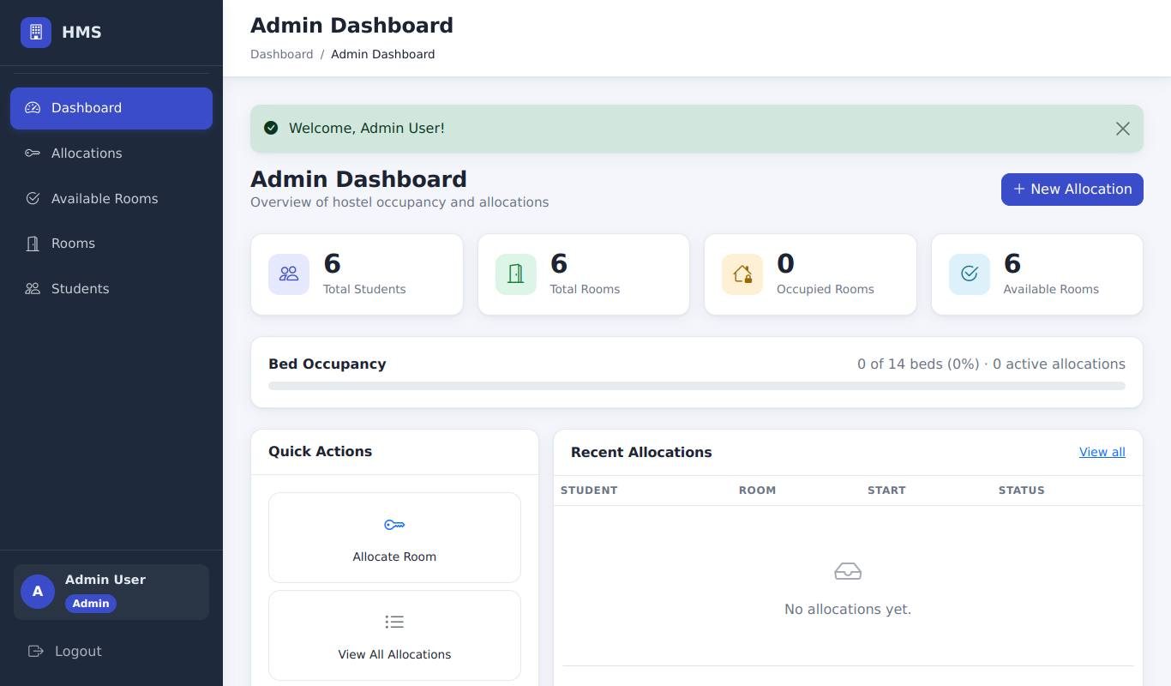
Admin dashboard after a successful login, with the welcome message
Result (to be recorded by the tester)
Actual result
Status | [ ] Pass [ ] Fail [ ] Blocked (not executed)
Executed by / date | /
Defect id
Tester evidence | Paste your screenshot here (save it as evidence/AUTH-01.png and record that file name)

AUTH-02 - Valid warden login
Requirement | RA-11 | Priority | P2
Technique | UI only | Module | Authentication

Preconditions | Not logged in.
Steps | 1. Open the login page  2. Enter the warden e-mail and password  3. Click Login
Input data | warden@hms.test / warden123
Expected result | Redirected to the Warden Dashboard; message "Welcome, Warden Smith!" is shown.
Reference screenshot (expected state, captured by script - not tester evidence)
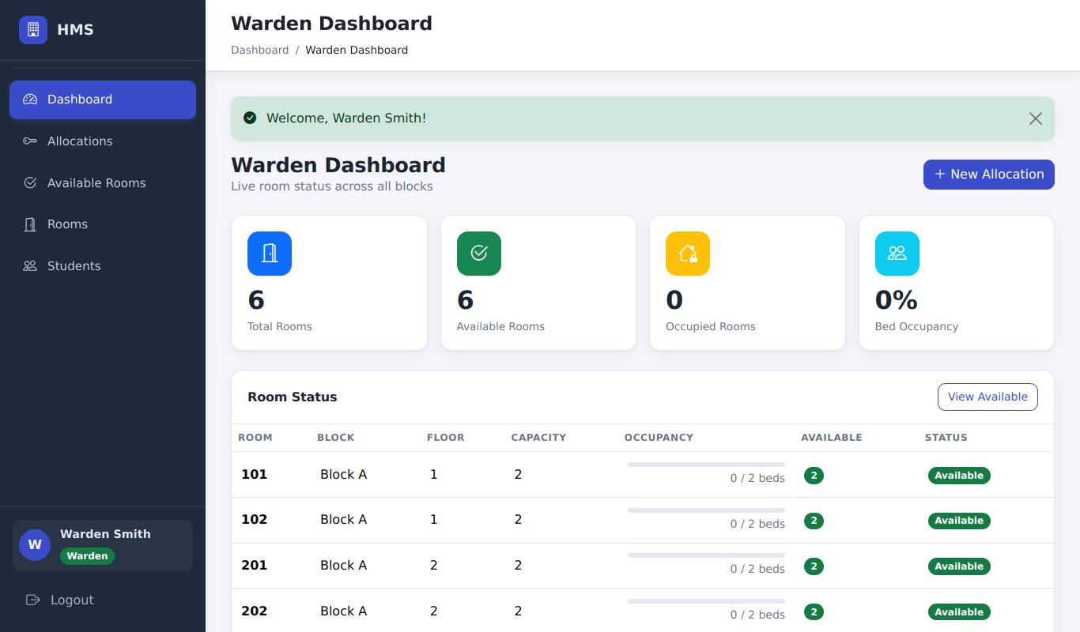
Warden dashboard after login
Result (to be recorded by the tester)
Actual result
Status | [ ] Pass [ ] Fail [ ] Blocked (not executed)
Executed by / date | /
Defect id
Tester evidence | Paste your screenshot here (save it as evidence/AUTH-02.png and record that file name)

AUTH-03 - Valid student login
Requirement | RA-11 | Priority | P2
Technique | UI only | Module | Authentication

Preconditions | Not logged in.
Steps | 1. Open the login page  2. Enter the student e-mail and password  3. Click Login
Input data | john@student.test / student123
Expected result | Redirected to the Student Dashboard; message "Welcome, John Doe!" is shown.
Reference screenshot (expected state, captured by script - not tester evidence)
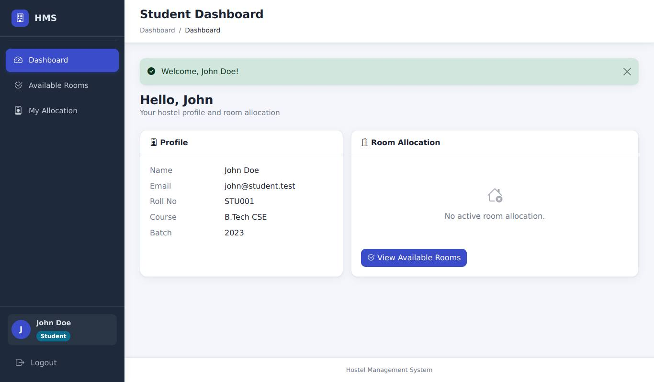
Student dashboard after login
Result (to be recorded by the tester)
Actual result
Status | [ ] Pass [ ] Fail [ ] Blocked (not executed)
Executed by / date | /
Defect id
Tester evidence | Paste your screenshot here (save it as evidence/AUTH-03.png and record that file name)

AUTH-04 - Wrong password rejected
Requirement | RA-11 | Priority | P1
Technique | UI only | Module | Authentication

Preconditions | Not logged in.
Steps | 1. Open the login page  2. Enter admin@hms.test with password "wrong-password"  3. Click Login
Input data | admin@hms.test / wrong-password
Expected result | Stay on the login page; error "Invalid email or password." is shown; no session is created.
Reference screenshot (expected state, captured by script - not tester evidence)
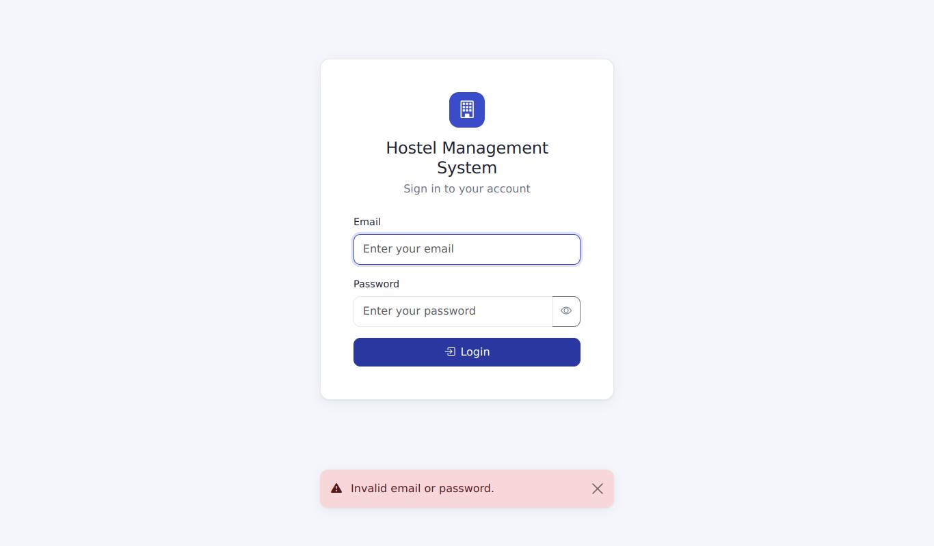
Wrong password: error message, still on the login page
Result (to be recorded by the tester)
Actual result
Status | [ ] Pass [ ] Fail [ ] Blocked (not executed)
Executed by / date | /
Defect id
Tester evidence | Paste your screenshot here (save it as evidence/AUTH-04.png and record that file name)

AUTH-05 - Unknown user rejected
Requirement | RA-11 | Priority | P2
Technique | UI only | Module | Authentication

Preconditions | Not logged in.
Steps | 1. Open the login page  2. Enter nobody@example.com with any password  3. Click Login
Input data | nobody@example.com / x
Expected result | Same error "Invalid email or password." (the message must not reveal whether the account exists).
Reference screenshot (expected state, captured by script - not tester evidence)
Unknown user: the same generic error message
Result (to be recorded by the tester)
Actual result
Status | [ ] Pass [ ] Fail [ ] Blocked (not executed)
Executed by / date | /
Defect id
Tester evidence | Paste your screenshot here (save it as evidence/AUTH-05.png and record that file name)

AUTH-06 - Logout ends the session
Requirement | RA-11 | Priority | P1
Technique | UI only | Module | Authentication

Preconditions | Logged in as admin.
Steps | 1. Click Logout at the bottom of the sidebar  2. In the address bar open http://127.0.0.1:5000/allocation/
Input data | -
Expected result | After step 1: login page with "You have been logged out."; after step 2: redirected to the login page with "Please log in to access this page."
Reference screenshots (expected state, captured by script - not tester evidence)
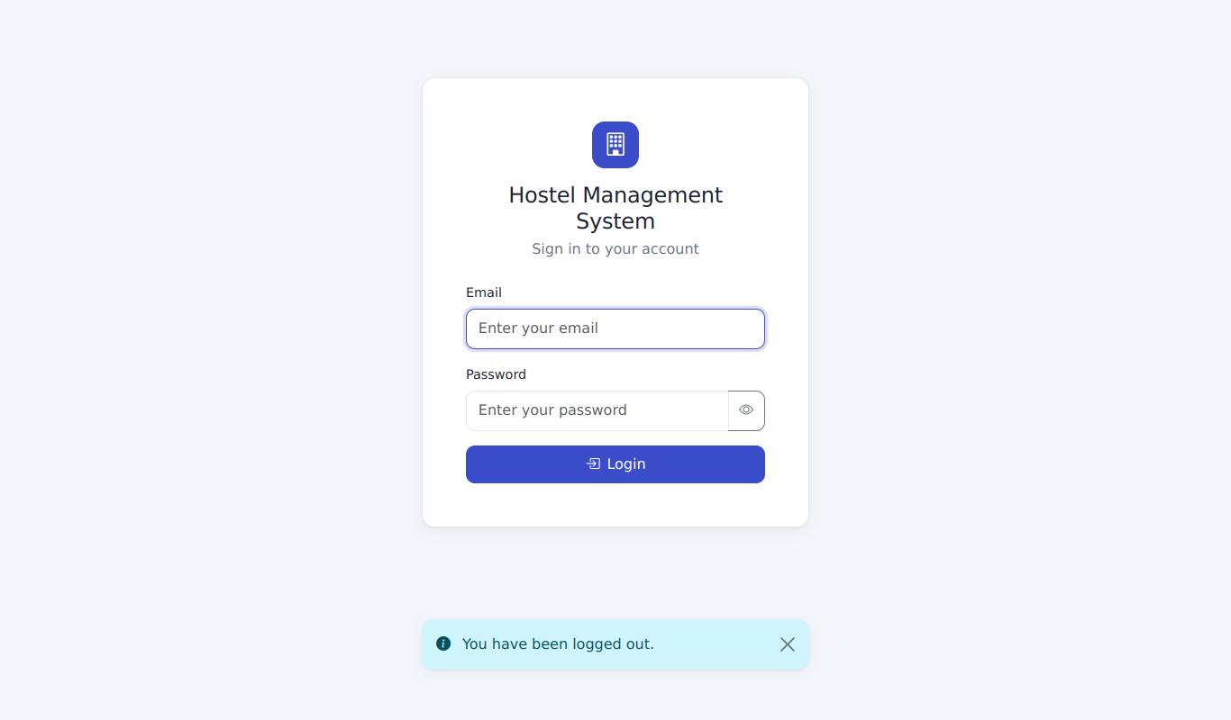
Step 1: after clicking Logout - login page with "You have been logged out."
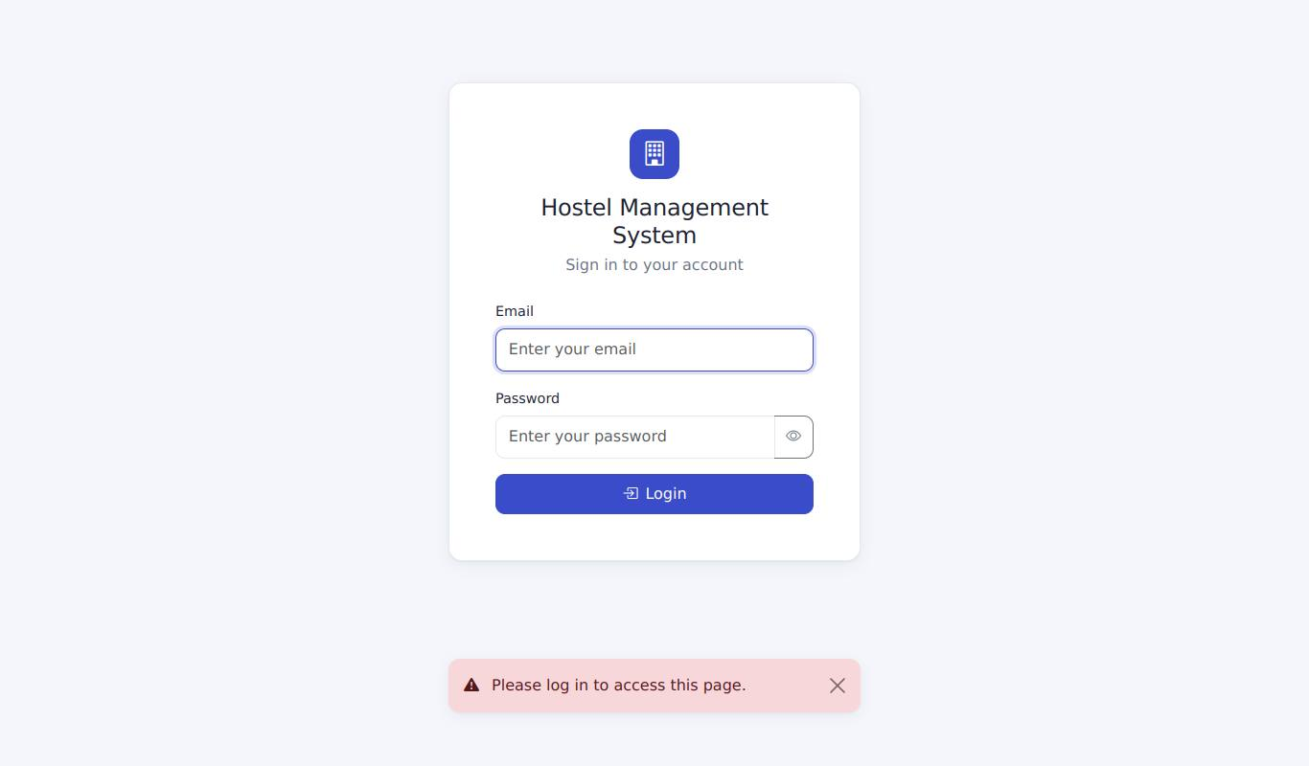
Step 2: opening /allocation/ while logged out redirects to the login page
Result (to be recorded by the tester) - AUTH-06: Logout ends the session
Actual result
Status | [ ] Pass [ ] Fail [ ] Blocked (not executed)
Executed by / date | /
Defect id
Tester evidence | Paste your screenshot here (save it as evidence/AUTH-06.png and record that file name)

AUTH-07 - Anonymous access is blocked
Requirement | RA-11 | Priority | P1
Technique | UI only | Module | Authentication

Preconditions | Not logged in.
Steps | 1. Open http://127.0.0.1:5000/  2. Open /allocation/  3. Open /rooms
Input data | -
Expected result | Every URL redirects to the login page with "Please log in to access this page."
Reference screenshot (expected state, captured by script - not tester evidence)
Anonymous access to /rooms is redirected to the login page with a message
Result (to be recorded by the tester)
Actual result
Status | [ ] Pass [ ] Fail [ ] Blocked (not executed)
Executed by / date | /
Defect id
Tester evidence | Paste your screenshot here (save it as evidence/AUTH-07.png and record that file name)

AUTH-08 - Login requires a CSRF token
Requirement | RA-12 | Priority | P1
Technique | UI + browser DevTools | Module | Authentication

Preconditions | Not logged in; browser DevTools open.
Steps | 1. Open the login page  2. In DevTools > Elements delete the hidden <input name="csrf_token">  3. Enter valid admin credentials and click Login
Input data | admin@hms.test / admin123
Expected result | The server rejects the request: page titled "Your request could not be verified" (HTTP 400, visible in the DevTools Network tab). You are not logged in.
Reference screenshot (expected state, captured by script - not tester evidence)
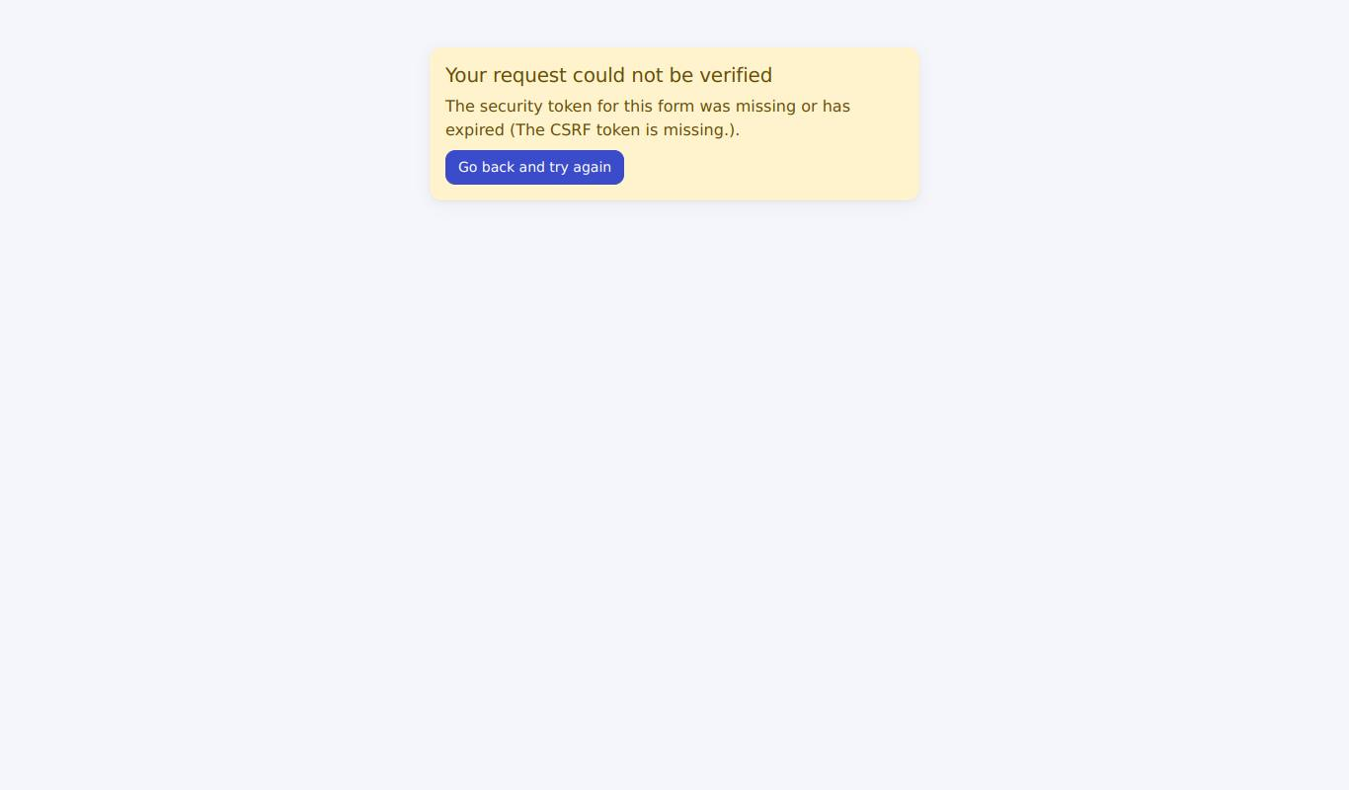
Login without the CSRF token: request rejected (HTTP 400 page)
Result (to be recorded by the tester)
Actual result
Status | [ ] Pass [ ] Fail [ ] Blocked (not executed)
Executed by / date | /
Defect id
Tester evidence | Paste your screenshot here (save it as evidence/AUTH-08.png and record that file name)

AUTH-09 - Lockout after repeated failed logins
Requirement | RA-11 | Priority | P2
Technique | UI only | Module | Authentication

Preconditions | Restart the server with LOGIN_MAX_ATTEMPTS=5 (TESTING_PROCEDURE.md section 3). Not logged in.
Steps | 1. Submit the login form 5 times with dana@student.test and a wrong password  2. Submit a 6th time with the CORRECT password (student123)  3. Log in with john@student.test / student123
Input data | dana@student.test
Expected result | Attempts 1-5: "Invalid email or password."; attempt 6 (even with the correct password): "Too many failed login attempts. Try again in about 15 minute(s)."; step 3 (a different account) still works.
Reference screenshots (expected state, captured by script - not tester evidence)
Attempt 5 of 5 (wrong password): still the normal error message
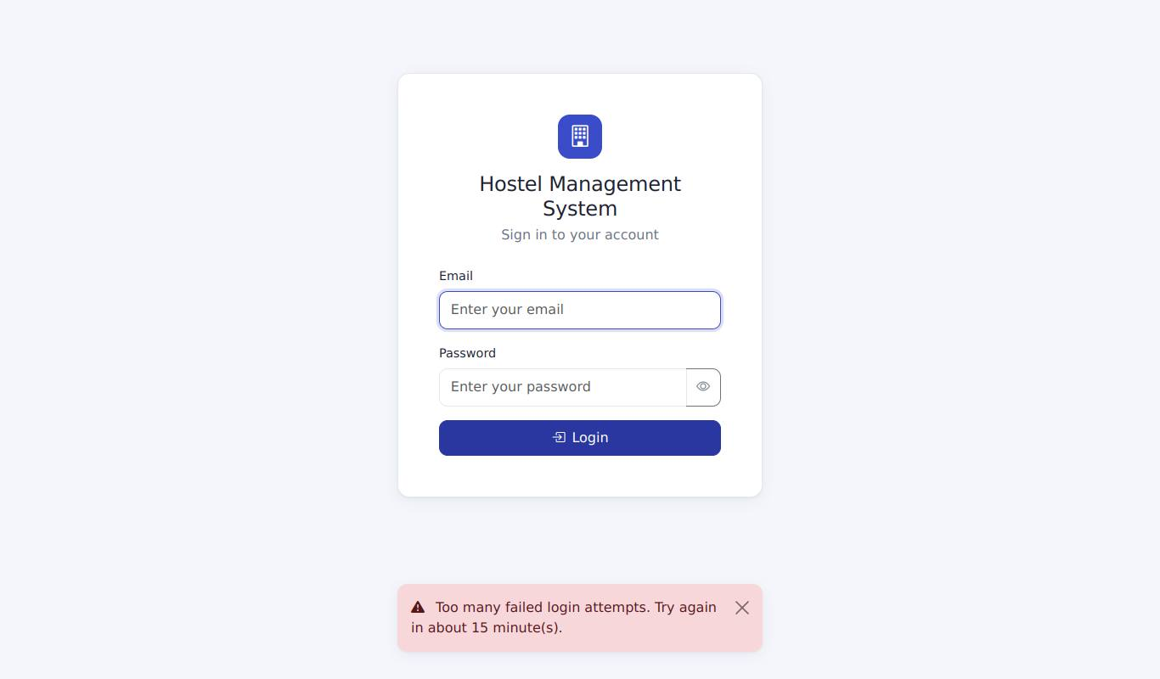
Attempt 6 with the CORRECT password: locked out message
A different account (John) can still log in
Result (to be recorded by the tester) - AUTH-09: Lockout after repeated failed logins
Actual result
Status | [ ] Pass [ ] Fail [ ] Blocked (not executed)
Executed by / date | /
Defect id
Tester evidence | Paste your screenshot here (save it as evidence/AUTH-09.png and record that file name)

AUTH-10 - Logout is not possible via a link (GET)
Requirement | RA-11, RA-12 | Priority | P1
Technique | UI only | Module | Authentication

Preconditions | Logged in as admin.
Steps | 1. In the address bar open http://127.0.0.1:5000/auth/logout  2. Open http://127.0.0.1:5000/
Input data | -
Expected result | Step 1 shows "Method Not Allowed" (HTTP 405). Step 2 shows the dashboard: you are still logged in.
Reference screenshots (expected state, captured by script - not tester evidence)
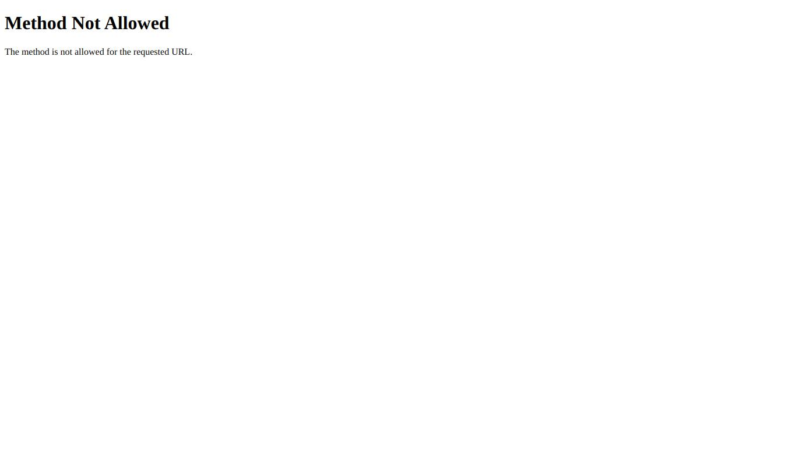
Step 1: opening /auth/logout in the address bar - "Method Not Allowed"
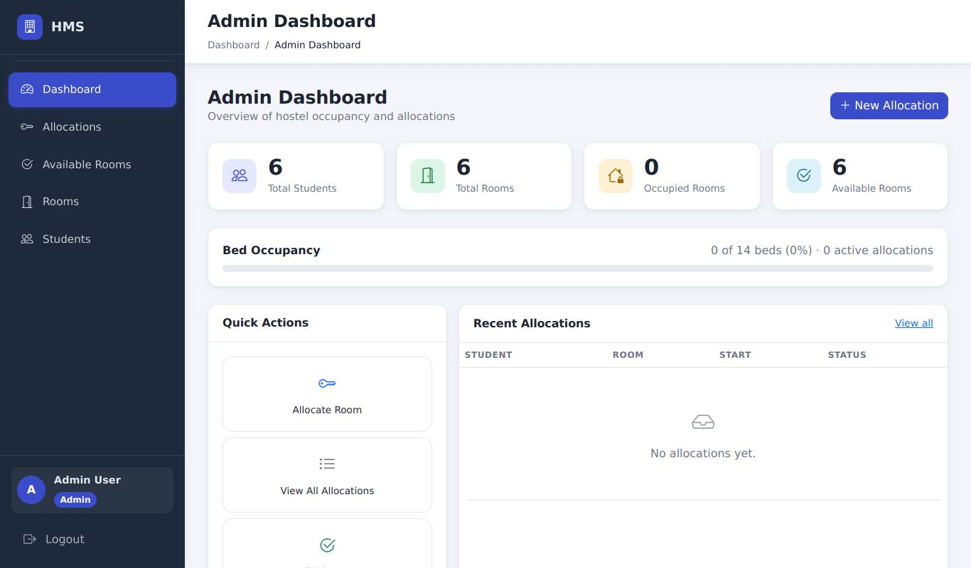
Step 2: the dashboard is still shown - you are still logged in
Result (to be recorded by the tester) - AUTH-10: Logout is not possible via a link (GET)
Actual result
Status | [ ] Pass [ ] Fail [ ] Blocked (not executed)
Executed by / date | /
Defect id
Tester evidence | Paste your screenshot here (save it as evidence/AUTH-10.png and record that file name)

6.2 Allocation

ALLOC-01 - Allocate a student, open-ended
Requirement | RA-01 | Priority | P1
Technique | UI only | Module | Allocation

Preconditions | Logged in as admin. Fresh demo data without allocations. No allocations exist.
Steps | 1. Sidebar > Allocations > New Allocation  2. Student: John Doe; Room: Block A, room 101  3. Leave the start date at today; leave End date empty  4. Click Create allocation
Input data | John Doe -> Block A / 101
Expected result | Redirected to the allocation list; message "Room 101 allocated to John Doe successfully."; list shows John Doe, Block A, room 101, Status Active, End "—".
Reference screenshot (expected state, captured by script - not tester evidence)
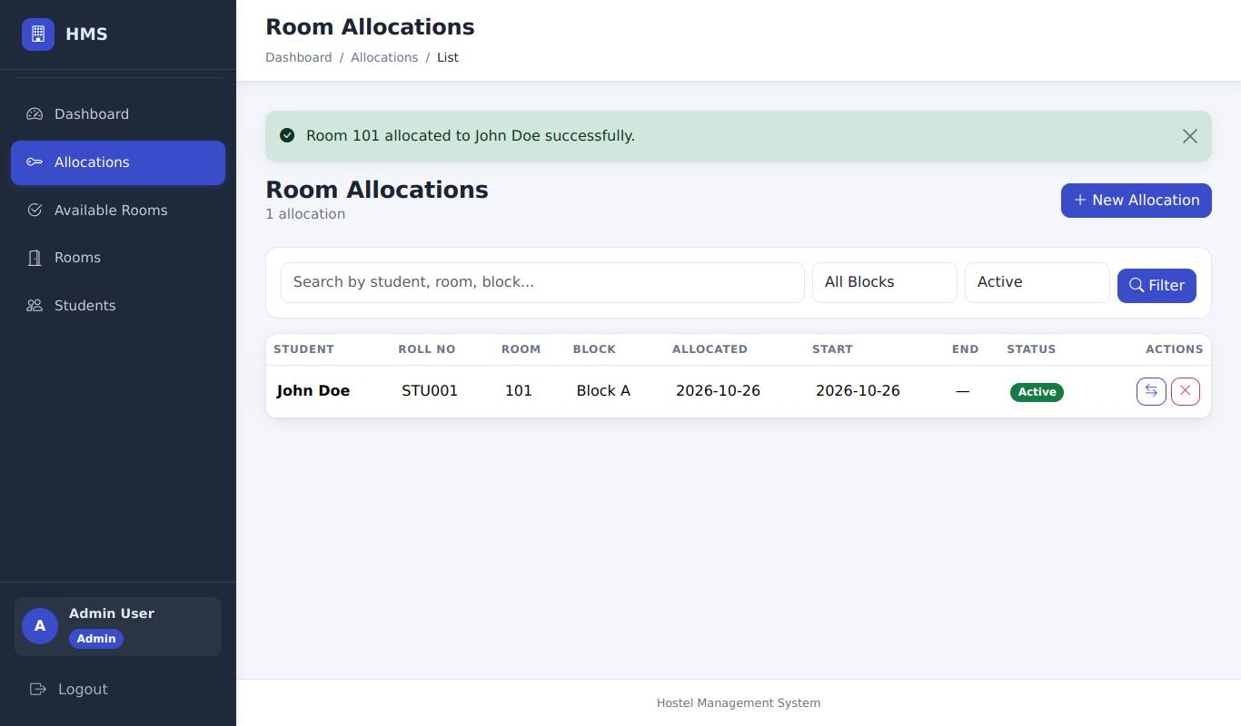
John Doe allocated to Block A 101 (open-ended): success message and the new row
Result (to be recorded by the tester)
Actual result
Status | [ ] Pass [ ] Fail [ ] Blocked (not executed)
Executed by / date | /
Defect id
Tester evidence | Paste your screenshot here (save it as evidence/ALLOC-01.png and record that file name)

ALLOC-08 - Allocate with an end date
Requirement | RA-01 | Priority | P2
Technique | UI only | Module | Allocation

Preconditions | ALLOC-01 done.
Steps | 1. New Allocation  2. Student: Jane Smith; Room: Block A, room 101  3. Start: today; End: today + 90 days  4. Create allocation
Input data | Jane Smith -> Block A / 101
Expected result | Success message for room 101 and Jane Smith; list shows the end date. Room Block A 101 is now 2/2.
Reference screenshot (expected state, captured by script - not tester evidence)
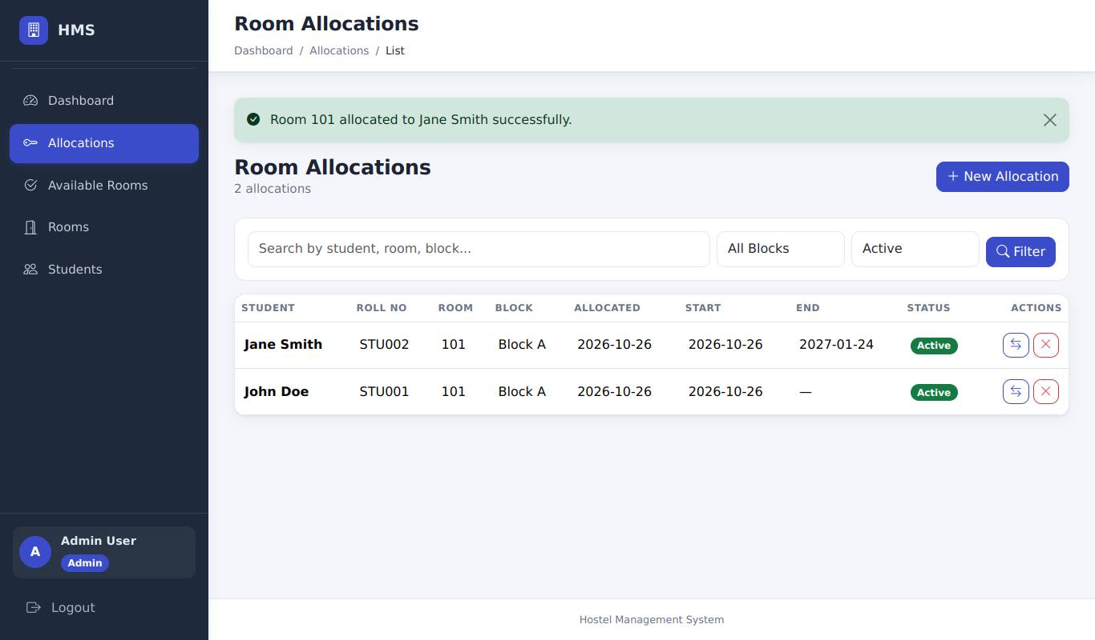
Jane Smith allocated with an end date (90 days ahead)
Result (to be recorded by the tester)
Actual result
Status | [ ] Pass [ ] Fail [ ] Blocked (not executed)
Executed by / date | /
Defect id
Tester evidence | Paste your screenshot here (save it as evidence/ALLOC-08.png and record that file name)

ALLOC-05 - Student with an active allocation cannot get a second
Requirement | RA-03 | Priority | P1
Technique | UI only | Module | Allocation

Preconditions | ALLOC-01 done (John has an active allocation).
Steps | 1. New Allocation  2. Student: John Doe; Room: Block B, room 101  3. Create allocation
Input data | John Doe -> Block B / 101
Expected result | Error "Student John Doe already has an active room allocation."; no new row in the allocation list.
Reference screenshot (expected state, captured by script - not tester evidence)
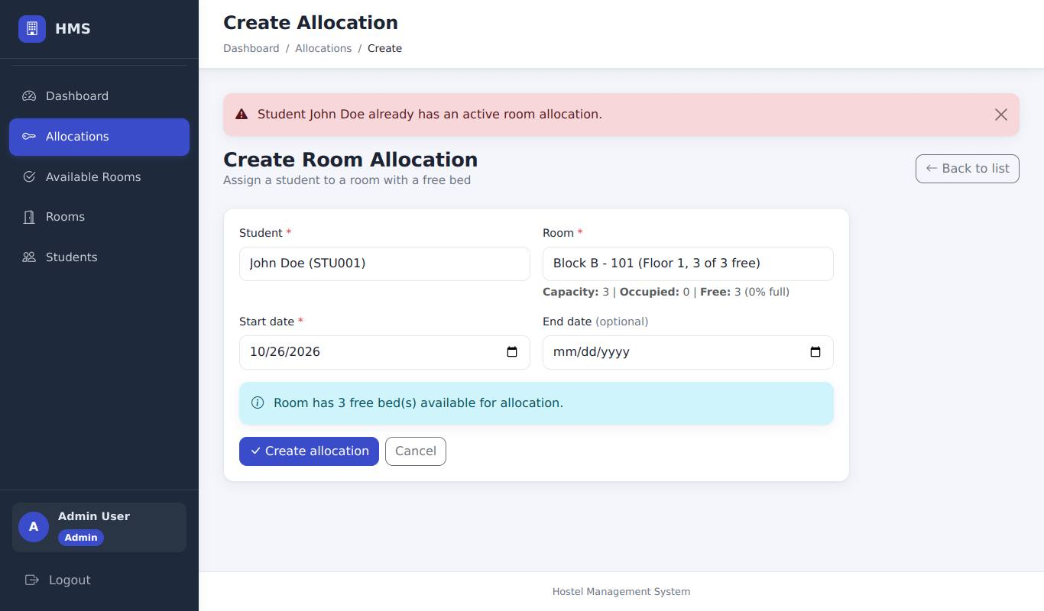
Second allocation for John refused: "already has an active room allocation"
Result (to be recorded by the tester)
Actual result
Status | [ ] Pass [ ] Fail [ ] Blocked (not executed)
Executed by / date | /
Defect id
Tester evidence | Paste your screenshot here (save it as evidence/ALLOC-05.png and record that file name)

ALLOC-15 - Form keeps your input after a server-side error
Requirement | RA-02, UI-03 | Priority | P2
Technique | UI only | Module | Allocation

Preconditions | Immediately after ALLOC-05.
Steps | 1. Look at the New Allocation form that is displayed together with the error
Input data | -
Expected result | The form is shown again with Student = John Doe, Room = Block B 101 and the start date still selected (you do not have to re-enter everything).
Reference screenshot (expected state, captured by script - not tester evidence)
The same screen: the form is shown again with John Doe and Block B 101 still selected
Result (to be recorded by the tester)
Actual result
Status | [ ] Pass [ ] Fail [ ] Blocked (not executed)
Executed by / date | /
Defect id
Tester evidence | Paste your screenshot here (save it as evidence/ALLOC-15.png and record that file name)

ALLOC-11 - Start date equal to end date is accepted
Requirement | RA-01 | Priority | P2
Technique | UI only | Module | Allocation

Preconditions | Logged in as admin.
Steps | 1. New Allocation  2. Student: Bob Wilson; Room: Block A, room 102  3. Start: today; End: today  4. Create allocation
Input data | Bob Wilson -> Block A / 102
Expected result | Success message "Room 102 allocated to Bob Wilson successfully."
Reference screenshot (expected state, captured by script - not tester evidence)
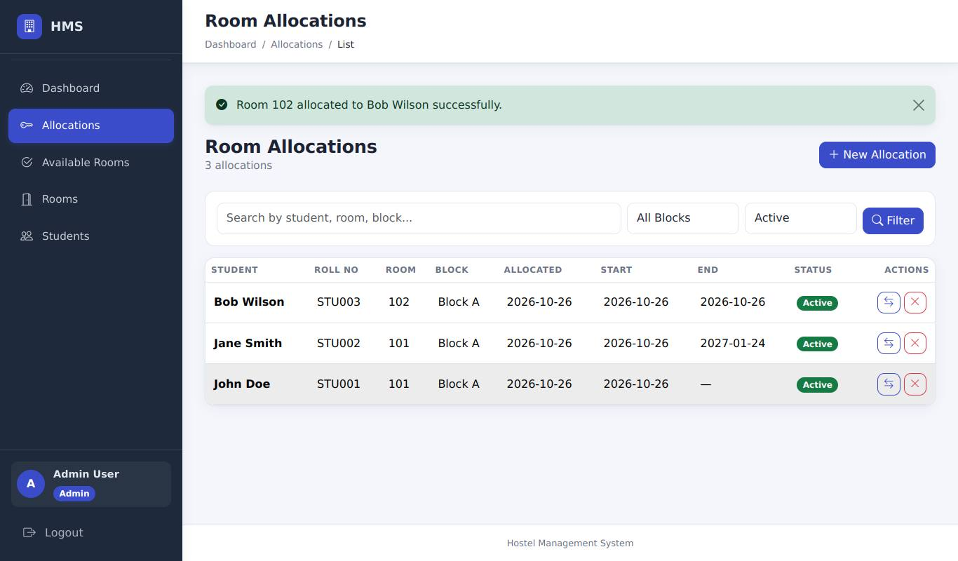
Bob Wilson allocated with start date = end date = today
Result (to be recorded by the tester)
Actual result
Status | [ ] Pass [ ] Fail [ ] Blocked (not executed)
Executed by / date | /
Defect id
Tester evidence | Paste your screenshot here (save it as evidence/ALLOC-11.png and record that file name)

ALLOC-02 - Allocating to a room that filled up meanwhile is refused
Requirement | RA-04 | Priority | P1
Technique | UI + browser DevTools | Module | Allocation

Preconditions | Block A 102 has exactly 1 free bed (Bob only). Two browser tabs on the New Allocation form, both opened BEFORE step 1 (both list Block A 102).
Steps | 1. Tab 1: allocate Alice Brown to Block A 102 and submit (succeeds, room now full)  2. Tab 2 (stale form, still lists room 102): select Carlos Diaz and Block A 102, submit
Input data | Carlos Diaz -> Block A / 102 (stale form)
Expected result | Tab 2 shows error "Room 102 is not available (capacity: 2, occupied: 2)."; Carlos has no allocation; room 102 stays 2/2.
Reference screenshot (expected state, captured by script - not tester evidence)
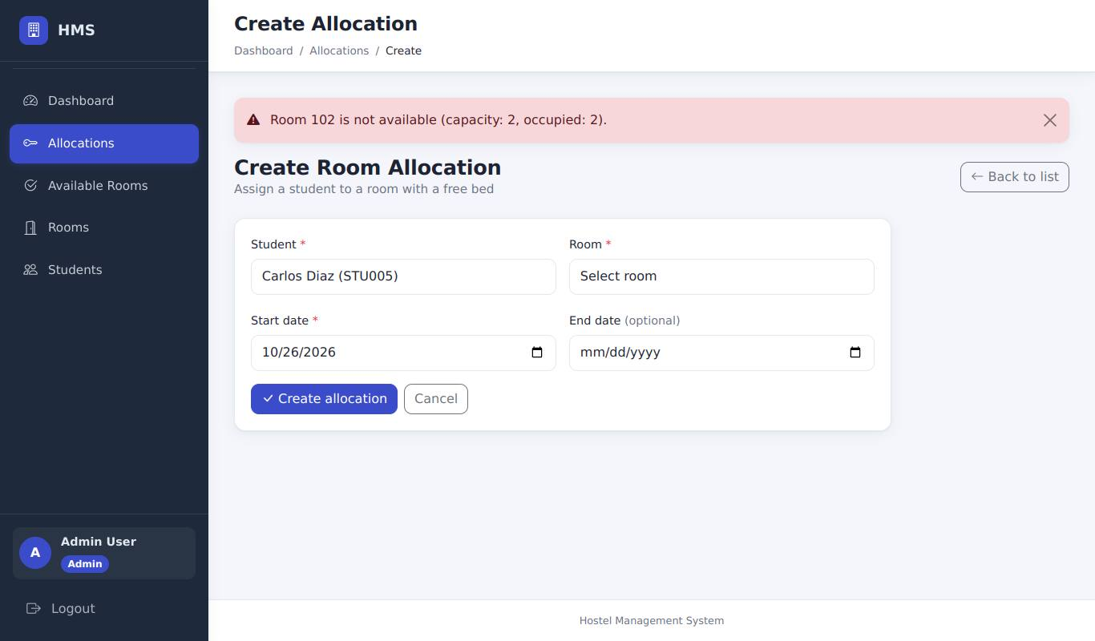
Tab 2 (stale form): room 102 is no longer available - the server refuses the allocation
Result (to be recorded by the tester)
Actual result
Status | [ ] Pass [ ] Fail [ ] Blocked (not executed)
Executed by / date | /
Defect id
Tester evidence | Paste your screenshot here (save it as evidence/ALLOC-02.png and record that file name)

ALLOC-09 - Warden can create an allocation
Requirement | RA-01 | Priority | P2
Technique | UI only | Module | Allocation

Preconditions | Logged in as WARDEN (log out first).
Steps | 1. New Allocation  2. Student: Carlos Diaz; Room: Block A, room 201  3. Create allocation
Input data | warden@hms.test / warden123 / Carlos Diaz -> Block A / 201
Expected result | Success message "Room 201 allocated to Carlos Diaz successfully."
Reference screenshot (expected state, captured by script - not tester evidence)
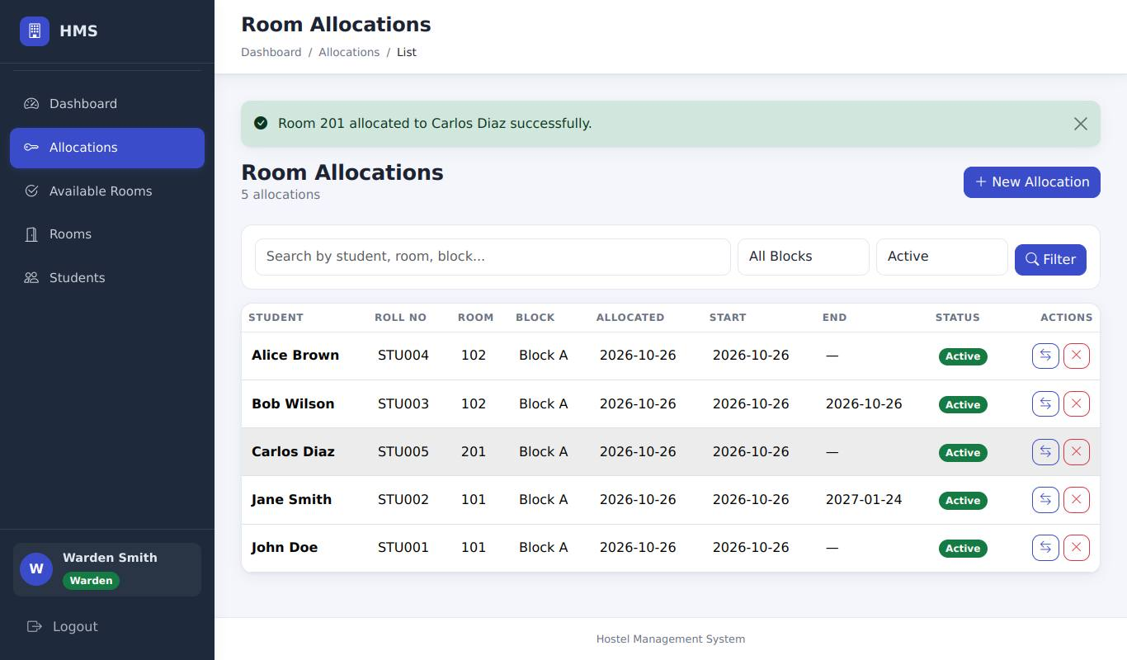
Warden allocates Carlos Diaz to Block A 201
Result (to be recorded by the tester)
Actual result
Status | [ ] Pass [ ] Fail [ ] Blocked (not executed)
Executed by / date | /
Defect id
Tester evidence | Paste your screenshot here (save it as evidence/ALLOC-09.png and record that file name)

ALLOC-03 - Non-existent student id is rejected
Requirement | RA-02 | Priority | P2
Technique | UI + browser DevTools | Module | Allocation

Preconditions | Logged in as admin.
Steps | 1. Open New Allocation  2. In DevTools change the value of one <option> in the Student select to 99999  3. Select that option, choose a room, submit
Input data | student_id=99999
Expected result | Error "Selected student does not exist."; nothing created.
Reference screenshot (expected state, captured by script - not tester evidence)
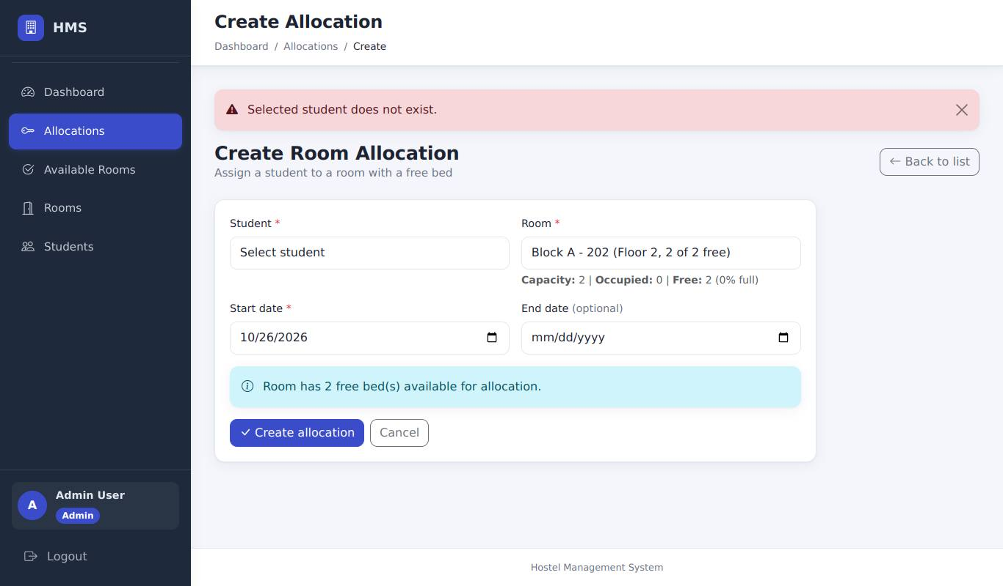
Student id 99999 (edited in DevTools): "Selected student does not exist."
Result (to be recorded by the tester)
Actual result
Status | [ ] Pass [ ] Fail [ ] Blocked (not executed)
Executed by / date | /
Defect id
Tester evidence | Paste your screenshot here (save it as evidence/ALLOC-03.png and record that file name)

ALLOC-04 - Non-existent room id is rejected
Requirement | RA-02 | Priority | P2
Technique | UI + browser DevTools | Module | Allocation

Preconditions | Logged in as admin.
Steps | 1. Open New Allocation  2. In DevTools change the value of one <option> in the Room select to 99999  3. Select a student and that room option, submit
Input data | room_id=99999
Expected result | Error "Selected room does not exist."; nothing created.
Reference screenshot (expected state, captured by script - not tester evidence)
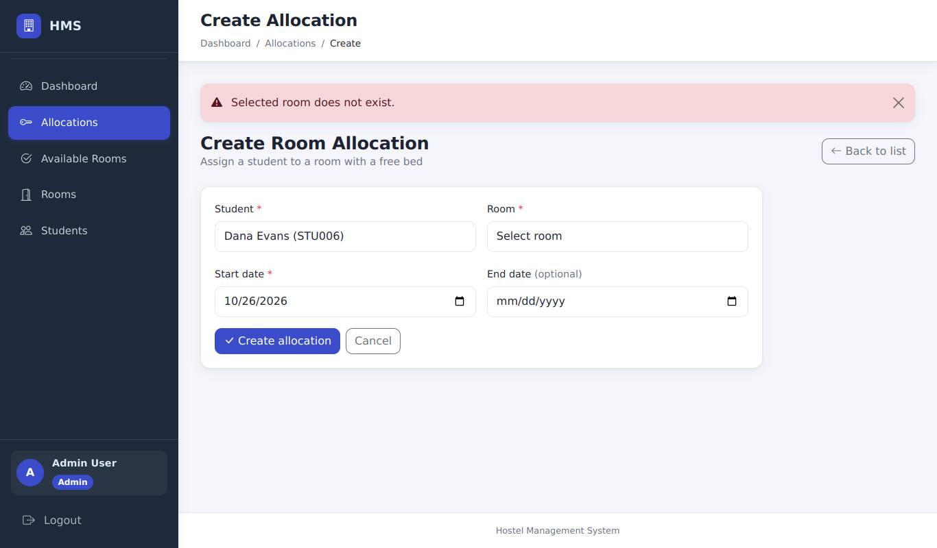
Room id 99999 (edited in DevTools): "Selected room does not exist."
Result (to be recorded by the tester)
Actual result
Status | [ ] Pass [ ] Fail [ ] Blocked (not executed)
Executed by / date | /
Defect id
Tester evidence | Paste your screenshot here (save it as evidence/ALLOC-04.png and record that file name)

ALLOC-06 - Required fields
Requirement | RA-02 | Priority | P1
Technique | UI only | Module | Allocation

Preconditions | Logged in as admin.
Steps | 1. Open New Allocation  2. Leave Student and Room unselected  3. Click Create allocation
Input data | -
Expected result | The form is not submitted: the empty required fields are highlighted/flagged and the Create allocation button is still clickable (it must not stay stuck on "Processing..."). (If you bypass the browser check the server answers "Student, room, and start date are required.")
Reference screenshot (expected state, captured by script - not tester evidence)
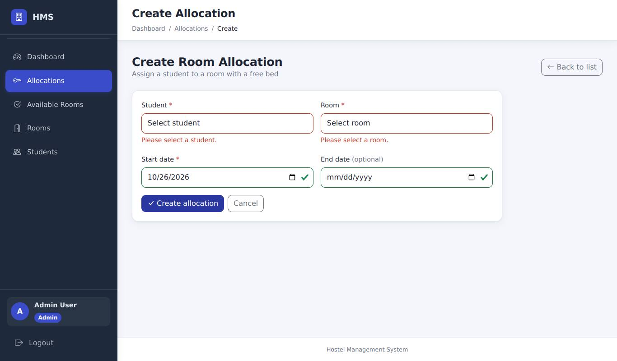
Submitting with Student and Room empty: the required fields are flagged and nothing is sent
Result (to be recorded by the tester)
Actual result
Status | [ ] Pass [ ] Fail [ ] Blocked (not executed)
Executed by / date | /
Defect id
Tester evidence | Paste your screenshot here (save it as evidence/ALLOC-06.png and record that file name)

ALLOC-07 - Invalid date text is rejected
Requirement | RA-02 | Priority | P2
Technique | UI + browser DevTools | Module | Allocation

Preconditions | Logged in as admin.
Steps | 1. Open New Allocation  2. In DevTools change the Start date <input type="date"> to type="text"  3. Type 2026-13-45; select student and room; submit
Input data | 2026-13-45
Expected result | Error "Invalid date format. Use YYYY-MM-DD."; nothing created; entered values kept.
Reference screenshot (expected state, captured by script - not tester evidence)
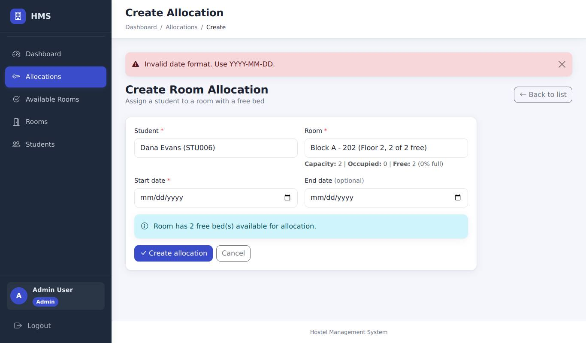
Start date "2026-13-45" (field changed to text in DevTools): "Invalid date format"
Result (to be recorded by the tester)
Actual result
Status | [ ] Pass [ ] Fail [ ] Blocked (not executed)
Executed by / date | /
Defect id
Tester evidence | Paste your screenshot here (save it as evidence/ALLOC-07.png and record that file name)

ALLOC-10 - End date before start date is rejected
Requirement | RA-02 | Priority | P1
Technique | UI only | Module | Allocation

Preconditions | Logged in as admin.
Steps | 1. Open New Allocation  2. Choose a student without allocation (Dana Evans) and any available room  3. Start: today + 10 days; End: today + 5 days  4. Submit
Input data | start > end
Expected result | Submission refused: either the browser/JS shows a validation message ("End date cannot be earlier than start date.") or the server shows it; the button stays clickable; no allocation created.
Reference screenshot (expected state, captured by script - not tester evidence)
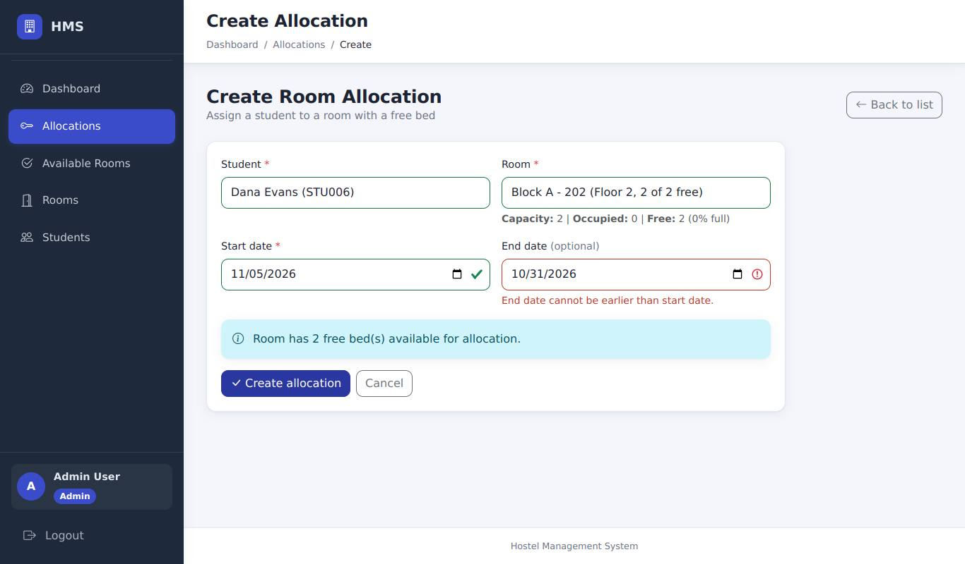
End date (today+5) before start date (today+10): the form refuses to submit
Result (to be recorded by the tester)
Actual result
Status | [ ] Pass [ ] Fail [ ] Blocked (not executed)
Executed by / date | /
Defect id
Tester evidence | Paste your screenshot here (save it as evidence/ALLOC-10.png and record that file name)

ALLOC-14 - Dates outside 2000-2100 are rejected
Requirement | RA-02 | Priority | P2
Technique | UI + browser DevTools | Module | Allocation

Preconditions | Logged in as admin.
Steps | 1. Open New Allocation  2. In DevTools change Start date to type="text" and enter 1900-01-01; choose Dana Evans and a room; submit  3. Repeat with 9999-12-31
Input data | 1900-01-01 / 9999-12-31
Expected result | Error "Dates must be between 2000-01-01 and 2100-12-31." both times; nothing created.
Reference screenshot (expected state, captured by script - not tester evidence)
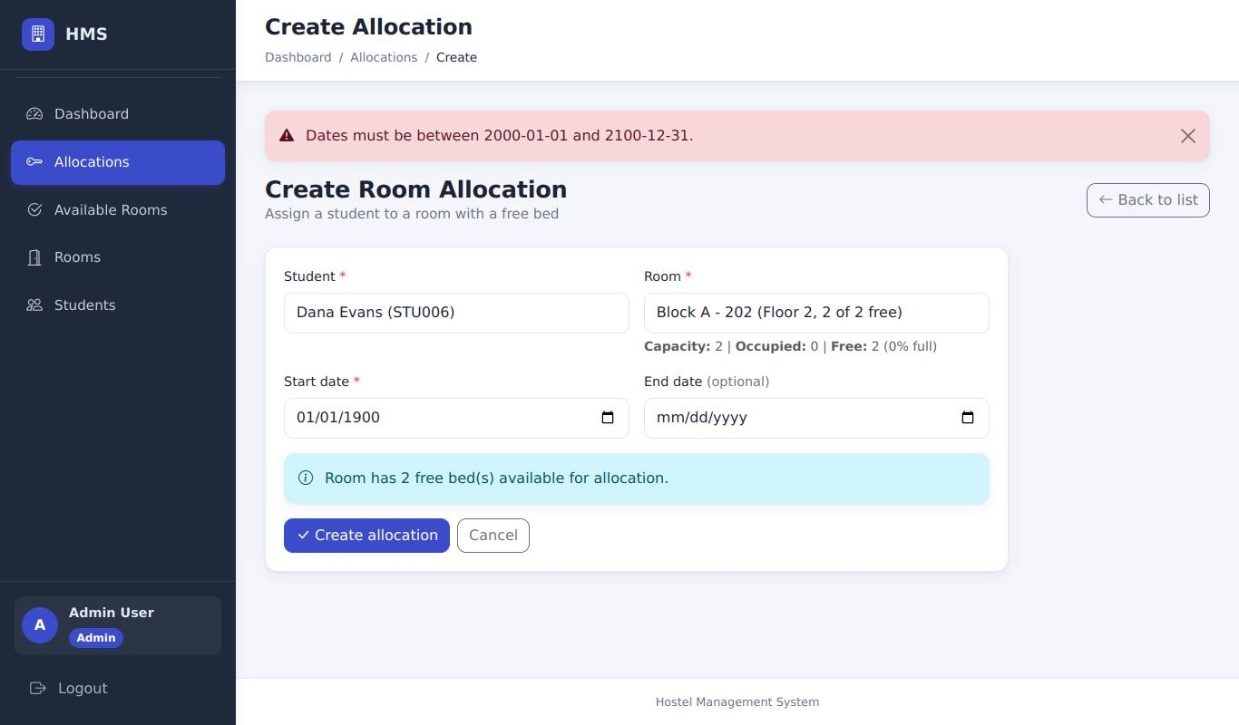
Start date 1900-01-01: "Dates must be between 2000-01-01 and 2100-12-31."
Result (to be recorded by the tester)
Actual result
Status | [ ] Pass [ ] Fail [ ] Blocked (not executed)
Executed by / date | /
Defect id
Tester evidence | Paste your screenshot here (save it as evidence/ALLOC-14.png and record that file name)

ALLOC-13 - Create requires a CSRF token
Requirement | RA-12 | Priority | P1
Technique | UI + browser DevTools | Module | Allocation

Preconditions | Logged in as admin.
Steps | 1. Open New Allocation and fill it with valid data (Dana Evans, Block A 202)  2. In DevTools delete the hidden <input name="csrf_token">  3. Submit
Input data | -
Expected result | Page "Your request could not be verified" (HTTP 400); no allocation created for Dana Evans.
Reference screenshot (expected state, captured by script - not tester evidence)
CSRF token deleted in DevTools: "Your request could not be verified" (HTTP 400)
Result (to be recorded by the tester)
Actual result
Status | [ ] Pass [ ] Fail [ ] Blocked (not executed)
Executed by / date | /
Defect id
Tester evidence | Paste your screenshot here (save it as evidence/ALLOC-13.png and record that file name)

6.3 Occupancy

OCC-01 - Room becomes Full at capacity
Requirement | RA-04 | Priority | P1
Technique | UI only | Module | Occupancy

Preconditions | ALLOC-01 and ALLOC-08 done.
Steps | 1. Sidebar > Rooms  2. Find Block A room 101
Input data | -
Expected result | Block A 101 shows 2 of 2 beds occupied and status Full.
Reference screenshot (expected state, captured by script - not tester evidence)
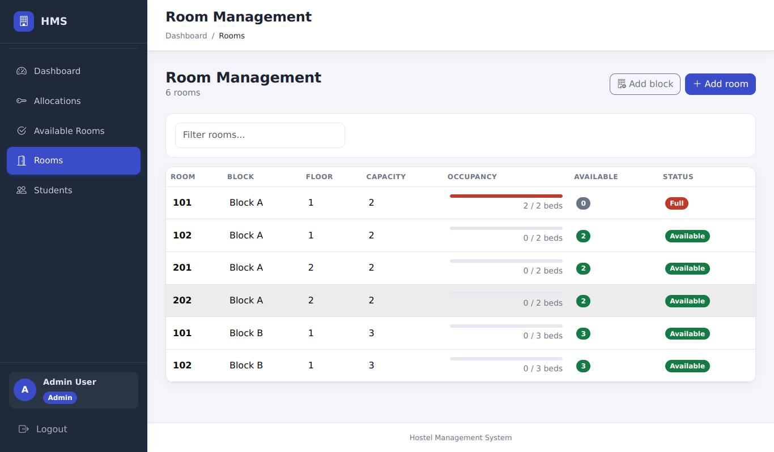
Rooms page: Block A 101 is 2 / 2 beds and Full
Result (to be recorded by the tester)
Actual result
Status | [ ] Pass [ ] Fail [ ] Blocked (not executed)
Executed by / date | /
Defect id
Tester evidence | Paste your screenshot here (save it as evidence/OCC-01.png and record that file name)

OCC-02 - Room becomes Available again when a bed is freed
Requirement | RA-04 | Priority | P1
Technique | UI only | Module | Occupancy

Preconditions | Right after REALLOC-01.
Steps | 1. Sidebar > Rooms  2. Find Block A room 101
Input data | -
Expected result | Block A 101 shows 1 of 2 beds occupied and status Available.
Reference screenshot (expected state, captured by script - not tester evidence)
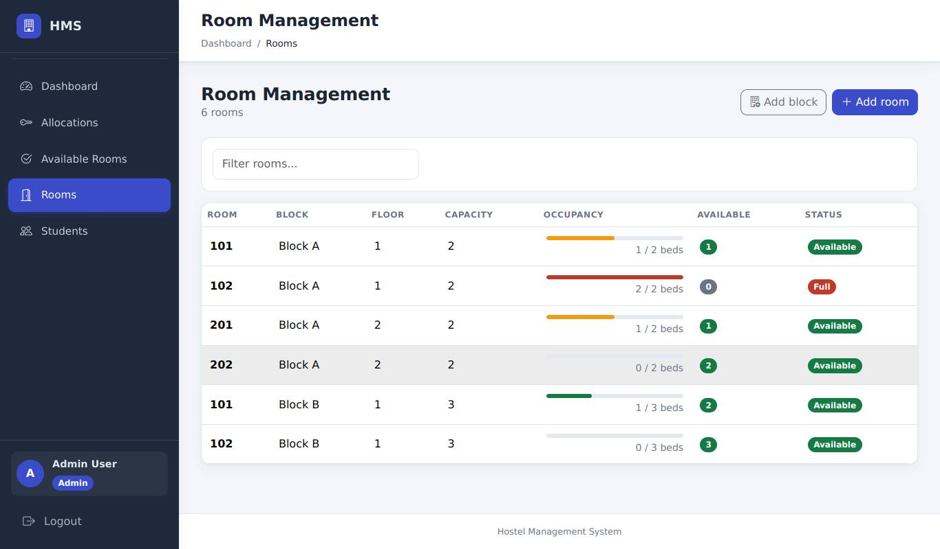
Rooms page: Block A 101 is now 1 / 2 beds and Available; Block B 101 is 1 / 3
Result (to be recorded by the tester)
Actual result
Status | [ ] Pass [ ] Fail [ ] Blocked (not executed)
Executed by / date | /
Defect id
Tester evidence | Paste your screenshot here (save it as evidence/OCC-02.png and record that file name)

OCC-03 - Full rooms cannot be picked when creating
Requirement | RA-04 | Priority | P2
Technique | UI only | Module | Occupancy

Preconditions | Block A 102 is full.
Steps | 1. New Allocation > open the Room drop-down
Input data | -
Expected result | Block A 102 is not offered.
Reference screenshot (expected state, captured by script - not tester evidence)
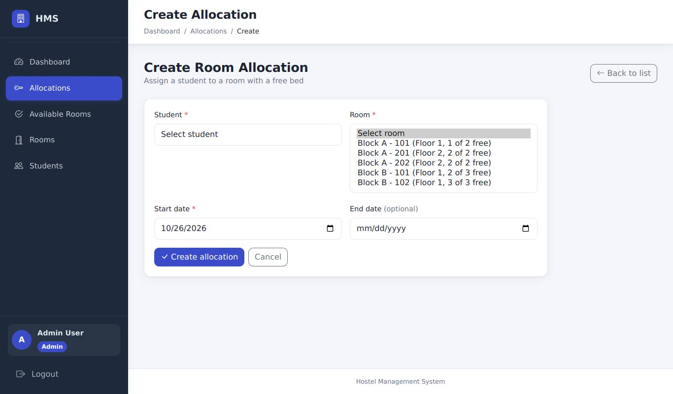
New Allocation room list (expanded for the screenshot): the full Block A 102 is not offered
Result (to be recorded by the tester)
Actual result
Status | [ ] Pass [ ] Fail [ ] Blocked (not executed)
Executed by / date | /
Defect id
Tester evidence | Paste your screenshot here (save it as evidence/OCC-03.png and record that file name)

6.4 Reallocation

REALLOC-01 - Reallocate to a room with a free bed
Requirement | RA-05 | Priority | P1
Technique | UI only | Module | Reallocation

Preconditions | John has an active allocation in Block A 101 (full 2/2).
Steps | 1. Allocations list > click the Reallocate icon on John Doe  2. New room: Block B, room 101  3. Click Reallocate
Input data | John: A/101 -> B/101
Expected result | Message "Student reallocated to room 101 successfully."; list shows John in Block B. Rooms page: Block A 101 is now 1/2 and Available; Block B 101 is 1/3.
Reference screenshot (expected state, captured by script - not tester evidence)
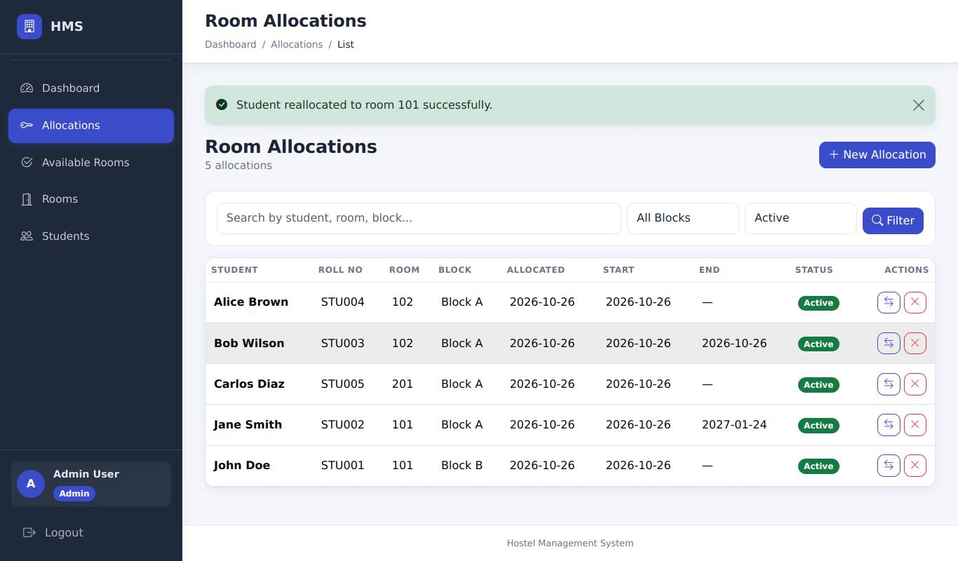
John reallocated to Block B 101: message "Student reallocated to room 101 successfully."
Result (to be recorded by the tester)
Actual result
Status | [ ] Pass [ ] Fail [ ] Blocked (not executed)
Executed by / date | /
Defect id
Tester evidence | Paste your screenshot here (save it as evidence/REALLOC-01.png and record that file name)

REALLOC-03 - Full rooms are not offered
Requirement | RA-05, RA-04 | Priority | P2
Technique | UI only | Module | Reallocation

Preconditions | Block A 102 is full (Bob + Alice from ALLOC-02).
Steps | 1. Click Reallocate on Carlos Diaz  2. Open the "New room" drop-down
Input data | -
Expected result | Block A 102 (full) is not in the list; only rooms with a free bed are offered.
Reference screenshot (expected state, captured by script - not tester evidence)
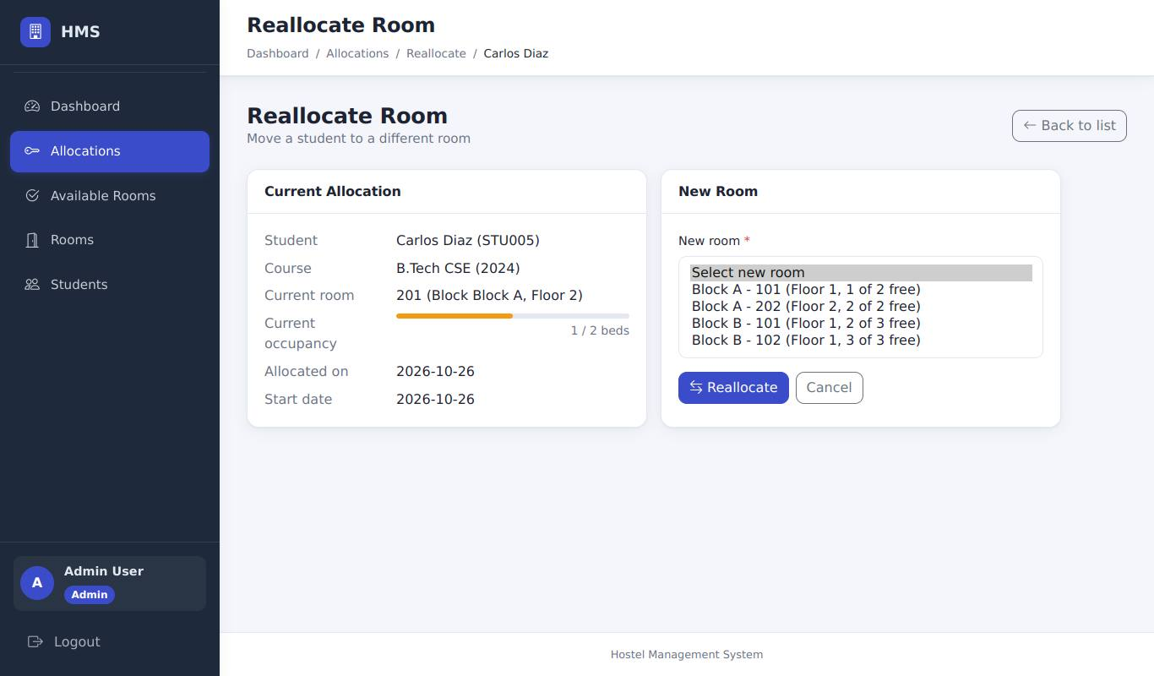
Reallocate form for Carlos (list expanded for the screenshot): Block A 102 (full) is not offered
Result (to be recorded by the tester)
Actual result
Status | [ ] Pass [ ] Fail [ ] Blocked (not executed)
Executed by / date | /
Defect id
Tester evidence | Paste your screenshot here (save it as evidence/REALLOC-03.png and record that file name)

REALLOC-06 - Reallocating to the same room is refused
Requirement | RA-05 | Priority | P3
Technique | UI + browser DevTools | Module | Reallocation

Preconditions | Jane Smith is allocated to Block A 101 (room id 1 in the demo data).
Steps | 1. Click Reallocate on Jane Smith (her current room is not offered in the list)  2. In DevTools > Elements change the value of any one <option> in the "New room" select to 1 (the id of Block A 101)  3. Select that option and click Reallocate
Input data | new_room_id=1 (her current room)
Expected result | Error "Student is already in that room. Choose a different room."; no change to the allocation or room counters.
Reference screenshot (expected state, captured by script - not tester evidence)
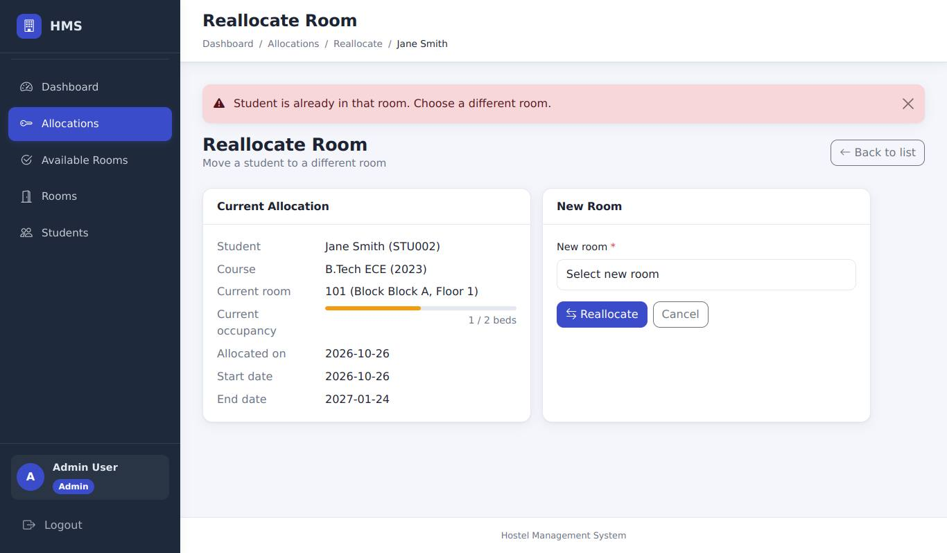
Room id 1 = Jane's current room (option value edited in DevTools): "Student is already in that room. Choose a different room."
Result (to be recorded by the tester)
Actual result
Status | [ ] Pass [ ] Fail [ ] Blocked (not executed)
Executed by / date | /
Defect id
Tester evidence | Paste your screenshot here (save it as evidence/REALLOC-06.png and record that file name)

REALLOC-04 - Room is required
Requirement | RA-05 | Priority | P2
Technique | UI only | Module | Reallocation

Preconditions | Reallocate form open.
Steps | 1. Leave "Select new room" selected  2. Click Reallocate
Input data | -
Expected result | Not submitted (field flagged) and the Reallocate button stays clickable; if bypassed the server says "New room is required."
Reference screenshot (expected state, captured by script - not tester evidence)
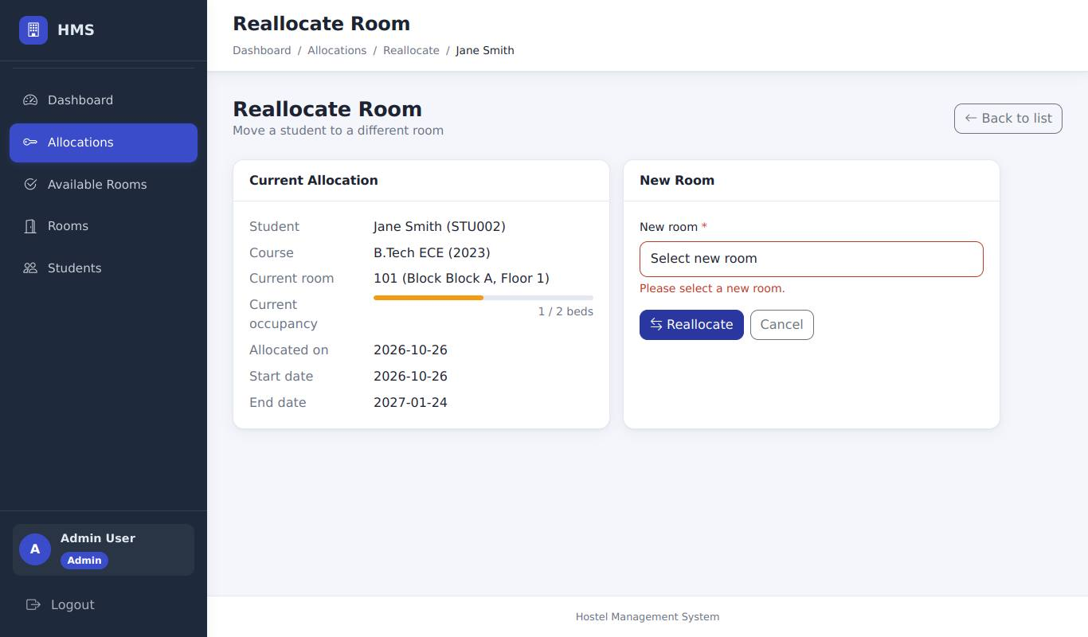
No room selected: the field is flagged and the form is not submitted
Result (to be recorded by the tester)
Actual result
Status | [ ] Pass [ ] Fail [ ] Blocked (not executed)
Executed by / date | /
Defect id
Tester evidence | Paste your screenshot here (save it as evidence/REALLOC-04.png and record that file name)

REALLOC-02 - Non-existent room id is rejected
Requirement | RA-05 | Priority | P3
Technique | UI + browser DevTools | Module | Reallocation

Preconditions | Reallocate form open.
Steps | 1. In DevTools change an <option> value to 99999  2. Select it and click Reallocate
Input data | room_id=99999
Expected result | Error "Selected room does not exist."; allocation unchanged.
Reference screenshot (expected state, captured by script - not tester evidence)
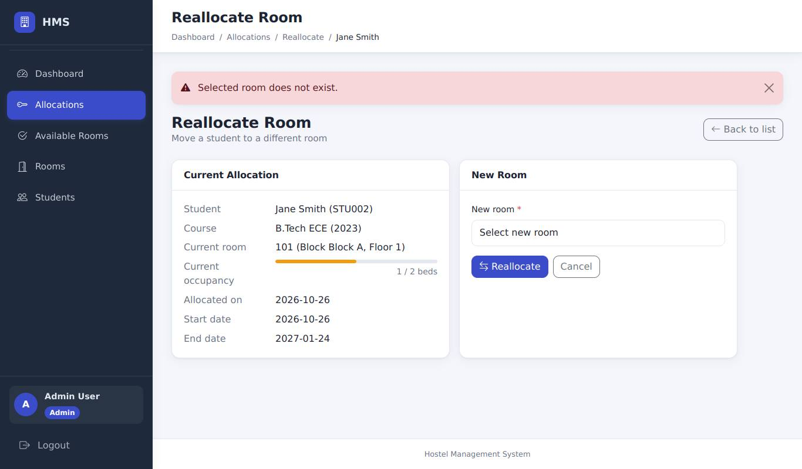
Room id 99999 (edited in DevTools): "Selected room does not exist."
Result (to be recorded by the tester)
Actual result
Status | [ ] Pass [ ] Fail [ ] Blocked (not executed)
Executed by / date | /
Defect id
Tester evidence | Paste your screenshot here (save it as evidence/REALLOC-02.png and record that file name)

REALLOC-05 - Reallocate requires a CSRF token
Requirement | RA-12 | Priority | P1
Technique | UI + browser DevTools | Module | Reallocation

Preconditions | Reallocate form open.
Steps | 1. Delete the hidden csrf_token input in DevTools  2. Choose a room; click Reallocate
Input data | -
Expected result | Page "Your request could not be verified" (HTTP 400); allocation unchanged.
Reference screenshot (expected state, captured by script - not tester evidence)
CSRF token deleted: "Your request could not be verified" (HTTP 400); Jane stays where she is
Result (to be recorded by the tester)
Actual result
Status | [ ] Pass [ ] Fail [ ] Blocked (not executed)
Executed by / date | /
Defect id
Tester evidence | Paste your screenshot here (save it as evidence/REALLOC-05.png and record that file name)

6.5 Cancellation

CANCEL-02 - "Go back" keeps the allocation
Requirement | RA-06, UI-03 | Priority | P1
Technique | UI only | Module | Cancellation

Preconditions | Active allocation exists (Carlos Diaz, Block A 201).
Steps | 1. Allocations list > click the red Cancel (x) icon on Carlos Diaz  2. In the dialog click "Go back"
Input data | -
Expected result | A modal "Please confirm - Are you sure you want to cancel this allocation?" appears; after Go back the dialog closes and the allocation is still Active.
Reference screenshots (expected state, captured by script - not tester evidence)
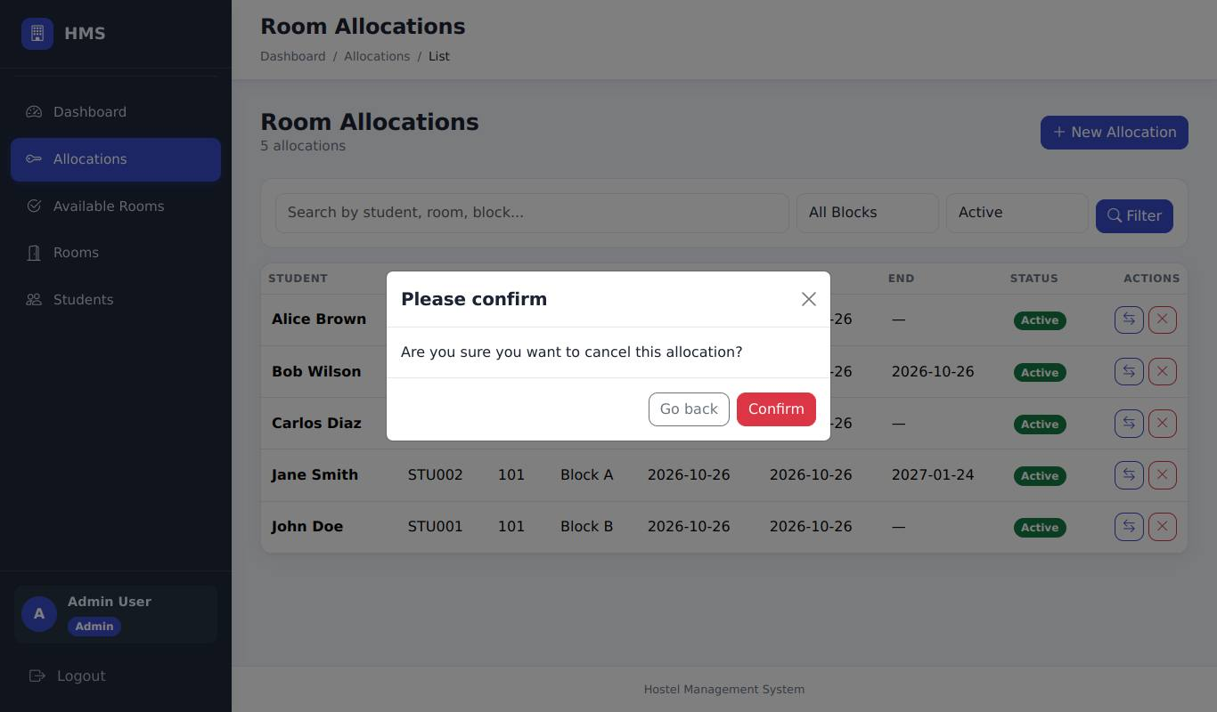
Confirmation dialog for cancelling Carlos Diaz's allocation
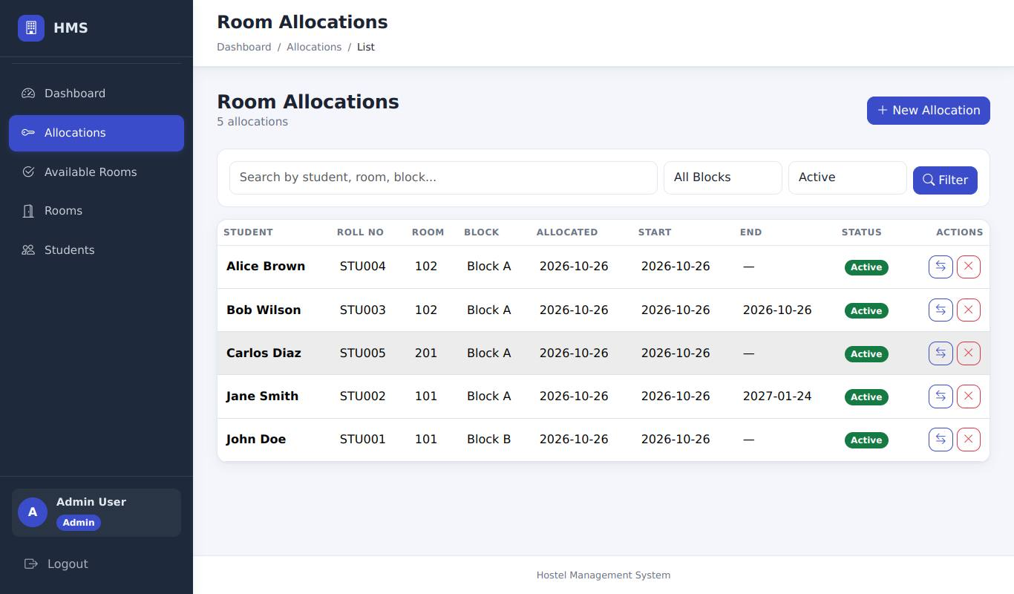
After "Go back": the dialog is closed and Carlos is still Active
Result (to be recorded by the tester) - CANCEL-02: "Go back" keeps the allocation
Actual result
Status | [ ] Pass [ ] Fail [ ] Blocked (not executed)
Executed by / date | /
Defect id
Tester evidence | Paste your screenshot here (save it as evidence/CANCEL-02.png and record that file name)

CANCEL-01 - Confirm cancels and frees the bed
Requirement | RA-06 | Priority | P1
Technique | UI only | Module | Cancellation

Preconditions | As CANCEL-02.
Steps | 1. Click the Cancel (x) icon on Carlos Diaz again  2. Click "Confirm"
Input data | -
Expected result | Message "Allocation cancelled successfully."; Carlos no longer appears under Status = Active; Block A 201 shows 0 of 2 beds.
Reference screenshot (expected state, captured by script - not tester evidence)
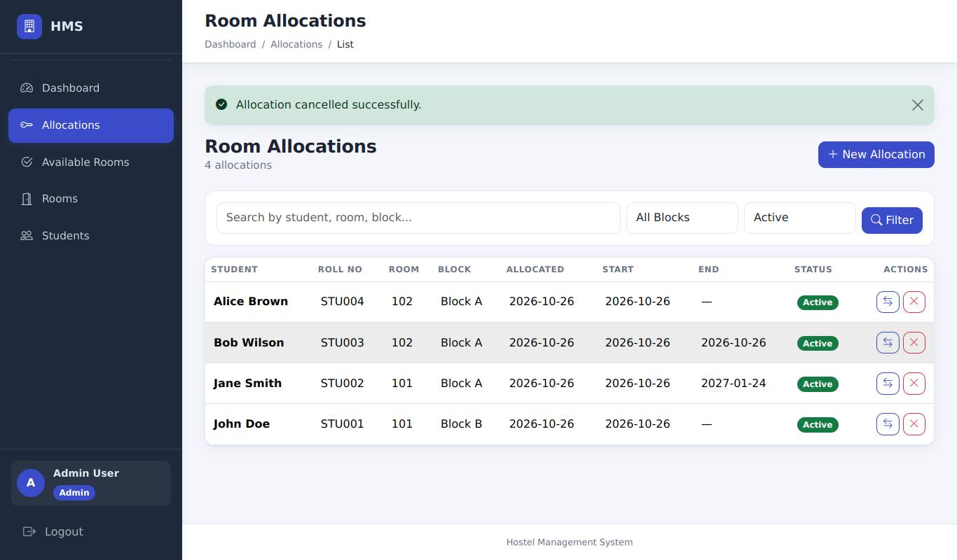
After "Confirm": "Allocation cancelled successfully." and Carlos is gone from the active list
Result (to be recorded by the tester)
Actual result
Status | [ ] Pass [ ] Fail [ ] Blocked (not executed)
Executed by / date | /
Defect id
Tester evidence | Paste your screenshot here (save it as evidence/CANCEL-01.png and record that file name)

CANCEL-04 - Cancelled allocations offer no actions
Requirement | RA-06 | Priority | P2
Technique | UI only | Module | Cancellation

Preconditions | CANCEL-01 done.
Steps | 1. Allocations list > set Status filter to Cancelled > Filter
Input data | -
Expected result | Carlos Diaz is listed with status Cancelled and there are no Reallocate/Cancel buttons on that row.
Reference screenshot (expected state, captured by script - not tester evidence)
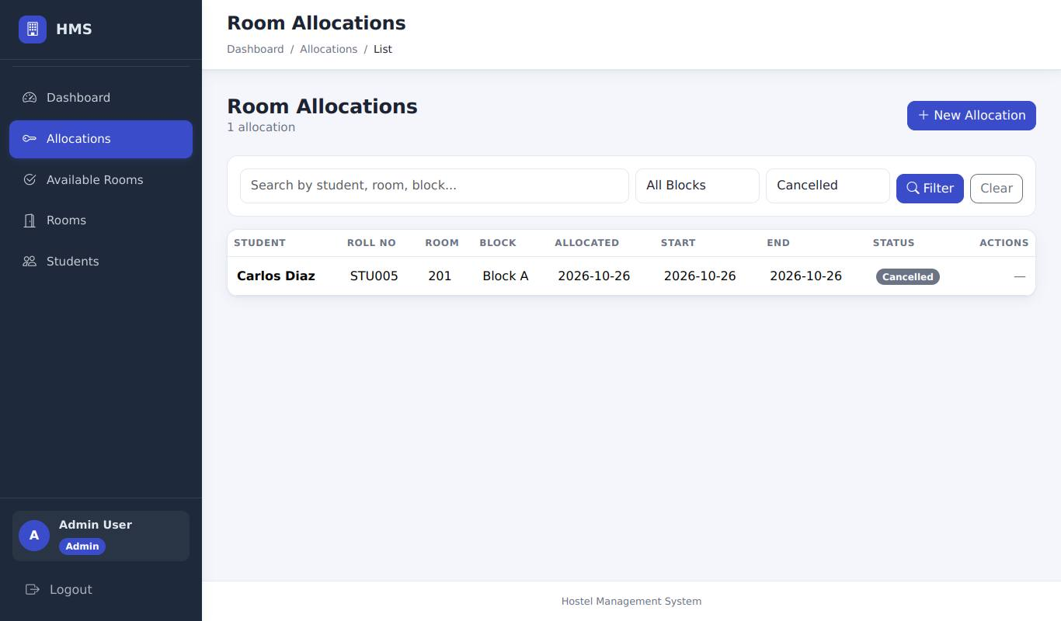
Status = Cancelled: Carlos is listed as Cancelled with no action buttons
Result (to be recorded by the tester)
Actual result
Status | [ ] Pass [ ] Fail [ ] Blocked (not executed)
Executed by / date | /
Defect id
Tester evidence | Paste your screenshot here (save it as evidence/CANCEL-04.png and record that file name)

CANCEL-03 - Cancel requires a CSRF token
Requirement | RA-12 | Priority | P1
Technique | UI + browser DevTools | Module | Cancellation

Preconditions | Active allocation exists (e.g. Bob Wilson).
Steps | 1. In DevTools delete the hidden csrf_token input inside the Cancel form of Bob Wilson  2. Click Cancel and Confirm
Input data | -
Expected result | Page "Your request could not be verified" (HTTP 400); Bob's allocation is still Active.
Reference screenshot (expected state, captured by script - not tester evidence)
Cancel without a CSRF token: HTTP 400 page; Bob's allocation is untouched
Result (to be recorded by the tester)
Actual result
Status | [ ] Pass [ ] Fail [ ] Blocked (not executed)
Executed by / date | /
Defect id
Tester evidence | Paste your screenshot here (save it as evidence/CANCEL-03.png and record that file name)

6.6 Allocation list

LIST-01 - Search filters the list
Requirement | RA-07 | Priority | P2
Technique | UI only | Module | Allocation list

Preconditions | Several active allocations.
Steps | 1. Allocations list > type "Jane" in the search box > Filter  2. Search "nobody-matches"
Input data | Jane / nobody-matches
Expected result | Step 1: only Jane Smith's row; step 2: "No allocations found."
Reference screenshots (expected state, captured by script - not tester evidence)
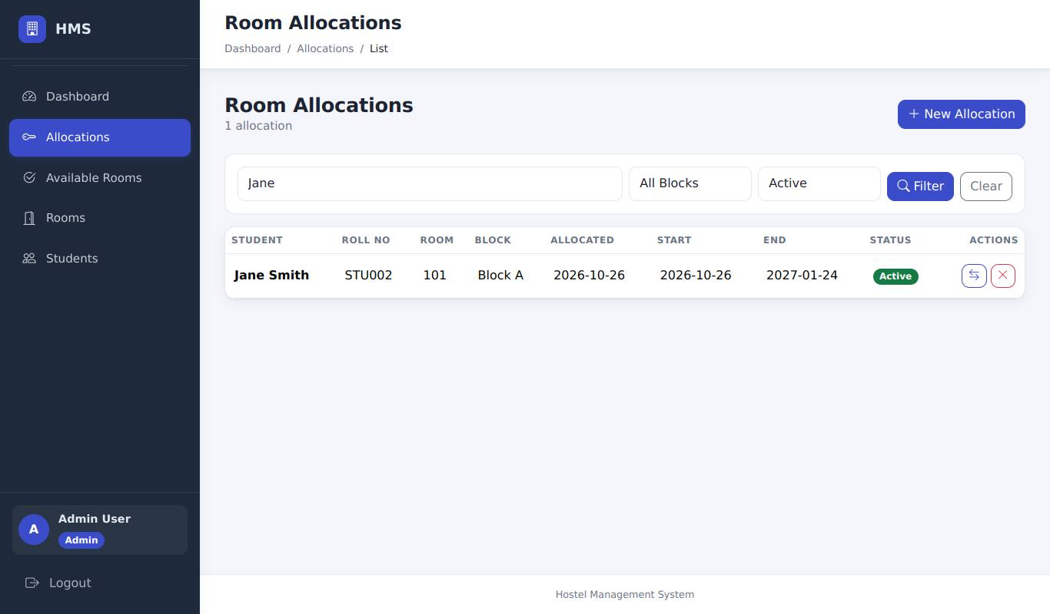
Search "Jane": only Jane Smith's row
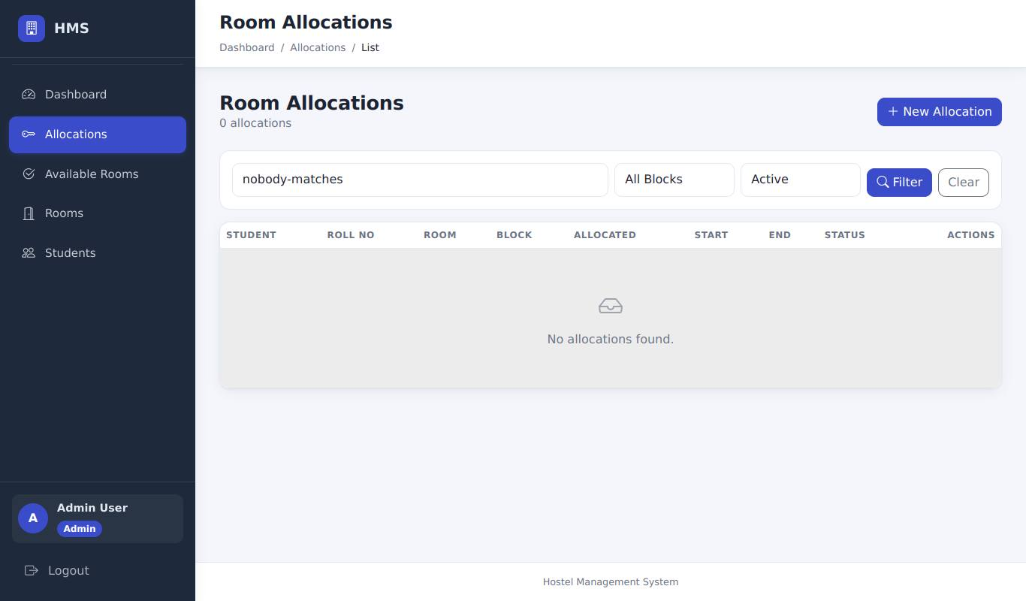
Search "nobody-matches": "No allocations found."
Result (to be recorded by the tester) - LIST-01: Search filters the list
Actual result
Status | [ ] Pass [ ] Fail [ ] Blocked (not executed)
Executed by / date | /
Defect id
Tester evidence | Paste your screenshot here (save it as evidence/LIST-01.png and record that file name)

LIST-02 - Block and status filters
Requirement | RA-07 | Priority | P2
Technique | UI only | Module | Allocation list

Preconditions | Active and cancelled allocations exist.
Steps | 1. Select Block B > Filter  2. Select Status Cancelled > Filter
Input data | -
Expected result | Step 1 lists only Block B rows; step 2 lists only cancelled allocations.
Reference screenshots (expected state, captured by script - not tester evidence)
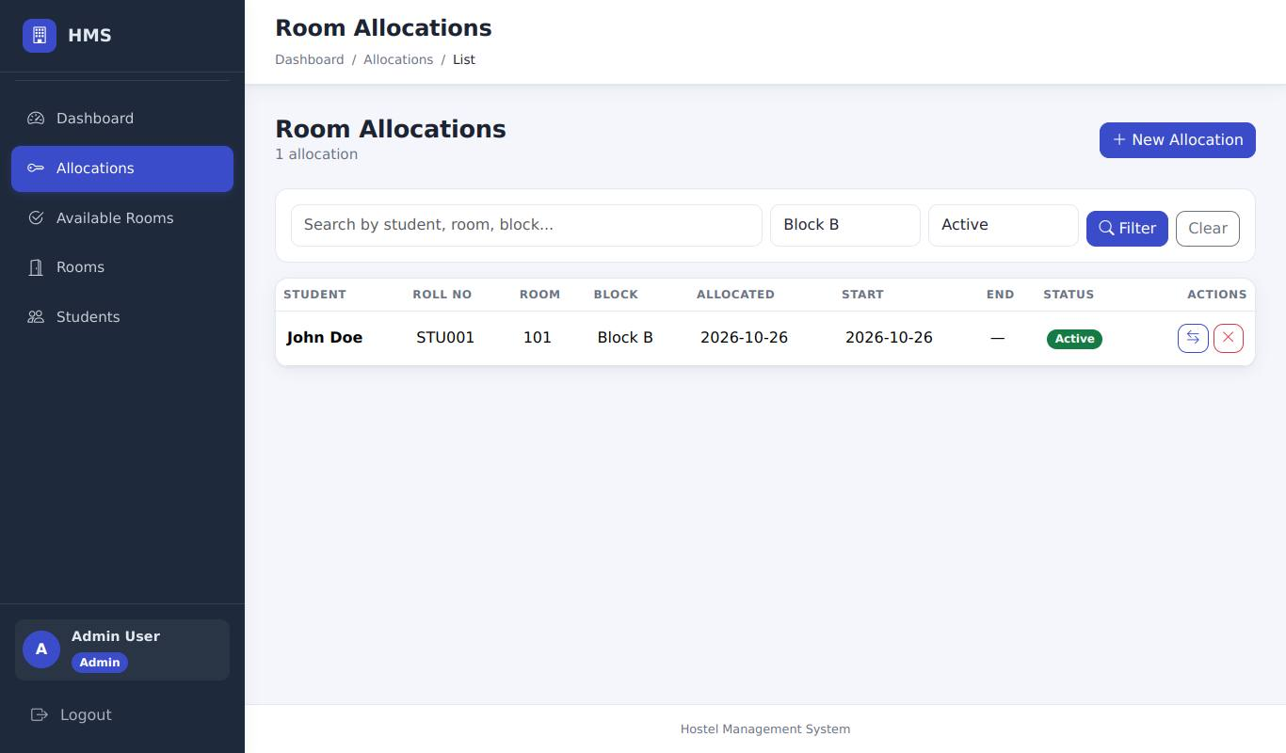
Block B filter: only Block B rows
Status Cancelled filter: only cancelled allocations
Result (to be recorded by the tester) - LIST-02: Block and status filters
Actual result
Status | [ ] Pass [ ] Fail [ ] Blocked (not executed)
Executed by / date | /
Defect id
Tester evidence | Paste your screenshot here (save it as evidence/LIST-02.png and record that file name)

6.7 Available rooms

AVAIL-01 - Only rooms with free beds are listed
Requirement | RA-08 | Priority | P1
Technique | UI only | Module | Available rooms

Preconditions | Block A 101 (1/2), Block A 102 (full).
Steps | 1. Sidebar > Available Rooms
Input data | -
Expected result | Block A 102 (full) is NOT listed; Block A 101 is listed with its free beds.
Reference screenshot (expected state, captured by script - not tester evidence)
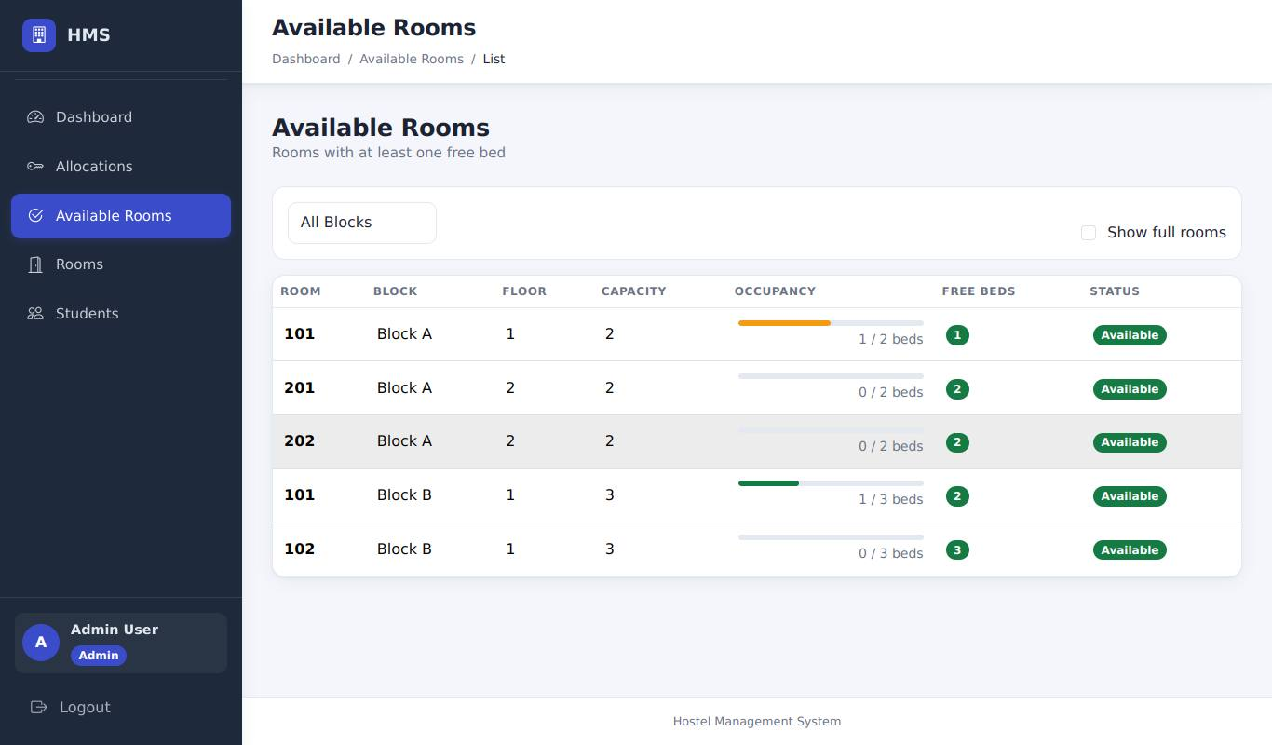
Available Rooms: Block A 102 (full) is not listed
Result (to be recorded by the tester)
Actual result
Status | [ ] Pass [ ] Fail [ ] Blocked (not executed)
Executed by / date | /
Defect id
Tester evidence | Paste your screenshot here (save it as evidence/AVAIL-01.png and record that file name)

AVAIL-03 - Block filter and "Show full rooms"
Requirement | RA-08, RA-04 | Priority | P2
Technique | UI only | Module | Available rooms

Preconditions | As AVAIL-01.
Steps | 1. Tick "Show full rooms"  2. Choose Block B in the block drop-down
Input data | -
Expected result | Step 1: Block A 102 appears marked full. Step 2: only Block B rooms are shown (no Block A rooms, full or not).
Reference screenshots (expected state, captured by script - not tester evidence)
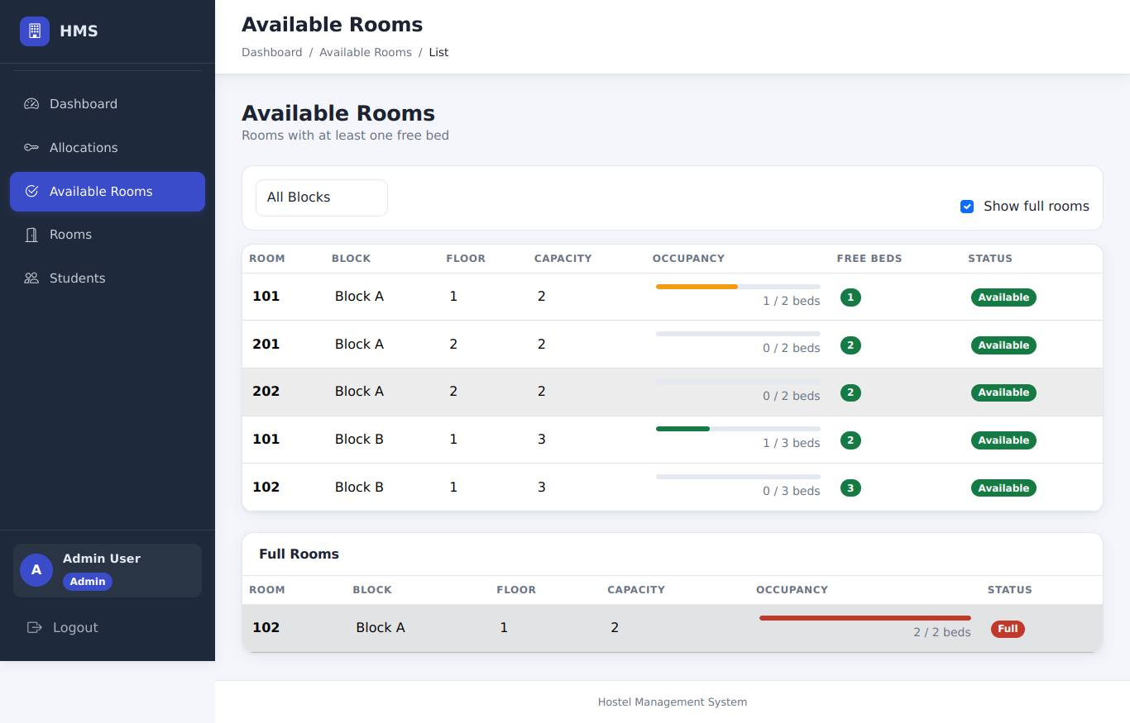
Step 1: "Show full rooms" ticked - the full room appears
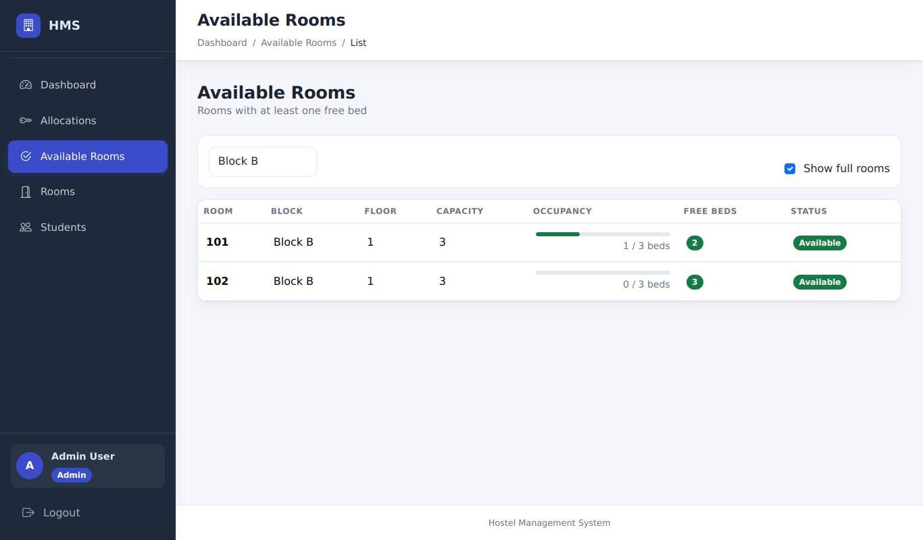
Step 2: Block B selected - only Block B rooms
Result (to be recorded by the tester) - AVAIL-03: Block filter and "Show full rooms"
Actual result
Status | [ ] Pass [ ] Fail [ ] Blocked (not executed)
Executed by / date | /
Defect id
Tester evidence | Paste your screenshot here (save it as evidence/AVAIL-03.png and record that file name)

AVAIL-02 - Student can view available rooms (read-only)
Requirement | RA-08 | Priority | P2
Technique | UI only | Module | Available rooms

Preconditions | Logged in as student.
Steps | 1. Sidebar > Available Rooms
Input data | -
Expected result | Page loads; no allocation actions are offered.
Reference screenshot (expected state, captured by script - not tester evidence)
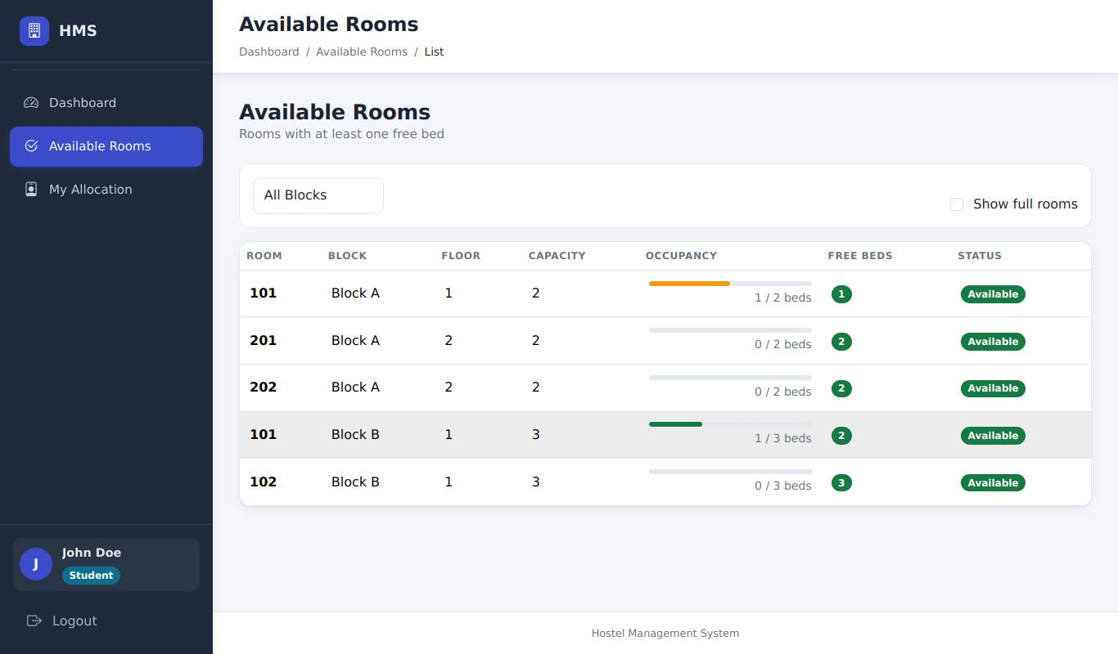
Student view of Available Rooms (read-only)
Result (to be recorded by the tester)
Actual result
Status | [ ] Pass [ ] Fail [ ] Blocked (not executed)
Executed by / date | /
Defect id
Tester evidence | Paste your screenshot here (save it as evidence/AVAIL-02.png and record that file name)

6.8 Student view

STUDENT-01 - Student sees own allocation
Requirement | RA-09 | Priority | P1
Technique | UI only | Module | Student view

Preconditions | Logged in as John Doe (allocated).
Steps | 1. Sidebar > My Allocation
Input data | -
Expected result | Page shows John Doe's room and block (Block B 101 after REALLOC-01).
Reference screenshot (expected state, captured by script - not tester evidence)
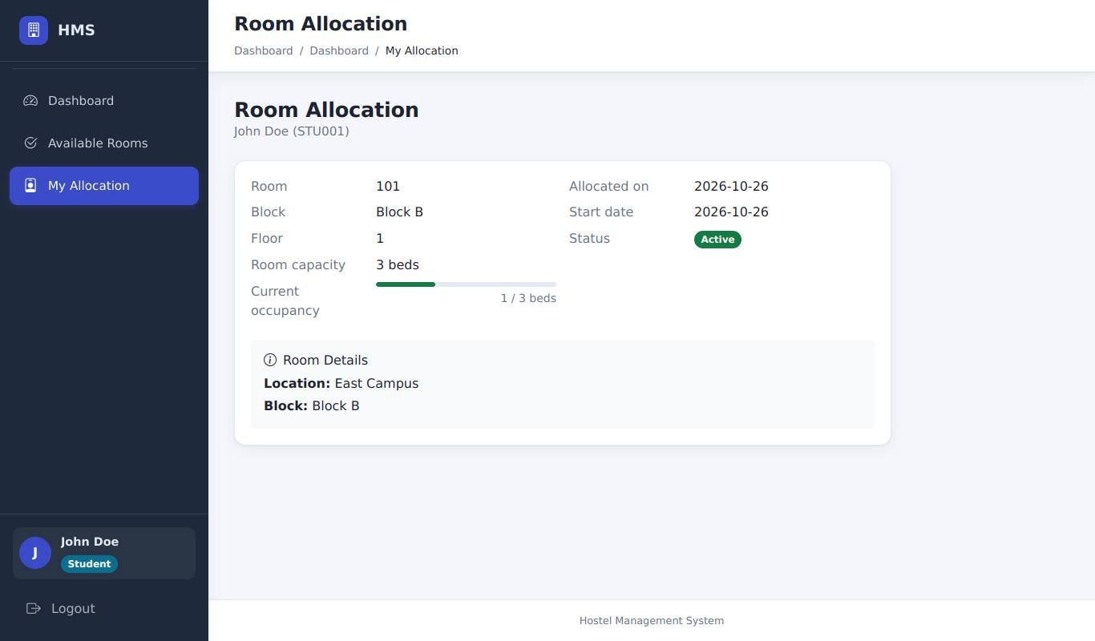
My Allocation: John Doe's room (Block B 101 after the reallocation)
Result (to be recorded by the tester)
Actual result
Status | [ ] Pass [ ] Fail [ ] Blocked (not executed)
Executed by / date | /
Defect id
Tester evidence | Paste your screenshot here (save it as evidence/STUDENT-01.png and record that file name)

STUDENT-02 - Student cannot view another student's allocation
Requirement | RA-09 | Priority | P1
Technique | UI only | Module | Student view

Preconditions | Logged in as John Doe. Jane Smith has student id 2.
Steps | 1. In the address bar open http://127.0.0.1:5000/allocation/student/2
Input data | -
Expected result | Redirected to the dashboard with "You can only view your own allocation."
Reference screenshot (expected state, captured by script - not tester evidence)
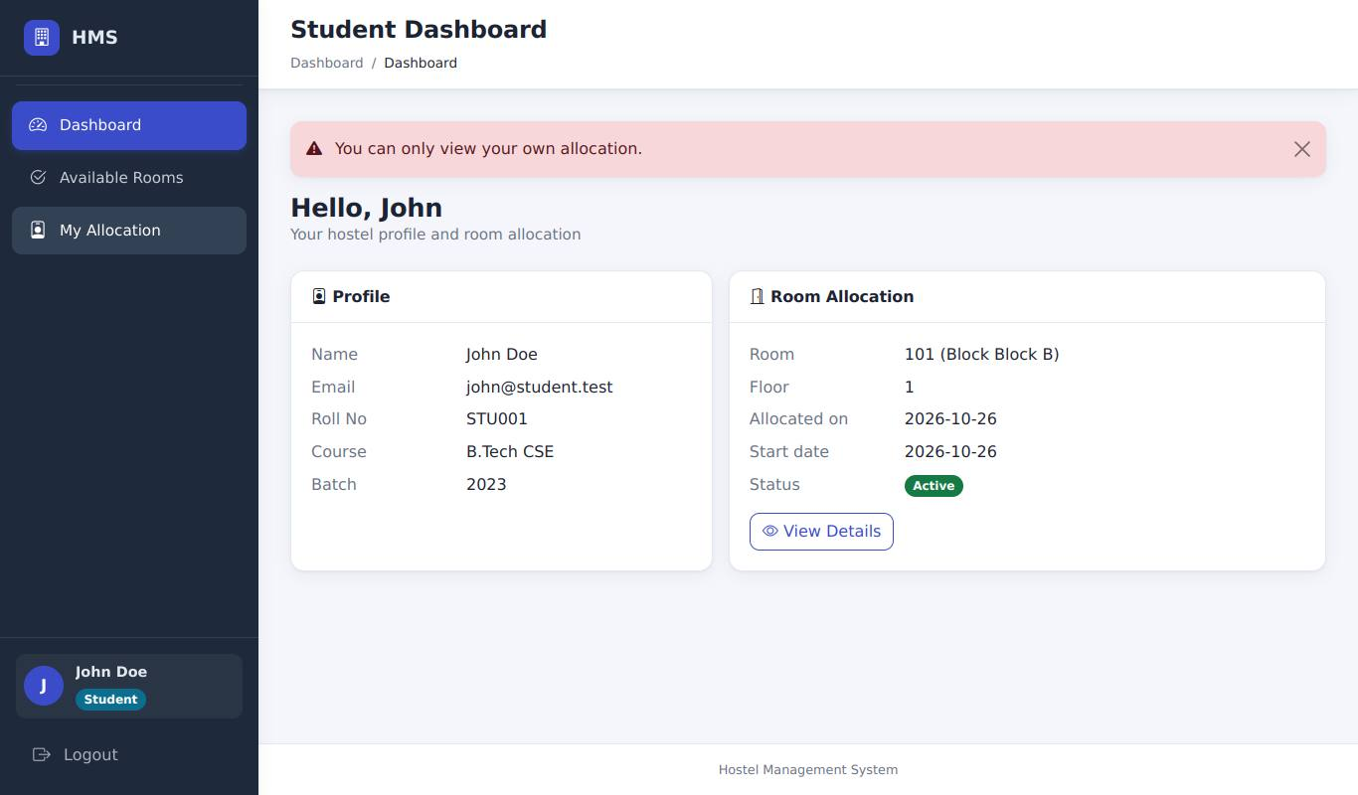
Opening another student's allocation: redirected to the dashboard with a message
Result (to be recorded by the tester)
Actual result
Status | [ ] Pass [ ] Fail [ ] Blocked (not executed)
Executed by / date | /
Defect id
Tester evidence | Paste your screenshot here (save it as evidence/STUDENT-02.png and record that file name)

6.9 Authorization

AUTHZ-01 - Admin reaches all management pages
Requirement | RA-10 | Priority | P1
Technique | UI only | Module | Authorization

Preconditions | Logged in as admin.
Steps | 1. Open Allocations, New Allocation, Available Rooms, Rooms, Students from the sidebar/buttons
Input data | -
Expected result | All pages load without a permission error.
Reference screenshot (expected state, captured by script - not tester evidence)
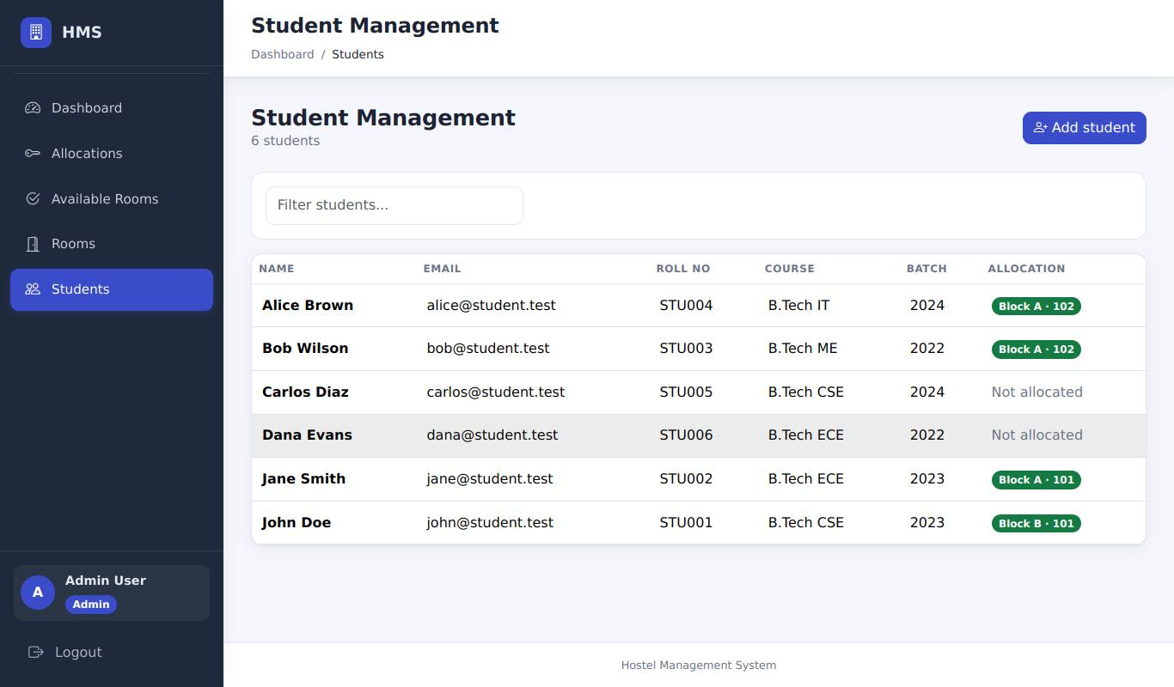
Admin can open the Students page (all management pages load)
Result (to be recorded by the tester)
Actual result
Status | [ ] Pass [ ] Fail [ ] Blocked (not executed)
Executed by / date | /
Defect id
Tester evidence | Paste your screenshot here (save it as evidence/AUTHZ-01.png and record that file name)

AUTHZ-02 - Warden reaches all management pages
Requirement | RA-10 | Priority | P2
Technique | UI only | Module | Authorization

Preconditions | Logged in as warden.
Steps | 1. Repeat the AUTHZ-01 pages
Input data | -
Expected result | All pages load.
Reference screenshot (expected state, captured by script - not tester evidence)
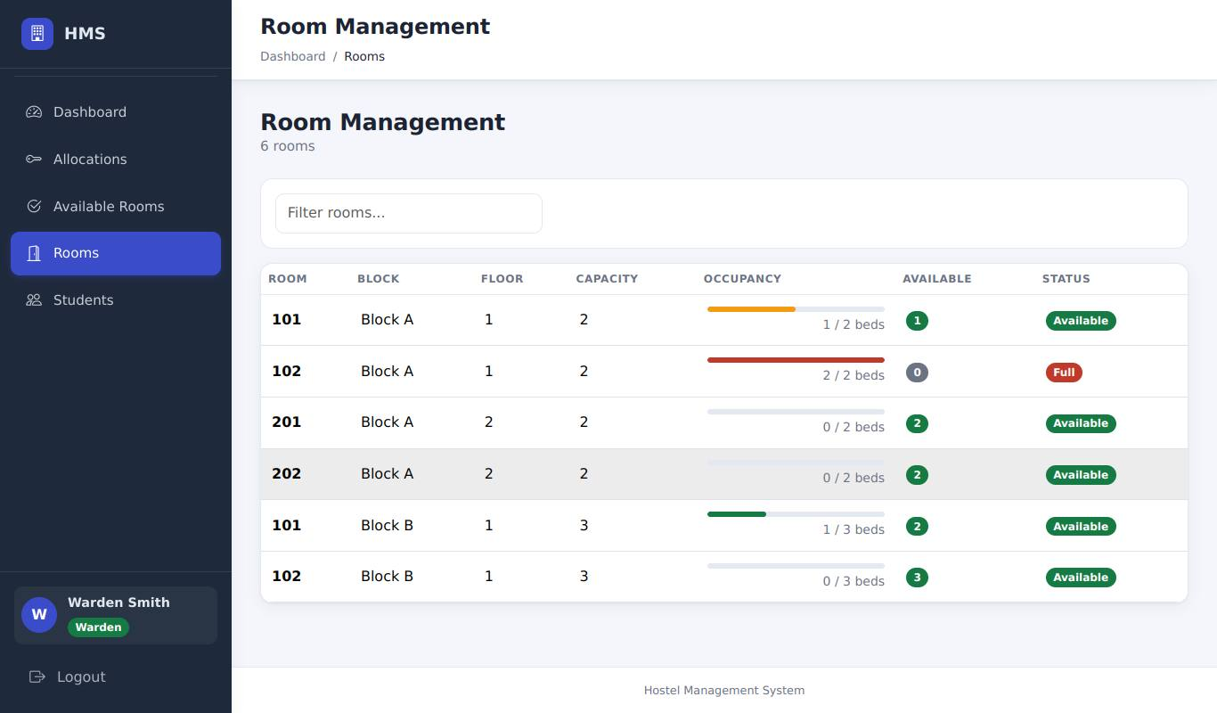
Warden can open the Rooms page
Result (to be recorded by the tester)
Actual result
Status | [ ] Pass [ ] Fail [ ] Blocked (not executed)
Executed by / date | /
Defect id
Tester evidence | Paste your screenshot here (save it as evidence/AUTHZ-02.png and record that file name)

AUTHZ-03 - Student blocked from allocation management
Requirement | RA-10 | Priority | P1
Technique | UI only | Module | Authorization

Preconditions | Logged in as student.
Steps | 1. Open http://127.0.0.1:5000/allocation/  2. Open /allocation/create
Input data | -
Expected result | Each redirects to the dashboard with "You do not have permission to access this page."
Reference screenshot (expected state, captured by script - not tester evidence)
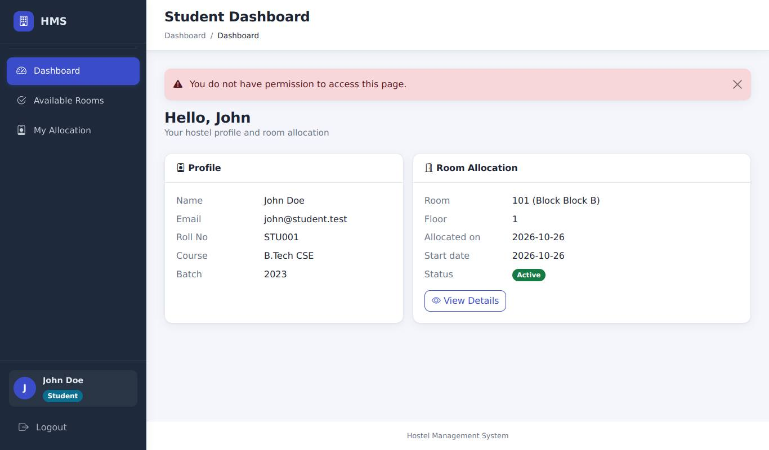
Student opening /allocation/: redirected with "You do not have permission..."
Result (to be recorded by the tester)
Actual result
Status | [ ] Pass [ ] Fail [ ] Blocked (not executed)
Executed by / date | /
Defect id
Tester evidence | Paste your screenshot here (save it as evidence/AUTHZ-03.png and record that file name)

AUTHZ-05 - Accountant blocked from allocations
Requirement | RA-10 | Priority | P2
Technique | UI only | Module | Authorization

Preconditions | Logged in as accountant@hms.test / accountant123.
Steps | 1. Open /allocation/
Input data | -
Expected result | Redirected with "You do not have permission to access this page."
Reference screenshot (expected state, captured by script - not tester evidence)
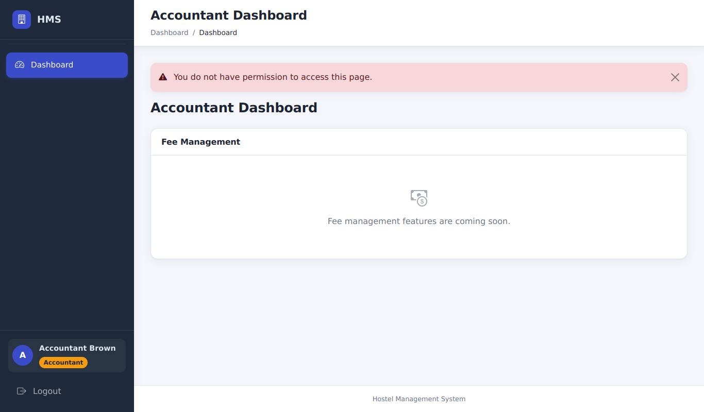
Accountant opening /allocation/: permission message
Result (to be recorded by the tester)
Actual result
Status | [ ] Pass [ ] Fail [ ] Blocked (not executed)
Executed by / date | /
Defect id
Tester evidence | Paste your screenshot here (save it as evidence/AUTHZ-05.png and record that file name)

AUTHZ-07 - Student blocked from rooms and students pages
Requirement | RA-10 | Priority | P1
Technique | UI only | Module | Authorization

Preconditions | Logged in as student.
Steps | 1. Open /rooms  2. Open /students
Input data | -
Expected result | Both redirect with "You do not have permission to access this page."
Reference screenshot (expected state, captured by script - not tester evidence)
Student opening /rooms: permission message
Result (to be recorded by the tester)
Actual result
Status | [ ] Pass [ ] Fail [ ] Blocked (not executed)
Executed by / date | /
Defect id
Tester evidence | Paste your screenshot here (save it as evidence/AUTHZ-07.png and record that file name)

AUTHZ-10 - Student cannot open another allocation's reallocate page
Requirement | RA-10 | Priority | P2
Technique | UI only | Module | Authorization

Preconditions | Logged in as student. An allocation with id 2 exists.
Steps | 1. Open http://127.0.0.1:5000/allocation/2/reallocate
Input data | -
Expected result | Redirected with "You do not have permission to access this page."
Reference screenshot (expected state, captured by script - not tester evidence)
Student opening /allocation/2/reallocate: permission message
Result (to be recorded by the tester)
Actual result
Status | [ ] Pass [ ] Fail [ ] Blocked (not executed)
Executed by / date | /
Defect id
Tester evidence | Paste your screenshot here (save it as evidence/AUTHZ-10.png and record that file name)

AUTHZ-11 - Student cannot cancel an allocation
Requirement | RA-10, RA-12 | Priority | P2
Technique | UI + browser DevTools | Module | Authorization

Preconditions | Logged in as student. Allocation id 2 is Active.
Steps | 1. Open DevTools > Console and run:  fetch("/allocation/2/cancel",{method:"POST",headers:{"Content-Type":"application/x-www-form-urlencoded"},body:"csrf_token="+document.querySelector("input[name=csrf_token]").value})  2. Log in as admin and check allocation 2
Input data | -
Expected result | The student request is refused (redirect to the dashboard / permission message); allocation 2 is still Active.
Reference screenshot (expected state, captured by script - not tester evidence)
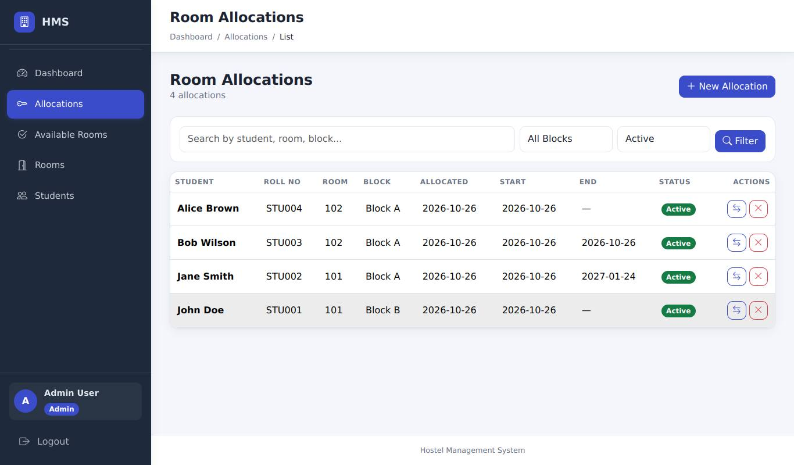
Admin check after the student's forged request: Jane's allocation (id 2) is still Active
Result (to be recorded by the tester)
Actual result
Status | [ ] Pass [ ] Fail [ ] Blocked (not executed)
Executed by / date | /
Defect id
Tester evidence | Paste your screenshot here (save it as evidence/AUTHZ-11.png and record that file name)

6.10 Security

SEC-01 - SQL injection in the search box
Requirement | RA-14 | Priority | P1
Technique | UI only | Module | Security

Preconditions | Logged in as admin.
Steps | 1. Allocations list > search for: ' OR '1'='1  2. Search for: '; DROP TABLE rooms; --
Input data | SQL payloads
Expected result | Page renders normally ("No allocations found." or a normal list); no error page; Rooms page still shows all rooms.
Reference screenshots (expected state, captured by script - not tester evidence)
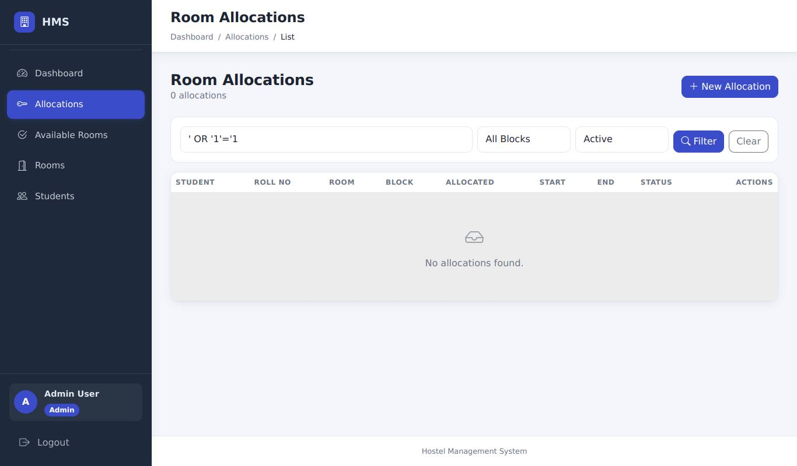
Payload 1 in the search box: normal page, no error
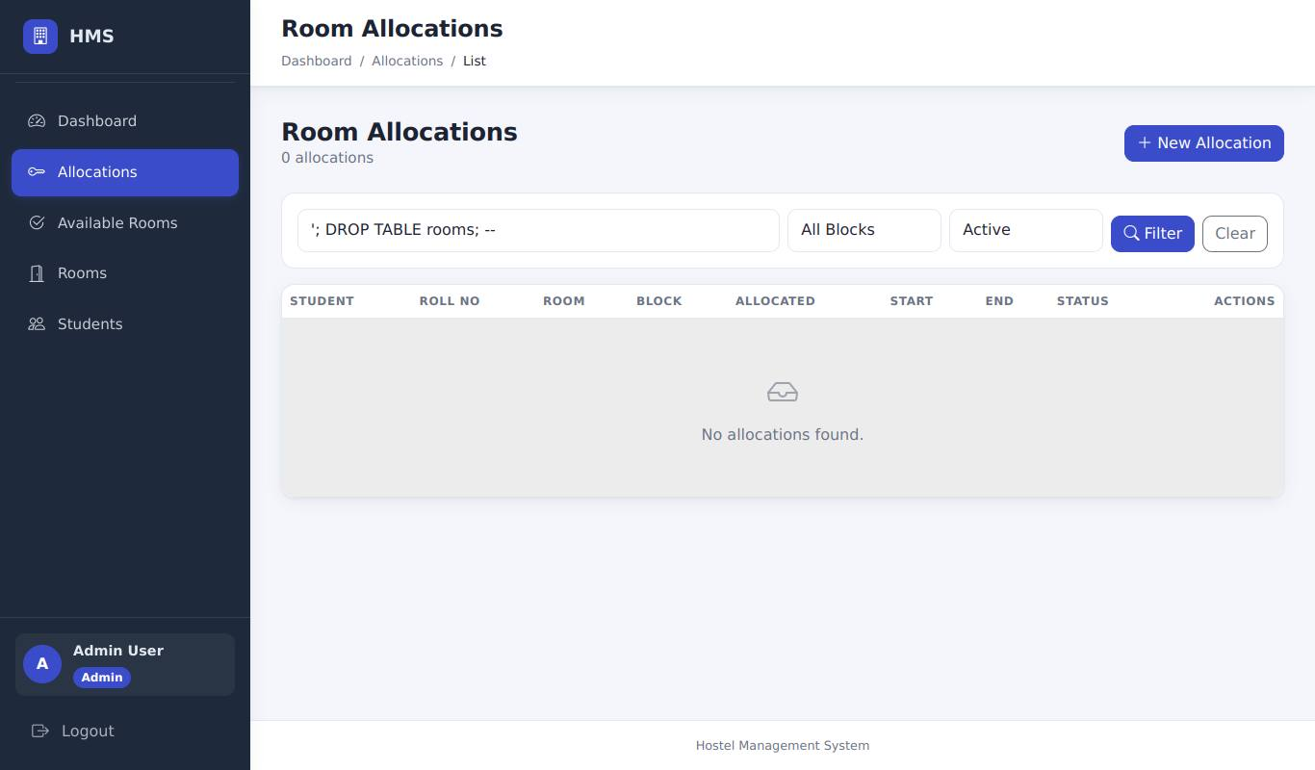
Payload 2: normal page; the Rooms table is unaffected
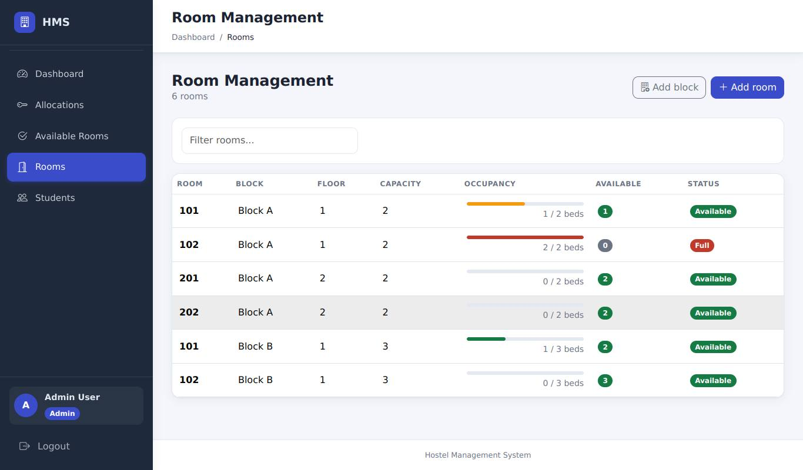
Rooms page afterwards: all rooms are still there
Result (to be recorded by the tester) - SEC-01: SQL injection in the search box
Actual result
Status | [ ] Pass [ ] Fail [ ] Blocked (not executed)
Executed by / date | /
Defect id
Tester evidence | Paste your screenshot here (save it as evidence/SEC-01.png and record that file name)

SEC-03 - XSS in the search box
Requirement | RA-14 | Priority | P1
Technique | UI only | Module | Security

Preconditions | Logged in as admin.
Steps | 1. Allocations list > search for: <script>alert(1)</script>
Input data | <script>alert(1)</script>
Expected result | No alert box appears; the text is displayed as plain text in the search field (escaped).
Reference screenshot (expected state, captured by script - not tester evidence)
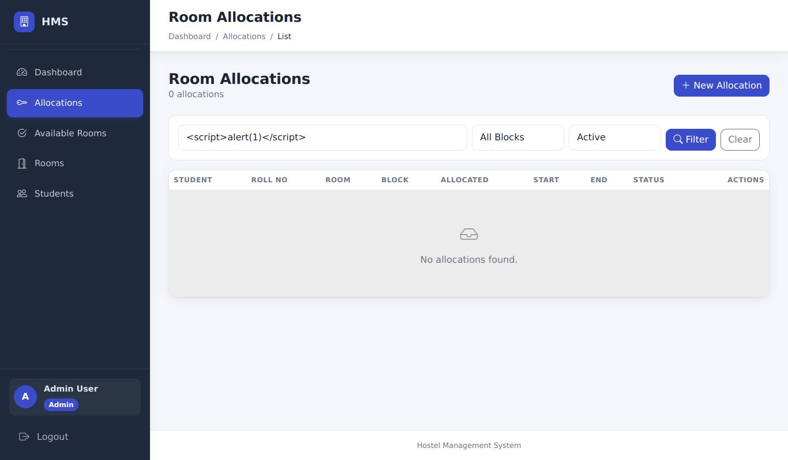
XSS payload: shown as plain text in the search field, no alert box
Result (to be recorded by the tester)
Actual result
Status | [ ] Pass [ ] Fail [ ] Blocked (not executed)
Executed by / date | /
Defect id
Tester evidence | Paste your screenshot here (save it as evidence/SEC-03.png and record that file name)

SEC-05 - Forged CSRF token is rejected
Requirement | RA-12 | Priority | P2
Technique | UI + browser DevTools | Module | Security

Preconditions | Logged in as admin.
Steps | 1. Open New Allocation, fill the form  2. In DevTools set the hidden csrf_token value to "forged"  3. Submit
Input data | csrf_token=forged
Expected result | Page "Your request could not be verified" (HTTP 400); nothing created.
Reference screenshot (expected state, captured by script - not tester evidence)
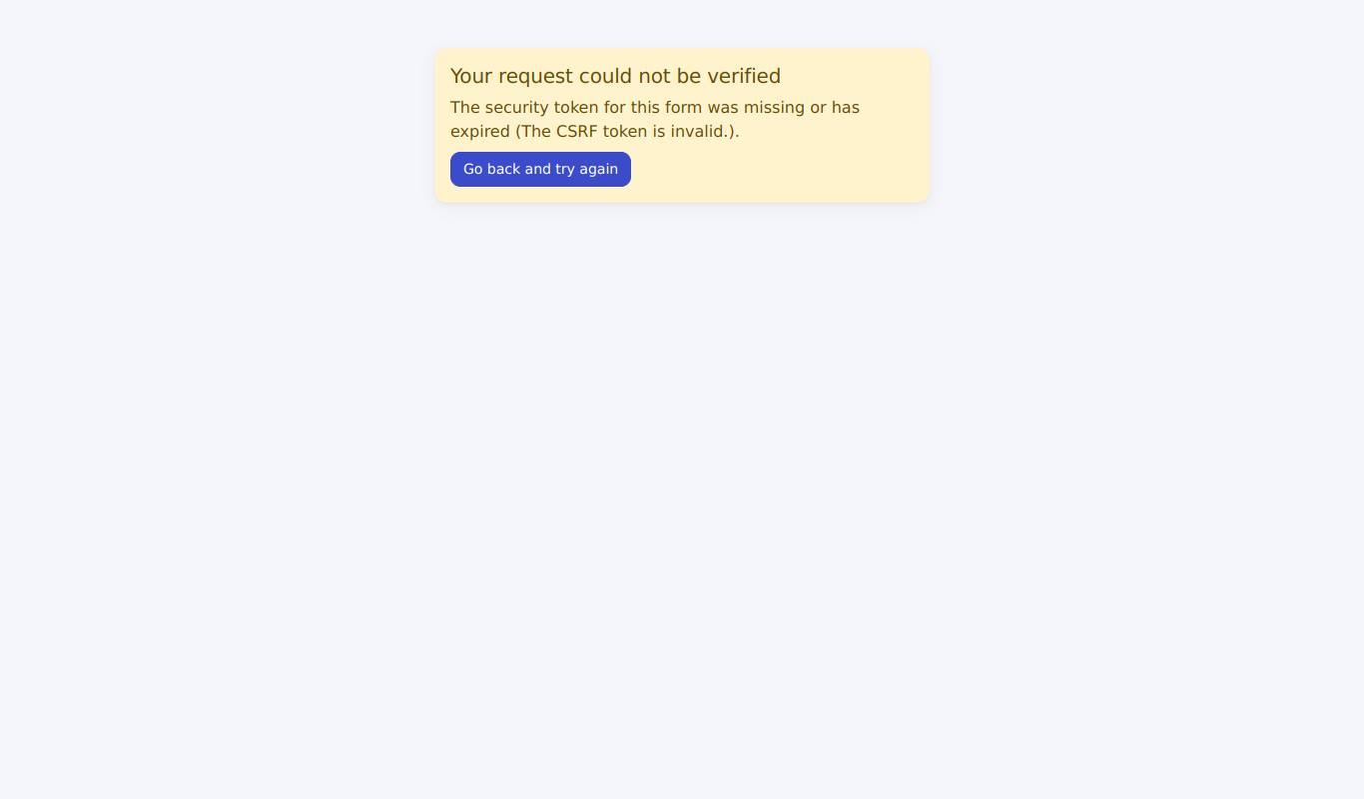
Forged CSRF token: HTTP 400 "Your request could not be verified"
Result (to be recorded by the tester)
Actual result
Status | [ ] Pass [ ] Fail [ ] Blocked (not executed)
Executed by / date | /
Defect id
Tester evidence | Paste your screenshot here (save it as evidence/SEC-05.png and record that file name)

SEC-06 - No session bleed between users
Requirement | RA-11 | Priority | P2
Technique | UI only | Module | Security

Preconditions | -
Steps | 1. Log in as admin, then Logout  2. Log in as warden
Input data | -
Expected result | Warden Dashboard shows the warden's name and no admin-only content.
Reference screenshot (expected state, captured by script - not tester evidence)
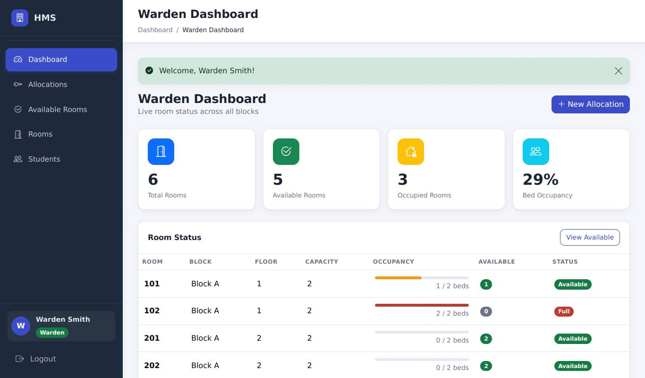
After admin logout and warden login: the Warden dashboard only
Result (to be recorded by the tester)
Actual result
Status | [ ] Pass [ ] Fail [ ] Blocked (not executed)
Executed by / date | /
Defect id
Tester evidence | Paste your screenshot here (save it as evidence/SEC-06.png and record that file name)

SEC-07 - Demo credentials are not displayed
Requirement | RA-13 | Priority | P1
Technique | UI only | Module | Security

Preconditions | Server started normally (SHOW_DEMO_CREDENTIALS not set).
Steps | 1. Open the login page and read it completely
Input data | -
Expected result | No demo accounts or passwords are listed on the page.
Reference screenshot (expected state, captured by script - not tester evidence)
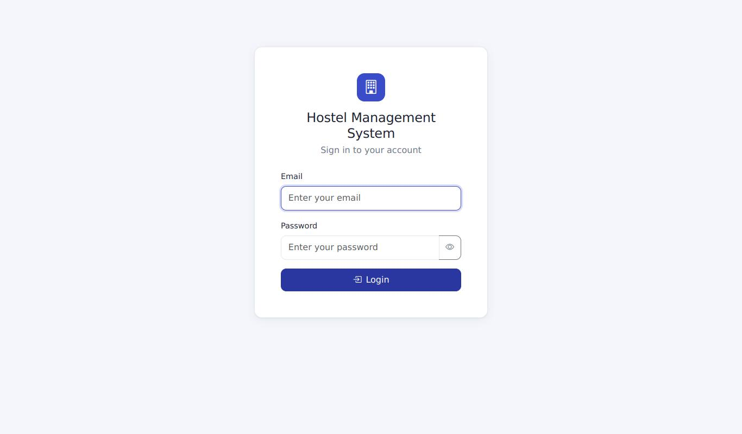
Login page: no demo accounts or passwords are displayed
Result (to be recorded by the tester)
Actual result
Status | [ ] Pass [ ] Fail [ ] Blocked (not executed)
Executed by / date | /
Defect id
Tester evidence | Paste your screenshot here (save it as evidence/SEC-07.png and record that file name)

6.11 Dashboards

DASH-01 - Dashboards match the data
Requirement | RA-15 | Priority | P2
Technique | UI only | Module | Dashboards

Preconditions | Allocations from the cases above exist.
Steps | 1. View the Admin, Warden and Student dashboards in turn
Input data | -
Expected result | Admin: Total Students = 6 and Total Rooms = 6 equal what the Students and Rooms pages show; active allocations and occupancy bar agree with the Allocations list. Student: shows own room.
Reference screenshot (expected state, captured by script - not tester evidence)
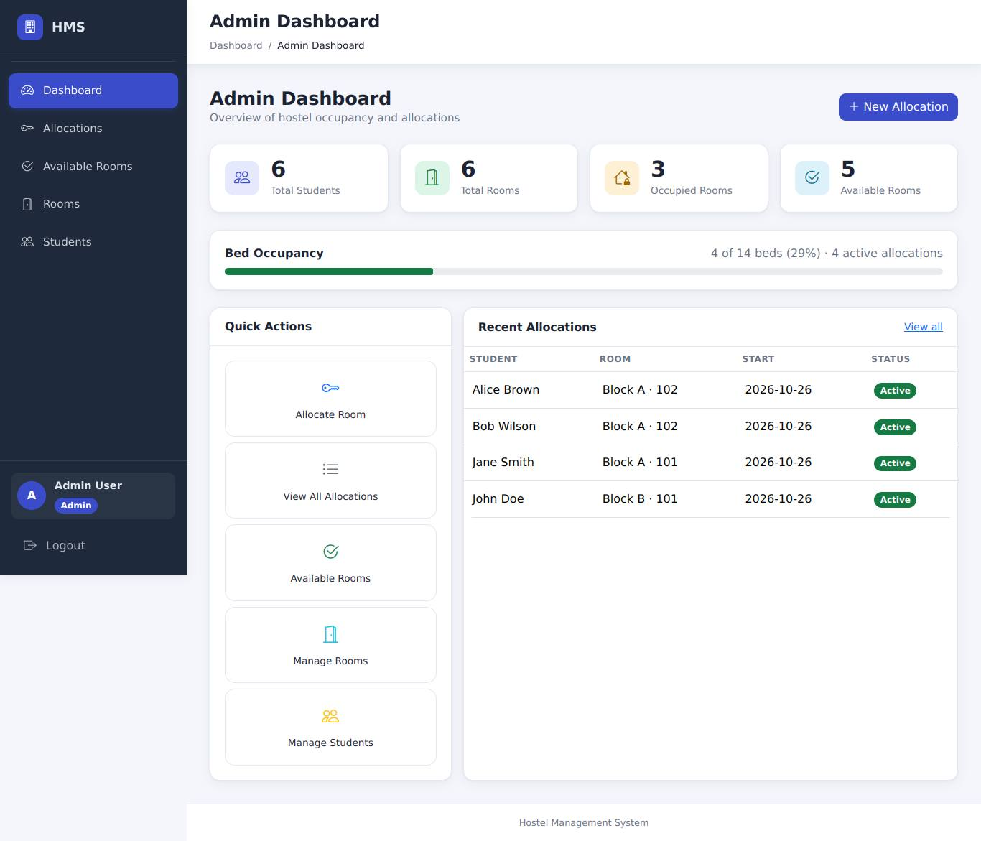
Admin dashboard with the data created by the previous cases
Result (to be recorded by the tester)
Actual result
Status | [ ] Pass [ ] Fail [ ] Blocked (not executed)
Executed by / date | /
Defect id
Tester evidence | Paste your screenshot here (save it as evidence/DASH-01.png and record that file name)

6.12 UI

UI-01 - Mobile layout (390 px wide)
Requirement | UI-02 | Priority | P1
Technique | UI + browser DevTools | Module | UI

Preconditions | Logged in as admin; DevTools device toolbar set to 390 x 844.
Steps | 1. Visit Dashboard, Allocations, Available Rooms, Rooms, Students, New Allocation  2. On each page: scroll horizontally; look at the title next to the hamburger button  3. Tap the hamburger button
Input data | -
Expected result | No page scrolls sideways (wide tables scroll inside their card); the hamburger never covers the page title; tapping it opens the navigation drawer.
Reference screenshots (expected state, captured by script - not tester evidence)
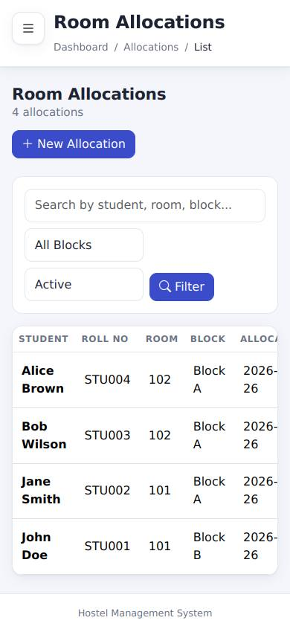
Mobile (390 px): Allocations - no sideways scrolling, hamburger beside the title
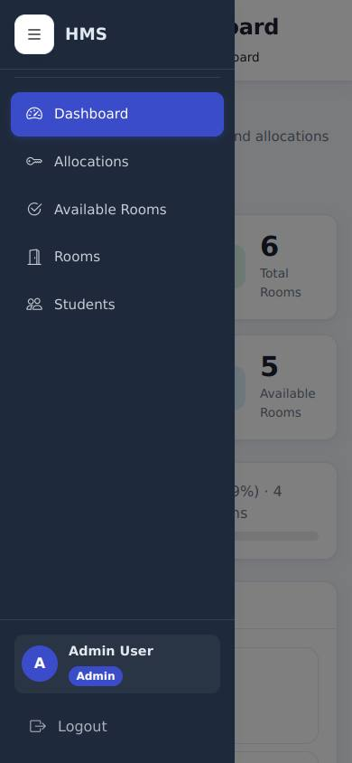
Mobile: the navigation drawer after tapping the hamburger button
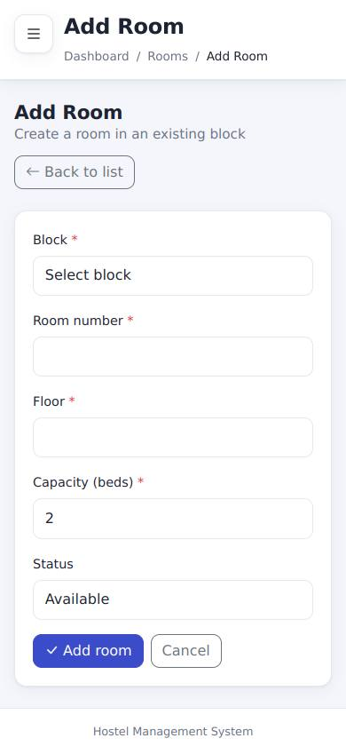
Mobile: a form page (Add room) also fits the screen
Result (to be recorded by the tester) - UI-01: Mobile layout (390 px wide)
Actual result
Status | [ ] Pass [ ] Fail [ ] Blocked (not executed)
Executed by / date | /
Defect id
Tester evidence | Paste your screenshot here (save it as evidence/UI-01.png and record that file name)

UI-02 - Menus match the role
Requirement | UI-01 | Priority | P2
Technique | UI only | Module | UI

Preconditions | -
Steps | 1. Log in as admin, then warden, then student; read the sidebar each time
Input data | -
Expected result | Admin and warden: Dashboard, Allocations, Available Rooms, Rooms, Students. Student: Dashboard, Available Rooms, My Allocation. "My Allocation" never appears for admin/warden.
Reference screenshots (expected state, captured by script - not tester evidence)
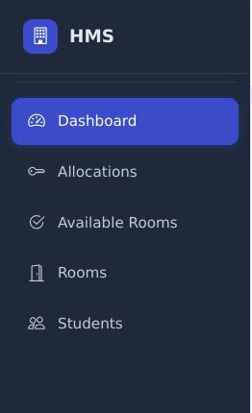
Admin sidebar
Warden sidebar
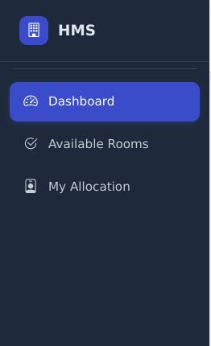
Student sidebar
Result (to be recorded by the tester) - UI-02: Menus match the role
Actual result
Status | [ ] Pass [ ] Fail [ ] Blocked (not executed)
Executed by / date | /
Defect id
Tester evidence | Paste your screenshot here (save it as evidence/UI-02.png and record that file name)

UI-03 - Single logout; cache not reused after logout
Requirement | UI-05, RA-11 | Priority | P1
Technique | UI only | Module | UI

Preconditions | Logged in as admin.
Steps | 1. Count the Logout controls visible on screen  2. Click Logout  3. Press the browser Back button
Input data | -
Expected result | Exactly one Logout control. After Back the dashboard content is NOT shown; you are sent to the login page.
Reference screenshots (expected state, captured by script - not tester evidence)
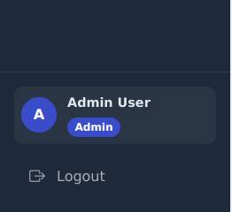
Exactly one Logout control (bottom of the sidebar)
After Logout and the browser Back button: the login page, not the dashboard
Result (to be recorded by the tester) - UI-03: Single logout; cache not reused after logout
Actual result
Status | [ ] Pass [ ] Fail [ ] Blocked (not executed)
Executed by / date | /
Defect id
Tester evidence | Paste your screenshot here (save it as evidence/UI-03.png and record that file name)

6.13 Data entry

ADD-01 - Add a hostel block
Requirement | RA-16 | Priority | P2
Technique | UI only | Module | Data entry

Preconditions | Logged in as admin. Run AFTER all other cases (it changes the totals checked by DASH-01).
Steps | 1. Sidebar > Rooms > Add block  2. Block name: Block C; Location: South Campus  3. Click Add block
Input data | Block C / South Campus
Expected result | Redirected to the Rooms page with the message "Block "Block C" added."; Block C appears in the block filter of Allocations.
Reference screenshot (expected state, captured by script - not tester evidence)
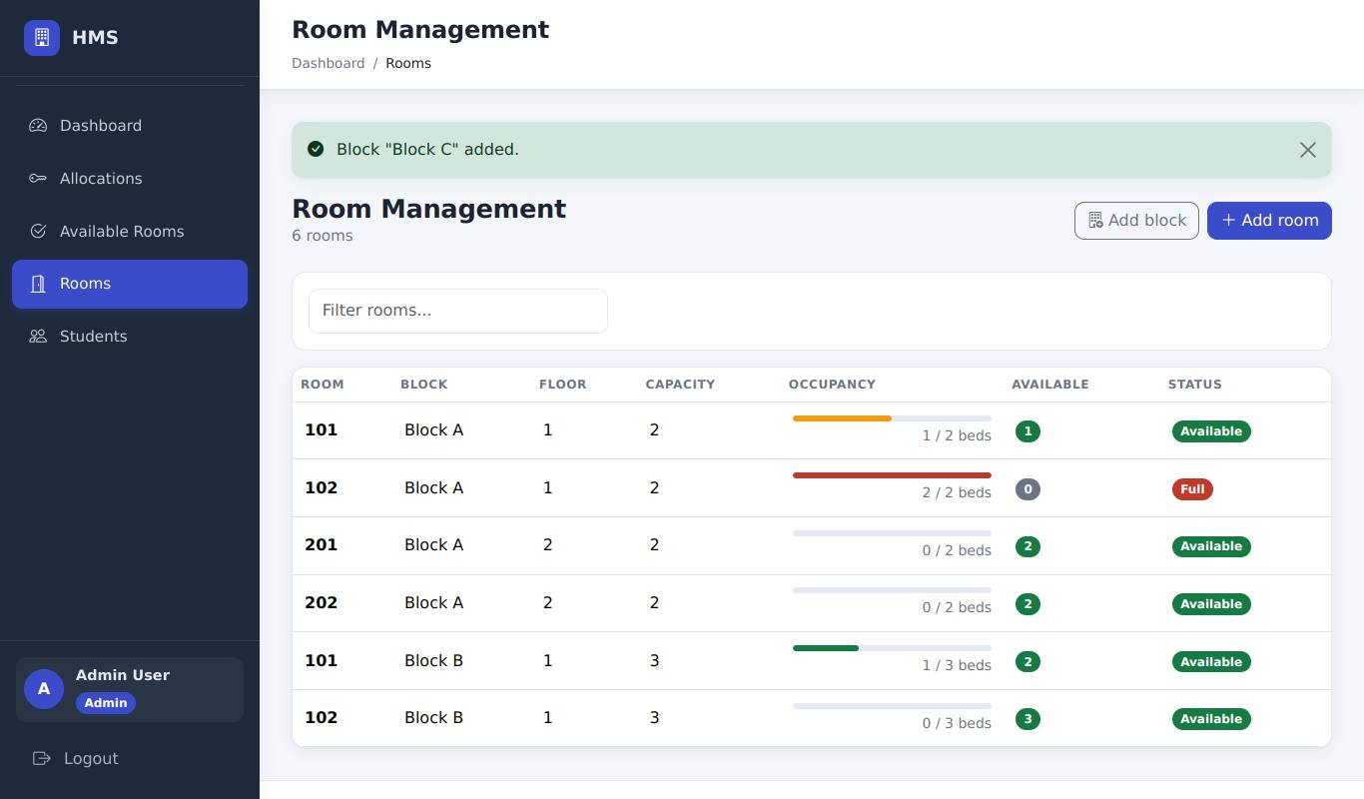
Block C added: message on the Rooms page
Result (to be recorded by the tester)
Actual result
Status | [ ] Pass [ ] Fail [ ] Blocked (not executed)
Executed by / date | /
Defect id
Tester evidence | Paste your screenshot here (save it as evidence/ADD-01.png and record that file name)

ADD-02 - Add a room
Requirement | RA-16 | Priority | P2
Technique | UI only | Module | Data entry

Preconditions | ADD-01 done.
Steps | 1. Rooms > Add room  2. Block: Block C; Room number: 301; Floor: 3; Capacity: 2; Status: Available  3. Click Add room
Input data | Block C / 301 / floor 3 / 2 beds
Expected result | Message "Room 301 added to Block C."; the Rooms table shows Block C 301 with 0 / 2 beds" and status Available; the New Allocation room list offers it."
Reference screenshot (expected state, captured by script - not tester evidence)
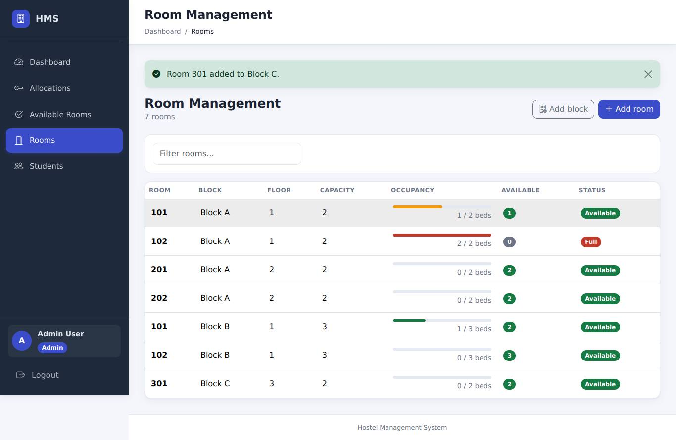
Room 301 added to Block C: message and the new row in the table
Result (to be recorded by the tester)
Actual result
Status | [ ] Pass [ ] Fail [ ] Blocked (not executed)
Executed by / date | /
Defect id
Tester evidence | Paste your screenshot here (save it as evidence/ADD-02.png and record that file name)

ADD-03 - Add a student and log in as that student
Requirement | RA-16 | Priority | P2
Technique | UI only | Module | Data entry

Preconditions | ADD-02 done.
Steps | 1. Students > Add student  2. Name: Frank Green; E-mail: frank@student.test; Roll number: STU900; Course: B.Tech IT; Batch: 2026; Password and confirmation: Frank#Pass123  3. Click Add student  4. Log out; log in as frank@student.test / Frank#Pass123
Input data | Frank Green / STU900
Expected result | Message "Student Frank Green (STU900) added."; Frank appears in the Students list with no allocation; the new login works and shows the student menu (Dashboard, Available Rooms, My Allocation).
Reference screenshots (expected state, captured by script - not tester evidence)
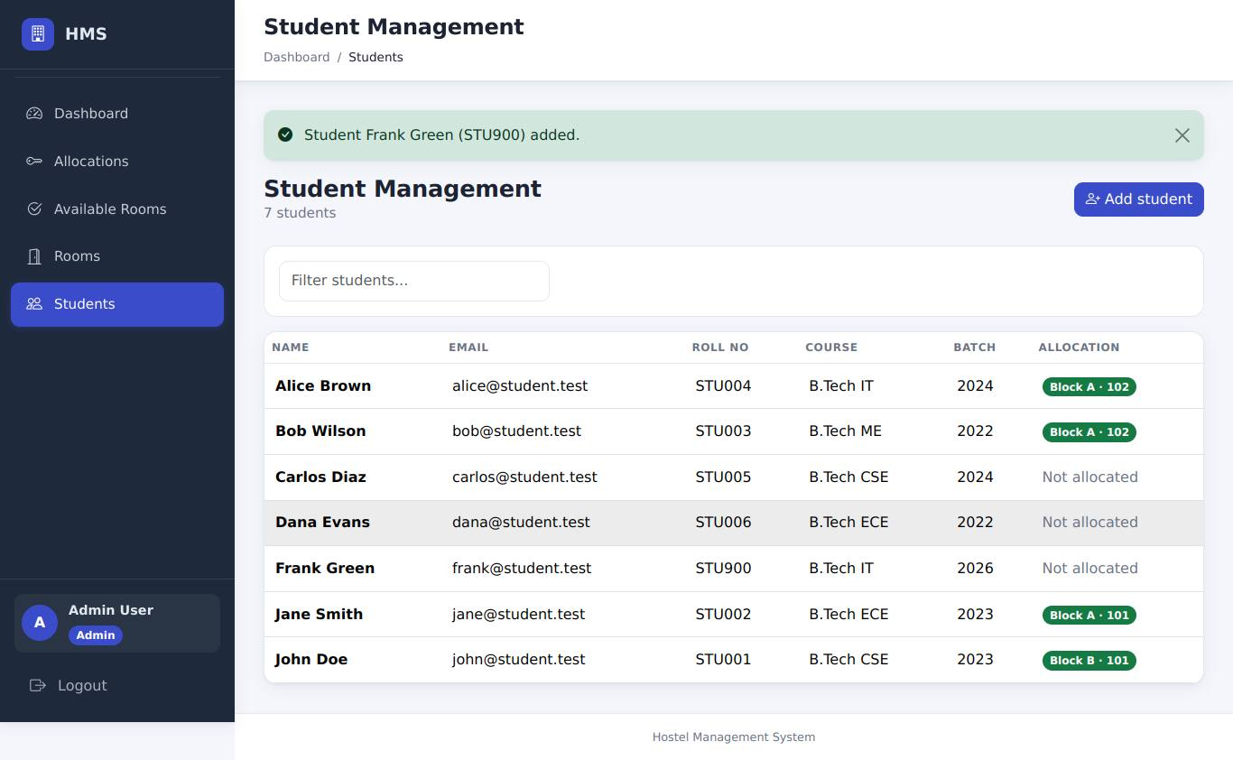
Step 3: Frank Green added - message and the new row in the Students list
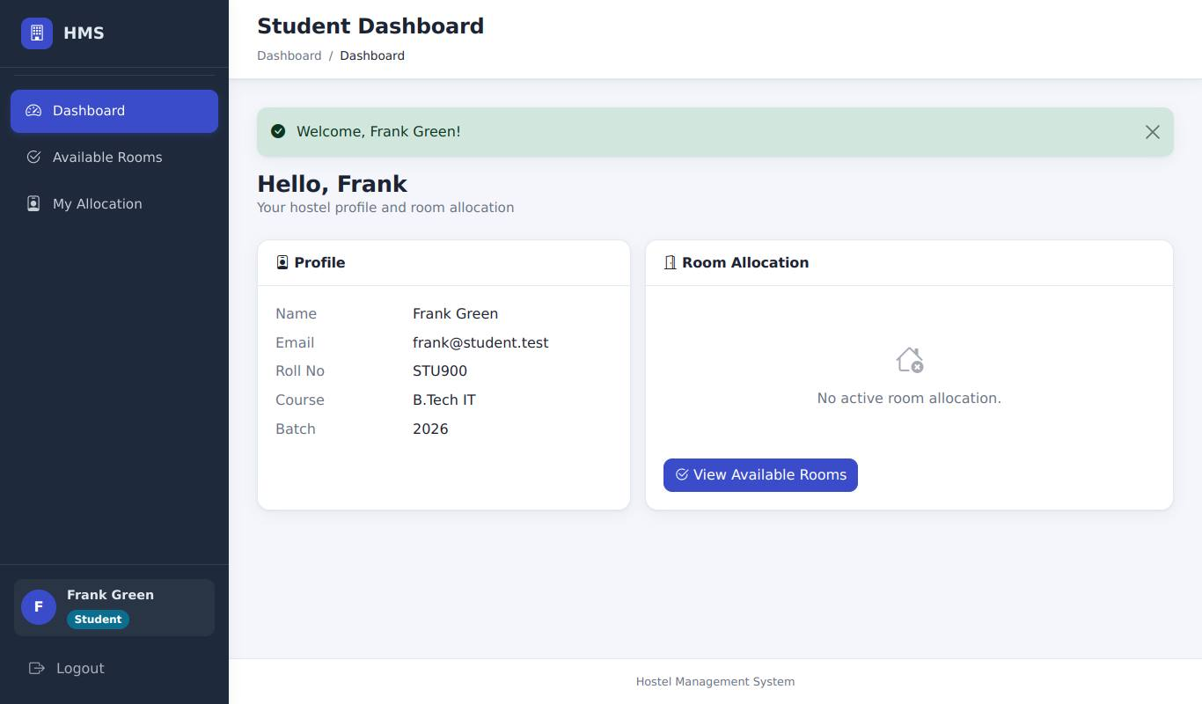
Step 4: logging in as Frank works and shows the student menu
Result (to be recorded by the tester) - ADD-03: Add a student and log in as that student
Actual result
Status | [ ] Pass [ ] Fail [ ] Blocked (not executed)
Executed by / date | /
Defect id
Tester evidence | Paste your screenshot here (save it as evidence/ADD-03.png and record that file name)

ADD-04 - Validation and duplicates on the add forms
Requirement | RA-16 | Priority | P2
Technique | UI only | Module | Data entry

Preconditions | Logged in as admin; ADD-03 done.
Steps | 1. Add student with E-mail john@student.test and everything else valid  2. Add student with Roll number STU900 and a new e-mail  3. Add student with Password abc and confirmation abc  4. Add room: Block C, room number 301 again  5. Add block named "block c"
Input data | see steps
Expected result | 1: "A user with e-mail john@student.test already exists."; 2: "Roll number STU900 is already in use."; 3: "Password must be 8 to 128 characters long."; 4: "Room 301 already exists in Block C."; 5: "A block named "block c" already exists." Every form is shown again with your entries kept (passwords are never refilled); nothing is created.
Reference screenshots (expected state, captured by script - not tester evidence)
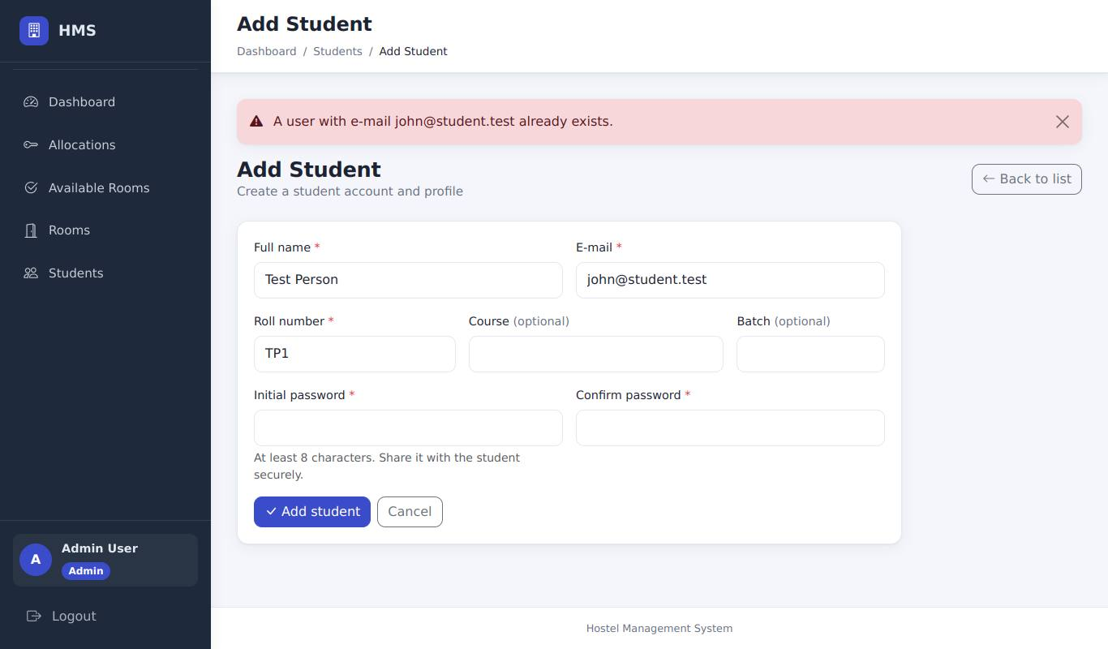
1: duplicate e-mail rejected
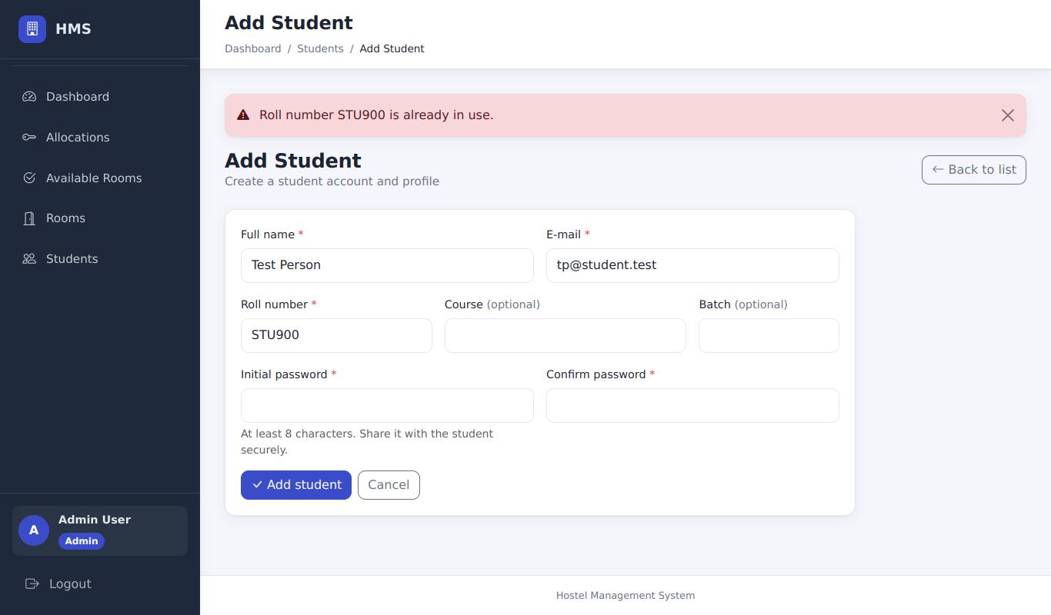
2: duplicate roll number rejected
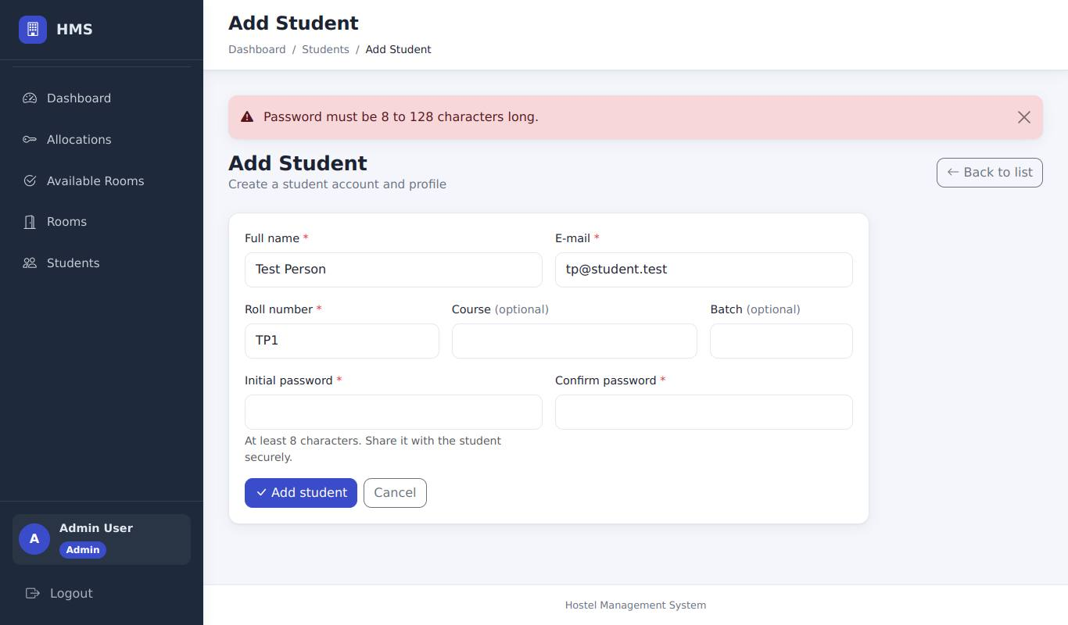
3: too-short password rejected
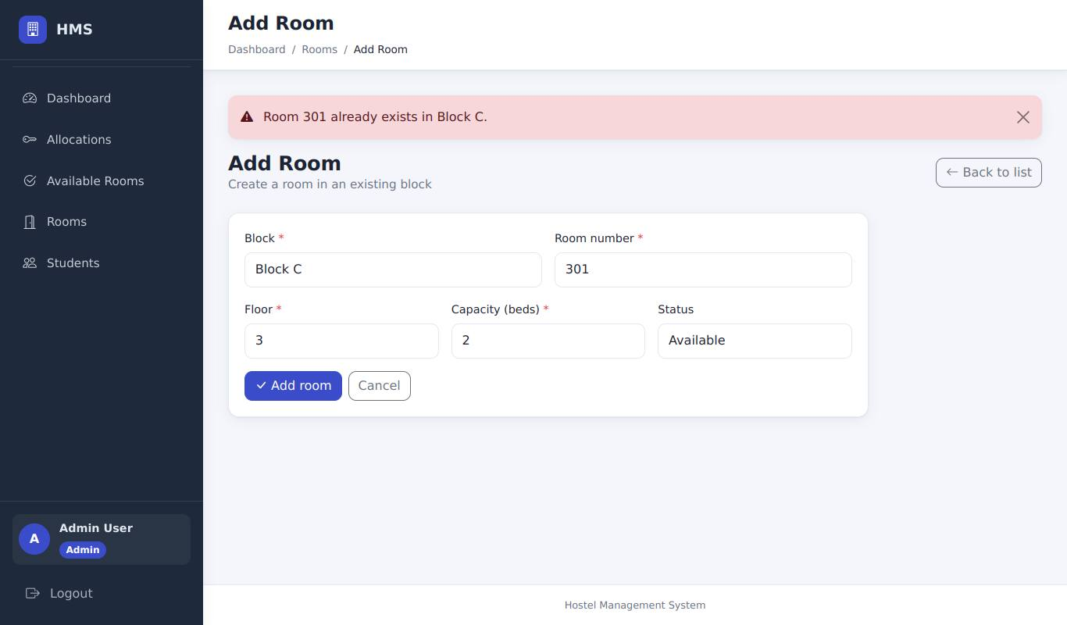
4: duplicate room number in the same block rejected
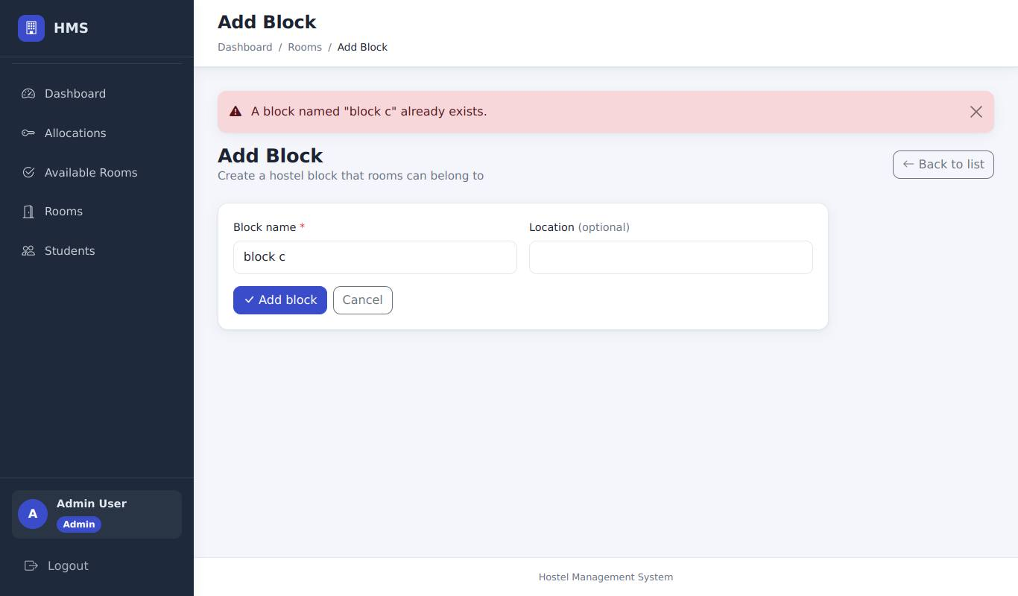
5: duplicate block name rejected (case-insensitive)
Result (to be recorded by the tester) - ADD-04: Validation and duplicates on the add forms
Actual result
Status | [ ] Pass [ ] Fail [ ] Blocked (not executed)
Executed by / date | /
Defect id
Tester evidence | Paste your screenshot here (save it as evidence/ADD-04.png and record that file name)

ADD-05 - Only admins can add data
Requirement | RA-16, RA-10 | Priority | P2
Technique | UI only | Module | Data entry

Preconditions | Logged in as warden, then as student.
Steps | 1. As warden open Rooms and Students: look for Add buttons  2. As warden open http://127.0.0.1:5000/rooms/new  3. As student open http://127.0.0.1:5000/students/new
Input data | -
Expected result | Warden sees no Add buttons; both URLs redirect to the dashboard with "You do not have permission to access this page."
Reference screenshots (expected state, captured by script - not tester evidence)
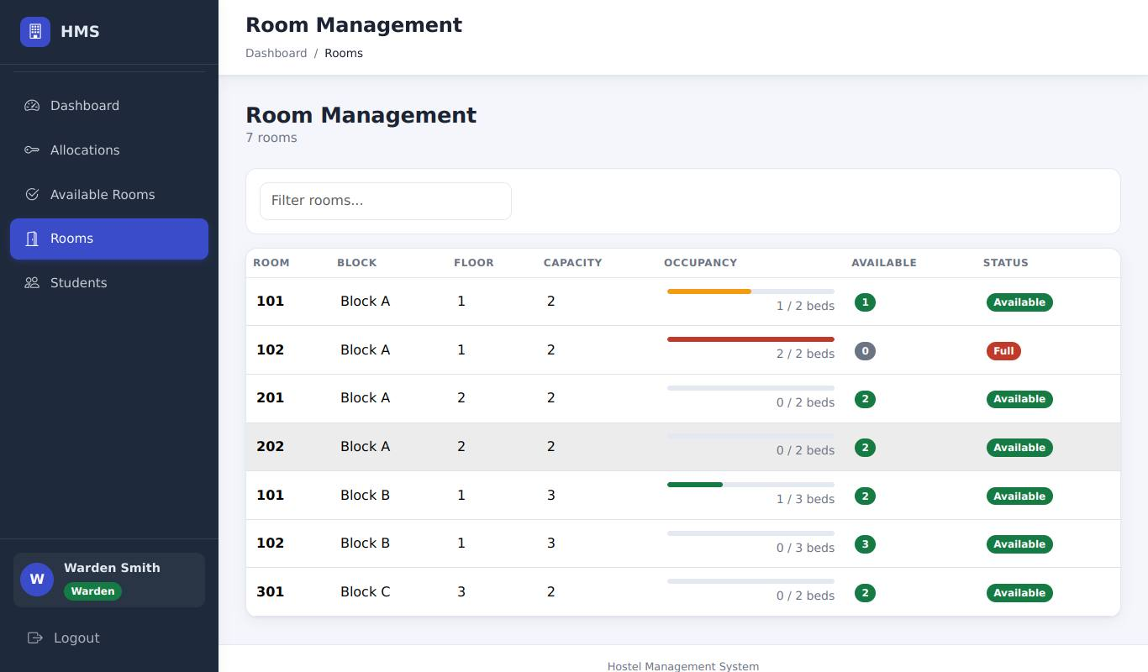
Warden: the Rooms page has no Add buttons
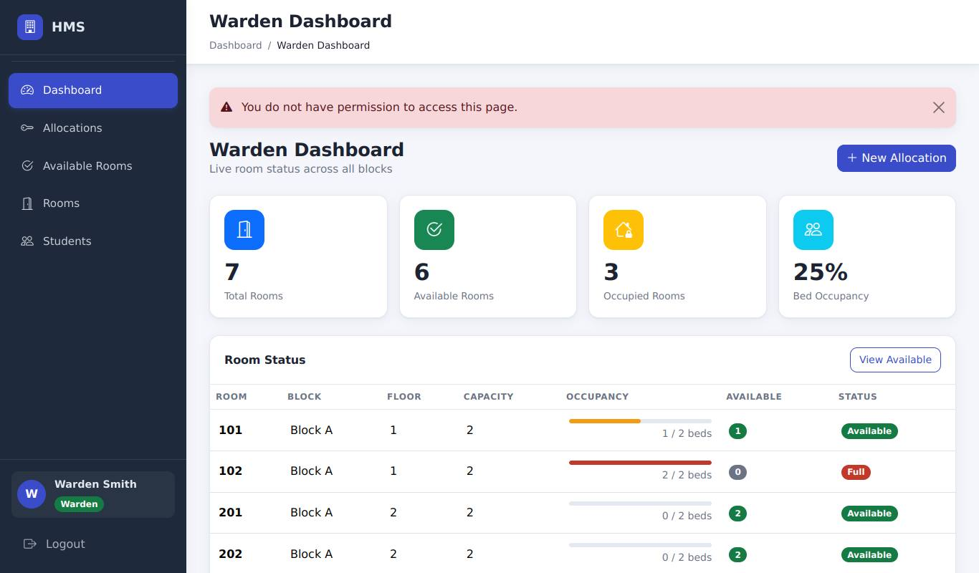
Warden opening /rooms/new: permission message
Student opening /students/new: permission message
Result (to be recorded by the tester) - ADD-05: Only admins can add data
Actual result
Status | [ ] Pass [ ] Fail [ ] Blocked (not executed)
Executed by / date | /
Defect id
Tester evidence | Paste your screenshot here (save it as evidence/ADD-05.png and record that file name)

7. Results summary
Group | Pass | Fail | Blocked | Not executed | Total
All cases | 0 | 0 | 0 | 65 | 65
Priority P1 | 0 | 0 | 0 | 30 | 30
Priority P2 | 0 | 0 | 0 | 33 | 33
Priority P3 | 0 | 0 | 0 | 2 | 2
No case has been executed yet; the table will fill in when results are recorded and this document is regenerated.

8. Defects found during manual testing
Case | Scenario | Defect id | What was observed

9. Sign-off
 | Name | Signature | Date
Tester
Reviewer

Appendix A. How the reference screenshots were made
The reference screenshots were produced by scripts/browser/capture_manual_case_screens.mjs. It starts the demo server on a fresh database (no allocations, lockout limit 5), walks the cases in the order of this document with a headless Chrome browser at 1366 x 800 pixels (390 x 844 for the mobile cases) and saves the decisive screen of each case.
Where a case needs developer tools (editing a field, removing a CSRF token) the script performs the same change, and for drop-down lists it expands the list so the options are visible in the picture. The images therefore show what a correct application displays. They do not replace a tester's own evidence and are not proof that a person ran the case.
Dates inside the screenshots (for example default start dates) are the dates on which the script ran and will differ from the dates on your screen.

