# Test Summary Report – ParaBank

## 1. Objective of Testing

The objective of this testing cycle was to validate core functionalities of the ParaBank application. The focus was on ensuring that registration, login, and transaction modules work as expected with proper validation, error handling, and security checks.

## 2. Test Statistics

Total Test Cases Designed: 36

Total Test Cases Executed: 36

Passed: 27

Failed: 9

Blocked: 0

Execution Coverage: 100%

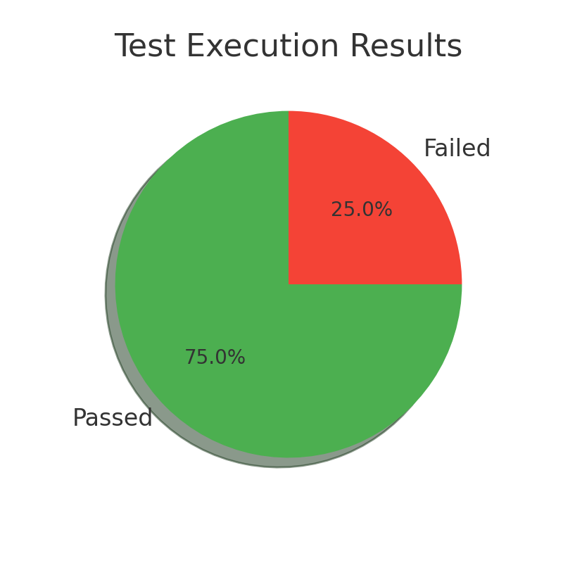

## 3. Defect Summary

|  |  |  |  |  |  |
| --- | --- | --- | --- | --- | --- |
| Defect ID | Test Case | Issue | Severity | Priority | Status |
| BUG-001 | TC-006 | Verify successful registration redirects to account overview | High | High | Failed |
| BUG-002 | TC-014 | Verify account lock after multiple failed login attempts | High | High | Failed |
| BUG-003 | TC-015 | Verify registration with invalid data format | High | High | Failed |
| BUG-004 | TC-017 | Verify session timeout after login | High | High | Failed |
| BUG-005 | TC-020 | Verify transfer fails with insufficient funds | High | High | Failed |
| BUG-006 | TC-022 | Verify system rejects transfer amount ≤ 0 | High | High | Failed |
| BUG-007 | TC-024 | Verify system prevents transfer when source and destination accounts are the same | High | High | Failed |
| BUG-008 | TC-025 | Verify that transfer fails when amount field is left blank. | High | High | Failed |
| BUG-009 | TC-028 | Verify destination account name is displayed before transfer confirmation | High | High | Failed |

**Summary by Severity:**

High: 9

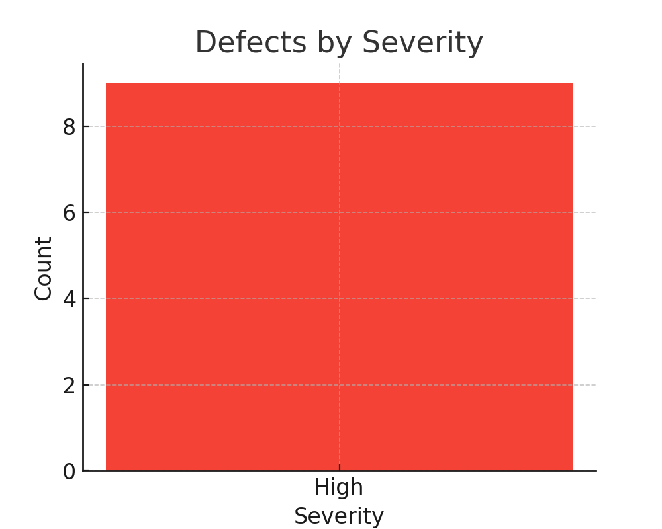

## 4. Risks & Recommendations

**Risks:**

* Security vulnerabilities if login/session management defects persist.
* Usability issues due to missing or inconsistent error messages.
* Functional gaps in transaction handling with invalid inputs.

**Recommendations:**

* Fix high severity defects immediately and retest.
* Standardize error messages for consistency.
* Strengthen session and transaction validation.

## 5. Final Sign-Off Decision

Due to open high-severity defects, sign-off is deferred. The application requires fixes and re-testing before release.