What this handout is about

This handout will help you understand how paragraphs are formed, how to develop stronger paragraphs, and how to completely and clearly express your ideas.

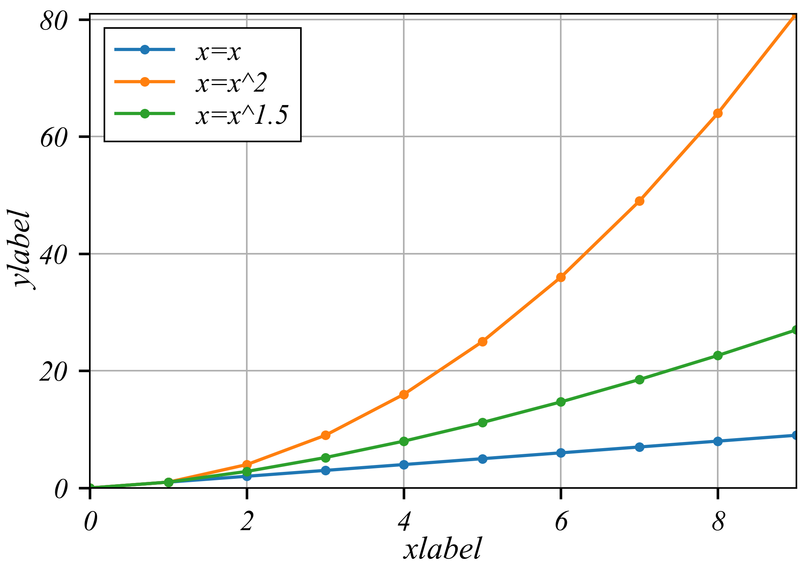

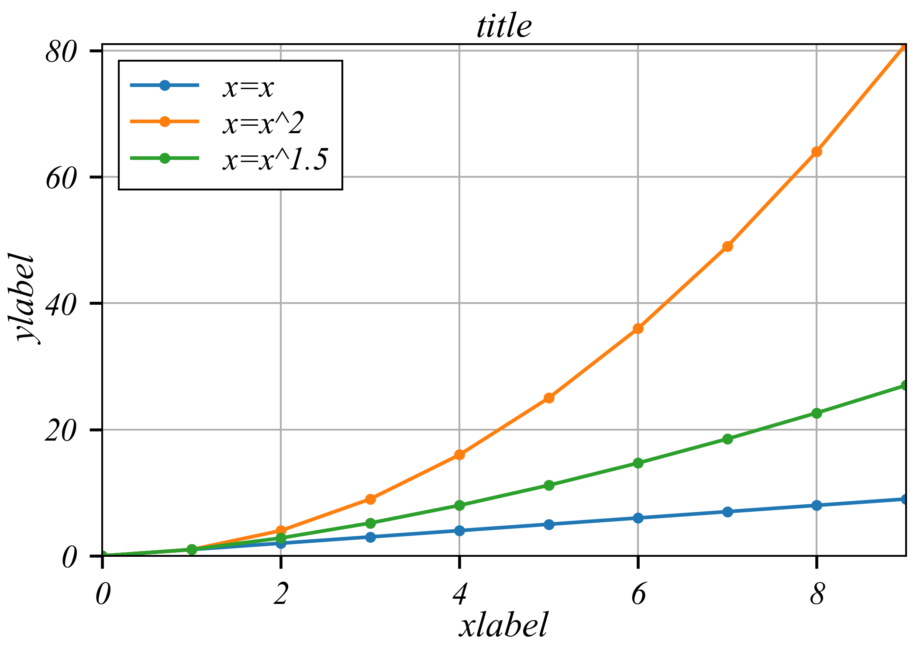

What is a paragraph?

Paragraphs are the building blocks of papers. Many students defineparagraphs in terms of length: a paragraph is a group of at least five sentences, a paragraph is half a page long, etc. In reality, though, the unity and coherence of ideas among sentences is what constitutes a paragraph.

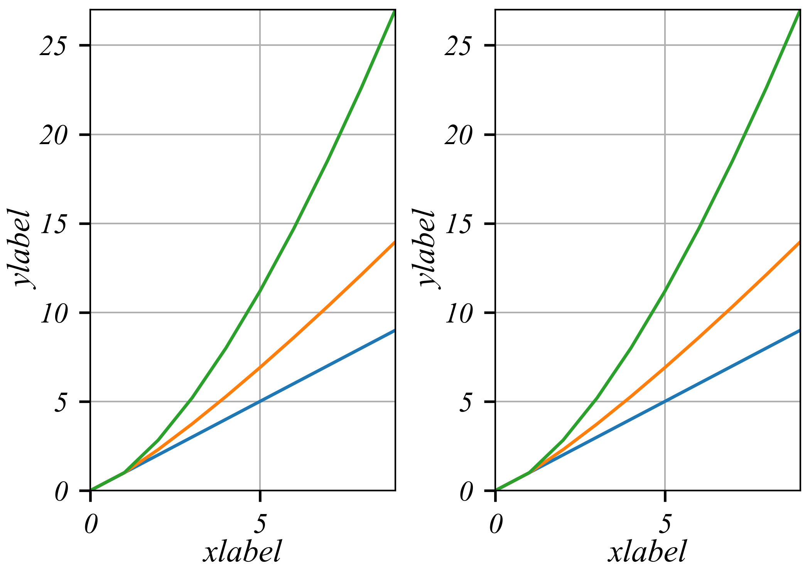A paragraph is defined as “a group of sentences or a single sentence that forms a unit” (Lunsford and Connors 116). Length and appearance do not determine whether a section in a paper is a paragraph.

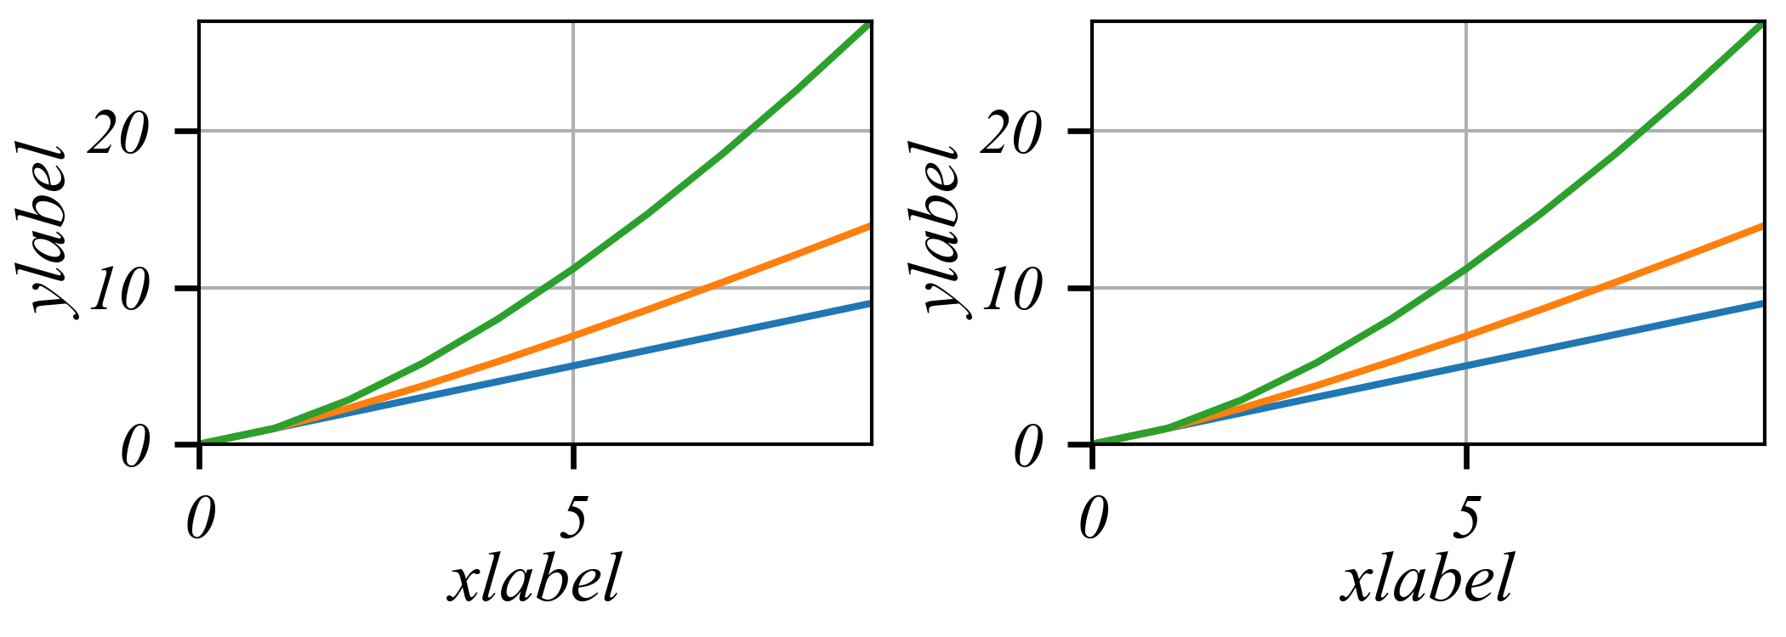

For instance, in some styles of writing, particularly journalistic styles, a paragraph can be just one sentence long. Ultimately, a paragraph is a sentence or group of sentences that support one main idea. In this handout, we will refer to this as the “controlling idea,” because it controls what happens in the rest of the paragraph.

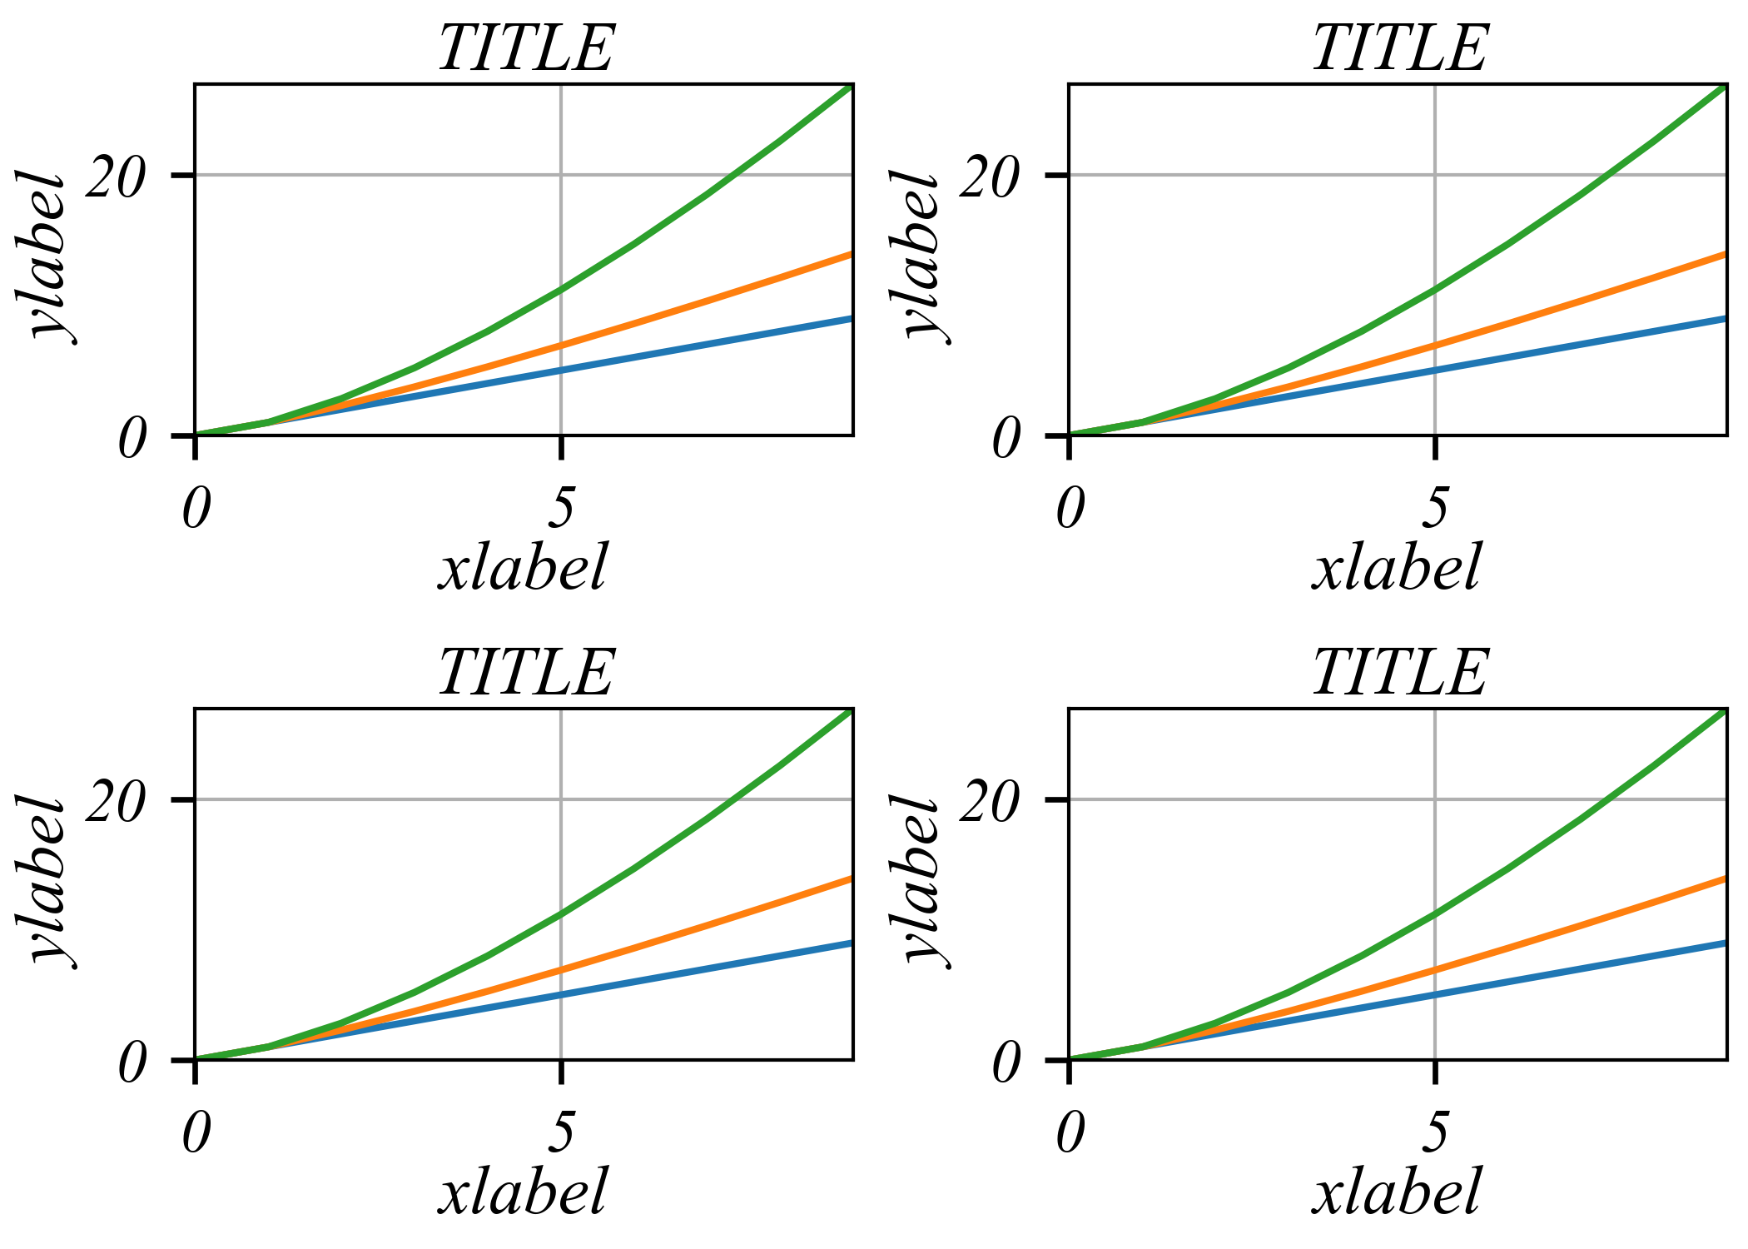

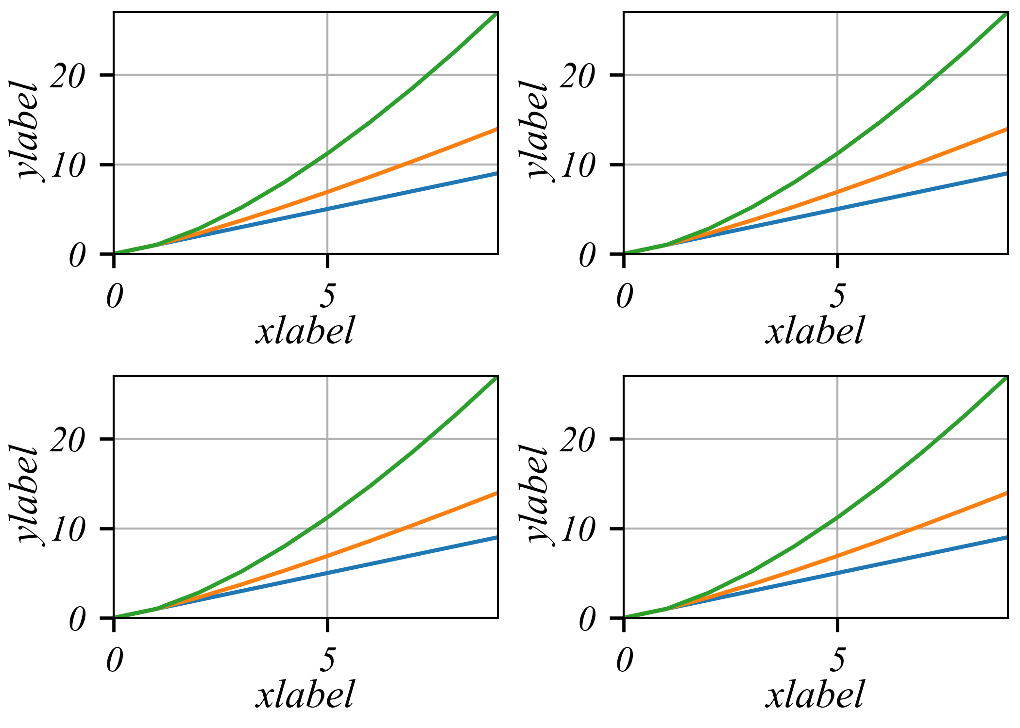

How do I decide what to put in a paragraph?

Before you can begin to determine what the composition of a particular paragraph will be, you must first decide on an [argument](https://writingcenter.unc.edu/tips-and-tools/argument/) and a working [thesis statement](https://writingcenter.unc.edu/tips-and-tools/thesis-statements/) for your paper. What is the most important idea that you are trying to convey to your reader? The information in each paragraph must be related to that idea.

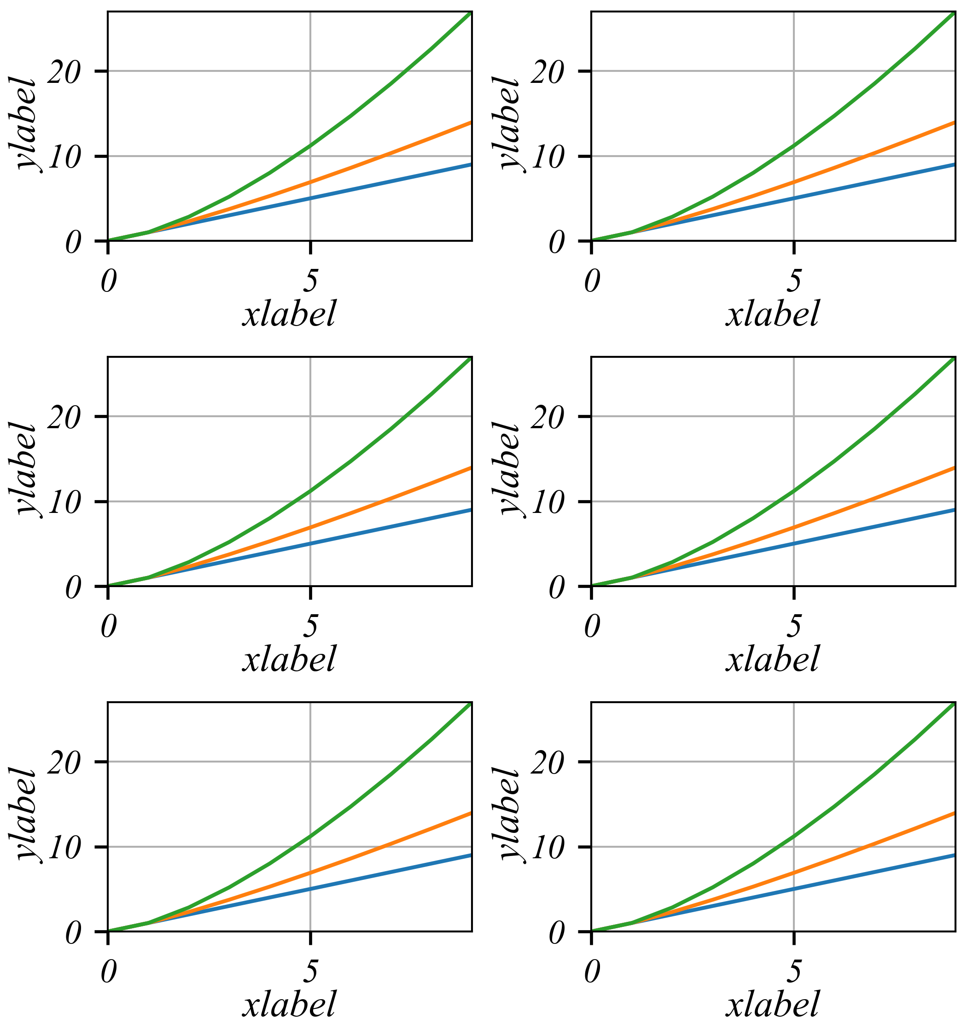In other words, your paragraphs should remind your reader that there is a recurrent relationship between your thesis and the informa

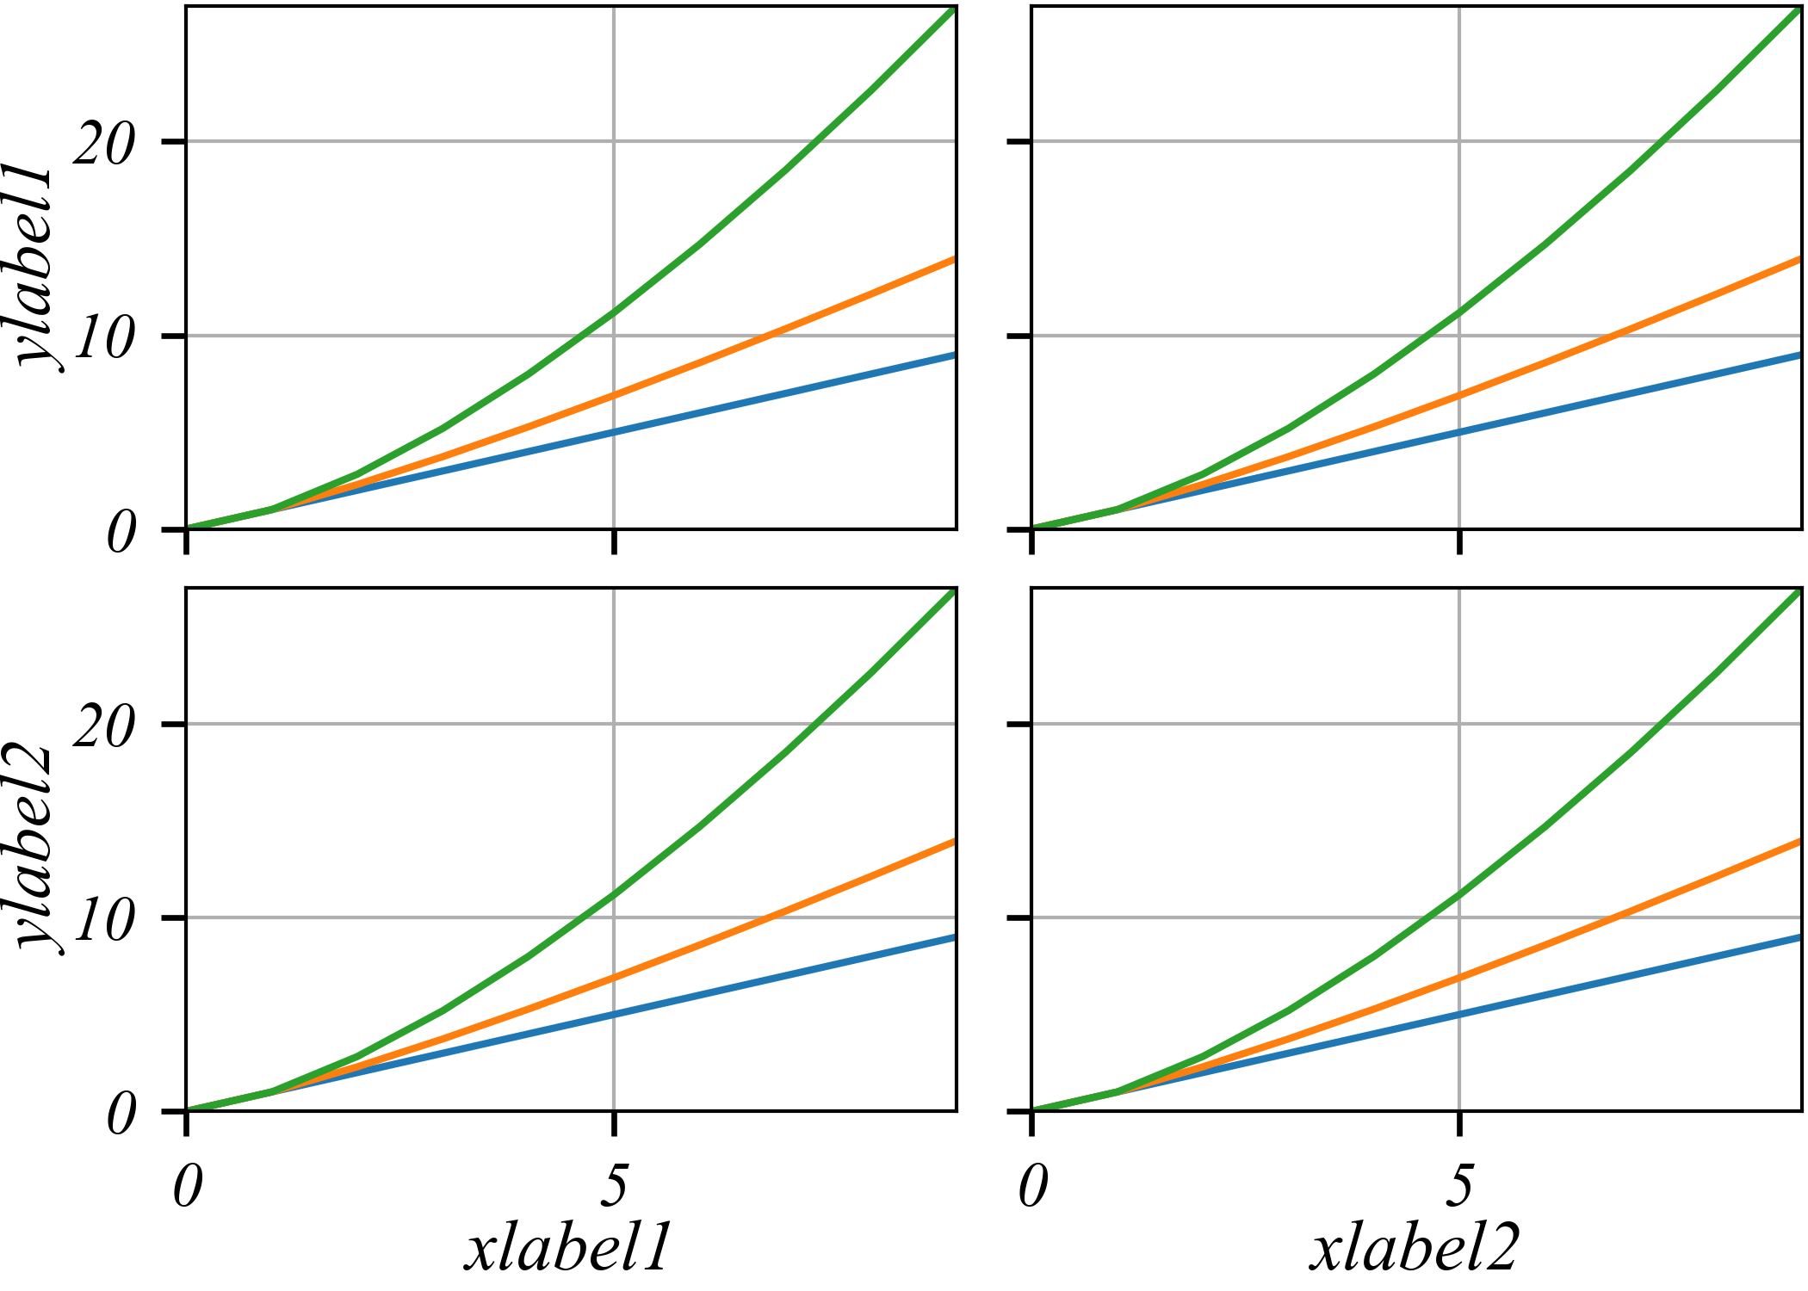

Step 5. Complete the paragraph’s idea or transition into the next paragraph

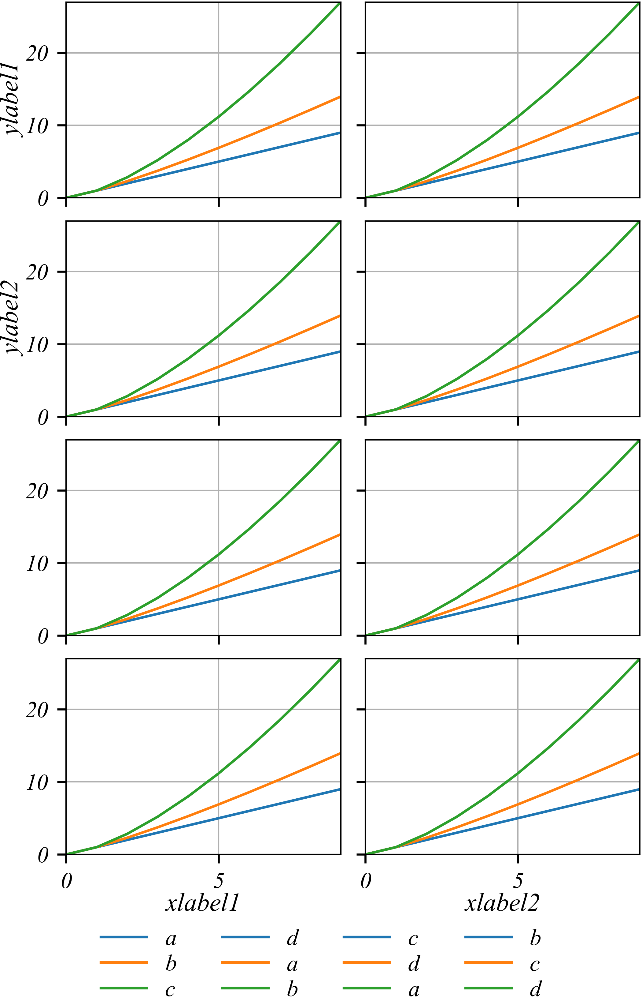

The final movement in paragraph development involves tying up the loose ends of the paragraph. At this point, you can remind your reader about the relevance of the information to the larger paper, or you can make a concluding point for this example. You might, however, simply transition to the next paragraph.

**Sentences for completing a paragraph** — While the trope of the man-eating piranhas lends excitement to the adventure stories, it bears little resemblance to the real-life piranha. By paying more attention to fact than fiction, humans may finally be able to let go of this inaccurate belief

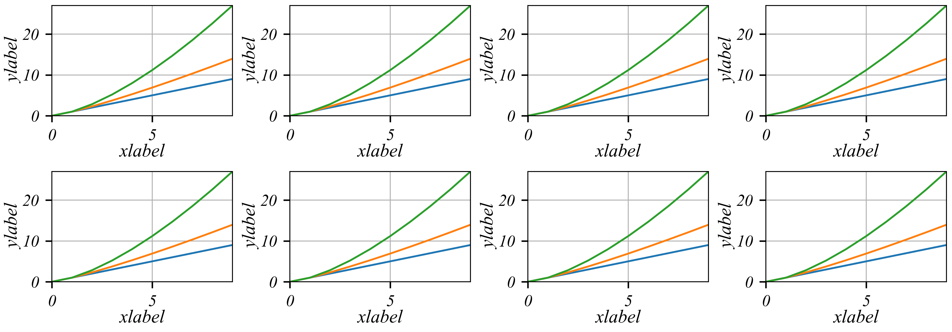

Finished paragraph

Despite the fact that piranhas are relatively harmless, many people continue to believe the pervasive myth that piranhas are dangerous to humans. This impression of piranhas is exacerbated by their mischaracterization in popular media. For example, the promotional poster for the 1978 horror film *Piranha* features an oversized piranha poised to bite the leg of an unsuspecting woman.

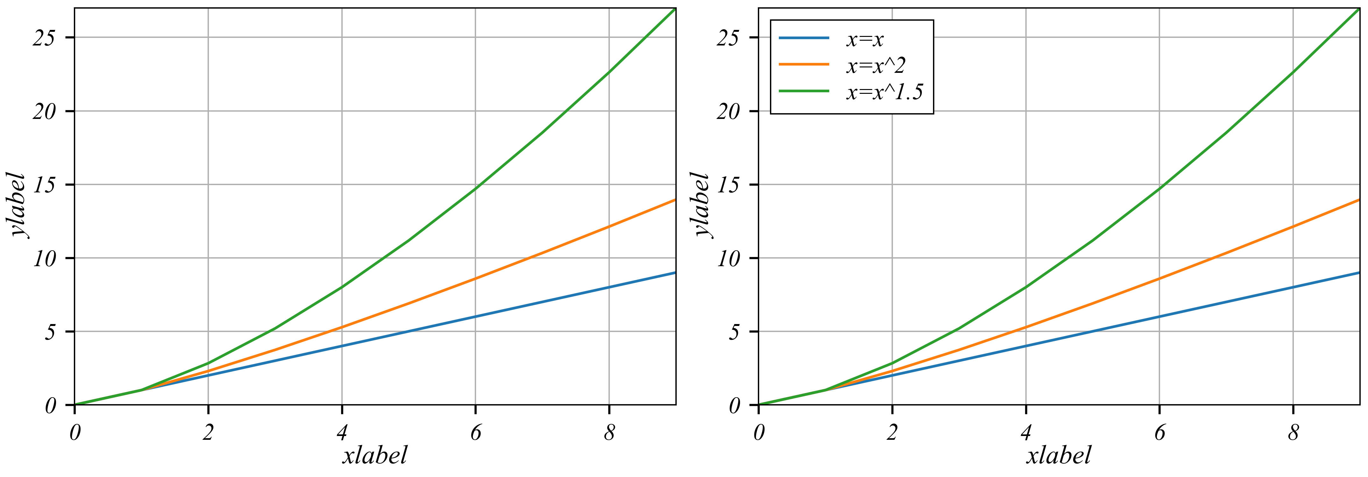 Such a terrifying representation easily captures the imagination and promotes unnecessary fear. While the trope of the man-eating piranhas lends excitement to the adventure stories, it bears little resemblance to the real-life piranha. By paying more attention to fact than fiction, humans may finally be able to let go of this inaccurate belief.

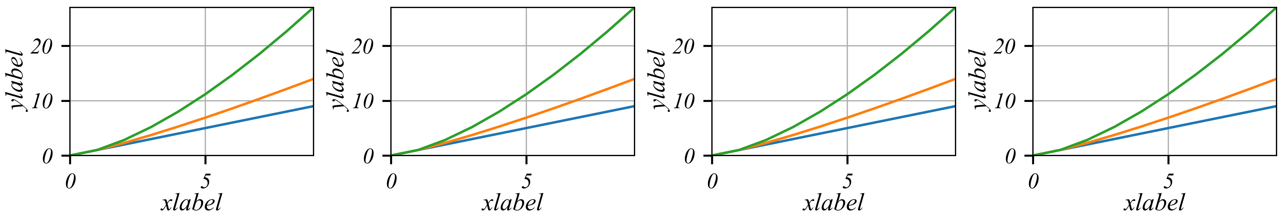

Troubleshooting paragraphs

Problem: the paragraph has no topic sentence

Imagine each paragraph as a sandwich. The real content of the sandwich—the meat or other filling—is in the middle. It includes all the evidence you need to make the point. But it gets kind of messy to eat a sandwich without any bread.

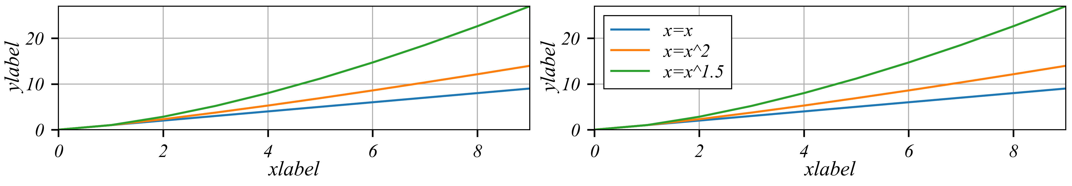

Your readers don’t know what to do with all the evidence you’ve given them. So, the top slice of bread (the first sentence of the paragraph) explains the topic (or controlling idea) of the paragraph. And, the bottom slice (the last sentence of the paragraph) tells the reader how the paragraph relates to the broader argument. In the original and revised paragraphs below, notice how a topic sentence expressing the controlling idea tells the reader the point of all the evidence.

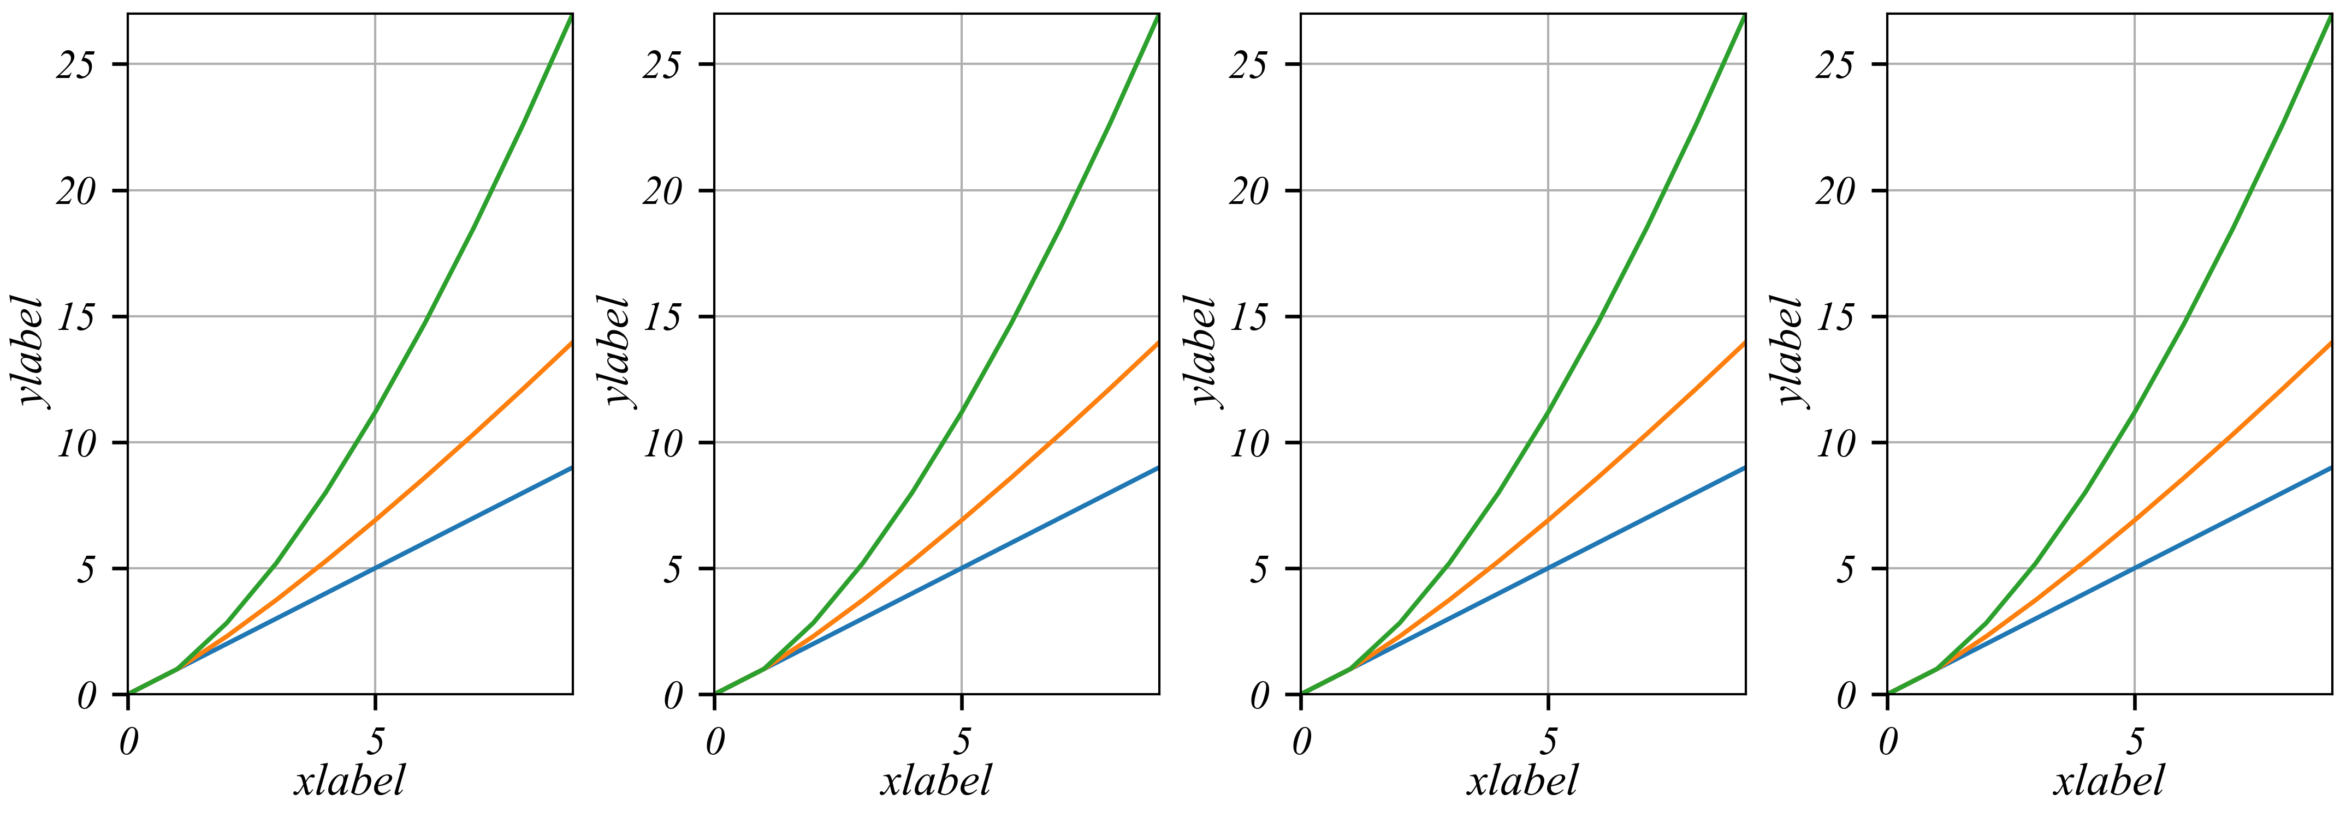

**Original paragraph**

Piranhas rarely feed on large animals; they eat smaller fish and aquatic plants. When confronted with humans, piranhas’ first instinct is to flee, not attack. Their fear of humans makes sense. Far more piranhas are eaten by people than people are eaten by piranhas. If the fish are well-fed, they won’t bite humans.

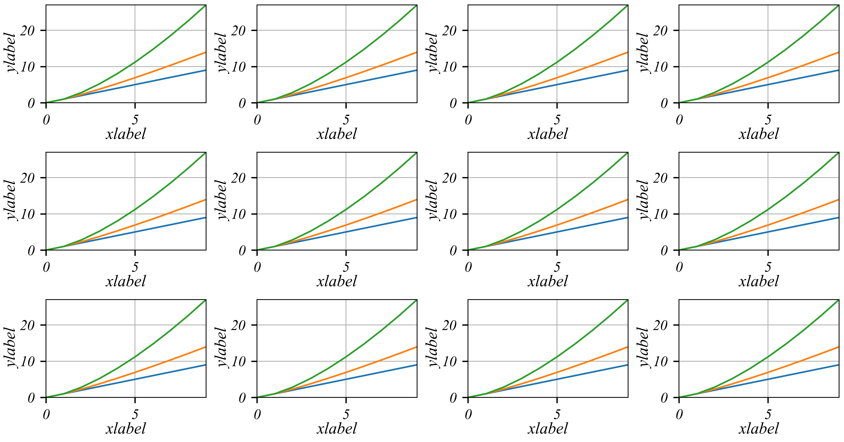

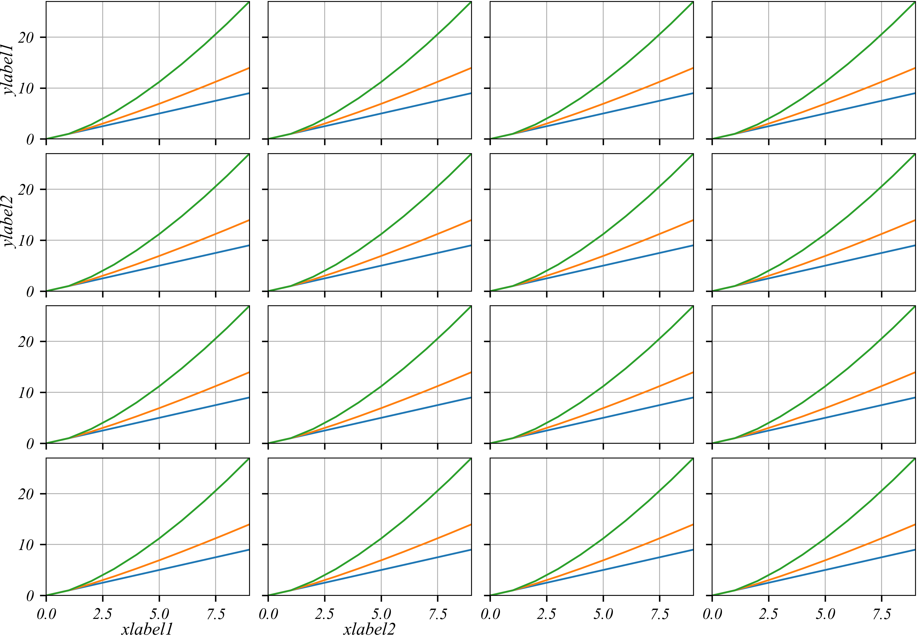

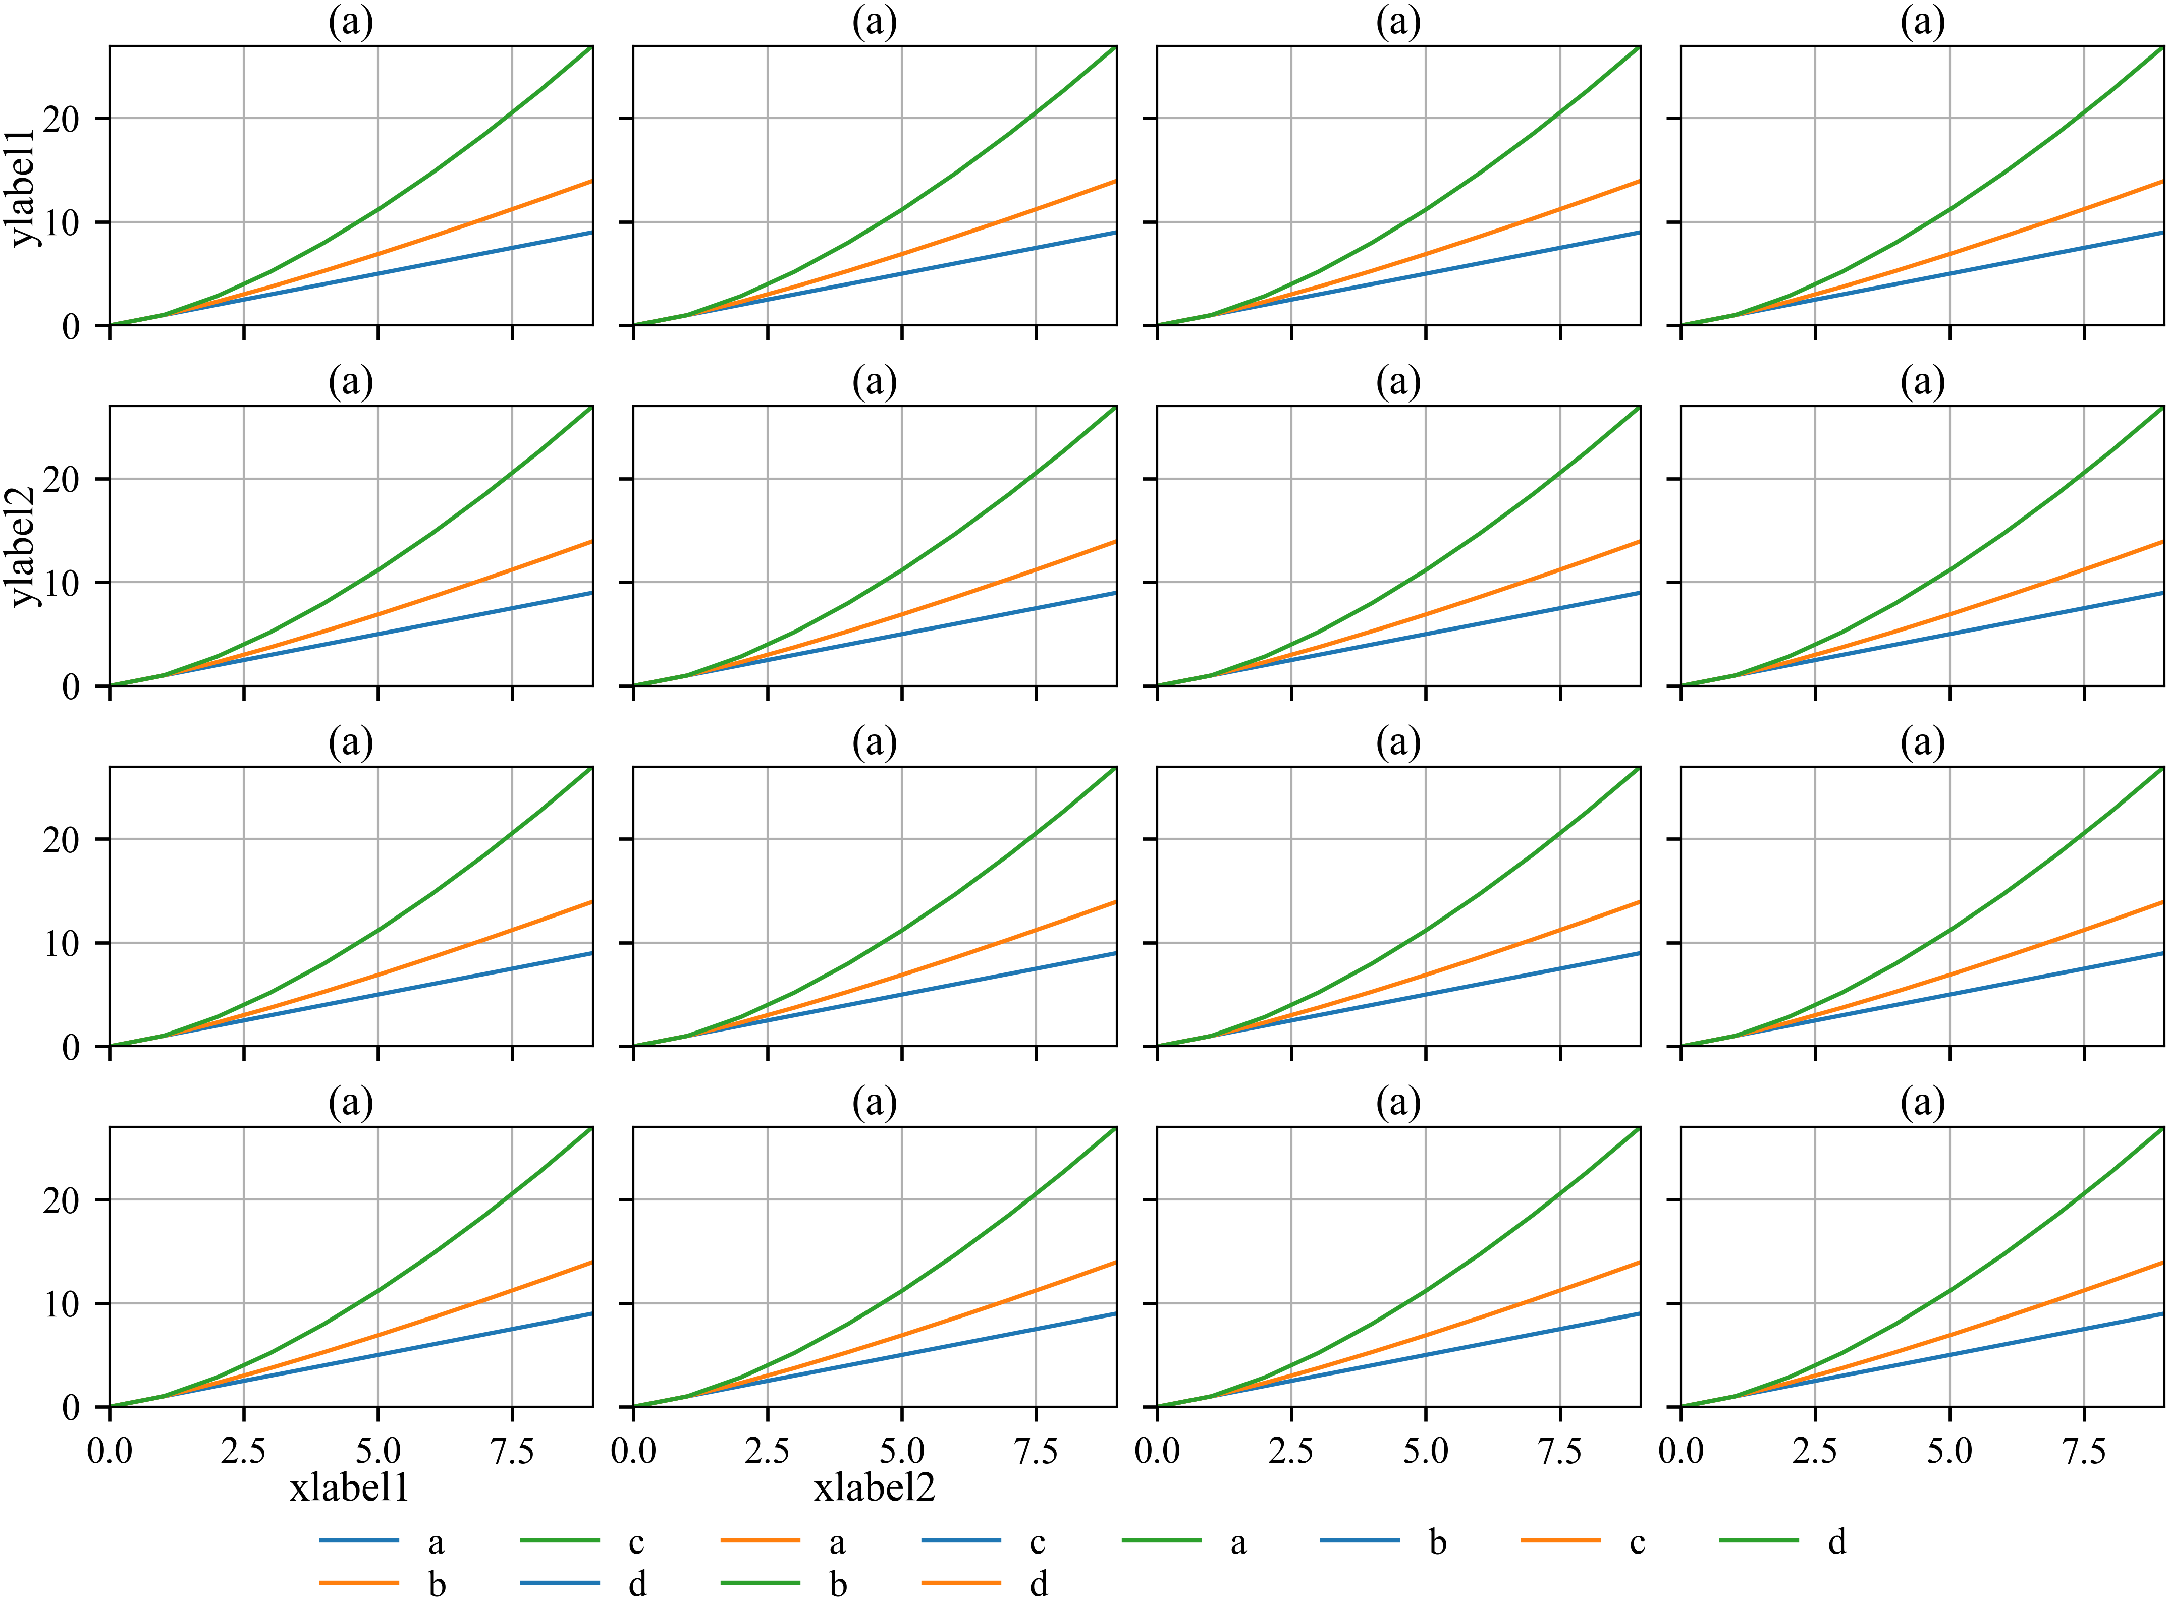

**Revised paragraph**

Although most people consider piranhas to be quite dangerous, they are, for the most part, entirely harmless. Piranhas rarely feed on large animals; they eat smaller fish and aquatic plants. When confronted with humans, piranhas’ first instinct is to flee, not attack. Their fear of humans makes sense. Far more piranhas are eaten by people than people are eaten by piranhas. If the fish are well-fed, they won’t bite humans.

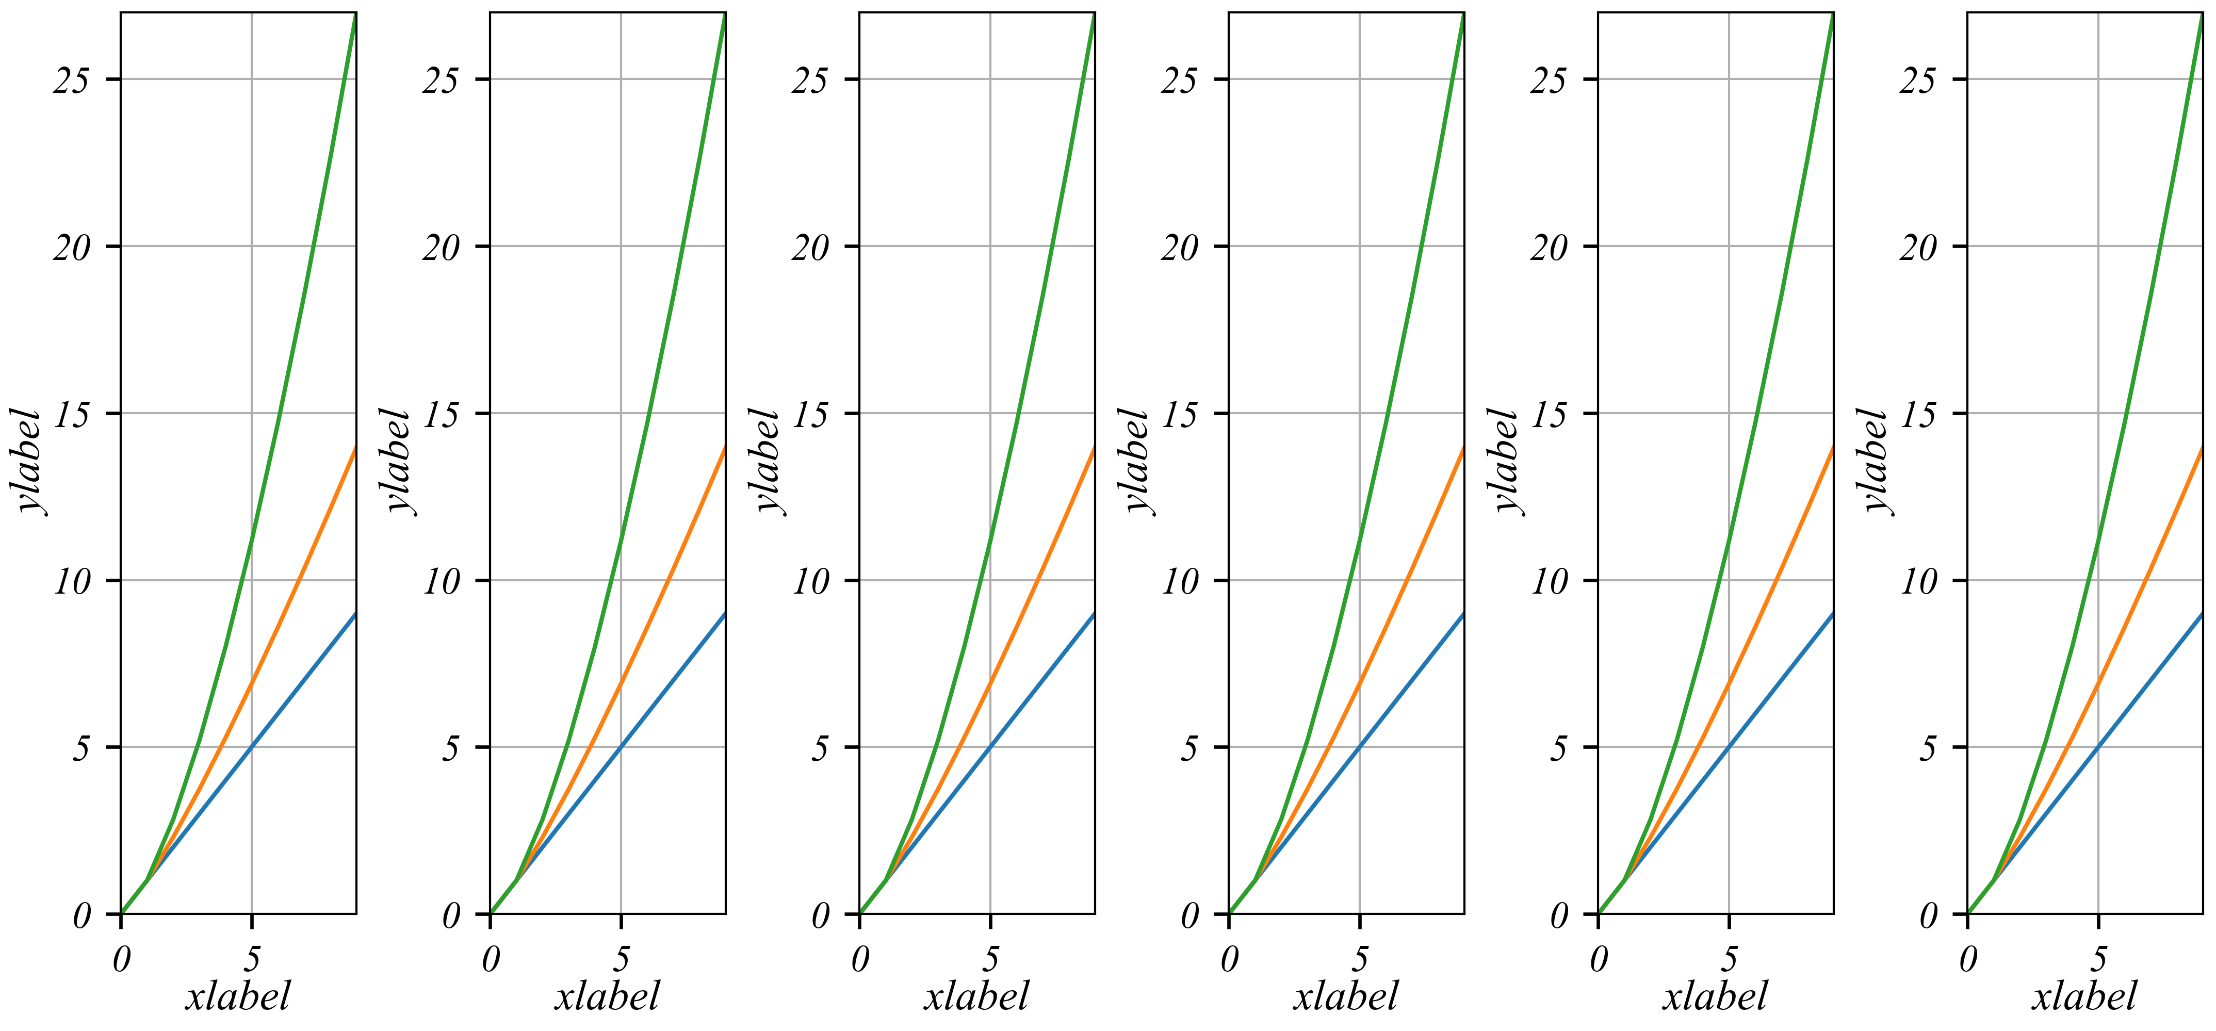

Once you have mastered the use of topic sentences, you may decide that the topic sentence for a particular paragraph really shouldn’t be the first sentence of the paragraph. This is fine—the topic sentence can actually go at the beginning, middle, or end of a paragraph; what’s important is that it is in there somewhere so that readers know what the main idea of the paragraph is and how it relates back to the thesis of your paper. Suppose that we wanted to start the piranha paragraph with a transition sentence—something that reminds the reader of what happened in the previous paragraph—rather than with the topic sentence. Let’s suppose that the previous paragraph was about all kinds of animals that people are afraid of, like sharks, snakes, and spiders. Our paragraph might look like this (the topic sentence is bold):

Like sharks, snakes, and spiders, piranhas are widely feared. **Although most people consider piranhas to be quite dangerous, they are, for the most part, entirely harmless**. Piranhas rarely feed on large animals; they eat smaller fish and aquatic plants. When confronted with humans, piranhas’ first instinct is to flee, not attack. Their fear of humans makes sense. Far more piranhas are eaten by people than people are eaten by piranhas. If the fish are well-fed, they won’t bite humans.

Problem: the paragraph has more than one controlling idea

If a paragraph has more than one main idea, consider eliminating sentences that relate to the second idea, or split the paragraph into two or more paragraphs, each with only one main idea. Watch our [short video on reverse outlining](https://writingcenter.unc.edu/tips-and-tools/reverse-outline/) to learn a quick way to test whether your paragraphs are unified. In the following paragraph, the final two sentences branch off into a different topic; so, the revised paragraph eliminates them and concludes with a sentence that reminds the reader of the paragraph’s main idea.

**Original paragraph**

Although most people consider piranhas to be quite dangerous, they are, for the most part, entirely harmless. Piranhas rarely feed on large animals; they eat smaller fish and aquatic plants. When confronted with humans, piranhas’ first instinct is to flee, not attack. Their fear of humans makes sense. Far more piranhas are eaten by people than people are eaten by piranhas.

**Revised paragraph**

Although most people consider piranhas to be quite dangerous, they are, for the most part, entirely harmless. Piranhas rarely feed on large animals; they eat smaller fish and aquatic plants. When confronted with humans, piranhas’ first instinct is to flee, not attack. Their fear of humans makes sense. Far more piranhas are eaten by people than people are eaten by piranhas. If the fish are well-fed, they won’t bite humans.

Problem: transitions are needed within the paragraph

You are probably familiar with the idea that transitions may be needed between paragraphs or sections in a paper (see our [handout on transitions](https://writingcenter.unc.edu/tips-and-tools/transitions/)). Sometimes they are also helpful within the body of a single paragraph. Within a paragraph, transitions are often single words or short phrases that help to establish relationships between ideas and to create a logical progression of those ideas in a paragraph. This is especially likely to be true within paragraphs that discuss multiple examples. Let’s take a look at a version of our piranha paragraph that uses transitions to orient the reader:

Although most people consider piranhas to be quite dangerous, they are, except in two main situations, entirely harmless. Piranhas rarely feed on large animals; they eat smaller fish and aquatic plants. When confronted with humans, piranhas’ instinct is to flee, not attack. But there are two situations in which a piranha bite is likely. The first is when a frightened piranha is lifted out of the water—for example, if it has been caught in a fishing net. The second is when the water level in pools where piranhas are living falls too low. A large number of fish may be trapped in a single pool, and if they are hungry, they may attack anything that enters the water.

In this example, you can see how the phrases “the first” and “the second” help the reader follow the organization of the ideas in the paragraph.

Works consulted

We consulted these works while writing this handout. This is not a comprehensive list of resources on the handout’s topic, and we encourage you to do your own research to find additional publications. Please do not use this list as a model for the format of your own reference list, as it may not match the citation style you are using. For guidance on formatting citations, please see the [UNC Libraries citation tutorial](http://www.lib.unc.edu/instruct/citations/). We revise these tips periodically and welcome feedback.

Lunsford, Andrea. 2008. *The St. Martin’s Handbook: Annotated Instructor’s Edition*, 6th ed. New York: St. Martin’s.

Rosen, Leonard J., and Laurence Behrens. 2003. *The Allyn & Bacon Handbook*, 5th ed. New York: Longman.

序　言

中国是世界上历史最悠久的国家之一。中国各族人民共同创造了光辉灿烂的文化，具有光荣的革命传统。

一八四○年以后，封建的中国逐渐变成半殖民地、半封建的国家。中国人民为国家独立、民族解放和民主自由进行了前仆后继的英勇奋斗。

二十世纪，中国发生了翻天覆地的伟大历史变革。

一九一一年孙中山先生领导的辛亥革命，废除了封建帝制，创立了中华民国。但是，中国人民反对帝国主义和封建主义的历史任务还没有完成。

一九四九年，以毛泽东主席为领袖的中国共产党领导中国各族人民，在经历了长期的艰难曲折的武装斗争和其他形式的斗争以后，终于推翻了帝国主义、封建主义和官僚资本主义的统治，取得了新民主主义革命的伟大胜利，建立了中华人民共和国。从此，中国人民掌握了国家的权力，成为国家的主人。

中华人民共和国成立以后，我国社会逐步实现了由新民主主义到社会主义的过渡。生产资料私有制的社会主义改造已经完成，人剥削人的制度已经消灭，社会主义制度已经确立。工人阶级领导的、以工农联盟为基础的人民民主专政，实质上即无产阶级专政，得到巩固和发展。中国人民和中国人民解放军战胜了帝国主义、霸权主义的侵略、破坏和武装挑衅，维护了国家的独立和安全，增强了国防。经济建设取得了重大的成就，独立的、比较完整的社会主义工业体系已经基本形成，农业生产显著提高。教育、科学、文化等事业有了很大的发展，社会主义思想教育取得了明显的成效。广大人民的生活有了较大的改善。

中国新民主主义革命的胜利和社会主义事业的成就，是中国共产党领导中国各族人民，在马克思列宁主义、毛泽东思想的指引下，坚持真理，修正错误，战胜许多艰难险阻而取得的。我国将长期处于社会主义初级阶段。国家的根本任务是，沿着中国特色社会主义道路，集中力量进行社会主义现代化建设。中国各族人民将继续在中国共产党领导下，在马克思列宁主义、毛泽东思想、邓小平理论、“三个代表”重要思想、科学发展观、习近平新时代中国特色社会主义思想指引下，坚持人民民主专政，坚持社会主义道路，坚持改革开放，不断完善社会主义的各项制度，发展社会主义市场经济，发展社会主义民主，健全社会主义法治，贯彻新发展理念，自力更生，艰苦奋斗，逐步实现工业、农业、国防和科学技术的现代化，推动物质文明、政治文明、精神文明、社会文明、生态文明协调发展，把我国建设成为富强民主文明和谐美丽的社会主义现代化强国，实现中华民族伟大复兴。

在我国，剥削阶级作为阶级已经消灭，但是阶级斗争还将在一定范围内长期存在。中国人民对敌视和破坏我国社会主义制度的国内外的敌对势力和敌对分子，必须进行斗争。

台湾是中华人民共和国的神圣领土的一部分。完成统一祖国的大业是包括台湾同胞在内的全中国人民的神圣职责。

社会主义的建设事业必须依靠工人、农民和知识分子，团结一切可以团结的力量。在长期的革命、建设、改革过程中，已经结成由中国共产党领导的，有各民主党派和各人民团体参加的，包括全体社会主义劳动者、社会主义事业的建设者、拥护社会主义的爱国者、拥护祖国统一和致力于中华民族伟大复兴的爱国者的广泛的爱国统一战线，这个统一战线将继续巩固和发展。中国人民政治协商会议是有广泛代表性的统一战线组织，过去发挥了重要的历史作用，今后在国家政治生活、社会生活和对外友好活动中，在进行社会主义现代化建设、维护国家的统一和团结的斗争中，将进一步发挥它的重要作用。中国共产党领导的多党合作和政治协商制度将长期存在和发展。

中华人民共和国是全国各族人民共同缔造的统一的多民族国家。平等团结互助和谐的社会主义民族关系已经确立，并将继续加强。在维护民族团结的斗争中，要反对大民族主义，主要是大汉族主义，也要反对地方民族主义。国家尽一切努力，促进全国各民族的共同繁荣。

中国革命、建设、改革的成就是同世界人民的支持分不开的。中国的前途是同世界的前途紧密地联系在一起的。中国坚持独立自主的对外政策，坚持互相尊重主权和领土完整、互不侵犯、互不干涉内政、平等互利、和平共处的五项原则，坚持和平发展道路，坚持互利共赢开放战略，发展同各国的外交关系和经济、文化交流，推动构建人类命运共同体；坚持反对帝国主义、霸权主义、殖民主义，加强同世界各国人民的团结，支持被压迫民族和发展中国家争取和维护民族独立、发展民族经济的正义斗争，为维护世界和平和促进人类进步事业而努力。

本宪法以法律的形式确认了中国各族人民奋斗的成果，规定了国家的根本制度和根本任务，是国家的根本法，具有最高的法律效力。全国各族人民、一切国家机关和武装力量、各政党和各社会团体、各企业事业组织，都必须以宪法为根本的活动准则，并且负有维护宪法尊严、保证宪法实施的职责。

第一章　总　纲

第一条　中华人民共和国是工人阶级领导的、以工农联盟为基础的人民民主专政的社会主义国家。

社会主义制度是中华人民共和国的根本制度。中国共产党领导是中国特色社会主义最本质的特征。禁止任何组织或者个人破坏社会主义制度。

第二条　中华人民共和国的一切权力属于人民。

人民行使国家权力的机关是全国人民代表大会和地方各级人民代表大会。

人民依照法律规定，通过各种途径和形式，管理国家事务，管理经济和文化事业，管理社会事务。

第三条　中华人民共和国的国家机构实行民主集中制的原则。

全国人民代表大会和地方各级人民代表大会都由民主选举产生，对人民负责，受人民监督。

国家行政机关、监察机关、审判机关、检察机关都由人民代表大会产生，对它负责，受它监督。

中央和地方的国家机构职权的划分，遵循在中央的统一领导下，充分发挥地方的主动性、积极性的原则。

第四条　中华人民共和国各民族一律平等。国家保障各少数民族的合法的权利和利益，维护和发展各民族的平等团结互助和谐关系。禁止对任何民族的歧视和压迫，禁止破坏民族团结和制造民族分裂的行为。

国家根据各少数民族的特点和需要，帮助各少数民族地区加速经济和文化的发展。

各少数民族聚居的地方实行区域自治，设立自治机关，行使自治权。各民族自治地方都是中华人民共和国不可分离的部分。

各民族都有使用和发展自己的语言文字的自由，都有保持或者改革自己的风俗习惯的自由。

第五条　中华人民共和国实行依法治国，建设社会主义法治国家。

国家维护社会主义法制的统一和尊严。

一切法律、行政法规和地方性法规都不得同宪法相抵触。

一切国家机关和武装力量、各政党和各社会团体、各企业事业组织都必须遵守宪法和法律。一切违反宪法和法律的行为，必须予以追究。

任何组织或者个人都不得有超越宪法和法律的特权。

第六条　中华人民共和国的社会主义经济制度的基础是生产资料的社会主义公有制，即全民所有制和劳动群众集体所有制。社会主义公有制消灭人剥削人的制度，实行各尽所能、按劳分配的原则。

国家在社会主义初级阶段，坚持公有制为主体、多种所有制经济共同发展的基本经济制度，坚持按劳分配为主体、多种分配方式并存的分配制度。

第七条　国有经济，即社会主义全民所有制经济，是国民经济中的主导力量。国家保障国有经济的巩固和发展。

第八条　农村集体经济组织实行家庭承包经营为基础、统分结合的双层经营体制。农村中的生产、供销、信用、消费等各种形式的合作经济，是社会主义劳动群众集体所有制经济。参加农村集体经济组织的劳动者，有权在法律规定的范围内经营自留地、自留山、家庭副业和饲养自留畜。

城镇中的手工业、工业、建筑业、运输业、商业、服务业等行业的各种形式的合作经济，都是社会主义劳动群众集体所有制经济。

国家保护城乡集体经济组织的合法的权利和利益，鼓励、指导和帮助集体经济的发展。

第九条　矿藏、水流、森林、山岭、草原、荒地、滩涂等自然资源，都属于国家所有，即全民所有；由法律规定属于集体所有的森林和山岭、草原、荒地、滩涂除外。

国家保障自然资源的合理利用，保护珍贵的动物和植物。禁止任何组织或者个人用任何手段侵占或者破坏自然资源。

第十条　城市的土地属于国家所有。

农村和城市郊区的土地，除由法律规定属于国家所有的以外，属于集体所有；宅基地和自留地、自留山，也属于集体所有。

国家为了公共利益的需要，可以依照法律规定对土地实行征收或者征用并给予补偿。

任何组织或者个人不得侵占、买卖或者以其他形式非法转让土地。土地的使用权可以依照法律的规定转让。

一切使用土地的组织和个人必须合理地利用土地。