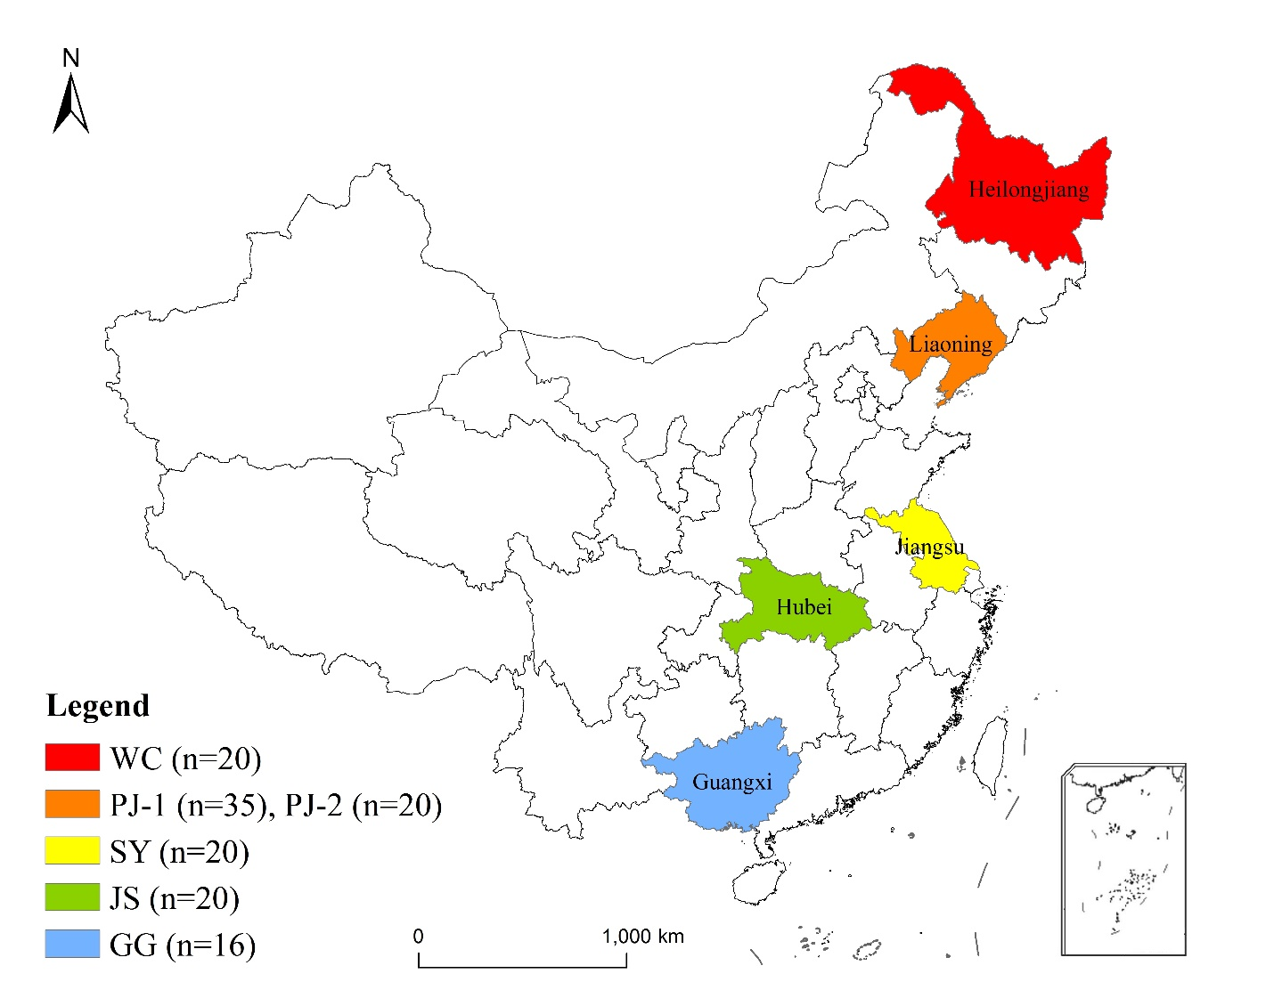

Fig.1. Geographical information of GI rice samples collected from different regions of China with corresponding sample size.

(a)

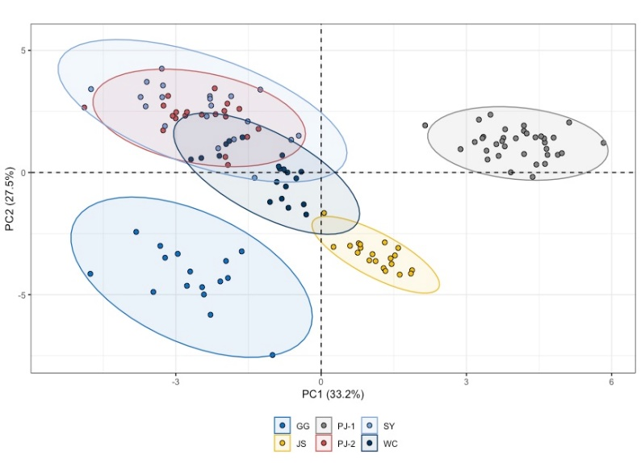

(b)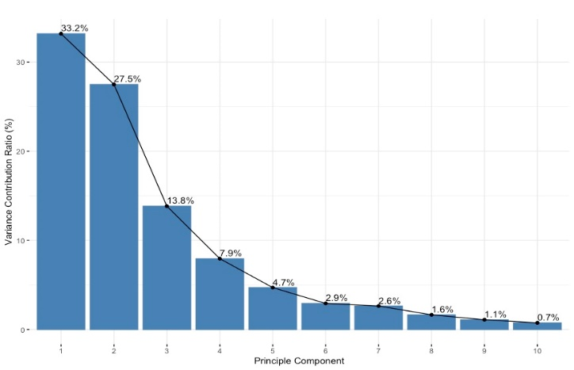(c)

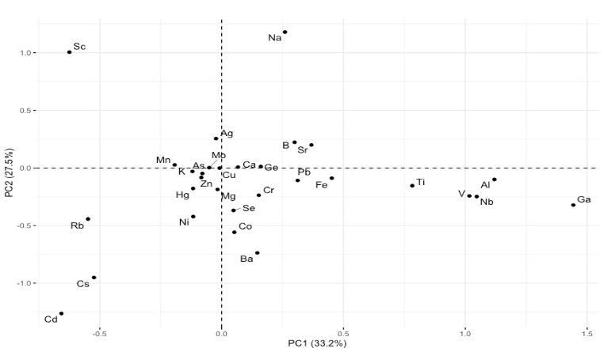

Fig.2.PCA on elemental concentration based on 30 variables in six GI rice: (a) Score plot of PC1 and PC2, with 95% confidence interval eclipse; (b) Distribution of variance contribution ratio of first ten PC (c) Loading plot of all variables on first two PCs.

Fig. 3. Relative variable importance based on Relief algorithm.

Fig. 4. 10-fold grid-search results for finding the optimal classifiers. Both classifiers could reach 100% accuracy during the training process with only top 4 features selected. The best RF classifier has hyperparameters of max_depth equals 37, max_features set to ‘auto’ and n_estimators equals 200. The best SVM classifier has ‘rbf’ kernel with C value of 1 and gamma value of 0.1.

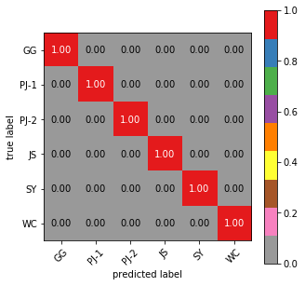

Figure 5: confusion matrix of the optimal classifier (TBD).

Table 2: accuracy and Kappa achieved of the 2 optimal classifiers on test set.

|  |  |  |  |
| --- | --- | --- | --- |
| Method | Number of variables selected | Accuracy | Kappa |
| ReliefF + SVM | 4 | 1 | 1 |
| ReliefF + RF | 4 | 1 | 1 |
|  |  |  |  |

Table 1. The concentrations of 30 elements in six GI rice.

|  |  |  |  |  |  |  |  |
| --- | --- | --- | --- | --- | --- | --- | --- |
| Type of GI Rice | | | | | | |  |
|  |
| Element | GG (n=16) | JS (n=20) | PJ-1（n=35） | PJ-2 (n=20) | WC (n=20) | SY (n=20) | p value |
|
| 10B (ng/kg) | 392.50 ± 41.03a | 302.00 ± 36.18c | 727.39 ± 75.75a | 425.56 ± 49.09b | 320.33 ± 28.38c | 440.56 ± 50.61b | 0.000 |
| 23Na (mg/kg) | 2.08 ± 0.19de | 1.18 ± 0.12e | 14.25 ± 6.41b | 6.00 ± 0.63c | 5.30 ± 0.59cd | 20.00 ± 3.14a | 0.000 |
| 24Mg (mg/kg) | 257.01 ± 20.61a | 254.94 ± 16.05a | 187.29 ± 22.75b | 187.41 ± 13.29b | 183.24 ± 13.86b | 185.46 ± 22.02b | 0.000 |
| 27Al (ng/kg) | 403.07 ± 79.75c | 1483.52 ± 213.89b | 2361.21 ± 785.19a | 326.91 ± 62.13c | 526.28 ± 125.48c | 402.23 ± 78.87c | 0.000 |
| 39K (mg/kg) | 961.45 ± 65.69b | 770.48 ± 44.69d | 723.98 ± 75.70de | 702.17 ± 45.36e | 842.62 ± 45.82c | 1053.24 ± 104.88a | 0.000 |
| 43Ca (mg/kg) | 63.14 ± 6.30a | 43.81 ± 2.36c | 63.56 ± 7.03a | 55.93 ± 3.27b | 56.81 ± 3.34b | 46.44 ± 3.57c | 0.000 |
| 45Sc (ng/kg) | 0.07 ± 0.08bc | 0.10 ± 0.07b | 0.23 ± 0.16a | 0.01 ± 0.02c | 0.07 ± 0.08bc | 0.02 ± 0.03bc | 0.000 |
| 48Ti (ng/kg) | 38.74 ± 19.18bc | 48.22 ± 11.75b | 89.01 ± 26.74a | 19.67 ± 6.75d | 31.07 ± 8.17cd | 23.68 ± 8.12cd | 0.000 |
| 51V (ng/kg) | 1.01 ± 0.26cd | 2.58 ± 0.33b | 3.71 ± 0.75a | 0.54 ± 0.12e | 1.19 ± 0.30c | 0.71 ± 0.19de | 0.000 |
| 52Cr (ng/kg) | 15.97 ± 6.26b | 33.49 ± 37.03a | 15.73 ± 7.38b | 11.48 ± 2.64b | 10.89 ± 3.75b | 16.75 ± 5.28b | 0.000 |
| 55Mn (mg/kg) | 9.91 ± 0.99b | 5.15 ± 0.49e | 7.03 ± 0.80d | 8.71 ± 0.75c | 13.53 ± 0.85a | 7.45 ± 0.68d | 0.000 |
| 56Fe (mg/kg) | 2.66 ± 0.57b | 2.62 ± 0.42b | 4.06 ± 0.85a | 1.53 ± 0.12d | 1.53 ± 0.13d | 2.05 ± 0.23c | 0.000 |
| 59Co (ng/kg) | 8.09 ± 1.15a | 5.24 ± 0.66b | 3.26 ± 0.49c | 2.01 ± 0.30e | 2.81 ± 0.75cd | 2.53 ± 0.42de | 0.000 |
| 60Ni (ng/kg) | 243.99 ± 57.89a | 190.93 ± 28.04b | 101.99 ± 21.33d | 83.60 ± 21.27d | 130.23 ± 36.40c | 148.014 ± 29.83c | 0.000 |
| 65Cu (mg/kg) | 2.42 ± 0.30a | 1.83 ± 0.14c | 2.13 ± 0.24b | 1.74 ± 0.15c | 1.71 ± 0.14c | 2.57 ± 0.24a | 0.000 |
| 66Zn (mg/kg) | 14.66 ± 1.29a | 11.12 ± 0.64bc | 10.58 ± 0.98c | 11.57 ± 0.86b | 11.23 ± 0.59bc | 11.49 ± 0.81b | 0.000 |
| 70Ga (ng/kg) | 0.22 ± 0.08c | 0.56 ± 0.15b | 1.20 ± 0.60a | 0.10 ± 0.05c | 0.31 ± 0.12bc | 0.11 ± 0.08c | 0.000 |
| 73Ge (ng/kg) | 1.59 ± 0.22b | 1.67 ± 0.23b | 2.11 ± 0.41a | 2.14 ± 0.44a | 1.56 ± 0.29b | 1.15 ± 0.25c | 0.000 |
| 75As (ng/kg) | 103.78 ± 12.31b | 110.52 ± 8.72b | 90.78 ± 7.79c | 125.56 ± 16.05a | 114.63 ± 18.40ab | 88.45 ± 11.13c | 0.000 |
| 78Se (ng/kg) | 48.60 ± 12.10a | 53.51 ± 17.15a | 32.01 ± 9.86b | 34.20 ± 9.90b | 28.09 ± 9.17bc | 20.32 ± 9.24c | 0.000 |
| 85Rb (ng/kg) | 2219.95 ± 537.81a | 1424.81 ± 111.55b | 533.78 ± 91.24d | 1022.20 ± 180.70c | 2143.93 ± 173.53a | 1210.34 ± 301.79bc | 0.000 |
| 86Sr (ng/kg) | 67.66 ± 13.59cd | 57.78 ± 5.18d | 145.15 ± 23.96a | 97.90 ± 6.72b | 75.87 ± 6.75c | 56.64 ± 5.37d | 0.000 |
| 93Nb (ng/kg) | 0.08 ± 0.04c | 0.13 ± 0.03b | 0.24 ± 0.07a | 0.03 ± 0.01c | 0.06 ± 0.02c | 0.04 ± 0.01c | 0.000 |
| 98Mo (ng/kg) | 445.78 ± 71.50a | 318.88 ± 32.38d | 378.99 ± 34.02bc | 344.26 ± 28.46cd | 412.87 ± 59.05ab | 427.95 ± 40.65a | 0.000 |
| 107Ag (ng/kg) | 2.24 ± 0.36a | 0.48 ± 0.14d | 1.91 ± 0.39b | 1.29 ± 0.26c | 1.39 ± 0.23c | 1.78 ± 0.24b | 0.000 |
| 114Cd (ng/kg) | 228.36 ± 37.34a | 43.63 ± 11.93b | 9.03 ± 3.95c | 10.53 ± 3.82c | 16.70 ± 6.91c | 18.68 ± 4.85c | 0.000 |
| 133Cs (ng/kg) | 18.76 ± 22.87a | 1.68 ± 0.18b | 0.83 ± 0.15b | 1.06 ± 0.23b | 2.05 ± 0.35b | 1.07 ± 0.28b | 0.000 |
| 138Ba (ng/kg) | 181.91 ± 26.94a | 158.70 ± 17.87b | 74.31 ± 34.07c | 73.29 ± 10.79cd | 54.73 ± 10.15d | 25.10 ± 4.44e | 0.000 |
| 201Hg (ng/kg) | 3.24 ± 1.00a | 1.32 ± 0.23c | 1.64 ± 0.30c | 1.48 ± 0.36c | 2.23 ± 0.86b | 1.64 ± 0.42c | 0.000 |
| 208Pb (ng/kg) | 15.02 ± 9.85a | 10.61 ± 7.98a | 15.83 ± 8.60a | 10.93 ± 9.37a | 8.23 ± 12.03a | 11.52 ± 10.91a | 0.084 |
| Note: small letters represent significant difference at p=0.05 confident level. | | | | |  |  |  |

Table S1. Recoveries of elements in SRM (1568b)

|  |  |
| --- | --- |
| Element in SRM | Recovery (%) |
| 24 Mg | 94.70 % |
| 27 Al | 97.42 % |
| 39 K | 99.23 % |
| 44 Ca | 101.87 % |
| 55 Mn | 91.84 % |
| 56 Fe | 98.58 % |
| 63 Cu | 95.75 % |
| 66 Zn | 85.50 % |
| 75 As | 102.34 % |
| 78 Se | 95.53 % |
| 95 Mo | 89.67 % |
| 111 Cd | 80.80 % |