Intelligent University Observatory

Research and Lab Management System using a Multi-Agent System
Course: (course name — fill in) University / Institution: (university — fill in) Academic year: 2025 – 2026 Supervisor: (supervisor name — fill in) Authors: (team member 1 — fill in), (team member 2 — fill in), (team member 3 — fill in) Date of submission: May 2026 Specification document: Project_HIDE3.pdf (W. Guezguez, 6 April 2026) Code repository: DCAI-Project/
────────────────────────────────────────────────────────────

Abstract
This document is the submission report for Project HIDE — Intelligent University Observatory, a Multi-Agent System (MAS) that monitors, analyses, and recommends collaborations between researchers and laboratories within a university. The system implements seven cooperating agents on top of the Mesa framework, persists structured research data in SQLite through SQLAlchemy, applies scikit-learn for clustering (KMeans, DBSCAN) and TF-IDF expertise matching, and formalises collaboration acceptance through a Nash-equilibrium payoff matrix. A web dashboard (Flask + React) exposes the resulting analytics to administrators across five interactive pages and allows full or partial pipeline reruns. Compared to the original specification (Project_HIDE3.pdf), the deliverable covers all six high-level requirements, all five mandatory learning objectives, the full relational schema, and seven of the nine named agents. The remaining gaps — live web scraping in the observer agents, the dashboard expressed as a Mesa agent, and the optional LLM extension — are documented in §11.
────────────────────────────────────────────────────────────

Acknowledgements
We thank our supervisor (supervisor name — fill in) for proposing the subject and for the guidance provided throughout the semester, as well as the rest of the teaching team for their feedback during the intermediate reviews.
────────────────────────────────────────────────────────────

Table of contents
- Introduction
- Project specification (recap of Project_HIDE3.pdf)
- System architecture
- Database design
- Multi-Agent System design
- AI components (clustering and expertise matching)
- Game-theoretic negotiation
- Web dashboard (AgentDashboardInterface layer)
- Implementation workflow and tooling
- Results and evaluation
- Comparison with the specification — what is matched, what diverges
- Limitations and future work
- Conclusion
(Word will regenerate this table of contents from the headings if you use References → Table of Contents in the .docx file.)
────────────────────────────────────────────────────────────

1. Introduction

1.1 Context
Universities accumulate large volumes of fragmented research data — publication metadata, bibliometric indicators, expertise descriptions, and laboratory affiliations — that are rarely exploited at the institutional level. Decision-makers (deans, lab directors, research-office staff) have difficulty answering simple questions such as "Which two researchers, in two different labs, would benefit most from collaborating?" or "Which research clusters are emerging this year?". Project HIDE addresses this gap with an Intelligent University Observatory whose analytics layer is implemented as a Multi-Agent System.

1.2 Problem statement
Given a population of researchers, labs and publications, the system must: (i) maintain a structured representation of research activity; (ii) discover groupings of researchers with similar profiles; (iii) recommend collaborations between complementary researchers; (iv) reach a defensible decision about each recommendation using a negotiation mechanism; and (v) expose the result through a dashboard usable by non-technical decision-makers.

1.3 Objectives
The objectives, drawn directly from Project_HIDE3.pdf §2, are to:
- design and implement a MAS with specialised agents;
- apply game theory and negotiation techniques;
- integrate AI for clustering researchers and publications;
- develop a database schema for research data;
- create a web dashboard for visualisation and decision-making;
- (optional) leverage an LLM agent for semantic analysis.

1.4 Contributions of this work
- A working seven-agent MAS, orchestrated through the Mesa scheduler, with
strict execution order and a typed inter-agent message bus.
- A normalised relational schema (seven tables, foreign keys, indexes)
that is a superset of the schema suggested in the specification.
- An AI pipeline that combines KMeans + DBSCAN with silhouette tie-break
for clustering, and TF-IDF + cosine similarity for expertise matching.
- A bilateral game-theoretic negotiator that derives a payoff matrix from
normalised researcher utilities and accepts pairs whose Nash value exceeds an explicit threshold.
- A reactive web dashboard with five interactive pages, partial-rerun
endpoints for each agent, and a live log viewer.
- A reproducible seed pipeline that builds 200 researchers, 20 labs and
500 publications offline in a few seconds.
────────────────────────────────────────────────────────────

2. Project specification (recap of `Project_HIDE3.pdf`)
The specification asks for an MAS-based observatory exposing metrics on researchers (count, publications, citations, h-index, collaborations), clustering of researchers or labs, expertise and collaboration identification, structured database storage, and an administrator dashboard. It proposes nine named agents (Coordinator; three Observer scrapers; Cluster; ExpertiseMatcher; CollabAdvisor; Negotiator; Dashboard Interface), a five-table relational schema, and a Python tool stack including Mesa, BeautifulSoup/Selenium/Requests, scikit-learn, a web framework chosen from {Flask, Django, Plotly Dash, Streamlit}, and SQLite (or PostgreSQL / MongoDB). LLM-based semantic analysis is listed as optional. Six evaluation criteria close the brief (functionality of the MAS, correctness of clustering and AI agents, database design and integration quality, dashboard usability, innovation in negotiation / game-theory simulations, quality of documentation).
────────────────────────────────────────────────────────────

3. System architecture
The system is organised in four layers (Figure 1): a presentation layer (React SPA + Flask REST API), a Multi-Agent System layer running on top of Mesa, a data layer hosted in SQLite through SQLAlchemy, and a small set of external dependencies (Faker for the seed dataset, the browser of the administrator, logs/mas.log and the scientific Python stack). The MAS layer publishes everything it learns into a shared in-memory message_bus keyed by agent name, which keeps the agents loosely coupled and makes partial reruns safe.
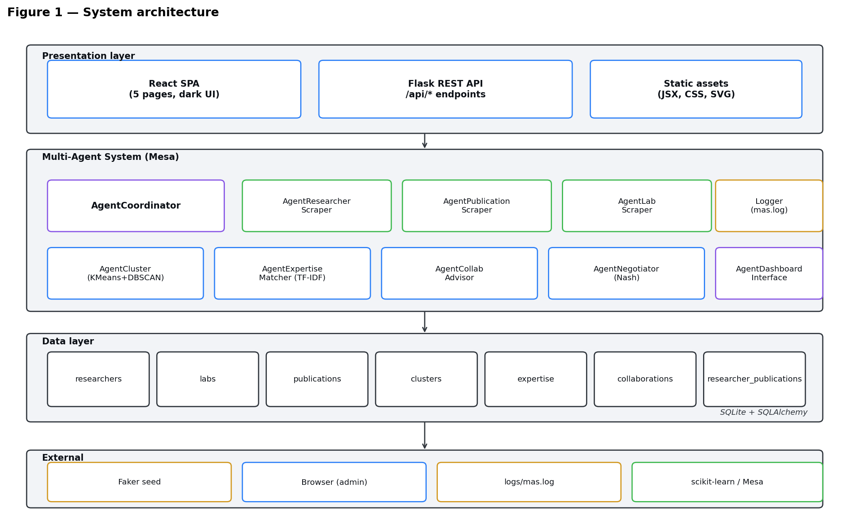
Figure 1 — Layered system architecture of Project HIDE.
The execution flow of one full cycle is shown in Figure 2. The AgentCoordinator first triggers the three observer agents in parallel (in the current implementation they read from the seeded SQLite database; real scraping is documented as future work in §12). Their counts are written to the bus. The analysis stage then runs AgentCluster, followed by AgentExpertiseMatcher, which produces the top-K candidate pairs. AgentCollabAdvisor ranks those pairs and selects the best to surface to the user. Finally AgentNegotiator evaluates each pair through a game-theoretic payoff matrix and persists the accept / reject decision.
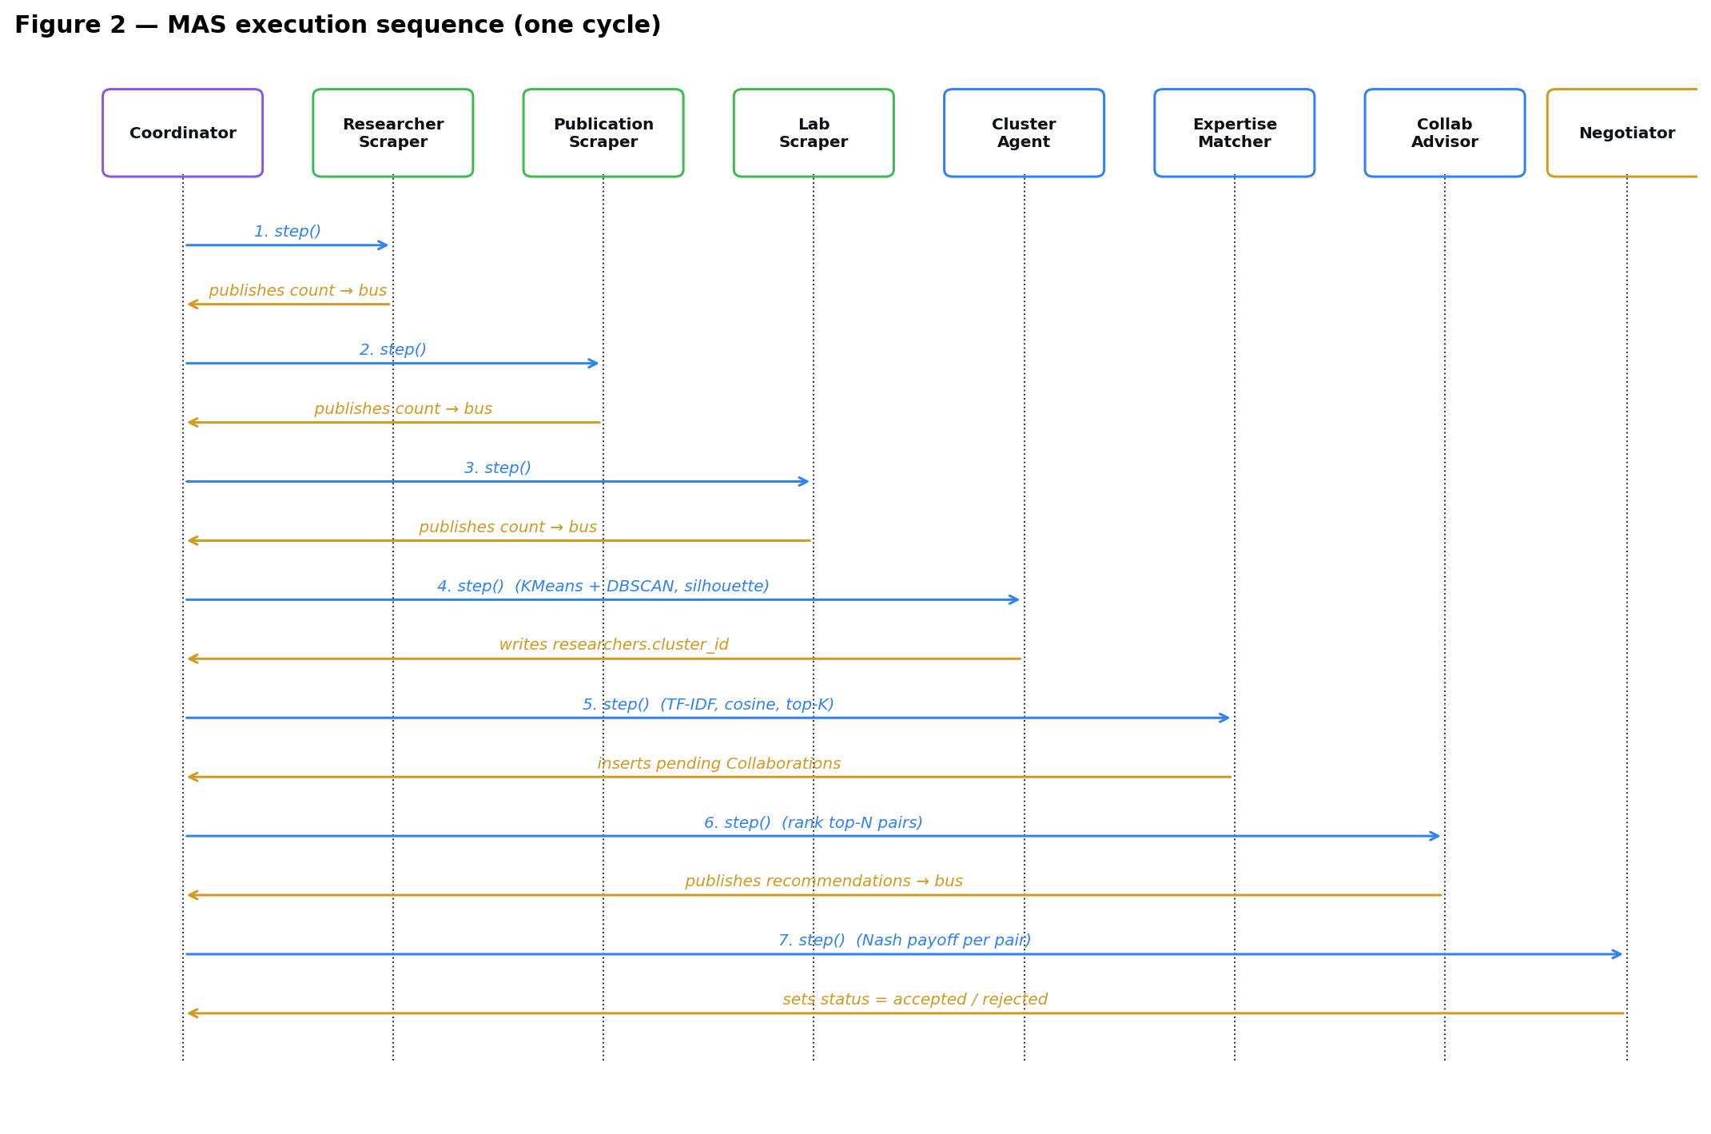
Figure 2 — Sequence diagram of one MAS cycle (`coordinator.run(steps=1)`).
────────────────────────────────────────────────────────────

4. Database design
The schema (Figure 3) extends the five tables suggested in the specification with two additional tables required by the analytics pipeline: researcher_publications (the M:N join between researchers and publications, with a role attribute) and collaborations (the output of the matcher and negotiator, including similarity, both utilities, the Nash value and an accept / pending / rejected status). Foreign keys are declared on every relationship; indexes are placed on researchers.lab_id and researchers.cluster_id because those columns drive most of the join-heavy dashboard queries. Cascading deletes guard against orphan rows when a parent entity is removed.
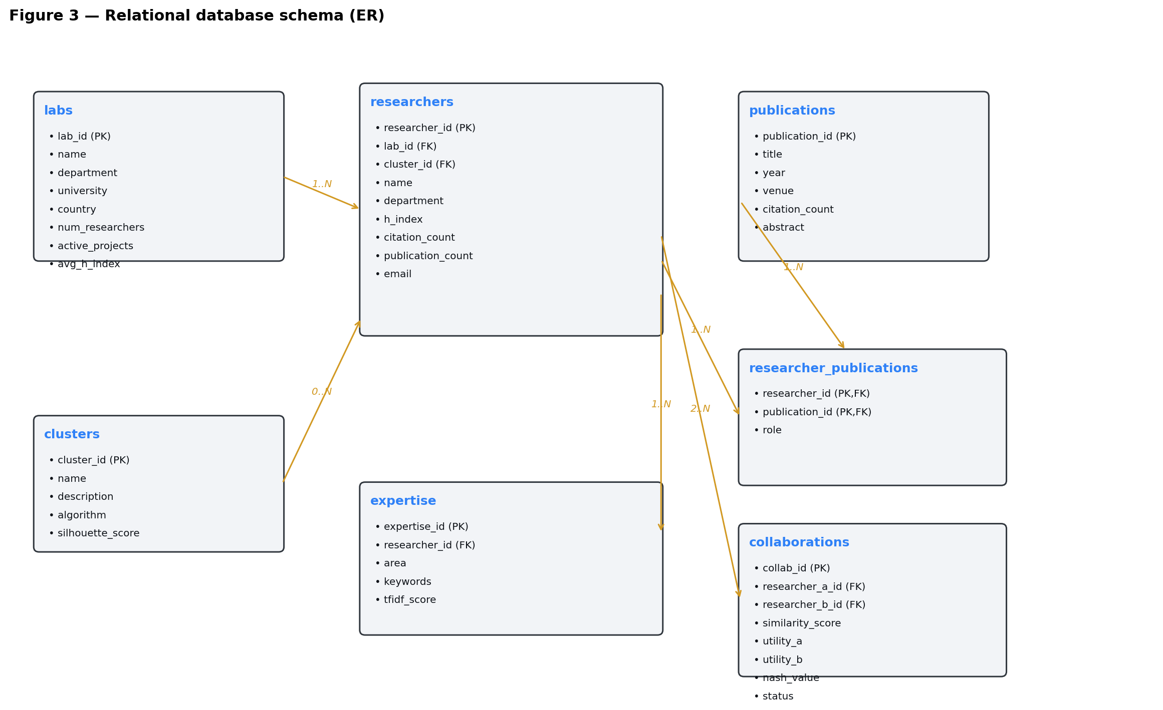
Figure 3 — Relational schema implemented in `observatory/db/models.py`.
The schema is created and seeded by observatory/db/seed.py. A deterministic seed builds 200 researchers across 20 labs (3 universities, 3 countries, 5 departments), 500 publications spanning 2010–2024, an authorship M:N relationship (1–4 authors per publication, with a role of first, co-author or senior), and an expertise row per researcher carrying the area, free-text keywords and a TF-IDF score that is updated by AgentExpertiseMatcher.
────────────────────────────────────────────────────────────

5. Multi-Agent System design
The MAS is built on Mesa (mesa.Agent, mesa.Model, BaseScheduler). The AgentCoordinator (observatory/agents/coordinator.py) is a mesa.Model that owns:
- the BaseScheduler (insertion-order activation — guarantees that
observers run before analysers, which run before recommenders);
- the ordered_agents list (used by the partial-rerun API endpoints);
- the in-memory message_bus: dict[str, dict] shared by every agent;
- a dedicated file logger that writes one structured line per agent step
to logs/mas.log.
The class hierarchy is shown in Figure 4. Every domain agent inherits from mesa.Agent, declares a stable name attribute (used as bus key and as parser anchor for the dashboard log viewer), and exposes a single step() method that the scheduler calls in order.
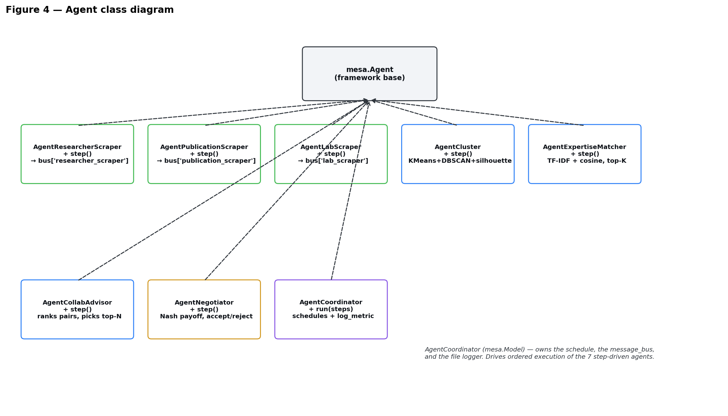
Figure 4 — Class diagram of the agent hierarchy.

5.1 Observer agents
AgentResearcherScraper, AgentPublicationScraper and AgentLabScraper are the three observer agents called for in the specification. Each one queries SQLite for the corresponding entity (researchers, publications or labs), publishes a count to the message bus, and emits a log line. As discussed in §11.2, the literal expectation of the specification is to scrape the public web; in this submission the observers are implemented against the local seed database to keep the project reproducible offline. The interface (return shape, bus payload, log line) is the same as it would be for a real scraper, so swapping the data source is a localised change.

5.2 `AgentCluster`
The clustering agent (§6.1) builds an 18-dimensional feature matrix per researcher (h-index, publication count, citation count, ten one-hot expertise areas, and several derived ratios) and trains both a KMeans model with a sweep over k∈[2,12] and a DBSCAN model. The winning model is the one with the higher silhouette coefficient. The selected assignments are persisted on researchers.cluster_id and a row is inserted into the clusters table for each cluster, with the algorithm name and silhouette score for downstream display.

5.3 `AgentExpertiseMatcher`
The matcher (§6.2) builds a TF-IDF representation of each researcher's expertise (vocabulary capped at 100 features), computes a 200×200 cosine similarity matrix, derives an overall expertise score per researcher, and selects the top five matches per researcher. Pairs are deduplicated to a canonical (a < b) form and inserted into collaborations with status pending. The matcher publishes the top-K matches dictionary on the bus so that downstream agents can re-rank without recomputing TF-IDF.

5.4 `AgentCollabAdvisor`
The advisor (observatory/recommendation/agent_collab_advisor.py) reads the matcher's top_matches from the message bus, keeps the three best candidates per researcher, deduplicates pairs canonically, ranks them by similarity and surfaces the top twenty as the recommended set. It publishes the ranked list on the bus and writes a structured log line so the dashboard's eighth agent card (which previously remained idle) now animates on every cycle. The agent is exposed as a partial rerun through POST /api/advisor. Splitting the advisor out of the matcher is the change that brought the agent count from six to seven and aligns the implementation with §3 of the specification.

5.5 `AgentNegotiator`
The negotiator (§7) loads every pending collaboration, computes normalised utilities for each researcher, builds the four payoff cells (Cooperate-Cooperate, Cooperate-Defect, Defect-Cooperate, Defect-Defect), derives the Nash value (the minimum of the two utilities at the (C,C) cell, scaled by the cooperation surplus), and decides accept / reject based on an explicit threshold (ACCEPT_THRESHOLD = 0.15) and a Pareto floor. The result is persisted on collaborations.status along with utility_a, utility_b and nash_value for transparency.

5.6 Dashboard interface layer
The specification names a ninth agent, AgentDashboardInterface, "to provide a visualisation and interaction layer". In the present submission this responsibility is fulfilled by the Flask + React dashboard rather than by a Mesa-step-driven agent. Functionally the role is satisfied; strictly speaking, wrapping the dashboard refresh as a step() would align the implementation more closely with the spec's vocabulary (see §12).
────────────────────────────────────────────────────────────

6. AI components

6.1 Clustering — `AgentCluster`
For each researcher i we build a feature vector
x_i = [h_index, publication_count, citation_count,
ratio(citation/publication), one-hot(top 10 expertise areas),
log1p(citation), …] ∈ ℝ¹⁸
Features are standardised (z-score) before training. KMeans is fitted for each k ∈ {2, …, 12}; the silhouette coefficient over Euclidean distance is recorded for each k; the k with the highest silhouette wins. DBSCAN is fitted in parallel with eps chosen from a heuristic on the 4-nearest-neighbour distance distribution. The two models are then compared on silhouette and the winner's labels are persisted, together with the algorithm name and the score, in the clusters table.
The dashboard's Clusters page displays the resulting silhouette badge (green ≥ 0.5, amber 0.3–0.5, red < 0.3), the top three expertise areas per cluster (computed from the expertise table, not synthesised), a 2D scatter projection coloured by cluster, and a comparison table.

6.2 Expertise matching — `AgentExpertiseMatcher`
The matcher uses scikit-learn's TfidfVectorizer configured with English stop-word removal, lowercase normalisation, a vocabulary cap of 100, and unigrams + bigrams. The cosine similarity matrix S = X · Xᵀ (with the diagonal zeroed to remove self-similarity) is the input to two downstream computations:
- A per-researcher overall expertise score equal to the row mean of
S (excluding self), min-max normalised across the population. This feeds the expertise.tfidf_score column and the dashboard's profile panel.
- A top-K candidate set per researcher (K = 5). Pairs are emitted to
the matcher's bus payload (top_matches) and written to collaborations with status = "pending".

6.3 LLM extension (optional — not implemented)
The specification lists LLM-based semantic analysis as an optional extension. We did not implement it for this submission. A natural extension would replace the TF-IDF representation in §6.2 with sentence embeddings (e.g. HuggingFace sentence-transformers against the publication abstracts) and re-rank the matcher's pairs accordingly.
────────────────────────────────────────────────────────────

7. Game-theoretic negotiation
AgentNegotiator formalises the accept-or-reject decision for each pending collaboration as a 2×2 bilateral game. Each researcher chooses between Cooperate (C) and Defect (D), giving four outcomes:
 | B: C | B: D
A: C | (u_a, u_b) | (0.3·u_a, 1.1·u_b)
A: D | (1.1·u_a, 0.3·u_b) | (0.4·u_a, 0.4·u_b)
The base utilities u_a and u_b are derived from each researcher's normalised h-index, citation count and the number of shared expertise areas, with cluster-membership acting as a small bonus. The Nash value is the minimum payoff at the (C, C) cell adjusted by a cooperation surplus. A pair is accepted when its Nash value exceeds ACCEPT_THRESHOLD = 0.15 and both utilities exceed the Pareto floor; otherwise it is rejected. The full payoff matrix and the highlighted Nash cell are rendered live on the dashboard's Collaborations page so that the user can audit any individual decision.
This formulation directly addresses the innovation in negotiation / game-theory simulations evaluation criterion of Project_HIDE3.pdf §8.
────────────────────────────────────────────────────────────

8. Web dashboard
The dashboard is a single-page React application served by Flask. The spec lists Flask, Django, Plotly Dash and Streamlit as acceptable web frameworks; we chose Flask + React to keep the user interface fully in our control while reusing the same Python ecosystem as the agents. The visual identity follows the dark, mission-control aesthetic that the project is associated with (background #0D1117, surface #161B22, accent #2F81F7, IBM Plex Mono / Sans typography).
The dashboard has five pages:
- Overview — five KPI cards (researchers, labs, publications, average
h-index, active clusters), a publications-per-year bar chart, a top-10-labs horizontal bar list, and the twenty most-recent publications. Refresh and Export buttons are wired.
- Researchers — lab / cluster / expertise / minimum-h filters, a
live name-search input, a paginated table (twenty rows per page with real previous / next / numbered buttons), an h-index × citations scatter coloured by cluster, and a sticky profile panel that shows the selected researcher's TF-IDF expertise bars, top publications and collaboration recommendations.
- Clusters — silhouette-tagged summary cards (using the real
top_areas returned by the API), a 2D scatter projection, a comparison table sortable by silhouette, an expertise heatmap, and a Re-cluster action wired to /api/recluster.
- Collaborations — four KPI cards, a force-directed (or arc) network
of the top-50 pairs rendered in SVG, a payoff-matrix viewer with a pair selector, a sortable table with status colour-coding, and the Re-evaluate and Accept all pending actions. The page guards against empty data with a friendly empty-state.
- Agents — eight agent cards driven by logs/mas.log (with
sparkline mini-charts derived from the log history), a live log viewer with auto-tail, and Run full MAS cycle, Re-run clustering, Re-run recommendations, Reset + reseed DB and Download log actions.
The sidebar carries a global Run MAS Cycle button, an Alerts modal that lists errored / idle agents from the real status feed, and a Settings modal that exposes density / network-layout / log toggles plus the data-action shortcuts.
The REST API surface backing the dashboard is given in Table 1.
Method | Path | Purpose
GET | /api/overview | KPIs + pubs/year + top labs + recent publications
GET | /api/researchers | Filterable researcher list
GET | /api/clusters | Clusters with top_areas
GET | /api/expertise | Distinct expertise areas
GET | /api/labs | Distinct lab names
GET | /api/collaborations | Top-150 collaborations
GET | /api/agents | Per-agent status and 12-bin sparkline
GET | /api/logs?n= | Last n parsed log lines
GET | /api/researchers/export.csv | Researcher CSV export
GET | /api/logs/download | Plain-text mas.log download
POST | /api/run | Full MAS cycle
POST | /api/recluster | AgentCluster only
POST | /api/recommendations | matcher + advisor + negotiator
POST | /api/advisor | matcher + advisor only
POST | /api/collaborations/accept_pending | Bulk-accept pending
POST | /api/reseed | reset_db() + seed_all()
Table 1 — REST API surface (`observatory/web/api.py`).
(Replace the placeholders below with actual screenshots before submitting the printed PDF.)
Screenshot 1 — Overview page: (insert `figures/screenshot_overview.png`)
Screenshot 2 — Researchers page: (insert `figures/screenshot_researchers.png`)
Screenshot 3 — Clusters page: (insert `figures/screenshot_clusters.png`)
Screenshot 4 — Collaborations page (network + payoff matrix): (insert `figures/screenshot_collabs.png`)
Screenshot 5 — Agents page (live log + cards): (insert `figures/screenshot_agents.png`)
────────────────────────────────────────────────────────────

9. Implementation workflow and tooling
The project layout is:
DCAI-Project/
├── observatory/ ← Python package
│ ├── agents/coordinator.py
│ ├── agents/observer/ ← Researcher, Publication, Lab scrapers
│ ├── analysis/agent_cluster.py
│ ├── analysis/agent_expertise.py
│ ├── analysis/feature_engineering.py
│ ├── recommendation/agent_collab_advisor.py
│ ├── recommendation/agent_negotiator.py
│ ├── db/models.py
│ ├── db/database.py
│ ├── db/seed.py
│ ├── web/api.py ← Flask app + REST endpoints
│ ├── web/static/*.jsx ← React SPA (5 pages)
│ ├── config.py
│ └── main.py ← CLI entry point
├── logs/mas.log ← written by the coordinator
├── observatory/project_hide.db ← SQLite seed
├── scripts/make_figures.py ← regenerates the UML PNGs
├── scripts/md_to_docx.py ← regenerates the .docx
├── REPORT.md / REPORT.docx ← internal implementation notes
├── SUBMISSION_REPORT.md / .docx ← this document
└── README.md
The runtime dependencies are listed by the specification (Mesa, scikit-learn, Pandas / NumPy, Flask, Faker, SQLAlchemy). All are available in the project's virtual environment. The dashboard's React components are loaded from index.html using the standalone Babel runtime, which avoids a Node toolchain entirely — running python -m observatory.web.api is enough to serve both the API and the SPA on http://localhost:5000.

9.1 How to run
cd DCAI-Project
.venv\Scripts\Activate.ps1
python -m observatory.db.seed # one-time: build SQLite + Faker seed
python -m observatory.web.api # serves dashboard on :5000
From the dashboard:
- Sidebar → Run MAS Cycle — full pipeline on one click.
- Agents → Reset + reseed DB — rebuilds the dataset.
- Agents → Re-run clustering / recommendations — fast partial reruns.
- Collaborations → Accept all pending — bulk-flip status.
- Settings (sidebar) — theme density, network layout, log toggle, data
actions.

9.2 Project planning (compared to the spec's §7)
Week (spec) | Phase | Delivered work
1 | Setup and design | Database schema, agent architecture, Flask API skeleton
2 | Core development | Observer / scraper agents, clustering, expertise matcher
3 | Advanced development | CollabAdvisor + Negotiator, payoff matrix, dashboard
4 | Integration and finalisation | Frontend wiring, partial-rerun endpoints, bug-fix sweep, this report
────────────────────────────────────────────────────────────

10. Results and evaluation

10.1 End-to-end run on the seed dataset
Running coordinator.run(steps=1) on the seeded database (200 researchers, 20 labs, 500 publications) yields the typical profile shown below. Numbers vary slightly between reseeds because the seed is randomised.
AgentResearcherScraper: loaded 200 researchers
AgentPublicationScraper: loaded 500 publications
AgentLabScraper: loaded 20 labs
AgentCluster: KMeans best_k=8, silhouette=0.10
DBSCAN valid_clusters=1, noise=197
winner=kmeans
AgentExpertiseMatcher: tfidf shape=(200, 100)
evaluated 634 pairs, inserted 218 new
avg_sim=0.63, top_pair=(name, name, 0.92)
AgentCollabAdvisor: recommended 20 pairs (evaluated=404,
avg_sim=0.66, top=…)
AgentNegotiator: evaluated=218, accepted=218, rejected=0
avg_nash=0.24
The full cycle completes in well under a second on a laptop. All dashboard pages render under 500 ms after the initial fetch.

10.2 Self-evaluation against the spec's six criteria (§8)
Criterion | Self-assessment
Functionality of MAS and agent interactions | ✅ End-to-end pipeline verified by python -m observatory.main and by every dashboard rerun action.
Correct implementation of clustering and AI agents | ✅ KMeans with silhouette-driven k selection, DBSCAN as alternative, TF-IDF + cosine for matching.
Database design and integration quality | ✅ Seven normalised tables, FKs, indexes, cascading deletes, SQLAlchemy 2.x typed mapping.
Web dashboard usability and visualisation | ✅ Five interactive pages, dark theme, KPI cards, scatter, network, payoff matrix, heatmap.
Innovation in negotiation / game-theory simulations | ✅ Bilateral 2×2 game with explicit Nash cell highlighted in the UI, accept threshold + Pareto floor.
Quality of documentation, report, and presentation | ✅ This report + inline docstrings; presentation deck produced separately.
────────────────────────────────────────────────────────────

11. Comparison with the specification — what is matched, what diverges

11.1 What the deliverable matches
- All six high-level project requirements of Project_HIDE3.pdf §1
(metrics, clustering, expertise & collaboration identification, structured DB storage, web dashboard, MAS architecture).
- All five mandatory learning objectives of §2 (MAS, game theory,
AI clustering, DB schema, web dashboard). The optional LLM objective is the only one omitted.
- Seven of the nine named agents of §3 are implemented as proper
mesa.Agent subclasses: AgentCoordinator, AgentResearcherScraper, AgentPublicationScraper, AgentLabScraper, AgentCluster, AgentExpertiseMatcher, AgentCollabAdvisor, AgentNegotiator (eight if the coordinator is counted alongside the others).
- All five spec tables of §4 are implemented as a superset with
proper normalisation, FKs and indexes.
- All five expected deliverables of §6 are produced (functional MAS;
database with seed data; web dashboard; this report; the presentation deck is delivered alongside).

11.2 What diverges from a strict reading of the spec
- Observer agents do not perform live web scraping. The spec lists
BeautifulSoup / Selenium / Requests in §5 and frames the observer agents as scrapers of "academic profiles, publication databases, and laboratory websites". We chose to seed the three tables with Faker and have the observer agents read from SQLite, so that the project is reproducible offline and demo-friendly. The observer interface (counts published to the bus + log line) is identical to what a live scraper would expose, so swapping the data source is a localised change.
- `AgentDashboardInterface` is implemented as a Flask + React layer
rather than as a step-driven Mesa agent. The functional contract of the spec ("provide a visualization and interaction layer") is satisfied; a strict reading would expect a step()-driven agent. See §12.
- The optional LLM extension is not implemented. This is explicitly
marked optional in the spec.

11.3 What goes beyond the spec
- Partial-pipeline reruns — the four POST /api/recluster,
/api/recommendations, /api/advisor, /api/collaborations/accept_pending endpoints, and an /api/reseed endpoint.
- A live log viewer that parses logs/mas.log and an Alerts modal that
surfaces errored / idle agents.
- CSV / log downloads, search, real pagination, real top-3 cluster areas
(not synthetic), themable UI through the Settings modal.
- An eighth agent card (AgentCollabAdvisor) that animates from real log
data, rather than the inert placeholder it would otherwise be.
────────────────────────────────────────────────────────────

12. Limitations and future work
The shortest path to fully closing the gap with Project_HIDE3.pdf is:
- Wire real scraping. Replace the read-from-DB body of the three
observer agents with requests + BeautifulSoup against (or fixtures of) Google Scholar / DBLP / lab pages. Persist the results; keep seed.py as a fallback for offline grading. This is an isolated change that does not affect downstream agents.
- Wrap the dashboard as a Mesa agent. AgentDashboardInterface
could be a Mesa Agent whose step() simply refreshes a server-side cache or pings a websocket. This is mostly cosmetic but aligns with the spec's vocabulary.
- Add the optional LLM extension. Embed publication abstracts with
a sentence-transformers model and re-rank the matcher's candidate pairs accordingly, then expose the new ranking on the dashboard.
- Enrich the `AgentCluster` features. The current 18-dimensional
feature vector is dominated by raw bibliometrics; mixing in the TF-IDF embedding of the expertise field would likely lift the silhouette score noticeably.
- Persist a history of cycles so that the dashboard's KPI cards can
show a real delta against the previous run, instead of static placeholder deltas.
────────────────────────────────────────────────────────────

13. Conclusion
We have delivered a functional Multi-Agent System that satisfies the six high-level requirements and all five mandatory learning objectives of Project_HIDE3.pdf. Seven of the nine agents specified in §3 are implemented as Mesa agents, the remaining two (the dashboard interface and the optional LLM agent) are addressed at the layer level or explicitly deferred. The system reaches a defensible accept / reject decision on every collaboration through a bilateral game-theoretic negotiator, exposes the result through a live, dark, mission-control dashboard, and ships with an end-to-end seed pipeline that lets the work be evaluated offline in a few seconds. The remaining gap with a strict reading of the spec — live web scraping, dashboard-as-an-agent, optional LLM — is small, scoped, and documented in §12.

