Hibernate: create table product (id bigint generated by default as identity, product_name varchar(255), units_in_stock integer, primary key (id))
Hibernate: insert into product (id, product_name, units_in_stock) values (default, ?, ?)
Hibernate: values identity_val_local()
Hibernate: select product0_.id as id1_0_, product0_.product_name as product_2_0_, product0_.units_in_stock as units_in3_0_ from product product0_
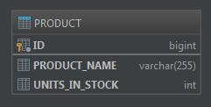


@ManyToOne
private Supplier isSuppliedBy;
Hibernate: create table product (id bigint generated by default as identity, product_name varchar(255), units_in_stock integer, is_supplied_by_id bigint, primary key (id))
Hibernate: create table supplier (id bigint generated by default as identity, city varchar(255), company_name varchar(255), street varchar(255), primary key (id))
Hibernate: alter table product add constraint FKlwhrb09ktake3x7tkh6dpoehp foreign key (is_supplied_by_id) references supplier
Hibernate: insert into supplier (id, city, company_name, street) values (default, ?, ?, ?)
Hibernate: values identity_val_local()
Hibernate: insert into product (id, is_supplied_by_id, product_name, units_in_stock) values (default, ?, ?, ?)
Hibernate: values identity_val_local()
Hibernate: select product0_.id as id1_0_, product0_.is_supplied_by_id as is_suppl4_0_, product0_.product_name as product_2_0_, product0_.units_in_stock as units_in3_0_ from product product0_
Hibernate: select supplier0_.id as id1_1_0_, supplier0_.city as city2_1_0_, supplier0_.company_name as company_3_1_0_, supplier0_.street as street4_1_0_ from supplier supplier0_ where supplier0_.id=?
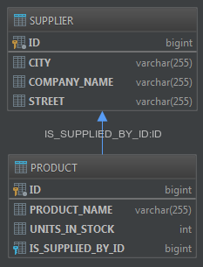


Z TABELĄ ŁĄCZNIKOWĄ

@OneToMany(fetch = FetchType.EAGER)
private Set<Product> supplies;
Hibernate: create table product (id bigint generated by default as identity, product_name varchar(255), units_in_stock integer, primary key (id))
Hibernate: create table supplier (id bigint generated by default as identity, city varchar(255), company_name varchar(255), street varchar(255), primary key (id))
Hibernate: create table supplier_supplies (supplier_id bigint not null, supplies_id bigint not null, primary key (supplier_id, supplies_id))
Hibernate: alter table supplier_supplies add constraint UK_vqhko40rvv86jdltmht15xg0 unique (supplies_id)
Hibernate: alter table supplier_supplies add constraint FK3k7hv4mxebktlptdmv9542thn foreign key (supplies_id) references product
Hibernate: alter table supplier_supplies add constraint FKpctl5ya92hopaffb2mg3atatk foreign key (supplier_id) references supplier
Hibernate: insert into supplier (id, city, company_name, street) values (default, ?, ?, ?)
Hibernate: values identity_val_local()
Hibernate: insert into product (id, product_name, units_in_stock) values (default, ?, ?)
Hibernate: values identity_val_local()
Hibernate: select supplier0_.id as id1_1_0_, supplier0_.city as city2_1_0_, supplier0_.company_name as company_3_1_0_, supplier0_.street as street4_1_0_ from supplier supplier0_ where supplier0_.id=?
Hibernate: select supplies0_.supplier_id as supplier1_2_0_, supplies0_.supplies_id as supplies2_2_0_, product1_.id as id1_0_1_, product1_.product_name as product_2_0_1_, product1_.units_in_stock as units_in3_0_1_ from supplier_supplies supplies0_ inner join product product1_ on supplies0_.supplies_id=product1_.id where supplies0_.supplier_id=?
Hibernate: select product0_.id as id1_0_0_, product0_.product_name as product_2_0_0_, product0_.units_in_stock as units_in3_0_0_ from product product0_ where product0_.id=?
Hibernate: insert into supplier_supplies (supplier_id, supplies_id) values (?, ?)
Hibernate: select supplier0_.id as id1_1_, supplier0_.city as city2_1_, supplier0_.company_name as company_3_1_, supplier0_.street as street4_1_ from supplier supplier0_
Hibernate: select supplies0_.supplier_id as supplier1_2_0_, supplies0_.supplies_id as supplies2_2_0_, product1_.id as id1_0_1_, product1_.product_name as product_2_0_1_, product1_.units_in_stock as units_in3_0_1_ from supplier_supplies supplies0_ inner join product product1_ on supplies0_.supplies_id=product1_.id where supplies0_.supplier_id=?
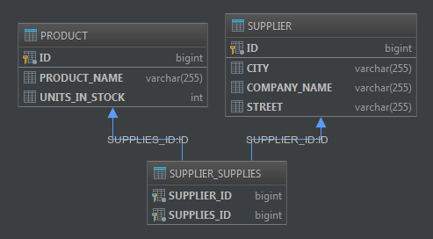

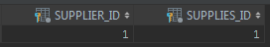
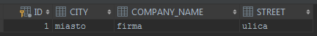

BEZ TABELI ŁĄCZNIKOWEJ

@OneToMany(fetch = FetchType.EAGER)
@JoinColumn(name="SUPPLIER")
private Set<Product> supplies;
Hibernate: create table product (id bigint generated by default as identity, product_name varchar(255), units_in_stock integer, supplier bigint, primary key (id))
Hibernate: create table supplier (id bigint generated by default as identity, city varchar(255), company_name varchar(255), street varchar(255), primary key (id))
Hibernate: alter table product add constraint FKhk956bj7gcdn9e2paefdt5spw foreign key (supplier) references supplier
Hibernate: insert into supplier (id, city, company_name, street) values (default, ?, ?, ?)
Hibernate: values identity_val_local()
Hibernate: insert into product (id, product_name, units_in_stock) values (default, ?, ?)
Hibernate: values identity_val_local()
Hibernate: select supplier0_.id as id1_1_0_, supplier0_.city as city2_1_0_, supplier0_.company_name as company_3_1_0_, supplier0_.street as street4_1_0_ from supplier supplier0_ where supplier0_.id=?
Hibernate: select supplies0_.supplier as supplier4_0_0_, supplies0_.id as id1_0_0_, supplies0_.id as id1_0_1_, supplies0_.product_name as product_2_0_1_, supplies0_.units_in_stock as units_in3_0_1_ from product supplies0_ where supplies0_.supplier=?
Hibernate: select product0_.id as id1_0_0_, product0_.product_name as product_2_0_0_, product0_.units_in_stock as units_in3_0_0_ from product product0_ where product0_.id=?
Hibernate: update product set supplier=? where id=?
Hibernate: select supplier0_.id as id1_1_, supplier0_.city as city2_1_, supplier0_.company_name as company_3_1_, supplier0_.street as street4_1_ from supplier supplier0_
Hibernate: select supplies0_.supplier as supplier4_0_0_, supplies0_.id as id1_0_0_, supplies0_.id as id1_0_1_, supplies0_.product_name as product_2_0_1_, supplies0_.units_in_stock as units_in3_0_1_ from product supplies0_ where supplies0_.supplier=?
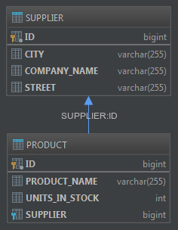
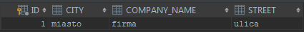

W OBIE STRONY
ZAROWNO TABELA ŁĄCZNIKOWA JAK I BEZPOŚREDNI ODNOŚNIK

@ManyToOne
private Supplier isSuppliedBy;

@OneToMany(fetch = FetchType.EAGER)
private Set<Product> supplies;
Hibernate: create table product (id bigint generated by default as identity, product_name varchar(255), units_in_stock integer, is_supplied_by_id bigint, primary key (id))
Hibernate: create table supplier (id bigint generated by default as identity, city varchar(255), company_name varchar(255), street varchar(255), primary key (id))
Hibernate: create table supplier_supplies (supplier_id bigint not null, supplies_id bigint not null, primary key (supplier_id, supplies_id))
Hibernate: alter table supplier_supplies add constraint UK_vqhko40rvv86jdltmht15xg0 unique (supplies_id)
Hibernate: alter table product add constraint FKlwhrb09ktake3x7tkh6dpoehp foreign key (is_supplied_by_id) references supplier
Hibernate: alter table supplier_supplies add constraint FK3k7hv4mxebktlptdmv9542thn foreign key (supplies_id) references product
Hibernate: alter table supplier_supplies add constraint FKpctl5ya92hopaffb2mg3atatk foreign key (supplier_id) references supplier
Hibernate: insert into supplier (id, city, company_name, street) values (default, ?, ?, ?)
Hibernate: values identity_val_local()
Hibernate: insert into product (id, is_supplied_by_id, product_name, units_in_stock) values (default, ?, ?, ?)
Hibernate: values identity_val_local()
Hibernate: select supplier0_.id as id1_1_0_, supplier0_.city as city2_1_0_, supplier0_.company_name as company_3_1_0_, supplier0_.street as street4_1_0_ from supplier supplier0_ where supplier0_.id=?
Hibernate: select supplies0_.supplier_id as supplier1_2_0_, supplies0_.supplies_id as supplies2_2_0_, product1_.id as id1_0_1_, product1_.is_supplied_by_id as is_suppl4_0_1_, product1_.product_name as product_2_0_1_, product1_.units_in_stock as units_in3_0_1_, supplier2_.id as id1_1_2_, supplier2_.city as city2_1_2_, supplier2_.company_name as company_3_1_2_, supplier2_.street as street4_1_2_ from supplier_supplies supplies0_ inner join product product1_ on supplies0_.supplies_id=product1_.id left outer join supplier supplier2_ on product1_.is_supplied_by_id=supplier2_.id where supplies0_.supplier_id=?
Hibernate: select product0_.id as id1_0_0_, product0_.is_supplied_by_id as is_suppl4_0_0_, product0_.product_name as product_2_0_0_, product0_.units_in_stock as units_in3_0_0_, supplier1_.id as id1_1_1_, supplier1_.city as city2_1_1_, supplier1_.company_name as company_3_1_1_, supplier1_.street as street4_1_1_, supplies2_.supplier_id as supplier1_2_2_, product3_.id as supplies2_2_2_, product3_.id as id1_0_3_, product3_.is_supplied_by_id as is_suppl4_0_3_, product3_.product_name as product_2_0_3_, product3_.units_in_stock as units_in3_0_3_ from product product0_ left outer join supplier supplier1_ on product0_.is_supplied_by_id=supplier1_.id left outer join supplier_supplies supplies2_ on supplier1_.id=supplies2_.supplier_id left outer join product product3_ on supplies2_.supplies_id=product3_.id where product0_.id=?
Hibernate: insert into supplier_supplies (supplier_id, supplies_id) values (?, ?)
Hibernate: select product0_.id as id1_0_, product0_.is_supplied_by_id as is_suppl4_0_, product0_.product_name as product_2_0_, product0_.units_in_stock as units_in3_0_ from product product0_
Hibernate: select supplier0_.id as id1_1_0_, supplier0_.city as city2_1_0_, supplier0_.company_name as company_3_1_0_, supplier0_.street as street4_1_0_, supplies1_.supplier_id as supplier1_2_1_, product2_.id as supplies2_2_1_, product2_.id as id1_0_2_, product2_.is_supplied_by_id as is_suppl4_0_2_, product2_.product_name as product_2_0_2_, product2_.units_in_stock as units_in3_0_2_, supplier3_.id as id1_1_3_, supplier3_.city as city2_1_3_, supplier3_.company_name as company_3_1_3_, supplier3_.street as street4_1_3_ from supplier supplier0_ left outer join supplier_supplies supplies1_ on supplier0_.id=supplies1_.supplier_id left outer join product product2_ on supplies1_.supplies_id=product2_.id left outer join supplier supplier3_ on product2_.is_supplied_by_id=supplier3_.id where supplier0_.id=?
Hibernate: select supplier0_.id as id1_1_, supplier0_.city as city2_1_, supplier0_.company_name as company_3_1_, supplier0_.street as street4_1_ from supplier supplier0_
Hibernate: select supplies0_.supplier_id as supplier1_2_0_, supplies0_.supplies_id as supplies2_2_0_, product1_.id as id1_0_1_, product1_.is_supplied_by_id as is_suppl4_0_1_, product1_.product_name as product_2_0_1_, product1_.units_in_stock as units_in3_0_1_, supplier2_.id as id1_1_2_, supplier2_.city as city2_1_2_, supplier2_.company_name as company_3_1_2_, supplier2_.street as street4_1_2_ from supplier_supplies supplies0_ inner join product product1_ on supplies0_.supplies_id=product1_.id left outer join supplier supplier2_ on product1_.is_supplied_by_id=supplier2_.id where supplies0_.supplier_id=?
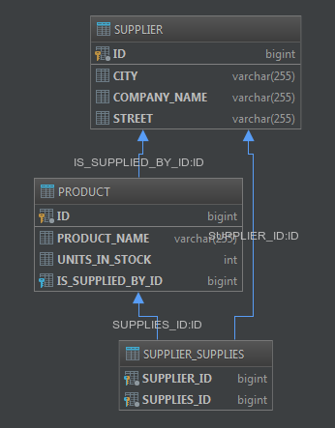
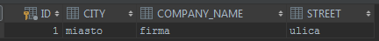
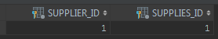

W OBIE STRONY
BEZ TABELI ŁĄCZNIKOWEJ

@ManyToOne
private Supplier isSuppliedBy;

@OneToMany(fetch = FetchType.EAGER, mappedBy = "isSuppliedBy")
private Set<Product> supplies;
Hibernate: create table product (id bigint generated by default as identity, product_name varchar(255), units_in_stock integer, is_supplied_by_id bigint, primary key (id))
Hibernate: create table supplier (id bigint generated by default as identity, city varchar(255), company_name varchar(255), street varchar(255), primary key (id))
Hibernate: alter table product add constraint FKlwhrb09ktake3x7tkh6dpoehp foreign key (is_supplied_by_id) references supplier
Hibernate: insert into supplier (id, city, company_name, street) values (default, ?, ?, ?)
Hibernate: values identity_val_local()
Hibernate: insert into product (id, is_supplied_by_id, product_name, units_in_stock) values (default, ?, ?, ?)
Hibernate: values identity_val_local()
Hibernate: select supplier0_.id as id1_1_0_, supplier0_.city as city2_1_0_, supplier0_.company_name as company_3_1_0_, supplier0_.street as street4_1_0_ from supplier supplier0_ where supplier0_.id=?
Hibernate: select supplies0_.is_supplied_by_id as is_suppl4_0_0_, supplies0_.id as id1_0_0_, supplies0_.id as id1_0_1_, supplies0_.is_supplied_by_id as is_suppl4_0_1_, supplies0_.product_name as product_2_0_1_, supplies0_.units_in_stock as units_in3_0_1_ from product supplies0_ where supplies0_.is_supplied_by_id=?
Hibernate: select product0_.id as id1_0_, product0_.is_supplied_by_id as is_suppl4_0_, product0_.product_name as product_2_0_, product0_.units_in_stock as units_in3_0_ from product product0_
Hibernate: select supplier0_.id as id1_1_0_, supplier0_.city as city2_1_0_, supplier0_.company_name as company_3_1_0_, supplier0_.street as street4_1_0_, supplies1_.is_supplied_by_id as is_suppl4_0_1_, supplies1_.id as id1_0_1_, supplies1_.id as id1_0_2_, supplies1_.is_supplied_by_id as is_suppl4_0_2_, supplies1_.product_name as product_2_0_2_, supplies1_.units_in_stock as units_in3_0_2_ from supplier supplier0_ left outer join product supplies1_ on supplier0_.id=supplies1_.is_supplied_by_id where supplier0_.id=?
Hibernate: select supplier0_.id as id1_1_, supplier0_.city as city2_1_, supplier0_.company_name as company_3_1_, supplier0_.street as street4_1_ from supplier supplier0_
Hibernate: select supplies0_.is_supplied_by_id as is_suppl4_0_0_, supplies0_.id as id1_0_0_, supplies0_.id as id1_0_1_, supplies0_.is_supplied_by_id as is_suppl4_0_1_, supplies0_.product_name as product_2_0_1_, supplies0_.units_in_stock as units_in3_0_1_ from product supplies0_ where supplies0_.is_supplied_by_id=?
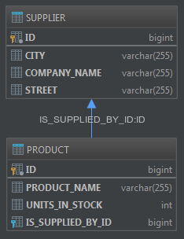
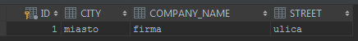

CATEGORIE

@OneToMany(fetch = FetchType.EAGER, mappedBy = "category")
private Set<Product> products;

@ManyToOne
private Category category;

Hibernate: create table category (id bigint generated by default as identity, category_name varchar(255), primary key (id))
Hibernate: create table product (id bigint generated by default as identity, product_name varchar(255), units_in_stock integer, is_supplied_by_id bigint, category bigint, primary key (id))
Hibernate: create table supplier (id bigint generated by default as identity, city varchar(255), company_name varchar(255), street varchar(255), primary key (id))
Hibernate: alter table product add constraint FKlwhrb09ktake3x7tkh6dpoehp foreign key (is_supplied_by_id) references supplier
Hibernate: alter table product add constraint FKqx9wikktsev17ctu0kcpkrafc foreign key (category) references category
Hibernate: insert into supplier (id, city, company_name, street) values (default, ?, ?, ?)
Hibernate: values identity_val_local()
Hibernate: insert into product (id, is_supplied_by_id, product_name, units_in_stock) values (default, ?, ?, ?)
Hibernate: values identity_val_local()
Hibernate: insert into product (id, is_supplied_by_id, product_name, units_in_stock) values (default, ?, ?, ?)
Hibernate: values identity_val_local()
Hibernate: select supplier0_.id as id1_2_0_, supplier0_.city as city2_2_0_, supplier0_.company_name as company_3_2_0_, supplier0_.street as street4_2_0_ from supplier supplier0_ where supplier0_.id=?
Hibernate: select supplies0_.is_supplied_by_id as is_suppl4_1_0_, supplies0_.id as id1_1_0_, supplies0_.id as id1_1_1_, supplies0_.is_supplied_by_id as is_suppl4_1_1_, supplies0_.product_name as product_2_1_1_, supplies0_.units_in_stock as units_in3_1_1_ from product supplies0_ where supplies0_.is_supplied_by_id=?
Hibernate: insert into category (id, category_name) values (default, ?)
Hibernate: values identity_val_local()
Hibernate: update product set category=? where id=?
Hibernate: update product set category=? where id=?
Hibernate: select product0_.id as id1_1_, product0_.is_supplied_by_id as is_suppl4_1_, product0_.product_name as product_2_1_, product0_.units_in_stock as units_in3_1_ from product product0_
Hibernate: select supplier0_.id as id1_2_0_, supplier0_.city as city2_2_0_, supplier0_.company_name as company_3_2_0_, supplier0_.street as street4_2_0_, supplies1_.is_supplied_by_id as is_suppl4_1_1_, supplies1_.id as id1_1_1_, supplies1_.id as id1_1_2_, supplies1_.is_supplied_by_id as is_suppl4_1_2_, supplies1_.product_name as product_2_1_2_, supplies1_.units_in_stock as units_in3_1_2_ from supplier supplier0_ left outer join product supplies1_ on supplier0_.id=supplies1_.is_supplied_by_id where supplier0_.id=?
Hibernate: select supplier0_.id as id1_2_, supplier0_.city as city2_2_, supplier0_.company_name as company_3_2_, supplier0_.street as street4_2_ from supplier supplier0_
Hibernate: select supplies0_.is_supplied_by_id as is_suppl4_1_0_, supplies0_.id as id1_1_0_, supplies0_.id as id1_1_1_, supplies0_.is_supplied_by_id as is_suppl4_1_1_, supplies0_.product_name as product_2_1_1_, supplies0_.units_in_stock as units_in3_1_1_ from product supplies0_ where supplies0_.is_supplied_by_id=?
Hibernate: select category0_.id as id1_0_, category0_.category_name as category2_0_ from category category0_
Hibernate: select products0_.category as category5_1_0_, products0_.id as id1_1_0_, products0_.id as id1_1_1_, products0_.is_supplied_by_id as is_suppl4_1_1_, products0_.product_name as product_2_1_1_, products0_.units_in_stock as units_in3_1_1_, supplier1_.id as id1_2_2_, supplier1_.city as city2_2_2_, supplier1_.company_name as company_3_2_2_, supplier1_.street as street4_2_2_ from product products0_ left outer join supplier supplier1_ on products0_.is_supplied_by_id=supplier1_.id where products0_.category=?
Hibernate: select supplies0_.is_supplied_by_id as is_suppl4_1_0_, supplies0_.id as id1_1_0_, supplies0_.id as id1_1_1_, supplies0_.is_supplied_by_id as is_suppl4_1_1_, supplies0_.product_name as product_2_1_1_, supplies0_.units_in_stock as units_in3_1_1_ from product supplies0_ where supplies0_.is_supplied_by_id=?
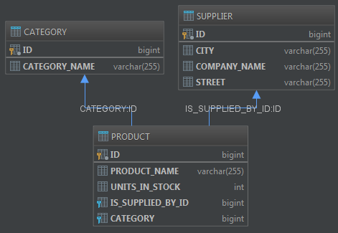

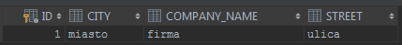

PÓŹNIEJ PROBLEMY Z NAZWĄ TABELI TRANSACTION

PO ZAJĘCIACH

TRANSAKCJE

@ManyToMany(fetch = FetchType.EAGER)
private Set<Product> sales;

@ManyToMany(fetch = FetchType.EAGER, mappedBy = "sales")
private Set<BusinessTransaction> canBeSoldOn;
Hibernate: create table business_transaction (id bigint generated by default as identity, primary key (id))
Hibernate: create table business_transaction_sales (can_be_sold_on_id bigint not null, sales_id bigint not null, primary key (can_be_sold_on_id, sales_id))
Hibernate: create table category (id bigint generated by default as identity, category_name varchar(255), primary key (id))
Hibernate: create table product (id bigint generated by default as identity, product_name varchar(255), units_in_stock integer, is_supplied_by_id bigint, category bigint, primary key (id))
Hibernate: create table supplier (id bigint generated by default as identity, city varchar(255), company_name varchar(255), street varchar(255), primary key (id))
Hibernate: alter table business_transaction_sales add constraint FKoar2gh2emo3vnly2lmen7jfdx foreign key (sales_id) references product
Hibernate: alter table business_transaction_sales add constraint FKbcly7l6bvddri645pjvcc5bs5 foreign key (can_be_sold_on_id) references business_transaction
Hibernate: alter table product add constraint FKlwhrb09ktake3x7tkh6dpoehp foreign key (is_supplied_by_id) references supplier
Hibernate: alter table product add constraint FKqx9wikktsev17ctu0kcpkrafc foreign key (category) references category
Hibernate: insert into supplier (id, city, company_name, street) values (default, ?, ?, ?)
Hibernate: values identity_val_local()
Hibernate: insert into product (id, is_supplied_by_id, product_name, units_in_stock) values (default, ?, ?, ?)
Hibernate: values identity_val_local()
Hibernate: insert into product (id, is_supplied_by_id, product_name, units_in_stock) values (default, ?, ?, ?)
Hibernate: values identity_val_local()
Hibernate: insert into category (id, category_name) values (default, ?)
Hibernate: values identity_val_local()
Hibernate: update product set category=? where id=?
Hibernate: update product set category=? where id=?
Hibernate: insert into business_transaction (id) values (default)
Hibernate: values identity_val_local()
Hibernate: insert into business_transaction_sales (can_be_sold_on_id, sales_id) values (?, ?)
Hibernate: insert into business_transaction_sales (can_be_sold_on_id, sales_id) values (?, ?)
Hibernate: insert into business_transaction (id) values (default)
Hibernate: values identity_val_local()
Hibernate: insert into business_transaction_sales (can_be_sold_on_id, sales_id) values (?, ?)
Hibernate: insert into business_transaction_sales (can_be_sold_on_id, sales_id) values (?, ?)
Hibernate: select businesstr0_.id as id1_0_ from business_transaction businesstr0_
Hibernate: select sales0_.can_be_sold_on_id as can_be_s1_1_0_, sales0_.sales_id as sales_id2_1_0_, product1_.id as id1_3_1_, product1_.is_supplied_by_id as is_suppl4_3_1_, product1_.product_name as product_2_3_1_, product1_.units_in_stock as units_in3_3_1_, supplier2_.id as id1_4_2_, supplier2_.city as city2_4_2_, supplier2_.company_name as company_3_4_2_, supplier2_.street as street4_4_2_ from business_transaction_sales sales0_ inner join product product1_ on sales0_.sales_id=product1_.id left outer join supplier supplier2_ on product1_.is_supplied_by_id=supplier2_.id where sales0_.can_be_sold_on_id=?
Hibernate: select canbesoldo0_.sales_id as sales_id2_1_0_, canbesoldo0_.can_be_sold_on_id as can_be_s1_1_0_, businesstr1_.id as id1_0_1_ from business_transaction_sales canbesoldo0_ inner join business_transaction businesstr1_ on canbesoldo0_.can_be_sold_on_id=businesstr1_.id where canbesoldo0_.sales_id=?
Hibernate: select sales0_.can_be_sold_on_id as can_be_s1_1_0_, sales0_.sales_id as sales_id2_1_0_, product1_.id as id1_3_1_, product1_.is_supplied_by_id as is_suppl4_3_1_, product1_.product_name as product_2_3_1_, product1_.units_in_stock as units_in3_3_1_, supplier2_.id as id1_4_2_, supplier2_.city as city2_4_2_, supplier2_.company_name as company_3_4_2_, supplier2_.street as street4_4_2_ from business_transaction_sales sales0_ inner join product product1_ on sales0_.sales_id=product1_.id left outer join supplier supplier2_ on product1_.is_supplied_by_id=supplier2_.id where sales0_.can_be_sold_on_id=?
Hibernate: select supplies0_.is_supplied_by_id as is_suppl4_3_0_, supplies0_.id as id1_3_0_, supplies0_.id as id1_3_1_, supplies0_.is_supplied_by_id as is_suppl4_3_1_, supplies0_.product_name as product_2_3_1_, supplies0_.units_in_stock as units_in3_3_1_ from product supplies0_ where supplies0_.is_supplied_by_id=?
Hibernate: select canbesoldo0_.sales_id as sales_id2_1_0_, canbesoldo0_.can_be_sold_on_id as can_be_s1_1_0_, businesstr1_.id as id1_0_1_ from business_transaction_sales canbesoldo0_ inner join business_transaction businesstr1_ on canbesoldo0_.can_be_sold_on_id=businesstr1_.id where canbesoldo0_.sales_id=?
1 sales woda
1 sales szafa
2 sales woda
2 sales szafa
Hibernate: select product0_.id as id1_3_, product0_.is_supplied_by_id as is_suppl4_3_, product0_.product_name as product_2_3_, product0_.units_in_stock as units_in3_3_ from product product0_
Hibernate: select supplier0_.id as id1_4_0_, supplier0_.city as city2_4_0_, supplier0_.company_name as company_3_4_0_, supplier0_.street as street4_4_0_, supplies1_.is_supplied_by_id as is_suppl4_3_1_, supplies1_.id as id1_3_1_, supplies1_.id as id1_3_2_, supplies1_.is_supplied_by_id as is_suppl4_3_2_, supplies1_.product_name as product_2_3_2_, supplies1_.units_in_stock as units_in3_3_2_, canbesoldo2_.sales_id as sales_id2_1_3_, businesstr3_.id as can_be_s1_1_3_, businesstr3_.id as id1_0_4_ from supplier supplier0_ left outer join product supplies1_ on supplier0_.id=supplies1_.is_supplied_by_id left outer join business_transaction_sales canbesoldo2_ on supplies1_.id=canbesoldo2_.sales_id left outer join business_transaction businesstr3_ on canbesoldo2_.can_be_sold_on_id=businesstr3_.id where supplier0_.id=?
Hibernate: select sales0_.can_be_sold_on_id as can_be_s1_1_0_, sales0_.sales_id as sales_id2_1_0_, product1_.id as id1_3_1_, product1_.is_supplied_by_id as is_suppl4_3_1_, product1_.product_name as product_2_3_1_, product1_.units_in_stock as units_in3_3_1_, supplier2_.id as id1_4_2_, supplier2_.city as city2_4_2_, supplier2_.company_name as company_3_4_2_, supplier2_.street as street4_4_2_ from business_transaction_sales sales0_ inner join product product1_ on sales0_.sales_id=product1_.id left outer join supplier supplier2_ on product1_.is_supplied_by_id=supplier2_.id where sales0_.can_be_sold_on_id=?
Hibernate: select sales0_.can_be_sold_on_id as can_be_s1_1_0_, sales0_.sales_id as sales_id2_1_0_, product1_.id as id1_3_1_, product1_.is_supplied_by_id as is_suppl4_3_1_, product1_.product_name as product_2_3_1_, product1_.units_in_stock as units_in3_3_1_, supplier2_.id as id1_4_2_, supplier2_.city as city2_4_2_, supplier2_.company_name as company_3_4_2_, supplier2_.street as street4_4_2_ from business_transaction_sales sales0_ inner join product product1_ on sales0_.sales_id=product1_.id left outer join supplier supplier2_ on product1_.is_supplied_by_id=supplier2_.id where sales0_.can_be_sold_on_id=?
woda can be sold on 2
woda can be sold on 1
szafa can be sold on 2
szafa can be sold on 1
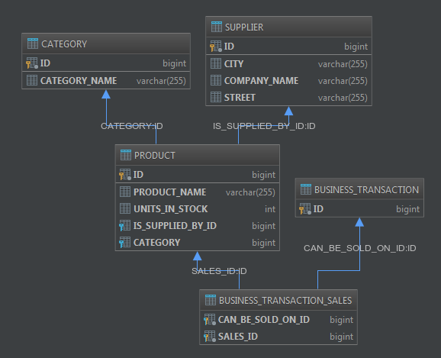
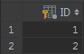
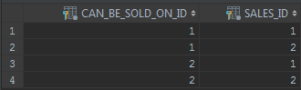

KASKADY

@ManyToMany(fetch = FetchType.EAGER, mappedBy = "sales", cascade = CascadeType.PERSIST)
private Set<BusinessTransaction> canBeSoldOn;
Hibernate: create table business_transaction (id bigint generated by default as identity, primary key (id))
Hibernate: create table business_transaction_sales (can_be_sold_on_id bigint not null, sales_id bigint not null, primary key (can_be_sold_on_id, sales_id))
Hibernate: create table category (id bigint generated by default as identity, category_name varchar(255), primary key (id))
Hibernate: create table product (id bigint generated by default as identity, product_name varchar(255), units_in_stock integer, category_id bigint, is_supplied_by_id bigint, primary key (id))
Hibernate: create table supplier (id bigint generated by default as identity, city varchar(255), company_name varchar(255), street varchar(255), primary key (id))
Hibernate: alter table business_transaction_sales add constraint FKoar2gh2emo3vnly2lmen7jfdx foreign key (sales_id) references product
Hibernate: alter table business_transaction_sales add constraint FKbcly7l6bvddri645pjvcc5bs5 foreign key (can_be_sold_on_id) references business_transaction
Hibernate: alter table product add constraint FK1mtsbur82frn64de7balymq9s foreign key (category_id) references category
Hibernate: alter table product add constraint FKlwhrb09ktake3x7tkh6dpoehp foreign key (is_supplied_by_id) references supplier
Hibernate: insert into supplier (id, city, company_name, street) values (default, ?, ?, ?)
Hibernate: values identity_val_local()
Hibernate: insert into category (id, category_name) values (default, ?)
Hibernate: values identity_val_local()
Hibernate: insert into product (id, category_id, is_supplied_by_id, product_name, units_in_stock) values (default, ?, ?, ?, ?)
Hibernate: values identity_val_local()
Hibernate: insert into product (id, category_id, is_supplied_by_id, product_name, units_in_stock) values (default, ?, ?, ?, ?)
Hibernate: values identity_val_local()
Hibernate: insert into business_transaction (id) values (default)
Hibernate: values identity_val_local()
Hibernate: insert into business_transaction_sales (can_be_sold_on_id, sales_id) values (?, ?)
Hibernate: insert into business_transaction_sales (can_be_sold_on_id, sales_id) values (?, ?)
Hibernate: insert into business_transaction (id) values (default)
Hibernate: values identity_val_local()
Hibernate: insert into business_transaction_sales (can_be_sold_on_id, sales_id) values (?, ?)
Hibernate: insert into business_transaction_sales (can_be_sold_on_id, sales_id) values (?, ?)
Hibernate: insert into category (id, category_name) values (default, ?)
Hibernate: values identity_val_local()
Hibernate: insert into product (id, category_id, is_supplied_by_id, product_name, units_in_stock) values (default, ?, ?, ?, ?)
Hibernate: values identity_val_local()
Hibernate: insert into business_transaction (id) values (default)
Hibernate: values identity_val_local()
Hibernate: insert into business_transaction_sales (can_be_sold_on_id, sales_id) values (?, ?)
Hibernate: select product0_.id as id1_3_, product0_.category_id as category4_3_, product0_.is_supplied_by_id as is_suppl5_3_, product0_.product_name as product_2_3_, product0_.units_in_stock as units_in3_3_ from product product0_
Hibernate: select category0_.id as id1_2_0_, category0_.category_name as category2_2_0_, products1_.category_id as category4_3_1_, products1_.id as id1_3_1_, products1_.id as id1_3_2_, products1_.category_id as category4_3_2_, products1_.is_supplied_by_id as is_suppl5_3_2_, products1_.product_name as product_2_3_2_, products1_.units_in_stock as units_in3_3_2_, canbesoldo2_.sales_id as sales_id2_1_3_, businesstr3_.id as can_be_s1_1_3_, businesstr3_.id as id1_0_4_, supplier4_.id as id1_4_5_, supplier4_.city as city2_4_5_, supplier4_.company_name as company_3_4_5_, supplier4_.street as street4_4_5_ from category category0_ left outer join product products1_ on category0_.id=products1_.category_id left outer join business_transaction_sales canbesoldo2_ on products1_.id=canbesoldo2_.sales_id left outer join business_transaction businesstr3_ on canbesoldo2_.can_be_sold_on_id=businesstr3_.id left outer join supplier supplier4_ on products1_.is_supplied_by_id=supplier4_.id where category0_.id=?
Hibernate: select sales0_.can_be_sold_on_id as can_be_s1_1_0_, sales0_.sales_id as sales_id2_1_0_, product1_.id as id1_3_1_, product1_.category_id as category4_3_1_, product1_.is_supplied_by_id as is_suppl5_3_1_, product1_.product_name as product_2_3_1_, product1_.units_in_stock as units_in3_3_1_, category2_.id as id1_2_2_, category2_.category_name as category2_2_2_, supplier3_.id as id1_4_3_, supplier3_.city as city2_4_3_, supplier3_.company_name as company_3_4_3_, supplier3_.street as street4_4_3_ from business_transaction_sales sales0_ inner join product product1_ on sales0_.sales_id=product1_.id left outer join category category2_ on product1_.category_id=category2_.id left outer join supplier supplier3_ on product1_.is_supplied_by_id=supplier3_.id where sales0_.can_be_sold_on_id=?
Hibernate: select sales0_.can_be_sold_on_id as can_be_s1_1_0_, sales0_.sales_id as sales_id2_1_0_, product1_.id as id1_3_1_, product1_.category_id as category4_3_1_, product1_.is_supplied_by_id as is_suppl5_3_1_, product1_.product_name as product_2_3_1_, product1_.units_in_stock as units_in3_3_1_, category2_.id as id1_2_2_, category2_.category_name as category2_2_2_, supplier3_.id as id1_4_3_, supplier3_.city as city2_4_3_, supplier3_.company_name as company_3_4_3_, supplier3_.street as street4_4_3_ from business_transaction_sales sales0_ inner join product product1_ on sales0_.sales_id=product1_.id left outer join category category2_ on product1_.category_id=category2_.id left outer join supplier supplier3_ on product1_.is_supplied_by_id=supplier3_.id where sales0_.can_be_sold_on_id=?
Hibernate: select category0_.id as id1_2_0_, category0_.category_name as category2_2_0_, products1_.category_id as category4_3_1_, products1_.id as id1_3_1_, products1_.id as id1_3_2_, products1_.category_id as category4_3_2_, products1_.is_supplied_by_id as is_suppl5_3_2_, products1_.product_name as product_2_3_2_, products1_.units_in_stock as units_in3_3_2_, canbesoldo2_.sales_id as sales_id2_1_3_, businesstr3_.id as can_be_s1_1_3_, businesstr3_.id as id1_0_4_, supplier4_.id as id1_4_5_, supplier4_.city as city2_4_5_, supplier4_.company_name as company_3_4_5_, supplier4_.street as street4_4_5_ from category category0_ left outer join product products1_ on category0_.id=products1_.category_id left outer join business_transaction_sales canbesoldo2_ on products1_.id=canbesoldo2_.sales_id left outer join business_transaction businesstr3_ on canbesoldo2_.can_be_sold_on_id=businesstr3_.id left outer join supplier supplier4_ on products1_.is_supplied_by_id=supplier4_.id where category0_.id=?
Hibernate: select sales0_.can_be_sold_on_id as can_be_s1_1_0_, sales0_.sales_id as sales_id2_1_0_, product1_.id as id1_3_1_, product1_.category_id as category4_3_1_, product1_.is_supplied_by_id as is_suppl5_3_1_, product1_.product_name as product_2_3_1_, product1_.units_in_stock as units_in3_3_1_, category2_.id as id1_2_2_, category2_.category_name as category2_2_2_, supplier3_.id as id1_4_3_, supplier3_.city as city2_4_3_, supplier3_.company_name as company_3_4_3_, supplier3_.street as street4_4_3_ from business_transaction_sales sales0_ inner join product product1_ on sales0_.sales_id=product1_.id left outer join category category2_ on product1_.category_id=category2_.id left outer join supplier supplier3_ on product1_.is_supplied_by_id=supplier3_.id where sales0_.can_be_sold_on_id=?
Hibernate: select supplies0_.is_supplied_by_id as is_suppl5_3_0_, supplies0_.id as id1_3_0_, supplies0_.id as id1_3_1_, supplies0_.category_id as category4_3_1_, supplies0_.is_supplied_by_id as is_suppl5_3_1_, supplies0_.product_name as product_2_3_1_, supplies0_.units_in_stock as units_in3_3_1_, category1_.id as id1_2_2_, category1_.category_name as category2_2_2_ from product supplies0_ left outer join category category1_ on supplies0_.category_id=category1_.id where supplies0_.is_supplied_by_id=?
woda can be sold on 2
woda can be sold on 1
szafa can be sold on 2
szafa can be sold on 1
piłka can be sold on 3
Hibernate: select businesstr0_.id as id1_0_ from business_transaction businesstr0_
Hibernate: select sales0_.can_be_sold_on_id as can_be_s1_1_0_, sales0_.sales_id as sales_id2_1_0_, product1_.id as id1_3_1_, product1_.category_id as category4_3_1_, product1_.is_supplied_by_id as is_suppl5_3_1_, product1_.product_name as product_2_3_1_, product1_.units_in_stock as units_in3_3_1_, category2_.id as id1_2_2_, category2_.category_name as category2_2_2_, supplier3_.id as id1_4_3_, supplier3_.city as city2_4_3_, supplier3_.company_name as company_3_4_3_, supplier3_.street as street4_4_3_ from business_transaction_sales sales0_ inner join product product1_ on sales0_.sales_id=product1_.id left outer join category category2_ on product1_.category_id=category2_.id left outer join supplier supplier3_ on product1_.is_supplied_by_id=supplier3_.id where sales0_.can_be_sold_on_id=?
Hibernate: select supplies0_.is_supplied_by_id as is_suppl5_3_0_, supplies0_.id as id1_3_0_, supplies0_.id as id1_3_1_, supplies0_.category_id as category4_3_1_, supplies0_.is_supplied_by_id as is_suppl5_3_1_, supplies0_.product_name as product_2_3_1_, supplies0_.units_in_stock as units_in3_3_1_, category1_.id as id1_2_2_, category1_.category_name as category2_2_2_ from product supplies0_ left outer join category category1_ on supplies0_.category_id=category1_.id where supplies0_.is_supplied_by_id=?
Hibernate: select canbesoldo0_.sales_id as sales_id2_1_0_, canbesoldo0_.can_be_sold_on_id as can_be_s1_1_0_, businesstr1_.id as id1_0_1_ from business_transaction_sales canbesoldo0_ inner join business_transaction businesstr1_ on canbesoldo0_.can_be_sold_on_id=businesstr1_.id where canbesoldo0_.sales_id=?
Hibernate: select sales0_.can_be_sold_on_id as can_be_s1_1_0_, sales0_.sales_id as sales_id2_1_0_, product1_.id as id1_3_1_, product1_.category_id as category4_3_1_, product1_.is_supplied_by_id as is_suppl5_3_1_, product1_.product_name as product_2_3_1_, product1_.units_in_stock as units_in3_3_1_, category2_.id as id1_2_2_, category2_.category_name as category2_2_2_, supplier3_.id as id1_4_3_, supplier3_.city as city2_4_3_, supplier3_.company_name as company_3_4_3_, supplier3_.street as street4_4_3_ from business_transaction_sales sales0_ inner join product product1_ on sales0_.sales_id=product1_.id left outer join category category2_ on product1_.category_id=category2_.id left outer join supplier supplier3_ on product1_.is_supplied_by_id=supplier3_.id where sales0_.can_be_sold_on_id=?
Hibernate: select sales0_.can_be_sold_on_id as can_be_s1_1_0_, sales0_.sales_id as sales_id2_1_0_, product1_.id as id1_3_1_, product1_.category_id as category4_3_1_, product1_.is_supplied_by_id as is_suppl5_3_1_, product1_.product_name as product_2_3_1_, product1_.units_in_stock as units_in3_3_1_, category2_.id as id1_2_2_, category2_.category_name as category2_2_2_, supplier3_.id as id1_4_3_, supplier3_.city as city2_4_3_, supplier3_.company_name as company_3_4_3_, supplier3_.street as street4_4_3_ from business_transaction_sales sales0_ inner join product product1_ on sales0_.sales_id=product1_.id left outer join category category2_ on product1_.category_id=category2_.id left outer join supplier supplier3_ on product1_.is_supplied_by_id=supplier3_.id where sales0_.can_be_sold_on_id=?
Hibernate: select products0_.category_id as category4_3_0_, products0_.id as id1_3_0_, products0_.id as id1_3_1_, products0_.category_id as category4_3_1_, products0_.is_supplied_by_id as is_suppl5_3_1_, products0_.product_name as product_2_3_1_, products0_.units_in_stock as units_in3_3_1_, supplier1_.id as id1_4_2_, supplier1_.city as city2_4_2_, supplier1_.company_name as company_3_4_2_, supplier1_.street as street4_4_2_ from product products0_ left outer join supplier supplier1_ on products0_.is_supplied_by_id=supplier1_.id where products0_.category_id=?
Hibernate: select canbesoldo0_.sales_id as sales_id2_1_0_, canbesoldo0_.can_be_sold_on_id as can_be_s1_1_0_, businesstr1_.id as id1_0_1_ from business_transaction_sales canbesoldo0_ inner join business_transaction businesstr1_ on canbesoldo0_.can_be_sold_on_id=businesstr1_.id where canbesoldo0_.sales_id=?
Hibernate: select products0_.category_id as category4_3_0_, products0_.id as id1_3_0_, products0_.id as id1_3_1_, products0_.category_id as category4_3_1_, products0_.is_supplied_by_id as is_suppl5_3_1_, products0_.product_name as product_2_3_1_, products0_.units_in_stock as units_in3_3_1_, supplier1_.id as id1_4_2_, supplier1_.city as city2_4_2_, supplier1_.company_name as company_3_4_2_, supplier1_.street as street4_4_2_ from product products0_ left outer join supplier supplier1_ on products0_.is_supplied_by_id=supplier1_.id where products0_.category_id=?
Hibernate: select canbesoldo0_.sales_id as sales_id2_1_0_, canbesoldo0_.can_be_sold_on_id as can_be_s1_1_0_, businesstr1_.id as id1_0_1_ from business_transaction_sales canbesoldo0_ inner join business_transaction businesstr1_ on canbesoldo0_.can_be_sold_on_id=businesstr1_.id where canbesoldo0_.sales_id=?
1 sales szafa
1 sales woda
2 sales szafa
2 sales woda
3 sales piłka
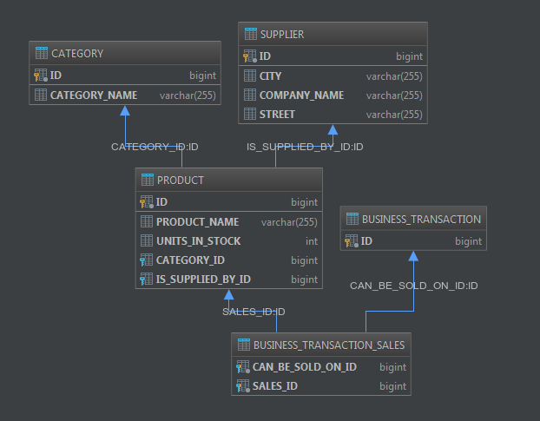
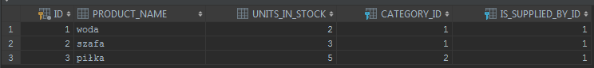
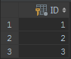
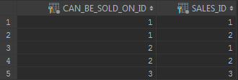

WBUDOWANY ADRES

@Data
@NoArgsConstructor
@Embeddable
public class Address {
private String street;
private String city;
}

@Embedded
private Address address;
Hibernate: create table business_transaction (id bigint generated by default as identity, primary key (id))
Hibernate: create table business_transaction_sales (can_be_sold_on_id bigint not null, sales_id bigint not null, primary key (can_be_sold_on_id, sales_id))
Hibernate: create table category (id bigint generated by default as identity, category_name varchar(255), primary key (id))
Hibernate: create table product (id bigint generated by default as identity, product_name varchar(255), units_in_stock integer, category_id bigint, is_supplied_by_id bigint, primary key (id))
Hibernate: create table supplier (id bigint generated by default as identity, city varchar(255), street varchar(255), company_name varchar(255), primary key (id))
Hibernate: alter table business_transaction_sales add constraint FKoar2gh2emo3vnly2lmen7jfdx foreign key (sales_id) references product
Hibernate: alter table business_transaction_sales add constraint FKbcly7l6bvddri645pjvcc5bs5 foreign key (can_be_sold_on_id) references business_transaction
Hibernate: alter table product add constraint FK1mtsbur82frn64de7balymq9s foreign key (category_id) references category
Hibernate: alter table product add constraint FKlwhrb09ktake3x7tkh6dpoehp foreign key (is_supplied_by_id) references supplier
Hibernate: insert into supplier (id, city, street, company_name) values (default, ?, ?, ?)
Hibernate: values identity_val_local()
Hibernate: insert into category (id, category_name) values (default, ?)
Hibernate: values identity_val_local()
Hibernate: insert into product (id, category_id, is_supplied_by_id, product_name, units_in_stock) values (default, ?, ?, ?, ?)
Hibernate: values identity_val_local()
Hibernate: insert into product (id, category_id, is_supplied_by_id, product_name, units_in_stock) values (default, ?, ?, ?, ?)
Hibernate: values identity_val_local()
Hibernate: insert into business_transaction (id) values (default)
Hibernate: values identity_val_local()
Hibernate: insert into business_transaction_sales (can_be_sold_on_id, sales_id) values (?, ?)
Hibernate: insert into business_transaction_sales (can_be_sold_on_id, sales_id) values (?, ?)
Hibernate: insert into business_transaction (id) values (default)
Hibernate: values identity_val_local()
Hibernate: insert into business_transaction_sales (can_be_sold_on_id, sales_id) values (?, ?)
Hibernate: insert into business_transaction_sales (can_be_sold_on_id, sales_id) values (?, ?)
Hibernate: insert into category (id, category_name) values (default, ?)
Hibernate: values identity_val_local()
Hibernate: insert into product (id, category_id, is_supplied_by_id, product_name, units_in_stock) values (default, ?, ?, ?, ?)
Hibernate: values identity_val_local()
Hibernate: insert into business_transaction (id) values (default)
Hibernate: values identity_val_local()
Hibernate: insert into business_transaction_sales (can_be_sold_on_id, sales_id) values (?, ?)
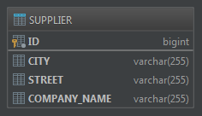


DRUGA TABELA

@SecondaryTable(name="ADDRESS_TABLE")
public class Supplier {

@Column(table = "ADDRESS_TABLE")
private String street;
@Column(table = "ADDRESS_TABLE")
private String city;
Hibernate: create table address_table (city varchar(255), street varchar(255), id bigint not null, primary key (id))
Hibernate: create table business_transaction (id bigint generated by default as identity, primary key (id))
Hibernate: create table business_transaction_sales (can_be_sold_on_id bigint not null, sales_id bigint not null, primary key (can_be_sold_on_id, sales_id))
Hibernate: create table category (id bigint generated by default as identity, category_name varchar(255), primary key (id))
Hibernate: create table product (id bigint generated by default as identity, product_name varchar(255), units_in_stock integer, category_id bigint, is_supplied_by_id bigint, primary key (id))
Hibernate: create table supplier (id bigint generated by default as identity, company_name varchar(255), primary key (id))
Hibernate: alter table address_table add constraint FK5ppcn9pvnji1lahcf2q8oai4o foreign key (id) references supplier
Hibernate: alter table business_transaction_sales add constraint FKoar2gh2emo3vnly2lmen7jfdx foreign key (sales_id) references product
Hibernate: alter table business_transaction_sales add constraint FKbcly7l6bvddri645pjvcc5bs5 foreign key (can_be_sold_on_id) references business_transaction
Hibernate: alter table product add constraint FK1mtsbur82frn64de7balymq9s foreign key (category_id) references category
Hibernate: alter table product add constraint FKlwhrb09ktake3x7tkh6dpoehp foreign key (is_supplied_by_id) references supplier
Hibernate: insert into supplier (id, company_name) values (default, ?)
Hibernate: values identity_val_local()
Hibernate: insert into address_table (city, street, id) values (?, ?, ?)
Hibernate: insert into category (id, category_name) values (default, ?)
Hibernate: values identity_val_local()
Hibernate: insert into product (id, category_id, is_supplied_by_id, product_name, units_in_stock) values (default, ?, ?, ?, ?)
Hibernate: values identity_val_local()
Hibernate: insert into product (id, category_id, is_supplied_by_id, product_name, units_in_stock) values (default, ?, ?, ?, ?)
Hibernate: values identity_val_local()
Hibernate: insert into business_transaction (id) values (default)
Hibernate: values identity_val_local()
Hibernate: insert into business_transaction_sales (can_be_sold_on_id, sales_id) values (?, ?)
Hibernate: insert into business_transaction_sales (can_be_sold_on_id, sales_id) values (?, ?)
Hibernate: insert into business_transaction (id) values (default)
Hibernate: values identity_val_local()
Hibernate: insert into business_transaction_sales (can_be_sold_on_id, sales_id) values (?, ?)
Hibernate: insert into business_transaction_sales (can_be_sold_on_id, sales_id) values (?, ?)
Hibernate: insert into category (id, category_name) values (default, ?)
Hibernate: values identity_val_local()
Hibernate: insert into product (id, category_id, is_supplied_by_id, product_name, units_in_stock) values (default, ?, ?, ?, ?)
Hibernate: values identity_val_local()
Hibernate: insert into business_transaction (id) values (default)
Hibernate: values identity_val_local()
Hibernate: insert into business_transaction_sales (can_be_sold_on_id, sales_id) values (?, ?)
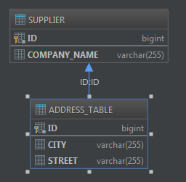

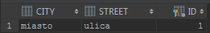

DZIEDZICZENIE POJEDYŃCZA TABELA

@Entity
@Inheritance(strategy= InheritanceType.SINGLE_TABLE)
public abstract class Company {
@Id
@GeneratedValue
private Long id;
private String companyName;
private String street;
private String city;
}

@Entity
public class Supplier extends Company {
private String bankAccountNumber;
}

@Entity
public class Customer extends Company {
private Double discount;
}
Hibernate: create table business_transaction (id bigint generated by default as identity, primary key (id))
Hibernate: create table business_transaction_sales (can_be_sold_on_id bigint not null, sales_id bigint not null, primary key (can_be_sold_on_id, sales_id))
Hibernate: create table category (id bigint generated by default as identity, category_name varchar(255), primary key (id))
Hibernate: create table company (dtype varchar(31) not null, id bigint generated by default as identity, city varchar(255), company_name varchar(255), street varchar(255), discount double, bank_account_number varchar(255), primary key (id))
Hibernate: create table product (id bigint generated by default as identity, product_name varchar(255), units_in_stock integer, category_id bigint, is_supplied_by_id bigint, primary key (id))
Hibernate: alter table business_transaction_sales add constraint FKoar2gh2emo3vnly2lmen7jfdx foreign key (sales_id) references product
Hibernate: alter table business_transaction_sales add constraint FKbcly7l6bvddri645pjvcc5bs5 foreign key (can_be_sold_on_id) references business_transaction
Hibernate: alter table product add constraint FK1mtsbur82frn64de7balymq9s foreign key (category_id) references category
Hibernate: alter table product add constraint FK9wd24w12n3jyxwpq6uem9rvs0 foreign key (is_supplied_by_id) references company
Hibernate: insert into company (id, city, company_name, street, bank_account_number, dtype) values (default, ?, ?, ?, ?, 'Supplier')
Hibernate: values identity_val_local()
Hibernate: insert into category (id, category_name) values (default, ?)
Hibernate: values identity_val_local()
Hibernate: insert into product (id, category_id, is_supplied_by_id, product_name, units_in_stock) values (default, ?, ?, ?, ?)
Hibernate: values identity_val_local()
Hibernate: insert into product (id, category_id, is_supplied_by_id, product_name, units_in_stock) values (default, ?, ?, ?, ?)
Hibernate: values identity_val_local()
Hibernate: insert into business_transaction (id) values (default)
Hibernate: values identity_val_local()
Hibernate: insert into business_transaction_sales (can_be_sold_on_id, sales_id) values (?, ?)
Hibernate: insert into business_transaction_sales (can_be_sold_on_id, sales_id) values (?, ?)
Hibernate: insert into business_transaction (id) values (default)
Hibernate: values identity_val_local()
Hibernate: insert into business_transaction_sales (can_be_sold_on_id, sales_id) values (?, ?)
Hibernate: insert into business_transaction_sales (can_be_sold_on_id, sales_id) values (?, ?)
Hibernate: insert into category (id, category_name) values (default, ?)
Hibernate: values identity_val_local()
Hibernate: insert into product (id, category_id, is_supplied_by_id, product_name, units_in_stock) values (default, ?, ?, ?, ?)
Hibernate: values identity_val_local()
Hibernate: insert into business_transaction (id) values (default)
Hibernate: values identity_val_local()
Hibernate: insert into business_transaction_sales (can_be_sold_on_id, sales_id) values (?, ?)
Hibernate: insert into company (id, city, company_name, street, discount, dtype) values (default, ?, ?, ?, ?, 'Customer')
Hibernate: values identity_val_local()
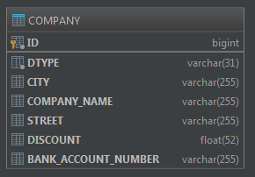

DZIEDZICZENIE ŁĄCZONE

@Inheritance(strategy= InheritanceType.JOINED)
public abstract class Company {
Hibernate: create table business_transaction (id bigint generated by default as identity, primary key (id))
Hibernate: create table business_transaction_sales (can_be_sold_on_id bigint not null, sales_id bigint not null, primary key (can_be_sold_on_id, sales_id))
Hibernate: create table category (id bigint generated by default as identity, category_name varchar(255), primary key (id))
Hibernate: create table company (id bigint generated by default as identity, city varchar(255), company_name varchar(255), street varchar(255), primary key (id))
Hibernate: create table customer (discount double, id bigint not null, primary key (id))
Hibernate: create table product (id bigint generated by default as identity, product_name varchar(255), units_in_stock integer, category_id bigint, is_supplied_by_id bigint, primary key (id))
Hibernate: create table supplier (bank_account_number varchar(255), id bigint not null, primary key (id))
Hibernate: alter table business_transaction_sales add constraint FKoar2gh2emo3vnly2lmen7jfdx foreign key (sales_id) references product
Hibernate: alter table business_transaction_sales add constraint FKbcly7l6bvddri645pjvcc5bs5 foreign key (can_be_sold_on_id) references business_transaction
Hibernate: alter table customer add constraint FKsqr49lri4ewqfajw6a8pgvf8x foreign key (id) references company
Hibernate: alter table product add constraint FK1mtsbur82frn64de7balymq9s foreign key (category_id) references category
Hibernate: alter table product add constraint FKlwhrb09ktake3x7tkh6dpoehp foreign key (is_supplied_by_id) references supplier
Hibernate: alter table supplier add constraint FK71m1n4p1p7ctayy3x2xg9cw76 foreign key (id) references company
Hibernate: insert into company (id, city, company_name, street) values (default, ?, ?, ?)
Hibernate: values identity_val_local()
Hibernate: insert into supplier (bank_account_number, id) values (?, ?)
Hibernate: insert into category (id, category_name) values (default, ?)
Hibernate: values identity_val_local()
Hibernate: insert into product (id, category_id, is_supplied_by_id, product_name, units_in_stock) values (default, ?, ?, ?, ?)
Hibernate: values identity_val_local()
Hibernate: insert into product (id, category_id, is_supplied_by_id, product_name, units_in_stock) values (default, ?, ?, ?, ?)
Hibernate: values identity_val_local()
Hibernate: insert into business_transaction (id) values (default)
Hibernate: values identity_val_local()
Hibernate: insert into business_transaction_sales (can_be_sold_on_id, sales_id) values (?, ?)
Hibernate: insert into business_transaction_sales (can_be_sold_on_id, sales_id) values (?, ?)
Hibernate: insert into business_transaction (id) values (default)
Hibernate: values identity_val_local()
Hibernate: insert into business_transaction_sales (can_be_sold_on_id, sales_id) values (?, ?)
Hibernate: insert into business_transaction_sales (can_be_sold_on_id, sales_id) values (?, ?)
Hibernate: insert into category (id, category_name) values (default, ?)
Hibernate: values identity_val_local()
Hibernate: insert into product (id, category_id, is_supplied_by_id, product_name, units_in_stock) values (default, ?, ?, ?, ?)
Hibernate: values identity_val_local()
Hibernate: insert into business_transaction (id) values (default)
Hibernate: values identity_val_local()
Hibernate: insert into business_transaction_sales (can_be_sold_on_id, sales_id) values (?, ?)
Hibernate: insert into company (id, city, company_name, street) values (default, ?, ?, ?)
Hibernate: values identity_val_local()
Hibernate: insert into customer (discount, id) values (?, ?)
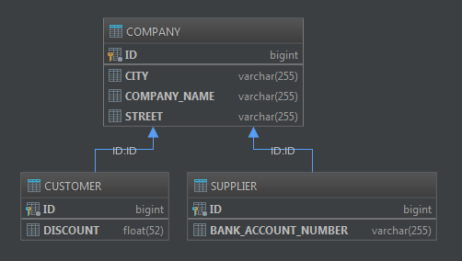
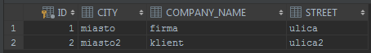
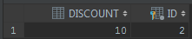
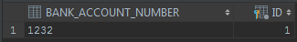

DZIEDZICZENIE TABELA DLA KLASY

@Inheritance(strategy= InheritanceType.TABLE_PER_CLASS)
public abstract class Company {
@Id
@GeneratedValue(strategy = GenerationType.TABLE)
protected Long id;
Hibernate: create table business_transaction (id bigint generated by default as identity, primary key (id))
Hibernate: create table business_transaction_sales (can_be_sold_on_id bigint not null, sales_id bigint not null, primary key (can_be_sold_on_id, sales_id))
Hibernate: create table category (id bigint generated by default as identity, category_name varchar(255), primary key (id))
Hibernate: create table customer (id bigint not null, city varchar(255), company_name varchar(255), street varchar(255), discount double, primary key (id))
Hibernate: create table hibernate_sequences (sequence_name varchar(255) not null, sequence_next_hi_value bigint, primary key (sequence_name))
Hibernate: create table product (id bigint generated by default as identity, product_name varchar(255), units_in_stock integer, category_id bigint, is_supplied_by_id bigint, primary key (id))
Hibernate: create table supplier (id bigint not null, city varchar(255), company_name varchar(255), street varchar(255), bank_account_number varchar(255), primary key (id))
Hibernate: alter table business_transaction_sales add constraint FKoar2gh2emo3vnly2lmen7jfdx foreign key (sales_id) references product
Hibernate: alter table business_transaction_sales add constraint FKbcly7l6bvddri645pjvcc5bs5 foreign key (can_be_sold_on_id) references business_transaction
Hibernate: alter table product add constraint FK1mtsbur82frn64de7balymq9s foreign key (category_id) references category
Hibernate: alter table product add constraint FKlwhrb09ktake3x7tkh6dpoehp foreign key (is_supplied_by_id) references supplier
Hibernate: select sequence_next_hi_value from hibernate_sequences where sequence_name = 'company' for update with rs
Hibernate: insert into hibernate_sequences(sequence_name, sequence_next_hi_value) values('company', ?)
Hibernate: update hibernate_sequences set sequence_next_hi_value = ? where sequence_next_hi_value = ? and sequence_name = 'company'
Hibernate: insert into supplier (city, company_name, street, bank_account_number, id) values (?, ?, ?, ?, ?)
Hibernate: insert into category (id, category_name) values (default, ?)
Hibernate: values identity_val_local()
Hibernate: insert into product (id, category_id, is_supplied_by_id, product_name, units_in_stock) values (default, ?, ?, ?, ?)
Hibernate: values identity_val_local()
Hibernate: insert into product (id, category_id, is_supplied_by_id, product_name, units_in_stock) values (default, ?, ?, ?, ?)
Hibernate: values identity_val_local()
Hibernate: insert into business_transaction (id) values (default)
Hibernate: values identity_val_local()
Hibernate: insert into business_transaction_sales (can_be_sold_on_id, sales_id) values (?, ?)
Hibernate: insert into business_transaction_sales (can_be_sold_on_id, sales_id) values (?, ?)
Hibernate: insert into business_transaction (id) values (default)
Hibernate: values identity_val_local()
Hibernate: insert into business_transaction_sales (can_be_sold_on_id, sales_id) values (?, ?)
Hibernate: insert into business_transaction_sales (can_be_sold_on_id, sales_id) values (?, ?)
Hibernate: insert into category (id, category_name) values (default, ?)
Hibernate: values identity_val_local()
Hibernate: insert into product (id, category_id, is_supplied_by_id, product_name, units_in_stock) values (default, ?, ?, ?, ?)
Hibernate: values identity_val_local()
Hibernate: insert into business_transaction (id) values (default)
Hibernate: values identity_val_local()
Hibernate: insert into business_transaction_sales (can_be_sold_on_id, sales_id) values (?, ?)
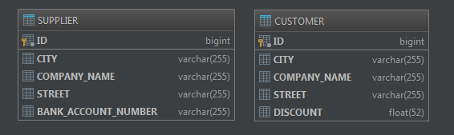

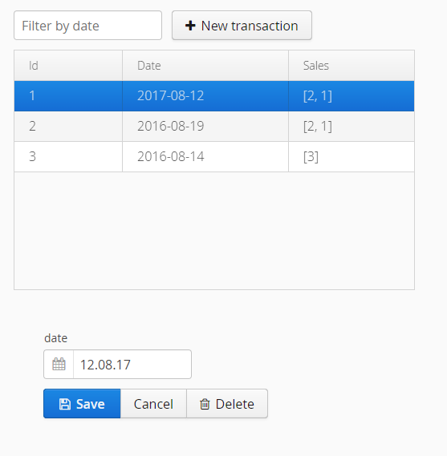

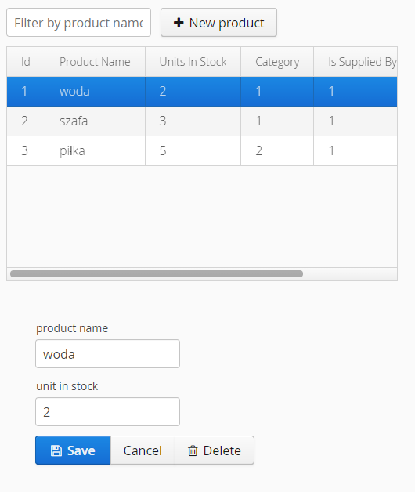

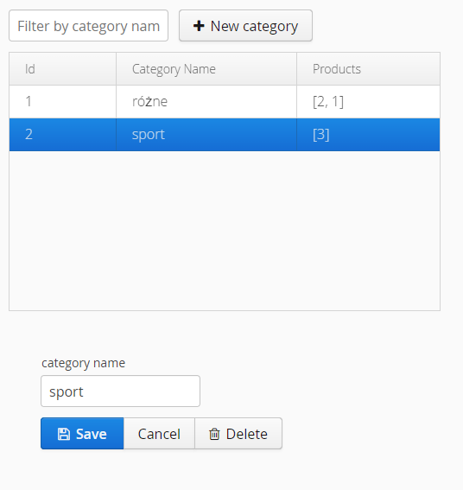

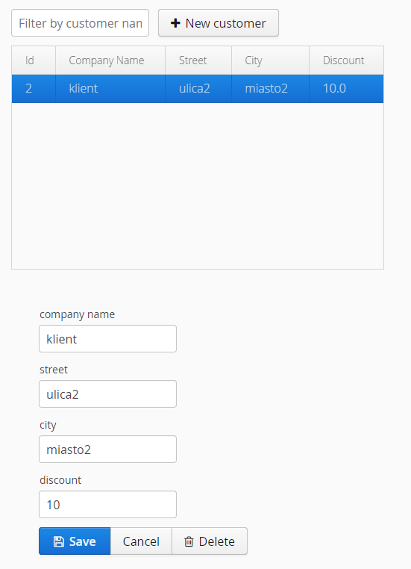

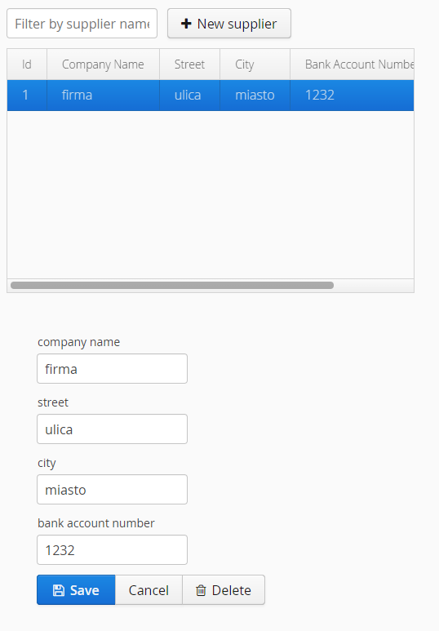

REPOZYTORIUM:
https://github.com/Fapfood/jpa_siwik

