|  |  |  |  |
| --- | --- | --- | --- |
| Company | Industries | Area | Position |
| Watsons Personal Care Store | Retail Industry | Sales and Customer Services | Customer Assistant |

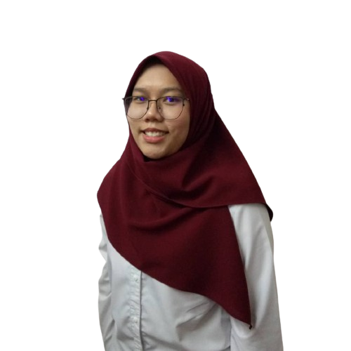

Helping Permata Camar Orphanage in their Badminton preparations for the "Sukan Anak Yatim"

Resilience and Success Stories

Director of “Program Bughak Sukan”

Experiences

Badminton athlete since primary school

As a fresh graduate in Statistics, I am embarking on a career in UI/UX design, My ambition burned brightly, fueled by a passion for creating intuitive and impactful digital experiences. Despite the difference in my degree course, I see a promising opportunity in UI/UX Design that aligns with my life's vision of enhancing people's lives.

Professional Skills: UI UX Design

My principal of life is to commit to personal growth. Continuously learn and improve to reach my full potential.

Career Objective: To leverage my skills in user interface design, user experience research, and prototyping to create intuitive, user friendly digital products. I aim to contribute to a dynamic team where I can apply my strong visual design abilities, empathy for users, and commitment to continuous improvement to deliver innovative solutions that enhance user satisfaction and drive business success.

About

Personal and Career Objective

Faqihah, Wan Nur Faqihah Binti Wan Zaharudin

wannurfaqihahwz@gmail.com

+6019-6805792

Pekan, Pahang

Adaptive Transformation: Transformed from being hesitant in speaking to strangers into a confident individual capable of engaging smoothly with customers.

Strategic Achievement: Successfully achieved the company's set KPIs and was rewarded with prizes.

|  |  |  |  |
| --- | --- | --- | --- |
| Education | Majoring | Completion | Institute |
| Degree | Statistics | 2019-2023 | Universiti Putra Malaysia |
| Foundation | Agricultural Science | 2018-2019 | Universiti Putra Malaysia |
| SPM | Science Stream | 2017 | MARA Junior Science College Muadzam Shah |

|  |  |  |  |
| --- | --- | --- | --- |
| Company | Contact Number | Name | Position |
| Watsons Personal Care Store | References available upon request | Rashila Binti Sobri | Manager |
| Universiti Putra Malaysia | Assoc. Prof. Dr. Jayanthi A/P Arasan | Project Supervisor (Final Year Project) |

Reference & Testimonials

Education Background