
LABORATORIUM SISTEM INFORMASI
Sekolah Tinggi Manajemen Informatika dan Komputer
STMIK JAKARTA STI&K
Jl.BRI Radio Dalam No.17 Kebayoran Baru Jakarta Selatan 12140 Telp : (021) - 7397973, 7210722 Website : http://www.jak-stik.ac.id

LAPORAN AKHIR PRAKTIKUM
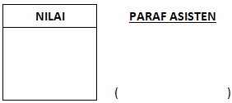
NAMA PRAKTIKAN : FAQIH YUGO SUSILO
N.P.M / KELAS : 10417082/104
PRAKTEK TANGGAL : 16 MARET 2018
NAMA PRAKTIKUM : PEMROGRAMAN 1 VISUAL BASIC

- Form
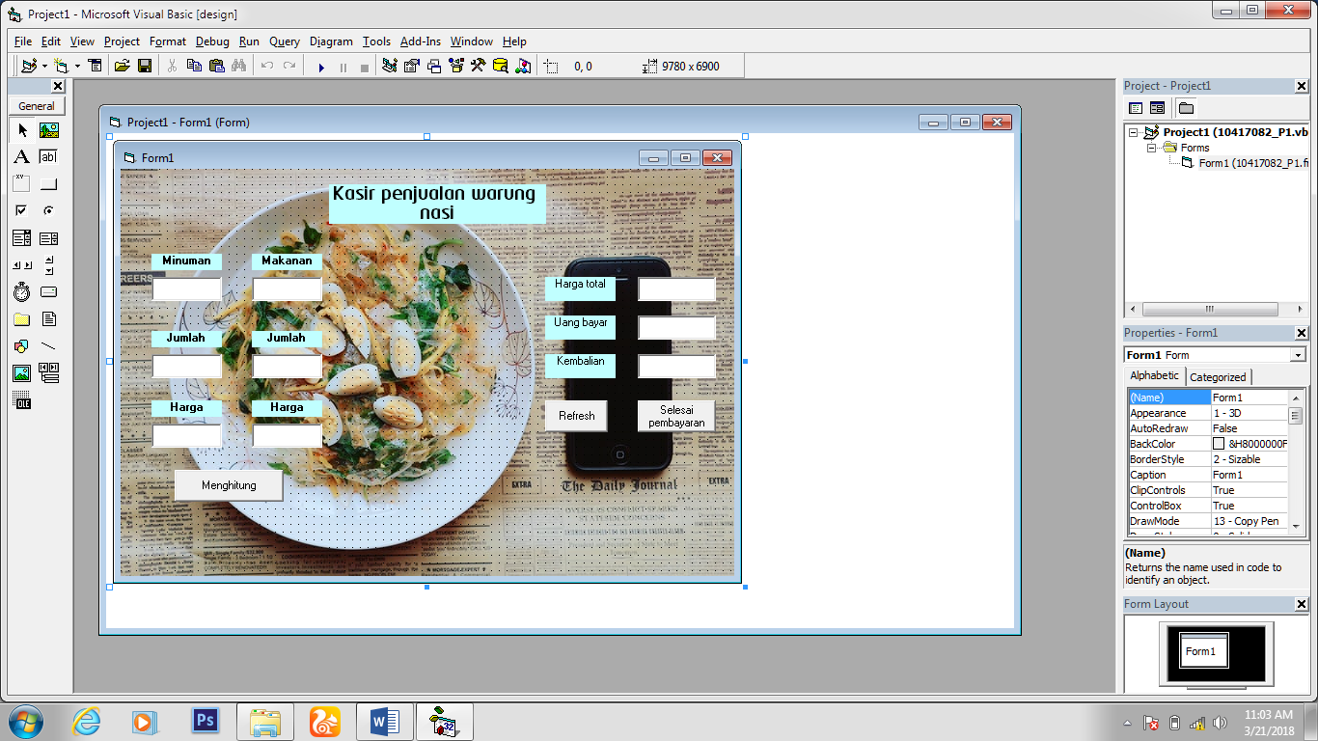
- Kodingan
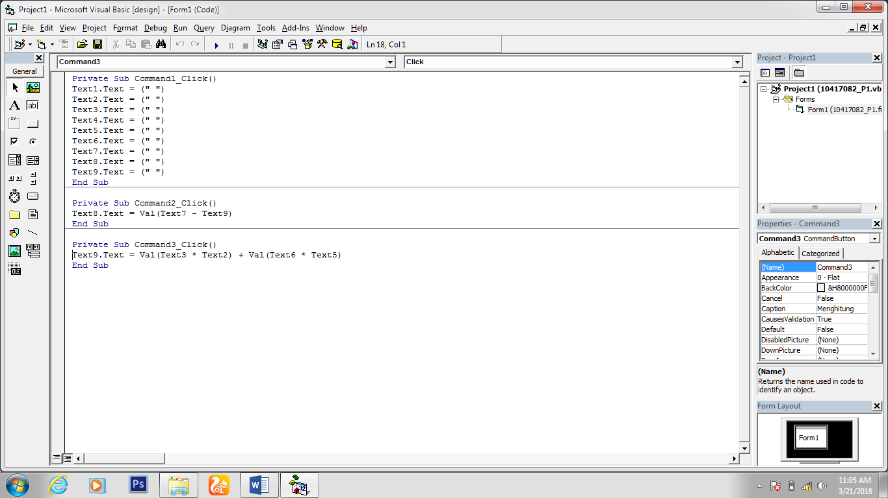
- Program berjalan
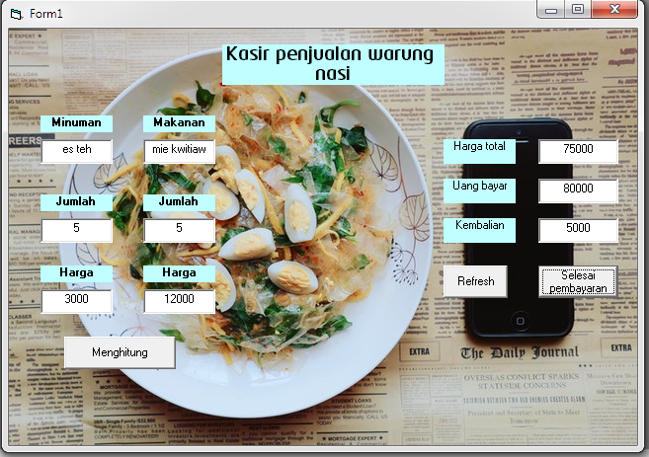

Objek | Properties | value
Label 1 | Font  Backcolor  Aligment  Caption | Neo tech/bold/ size 14  Biru muda  Center  Kasir penjualan warung nasi
Form 1 | picture | Bitmap
Label 2 | Font  Backcolor  Aligment  Caption | MS Sans Serif/bold  Biru muda  Center  Makanan
Label 3 | Font  Backcolor  Aligment  Caption | MS Sans Serif/bold  Biru muda  Center  Harga
Label 4 | Font  Backcolor  Aligment  Caption | MS Sans Serif/bold  Biru muda  Center  Jumlah
Label 5 | Font  Backcolor  Aligment  Caption | MS Sans Serif/bold  Biru muda  Center  Minuman
Label 6 | Font  Backcolor  Aligment  Caption | MS Sans Serif/bold  Biru muda  Center  Harga
Label 7 | Font  Backcolor  Aligment  Caption | MS Sans Serif/bold  Biru muda  Center  Jumlah
Label 8 | Font  Backcolor  Aligment  Caption | MS Sans Serif  Biru muda  Center  Kembalian
Label 9 | Font  Backcolor  Aligment  Caption | MS Sans Serif  Biru muda  Center  Uang bayar
Label 10 | Font  Backcolor  Aligment  Caption | MS Sans Serif  Biru muda  Center  Harga total
Textbox 1 | Aligment | Center
Textbox 2 | Aligment | Center
Textbox 3 | Aligment | Center
Textbox 4 | Aligment | Center
Textbox 5 | Aligment | Center
Textbox 6 | Aligment | Center
Textbox 7 | Aligment | Center
Textbox 8 | Aligment  Enable | Center  False
Textbox 9 | Aligment  Enable | Center  False
Command 1 | Caption | Refresh
Command 2 | Caption | Selesai pembayaran
Command 3 | Caption | Menghitung
Frame 1 | Caption  Backcolor | Input  Biru muda

