**Connecting to Remote Desktop(Linux)**

First we open Kali and type:

sudo service xrdp start

and then we find our ip address by typing ip add

then we take our ip address and put it in the Remote Desktop Connection prompt

cat is used to display the content of a file. 🡺cat text.txt 🡺Hello world

echo command is used to write arguments to the standard output. It just echoes whatever you pass as an argument.

**Virtual machines (VM)**

Vms are basically machines inside real machines. We realize it with the hypervisor. Hypervisor is just an application.

Virtualization is the process of creating a software-based, or "virtual" version of a computer, with dedicated amounts of CPU, memory, and storage that are "borrowed" from a physical host computer—such as your personal computer— and/or a remote server—such as a server in a cloud provider's datacenter. A virtual machine is a computer file, typically called an image, that behaves like an actual computer. It can run in a window as a separate computing environment, often to run a different operating system—or even to function as the user's entire computer experience—as is common on many people's work computers. The virtual machine is partitioned from the rest of the system, meaning that the software inside a VM can't interfere with the host computer's primary operating system.

Hypervisor virtualizes hardware components (cpu,ram,storage…) from the host machine.

A hypervisor, also known as a virtual machine monitor or VMM, is software that creates and runs virtual machines (VMs). A hypervisor allows one host computer to support multiple guest VMs by virtually sharing its resources, such as memory and processing.

This type of hypervisor is called the type 2 hypervisor. Host os allows guest os’s to use his resources.

So the type 2 hypervisor asks the host’s os for the resources whereas the type 1 hypervisor has direct full control to the host’s hardware.

In type 2 hypervisor the os of the host shares its resources for vms meaning that if there are many vms it has to share its resources for all of them.

We install ISO files of the os that we want. An ISO file (often called an ISO image), is an archive file that contains an identical copy (or image) of data found on an optical disc, like a CD or DVD (so when we install an os we use cds here it is an image of the disk). They are often used for backing up optical discs, or for distributing large file sets that are intended to burned to an optical disc.

ISO image as a complete copy of everything stored on a physical optical disc like CD, DVD, or Blu-ray disc—including the file system itself. So we install iso images to have vms. Kali linux iso and etc.

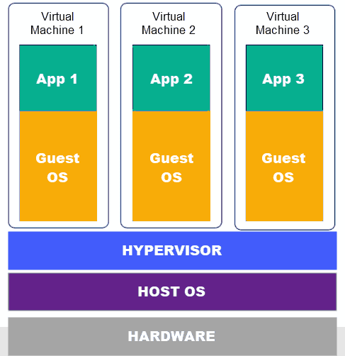

**Grep**

The grep command searches the given input files for lines containing a match to the given PATTERN.



-i: --ignore-case ignores case distinctions.

**VI and VIM**

Vi is the standard and the original full-screen text editor of the Linux family which was originally designed for UNIS systems. Vim is an enhanced version of the vi editor written and maintained by Bram Moolenaar. Vim means 'vi improved'. Vim commands and their syntax are fully compatible with vi. Vi stands for Visual. It is a text editor that is an early attempt to a visual text editor. Vim stands for Vi IMproved. It is an implementation of the Vi standard with many additions. It is the most commonly used implementation of the standard. Most Linux distributions come with Vim already installed.

Vi or vim filename – creates a file 🡺

 Or 

**Flags and options**

"Flags" specifically, are Boolean arguments, set by the mere inclusion of the command-line argument, with no additional data needed or allowed for the argument. If you include the argument/option/flag, it counts as "true" and if you exclude it, it counts as "false".

An option can itself take an argument (e.g.,--color=always ), or occasionally multiple arguments. "Flags" are, in my experience, the same as options, but usually do not take arguments themselves and essentially represent boolean on-off switches.

**-c command**

The -c flag means execute the following command as interpreted by this program.

sh -c "echo This is a test string" or

sh -c "wget 'https://docs.google.com/documet… " it will download a document from Google Drive and open it up for editing on the desktop