**Saga pattern**

Saga pattern is in a distributed system where 2 microservices need to communicate with each other. Managing transactions across multiple microservices is difficult and that’s where saga pattern comes into existence.

In saga pattern, we keep track of each transaction and if one transaction fails the the whole transaction fails.

There are 2 types of saga pattern implementations. The first one is chereography.

In chereography, each microservice communicates with each other through events. There is no centrelized coordinator.

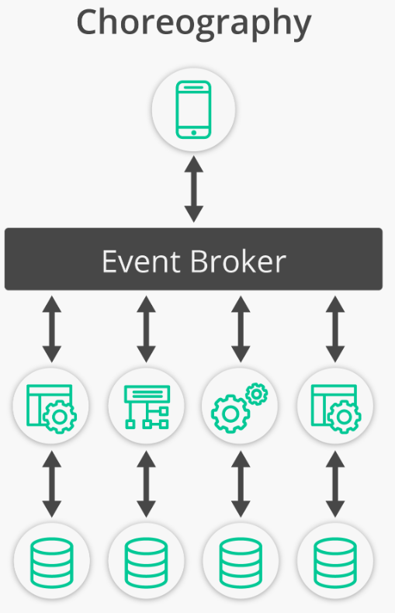

We can use message brokers, for instance RabbitMQ.

One of the pros of this approach over orchestration is that there is no single point of failure. Also, it is easy to start with since we don’t need to set up a coordinator.

However, it gets complex in case to manage large number of microservices.

To actually rollback the entire transaction we will need to compensate other transactions meaning that if the order is already committed then if whole transaction fails then we just remove the added order from the service’s db.

The second implementation of saga pattern is orchestration.

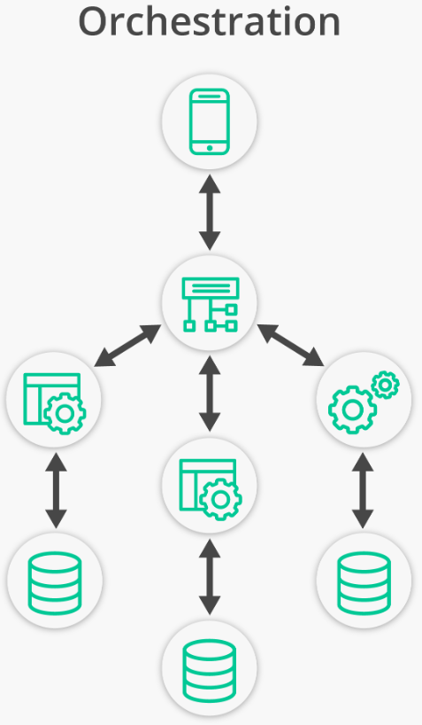

The orchestrator tells each microservice which operation to perform. And in case of an issue, it also sends messages to different microservices for rollback of the transaction. It manages state of each task through a state machine.

**Outbox pattern**

Suppose we have a situation where we save an order and then send a message to a queue in a distributed system. Let’s say when we send the message to the queue we encounter an error (an exception) 🡺

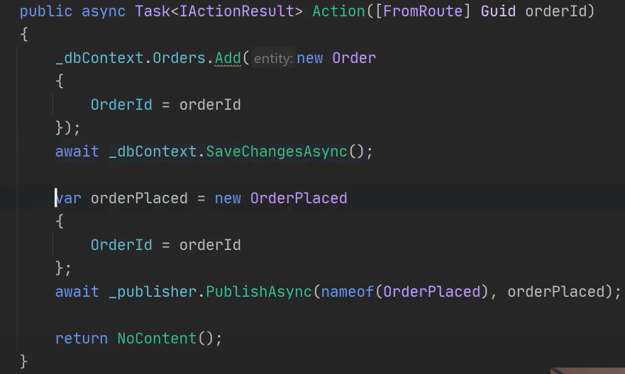

We save an order and send a message to a queue via the publisher. We can actually save all messages or events in the database and later a separate service or job can pull the messages or events and send them again. This way the message broker service is down it can later do its job.

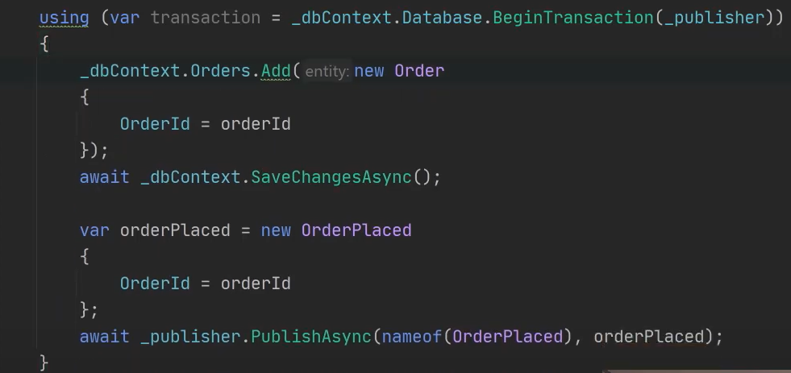

By giving the publisher of the message broker, we are also saving the message in the database.

