**Network**

Normally, computers are connected to switches. Every LAN has to have a switch so that computers can communicate with each other via switch. Then we can connect our lan to another network via Router and etc. So this is the Internet the world’s largest network.

Switches are layer 2 devices.

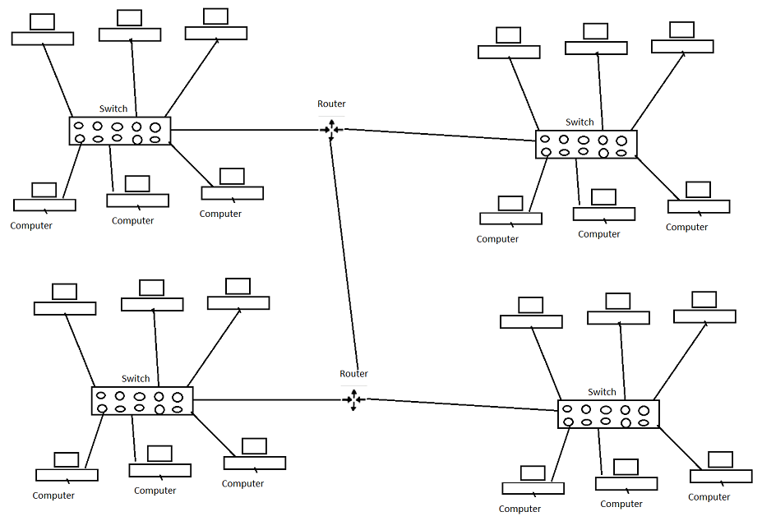

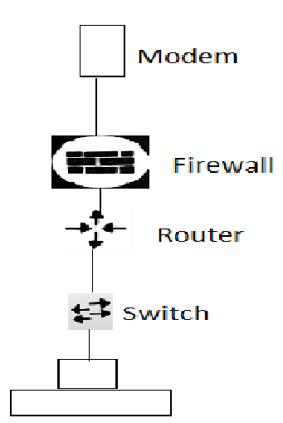

WAP –wireless access point is used to broadcast the network over the air waves.

Before switches, people used hubs. But they are dump because it sends the information to every device that it is connected to. Hubs just repeat electrical signal.

A switch stores all the mac addresses of each computer connected to it in its CAM table.

CAM stands for content addresable memory. MAC-Media access control (layer 2 data link layer). Every single device has the mac address.

When a switch receives information from a computer it becomes a frame. Then the receiver gets the message it becomes a packet because there is an ip address (layer 3) involved. In other words, we send frames (with source MAC address, which is used to populate CAM table, and destination MAC address) to switches and we send packets to routers.

Switches use destination mac addresses to make forwarding decisions.

**Routers**

Roters are layer 3 devices meaning that they can see 3 layers: Physical layer, data link layer (mac address), network layer (ip address).

The default gateway is the path used to pass information when the device doesn't know where the destination is. A default gateway makes it possible for devices in one network to communicate with devices in another network. If a computer, for example, requests a web page, the request goes through the default gateway before exiting the local network (LAN) to reach the internet.

**The default gateway is the ip address of our router.**



The ip address of the device is 192.168.31.55

Our device knows if the request is between the range of

192.168.31.0 ---192.168.31.255 then it is in our network. Otherwise, it is in another network. And it will exit our LAN through the default gateway.

So when one of the devices exit the LAN it uses the default gateway. When they see unknown ip address they know that they have to exit their network.

ARP – Address Resolution Protocol is used to discover mac addresses and map them to an ip address.

Let’s say that we have a network and 3 devices are connected A, B and C. Let’s say there is a new device D that just has been connected to the network. It will be given an ip address.

Now host A wants to communicate with host D. Since A only has the ip address of D it will have to first figure out the mac address of D. A will look at the ARP cache to see if D’s mac address is there. Since it is a new device A will have to send a broadcast message (asking everyone who is 192.168.0.4). Then D responds and after this A stores the mac address of D in its ARP cache. Then they will be able to communicate because A knows the mac address of D.

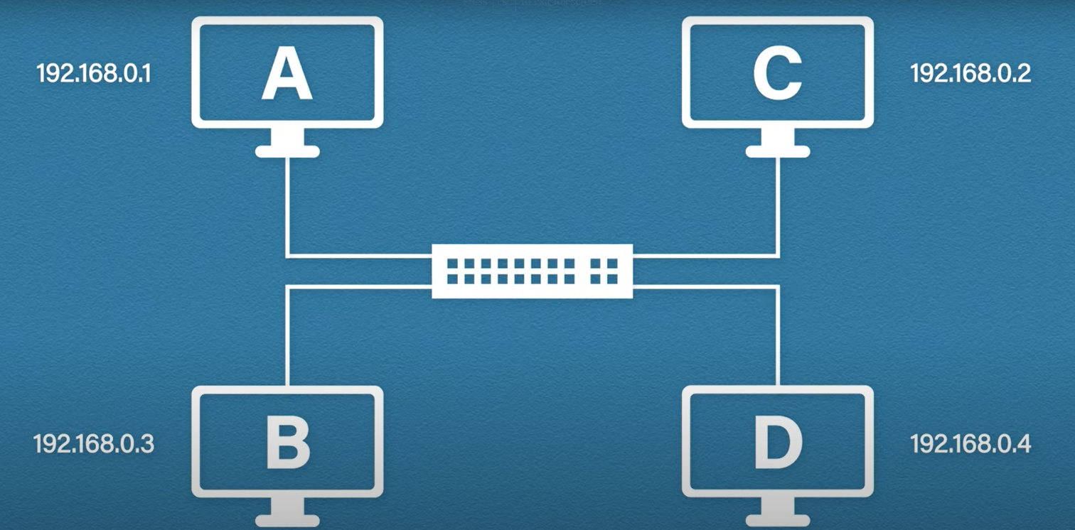

ARP cache 🡪

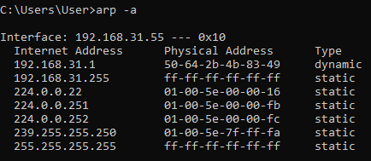

Dynamic types are created by arp itself when we make requests (the one that we just saw). But static ones are created manually and they are not deleted. In contrast, dynamic types get removed after sometime to make space.

So ARP is used to translate from 32 bits (ip address) into 48 bits (mac address).

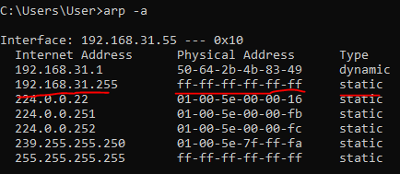

The first top static type is called direct broadcast address. We can know that it is a broadcast message from the physical address (FF-FF-FF-FF)

And also the Ip address is the last ip address in the network because of 255.

When we send a get request, let’s say for example we want to communicate with another server (facebook etc.), first what happens is our device will compare its ip address with the searched one to see if that ip address is in our network. Knowing that it is from outside of the network, it will have to go off our network. To do this, it will look at the ARP cache to find the default gateway ip address to get the mac address of our router. If it is not there, then it will send a broadcast message to find our router. Then it will populate the arp cache table and after this our device will take the destination mac address (router’s) and go to it. When the router receives our request it will send its mac address as well as the ip address of the website (or server in this case).

So the entire process 🡪

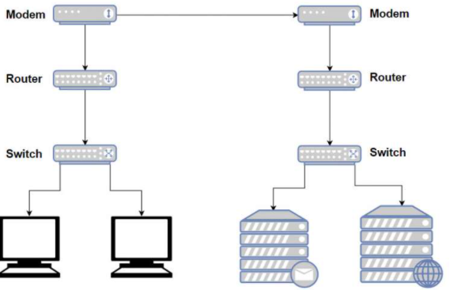

If host A wants to communicate with host B then host A first looks at its ARP table to find the mac address of the host B. if it is not there then it sends a broadcast message. When our ARP populates host B’s mac address then it will be able to communicate with host B.

If we want to communicate with another server then we get off our network through the default gateway. The same process goes. host A first looks at its ARP table to find the mac address of our router. if it is not there then it sends a broadcast message. The gateway is the IP address of our router. After this host A sends a request through the default gateway.

Our computer needs the mac address of our router so that it is sent through the switch.

**TCP/IP**

TCP/IP is just a list of guidelines, rules, standards on how diffrerent computers (Windows,MAc) can communicate. The functions are divided into layers.

TCP/IP OSI(Open system’s interconnection)

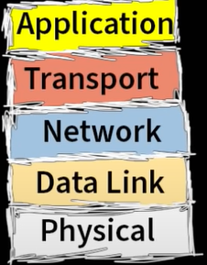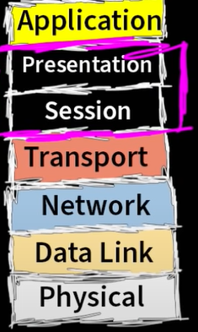

TCP/IP and OCI networking models that define as to how we connect to our computers.

As it goes down to other layers from the layer 7, it gets encapsulated. 🡪 In layer 4 (transport) we have TCP and UDP.

And as devices receive our packages (all the layers) they will decapsulate our package. If it is a switch, then it will only be able to see layer 2 and etc.

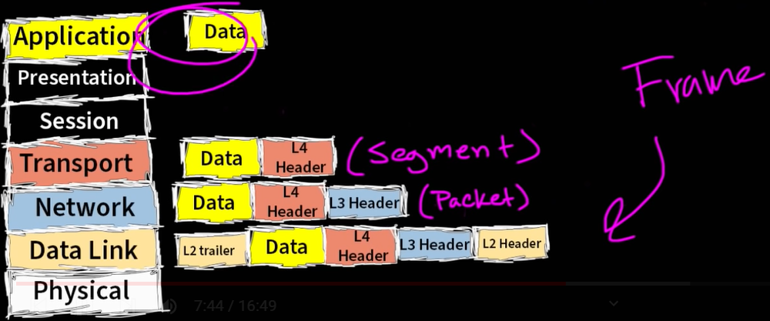

Presentation layer (layer 6) deals with the following tasks:

Data Format – file types such as .html, xml , jpg

Data encryption

Sessioning layer (layer 6) deals with the sessioning. This tells whether the communication should continue or not.

All these layers (session and presention) are just one layer in TCP/IP model.

**PORT**

When we get to the server with the ip address it doesn’t mean that we are in the spot NO! we gotta know the port number! In one server there might be lot of apps working and port is the enrty point that we say we want namely to this port, to his address because in one port there is only one application!

**Http requests**

These are just a set of rules. Get request 🡪

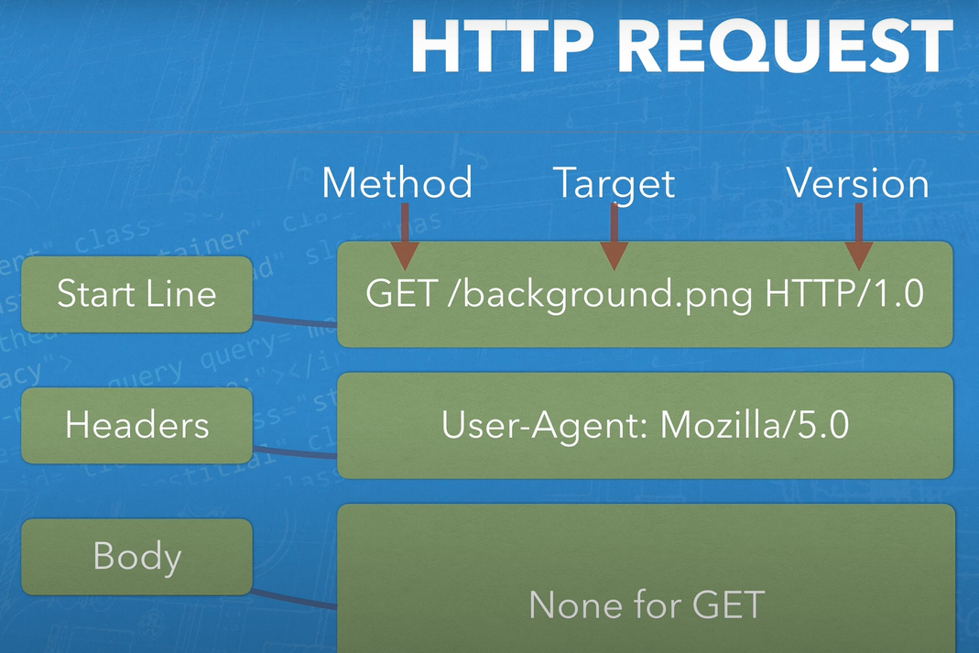

Http Post Request

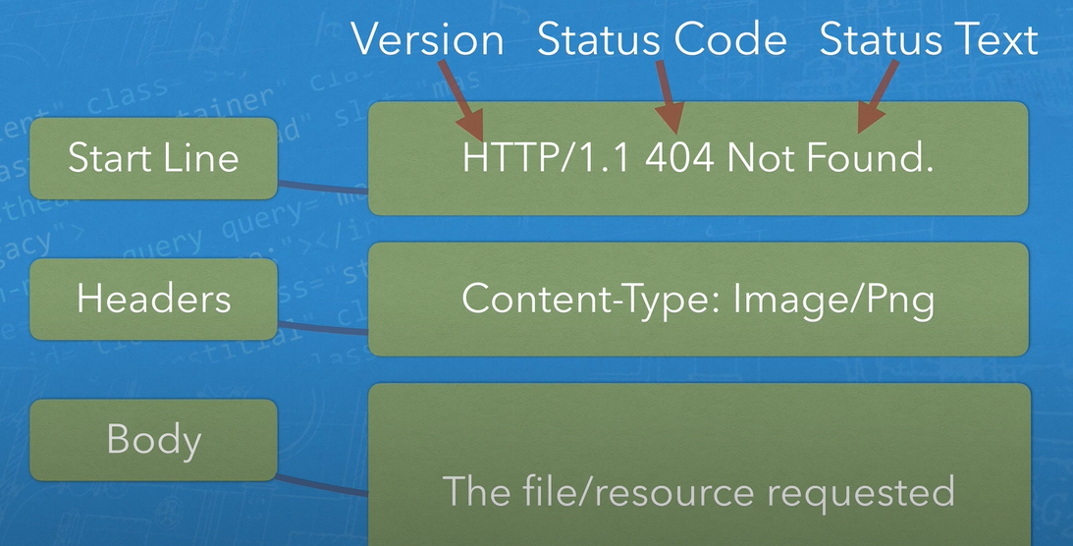

**Network Protocols**

Network Protocols for web browser and servers are categorized into two types: Stateless Protocol, and Stateful protocol. These two protocols are differentiated on the basis of the requirement of server or server-side software to save status or session information.

**Stateless Protocol**: Stateless Protocols are the type of network protocols in which Client sends a request to the server and server responses back according to the current state. It does not require the server to retain session information or a status about each communicating partner for multiple requests. Stateless protocols are independent. It doesn’t rememeber anything about the previous transaction. HTTP (Hypertext Transfer Protocol), UDP (User Datagram Protocol), DNS (Domain Name System) are the example of Stateless Protocol. Silent features of Stateless Protocols:

* Stateless Protocol simplifies the design of the Server.
* The stateless protocol requires less resources because system does not need to keep track of the multiple link communications and the session details.
* In Stateless Protocol each information packet travel on it’s own without reference to any other packet.
* Each communication in Stateless Protocol is discrete and unrelated to those that precedes or follow.

**Stateful Protocol**: In Stateful Protocol If client sends a request to the server then it expects some kind of response, if it does not get any response then it resends the request. FTP (File Transfer Protocol), Telnet, web sockets are the examples of Stateful Protocol. Silent features of Stateful Protocol:

* Stateful Protocols provide better performance to the client by keeping track of the connection information.
* Stateful Applications require Backing storage.
* Stateful requests are always dependent on the server-side state.
* TCP sessions follow stateful protocol because both systems maintain information about the session itself during its life.

A stateless protocol is a protocol in which each particular communication is handled as an independent event, unrelated to other similar communications. The opposite of stateless protocol is a stateful protocol, where an individual communication is handled as part of a greater set of communications.

**URI, URL, URN**

URI or uniform resource identifier can specify both the address or the name of the resource, or both at the same time.

URL or uniform resource locator specifies the address of the resource. URN or uniform resource name specifies the name of the the resource.

So all URLs and URNs are URIs.

**Load balancing and Round Robin**

Load balancing refers to efficiently distributing incoming network traffic across a group of backend servers, also known as a server farm or server pool.

A load balancer acts as the “traffic cop” sitting in front of your servers and routing client requests across all servers capable of fulfilling those requests in a manner that maximizes speed and capacity utilization and ensures that no one server is overworked, which could degrade performance. If a single server goes down, the load balancer redirects traffic to the remaining online servers. When a new server is added to the server group, the load balancer automatically starts to send requests to it. In this manner, a load balancer performs the following functions: Distributes client requests or network load efficiently across multiple servers Ensures high availability and reliability by sending requests only to servers that are online Provides the flexibility to add or subtract servers as demand dictates.

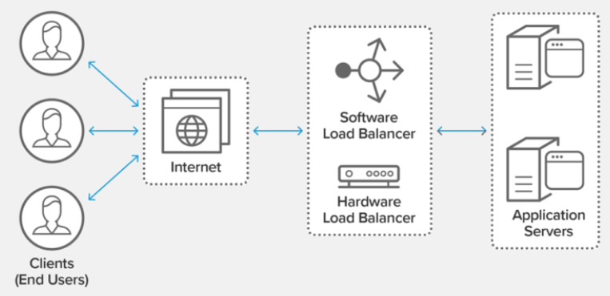

Different load balancing algorithms provide different benefits; the choice of load balancing method depends on your needs:

* **Round Robin** – Requests are distributed across the group of servers sequentially.
* **Weighted round robin**- uses weights (specs of servers such as ram, cpu). When a request is sent, it decides on weights where to send the quest so the the most powerful server gets the most and the least powerful one gets the least requests.
* **Least Connections** – A new request is sent to the server which has the fewest current connections to clients.
* **Weighted Least combinations -** this algorithm has now 2 responsibilities. It checks the weights as well as the number of current users and finds the best server to send the requests.
* **Random –** as the name implies the server is chosen randomly.

What is the Difference Between Weighted Load Balancing vs Round Robin Load Balancing? The biggest drawback of using the round robin algorithm in load balancing is that the algorithm assumes that servers are similar enough to handle equivalent loads. If certain servers have more CPU, RAM, or other specifications, the algorithm has no way to distribute more requests to these servers. As a result, servers with less capacity may overload and fail more quickly while capacity on other servers lie idle.

* The weighted round robin load balancing algorithm allows site administrators to assign weights to each server based on criteria like traffic-handling capacity. Servers with higher weights receive a higher proportion of client requests. For a simplified example, assume that an enterprise has a cluster of three servers:
* • Server A can handle 15 requests per second, on average  
  • Server B can handle 10 requests per second, on average  
  • Server C can handle 5 requests per second, on average
* Next, assume that the load balancer receives 6 requests.
* • 3 requests are sent to Server A  
  • 2 requests are sent to Server B  
  • 1 request is sent to Server C.
* In this manner, the weighted round robin algorithm distributes the load according to each server’s capacity.

Because of the inability to send requests according to the specs (ram, cpu specs) of servers, round and robin algorithm is best when the servers have identical specs.