X is right and left, Y is up and down and Z is forward and backward.

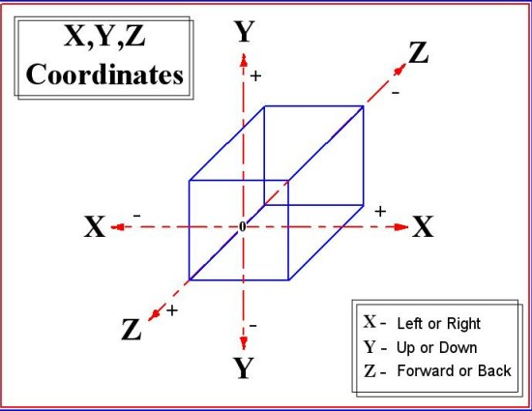

**The Inertial Measurement Unit**

The term IMU stands for “Inertial Measurement Unit,” and we use it to describe a collection of measurement tools. When installed in a device, these tools can capture data about the device’s movement. It contains an accelerometer and gyroscope (sometimes also a magnetometer and rarely a barometer). The first is responsible for acceleration measurements and the second is responsible for the angular velocity measurements.

Kinematics is the study of the motion of objects without reference to forces. Dynamics is the study of forces and their influence on the motion of objects.