CVE Assignment 8a Report

# Question 1 (PS8a)

Principal components are used in this capacity to describe trends and patterns in pressure, temperature and other atmospheric measurements. In the Eigenface technique, the space of images (library of faces), is projected into a low dimensional space using principal component analysis. In this method, the high dimensional n-space is transformed to a set of uncorrelated principal components that span most if not all variation in the original data set. The Olivetti dataset is used to test and train the PCA model.

## Training and testing the PCA Model

The dataset was passed through the model and a histogram of the top 10 people with greatest frequency. Each Image has a shape of 64x64

Figure Histogram of Frequency of the Top 10 individual

The main goal of PCA is dimensionality reduction. It has many applications in visualisation, feature extraction, data compression, etc. The idea behind it is to linearly project original data onto a lower dimensional subspace offering the principal components (eigenvectors) maximum variance of the projected data and/or minimum distortion error from the projection. Eigenfaces of the using the first 8 components are shown below.

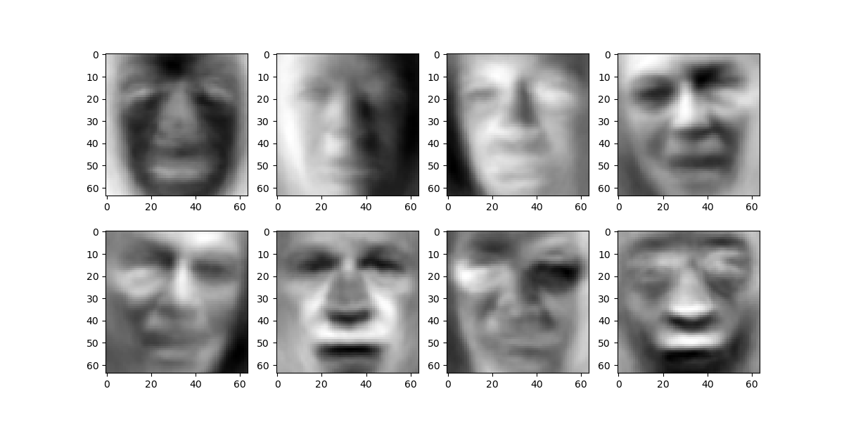Distribution of the data along with the initial confusion matrix for number of components set to 8 is displayed below

Figure 4 Confusion Matrix

Figure 3 Distribution of the Data

Figure Eigenfaces with the first 8 Components

The MLP Classifier was chosen as the classifier of choice. The target accuracy was expected to be at least 75%. Keeping this in mind, the regularization parameter was set to 1 and the number of iterations set to 1000. It was observed that the desired target was exceeded for component numbers greater than 100. Several classifiers were also tested, with the SVM Classifier peaking at an accuracy of 70% when using an RBF kernel, the Naïve Bayes Classifier had an accuracy of less than 40% at its peak, the Random Forest Classifier with a depth of 3 having an accuracy of about 50%.

Figure 5 Accuracy of MLP Classifier at different number of Components

The classifier was again trained with the PCA model having 120 as the number of components. The results are displayed below.

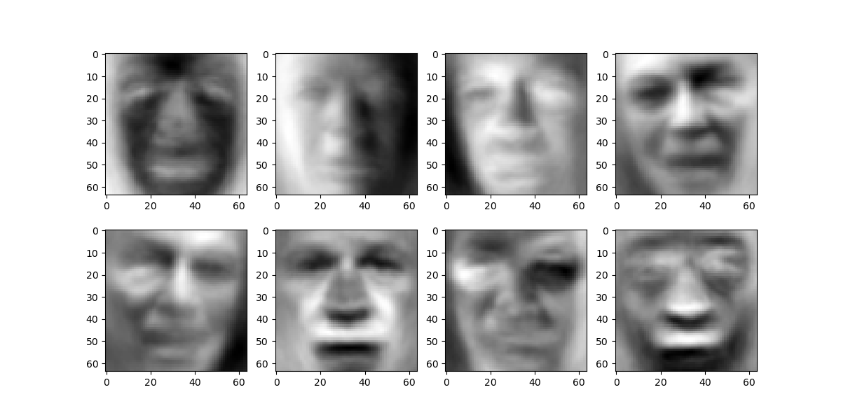

Figure 6 Eigenfaces with the retained classifier

The accuracy for the model was about 78.023%.

Figure 8 Confusion Matrix of the retrained model

Figure 7 Plotting the dataset passed to the retrained model

## Source Code of Training Script

import cv2

import math

import numpy as np

import matplotlib.pyplot as plt

from sklearn import decomposition

from sklearn.preprocessing import StandardScaler

from sklearn.model_selection import train_test_split

from sklearn.svm import SVC

from sklearn.neural_network import MLPClassifier

from sklearn.ensemble import RandomForestClassifier

from sklearn.naive_bayes import GaussianNB

from sklearn.utils.fixes import loguniform

from sklearn.model_selection import RandomizedSearchCV

from sklearn.metrics import ConfusionMatrixDisplay, confusion_matrix

import re

import random

from os import listdir

"""

TODO 0: Find out the image shape as a tuple and include it in your report.

"""

IMG_SHAPE = cv2.cvtColor(cv2.imread('ps8a-dataset/imagenet_val1000_downsampled/00001.png'),cv2.COLOR_BGR2GRAY).shape

print(f'Image Shape = {IMG_SHAPE}')

def load_data(data_dir, top_n=10):

"""

Load the data and return a list of images and their labels.

:param data_dir: The directory where the data is located

:param top_n: The number of people with the most images to use

Suggested return values, feel free to change as you see fit

:return data_top_n: A list of images of only people with top n number of images

:return target_top_n: Corresponding labels of the images

:return target_names: A list of all labels(names)

:return target_count: A dictionary of the number of images per person

"""

# read and randomize list of file names

print("Load Face Data -------------------------------------")

file_list = [fname for fname in listdir(data_dir) if fname.endswith('.pgm')]

print(f' Size of file list = {len(file_list)}')

random.shuffle(file_list)

name_list = [re.sub(r'_\d{4}.pgm', '', name).replace('_', ' ') for name in file_list]

print(f' Size of name list = {len(name_list)}')

# get a list of all labels

target_names = sorted(list(set(name_list)))

unsorted_name_list = np.array(list(name_list)).reshape((-1,1))

print(f' Size of unsorted name list = {unsorted_name_list.shape}')

# print(unsorted_name_list)

# get labels for each image

target = np.array([target_names.index(name) for name in name_list])

# read in all images

data = np.array([cv2.imread(data_dir + fname, 0) for fname in file_list])

print(f' Size of data list = {len(data)}')

print(f' Size of target list = {len(target)}')

"""

TODO 1: Only preserve images of 10 people with the highest occurence, then plot

a histogram of the number of images per person in the preserved dataset.

Include the histogram in your report.

"""

unique, counts = np.unique(target, return_counts=True)

target_count = dict(zip(unique, counts))

# YOUR CODE HERE

# target_count is a dictionary of the number of images per person

# where the key is an index to label ('target'), and the value is the number of images

# Try to use sorted() to sort the dictionary by value, then only keep the first 10 items of the output list.

target_count = dict(sorted(target_count.items(), key=lambda item: item[1], reverse=True))

print(f' Size of target_count list = {len(target_count)}')

target_top_n = list(target_count.keys())[0:top_n]

# data_top_n is a list of labels of only people with top n number of images

names_top_n = [target_names[id] for id in target_top_n]

target_top_n = []

index_list = []

for i in range(unsorted_name_list.shape[0]):

# print(i)

if (unsorted_name_list[i,0] in names_top_n):

index_list.append(i)

target_top_n.append(target_names.index(unsorted_name_list[i,0]))

target_top_n = np.array(target_top_n)

# index_list = [item for sublist in index_list for item in sublist]

print(f' Size of Index list = {len(index_list)}')

# print(index_list)

data_top_n = data[index_list][:][:]

data_top_n = np.array([row.flatten() for row in data_top_n])

print(f' Size of target_top_n list = {target_top_n.shape}')

print(f' Size of data_top_n list = {data_top_n.shape}')

# You can plot the histogram using plt.bar()

# autofmt_xdate() is also useful for rotating the x-axis labels

# Plot histogram

fig, ax = plt.subplots()

ax.bar(names_top_n, list(target_count.values())[0:top_n])

fig.autofmt_xdate()

plt.show()

# plt.autofmt_xdate()

return data_top_n, target_top_n, target_names, target_count

def load_data_nonface(data_dir):

"""

Your can write your functin comments here.

"""

"""

TODO 2: Load the nonface data and return a list of images.

"""

print("Load Non-Face Data -------------------------------------")

# YOUR CODE HERE

# Take a look at the load_data() function for reference

file_list = [fname for fname in listdir(data_dir) if fname.endswith('.png')]

print(f' Size of file list = {len(file_list)}')

random.shuffle(file_list)

data = np.array([cv2.imread(data_dir + fname, 0) for fname in file_list])

print(f' Size of data list = {len(data)}')

return data

def perform_pca(data_train, data_test, data_noneface, n_components, plot_PCA=False):

"""

Your can write your functin comments here.

"""

"""

TODO 3: Perform PCA on the training data, then transform the training, testing,

and nonface data. Return the transformed data. This includes:

a) Flatten the images if you haven't done so already

b) Standardize the data (0 mean, unit variance)

c) Perform PCA on the standardized training data

d) Transform the standardized training, testing, and nonface data

e) Plot the transformed training and nonface data using the first three

principal components if plot_PCA is True. Include the plots in your report.

f) Return the principal components and transformed training, testing, and nonface data

"""

# YOUR CODE HERE

# You can use the StandardScaler() function to standardize the data

scaler = StandardScaler()

data_train_centered = np.array([row.flatten() for row in data_train])

data_train_centered = scaler.fit_transform(data_train_centered)

# print(f'Data Train Shape : {data_train_centered.shape}')

data_test_centered = np.array([row.flatten() for row in data_test])

data_test_centered = scaler.transform(data_test_centered)

# print(f'Data Test Shape : {data_test_centered.shape}')

data_noneface_centered = np.array([row.flatten() for row in data_noneface])

data_noneface_centered = scaler.transform(data_noneface_centered)

# print(f'Data none face Shape : {data_noneface_centered.shape}')

# You can use the decomposition.PCA() and function to perform PCA

# You can check the example code in the documentation using the links below

# https://scikit-learn.org/stable/modules/generated/sklearn.decomposition.PCA.html

pca = decomposition.PCA(n_components = n_components)

# You can use the pca.transform() function to transform the data

data_train_pca = pca.fit_transform(data_train_centered)

# print(f'Trained Data after PCA = {data_train_pca.shape}')

data_test_pca = pca.transform(data_test_centered)

data_noneface_pca = pca.transform(data_noneface_centered)

# You can use the scatter3D() function to plot the transformed data

# Please not that 3 principal components may not be enough to separate the data

# So your plot of face and nonface data may not be clearly separated

if plot_PCA:

fig = plt.figure(figsize = (10, 7))

ax = plt.axes(projection ="3d")

# Creating plot

ax.scatter3D(data_train_pca[:,0], data_train_pca[:,1], data_train_pca[:,2], color = "green")

plt.title("Train Data PCA")

return pca, data_train_pca, data_test_pca, data_noneface_pca

def plot_eigenfaces(pca):

"""

TODO 4: Plot the first 8 eigenfaces. Include the plot in your report.

"""

n_row = 2

n_col = 4

eigenfaces = pca.components_[0:8]

fig, axes = plt.subplots(n_row, n_col, figsize=(12, 6))

ctr = 0

for i in range(n_row):

# YOUR CODE HERE

# The eigenfaces are the principal components of the training data

# Since we have flattened the images, you can use reshape() to reshape to the original image shape

for j in range(n_col):

axes[i][j].imshow(eigenfaces[ctr].reshape(IMG_SHAPE), cmap="gray")

ctr = ctr + 1

plt.show()

def train_classifier(data_train_pca, target_train):

"""

TODO 5: OPTIONAL: Train a classifier on the training data.

SVM is recommended, but feel free to use any classifier you want.

Also try using the RandomizedSearchCV to find the best hyperparameters.

Include the classifier you used as well as the parameters in your report.

Feel free to look up sklearn documentation and examples on usage of classifiers.

"""

# YOUR CODE HERE

# You can read the documents from sklearn to learn about the classifiers provided by sklearn

# https://scikit-learn.org/stable/auto_examples/classification/plot_classifier_comparison.html

# If you are using SVM, you can also check the example below

# https://scikit-learn.org/stable/modules/svm.html

# Also, you can use the RandomizedSearchCV to find the best hyperparameters

# clf = SVC(kernel='rbf',gamma = 'scale')

clf = MLPClassifier(alpha=1, max_iter=1000)

# clf = RandomForestClassifier(max_depth=3, random_state=0)

# clf = GaussianNB()

clf = clf.fit(data_train_pca, target_train)

return clf

if __name__ == '__main__':

"""

Load the data

Face Dataset from https://conradsanderson.id.au/lfwcrop/

Modified from original dataset http://vis-www.cs.umass.edu/lfw/

Noneface Dataset modified from http://image-net.org/download-images

All modified datasets are available in the Box folder

"""

data, target, target_names, target_count = load_data('ps8a-dataset/lfw_crop/', top_n=10)

data_train, data_test, target_train, target_test = train_test_split(data, target, test_size=0.25, random_state=42)

data_noneface = load_data_nonface('ps8a-dataset/imagenet_val1000_downsampled/')

print("Total dataset size:", data.shape[0])

print("Training dataset size:", data_train.shape[0])

print("Test dataset size:", data_test.shape[0])

print("Nonface dataset size:", data_noneface.shape[0])

# Perform PCA, you can change the number of components as you wish

pca, data_train_pca, data_test_pca, data_noneface_pca = perform_pca(

data_train, data_test, data_noneface, n_components=8, plot_PCA=True

)

# Plot the first 8 eigenfaces. To do this, make sure n_components is at least 8

plot_eigenfaces(pca)

"""

Start of PS 8-2

This part is optional. You will get extra credits if you complete this part.

"""

print('Start Part 2 of the problem ---------------------------')

# Train a classifier on the transformed training data

classifier = train_classifier(data_train_pca, target_train)

print('Classifier created')

# Evaluate the classifier

pred = classifier.predict(data_test_pca)

# Use a simple percentage of correct predictions as the metric

accuracy = np.count_nonzero(np.where(pred == target_test)) / pred.shape[0]

print("Accuracy: ", accuracy)

"""

TODO 6: OPTIONAL: Plot the confusion matrix of the classifier.

Include the plot and accuracy in your report.

You can use the sklearn.metrics.ConfusionMatrixDisplay function.

"""

# YOUR CODE HERE

cm = confusion_matrix(target_test, pred, labels=classifier.classes_)

disp = ConfusionMatrixDisplay(confusion_matrix=cm, display_labels=classifier.classes_)

disp.plot()

plt.show()

"""

TODO 7: OPTIONAL: Plot the accuracy with different number of principal components.

This might take a while to run. Feel free to decrease training iterations if

you want to speed up the process. We won't set a hard threshold on the accuracy.

Include the plot in your report.

"""

n_components_list = [3, 5, 10, 20, 40, 60, 80, 100, 120, 130]

accuracy_list = []

# YOUR CODE HERE

for n_component in n_components_list:

pca, data_train_pca, data_test_pca, data_noneface_pca = perform_pca(

data_train, data_test, data_noneface, n_components=n_component, plot_PCA=False)

classifier = train_classifier(data_train_pca, target_train)

pred = classifier.predict(data_test_pca)

accuracy_list.append(np.count_nonzero(np.where(pred == target_test)) / pred.shape[0])

print(f'Number of components = {n_component}, Accuracy = {accuracy_list[-1]}')

plt.plot(n_components_list,accuracy_list)

plt.show()

print('Resuls of Analysis')

pca, data_train_pca, data_test_pca, data_noneface_pca = perform_pca(

data_train, data_test, data_noneface, n_components=120, plot_PCA=True)

plot_eigenfaces(pca)

classifier = train_classifier(data_train_pca, target_train)

pred = classifier.predict(data_test_pca)

cm = confusion_matrix(target_test, pred, labels=classifier.classes_)

disp = ConfusionMatrixDisplay(confusion_matrix=cm, display_labels=classifier.classes_)

disp.plot()

plt.show()

# System Specifications

Operating System: macOS Monterey Version 12.5.1

Hardware: MacBook Air 2017 (Intel Core i5)

Python: Conda environment utilizing Python 3.9.1

IDE: Visual Studio Code

Time taken: 4 hours