glGame Design Document

Fill up the Following document

1. Write the title of your project.

Gladiater

1. What is the goal of the game?

Kill onther players

1. Write a brief story of your game?

In ancient Rome the gladiator games were held you are one o the gladiters you are ….. in the arena you have to fight to live and level up (max level 100) and get better equipment.

1. Which are the playing characters of this game?

* Playing characters are the ones which respond to the user based on the input from the user
* Cars, monkeys, dinos, wizards etc, are the playing characters in the game.

|  |  |  |
| --- | --- | --- |
| Number | Character Name | What can this character do? |
| 1 | gladiater | Fight, jump,swim |
| 2 |  |  |
| 3 |  |  |
| 4 |  |  |
| 5 |  |  |
| 6 |  |  |
| 7 |  |  |
| 8 |  |  |

1. Which are the Non Playing Characters of this game?

* Non Playing characters are the ones which don't have an action or a behaviour when the user interacts with the game.
* Hurdles, stones, bananas, coins, etc are non playing characters in the game.

|  |  |  |
| --- | --- | --- |
| Number | Character Name | What can this character do? |
| 1 | tiger | Fight, leap,swim |
| 2 | gurds | Fight,leap, swim |
| 3 | king | sit |
| 4 | crowd | Walk, sit |
| 5 |  |  |
| 6 |  |  |
| 7 |  |  |
| 8 |  |  |

Draw your imagination of this game. What does this game look like?

* Draw the game either on your computer or on paper,
* Add images of scenes of the game to show each of the playing and non-playing characters at least once.

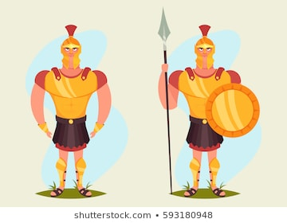



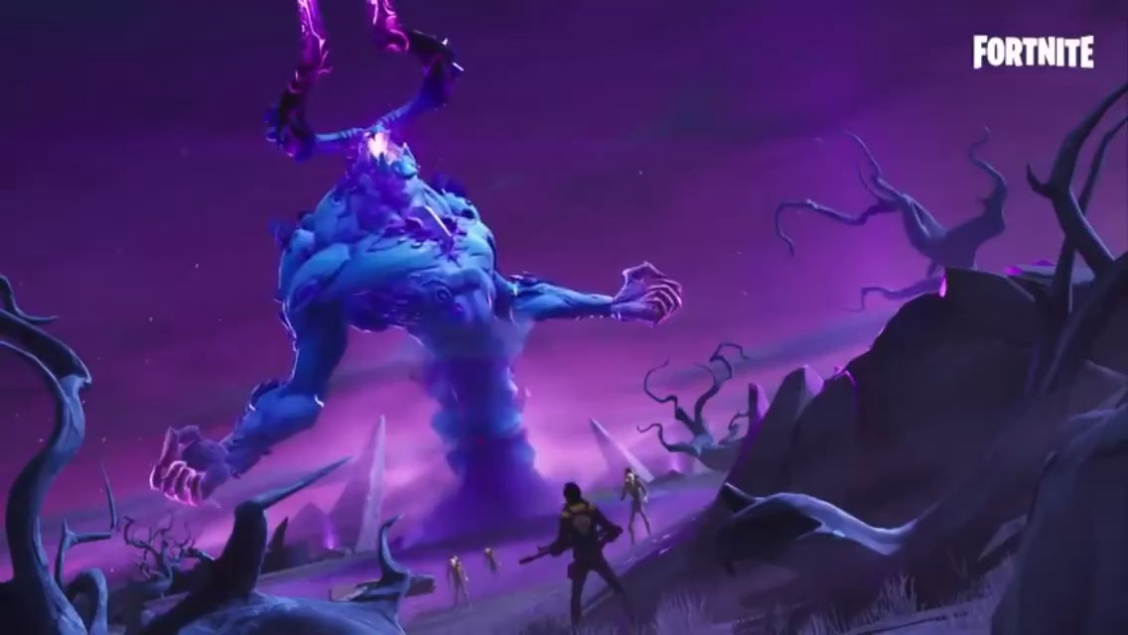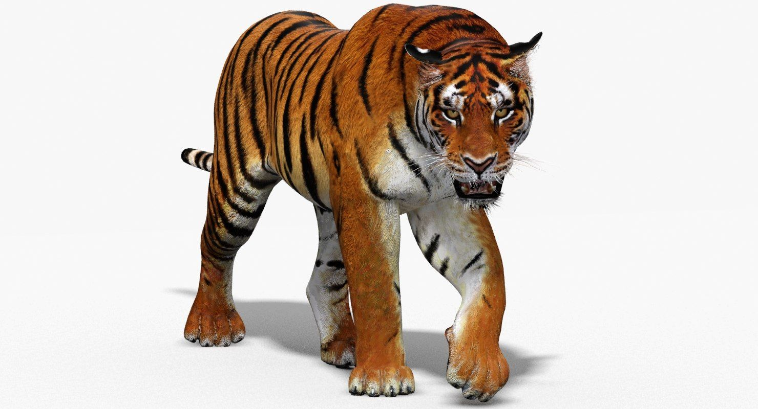

How do you plan to make your game engaging?

Forest arens, desrt arena, classic arena, extratime, gurd, tiger,equipment.