USE [Database]
SELECT
- Retrieve data from a Table using SELECT
- What to do / What not to do
CONCAT / +
- DIG + DIG
- STR + DIG
- STR + STR
UNION / UNION ALL
- One Example with UNION
- Difference Between UNION AND UNION ALL
WHERE CLAUSEL
- What is Where (for Filtering the Data)
- The importance of Operators in Where Clausel (Priority of Operators)
- In and not in
- in vs (= /Or)
- Between
- Not Between
- Like (See the notebooks Valuable examples)
GO
NEWID () / CHECKSUM (NEWID ())
DATE
- DATE / DATETIME / DATETIME2/ TIME
- DATEADD / DATEDIFF / YEAR () / MONTH () / DAY () / QUARTEL
- CONVERT
CAST
- For Example: CAST([Close Price] AS varchar (2) ) error
- TRY_CAST

AGGREGATE FUNCTION: SUM / AVG / …….

TOP
- What is TOP
- SELECT TOP 100 .. FROM ….
- SELECT TOP 100 Percent
- Top with ties
- SELECt TOP (@A) correct SELECT TOP @A Incorrect

DISTINCT
- What is DISTINCT
- Combination of Distinct and Count

Right/ Left Function
ORDER BY
- Order BY ColName
- Order BY 1, 2,3
- Using Order BY for getting arbitrary Rows Order BY NEWID ()
- ORDER BY (SELECT 1) OR ORDER BY (SELECT NULL)
SUBQUERY (TOP 100 Percent)
INDEX / HIP TABLE / Clustered / Non-Clustered Index
CASE
ISNULL/Coelesce
UPDATE
- What is Update (Syntax)
- Simultaneously UPDATE two columns
- Loop-back Update
IIF
Truncate
UPDATE RULES (By Changing the Header Table What Happened for Detail Tables)
- No Action
- SET NULL
- SET Default
- Cascade (Not Used for Delete) for Update It can be used
INSERT / Batch INSERT / BULK INSERT
- Default Value
- SET IDENTITY_INSERT
- SCOPE_IDENTITY
- Go INSERT …. GO (100)
JOINS
- INNER JOIN
- LEFT JOIN
- Right JOIN
- FULL JOIN
- CROSS JOIN
- ON is equivalent with Where
- NULL VALUES as Join Key
sys.objects / sys.columns / sys.Tables / Information_Schema.Tables
EXISTS
DROP
Variable / TABLE Variable
Alter Table / Alter Column
Combination of Update and Join
Sharp Table
- #T
- Difference Between #T and ##T
- IDENTITY and SELECT * into #t from T1 (Transfer of Identity fom T1 to #T) How to avoid
- Further data into #T using Insert
- SELECT * FROM tempdb.sys.tables where name like ‘%temp%’
- Identity(int,1,1) AS RW,. Into #Temp From ….
WHILE LOOP
GROUP BY
- Having
- STRING_AGG
- GROUP BY and INNER JOIN
Window Functions
- ROW_NUMBER()
- RANK()
- Dense_Rank()
- NTILE()
Analytic Function
- LEAD
- LAG
- First_Value
- Last_Value

CTE (Common Table Expression)
VIEW
- VIEW / UPDATE
- VIEW / DELETE AND INSERT
Functions
- Scalar Functions
- Table Functions
Locking
SP_rename
Truncate does not work on Header Table. The Table should be detailed
DBCC CHECKINDENT
ERROR Handling
Transaction
TRIGGER
PIVOT / UNPIVOT

  - Connecting to a Database
- Default database: master
- Use statement
  - Retrieving Specific Columns
SELECT NationalIDNumber,
LoginID,
JobTitle
FROM HumanResources.Employee;
1-3. Retrieving All Columns
SELECT * FROM HumanResources.Employee;
Please remember that, as good practice, it is better to reference the columns you want to retrieve explicitly
instead of using SELECT *. If you write an application that uses SELECT *, your application may expect the same columns (in the same order) from the query. If later on you add a new column to the underlying table or view, or if you reorder the table columns, you could break the calling application, because the new column in your result set is unexpected.

Using SELECT * can also negatively affect performance.
  - Specifying the Rows to Be Returned
-where
-and or
In a SELECT query, the WHERE clause restricts rows returned in the query result set. The WHERE clause provides search conditions that determine the rows returned by the query. Search conditions are written as predicates, which are expressions that evaluate to one of the Boolean results of TRUE, FALSE, or UNKNOWN. Only rows for which the final evaluation of the WHERE clause is TRUE are returned. Table 1-1 lists some of the common operators
available.
-operators
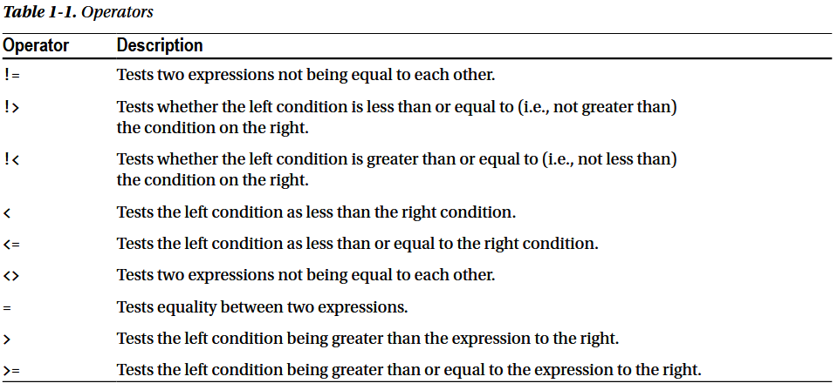
1-5. Renaming the Output Columns
You can specify any name you like for a column via the AS clause. The name you specify is termed a column alias
BusinessEntityID AS "Employee ID",
BusinessEntityID AS [Employee ID],
VacationHours AS Vacation,
VacationHours Vacation,
Vacation = VacationHours,

1-6. Building a Column from an Expression

1-7. Providing Shorthand Names for Tables
You are writing a query and want to qualify all your column references by indicating the source table. Your table name is long. You wish for a shorter nickname by which to refer to the table.
SELECT E.BusinessEntityID AS "Employee ID",
E.VacationHours AS "Vacation",
E.SickLeaveHours AS "Sick Time"
FROM HumanResources.Employee AS E;

1-8. Negating a Search Condition
SELECT Title,
FirstName,
LastName FROM Person.Person
WHERE NOT (Title = 'Ms.' OR Title = 'Mrs.');

SELECT Title,
FirstName,
LastName FROM Person.Person
WHERE Title != 'Ms.' AND Title != 'Mrs.';

1-9. Specifying A Range of Values
SELECT SalesOrderID,
ShipDate
FROM Sales.SalesOrderHeader
WHERE ShipDate BETWEEN '2005-07-23T00:00:00'
AND '2005-07-24T23:59:59';
1-10. Checking for NULL Values
SELECT ProductID,
Name,
Weight
FROM Production.Product
WHERE Weight IS NULL
1-11. Providing a List of Values
SELECT ProductID,
Name,
Color
FROM Production.Product
WHERE Color IN ('Silver', 'Black', 'Red');
WHERE Color IN ('Silver', 'Black', 'Red')
WHERE Color = 'Silver' OR Color = 'Black' OR Color = 'Red'
1-12. Performing Wildcard Searches
